华为路由与交换配置命令

前言：
1.蓝色字体表示命令行命令，正式执行时不要复制前面的> # []号，> # []号只是提示符
2.绿色字体表示注释，有时注释太多就不用绿色表示了
3.注意：本文档的所有操作请先在测环境进行实践，请不要直接在真实的服务器中操作！
4.本文档出现的所有设备序列号及其他信息均为作者个人在二手市场购买来专用于实验目的的，不涉及泄露任何公司生产环境的相关信息。

版权声明：
本文档以开源的形式发布，所有条款如下：
（1）无担保：作者不保证文档内容的准确无误，亦不承担由于使用此文档所导致的任何后果
（2）自由使用：任何人可以出于任何目的而自由地 阅读/链接/打印/转载/引用/分发/再创作 此文档，无需任何附加条件
若您 阅读/链接/打印/转载/引用/分发/再创作 本文档，则说明接受以上2个条款。

作者：李茂福
时间：2025-08-10

★第-1章、安装华为eNSP模拟器

★安装eNSP
先到华为官网下载eNSP模拟器安装包（官网已下架此软件，民间流传的最新版本为eNSP_1.3.00.100_Setup.exe）
然后要先安装以下三个依赖的软件：（先装依赖软件，最后再安装eNSP）
WinPcap 官网下载地址： https://www.winpcap.org/install/default.htm
Wireshark 官网下载地址： https://www.wireshark.org/#download
Oracle VM VirtualBox 官网下载地址： https://www.virtualbox.org/wiki/Downloads 建议用5.2.x版本
（https://download.virtualbox.org/virtualbox/5.2.44/VirtualBox-5.2.44-139111-Win.exe）

所以一共是要准备4个软件包，如果找不到要下载的资源，可以联系作者： sysyear@163.com

安装的过程就不多介绍了，双击安装，一路Next，装好eNSP模拟器后，找到它的图标：

点击右键，设置属性，将其兼容性改为Windows7，这一步很重要，有时路由器不能正常启动就是因为没有以win7的兼容性来运行程序。
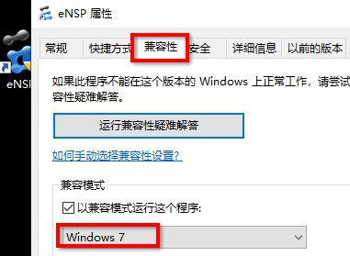
然后再双击图标，运行软件。
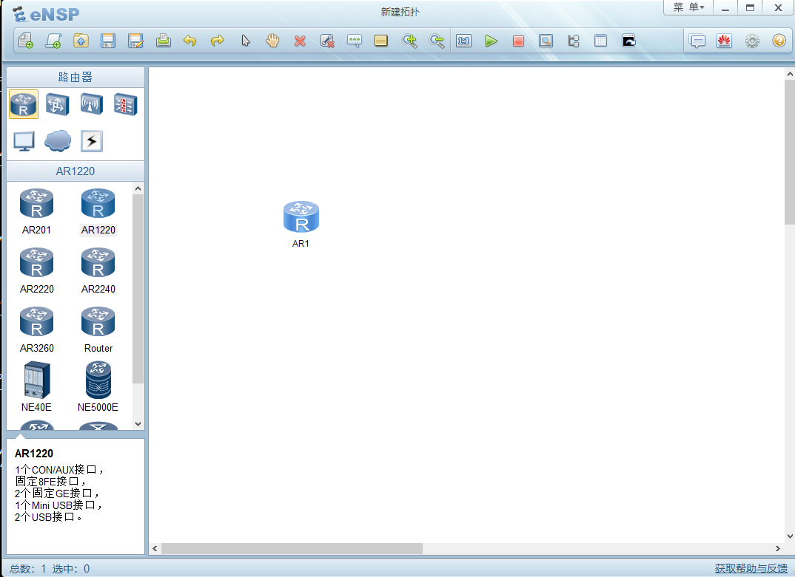
上图为eNSP的主界面，可以在左边拖入路由器或交换机等设备，放到右边的工作区里。然后右击选择启动，再双击设备的图标就可以进入命令行了。
具体的用法这里也不介绍了，本教程主要是教配置命令（有些高级特性命令是在实体设备上配置的）

如果有实体硬件设备，那最好是用真实的设备去测试。注意：不要在生产环境中做测试！！

★宿主机与模拟设备通信
让宿主机能通过网络访问到eNSP里的模拟设备，在拓扑中添加一朵云（cloud设备）
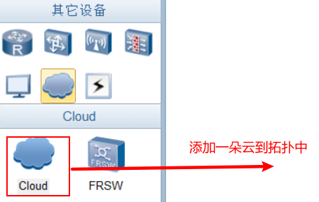
双击云，进行配置，增加2个端口，绑定信息：先创建UDP(Ethernet)，
再创建一个ethernet（绑定端口为宿主机上的网卡（如VirtualBox Host-Only Network）
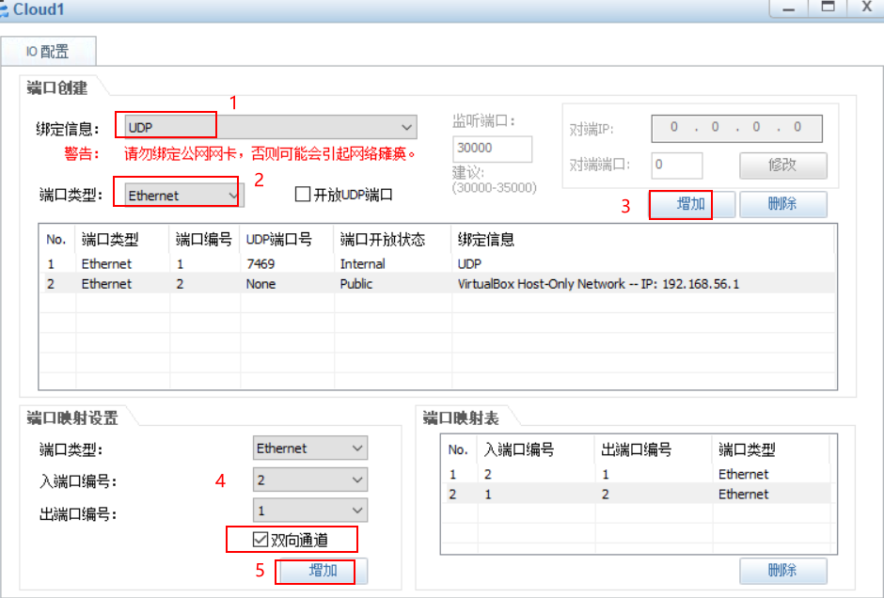
最后添加双向通道映射，入端口为2号，出端口为1号（顺序不可错了）
这时，可以将Cloud设备与其他模拟交换机/路由器连接了
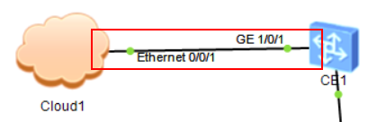

宿主机（个人电脑）的“VirtualBox Host-Only Network”这块网卡配置一个和交换机同网段的ip即可通信

★eNSP模拟器使用技巧
★设备自动水平对齐/垂直对齐
当我们按下Ctrl键，然后用鼠标选中多个目标设备时，就可按右键弹出功能菜单，里面有自动 水平对齐/垂直对齐的功能，不需要我们一个一个设备地手动用鼠标去调整位置了
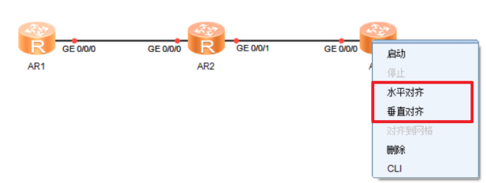
同理，可以显示网格
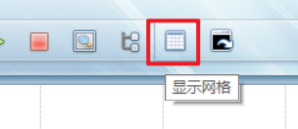
然后就可对齐到网格了，不需要手动调整设备间距了
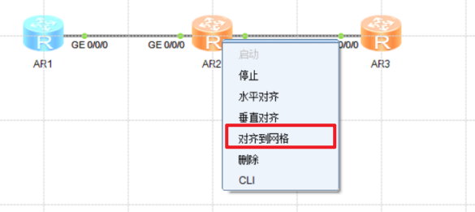

★调色板
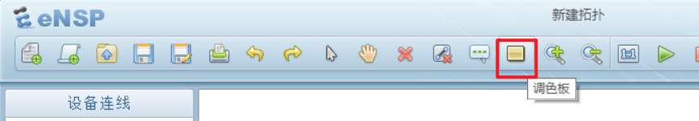
使用调色板可对某些设备划分背景区域
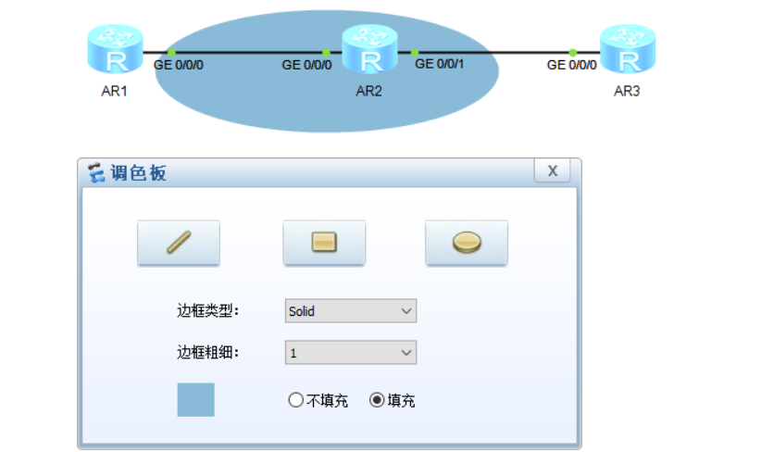

★多个cli窗口合并为一个
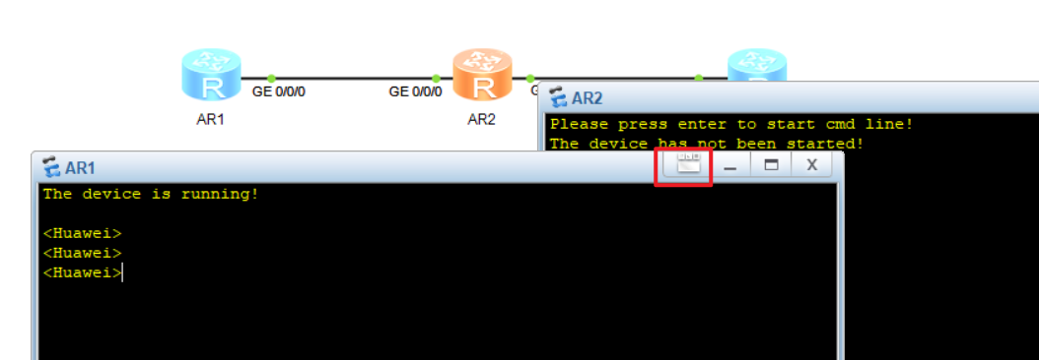
点击cli窗口右上角的按钮即可
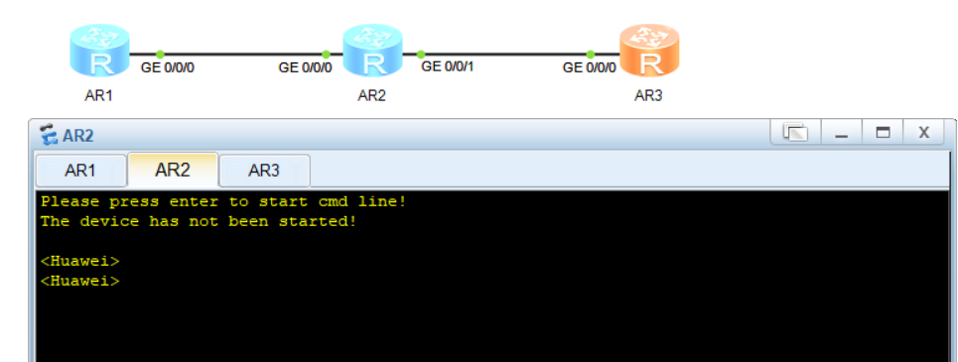
也可点击右上角的“菜单”→工具→合并/展开CLI
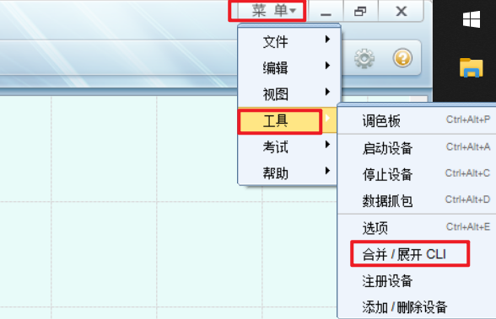

★设置cli默认背景前景色及字体
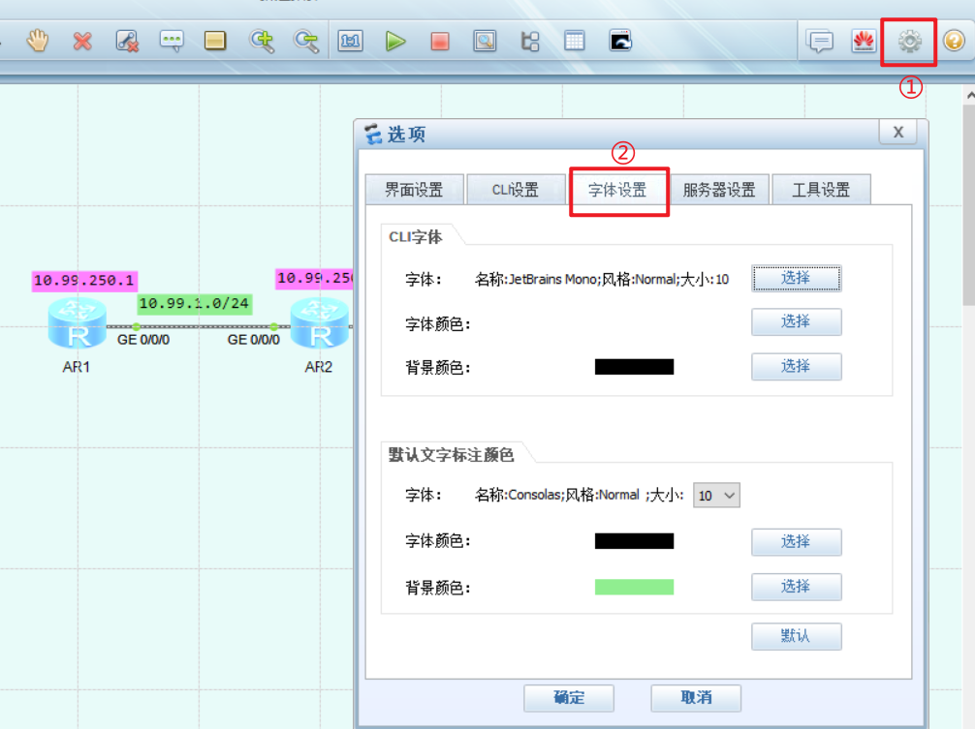

★eNSP模拟设备特性说明

★ensp模拟器中的AR2240等AR路由器的Tunnel接口起不来，建议使用NE40E设备进行相关配置

★VXLAN相关实验只能用CE12800交换机进行配置

★NE40E及CX等设备，默认开启了dcn功能，查看其接口时，有一堆子接口，可以使用 undo dcn命令关闭
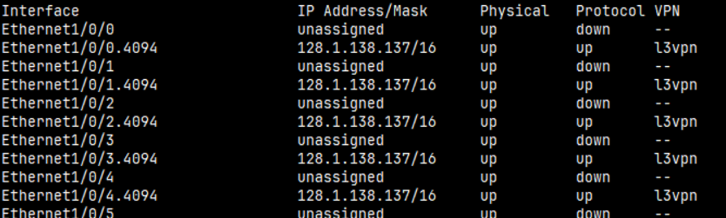
[~HUAWEI] undo dcn
Warning: This operation will disable DCN function. Continue? [Y/N]:y
Info: The operation may take a few seconds. Please wait for a moment...done.
[*HUAWEI] commit
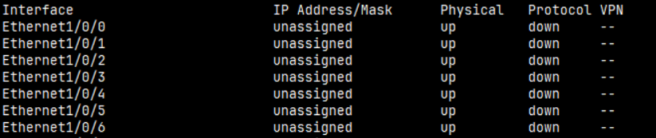

★如果需要访问模拟器里的防火墙时，请不要直接使用cloud连接防火墙设备，防火墙cpu-usage会异常升高，导致模拟器崩溃，可以在cloud和防火墙之间用一台交换机中转一下（如下图，在cloud和FW之间，连接一台交换机LSW3）
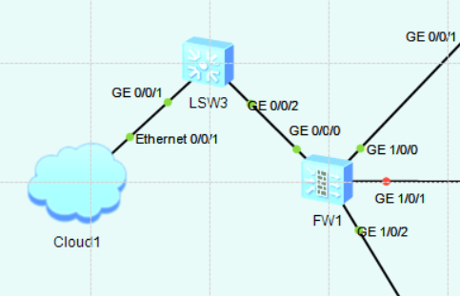

★模拟器里的USG6000防火墙支持HRP双机热备及vsys虚拟系统功能

★模拟器里的设备，reset saved-configuration清空配置，再reboot重启，会重启失败，断电再启动的话，原来的配置还在。彻底清空配置的方法是，关闭拓扑，到项目目录下，把需要清空配置的设备配置文件删除。
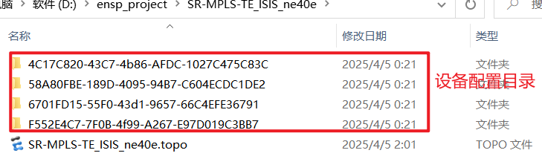

★第0章、安装华为eNSP_Pro模拟器

★安装eNSP_Pro
先到华为官网下载eNSP_Pro模拟器安装包，
https://support.huawei.com/enterprise/zh/training-and-certification-service/ensp-pro-pid-260215817/software
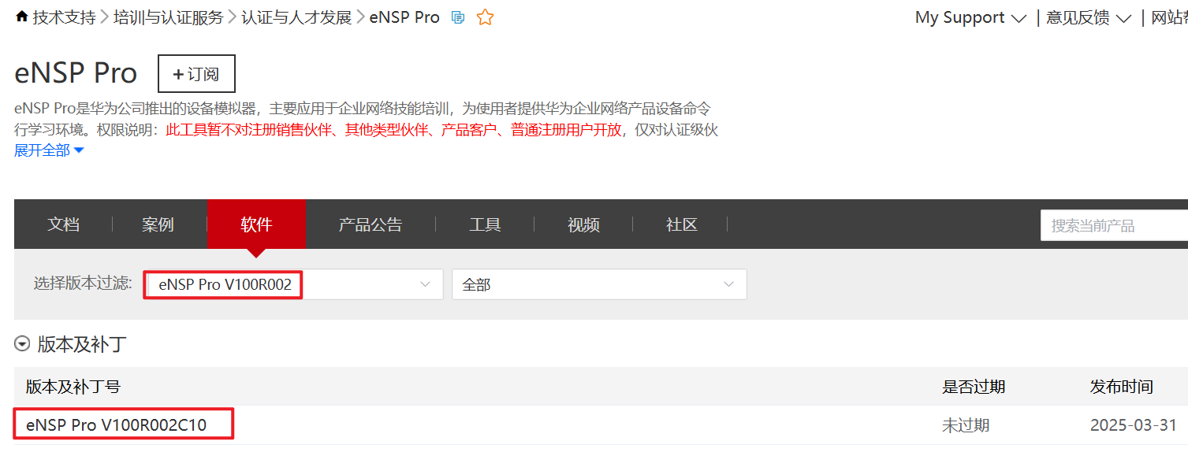
选择最新版本，点击进入软件下载页
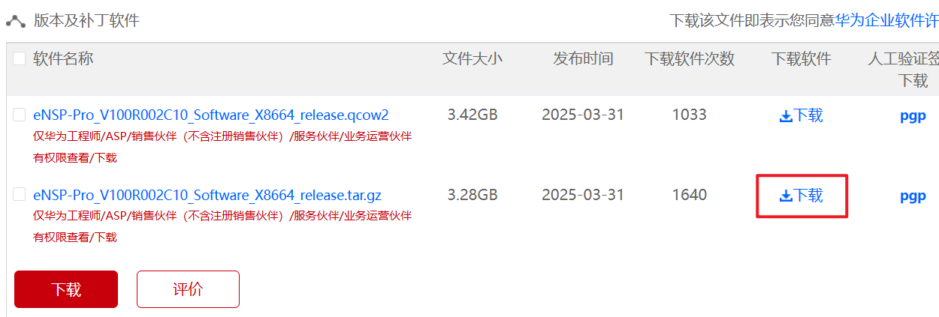
下载.tar.gz后缀的文件，下载之后，再解压到某个目录下，（解压后的xxx.vdi是一个磁盘文件）
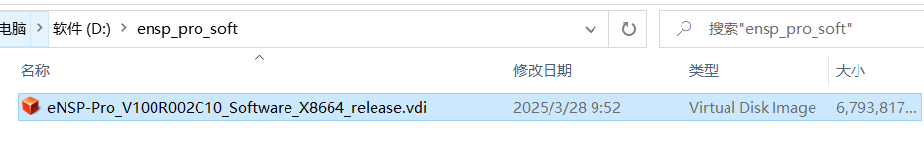
使用VirtualBox创建虚拟机，挂载此磁盘，并以此磁盘启动即可，操作步骤如下：
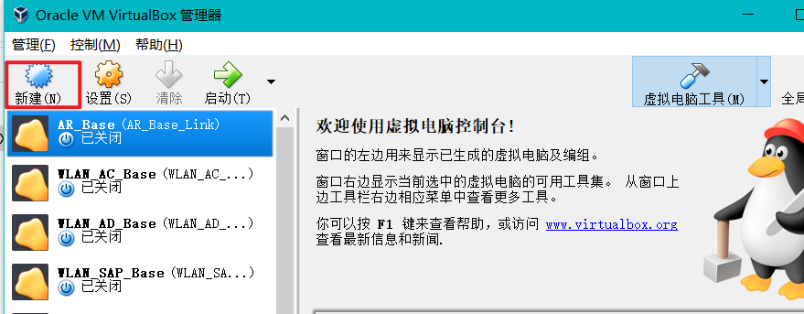
新建
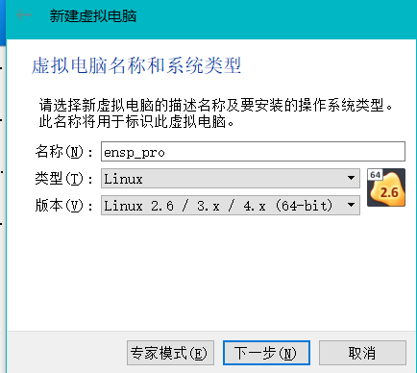

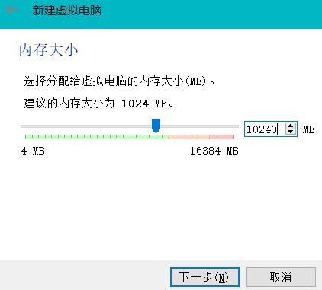
内存大小，建议在10GB以上
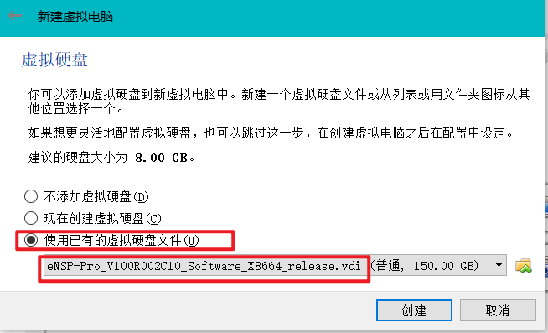
虚拟硬盘，直接使用我们刚刚解压的vdi磁盘文件
点击“创建”
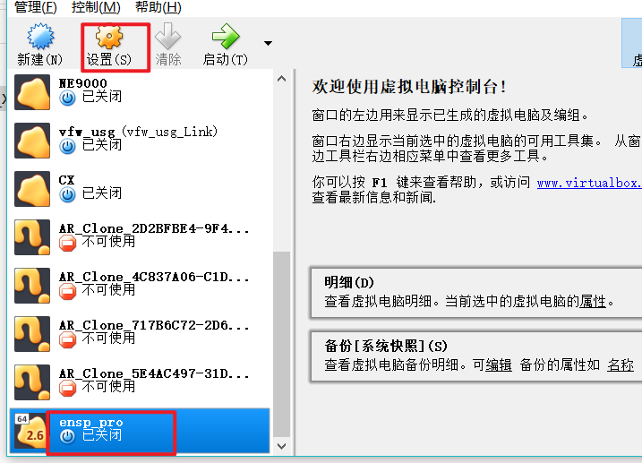
选中刚刚创建的虚拟机，点击工具栏的“设置”
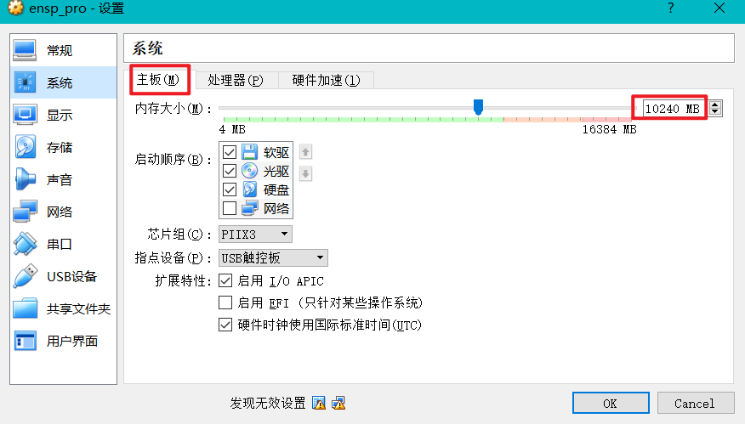
系统→主板→内存大小，根据自己电脑的内存情况，适当分配，建议在10GB以上，ensp_pro对内存的要求不高
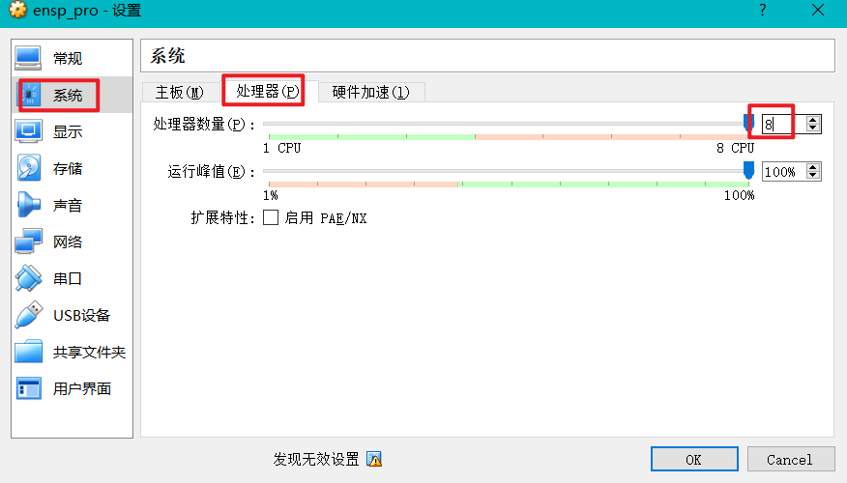
系统→处理器→处理器数量，建议在8核以上，ensp_pro对cpu性能要求较高

设置网络：网络→网卡1，勾选“启用网络连接”，连接方式：仅主机(Host-Only)网络，
界面名称：VirtualBox Host-Only Ethernet Adapter，此网络要开启DHCP功能，（ensp_pro虚拟机通过此网卡进行连接登录管理界面）
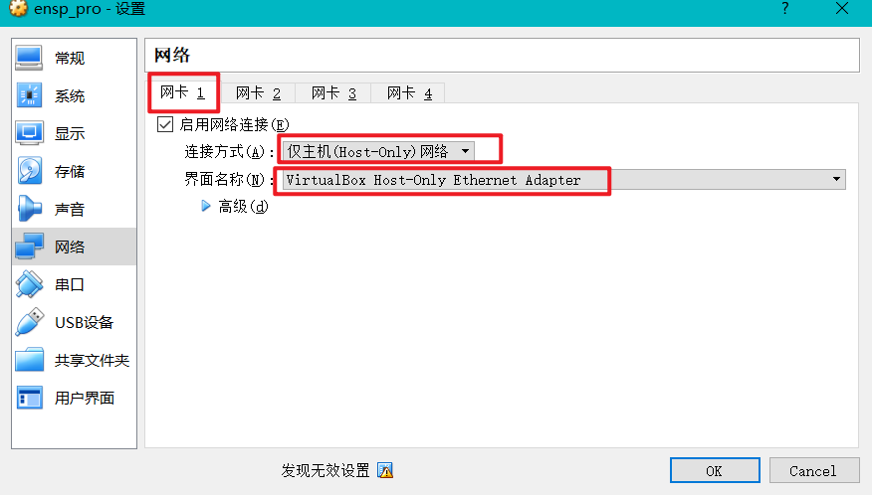
网络→网卡2，勾选“启用网络连接”，连接方式：网络地址转换(NAT），
界面名称：无，此网络默认开启DHCP功能，
（ensp_pro虚拟机通过此网卡进行连接公网，需要连到公网能登录华为uniportal账号）
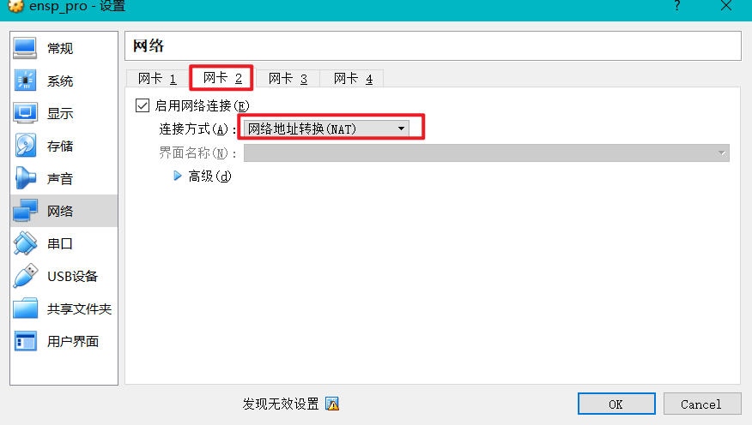
设置完毕，点击右下角“OK”
启动虚拟机
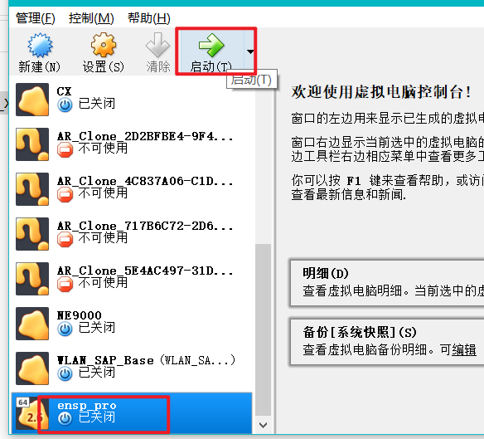
大概等待2-3分钟，虚拟机启动后，出现如下界面
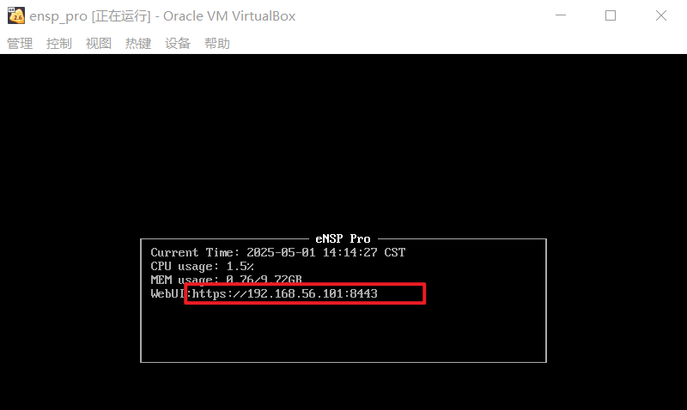
根据提示的信息，使用浏览器登录enp_pro管理界面 https://192.168.56.101:8443/
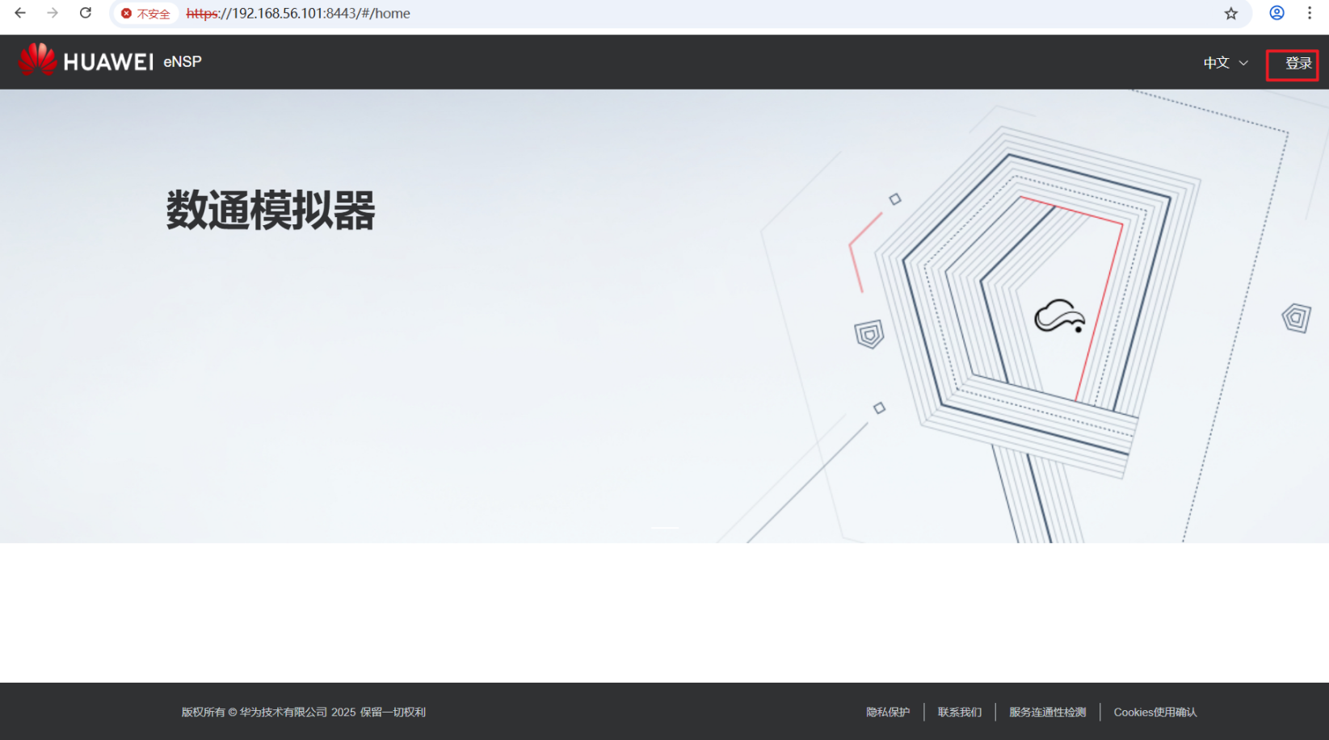

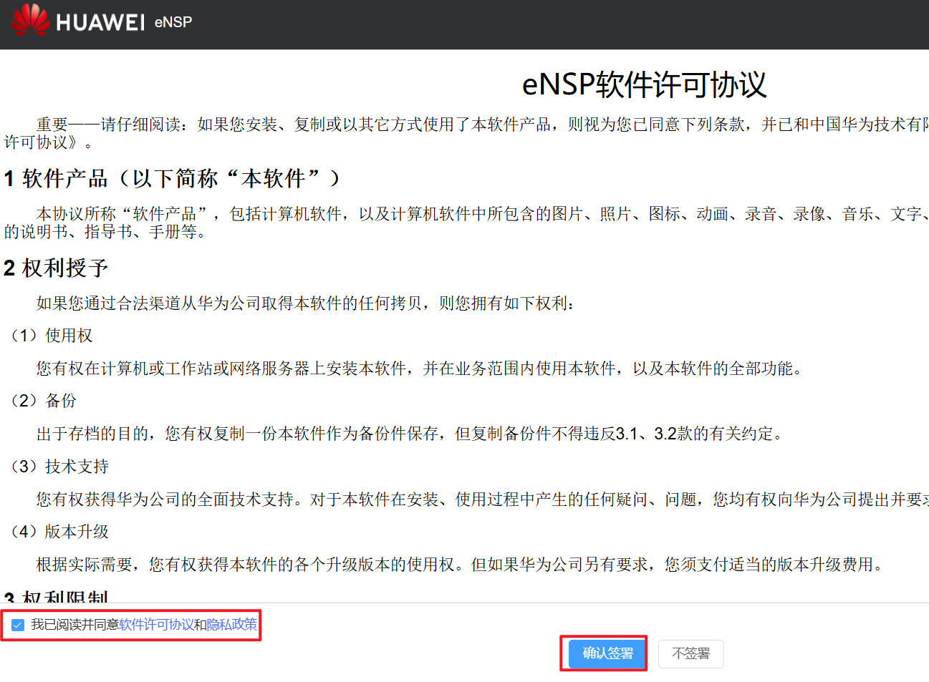
签署软件许可协议和隐私政策
虚拟机需要联网，然后要登录华为Uniportal账号，此账号要绑定华为认证级伙伴公司，才有权限使用ensp_pro
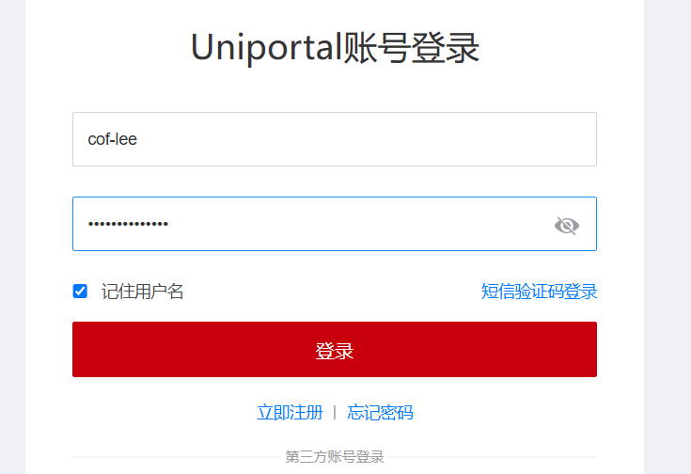
登录后，才可正常使用

如果后续使用中出现如下情况，可能是软件证书过期了，需要到官网下载最新的软件
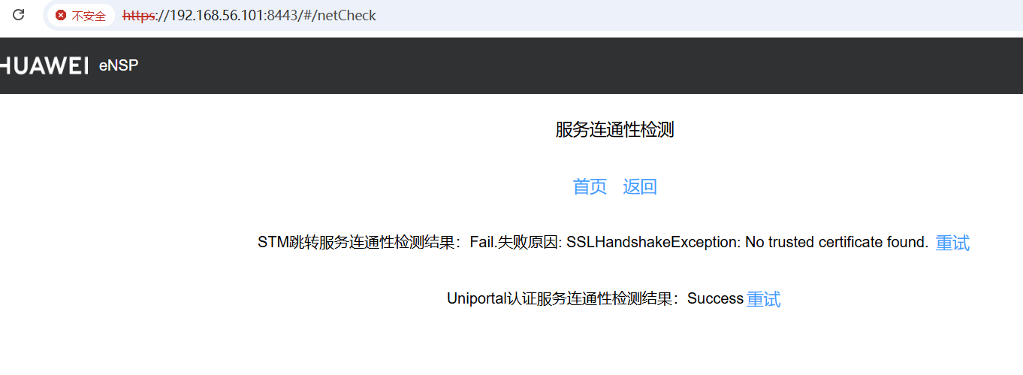

★创建沙箱
eNSP_Pro中的沙箱，就和旧版本的ensp里的拓扑一样，是指一个模拟环境
登录首页，点击上面的“仿真环境”→沙箱
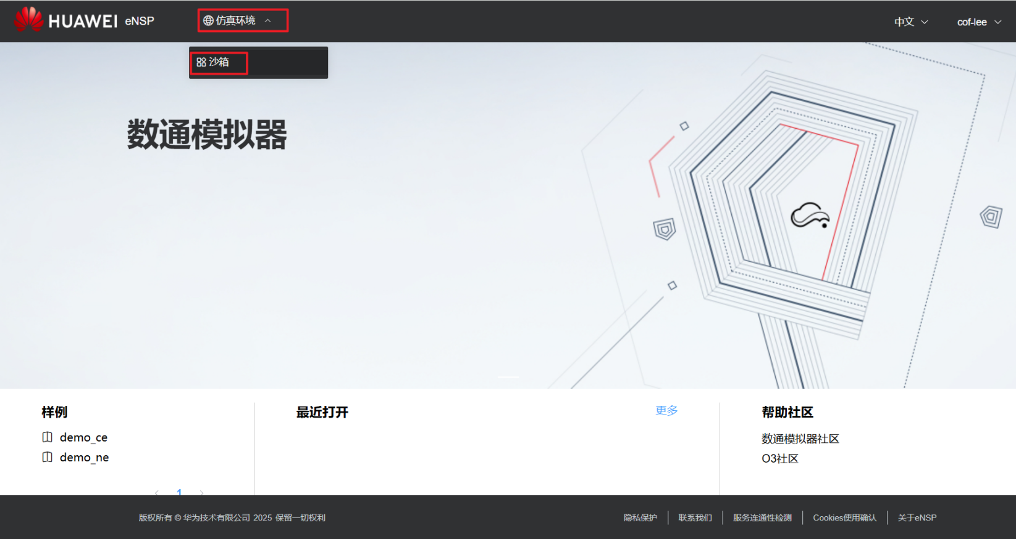
点击“创建沙箱”
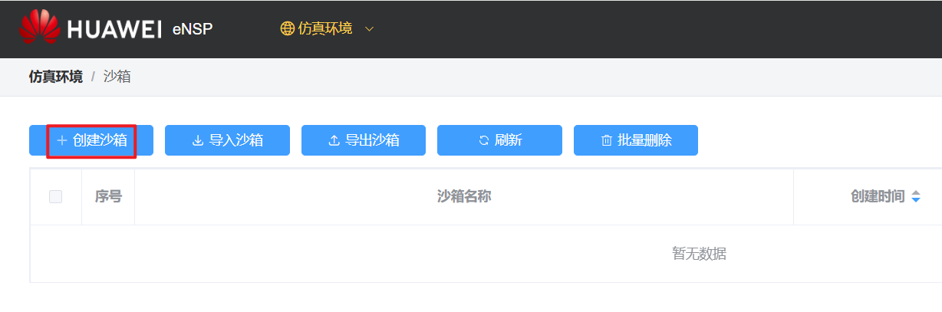

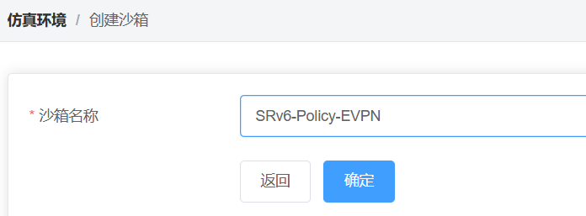
点击“确定”后，沙箱已创建，并自动进入沙箱界面
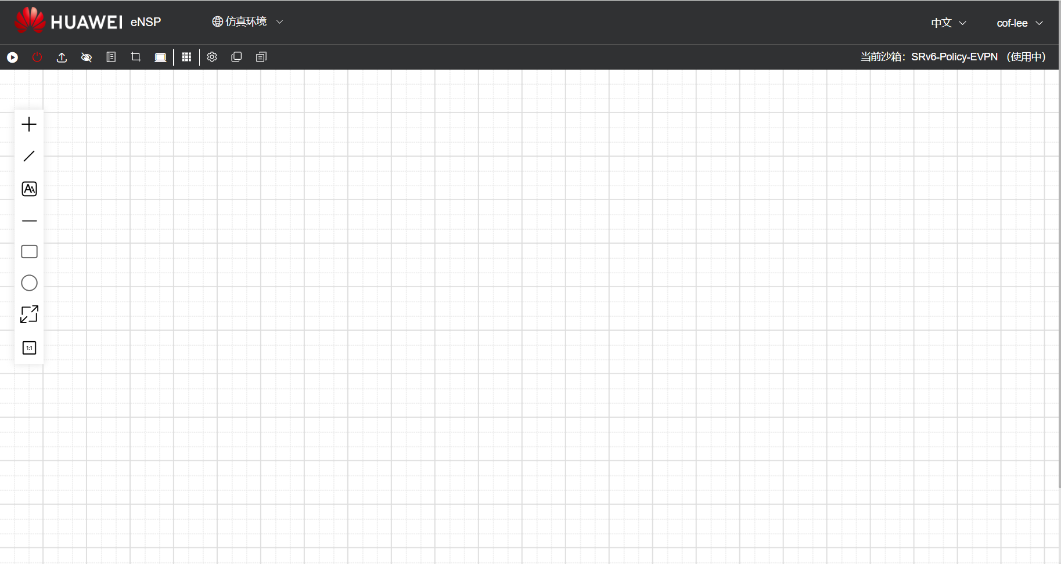
左侧有设备货架，点击“+”加号，可添加设备到拓扑中
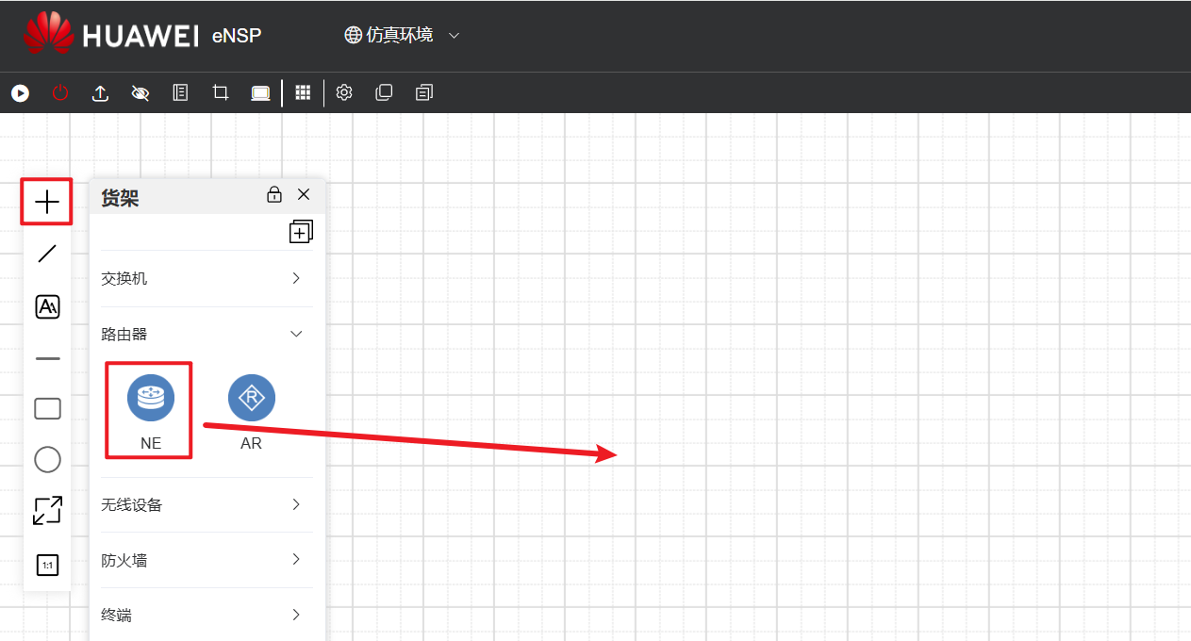
选中设备，点击鼠标右键，可进行“网络对齐”或其他对齐操作
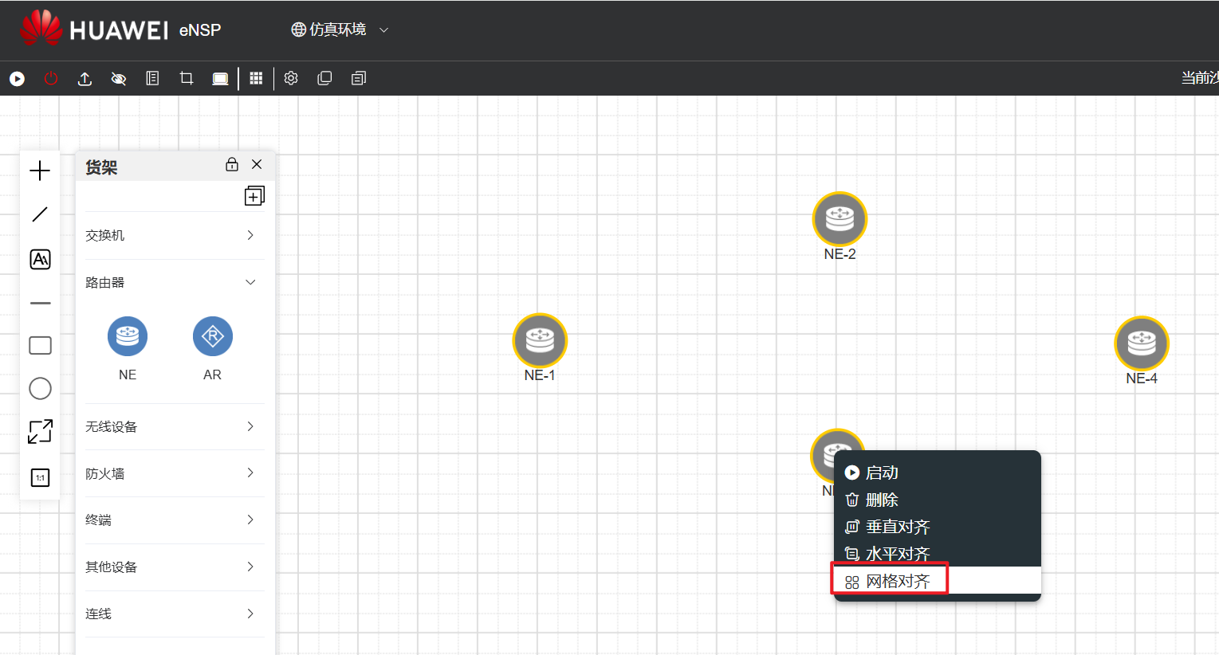
添加连线，
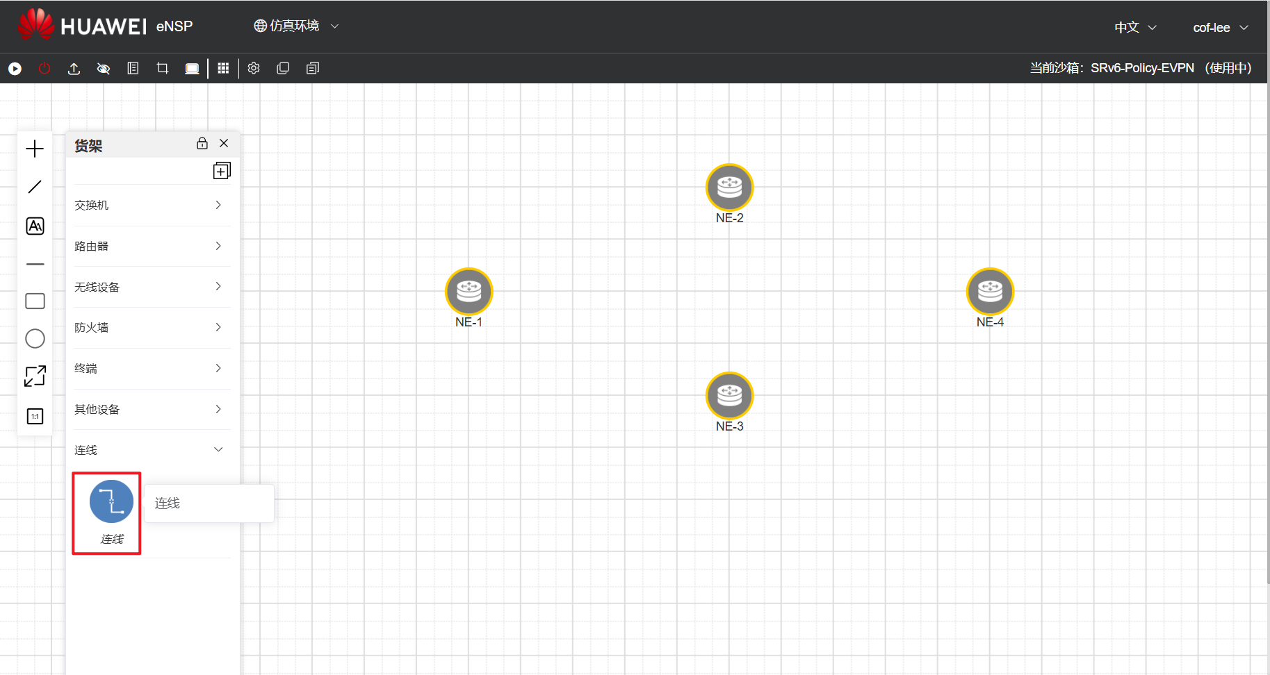
启动设备
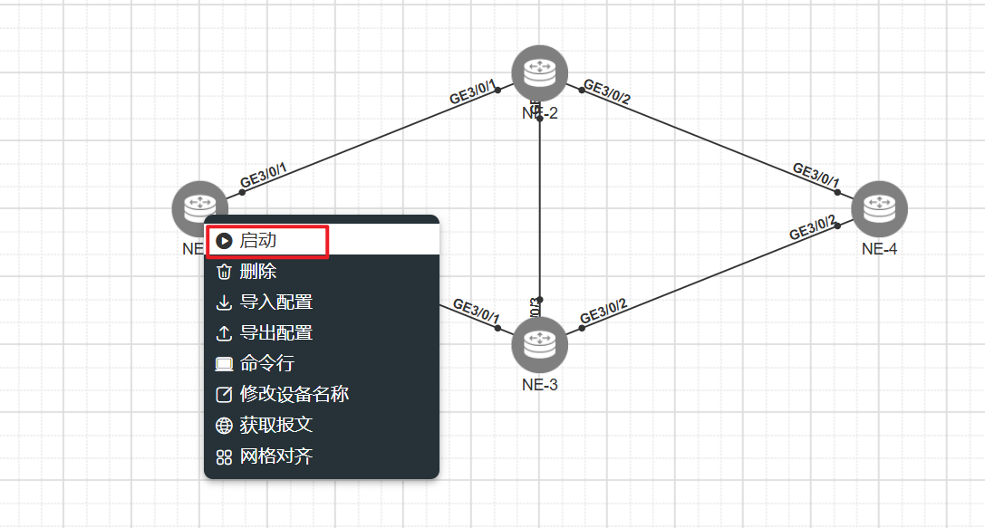
进入命令行：
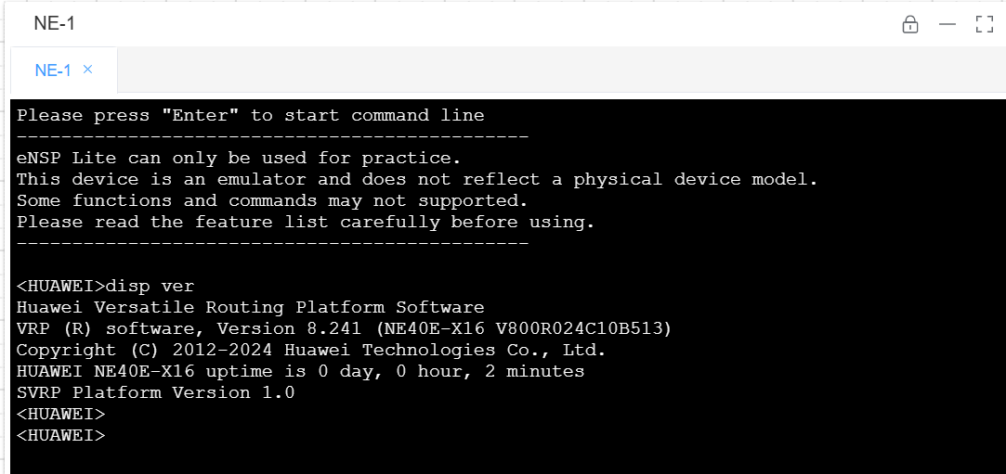
NE设备，默认是使用了PNP设置，可以进入配置界面，执行命令 undo pnp enable关闭
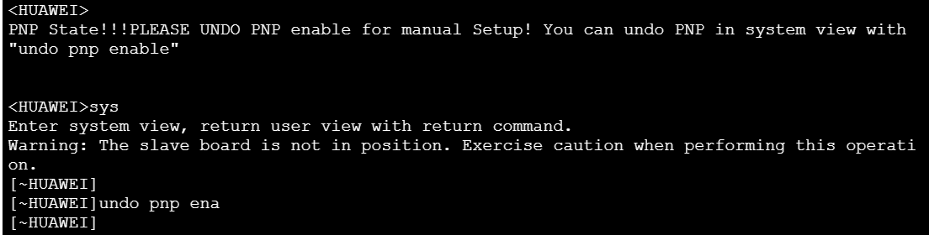

使用完毕后，要先关闭设备，再退出登录，最后关闭虚拟机

★宿主机与模拟设备通信
让宿主机能通过网络访问到eNSP Pro里的模拟设备
首先，默认情况下ensp的虚拟机，我们给它添加了2张网卡：
网卡1为仅主机模式，用于我们的电脑本地连接ensp的web界面的，这张网卡要能通过dhcp获取到ip地址
网卡2为NAT模式，用于ensp虚拟机访问公网（internet）的，用于我们登录华为uniportal账号
现在，需要给虚拟机再添加一张网卡（仅主机模式，先给VirtualBox或者vmware再新增一个虚拟网络）
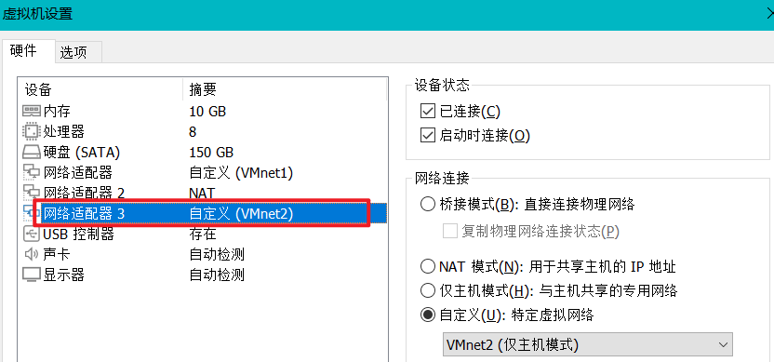

VirtualBox设置：
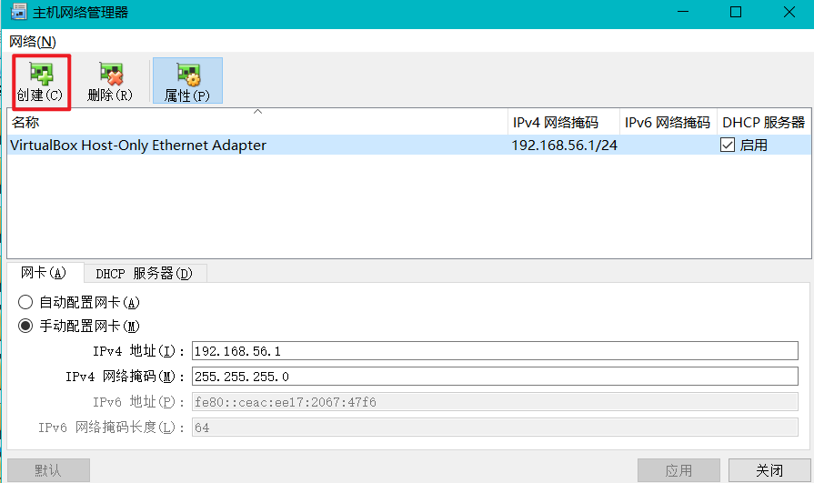
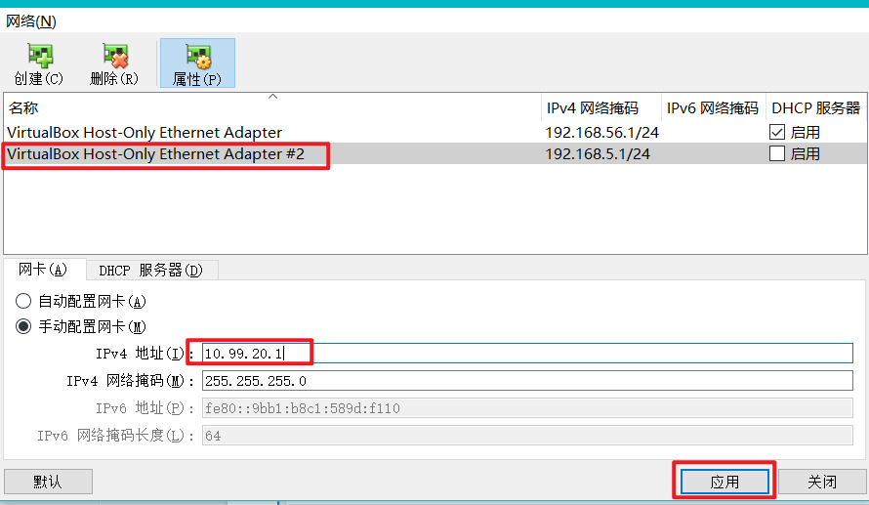
再给虚拟机添加网卡3
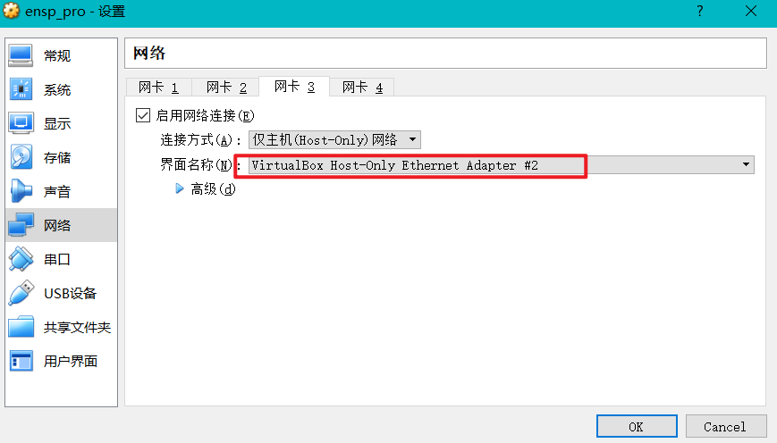

添加完成后，再重启ensp虚拟机

在沙箱拓扑中添加一朵云（cloud设备）
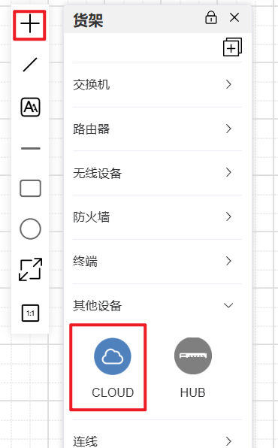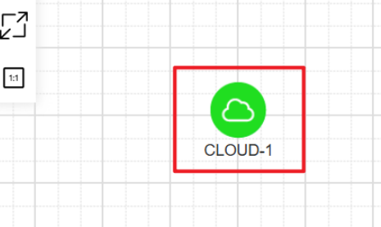
双击CLOUD-1，进行设置：添加一个Ethernet网口（选eth2，我们给ensp虚拟机新增的那张网卡）
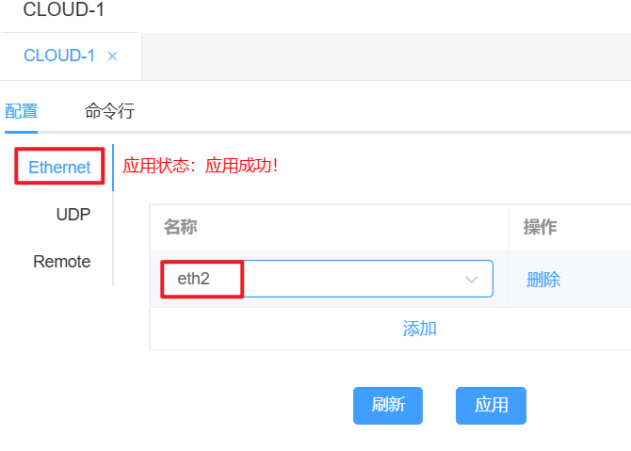

再添加我们需要做实验的设备，比如某台NE设备
把CLOUD-1的eth2连接到NE设备的某个网口就可以通信了（本例把EN-4设备的GE0/0/0连接到云的eth2）
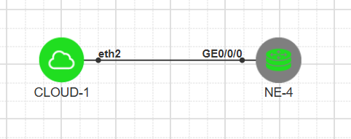
等NE设备开机后，再进行ssh相关配置，就可以远程登录了
ip vpn-instance Management
ipv4-family
#
interface GigabitEthernet0/0/0
undo shutdown
ip binding vpn-instance Management
ip address 10.99.20.10 255.255.255.0
#
aaa
local-user enspuser password irreversible-cipher YourPasssWord（要改为实际使用的密码）
local-user enspuser level 3
local-user enspuser service-type ssh
#
ssh authentication-type default password
ssh authorization-type default aaa
ssh user enspuser
ssh user enspuser authentication-type password
ssh user enspuser service-type sftp stelnet
ssh user enspuser sftp-directory cfcard:/
ssh server-source all-interface
y
ssh ipv6 server-source all-interface
y
stelnet server enable
sftp server enable
#
user-interface vty 0 4
authentication-mode aaa
y
protocol inbound ssh
idle-timeout 640
#
commit

# CE设备配置：
ip vpn-instance Management
ipv4-family
#
interface MEth0/0/0
undo shutdown
ip binding vpn-instance Management
ip address 10.99.20.11 255.255.255.0
#
aaa
local-aaa-user password policy administrator
undo password alert original
password expire 0
local-user enspuser password irreversible-cipher YourPasssWord（要改为实际使用的密码）
local-user enspuser privilege level 3
y
local-user enspuser service-type ssh
y
#
ssh authentication-type default password
ssh authorization-type default aaa
ssh user enspuser
ssh user enspuser authentication-type password
ssh user enspuser service-type sftp stelnet
ssh user enspuser sftp-directory flash:
ssh server-source all-interface
y
stelnet server enable
sftp server enable
#
user-interface vty 0 4
authentication-mode aaa
y
protocol inbound ssh
idle-timeout 640
#
commit

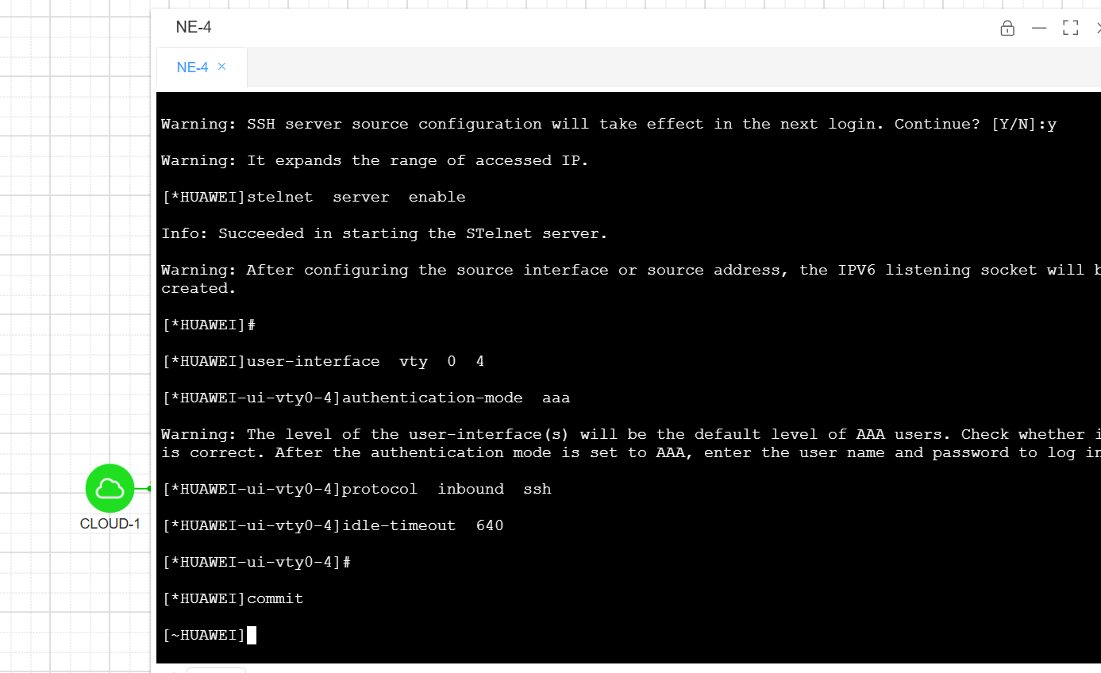
#作者的电脑上的网卡ip为10.99.20.1，给NE设备配置的管理地址为10.99.20.10
现在就可以直接在自己电脑上使用mobaXterm之类的shell终端进行远程连接了
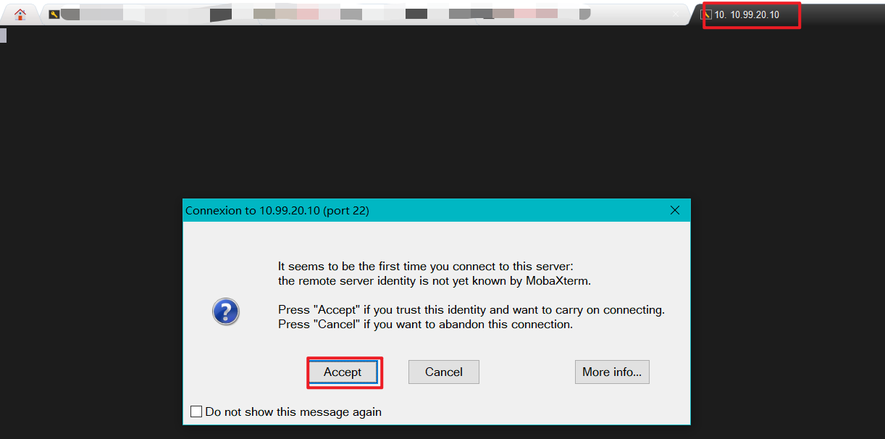

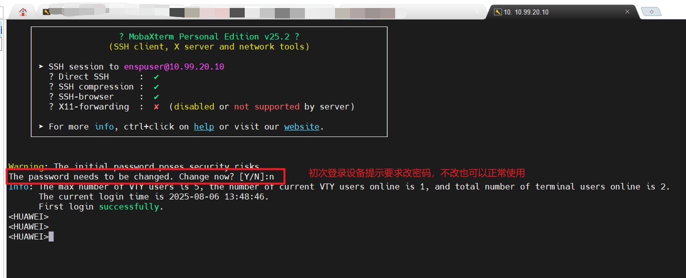
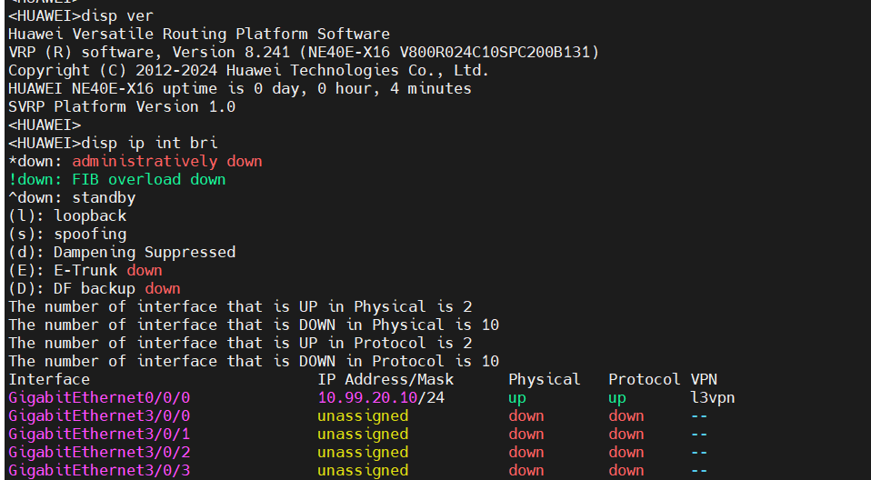
还能通过sftp下载配置文件
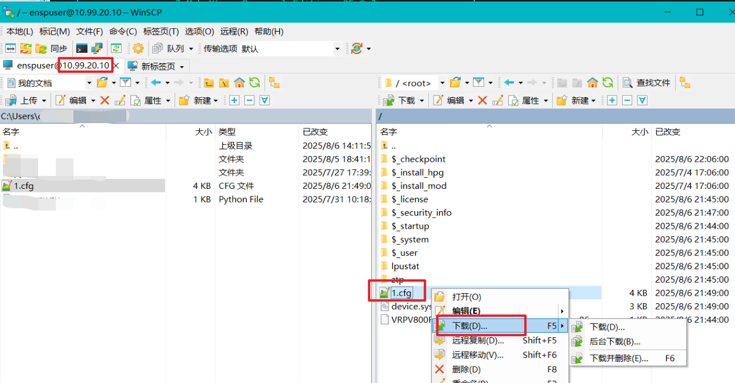

★第1章、设备基础信息操作

★设备基础信息查看
<HUAWEI> disp version #查看设备版本信息
Huawei Versatile Routing Platform Software
VRP (R) software, Version 5.170 (S5735 V200R021C00SPC100)
HUAWEI S5735S-L24T4S-A Routing Switch uptime is 0 week, 0 day, 0 hour, 59 minutes
ES5D2T28S022 0(Master) : uptime is 0 week, 0 day, 0 hour, 58 minutes
BootROM(1st) Version : 0000.0121
BootROM(2nd) Version : 0000.0200
BootLoad Version : 0215.0000
CPLD Version : 0108
Software Version : VRP (R) Software, Version 5.170 (V200R021C00SPC100)

<HUAWEI> disp esn #查看设备序列号，用于申请license
ESN of slot 0: 21980109152SL1604582 #此设备是作者个人在二手市场购买的，正式环境的序列号不可泄露
<HUAWEI> disp esn int #查看端口的（光模块的）esn
<HUAWEI> disp esn all #查看所有，含电源，风扇

<HUAWEI> disp elabel #查看设备电子标签
[Board Properties]
BoardType=S5735S-L24T4S-A
BarCode=21980109152SL1604582
Manufactured=2020-02-12
Model=S5735S-L24T4S-A
<HUAWEI> disp device elabel brief #同上，查看设备电子标签
Equipment SN(ESN): 4A1234567890
License ESN: --
-------------------------------------------------------------------------------
SlotID Sub Type SN P/N
-------------------------------------------------------------------------------
1 -- S5735-S48T4XE 4A1234567890 12345678
FAN1 -- -- --
PWR1 PAC80S12-CN 12341234567890123456 01234567
-------------------------------------------------------------------------------

<HUAWEI> disp bridge mac-address #查看设备网桥mac，同vlanif接口ip对应的mac地址
System bridge MAC address: 60d7-5574-fd76

<HUAWEI> disp device slot 1/2 #查看slot板卡信息

★设备状态查看
<HUAWEI> disp cpu-usage #查看CPU使用率
CPU Usage Stat. Cycle: 60 (Second)
CPU Usage : 4% Max: 59%
CPU Usage Stat. Time : 2024-08-12 05:11:46
CPU utilization for five seconds: 4%: one minute: 4%: five minutes: 4%
Max CPU Usage Stat. Time : 2024-08-12 04:23:05.

<HUAWEI> disp memory-usage #查看内存使用率
Memory utilization statistics at 2024-08-12 05:13:58+08:00
System Total Memory Is: 522190848 bytes
Total Memory Used Is: 136334224 bytes
Memory Using Percentage Is: 26%

<HUAWEI> disp power #查看电源状态
<HUAWEI> disp fan #查看风扇状态

<HUAWEI> disp temperature all #查看温度
-------------------------------------------------------------------------------
Slot Card Sensor Status Current(C) Lower(C) Lower Upper(C) Upper
Resume(C) Resume(C)
-------------------------------------------------------------------------------
1 NA NA Normal 41 -3 1 65 61
2 NA NA Normal 44 -3 1 65 61

★查看配置
<HUAWEI> disp saved-configuration #查看保存的配置
<HUAWEI> disp current-configuration #查看当前运行的配置
<HUAWEI> disp current-configuration interface vlan1 #查看接口上的配置
<HUAWEI> disp configuration commit changes #查看提交了的配置

★提交/清空候选配置
#较高型号的设备，v7以上的软件版本，如6800及以上系列，为了安全起见，默认配置模式下输入的配置是未提交（未生效）的，此时命令提示符前面有个*星号，必须输入commit后才生效
[*HUAWEI] display configuration candidate changes #查看当前未提交的配置
[HUAWEI] refresh configuration candidate #清除当前未提交的配置（此时命令提示符前没有*号）

如果想让执行的命令立即生效，可进入system-view时加个参数immediately：
<Huawei> system-view immediately #进入立即生效的命令配置界面
[HUAWEI] #此时执行的任何配置命令都是立即生效的，从安全的角度来讲，不建议这样操作。

★保存配置
[Huawei] return #返回到<>一般模式
<Huawei> save #配置完毕一定要记得保存配置，在一般模式下保存；默认保存到vrpcfg.zip
The current configuration will be written to the device.
Are you sure to continue? (y/n)[n]: y #输入y确定
It will take several minutes to save configuration file, please wait.......
Configuration file had been saved successfully
Note: The configuration file will take effect after being activated
<Huawei>
<Huawei> save /xxx.cfg #保存到指定的文件名xxx.cfg，保存配置时，需要交互输入y确认
The current configuration will be written to the device.
Are you sure to continue?[Y/N]y #输入y确定
Now saving the current configuration to the slot 0.
Aug 12 2024 02:12:00+08:00 Huawei %%01CFM/4/SAVE(s)[1]:The user chose Y when deciding whether to save the configuration to the device.
Aug 12 2024 02:12:00+08:00 Huawei %%01CFM/4/SAVE_FILE(s)[2]:When deciding whether to save the configuration to the file flash:/xxx.cfg, the user chose Y.
Save the configuration successfully.

<Huawei> save force vrpcfg.zip #强制保存到指定的配置文件，不需要交互输入y确认


[HUAWEI] configuration file auto-save interval 30 delay 5 #定时自动保存配置，30分钟，延迟5分钟

★文件目录操作
<HUAWEI> pwd #查看当前所在路径
flash:
<HUAWEI> cd ? #查看可进入的根路径
STRING The total length of absolute path is 64,the length of single
directory is 15
flash: Device name
<HUAWEI> cd flash: #进入flash:
<HUAWEI> dir #查看当前路径下的文件及子目录

<HUAWEI> mkdir back #在当前路径下创建一个子目录，名为 back
<HUAWEI> cd back #进入名为back的子目录
<HUAWEI> save back-xxx.cfg #保存配置到当前路径下，名为back-xxx.cfg
<HUAWEI> dir
Directory of flash:/back/
Idx Attr Size(Byte) Date Time FileName
0 -rw- 3,160 Jul 11 2022 23:22:53 back-xxx.cfg

<HUAWEI> copy back-xxx.cfg flash:/back-yyy.cfg #复制文件
Copy flash:/back/back-xxx.cfg to flash:/back-yyy.cfg?[Y/N]: y
100% complete.
<HUAWEI> unzip xxx.zip #解压某.zip文件
<HUAWEI> unzip xxx.zip xxx.cfg #解压某.zip文件解压后文件名为xxx.cfg，有的设备必须指定解压后文件名
<HUAWEI> tail fileName 1000 #查看文件内容，显示最后1000行，默认显示10

<HUAWEI> delete back-xxx.cfg #删除文件
Delete flash:/back/back-xxx.cfg?[Y/N]: y
Info: Deleting file flash:/back/back-xxx.cfg...succeeded.
<HUAWEI> undelete xxx.cfg #恢复文件，默认删除文件时是会放到回收站的
<HUAWEI> reset recycle-bin #清空回收站

<HUAWEI> delete /unreserved s5735_back_config.cfg #永久删除文件，不放入回收站
Warning: The contents of file flash:/s5735_back_config.cfg cannot be recycled. Continue? [Y/N]:y
Info: Deleting file flash:/s5735_back_config.cfg...succeeded.

<HUAWEI> fixdisk flash: #修复文件系统
Fix disk flash: will take long time if needed.
% Fix disk flash: completed.

★启动文件选择
<Huawei> display startup #查看启动文件
<Huawei> startup saved-configuration vrpcfg.zip #指定启动时使用的配置文件
This operation will take several minutes, please wait....
Info: Succeeded in setting the file for booting system
<Huawei> startup system-software xxxxxx.cc #指定启动时使用的系统镜像文件
<HUAWEI> startup patch xxx.pat #指定启动时加载的补丁包

★加载系统补丁
<HUAWEI> patch load xxx.pat all [run] #加载补丁包
<HUAWEI> patch active all #激活补丁包
<HUAWEI> patch run all #运行补丁包

<HUAWEI> patch delete all #删除补丁包

★安装模块
在官网下载相应版本的mod模块文件，然后使用ftp/tftp上传到设备上
> install-module S5735S-L_V200R022C00SPC500_WEAKEA.mod
Error: The file flash:/$_install_mod/S5735S-L_V200R022C00SPC500_WEAKEA.mod does not exist on the main board.
在根目录下，直接安装不行，它默认是要到flash:/$_install_mod/子目录下去找组件，所以先复制到此子目录下
> copy S5735S-L_V200R022C00SPC500_WEAKEA.mod flash:/$_install_mod/S5735S-L_V200R022C00SPC500_WEAKEA.mod
> install-module S5735S-L_V200R022C00SPC500_WEAKEA.mod

★license操作
<HUAWEI> display esn #查看设备序列号
ESN of slot 0: 21980109152SL1604582 #记录下此序列号，然后去找代理商申请相关许可
<HUAWEI> license verify xxxx.dat #验证许可文件 xxxx.dat
<HUAWEI> license active xxxx.dat #激活许可
<HUAWEI> display license #查看当前设备的License许可信息

★恢复出厂配置
<Huawei> save back-old-xxx.cfg #一定要先备份原来的配置！
<Huawei> disp startup #查看当前启动文件
<Huawei> reset saved-configuration #重置配置文件
Warning: The action will delete the saved configuration in the device.
The configuration will be erased to reconfigure. Continue? [Y/N]: y #确定清除配置
Warning: Now clearing the configuration in the device.
Info: Succeeded in clearing the configuration in the device.
<Huawei> reboot #配置文件重置后，得重启系统才恢复出厂的运行状态
Info: The system is now comparing the configuration, please wait.
Warning: All the configuration will be saved to the configuration file for the n
ext startup:, Continue?[Y/N]: n #这里问是否要保存配置，不保存
Info: If want to reboot with saving diagnostic information, input 'N' and then e
xecute 'reboot save diagnostic-information'.
System will reboot! Continue?[Y/N]: y #确定要重启
<Huawei>####### #重启中

初始化账号及密码：
s5735 账号 admin 密码 admin@huawei.com
ar2220 默认console密码： admin@huawei

★格式化flash
<HUAWEI> format flash: #格式化flash（相当于格式化系统盘，里面的所有文件都会被清除，谨慎操作）
All data(include configuration and system startup file) on flash: will be lost , proceed with format ? [Y/N]:y
...................................................................................................... ....................会一直输入...，可断电重启

格式化flash后，重启设备时会报错
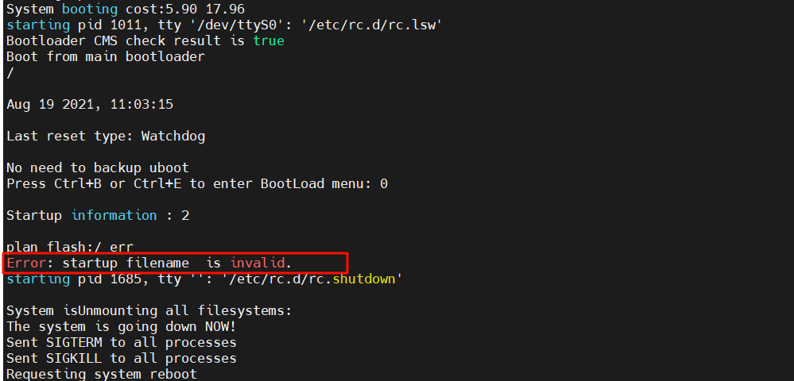
提示startup filename无效，因为bootrom里记录了启动系统文件及配置文件，而flash已被格式化了，没有任何文件
可重启设备时按下Ctrl+B进入bootrom模式上传需要的文件
BootLoad Menu
1. Boot with default mode
2. Enter startup submenu
3. Enter ethernet submenu
4. Enter filesystem submenu
5. Enter password submenu
6. Clear password for console user
7. Reboot
(Press Ctrl+E to enter diag menu)
Enter your choice(1-7): 2 #输入2，进入startup子菜单

Startup Configuration Submenu
1. Display startup configuration
2. Modify startup configuration
3. Return to main menu

Enter your choice(1-3): 1 #输入1查看bootrom里记录的重启配置文件名
Current startup configuration
startup type : Flash
startup file :
configuration file: back-yyy.cfg
patch package : s5735s-l-v200r021sph012.pat

Last time startup state : Success
Latest successful startup configuration #记录以下3个文件名，接下来需要下载以下文件
startup file : s5735-l-v200r021c00spc100.cc
configuration file: back-yyy.cfg
patch package : s5735s-l-v200r021sph012.pat

Startup Configuration Submenu
1. Display startup configuration
2. Modify startup configuration
3. Return to main menu

Enter your choice(1-3): 3 #输入3返回上一级菜单
BootLoad Menu

1. Boot with default mode
2. Enter startup submenu
3. Enter ethernet submenu
4. Enter filesystem submenu
5. Enter password submenu
6. Clear password for console user
7. Reboot
(Press Ctrl+E to enter diag menu)

Enter your choice(1-7): 3 #输入3进入ethernet子菜单

ETHERNET SUBMENU
1. Download file to Flash through ethernet interface
2. Modify ethernet interface boot parameter
3. Return to main menu

Enter your choice(1-3): 2 #输入2设置要下载的文件名、下载时使用的协议参数

BOOTLINE SUBMENU
1. Set TFTP protocol parameters
2. Set FTP protocol parameters
3. Set SFTP protocol parameters
4. Return to ethernet menu

Enter your choice(1-4): 2 #输入2使用ftp协议下载指定的文件，以及设置ftp账号密码等参数

Warning: FTP is not a secure protocol. SFTP is recommended.

'.' = clear field; '-' = go to previous field; 'Ctrl+D' = quit

Load File name : s5735_back_config.cfg . #如果已有配置参数，输入.点号再回车，可消除此项配置
Switch IP address : 192.168.2.2 .
Server IP address : .192.168.2.1
FTP User Name : .cof
FTP User Password :

Starting to write BOOTLINE into flash ... done

BOOTLINE SUBMENU

1. Set TFTP protocol parameters
2. Set FTP protocol parameters
3. Set SFTP protocol parameters
4. Return to ethernet menu

Enter your choice(1-4): 2 #再重新输入2进行参数设置

Warning: FTP is not a secure protocol. SFTP is recommended.
'.' = clear field; '-' = go to previous field; 'Ctrl+D' = quit

Load File name : s5735-l-v200r021c00spc100.cc #先下载系统文件
Switch IP address : 192.168.2.2
Server IP address : 192.168.2.1
FTP User Name : cof
FTP User Password :

Starting to write BOOTLINE into flash ... done

BOOTLINE SUBMENU
1. Set TFTP protocol parameters
2. Set FTP protocol parameters
3. Set SFTP protocol parameters
4. Return to ethernet menu

Enter your choice(1-4): 4

ETHERNET SUBMENU

1. Download file to Flash through ethernet interface
2. Modify ethernet interface boot parameter
3. Return to main menu

Enter your choice(1-3): 1 #输入1开始下载文件

Use ftp to download file : s5735-l-v200r021c00spc100.cc , please wait for a moment.
...................
Download file successfully. #提示下载成功，再按此步骤下载其他配置文件，所有文件都下载完成后，可返回上一级菜单，重启设备
ETHERNET SUBMENU

1. Download file to Flash through ethernet interface
2. Modify ethernet interface boot parameter
3. Return to main menu

Enter your choice(1-3):3 #返回上一级菜单
BootLoad Menu

1. Boot with default mode
2. Enter startup submenu
3. Enter ethernet submenu
4. Enter filesystem submenu
5. Enter password submenu
6. Clear password for console user
7. Reboot
(Press Ctrl+E to enter diag menu)

Enter your choice(1-7): 7 #重启设备

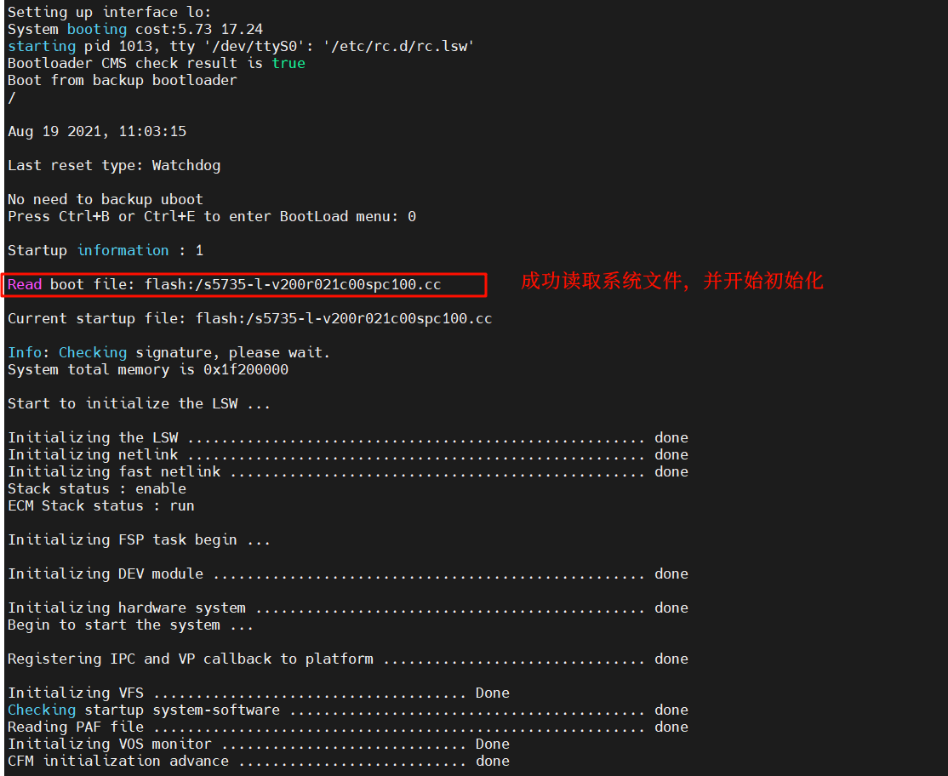

★设置系统时间
①手动配置时间
先配置时区，后配置时间才正确。
<Huawei> clock timezone CST add 08:00:00 #一定要先配时区，时区名称可自定义，如CST

[Huawei] undo ntp-service enable #不使用ntp，或者使用以下命令：
[HUAWEI] ntp-service disable #不使用ntp
[HUAWEI] ntp-service ipv6 disable #不使用ntp
Warning: NTP IPv4 service will be disabled. Continue?[Y/N] y
Info:Stop the NTP service successfully
[Huawei] quit
<Huawei> clock datetime 22:55:00 2022-07-11 #手动配置 时间 日期
<Huawei>
<HUAWEI> display clock #查看当前系统时间
2022-07-11 22:55:08+08:00
Monday
Time Zone(CST) : UTC+08:00

②使用ntp（客户端）
先配置时区，后配置时间才正确。
<Huawei> clock timezone CST add 08:00:00 #一定要先配时区，时区名称可自定义，如CST

[Huawei] undo ntp-service disable #使用ntp，开启ntp客户端
[Huawei] undo ntp-service ipv6 disable #使用ntp，开启ntp客户端
[Huawei] ntp-service source-interface Vlanif1 #指定同步ntp时使用的源接口
[Huawei] ntp-service unicast-server 10.99.4.1 preferred #指定上级ntp-server地址
[Huawei] ntp-service unicast-server 10.99.3.1 vpn-instance xxx #可指定多个
[HUAWEI] disp ntp-service status #查看ntp同步状态
clock status: synchronized
clock stratum: 15
reference clock ID: 10.99.4.1
nominal frequency: 100.0000 Hz
actual frequency: 100.0000 Hz
clock precision: 2^15
clock offset: 0.0000 ms
root delay: 21.98 ms
root dispersion: 4.24 ms
peer dispersion: 0.00 ms
reference time: 09:54:55.457 UTC Aug 11 2024(EA6308EF.7506CCA2)
synchronization state: clock set

[HUAWEI] disp clock #查看当前系统时间
2024-08-11 17:56:22+08:00
Sunday
Time Zone(CST) : UTC+08:00

★配置为ntp服务端
将设备配置为NTP服务端，给终端提供时间服务
[HUAWEI] ntp-service refclock-master 5 #设置本ntp服务端的服务层次为5（交换机默认的ntp层级（stratum）为16，不能提供时间服务，需要改小一些）
[HUAWEI] undo ntp-service server disable #开启ntp服务端功能
[HUAWEI] undo ntp-service ipv6 server disable #开启ntp服务端功能（ipv6）

[HUAWEI] disp ntp-service status #查看ntp同步状态
clock status: synchronized
clock stratum: 5
reference clock ID: LOCAL(0)
nominal frequency: 100.0000 Hz
actual frequency: 100.0000 Hz
clock precision: 2^15
clock offset: 0.0000 ms
root delay: 0.00 ms
root dispersion: 12.57 ms
peer dispersion: 10.00 ms
reference time: 10:04:40.882 UTC Aug 11 2024(EA630B38.E1E29B6B)
synchronization state: clock set

NTP时间服务器有层次（stratum）之分，取值范围1~15，数值越小级别越高，
与第 n 层服务器同步的设备将在第 n + 1 层运行，层的上限是15。
分层的目的是通过优先选择分层数值较低的服务器来避免同步循环。

★DNS
[Huawei] dns resolve #开启dns解析
[Huawei] dns server 8.8.8.8 #设置dns服务器
[Huawei] dns proxy enable #开启dns代理
[Huawei] ip host xx.com 10.1.1.33 #添加本地解析项
[Huawei] ip host ff.com 10.1.1.22
[Huawei]
[Huawei] ping xx.com #测试
PING xx.com (10.1.1.33): 56 data bytes, press CTRL_C to break

★终端信息设置

#关闭console终端信息输出
<Huawei> undo terminal monitor
Info: Current terminal monitor is off.
<HUAWEI> undo terminal debugging
<Huawei>

#终端显示行数
<USG6300E> screen-length ?
INTEGER<0-512> Display the number of lines on a screen (the value 0
indicates none split screen, and the default value is 24)
<USG6300E> screen-length 0 temporary # 0表示一次性显示完，不分页
Info: The configuration takes effect on the current user terminal interface only.

[USG6300E] user-interface console 0
[USG6300E-ui-console0] screen-length 24 #console登录时分页显示，一页24行
[USG6300E] user-interface vty 0 4
[USG6300E-ui-vty0-4] screen-length 0 #vty远程登录时不分页显示

#查看历史执行命令
[USG6300E] disp history-command all-users

★查看系统诊断信息
[Huawei] display diagnostic-information #查询当前系统的诊断信息,本命令集合了多条常用display命令的输出信息，包括display clock、display version、display current-configuration，可以看作是对系统常用display命令的批量执行
[Huawei] disp diagnostic-information ?
STRING<5-64> Name of the file stored diagnostic information (Default
directory is flash:/,the postfix of the filename must be .txt)
[Huawei] disp diagnostic-information diag-250712.txt #将诊断信息保存到文件中，文件名必须以.txt结尾

★第2章、设备登录管理配置

★带内管理（console本地登录）

①仅使用密码登录console
<Huawei> #刚开始进入的是一般模式
<Huawei> system-view #在一般模式下输入system-view进入系统配置模式
Enter system view, return user view with Ctrl+Z.
[Huawei] user-interface console 0 #进入console接口的配置界面
[Huawei-ui-console0] authentication-mode password #验证模式为仅密码
Please configure the login password (maximum length 16):123456
#如果是路由器，则要求立即输入密码，交换机则不会要求立即输入密码
[Huawei-ui-console0] user privilege level 15
#设置console登录的权限级别，15为管理员级别（6800及以上型号管理级别为3，）
[Huawei-ui-console0] set authentication password cipher 12pass6
#如果是交换机则要配置这行，设置console登录密码为12pass6
[Huawei-ui-console0]

②使用用户名和密码登录console
[Huawei] user-interface console 0
[Huawei-ui-console0] authentication-mode aaa #使用aaa认证登录，需要配置aaa
[Huawei-ui-console0]

★aaa表示：
Authentication认证，Authorization授权，Accounting计费的缩写
在交换机里表示使用 用户密码认证（可以是本地的，也可以是Radius等远程认证）

★建议仅使用密码登录console，防止aaa配置错误或使用了radius认证时访问不到radius服务器而导致登录失败。但一定要保管好console密码。

★带外管理（telnet远程登录）
①Telnet仅密码登录
[Huawei] telnet server enable #开启telnet服务
Error: TELNET server has been enabled
[Huawei] user-interface vty 0 4 #进入vty接口配置界面，0到4表示开启5条vty线路
[Huawei-ui-vty0-4] authentication-mode password #验证模式为仅密码
Please configure the login password (maximum length 16): 12xx56
#如果是路由器，则要求立即输入密码，交换机则不会要求立即输入密码
[Huawei-ui-vty0-4] user privilege level 15
[Huawei-ui-vty0-4] set authentication password cipher 12xx56 #如果是交换机要配这条
[Huawei-ui-vty0-4] protocol inbound telnet #允许telnet登录
[Huawei-ui-vty0-4]

②Telnet使用用户名和密码登录
[Huawei-ui-vty0-4] user-interface vty 0 4
[Huawei-ui-vty0-4] authentication-mode aaa
[Huawei-ui-vty0-4] protocol inbound telnet #允许telnet登录
[Huawei-ui-vty0-4]

（现在已经不建议使用不安全的连接方式，应当禁止telnet服务）
★禁用telnet服务
[Huawei] telnet server disable
[Huawei] telnet ipv6 server disable

★带外管理（ssh远程登录）
SSH用户名和密码登录

[Huawei] rsa local-key-pair create #创建系统的rsa密钥，6800及以上可以不手动创建
The key name will be: Host
% RSA keys defined for Host already exist.
Confirm to replace them? (y/n)[n]: y #输入y确定
The range of public key size is (512 ~ 2048).
NOTES: If the key modulus is greater than 512,
It will take a few minutes.
Input the bits in the modulus[default = 512]:2048 #推荐用2048及以上位数的密钥
Generating keys...
.........................+++

[Huawei] user-interface vty 0 4 #进入vty配置界面
[Huawei-ui-vty0-4] authentication-mode aaa
[Huawei-ui-vty0-4] protocol inbound ssh
#允许ssh登录，如果要允许telnet和ssh都能登录，则设置为 protocol inbound all
[Huawei-ui-vty0-4] user privilege level 15 #有这条配置后，再通过ssh-key密钥方式登录就有管理级别权限
[Huawei-ui-vty0-4] acl 3011 inbound #设置允许远程访问的acl，（可选）
[Huawei-ui-vty0-4] quit

先参考后面几小节《aaa创建用户》创建一个帐号；创建好了再继续：
[Huawei] ssh server-source -i MEth 0/0/1 #指定ssh服务监听接口，一般为管理口
Warning: SSH server source configuration will take effect in the next login. Continue? [Y/N]: y #输入y确定
[Huawei] ssh server-source all-interface #也可设置监听所有接口（与上面一条二选一）
Warning: SSH server source configuration will take effect in the next login. Continue? [Y/N]:y #输入y确定
Warning: It expandes the range of accessed Ip.
[Huawei] ssh server port 22 #设置ssh监听tcp端口号，默认22
[Huawei] ssh ipv4 server port 22 #较新型号设置ssh端口号方法
先指定监听的源ip或源端口，再开启ssh服务：
[Huawei] stelnet server enable #开启ssh服务

[Huawei] ssh server dh-exchange min-len 2048 #密钥交换材料长度
[Huawei] ssh server key-exchange dh_group14_sha256 dh_group15_sha512 dh_group_exchange_sha256 dh_group16_sha512
#密钥交换算法，至少要有dh_group14_sha256
[Huawei] ssh server publickey rsa rsa_sha2_256 rsa_sha2_512 #至少要有 rsa
[Huawei] ssh server cipher aes256_ctr aes128_ctr #至少要有aes128_ctr
[Huawei] ssh server hmac sha2_256 #一般只用这个

[Huawei] ssh authorization-type default aaa
[Huawei] ssh authentication-type default password
[Huawei] ssh user admin authentication-type password #添加ssh登录用户admin（认证方式还可为all）
[Huawei] ssh user admin service-type all #ssh用户服务类型为所有（sftp,stenlet,all）

[Huawei] sftp server enable #开启sftp服务，可选
[Huawei] sftp server default-directory flash: #登录sftp后的默认路径
[Huawei] ssh user admin sftp-directory flash: #指定用户的sftp默认路径

★ssh远程连接失败（不支持ecc）
[Huawei] ssh server publickey ecc dsa rsa #有些型号的设备默认是3个都有，但优先进行ecc密钥认证，失败则不再尝试其他算法，一般客户端工具只支持dsa和rsa，如果登录不上，请把ecc去除。报错情况一般如下：
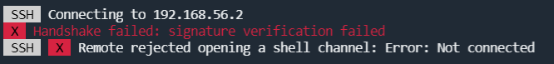
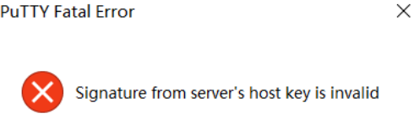

★aaa创建用户（及密码策略）
★aaa表示：
Authentication认证，Authorization授权，Accounting计费的缩写
在交换机里表示使用 用户密码认证（可以是本地的，也可以是Radius等远程认证）

[Huawei] aaa #进入aaa配置界面
[HUAWEI-aaa] undo local-user policy security-enhance #关闭增强型密码安全策略
[Huawei-aaa] local-user policy password expire 90 prompt 7 #密码90天过期，提前7天提醒用户
[Huawei-aaa] local-user authentication lock times 5 15 #密码输错5次锁定15分钟
[Huawei-aaa] local-user admin password cipher xxxx #创建用户admin密码为xxxx
[Huawei-aaa] local-user admin privilege level 15
#用户权限级别为15（管理员级别），6800及以上型号最高只有3级，设置如下：
[Huawei-aaa] local-user admin level 3
[Huawei-aaa] local-user admin service-type telnet terminal ssh http
#用户的服务类型 telnet, terminal, ssh, http 登录用户
[Huawei-aaa]

#如果关闭不了密码安全策略，则尝试使用以下设置：
[HUAWEI-aaa] local-aaa-user password policy administrator #进入密码策略设置界面
[HUAWEI-aaa-lupp-admin] password history record number 0
# 0表示不记录历史密码，改密码时就不会对比历史记录了，默认5
[HUAWEI-aaa-lupp-admin] undo password alert original #初次登录不提示用户更改密码
[HUAWEI-aaa-lupp-admin] password expire 0 #0天，密码永不过期，默认90天

#账号操作：
[Huawei] aaa
[Huawei-aaa] undo local-user cof #删除帐号（用户名为cof），谨慎操作
[Huawei-aaa]
[Huawei-aaa] local-user cof state block #锁定帐号，锁定后该帐号无法再使用
[Huawei-aaa] local-user cof state active #解锁帐号，解锁后该帐号又可以使用了
[Huawei-aaa]

★用户命令权限级别管理
默认情况下，权限级别按0～3级进行注册（6800及更高版本）说明如下：
level | 说明 | 包含命令
0 | 参观级 | 网络诊断命令，如ping tracert telnet
1 | 监控级 | 系统维护命令，含display等命令（在某些高版本设备中display命令为管理级level3的命令）
2 | 配置级 | 业务配置命令
3 | 管理级 | 用于繁育基本运行的命令，如文件系统、ftp、tftp下载以及debugging命令
高级别权限包含了所有低级别的权限（如level 2包含了level 0、level 1的所有权限）

低版本的设备（比6800低的）默认是0～15级的权限，如果想让所有设备使用相同的命令级别，可按如下配置：
[Huawei] command-privilege level rearrange #将命令级别批量提升（0-3级别类型提升为0-15级别类型）
命令级别提升后，原命令等级0、1、2、3升级为0、1、10、15级。2～9级和11～14级的命令级别中没有命令行。用户可以单独调整需要的命令行到这些级别中，以实现用户权限的精细化管理。
或者都用0～3级别：
[Huawei] undo command-privilege level rearrange #将命令级别批量降级（0-15级别类型降级为0-3级别类型）

★使用command-privilege命令可配置不同权限级别的用户可以执行哪些命令
例如：新建一个测试账号cof，其权限level为0
[Huawei] aaa
[Huawei-aaa] local-user cof password cipher xxxxxx
[Huawei-aaa] local-user cof privilege level 0
[Huawei-aaa] local-user cof service-type terminal ssh

level 0的用户级别，远程登录设备之后，其默认可执行的命令只有以下几个：
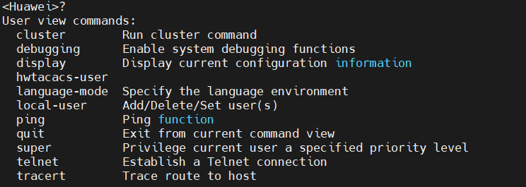
★添加指定命令到level0级别
[Huawei] command-privilege level 0 view shell display current-configuration
然后cof用户可执行的命令就多了一条：
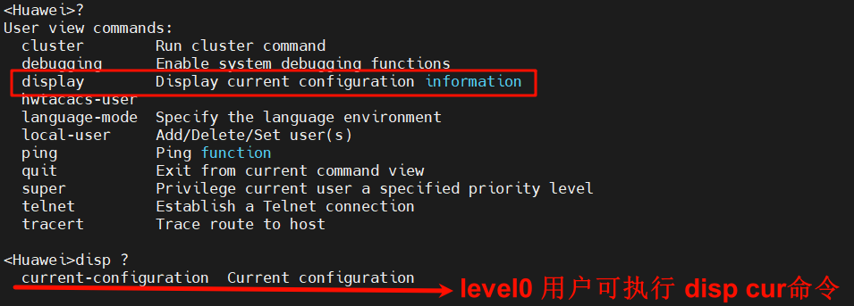

★使用Radius认证
Radius是Remote Access Dial In User Service的简称，Radius服务主要用来提供认证与计费功能，网络设备除了使用本地用户认证，还可使用radius网络认证服务
华为网络设备需要Radius服务器支持其私有属性，华为radius私有属性设置如下（以freeRadius为例）
★配置Vendor Specific属性
Vendor Specific属性文件所在路径：/usr/share/freeradius/
不同产品的Vendor Specific属性不一致，华为厂商名为Huawei，其Vendor-ID为2011，主要用到的厂商自定义raidus属性有：
id=29，含义为Huawei-Exec-Privilege（表示用户权限），类型为integer整型
则需要执行以下步骤添加此私有属性声明：
# vi /usr/share/freeradius/dictionary.huawei #添加以下内容
VENDOR Huawei 2011
BEGIN-VENDOR Huawei
ATTRIBUTE Huawei-Exec-Privilege 29 integer
END-VENDOR Huawei
# vi /usr/share/freeradius/dictionary #添加以下内容
$INCLUDE dictionary.huawei
创建一个测试用户：
# vi /etc/raddb/users #添加以下内容
cof Cleartext-Password := "admin123"
Service-Type = Administrative-User,
Auth-Type := CHAP,
Huawei-Exec-Privilege := 15

[HUAWEI] radius-server template 1 #创建radius服务器模板
[HUAWEI-radius-1] radius-server authentication 10.99.7.252 1812 source ip-address 10.99.7.2
[HUAWEI-radius-1] radius-server shared-key cipher testing123
[HUAWEI-radius-1] undo radius-server user-name domain-included #配置设备向RADIUS服务器发送的报文中的用户名不包含域名
[HUAWEI-radius-1] quit

[HUAWEI] test-aaa cof admin123 radius-template 1 chap #测试radius服务器是否可用
Info: Account test succeeded.

[HUAWEI] aaa
[HUAWEI-aaa] authentication-scheme cof-lee.com_authen #创建一个认证模板
[HUAWEI-aaa-authen-cof-lee.com_authen] authentication-mode radius local
[HUAWEI-aaa-authen-cof-lee.com_authen] undo server no-response accounting #配置用户在服务器认证无响应转入本地认证后，设备不发送计费报文（默认）
[HUAWEI-aaa-authen-cof-lee.com_authen] radius-reject local #配置管理员用户在RADIUS认证拒绝后转入本地认证，缺省情况下，未配置管理员用户在RADIUS认证拒绝后转入本地认证。在RADIUS认证拒绝后（即RADIUS服务器回应Access-Reject报文），认证流程结束，用户认证失败
[HUAWEI-aaa-authen-cof-lee.com_authen] authentication-type radius chap access-type admin #配置管理员用户在RADIUS认证时使用CHAP认证方式，缺省情况下，管理员用户在RADIUS认证时使用PAP认证方式
[HUAWEI-aaa-authen-cof-lee.com_authen] quit
[HUAWEI-aaa]
[HUAWEI-aaa] accounting-scheme cof-lee.com_account #创建一个计费模板
[HUAWEI-aaa-accounting-cof-lee.com_account] accounting-mode none #不计费，关闭实时计费
#缺省情况下，域使用名为“default”的计费方案。“default”计费方案的策略为：不计费，关闭实时计费
[HUAWEI-aaa-accounting-cof-lee.com_account] quit
[HUAWEI-aaa]
[HUAWEI-aaa] domain cof-lee.com #创建一个新的domain域
[HUAWEI-aaa-domain-cof-lee.com] authentication-scheme cof-lee.com_authen #使用指定的认证模板
[HUAWEI-aaa-domain-cof-lee.com] accounting-scheme cof-lee.com_account #使用指定的计费模板
[HUAWEI-aaa-domain-cof-lee.com] radius-server 1 #使用指定的radius服务器模板
[HUAWEI-aaa-domain-cof-lee.com] quit
[HUAWEI-aaa]
[HUAWEI-aaa] access-user remote authen-fail retry-interval 5 retry-time 3 block-time 15 #时间单位：分钟
[HUAWEI-aaa] administrator remote authen-fail retry-interval 5 retry-time 3 block-time 15
[HUAWEI-aaa] quit

[HUAWEI] domain cof-lee.com #指定普通用户的默认域
[HUAWEI] domain cof-lee.com admin #指定admin用户的默认域

[HUAWEI] display aaa configuration
Domain Name Delimiter : @
Domainname parse direction : Left to right
Domainname location : After-delimiter
Administrator user default domain : cof-lee.com
Normal user default domain : cof-lee.com
Domain : total: 32 used: 3
Authentication-scheme : total: 17 used: 3
Accounting-scheme : total: 16 used: 2
Authorization-scheme : total: 16 used: 2
Service-scheme : total: 128 used: 0
Recording-scheme : total: 3 used: 0
Local-user : total: 1000 used: 1
Local-user block retry-interval : 5 Min(s)
Local-user block retry-time : 3
Local-user block time : 5 Min(s)
Remote-access-user block retry-interval : 5 Min(s)
Remote-access-user block retry-time : 3
Remote-access-user block time : 15 Min(s)
Remote-admin-user block retry-interval : 5 Min(s)
Remote-admin-user block retry-time : 3
Remote-admin-user block time : 15 Min(s)
Session timeout invalid enable : No
Navigator first login state: : No

[HUAWEI] disp domain name cof-lee.com
Domain-name : cof-lee.com
Domain-index : 2
Domain-state : Active
Authentication-scheme-name : cof-lee.com_authen
Accounting-scheme-name : cof-lee.com_account
Authorization-scheme-name : -
Service-scheme-name : -
RADIUS-server-template : 1
Accounting-copy-RADIUS-template : -
HWTACACS-server-template : -
HACA-server-template : -
Push-url-address : -
Accounting-DualStack-Separate : -
Flow-statistic : -
使用radius用户（本例中用户名为cof）登录后，查看用户情况：
<HUAWEI>disp users
User-Intf Delay Type Network Address AuthenStatus AuthorcmdFlag
0 CON 0 00:00:24 pass no Username : admin
+ 34 VTY 0 00:00:00 SSH 10.99.7.8 pass no Username : cof

[HUAWEI] disp access-user username cof detail
------------------------------------------------------------------------------
Basic:
User ID : 2
User name : cof
Domain-name : cof-lee.com
User MAC : -
User IP address : 10.99.7.8
User IPv6 address : -
User access time : 2024/08/12 01:08:29
User accounting session ID : HUAWEI092552550000000009f****0000002
Option82 information : -
User access type : SSH
User Privilege : 15

AAA:
User authentication type : Administrator authentication
Current authentication method : RADIUS
Current authorization method : -
Current accounting method : None
------------------------------------------------------------------------------
Total: 1, printed: 1

[HUAWEI] disp remote-user authen-fail blocked
Info: No blocked user.
[HUAWEI] aaa
[HUAWEI-aaa] remote-user authen-fail unblock username cof #将认证失败的远端认证账号解锁
[HUAWEI-aaa] quit

★查看当前登录用户及踢除某用户
[HUAWEI] display users [all]
User-Intf Delay Type Network Address AuthenStatus AuthorcmdFlag
+ 0 CON 0 00:00:00 pass no Username : admin
[HUAWEI] quit
<HUAWEI> kill user-interface console 0 #踢除con 0用户
<HUAWEI> kill user-interface vty 0 #踢除vty 0用户

★虚拟终端vty数量限制
[HUAWEI] user-interface maximum-vty ?
INTEGER<0-15> The maximum number of VTY users, the default value is 5
[HUAWEI] user-interface maximum-vty 5 #最大终端数量为5（0到4）可根据实际需求设置
Info: VTY0-4 VTYs are available, and VTY 16 to VTY 20 are reserved for the NMS.

★登录超时设置
[Huawei] user-interface vty 0 4
[Huawei-ui-vty0-4] idle-timeout 15 #空闲15分钟则自动登出，默认10分钟
[Huawei-ui-vty0-4]

★用户登录提示语
[Huawei] header login information "xxxxxxxx"

★SSH客户端
[Huawei]
[Huawei] ssh client first-time enable #初次使用stelnet客户端要初始化客户端的密钥
[Huawei] stelnet 10.1.1.1 #使用stelnet远程登录到10.1.1.1
Please input the username: admin #输入用户名
Trying 10.1.1.1 ...
Press CTRL+K to abort
Connected to 10.1.1.1 ...
The server is not authenticated. Continue to access it? [Y/N] : y #确认
Save the server's public key? [Y/N] : y #确认
The server's public key will be saved with the name 10.1.1.1. Please wait...
Enter password: #输入密码
Info: The max number of VTY users is 5, and the number
of current VTY users on line is 1.
The current login time is 2019-12-03 09:41:47.
<S5700> #远程登录成功
<S5700> quit #退出登录

★使用ssh密钥登录设备
ssh协议支持使用账号密码的方式登录，也支持使用rsa密钥登录，只需要将rsa公钥放到交换机/路由器设备上，然后用户在终端使用私钥登录此设备

首先在用户电脑上生成rsa密钥对，并将公钥输出为二进制对应的十六进制字符，命令如下：
# ssh-keygen -t rsa -b 2048 -C "admin@switch5700" -P "" -f ~/sshkey-switch
#直接生成key文件及公钥.pub文件，无需交互，-C指定密钥的描述信息，-P指定加密密钥的密码，-f指定生成的文件名，sshkey-switch为私钥，sshkey-switch.pub为公钥

# ssh-keygen -e -m pem -f ~/sshkey-switch.pub | egrep -v 'BEGIN|END' | base64 -d | xxd -ps -u
3082010A0282010100BB3F60E40490EB7A77169CC15EF0299E59A5A8FEE0
7334A8EDFA70BE874B6BB8C54E76289908B8E618C8D0DA1CCCB32A32AB88
590522288DA4EC79F30B2A19A512D488458A6778E62848C863920D0BE642
B7F4FA5AC9C9BF0DD33FA0536430CE1A8A994D25B9732222DE8E613D4447
2AB277E6C6D78C804C9DFF3CE94E305167BC2D2C7A8078730BACAD7A566F
EF2CD2749ADE1C90278708CE072A1BD6A597874C270F84F542401B23ED84
C01E90010473597E2728B90C0E0F31A1D8A1E13CDC39B89909EF352BEB4D
846FCE39EA21DD587CD2796A4F29CB5A5C0AD0C1A135BC72852EBDA8D0FE
EB0F3916B697010091A56ECF0F9A48F11135EB94A47C21BFE70203010001

然后将公钥导入到交换机/路由器设备中
[Huawei] rsa peer-public-key rsa_pubkey_01 #创建一个名为rsa_pubkey_01的rsa公钥
[Huawei-rsa-public-key] public-key-code begin #接下来，将公钥的十六进制字符一行一行地复制粘贴
（旧版本的系统只能以十六进制形式导入公钥）
[Huawei-rsa-key-code]3082010A0282010100BB3F60E40490EB7A77169CC15EF0299E59A5A8FEE0
[Huawei-rsa-key-code]7334A8EDFA70BE874B6BB8C54E76289908B8E618C8D0DA1CCCB32A32AB88
[Huawei-rsa-key-code]590522288DA4EC79F30B2A19A512D488458A6778E62848C863920D0BE642
[Huawei-rsa-key-code]B7F4FA5AC9C9BF0DD33FA0536430CE1A8A994D25B9732222DE8E613D4447
[Huawei-rsa-key-code]2AB277E6C6D78C804C9DFF3CE94E305167BC2D2C7A8078730BACAD7A566F
[Huawei-rsa-key-code]EF2CD2749ADE1C90278708CE072A1BD6A597874C270F84F542401B23ED84
[Huawei-rsa-key-code]C01E90010473597E2728B90C0E0F31A1D8A1E13CDC39B89909EF352BEB4D
[Huawei-rsa-key-code]846FCE39EA21DD587CD2796A4F29CB5A5C0AD0C1A135BC72852EBDA8D0FE
[Huawei-rsa-key-code]EB0F3916B697010091A56ECF0F9A48F11135EB94A47C21BFE70203010001
[Huawei-rsa-key-code]
[Huawei-rsa-key-code] public-key-code end #退出当前层级
[Huawei-rsa-public-key] peer-public-key end #退出当前层级
[Huawei]
[Huawei] ssh user admin assign rsa-key rsa_pubkey_01 #设置admin用户使用指定的rsa公钥做认证
[Huawei] ssh user admin authentication-type password-rsa #允许admin用户使用密码及rsa密钥登录（先验证密钥，再输入密码（2次认证）
[Huawei] ssh user admin authentication-type all #允许admin用户使用任意方式认证

[Huawei] disp rsa peer-public-key name rsa_pubkey_01 #查看公钥内容
=====================================
Key name: rsa_pubkey_01
Key address:
=====================================
Key Code:
30820109
02820100
BB3F60E4 0490EB7A 77169CC1 5EF0299E 59A5A8FE E07334A8 EDFA70BE 874B6BB8
C54E7628 9908B8E6 18C8D0DA 1CCCB32A 32AB8859 0522288D A4EC79F3 0B2A19A5
12D48845 8A6778E6 2848C863 920D0BE6 42B7F4FA 5AC9C9BF 0DD33FA0 536430CE
1A8A994D 25B97322 22DE8E61 3D44472A B277E6C6 D78C804C 9DFF3CE9 4E305167
BC2D2C7A 8078730B ACAD7A56 6FEF2CD2 749ADE1C 90278708 CE072A1B D6A59787
4C270F84 F542401B 23ED84C0 1E900104 73597E27 28B90C0E 0F31A1D8 A1E13CDC
39B89909 EF352BEB 4D846FCE 39EA21DD 587CD279 6A4F29CB 5A5C0AD0 C1A135BC
72852EBD A8D0FEEB 0F3916B6 97010091 A56ECF0F 9A48F111 35EB94A4 7C21BFE7
0203
010001

★高版本系统支持以OpenSSH公钥字符串的形式导入
[~HUAWEI] rsa peer-public-key rsa_pubkey_02 encoding-type ?
der DER encoded public key # der就是旧版本默认支持的，十六进制形式
openssh OpenSSH encoded public key
pem PEM encoded public key
[Huawei] rsa peer-public-key rsa_pubkey_02 encoding-type openssh
[*Huawei-rsa-public-key] public-key-code begin #接下来，将公钥内容复制粘贴（可换行输入）
[*HUAWEI-rsa-public-key-rsa-key-code] ssh-rsa AAAAB3NzaC1yc2EAAAADAQABAAABAQC7P2D
kBJDrencWnMFe8CmeWaWo/uBzNKjt+nC+h0truMVOdiiZCLjmGMjQ2hzMsyoyq4hZBSIojaTsefMLKhm
lEtSIRYpneOYoSMhjkg0L5kK39Ppaycm/DdM/oFNkMM4aiplNJblzIiLejmE9REcqsnfmxteMgEyd/zz
pTjBRZ7wtLHqAeHMLrK16Vm/vLNJ0mt4ckCeHCM4HKhvWpZeHTCcPhPVCQBsj7YTAHpABBHNZficouQw
ODzGh2KHhPNw5uJkJ7zUr602Eb8456iHdWHzSeWpPKctaXArQwaE1vHKFLr2o0P7rDzkWtpcBAJGlbs8
PmkjxETXrlKR8Ib/n admin@switch5700
[*HUAWEI-rsa-public-key-rsa-key-code]
[*HUAWEI-rsa-public-key-rsa-key-code] public-key-code end
[*HUAWEI-rsa-public-key] peer-public-key end
[*HUAWEI] commit

[~HUAWEI] disp rsa peer-public-key name rsa_pubkey_02 #查看公钥内容
=====================================
Key name: rsa_pubkey_02
Encoding type: OPENSSH
=====================================
Key Code:
ssh-rsa AAAAB3NzaC1yc2EAAAADAQABAAABAQC7P2DkBJDrencWnMFe8CmeWaWo/uBzNKjt+nC+h0tr
uMVOdiiZCLjmGMjQ2hzMsyoyq4hZBSIojaTsefMLKhmlEtSIRYpneOYoSMhjkg0L5kK39Ppaycm/DdM/
oFNkMM4aiplNJblzIiLejmE9REcqsnfmxteMgEyd/zzpTjBRZ7wtLHqAeHMLrK16Vm/vLNJ0mt4ckCeH
CM4HKhvWpZeHTCcPhPVCQBsj7YTAHpABBHNZficouQwODzGh2KHhPNw5uJkJ7zUr602Eb8456iHdWHzS
eWpPKctaXArQwaE1vHKFLr2o0P7rDzkWtpcBAJGlbs8PmkjxETXrlKR8Ib/n rsa-key

#客户端使用私钥去登录交换机
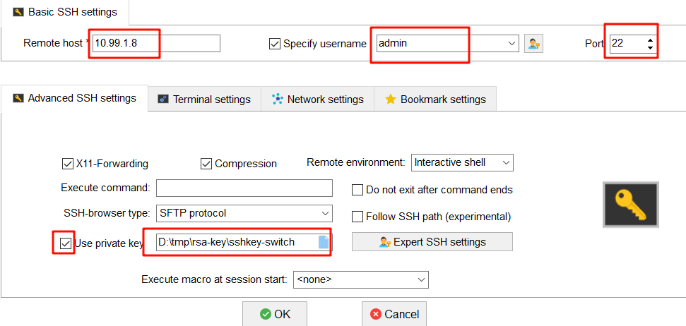
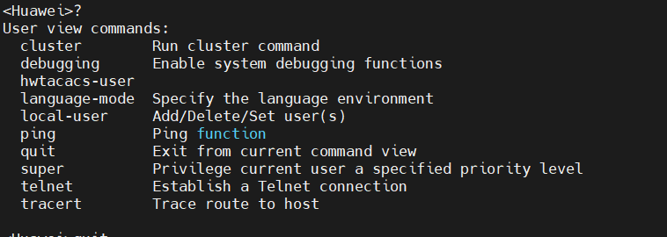
但是，使用rsa密钥登录的权限不够，原因是在配置ssh远程登录界面里未指定用户权限级别：
[Huawei] user-interface vty 0 4
[Huawei-ui-vty0-4] disp this
user-interface con 0
user-interface vty 0 4
authentication-mode aaa
protocol inbound all
需要添加一条配置：
[Huawei-ui-vty0-4] user privilege level 15 #有这条配置后，再通过ssh-key密钥方式登录就有管理级别权限

★LLDP
LLDP（Link Layer Discovery Protocol）是IEEE 802.1ab中定义的链路层发现协议。LLDP是一种标准的二层发现方式，可以将本端设备的管理地址、设备标识、接口标识等信息组织起来，并发布给自己的邻居设备，邻居设备收到这些信息后将其以标准的管理信息库MIB（Management Information Base）的形式保存起来，以供网络管理系统查询及判断链路的通信状况

[Huawei] lldp enable #全局开启lldp功能
[Huawei] lldp management-address 9.9.9.33 #设置lldp管理地址，即邻居发现我时，显示我的ip地址

[Huawei] int g0/0/1
[Huawei-GigabitEthernet0/0/1] lldp enable #接口上开启lldp
Info: LLDP on the port is already enabled.

[Huawei] disp lldp device-classifier information #查看lldp信息
Capability codes:
(T) Telephone, (B) Bridge, (R) Router
(W) WLAN Access Point, (O) Other

Local Intf Trigger Source Capability Exptime(s)
GE0/0/1 LLDP Packet B,R 135
GE0/0/2 LLDP Packet B,R 139

[Huawei] disp lldp neighbor brief #查看lldp邻居信息（所有网口）
Local Intf Neighbor Dev Neighbor Intf Exptime(s)
GE0/0/1 switch1 GE0/0/23 102
GE0/0/2 switch1 GE0/0/24 105
[Huawei] disp lldp neighbor #查看lldp邻居详细信息（所有网口）
[Huawei] disp lldp neighbor interface g0/0/1 #查看指定接口的lldp邻居

★syslog日志服务配置
[Huawei] info-center enable #全局开启信息中心服务
[Huawei] info-center channel 6 name syslog1 #重命名通道名称，1~9
[Huawei] info-center filter-id bymodule-alias xxx #过滤不需要输出的日志模块
[Huawei] info-center timestamp log date precision-time millisecond #配置时间戳精度
[Huawei] info-center local log-counter disable #关闭log信息的计数功能
[Huawei] info-center source default channel 6 log level informational
#source default 允许输出信息的模块为所有模块

[Huawei] info-center loghost 192.x.x.x source-ip 192.x.x.y channel 6 language english
#设置日志服务器为192.x.x.x；信息级别为informational，输出语言为英文

<Huawei> display channel #查看通道状态
<Huawei> disp logbuffer #查看log日志缓存

★cpu-defend攻击防护
[HUAWEI] acl number 4001
[HUAWEI-acl-L2-4001] rule 5 permit source-mac 0C11-2222-3333
[HUAWEI-acl-L2-4001] quit

[HUAWEI] cpu-defend policy cpu_defend_temp1 #创建攻击防护策略
[HUAWEI-cpu-defend-policy-cpu_defend_temp1] whitelist 1 acl 4001 #白名单（一律处理匹配的报文）
[HUAWEI-cpu-defend-policy-cpu_defend_temp1] blacklist 1 acl 4002 #黑名单（一律丢弃匹配的报文）
[HUAWEI-cpu-defend-policy-cpu_defend_temp1] auto-defend enable #开启攻击溯源检查功能（默认开启）
[HUAWEI-cpu-defend-policy-cpu_defend_temp1] auto-defend threshold 60 #阈值默认60
[HUAWEI-cpu-defend-policy-cpu_defend_temp1] car packet-type arp-request cir 128 cbs 131072
Warning: Improper parameter settings may affect stable operating of the system. Use this command under assistance of Huawei engineers. Continue? [Y/N]:y
[HUAWEI-cpu-defend-policy-cpu_defend_temp1] car packet-type dhcp-client cir 128 cbs 131072
Warning: Improper parameter settings may affect stable operating of the system. Use this command under assistance of Huawei engineers. Continue? [Y/N]:y
[HUAWEI-cpu-defend-policy-cpu_defend_temp1] car packet-type icmp cir 128 cbs 131072
Warning: Improper parameter settings may affect stable operating of the system. Use this command under assistance of Huawei engineers. Continue? [Y/N]:y
# Cir单位是Kbps Cbs单位是Byte
[HUAWEI-cpu-defend-policy-cpu_defend_temp1] quit
[HUAWEI] cpu-defend-policy cpu_defend_temp1 global #应用攻击防护策略

[HUAWEI] disp cpu-defend policy cpu_defend_temp1
Related slot : <0>
Configuration :
Whitelist 1 ACL number : 4001
Blacklist 1 ACL number : 4002
Car packet-type arp-request : CIR(128) CBS(131072)
Car packet-type dhcp-client : CIR(128) CBS(131072)
Car packet-type icmp : CIR(128) CBS(131072)

[HUAWEI] disp cpu-defend applied all #查看生效的防护情况
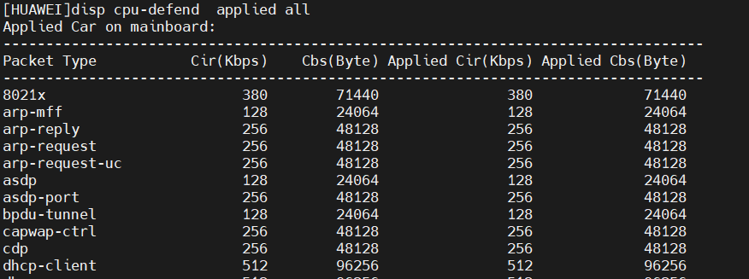
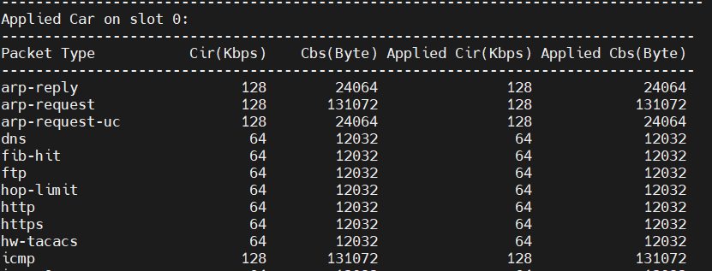

[HUAWEI] disp auto-defend configuration #查看攻击溯源配置信息
----------------------------------------------------------------------------
Name : cpu_defend_temp1
Related slot : <0>
auto-defend : enable
auto-defend attack-packet sample : 5
auto-defend threshold : 60 (pps)
auto-defend trace-type : source-mac source-ip
auto-defend protocol : arp icmp dhcp igmp tcp telnet 8021x nd dhcpv6 mld icmpv6
----------------------------------------------------------------------------

★SNMP
★v2c配置
[Huawei] snmp-agent #开启snmp代理功能
[Huawei] snmp-agent local-engineid xxxxxxxx
[Huawei] snmp-agent sys-info version v2c #指定snmp版本，v1, v2c, v3, all
[Huawei] snmp-agent sys-info location XXbuilding
[Huawei] snmp-agent sys-info contact coflee-1x912345678
[Huawei] snmp-agent community read publicxxxx acl 2002 #可用acl指定允许的管理站
[Huawei] snmp-agent target-host trap address udp-domain 10.1.1.252 udp-port 162 params \
securityname prtgxx v2c #设置trap参数，管理主机ip,trap端口号，团体字及版本
[Huawei] snmp-agent trap enable #开启trap功能
Warning: All switches of SNMP trap/notification will be open. Continue? [Y/N]:y
[Huawei] snmp-agent protocol source-interface Meth0/0/0

★v3配置
[Huawei] snmp-agent
[Huawei] snmp-agent local-engineid xxxxxxxx
[Huawei] snmp-agent sys-info location R09/22U
[Huawei] snmp-agent sys-info version v3
[Huawei] snmp-agent mib-view included iso-view iso
[Huawei] snmp-agent group v3 snmpgrp privacy read-view iso-view write-view notify-view acl 2001
[Huawei] snmp-agent usm-user v3 v3userxx
[Huawei] snmp-agent usm-user v3 v3userxx snmpgrp authentication-mode sha2-256 passwdxx1 \
privacy-mode aes128 passwdxx2
[Huawei] snmp-agent usm-user v3 v3userxx acl 2001
[Huawei] snmp-agent acl 2001
[Huawei] snmp-agent target-host [host-name trapHostxx ] trap address udp-domain 10.1.1.252 \
udp-port 162 params securityname trapsecurityxxxx v3 privacy
[Huawei] snmp-agent trap source Meth0/0/0
[Huawei] snmp-agent trap enable
[Huawei] snmp-agent protocol source-interface Meth0/0/0
[Huawei] undo snmp-agent protocol source-status all-interface
[Huawei] undo snmp-agent protocol source-status ipv6 all-interface
[Huawei] undo snmp-agent proxy protocol source-status all-interface
[Huawei] undo snmp-agent proxy protocol source-status ipv6 all-interface

★注意：
#以下2行写法要求输入加密后的密文
snmp-agent usm-user v3 v3userxx authentication-mode sha2-256 cipher xxxxxxxxx
snmp-agent usm-user v3 v3userxx privacy-mode aes128 cipher xxxxxxxxx

#以下写法可以写明文密码，执行后会自动加密（比上面多加了个组名）
snmp-agent usm-user v3 v3 userxx snmpgrp authentication-mode sha2-256 passwdxx privacy-mode aes128 passwdxx

★NETCONF
作为新一代的网络设备配置管理协议，NETCONF使用YANG作为它的数据建模语言（类似于SNMP使用MIB一样）。用户可以通过NETCONF增加、修改、删除网络设备的配置，获取网络设备的配置和状态信息。有了NETCONF协议，网络设备可以提供规范的应用程序编程接口API（Application Programming Interface），应用程序可以直接使用这些API，向网络设备发送和获取配置。

NETCONF是基于SSH和TCP协议的设备管理协议，使用XML来传输配置信息。默认时，netconf下发的配置立即生效，但不会保存到配置文件中，设备重启会丢失下发的配置，需要手动保存一下设备配置。

★s5700系列配置netconf
首先创建api类型的aaa账号
[HUAWEI] aaa
[HUAWEI-aaa] local-user service password cipher passwdxxxx #创建一个名为service的账号
[HUAWEI-aaa] local-user service privilege level 15
[HUAWEI-aaa] local-user service service-type api #服务类型必须为api
Warning: This command may cause a configuration conflict in NETCONF mode. Continue? [Y/N]:y

[HUAWEI] netconf #开启netconf功能
Warning: Enabling NETCONF will cause LNP to be disabled and STP to be enabled. Continue? [Y/N]:y
Info: NETCONF is being enabled. Please wait..........................................
[HUAWEI-netconf] source ip 10.99.2.55 port ?
INTEGER<830,55552-55807> Port number. The default value is 830.
[HUAWEI-netconf] source ip 10.99.2.55 port 830 #指定监听的源ip和端口号
[HUAWEI-netconf] user service assign rsa public-key rsa_pubkey_02 #使用密钥认证（可选）
[HUAWEI-netconf] rsa local-key-pair create
Warning: RSA keys already exist. Continue? [Y/N]:y

★CE12800系列配置netconf
首先创建ssh类型的aaa账号
[HUAWEI] aaa
[HUAWEI-aaa] local-user service password cipher passwdxxxx #创建一个名为service的账号
[HUAWEI-aaa] local-user service level 3
[HUAWEI-aaa] local-user service service-type ssh #服务类型为ssh也行

[~HUAWEI] snetconf server enable #开启netconf功能
[~HUAWEI] ssh user service authentication-type password
[~HUAWEI] ssh user service service-type snetconf

[~HUAWEI] netconf
[~HUAWEI-netconf] protocol inbound ssh port 830

[~HUAWEI] disp netconf capability #查看netconf支持的能力
--------------------------------------------------
Capability
--------------------------------------------------
urn:ietf:params:netconf:base:1.0
urn:ietf:params:netconf:base:1.1
urn:ietf:params:netconf:capability:writable-running:1.0
urn:ietf:params:netconf:capability:candidate:1.0
urn:ietf:params:netconf:capability:confirmed-commit:1.0
urn:ietf:params:netconf:capability:confirmed-commit:1.1
......

★编写python脚本
本章节以S3575为例，首先查看官方文档，找到netconf yang api相关示例配置：
NETCONF YANG API参考→NETCONF YANG API列表→配置管理→VLAN管理→创建VLAN→请求示例
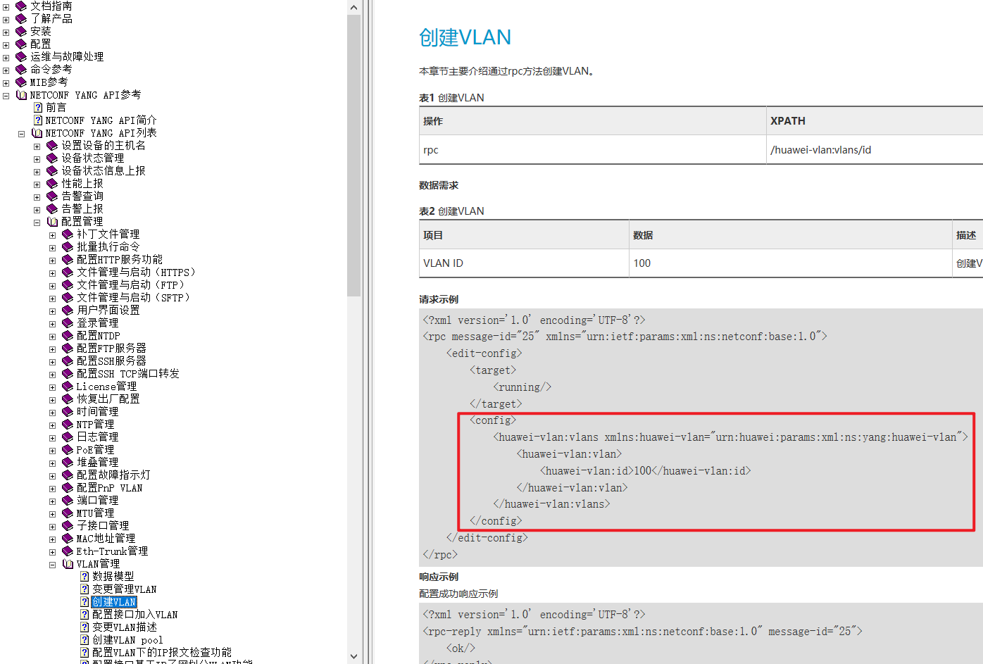

示例1：使用netconf协议连接设备并下发（创建vlan 102）配置，python脚本如下：
#!/usr/bin/env python3
# coding=utf-8
from ncclient import manager
create_vlan = """
<config>
<huawei-vlan:vlans xmlns:huawei-vlan="urn:huawei:params:xml:ns:yang:huawei-vlan">
<huawei-vlan:vlan>
<huawei-vlan:id>102</huawei-vlan:id>
</huawei-vlan:vlan>
</huawei-vlan:vlans>
</config>
"""
if __name__ == "__main__":
netconf = manager.connect(
host="10.1.0.6", # 设备IP地址或主机名
port=830, # 连接的端口，默认为830
username="service", # 登录用户名
password="passwdxxxx", # 登录密码
device_params={'name': 'huaweiyang'}, # 指定设备类型为华为，这会影响连接过程中的一些行为和参数设置
hostkey_verify=False, # 不校验主机密钥
allow_agent=False, # 不使用NETCONF agent
look_for_keys=False) # 不自动查找密钥
# ↓通过NETCONF连接对象netconf，执行编辑配置的操作，目标是运行中的配置
netconf.edit_config(target="running", config=create_vlan)
netconf.close_session() # 关闭会话
#device_params里，name写huawei和huaweiyang都可以，这是2个设备类型
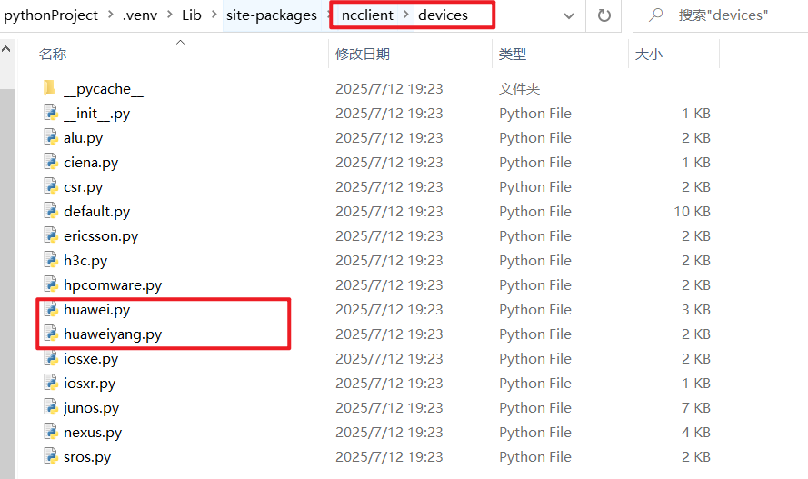
交换机查看：
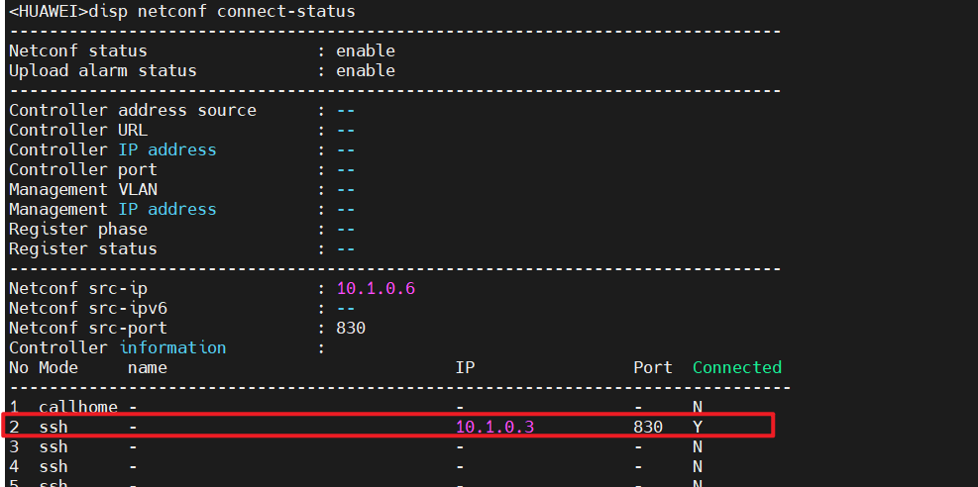

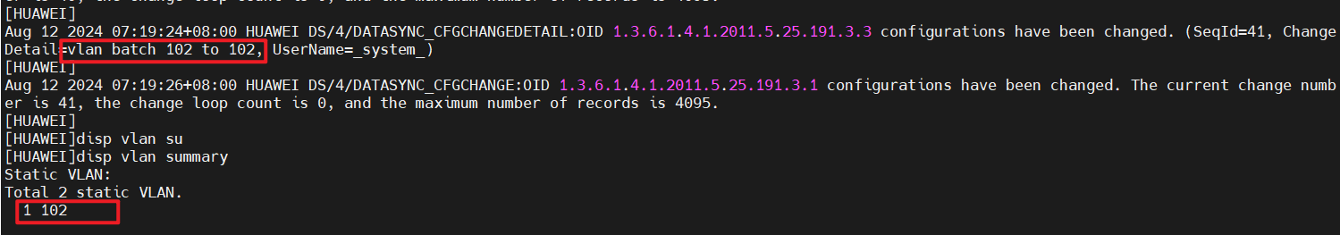

示例2：使用netconf协议连接设备并下发（给vlanif102配置ip地址）配置，python脚本如下：
#!/usr/bin/env python3
# coding=utf-8
from ncclient import manager
config_vlanif = """
<config>
<if:interfaces xmlns:if="urn:ietf:params:xml:ns:yang:ietf-interfaces">
<if:interface>
<if:name>Vlanif102</if:name>
<if:type xmlns:iana-if-type="urn:ietf:params:xml:ns:yang:iana-if-type">iana-if-type:propVirtual</if:type>
<ip:ipv4 xmlns:ip="urn:ietf:params:xml:ns:yang:ietf-ip">
<ip:address>
<ip:ip>10.99.102.1</ip:ip>
<ip:prefix-length>24</ip:prefix-length>
</ip:address>
</ip:ipv4>
</if:interface>
</if:interfaces>
</config>
"""
if __name__ == "__main__":
netconf = manager.connect(
host="10.1.0.6", # 设备IP地址或主机名
port=830, # 连接的端口，默认为830
username="service", # 登录用户名
password="passwdxxxx", # 登录密码
device_params={'name': 'huaweiyang'}, # 指定设备类型为华为，这会影响连接过程中的一些行为和参数设置
hostkey_verify=False, # 不校验主机密钥
allow_agent=False, # 不使用NETCONF agent
look_for_keys=False) # 不自动查找密钥
# ↓通过NETCONF连接对象netconf，执行编辑配置的操作，目标是运行中的配置
netconf.edit_config(target="running", config=config_vlanif)
netconf.close_session() # 关闭会话

交换机查看：
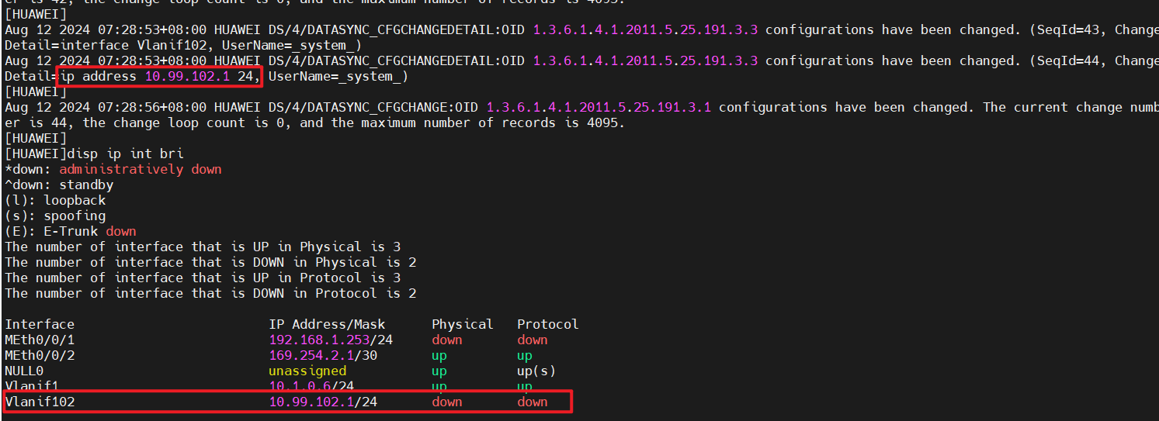
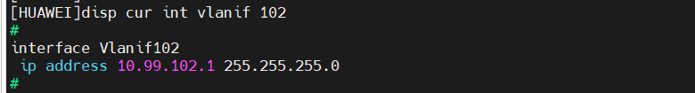

#其他配置方法
from ncclient import manager
from ncclient import xml_
set_interface = """
<edit-config>
<target>
<running/>
</target>
<config>
<if:interfaces xmlns:if="urn:ietf:params:xml:ns:yang:ietf-interfaces">
<if:interface>
<if:name>GigabitEthernet0/0/3</if:name>
<if:description>port description xxx</if:description>
<if:type xmlns:iana-if-type="urn:ietf:params:xml:ns:yang:iana-if-type">iana-if-type:ethernetCsmacd</if:type>
<if:enabled>true</if:enabled>
<if:link-up-down-trap-enable>disabled</if:link-up-down-trap-enable>
</if:interface>
</if:interfaces>
</config>
</edit-config>
"""
def netconf():
manager.connect(host="10.99.2.55", port=830, username="service", password="passwdxxxx",
allow_agent=False, hostkey_verify=False,
device_params={"name": "huaweiyang"}).rpc(xml_.to_ele(set_interface))
print("netconf设置成功")
if __name__ == '__main__':
netconf()
执行脚本后，查看交换机配置：
[HUAWEI] disp cur int g0/0/3
interface GigabitEthernet0/0/3
description port description xxx
undo shutdown
undo enable snmp trap updown

★清除netconf配置
[HUAWEI] reset netconf db-configuration #清除netconf配置，只能在[]配置模式下执行此命令，设备会重启
Warning: This operation will clear the database configuration and saved configuration file and restart the device. Continue? [Y/N]:y #输入y确认
Comparing the firmware versions
The latest firmware version is in use.
Info: System is rebooting, please wait... #设备会重启
..........
starting pid 2407, tty '': '/etc/rc.d/rc.shutdown'

System isUnmounting all filesystems:
The system is going down NOW!

★OPS
开放可编程系统OPS（Open Programmability System）是指设备通过提供统一的应用程序接口RESTful API（Representational State Transfer Application Programming Interface）来开放系统，使得系统具备可编程能力，可以运行python脚本实现用户自定义的功能。

首先编写一个简单的python测试脚本，例如 ops_demo_01.py，内容如下：
#!/usr/bin/env python
# -*- coding: utf-8 -*-
import sys
if __name__ == "__main__":
print(sys.getdefaultencoding()) # 查看python默认字符编码
print(sys.version_info) # 查看python版本信息

使用ftp/tftp协议将测试脚本文件上传到交换机设备
<HUAWEI> ftp 10.99.2.1
Trying 10.99.2.1 ...
Press CTRL+K to abort
Connected to 10.99.2.1.
220-FileZilla Server 1.4.1
220 Please visit https://filezilla-project.org/
User(10.99.2.1:(none)):ftpuser1
331 Please, specify the password.
Enter password:
230 Login successful.

[ftp] get ops_demo_01.py
200 PORT command successful.
150 Starting data transfer.
226 Operation successful
FTP: 220 byte(s) received in 0.033 second(s) 6.51Kbyte(s)/sec.
[ftp] quit
221 Goodbye.

<HUAWEI> ops install file ops_demo_01.py #安装ops脚本，默认安装到 flash:/$_user 目录下
<HUAWEI> disp ops script #查看已安装的ops脚本
<HUAWEI> ops run python ops_demo_01.py #运行指定的脚本（一次性的）用于测试脚本是否正常
确认脚本正常后，需要使用python脚本助手进行注册，才能被自动触发（可以是定时器触发，也可是满足其他指定的事件而触发）

★s5735等低版本的设备，不能run脚本，只能使用python脚本助手进行注册运行
（S5735 V200R021C00SPC100 内置的python解释器版本为 3.8.5），有的设备内置的python版本为2.7.x，需要事先确认再去写ops脚本。

需要在ops脚本里实现2个固定名称的函数：
ops_condition(ops) | 定义订阅处理函数ops_condition。该函数在配置脚本助手的时候调用，用于订阅事件，由设备内置的框架脚本_frame.py调度执行
ops_execute(ops) | 定义执行处理函数ops_execute。该函数在脚本事件执行的时候调用，用于执行动作，由设备内置的框架脚本_frame.py调度执行
示例脚本ops_test_05.py内容：
#!/usr/bin/env python
# -*- coding: utf-8 -*-
import ops
def ops_condition(ops):
# 定义订阅处理函数ops_condition。该函数用于订阅事件，在配置脚本助手时由设备内置的框架脚本_frame.py调度执行
status, err_str = ops.timer.cron("t1", "*/5 * * * *") # 订阅一个定时器，以t1标识，每5分钟
# 对于ops.timer.cron接口，status返回值为0表示该API执行成功，1表示该API执行失败。
# 第二个返回值err_str仅当第一个返回值status为1时返回，为字符串形式，描述执行失败的原因。
return 0 # 返回值为0时，ops_condition函数执行成功
def ops_execute(ops):
# 定义执行处理函数ops_execute。该函数用于执行动作，在脚本事件执行时由设备内置的框架脚本_frame.py调度执行
value, descri_str = ops.terminal.write("test alarm generated", vty="all") # 向终端输出信息
return 0 # 返回值为0时，ops_execute函数执行成功
将脚本上传到设备，过程省略
<HUAWEI> ops install file ops_test_05.py
<HUAWEI> system-view
[HUAWEI] ops #进入ops配置界面
[HUAWEI-ops] script-assistant python ops_test_05.py #配置python脚本助手，注册ops脚本里的事件
Info: Executing user script... Please wait...
Info: The script assistant ops_test_05.py is installed on the device successfully.

然后每隔5分钟都会在tty输出信息：
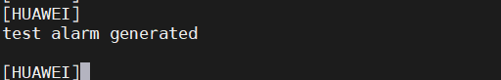
[HUAWEI] disp ops assistant current
------------------------------------------------------------------
Assistant State Condition
------------------------------------------------------------------
ops_test_05.py ready timer
------------------------------------------------------------------
[HUAWEI] disp ops assistant history
Assistant history information
Name :ops_test_05.py
Running information
Trigger condition :timer
Trigger event name :t1
Trigger time :2024-06-26 20:51:00
Execute start time :2024-06-26 20:51:00
Execute end time :2024-06-26 20:51:01
Execute result :normal
[HUAWEI] ops #进入ops配置界面
[HUAWEI-ops] shutdown script-assistant ops_test_05.py #停止指定脚本的python脚本助手
[HUAWEI-ops] disp ops assistant current
------------------------------------------------------------------
Assistant State Condition
------------------------------------------------------------------
ops_test_05.py shutdown timer
------------------------------------------------------------------
[HUAWEI-ops] assistant scheduler suspend #关闭ops维护助手功能
[HUAWEI-ops] disp ops assistant current
------------------------------------------------------------------
Assistant State Condition
------------------------------------------------------------------
ops_test_05.py suspend timer
------------------------------------------------------------------
[HUAWEI-ops] undo assistant scheduler suspend #重新开启ops维护助手功能（默认就是开启状态）
[HUAWEI-ops] undo script-assistant python ops_test_05.py #删除指定的python脚本助手
<HUAWEI> ops uninstall file ops_test_05.py #卸载ops脚本（前提是先删除指定的python脚本助手）
Info: The script file flash:/$_user/ops_test_05.py is uninstalled from the device successfully.

其他的订阅事件api，可参考官方文档的“设备管理配置”→“OPS配置”→“OPS API列表”

#!/usr/bin/env python
# -*- coding: utf-8 -*-
import traceback
import httplib
# Python 2.x中的"httplib"模块在Python 3.x中变成了"http.client"，目前交换机内置python 2.x
# import http.client
class OPSConnection(object):
"""Make an OPS connection instance."""
def __init__(self, host, port=80):
"""初始化类，创建一个HTTP连接"""
self.host = host
self.port = port
self.headers = {
"Content-type": "text/xml",
"Accept": "text/xml"
}
self.conn = None
def close(self):
"""关闭HTTP连接"""
self.conn.close()
def create(self, uri, req_data):
"""创建设备资源操作"""
ret = self.rest_call("POST", uri, req_data)
return ret
def get(self, uri, req_data=None):
"""查询设备资源操作"""
ret = self.rest_call("GET", uri, req_data)
return ret
def delete(self, uri, req_data):
"""删除设备资源操作"""
ret = self.rest_call("DELETE", uri, req_data)
return ret
def set(self, uri, req_data):
"""修改设备资源操作"""
ret = self.rest_call("PUT", uri, req_data)
return ret
def rest_call(self, method, uri, req_data):
""" REST call"""
print('| - - - - - - - - - - - - - - - request: - - - - - - - - - - - - - - -|')
print('%s %s HTTP/1.1\n' % (method, uri))
if req_data == None:
body = ""
else:
body = req_data
print(body)
if self.conn:
self.conn.close()
self.conn = httplib.HTTPConnection(self.host, self.port)
# self.conn = http.client.HTTPConnection(self.host, self.port)
self.conn.request(method, uri, body, self.headers)
response = self.conn.getresponse()
response.status = httplib.OK # stub code
# response.status = http.client.OK #stub code
ret = (response.status, response.reason, response.read())
print('| - - - - - - - - - - - - - - - response: - - - - - - - - - - - - - - -|')
print('HTTP/1.1 %s %s\n\n%s' % ret)
print('| - - - - - - - - - - - - - - - - - - - - - - - - - - - - - - - - - - -|')
return ret
def get_startup_info(ops_conn):
# 指定系统启动信息的URI。URI为Restful API中定义的管理对象，不同的管理对象有不同的URI
uri = "/cfg/startupInfos/startupInfo"
# 指定发送的请求内容。该部分内容与URI相对应，不同的URI对应不同的请求内容
req_data = """
<?xml version="1.0" encoding="UTF-8"?>
<startupInfo>
</startupInfo>
"""
ret, _, rsp_data = ops_conn.get(uri, req_data)
if ret != httplib.OK:
return None
return rsp_data
def clear_startup_info(ops_conn):
uri = "/cfg/clearStartup"
req_data = """
<?xml version="1.0" encoding="UTF-8"?>
<clearStartup>
</clearStartup>
"""
ret, _, rsp_data = ops_conn.create(uri, req_data)
if ret != httplib.OK:
return None
else:
return ret
def main():
# host表示环路地址，当前RESTful API为设备内部调用，即取值为"localhost"。
host = "localhost"
try:
ops_conn = OPSConnection(host) # 建立HTTP连接
rsp_data1 = get_startup_info(ops_conn) # 调用获取系统启动信息的函数
# rsp_data2 = clear_startup_info(ops_conn) # 清空系统启动配置信息
rsp_data3 = get_startup_info(ops_conn)
ops_conn.close() # 关闭HTTP连接
except:
errinfo = traceback.format_exc()
print(errinfo)
return
if __name__ == "__main__":
main()

★PnP即插即用配置
PnP（Plug and Play）即插即用 原是一种电脑硬件的术语，是指在电脑加上一个新的外部硬件时，能自动侦测硬件资源，
而不需要手动安装驱动程序。在网络设备中，即插即用 指的是空配置的网络设备接入网络后，无需人工配置，即可自动完成配置部署‌

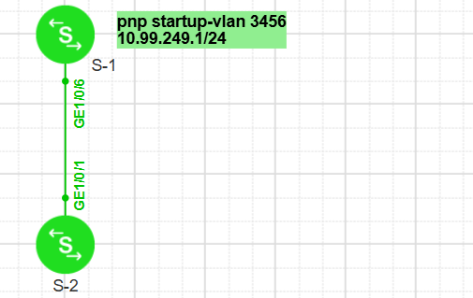

S-1配置（pnp管理交换机，一般为核心交换机）：
lldp tlv-enable legacy-tlv pnp startup-vlan #向下游设备发送的LLDP报文中携带PnP VLAN信息
#
pnp startup-vlan receive enable #接收上游设备发来的pnp报文，默认已开启
pnp startup-vlan send enable #向下游设备发送pnp报文，默认未开启，需要手动配置
pnp startup-vlan 3456 #配置有线PnP VLAN ID
pnp wireless startup-vlan 3456 #配置无线PnP VLAN ID
pnp startup-link-aggregation receive enable #接收上游设备发来的链路聚合的pnp报文
#
dhcp enable
#
vlan 3456
description pnp-vlan-3456
name vlan3456
#
interface Vlanif3456
ip address 10.99.249.1 255.255.255.0
dhcp select interface
dhcp server dns-list 10.99.249.1
dhcp server option 148 ascii \
agilemode=agile-cloud;agilemanage-mode=ip;agilemanage-domain=10.99.1.1;agilemanage-port=10020;ap-agilemode=tradition-fit;
dhcp server option 43 sub-option 3 ascii 10.99.248.12
#
interface Eth-Trunk 1
pnp startup-link-aggregation send enable #向链路聚合口下游设备发送pnp报文
#

S-2（核心下游设备，比如汇聚层及接入层交换机）无需配置，
直接空配置开机即可自动完成配置，获取到pnp vlan下发的ip地址及SDN控制器信息
S-2查看：
Recover configuration begin ...
Recover configuration end
Press ENTER to get started. #设备已启动，这里不要输入任何字符（不按下任何按键），若无用户从console口登录操作，则会进入pnp自动配置阶段：
#Easy-Operation: Start upgrading at 2024-08-12 06:09:53
Enter the status of requesting IP address.
Getting the IP address by DHCP.
The device is registering with the controller. Console inputs will stop the registration process. #此时若输入信息则会中断
NETCONF has been enabled, and console inputs are allowed. #出现这行提示时，表示已经完成自动配置了，可以从console界面登录交换机查看配置了
<HUAWEI> disp ip int brief
*down: administratively down
!down: FIB overload down
^down: standby
Interface IP Address/Mask Physical Protocol VPN
MEth0/0/0 192.168.1.253/24 up up --
NULL0 unassigned up up(s) --
Vlanif3456 10.99.249.99/24 up up --
<HUAWEI> disp cur int Vlanif 3456
interface Vlanif3456
ip address dhcp-alloc
#
<HUAWEI> disp netconf connect-status #查看交换机是否上线

说明：
①Ethernet0/0/0和MEth0/0/1管理口不支持EasyDeploy功能，只有加入缺省VLAN的业务口才支持
②向下游传递PnP VLAN的优先级顺序为：
静态配置的无线PnP VLAN > 静态配置的有线PnP VLAN > 从上游设备学习的无线PnP VLAN > 从上游设备学习的有线PnP VLAN‌
③pnp功能开启后，设备之间链路默认允许通过vlan1即可，pnp vlan 2345可以不允许通过也能正常通信，下游设备能正常获取ip和通信，查看vlanif状态为up。

★第3章、文件传输

★TFTP客户端
[Huawei] tftp client-source -a 10.1.1.1 #指定tftp客户端的源ip
Info: Succeeded in setting the source address of the TFTP client to 10.1.1.1.
[Huawei]quit
<Huawei> tftp 10.1.1.254 put vrpcfg.zip s5700_cfg.zip
#上传配置文件vrpcfg.zip到tftp服务器10.1.1.254，目的文件名为s5700_cfg.zip
Info: Transfer file in binary mode.
Uploading the file to the remote TFTP server. Please wait...

<HUAWEI> tftp -a 192.168.2.104 192.168.2.102 put src.file dst.filename
#上传时直接指定tftp客户端ip（-a指定客户端ip地址）

★FTP服务器
把交换机或路由器当作FTP服务器
[Huawei] ftp server enable #开启ftp服务器
Info: Succeeded in starting the FTP server.
[Huawei] aaa #进入aaa配置模式
[Huawei-aaa] local-user cof password cipher 12xx56 #创建用户cof作为ftp用户
Info: Add a new user.
[Huawei-aaa] local-user cof service-type ftp #用户仅开启ftp服务
[Huawei-aaa] local-user cof ftp-directory flash:/ #指定用户的ftp家目录为flash:/
[Huawei-aaa]quit
[Huawei]

★FTP客户端
<Huawei> ftp -a 10.1.1.2 10.1.1.1 #指定源ip为10.1.1.2,服务器ip为10.1.1.1
Trying 10.1.1.1 ...
Connected to 10.1.1.1.
220 FTP service ready.
User(10.1.1.1:(none)): cof #输入ftp用户名
331 Password required for cof.
Enter password: #输入密码
230 User logged in #登录成功
[Huawei-ftp] dir #查看服务器上的文件列表
200 Port command okay.
150 Opening ASCII mode data connection for *.
drwxrwxrwx 1 noone nogroup 0 Aug 06 2015 src
-rwxrwxrwx 1 noone nogroup 538 Dec 03 09:31 vrpcfg.zip
226 Transfer complete.
FTP: 194 byte(s) received in 0.160 second(s) 1.21Kbyte(s)/sec.

[Huawei-ftp] get vrpcfg.zip s5700.zip #下载文件
200 Port command okay.
150 Opening ASCII mode data connection for vrpcfg.zip.
226 Transfer complete.
FTP: 538 byte(s) received in 0.150 second(s) 3.58Kbyte(s)/sec.
[Huawei-ftp]quit
221 Server closing.
[Huawei-ftp] put srcxx dstxxx #上传文件

★第4章、端口操作

★配置端口速率及模式
[Huawei] int g0/0/3
[Huawei-GigabitEthernet0/0/3] undo negotiation auto #手动指定端口双工及速率参数时要先关闭自协商
[Huawei-GigabitEthernet0/0/3] duplex full #信道模式为全双工
[Huawei-GigabitEthernet0/0/3] speed 1000 #速率为1000M
[Huawei-GigabitEthernet0/0/3] combo-port copper #光电复用口指定为电口，光口为fiber

#有的新型号设备配置方式为：
[Huawei-GigabitEthernet0/0/3] negotiation disable #关闭自协商
[Huawei-GigabitEthernet0/0/3] port mode ge #设置速率为1000M

#或者：
[Huawei-100GE1/0/1] device transceiver 100GBASE-FIBER #指定为100G速率，光口

[Huawei-100GE1/0/1] negotiation disable
[Huawei-100GE1/0/1] fec mode rs #手动指定fec模式，使用铜缆时指定为rs

★注意：
①有的型号将每4个口分为一组，同一组内的口必须为同一速率，比如1-4，5-8，9-12，13-16，17-20，21-24各自为一组，一旦将同一组内某个口设置为xx速率，则同一组内其他口都会变为xx速率

②有的型号个别口不支持低速率的光模块，比如CE6881的10G口，有部分口（13-16，25-28）就不支持插1000兆的光模块

★查看接口ip及状态
<Huawei> disp ip int brief #查看接口的up/down状态及接口上的ip（ipv4）
*down: administratively down
^down: standby
(l): loopback
(s): spoofing
The number of interface that is UP in Physical is 2
The number of interface that is DOWN in Physical is 2
The number of interface that is UP in Protocol is 2
The number of interface that is DOWN in Protocol is 2
Interface IP Address/Mask Physical Protocol
GigabitEthernet0/0/0 unassigned down down
GigabitEthernet0/0/1 10.1.1.2/24 up up
GigabitEthernet0/0/2 unassigned down down
NULL0 unassigned up up(s)
<Huawei>
<Huawei> disp ipv6 int brief #查看接口的up/down状态及接口上的ip（ipv6）
*down: administratively down
!down: FIB overload down
(l): loopback
(s): spoofing
Interface Physical Protocol VPN
Vlanif1 up up --
[IPv6 Address] FD00:1234::FF02
Vlanif2 up up --
[IPv6 Address] FD88:1299::FF02

<HUAWEI> ping ipv6 FD00:1234::FF01 #ping ipv6
PING FD00:1234::FF01 : 56 data bytes, press CTRL_C to break
Reply from FD00:1234::FF01
bytes=56 Sequence=1 hop limit=64 time=29 ms
<HUAWEI> ping ipv6 FE80::727B:E8FF:FE64:7CDF -i vlanif 1 #ping IPv6链路本地地址时需要指定三层接口
PING FE80::727B:E8FF:FE64:7CDF : 56 data bytes, press CTRL_C to break
Reply from FE80::727B:E8FF:FE64:7CDF
bytes=56 Sequence=1 hop limit=64 time=17 ms

★接口流量统计时间设置
[Huawei] set flow-stat interval 60 #设置接口的流量统计时间间隔，单位：秒
[Huawei] undo set flow-stat interval #恢复默认时间间隔，300秒
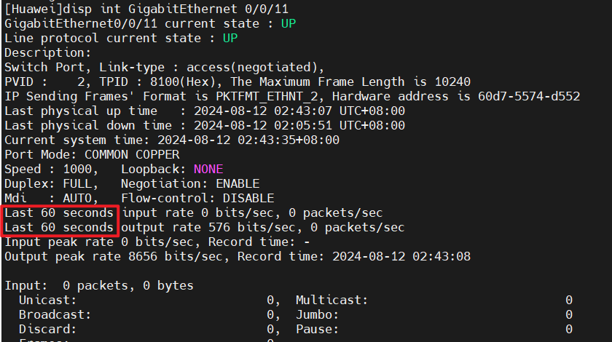

<Huawei> reset interface counters g0/0/11 #清除指定接口的统计信息
<Huawei> reset counters interface g0/0/11 #清除指定接口的统计信息

★二层口设置为三层口（保留vlan）
有些型号的交换机（比如早期的CE6800系列）二层口设置为三层口时，需要先配置保留vlan
[Huawei] vlan reserved for main-interface 4030 to 4063 #设置保留vlan
[Huawei] int eth-trunk 2 #聚合口，或者用物理口int g0/0/2都可以
[Huawei-Eth-Trunk2] undo portswitch #设置为3层口（路由口）

★交换机三层子接口配置vlan
[Huawei] int g0/0/2.2
[Huawei-GigabitEthernet0/0/2.20] dot1q termination vid 20
[Huawei-GigabitEthernet0/0/2.20] ip add 192.168.20.254 255.255.255.0

★清空某端口上的所有配置
[HUAWEI] interface GigabitEthernet0/0/17 #先进入端口配置模式
[HUAWEI-GigabitEthernet0/0/17] clear configuration this #清空本端口上的所有配置
Warning: All configurations of the interface will be cleared, and its state will be shutdown. Continue? [Y/N] : y #输入y确认

[HUAWEI] clear configuration interface GigabitEthernet0/0/18 #配置模式下直接清空
Warning: All configurations of the interface will be cleared, and its state will be shutdown. Continue? [Y/N] : y #输入y确认

★端口拆分port-split
[Huawei] port split mode mode2 slot 1 # mode1,mode2,mode3
<Huawei> reboot #重启后才生效

[Huawei] port split dimension int 100GE1/0/5 split-type 4*25GE #将5号口拆分为4个25GE的口
#再使用1分4线缆插入此端口，使用拆分后的口：
[Huawei] interface 100GE1/0/5:1 #使用拆分后的第1个子接口（25GE）
[Huawei] interface 100GE1/0/5:2 #使用拆分后的第2个子接口（25GE）
[Huawei] interface 100GE1/0/5:3 #使用拆分后的第3个子接口（25GE）
[Huawei] interface 100GE1/0/5:4 #使用拆分后的第4个子接口（25GE）

以CE8800系列为示例，其拆分模式为：
mode1 | 所有端口都不可拆分
mode2 | 不可拆分端口：1-4，17-20，33-36，49-52 （只能作为单个口使用）  不可使用的端口：12-16，28-32，44-48，60-64 （此模式下这些端口不可使用了）  其余可拆分：5-11，21-27，37-43，53-59 （就这些端口可拆分使用）
mode3 | 不可拆分端口：1-8，17-24，33-40，49-56 （只能作为单个口使用）  不可使用的端口：15-16，31-32，47-48，63-64 （此模式下这些端口不可使用了）  其余可拆分：9-14，25-30，41-46，57-62 （就这些端口可拆分使用）

不同型号的设备对端口的拆分支持情况不尽相同，需要事先查阅官方产品文档，确认之后，再进行规划使用

★DDM光口功率检测
（Digital Diagnostic Monitoring）数字诊断检测是由SFF Committee制定，遵循SFF-8472多源协议定义的标准参数，规范了光模块和网络设备的软硬件所需遵循的标准数值或范围。
实时测量参数：工作电压、工作温度、接收光功率、发射光功率和激光器偏置电流

[Huawei] disp transceiver interface g0/0/1 #显示端口的光功率等信息
[Huawei] disp transceiver interface GigabitEthernet0/0/26 verbose #查看端口的光功率等详细信息
[Huawei] disp interface GigabitEthernet0/0/1 transceiver verbose #显示指定端口的光功率信息
[Huawei] disp interface transceiver brief #显示端口的光功率等信息；详细信息用 verbose

★VCT电口检测
（virtual-cable-test）VCT是利用TDR（Time Domain Reflectometry-时域反射测试）来检测网络线缆的物理状态。
TDR检测原理类似于雷达，它工作方式是通过主动向导线发射一个脉冲信号并检测所发送的脉冲信号的反射结果来检测电缆故障。当发送的脉冲信号通过电缆的末端或电缆的故障点时，就会引起部分或全部的脉冲能量被反射回来到达原来的发送源，VCT技术根据测量脉冲信号在导线中的传输获得信号到达故障点或返回的时间，然后根据公式将相应时间换算为距离值。通过VCT可以检测电缆状态、故障距离是否极性交换、插入信号衰减、返回信号衰减等。

[HUAWEI] int g0/0/23 #先进入目标端口
[HUAWEI-GigabitEthernet0/0/23] virtual-cable-test #vct电口检测（电口会关闭几秒再打开，谨慎操作）
Warning: The command will stop service for a while. Continue? [Y/N]: y #输入y确认，大概会断开3～5秒左右
Info: This operation may take a few seconds. Please wait for a moment..done.
Pair A length: Unknown
Pair B length: Unknown
Pair C length: Unknown
Pair D length: Unknown
Pair A state: Ok
Pair B state: Ok
Pair C state: Ok
Pair D state: Ok
Info: The test result is only for reference.

★关闭非华为设备认证光模块告警
如果设备上插入的光模块不是华为设备认证光模块，则会产生大量告警，从而提醒用户更换为华为设备认证光模块，以便管理和维护光模块。用户可以通过关闭非华为设备认证光模块的告警开关来屏蔽该告警。
[Huawei] transceiver non-certified-alarm disable #关闭非华为设备认证光模块告警
[Huawei] transceiver phony-alarm-disable #关闭非华为设备认证光模块告警

Aug 12 2024 08:25:41+08:00 Huawei SRM/3/SFP_EXCEPTION:OID 1.3.6.1.4.1.2011.5.25.129.2.1.9 Optical module exception, SFP is not certified. (EntityPhysicalIndex=67438350, BaseTrapSeverity=5, BaseTrapProbableCause=136192, BaseTrapEventType=9, EntPhysicalContainedIn=67108873, EntPhysicalName=GigabitEthernet0/0/28, RelativeResource=Interface GigabitEthernet0/0/28 optical module exception, ReasonDescription=It has been observed that a transceiver has been installed that is not certified by Huawei Ethernet Switch. Huawei cannot ensure that it is completely adaptive and will not cause any adverse effects. If it is continued to be used, Huawei is not obligated to provide support to remedy defects or faults arising out of or resulting from installing and using of the non-certified transceiver.)

★光口开启ALS功能
开启ALS功能后，当接口光纤不在位或光纤链路发生故障时，激光器将自动关闭发光功能。光纤或光纤链路故障恢复后，激光器有两种重启模式：
automatic | 自动重启模式 | 激光器每隔一段时间自动发送一个探测光脉冲，探测链路是否恢复，恢复后，自动打开发光功能。
manual | 手动重启模式 | 用户在插上光纤或已知光纤链路恢复的情况下，手动打开激光器，打开后激光器会发送一个探测光脉冲，探测链路是否恢复。

int g0/0/1
als enable #开启接口的ALS功能，默认是关闭状态
als restart mode automatic #配置光模块激光器的重启模式为自动重启，默认为自动重启，也可配置为manual手动重启
als restart pulse-interval 100 #设置2次脉冲之间的时间间隔，单位：秒，默认是100秒
als restart pulse-width 2 #每次脉冲时间长度，单位：秒，默认是2秒
#

int g0/0/1
als restart #手动打开光模块的激光器，（手动重启模式下，当接口插上光纤或光纤链路修复后，必须执行此命令手动打开激光器）
#

[Huawei] disp als configuration interface g0/0/25
-------------------------------------------------------------------------------
Interface ALS Laser Restart Interval(s) Width(s)
Status Status Mode
-------------------------------------------------------------------------------
GigabitEthernet0/0/25 Enable On Auto 100 2
-------------------------------------------------------------------------------

★端口组操作port-group
创建一个端口组，并把一些端口放入此组，便于同时对这组端口进行端口相关的操作
[HUAWEI] port-group 1 #创建一个端口组，组号 1
[HUAWEI-port-group-1] group-member g0/0/4 to g0/0/8 #加入成员端口
[HUAWEI-port-group-1]
[HUAWEI-port-group-1] disp this
#
port-group 1
group-member GigabitEthernet0/0/4
group-member GigabitEthernet0/0/5
group-member GigabitEthernet0/0/6
group-member GigabitEthernet0/0/7
group-member GigabitEthernet0/0/8
#

★端口聚合Eth-Trunk
★lacp模式
[Huawei] int Eth-Trunk 1 #创建聚合口1
[Huawei-Eth-Trunk1] mode lacp #聚合模式为lacp，或者为：manual
[Huawei-Eth-Trunk1] least active-linknumber 1 #配置聚合口活动接口（UP的成员口）数量下限阈值，默认为1，两端设备配置不一致时，以数量较大的一方为准（当UP的成员口数量小于此值时聚合口会变为DOWN状态）
[Huawei-Eth-Trunk1] max active-linknumber 8 #配置聚合口活动接口数量上限阈值，默认为8，两端设备配置要保持一致（防止活动接口故障时聚合口产生震荡），两端设备配置不一致时，以数量较小的一方为准
[Huawei-Eth-Trunk1] lacp timeout fast #设置lacp短超时（发送周期1秒，超时3秒）
#默认为lacp timeout slow（发送周期30秒，超时90秒），链路2端的超时时间可以不一致
#注意：在本端设置之后，是让对端按这个周期发lacp报文给我（本端），不会协商修改对端的超时时间
[Huawei-Eth-Trunk1] mode lacp-dynamic #设置为lacp动态模式，静态为lacp-static
lacp动态模式和静态模式在协议交互上没有区别，区别仅为协商失败后的处理方式不一样：
静态lacp | 协商失败后Eth-Trunk变为Down，不能转发数据
动态lacp | 协商失败后Eth-Trunk变为Down，但其成员口继承Eth-Trunk的VLAN属性状态变为Indep，可独立进行二层数据转发。动态LACP模式下的Eth-Trunk通常应用于和服务器直连的场景，服务器多个网口一开始没有进行聚合绑定，lacp协商失败后单网口可直接二层通信，获取lacp配置后再创建聚合口，lacp协商成功，再通过聚合口转发数据。
[Huawei-Eth-Trunk1] lacp port-id-extension enable #双归场景下，配置其中一台设备的Eth-Trunk成员接口编号增加32768
[Huawei-Eth-Trunk1] lacp dampening state-flapping #配置Eth-Trunk接口状态震荡抑制功能
[Huawei-Eth-Trunk1] lacp dampening unexpected-mac disable #关闭LACP模式下的Eth-Trunk接口接收非法MAC报文抑制功能（即：接收非法MAC报文）
[Huawei-Eth-Trunk1] undo lacp dampening unexpected-mac disable #默认，LACP模式下的Eth-Trunk接口接收非法MAC报文抑制功能（即：不接收非法MAC报文）

★manual模式
[Huawei] int Eth-Trunk 1 #创建聚合口1
[Huawei-Eth-Trunk1] mode manual load-balance #手工模式，与lacp二选一，默认为load-balance
[Huawei-Eth-Trunk1] load-balance src-dst-ip #设置负载均衡模式
[Huawei-Eth-Trunk1] quit

★成员口加入聚合口
[Huawei] int g0/0/20
[Huawei-GigabitEthernet0/0/20] eth-trunk 1 #将g0/0/20指定为聚合口1的成员端口
[Huawei-GigabitEthernet0/0/20] quit
[Huawei] int g0/0/21
[Huawei-GigabitEthernet0/0/21] eth-trunk 1 #将g0/0/21指定为聚合口1的成员端口
[Huawei-GigabitEthernet0/0/21] quit

★聚合口里直接添加成员口
[Huawei] int eth-trunk 1
[HUAWEI-Eth-Trunk1] trunkport g0/0/2 #直接在聚合口里添加物理成员口
[Huawei-Eth-Trunk1]

[Huawei] disp lacp statistics eth-trunk 1
Eth-Trunk1's PDU statistic is:
------------------------------------------------------------------------------
Port LacpRevPdu LacpSentPdu MarkerRevPdu MarkerSentPdu
GigabitEthernet0/0/1 1256 1662 0 0
GigabitEthernet0/0/2 1348 1739 0 0

★端口安全（mac地址绑定及过滤）
端口安全是对进入端口的报文源mac地址进行过滤
[Huawei] int g0/0/9
[Huawei-GigabitEthernet0/0/9] port-security enable #开启端口安全
[Huawei-GigabitEthernet0/0/9] port-security protect-action protect #保护模式，也可设置为shutdown
[Huawei-GigabitEthernet0/0/9] port-security max-mac-num 10 #最多允许学习10个mac地址
#默认动态学习，可设置为sticky模式，学习到的mac不会老化
[Huawei-GigabitEthernet0/0/9] port-security mac-address sticky #sticky模式，学习到的mac不会老化，开启了sticky模式后，默认接口学习的mac地址限制数为1，需要>1时可设置max-mac-num为指定的数量
[Huawei-GigabitEthernet0/0/9] port-security mac-address sticky 0026-ab03-9f04 vlan 1
#手工添加一条不会老化的mac地址
[Huawei-GigabitEthernet0/0/9]

★端口安全保护模式：
protect | 只丢弃源MAC地址不存在的报文，不上报告警
restrict | 丢弃源MAC地址不存在的报文，并上报告警
shutdown | 接口状态被置为error-down，并上报告警

[Huawei] error-down auto-recovery cause port-security interval 300
#设置端口因保护关闭的自动恢复时间，300秒，不设置则不会自动恢复shutdown的端口

[Huawei] display mac-address sticky vlan 1 #查看sticky mac表项
[Huawei] display trapbuffer #查看trap告警信息

★端口隔离
端口隔离可以实现隔离同一vlan内的广播报文，端口隔离只对同一设备有效，对于不同设备上的端口，无法实现二层隔离的功能。

[Huawei] port-isolate mode l2 #配置端口隔离模式，默认为l2（二层隔离，三层互通）
[Huawei] int g0/0/1
[Huawei-GigabitEthernet0/0/1] port-isolate enable group 1 #将端口加入隔离组1，加入同一隔离组的各端口之间二层隔离了，各自发送的二层报文，不会发送到其他成员口。非同一隔离组之间的端口可以互访
[Huawei]
[Huawei] disp port-isolate group all #查看端口隔离组信息
The ports in isolate group 1:
GigabitEthernet0/0/1
GigabitEthernet0/0/9

[Huawei] int g0/0/2
[Huawei-GigabitEthernet0/0/2] am isolate g0/0/3 g0/0/5 #单向隔离，即g0/0/2口发出的二层报文不会发到g0/0/3及g0/0/5口，但g0/0/3及g0/0/5口发出的二层报文会发给g0/0/2
[Huawei]

[Huawei] int Vlanif 10
[Huawei-Vlanif10] arp-proxy inner-sub-vlan-proxy enable #当主机处于相同网段，并且属于相同的VLAN，但是VLAN内配置了端口隔离时，可以在vlanif配置界面执行此命令，通过VLAN内Proxy ARP实现主机之间的IP地址解析

[Huawei] clear configuration port-isolate #清除设备上所有的端口隔离配置

★IP和MAC绑定（可绑到端口上）
[H] user-bind static ip-address 10.1.1.92 mac-address 4c1f-cc6f-0f33 [ int g0/0/3 ]
#添加一条静态的ip和mac绑定条目
[Huawei] vlan 1
[Huawei-vlan1] ip source check user-bind enable #在相应vlan上开启ip-mac检查
[Huawei-vlan1]quit

★端口环路检测
[Huawei] loopback-detect packet-interval 20 #端口环路检测周期，20秒检测一次

[Huawei] int g0/0/10
[Huawei-GigabitEthernet0/0/10] loopback-detect recovery-time 180
#设置端口恢复时间180秒，默认为3倍interval时间，不能低于3倍interval时间
[Huawei-GigabitEthernet0/0/10] loopback-detect enable #在端口上开启
[Huawei-GigabitEthernet0/0/10] loopback-detect packet vlan 1 to 20
#检测的vlan，有数量限制，一般为32个vlan
[Huawei-GigabitEthernet0/0/10] loopback-detect action shutdown #惩戒动作
[Huawei-GigabitEthernet0/0/10] quit

[Huawei] loopback-detect enable #在全局上开启，所有端口都开启

[HUAWEI] error-down auto-recovery cause loopback-detect interval 300 #300秒后自动恢复为up

★风暴控制
[Huawei] int g0/0/3
[Huawei-GigabitEthernet0/0/3] storm-control interval 180 #惩戒时间180秒
[Huawei-GigabitEthernet0/0/3] storm-control action block #惩戒动作为block阻塞，或者error-down
[Huawei-GigabitEthernet0/0/3] storm-control enable log #开启日志
[Huawei-GigabitEthernet0/0/3] storm-control broadcast min-rate 1000 max-rate 1200
#广播包速率限制为1000 pps最大允许1200包每秒
[Huawei-GigabitEthernet0/0/3]
[Huawei] error-down auto-recovery cause storm-control interval 180

#或者新型号配置方式：
[Huawei-GigabitEthernet2/0/20] storm suppression multicast pts 1000
[Huawei-GigabitEthernet2/0/20] storm suppression broadcast 5
[Huawei-GigabitEthernet2/0/20] storm suppression multicast cir 100 kbps

★流量抑制
流量抑制若应用在设备的入端口处：则可以对 广播、未知单播、未知组播、已知单播、已知组播 进行限制
流量抑制若应用在设备的出端口处：则可以对 广播、未知单播、未知组播 进行限制
在vlan上，只支持对广播做抑制

[Huawei] suppression mode by-packets #或者by-bits，设置全局流量抑制模式，默认为by-packets
[Huawei] int g0/0/1
[Huawei-GigabitEthernet0/0/1] broadcast-suppression 5 #百分之5
[Huawei-GigabitEthernet0/0/1] broadcast-suppression packets 1000 #1000个包每秒
#端口下配置流量抑制时，抑制模式需要和全局的流量抑制模式一致

★风暴控制和流量抑制的区别：
storm-control 风暴控制 超限后全部流量都丢弃，可触发error-down
broadcast-supression 流量抑制 超限后只丢弃超出部分的流量，只限速，限额内的流量正常转发

★link-flap链路振荡抑制
[Huawei] port link-flap trigger error-down #开启接口的链路振荡保护功能，默认已开启
[Huawei] int g1/0/1 #进入目标接口
[Huawei-GigabitEthernet1/0/1] port link-flap interval 30 threshold 10 #设置link-flap的检测门限，30秒10次，默认为10秒5次，如果在链路振荡时间间隔内，链路振荡次数达到了设定值，则将关闭该接口，记录为error down（link-flap）状态，且默认不会自动恢复为UP状态

[Huawei-GigabitEthernet1/0/1] port link-flap threshold 0 #关闭link-flap检测
[Huawei-GigabitEthernet1/0/1] undo port link-flap trigger error-down #旧版本软件关闭link-flap检测

[Huawei] error-down auto-recovery cause link-flap interval 300 #300秒后自动恢复为up

[Huawei] disp error-down recovery int g1/0/1 #查看处于error-down状态的接口信息

★端口error-down自动恢复
[HUAWEI] error-down auto-recovery cause bpdu-protection interval 300 #300秒后自动恢复为up
[HUAWEI] error-down auto-recovery cause ?
as-not-ready The AS is not in service
auto-defend Auto-defend punishing function
bpdu-protection Specify BPDU protection function
efm-remote-failure Dying-gasp, link-fault, critical-event, or timeout
efm-threshold-event Error-frame, error-code, or error-frame-second event
error-statistics Specify CRC error-packet statistics exceed threshold protection function
link-flap Specify link flap protection function
mac-address-flapping MAC address flapping protection function
port-security Port security protection function
storm-control Storm-control punishing function
transceiver-power-low Specify transceiver power low protection function

★端口镜像Port-Mirroring
[Huawei] observe-port 1 int g0/0/3 #观察口，被镜像的数据流向此端口
[Huawei] int g0/0/2
[Huawei-GigabitEthernet0/0/2] port-mirroring to observe-port 1 both
#设置端口为被镜像口，镜像的数据为both（包含inbound和outbound），也可只镜像某一方向的，如inbound
[Huawei-GigabitEthernet0/0/2]quit

[Huawei] disp port-mirroring #查看端口镜像情况
Port-mirror:
----------------------------------------------------------------------
Mirror-port(镜像口) Direction Observe-port（观察口）
----------------------------------------------------------------------
GigabitEthernet0/0/2 Both GigabitEthernet0/0/3
----------------------------------------------------------------------
[Huawei]
[Huawei] disp observe-port #查看 观察口
----------------------------------------------------------------------
Index : 1
Untag-packet : No
Forwarding : Yes
Dynamic-alloc : No
Interface : GigabitEthernet0/0/3

observe-port group 2 #观察组，被镜像的数据流向此组里的所有端口
group-member GE1/0/1
group-member GE1/0/2
#
interface Eth-trunk 1 #在聚合口上做镜像
port-mirroring observe-port group 2 inbound
port-mirroring observe-port group 2 outbound
#

★匹配具体流量并镜像到观察口（流镜像）：
[Huawei] observe-port interface GigabitEthernet 0/0/2 #观察口，被镜像的数据流向此端口
[Huawei] acl number 2000 #创建基本acl
[Huawei-acl-basic-2000] rule 1 permit source 10.1.1.0 0.0.0.255 #匹配源网段，反掩码
[Huawei-acl-basic-2000] quit

[Huawei] traffic classifier class3 #定义流类
[Huawei-classifier-class3] if-match acl 2000 #匹配acl，该acl匹配目标流量
[Huawei-classifier-class3] quit
[Huawei] traffic behavior behav3 #定义流行为
[Huawei-behavior-behav3] mirror to observe-port #镜像到观察口
[Huawei-behavior-behav3] quit
[Huawei] traffic policy policy3 #定义流策略
[Huawei-trafficpolicy-policy3] classifier class3 behavior behav3 #匹配相应的类和行为
[Huawei-trafficpolicy-policy3] quit
[Huawei] int g0/0/1
[Huawei-GigabitEthernet0/0/1] traffic-policy policy3 inbound #在接口上应用策略
[Huawei-GigabitEthernet0/0/1] quit

★PPP点对点链路配置
[Huawei] int s4/0/1
[Huawei-Serial4/0/1] virtualbaudrate 2048000 #设置串口波特率为2M
[Huawei-Serial4/0/1] physical-mode async #串口传输模式设为异步的
[Huawei-Serial4/0/1] physical-mode sync #也可设为同步的（默认是同步的）
[Huawei-Serial4/0/1] link-protocol ppp #封装协议为ppp

[Huawei-Serial4/0/1] ppp authentication-mode chap #ppp使用chap
[Huawei-Serial4/0/1] ppp chap user cof #ppp用户名
[Huawei-Serial4/0/1] ppp chap password cipher xxxxx #ppp用户密码
[Huawei-Serial4/0/1] quit

[Huawei-Serial4/0/1] ppp authentication-mode pap #ppp使用pap
[Huawei-Serial4/0/1] ppp pap local-user cof password cipher xxxx
[Huawei-Serial4/0/1] quit

★capture-packet端口抓包
<> disp qos queue statistics interface G1/0/1 #看队列流量统计，只能看出方向的
<> reset qos queue statistics interface G1/0/1 #清空统计
<> capture-packet interface g1/0/2 destination terminal packet-len 64 packet-num 20
#每个包抓取前64字节，共抓20个包

★接口微突发检测
微突发是指接口在极短时间（毫秒级别）内收到大量突发流量，以至于瞬时速率达到平均速率的数十倍、数百倍，甚至超过接口带宽的现象。当微突发流量的瞬时速率超过设备的转发能力时，设备会将突发的数据进行缓存以便稍后发送。如果设备没有足够的缓存，那么超出的数据只能丢弃，这种现象就是拥塞丢包。
微突发检测功能可用于检测在极短时间内（毫秒级别）接口出方向的突发流量，便于维护人员确认是否是微突发引起丢包。

微突发检测有两种模式：
默认模式：报文的采样周期为5毫秒，支持多个接口同时使能微突发检测功能。
增强模式：报文的采样周期为1毫秒，仅支持一个接口使能微突发检测功能。

微突发检测的统计周期为5分钟，每5分钟统计一次接口的关键性能指标，并生成相关表项。设备最多支持保存使能微突发检测功能后300分钟内的统计数据。

qos micro-burst detection enable slot 1 #开启微突发检测功能
qos micro-burst detection enhanced enable slot 1 #开启增强模式的微突发检测功能
#
interface g0/0/1
qos micro-burst detection enable #接口上开启微突发检测功能
#

display qos micro-burst statistics interface g0/0/1 #查看接口的微突发检测统计数据
display qos micro-burst status all #查看所有接口的微突发检测状态及丢包情况
display qos micro-burst peak-buffer verbose interface g0/0/1 #查看接口的缓存峰值和缓存占用情况

★dot1x接入认证
可扩展的认证协议EAP（Extensible Authentication Protocol）中继认证方式

#不透传EAP报文
不使用EAP中继认证方式

#配置radius认证模板
radius-server template 1 #创建radius服务器模板
radius-server authentication 10.99.7.252 1812 source ip-address 10.99.7.2
radius-server shared-key cipher testing123
undo radius-server user-name domain-included #配置设备向RADIUS服务器发送的报文中的用户名不包含域名
#
test-aaa cof admin123 radius-template 1 chap #测试radius服务器是否可用
Info: Account test succeeded.

#配置认证scheme
aaa
authentication-scheme cof-lee.com_authen #创建一个认证scheme
authentication-mode radius local
undo server no-response accounting #配置用户在服务器认证无响应转入本地认证后，设备不发送计费报文（默认）
radius-reject local #配置管理员用户在RADIUS认证拒绝后转入本地认证，缺省情况下，未配置管理员用户在RADIUS认证拒绝后转入本地认证。在RADIUS认证拒绝后（即RADIUS服务器回应Access-Reject报文），认证流程结束，用户认证失败
authentication-type radius chap access-type admin #配置管理员用户在RADIUS认证时使用CHAP认证方式，缺省情况下，管理员用户在RADIUS认证时使用PAP认证方式
#

#配置计费scheme
aaa
accounting-scheme cof-lee.com_account #创建一个计费scheme
accounting-mode none #不计费，关闭实时计费
#缺省情况下，域使用名为“default”的计费方案。“default”计费方案的策略为：不计费，关闭实时计费
#

#配置认证域
aaa
domain cof-lee.com
authentication-scheme cof-lee.com_authen #使用指定的认证scheme
accounting-scheme cof-lee.com_account #使用指定的计费scheme
radius-server 1 #使用指定的radius服务器模板
#

#配置dot1x接入模板
dot1x-access-profile name dot1x_access_profile_1 #创建802.1X模板，并进入配置界面
dot1x authentication-method chap #配置802.1X用户的认证方式为chap，默认是eap中继认证方式
#非eap中继方式分2种：chap和pap；只有采用RADIUS认证时，才可以配置为EAP中继方式
authentication trigger-condition { dhcp | arp | dhcpv6 | nd | any-l2-packet } * #配置能够触发802.1X认证的报文类型。缺省情况下，DHCP/ARP/DHCPv6/ND报文均能够触发802.1X认证
dot1x unicast-trigger #开启单播报文触发802.1X认证功能，默认关闭
dot1x port-control { auto | authorized-force | unauthorized-force } #配置接口的授权状态，默认为auto
#auto表示接口初始状态为非授权状态，仅允许收发认证报文，不允许用户访问网络资源；如果认证通过，则接口切换到授权状态，允许用户访问网络资源。authorized-force强制授权模式：接口始终处于授权状态，允许用户不经认证授权即可访问网络资源。unauthorized-force强制非授权模式：接口始终处于非授权状态，不允许用户访问网络资源。
dot1x timer client-timeout 5 #客户端认证超时时间，默认为5秒
dot1x timer tx-period 30 #配置802.1X定时器，默认为30秒
dot1x reauthenticate #配置对在线802.1X用户进行重认证的功能，默认不进行重认证
dot1x timer reauthenticate-period 7200 #配置对在线802.1X用户进行重认证的周期，默认为3600秒
dot1x handshake #开启设备与在线802.1X用户的握手功能，默认关闭
#若802.1X客户端不支持与设备进行握手报文的交互，则握手周期内设备将不会收到握手回应报文。为了防止设备错误地认为用户下线，需要将在线用户握手功能关闭，该功能仅对有线用户生效
dot1x handshake packet-type { request-identity | srp-sha1-part2 } #配置802.1X认证握手报文的类型，默认为request-identity
dot1x timer handshake-period 15 #配置设备与非Eth-Trunk接口下的在线802.1X用户的握手周期，默认为15秒
dot1x timer eth-trunk-access 120 #配置设备与Eth-Trunk接口下的在线802.1X用户的握手周期，默认为120秒
dot1x retry 2 #配置向用户发送握手报文的重传次数，默认为2次
#

#配置认证模板
authentication-profile name my_authentication_profile_1 #创建认证模板
dot1x-access-profile dot1x_access_profile_1 #绑定802.1X接入模板
authentication mode multi-authen max-user 256 dot1x #允许接入的最大用户数
access-domain cof-lee.com force #配置802.1X认证用户强制域，默认未配置
#默认情况下，当用户输入的账号带有域名时，则去相应的域去认证，若不带域名，则到默认域去认证。当配置了用户认证强制域，则不论用户输入的账号是否带域名，都去指定的域下认证。
#authentication dot1x-mac-bypass #开启MAC旁路认证功能，如果MAC旁路认证延迟时间到达而802.1X认证仍未成功，则设备会对用户启动MAC认证流程
#dot1x timer mac-bypass-delay 30 #配置MAC认证延迟定时器，默认为30秒
#dot1x mac-bypass mac-auth-first #开启旁路认证过程中优先进行MAC认证功能，默认未开启
#mac-access-profile mac_accpess_profile_1 #绑定mac认证模板
#

#接口开启dot1x认证
int g0/0/1
dot1x enable #开启接口的802.1X认证功能
authentication-profile my_authentication_profile_1 #接口下应用认证模板
dot1x domain cof-lee.com #配置802.1X认证用户强制域，默认未配置
#authentication guest-vlan 10 #配置接口加入的Guest VLAN（未认证时）
#authentication restrict-vlan 20 #配置接口加入的Restrict VLAN（认证失败时）
#authentication critical-vlan 30 #配置接口加入的Critical VLAN（认证通信异常时）
#authentication critical eapol-succes #将用户加入critical-vlan后向用户回复Eapol-Success报文（默认已开启）
#authentication max-reauth-req 20 #配置对critical-vlan用户触发重认证的最大次数，默认20次
#

#guest-vlan及restrict-vlan也可在全局配置界面进行配置：
authentication guest-vlan 10 interface GigabitEthernet 0/0/1 to 0/0/8 #配置接口加入的Guest VLAN
authentication restrict-vlan 20 interface GigabitEthernet 0/0/1 to 0/0/8 #配置接口加入的Restrict VLAN
authentication critical-vlan 30 interface GigabitEthernet 0/0/1 to 0/0/8 #配置接口加入的Critical VLAN
authentication critical eapol-succes interface GigabitEthernet 0/0/1 to 0/0/8 #将用户加入critical-vlan后向用户回复Eapol-Success报文（默认已开启）
authentication max-reauth-req 20 interface GigabitEthernet 0/0/1 to 0/0/8 #配置对critical-vlan用户触发重认证的最大次数，默认20次
#Super VLAN不能作为Guest VLAN或Restrict VLAN

display authentication interface g0/0/1 #查看接口认证配置信息

★其他配置方式（ensp模拟器）
dot1x enable #全局开启802.1X认证功能，默认关闭
dot1x enable interface GigabitEthernet 0/0/1 to 0/0/8 #开启指定接口的802.1X认证功能
dot1x max-user 256 interface GigabitEthernet 0/0/1 to 0/0/8 #配置接口下允许接入的最大用户数量

dot1x authentication-method chap #配置设备对认证报文的处理方式
dot1x unicast-trigger interface GigabitEthernet 0/0/1 to 0/0/8 #开启单播报文触发802.1X认证功能
dot1x port-control auto interface GigabitEthernet 0/0/1 to 0/0/8 #配置接口授权状态
dot1x port-method mac interface GigabitEthernet 0/0/1 to 0/0/8 #配置接口接入控制方式
dot1x timer client-timeout 5 #客户端认证超时时间，默认为5秒
dot1x timer tx-period 30 #配置802.1X定时器，默认为30秒
dot1x reauthenticate interface GigabitEthernet 0/0/1 to 0/0/8 #开启接口的802.1X周期重认证功能
dot1x timer reauthenticate-period 7200 #配置对在线802.1X用户进行重认证的周期，默认为3600秒
dot1x handshake #开启802.1X的在线用户握手功能，默认关闭
dot1x handshake packet-type request-identity #配置802.1X认证握手报文的类型，默认为request-identity
dot1x timer handshake-period 15 #配置设备与非Eth-Trunk接口下的在线802.1X用户的握手周期，默认为15秒
dot1x timer eth-trunk-access handshake-period 120 #配置设备与Eth-Trunk接口下的在线802.1X用户的握手周期，默认为120秒
dot1x retry 2 #配置向用户发送握手报文的重传次数，默认为2次
dot1x mac-bypass interface GigabitEthernet 0/0/1 to 0/0/8 #开启MAC旁路认证功能
#

#透传EAP报文
若接入终端与认证交换机之间还有其他交换机，则需要在中间交换机透传EAP报文
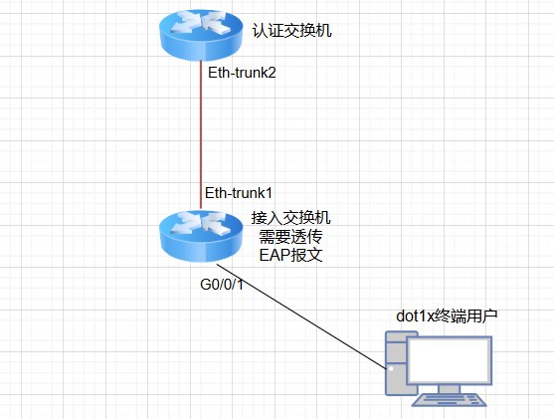

接入交换机配置（非认证交换机）：
l2protocol-tunnel user-defined-protocol dot1x protocol-mac 0180-c200-0003 group-mac 0100-0ccd-0002
#
interface Eth-Trunk1 #上行口，连接认证交换机
mode lacp-static
port link-type trunk
port trunk allow-pass vlan 200
l2protocol-tunnel user-defined-protocol dot1x enable
#
interface GigabitEthernet0/0/10 #下行口，连接终端
l2protocol-tunnel user-defined-protocol dot1x enable
#

认证交换机配置：
radius-server template radius_server_1
radius-server shared-key cipher testing123
radius-server authentication 10.99.7.252 1812
radius-server accounting 10.99.7.252 1813
radius-server authorization 10.99.7.252 shared-key cipher testing123
#
aaa
authentication-scheme authentication_scheme_1
authentication-mode radius
accounting-scheme accounting_scheme_1
accounting-mode radius
domain mydomain1
authentication-scheme authentication_scheme_1
accounting-scheme accounting_scheme_1
radius-server radius_server_1
#
dot1x-access-profile name dot1x_access_profile_1
dot1x authentication-method eap #配置802.1X用户的认证方式为eap，默认就是eap中继认证方式
#非eap中继方式分2种：chap和pap；只有采用RADIUS认证时，才可以配置为EAP中继方式
#
authentication-profile name my_authentication_profile_1
dot1x-access-profile dot1x_access_profile_1
authentication mode multi-authen max-user 500
access-domain mydomain1 force
#
interface Eth-Trunk2 #下行口，连接中间交换机（接入层交换机）
port hybrid untagged vlan 10 to 20 #终端业务vlan
port hybrid tagged vlan 200 #其他vlan，比如AP无线接入点的
authentication-profile my_authentication_profile_1
mode lacp-static
#

#由radius服务器给终端用户分配业务vlan

使用802.1X认证或MAC认证的RADIUS动态授权VLAN功能时，授权信息中含有下发的VLAN属性，设备端在接收到下发的VLAN属性后，会将用户所属的VLAN修改为下发VLAN。授权下发的VLAN的优先级高于用户配置的VLAN，即通过认证后起作用的VLAN是授权下发的VLAN，用户配置的VLAN在用户下线后生效。授权VLAN支持单VLAN或VLAN pool，使用时也需要在设备上提前配置好授权的VLAN。

Radius服务器下发动态VLAN时要求同时下发3个属性，分别是：
64号属性 Tunnel-Type Integer类型，值固定为13
65号属性 Tunnel-Medium-Type Integer类型，值固定为6
81号属性 Tunnel-Private-Group-Id String类型，值为具体的VLAN，也可以是设备上创建的VLAN的description

username2 Cleartext-Password := "userpasswd2"
Service-Type = Administrative-User,
Auth-Type := eap,
Tunnel-Type := 13,
Tunnel-Medium-Type := 6,
Tunnel-Private-Group-Id := "10"

EAP终结方式与EAP中继方式的认证流程相比，不同之处在于：
终结方式：EAP认证方法协商由客户端和设备端完成，之后设备端会把用户信息送给RADIUS服务器，进行相关的认证处理。
EAP中继方式：EAP认证方法协商由客户端和服务器完成，设备端只是负责将EAP报文封装在RADIUS报文中透传认证服务器，整个认证处理都由认证服务器来完成

★第5章、VLAN及STP操作

★创建vlan及查看vlan
[Huawei] vlan 10 #创建vlan 10（建议业务vlan为2到4000）
[Huawei-vlan10] description kefu #此vlan的描述信息
[Huawei-vlan10] quit
[Huawei]
[Huawei] vlan batch 100 101 102 #批量创建vlan
Info: This operation may take a few seconds. Please wait for a moment...done.
[Huawei]
[Huawei] vlan batch 20 to 30 #批量创建vlan（20到30共11个vlan）
Info: This operation may take a few seconds. Please wait for a moment...done.
[Huawei]
[Huawei] disp vlan summary #查看vlan汇总情况
static vlan:
Total 16 static vlan.
1 10 20 to 30 100 to 102

[Huawei] disp port vlan #查看各端口对应的vlan
Port Link Type PVID Trunk VLAN List
-------------------------------------------------------------------------------
Eth-Trunk1 access 1 -
GigabitEthernet2/0/1 auto 1 1-4094
GigabitEthernet2/0/2 auto 1 1-4094
GigabitEthernet2/0/19 trunk 1 1-4094
GigabitEthernet2/0/20 trunk 20 1-2 20 22-23

[Huawei] vlan 10
[Huawei-vlan10] management-vlan #设置vlan10为管理vlan（可选），管理vlan不能添加端口
[Huawei-vlan10]quit

[Huawei] int vlanif 10 #创建SVI三层虚拟接口
[Huawei-Vlanif10] ip address 10.18.1.1 255.255.255.0 #配置ip
[Huawei-Vlanif10] quit

★删除某个vlan
int 目标接口
undo port trunk allow-pass vlan 71 #首先在trunk口里undo要排除的vlan（不允许此vlan通过）
#
undo vlan 71 #删除目标vlan
#
commit
#

★trunk口新增一个允许通过的vlan
port trunk allow-pass vlan 22 23 24 58 33 #在原有配置上追加一个33，
port trunk allow-pass vlan 33 #华为设备可直接添加要新增的那个vlan，原有配置不会被清空
#建议是在原有配置上追加要新放通的vlan，防止某些老旧设备不会自动新增指定的单个vlan，当只写一个vlan时，原有的那些已放通的vlan就被覆盖了。

★二层口模式（access, trunk）
[Huawei] int GigabitEthernet 0/0/5
[Huawei-GigabitEthernet0/0/5] port link-type access #设置端口类型为access
[Huawei-GigabitEthernet0/0/5] port default vlan 20 #将端口加入vlan20
[Huawei-GigabitEthernet0/0/5] quit

[Huawei] interface GigabitEthernet 0/0/1
[Huawei-GigabitEthernet0/0/1] port link-type trunk #设置端口为trunk口
[Huawei-GigabitEthernet0/0/1] port trunk pvid vlan 10 #指定native vlan为10，默认为1
[Huawei-GigabitEthernet0/0/1] port trunk allow-pass vlan all
#华为的trunk口默认只允许vlan1通过，要手动指定允许通过的vlan
[Huawei-GigabitEthernet0/0/1] undo port trunk allow-pass vlan 1 #一般不允许默认vlan 1通过，防止环路
[Huawei-GigabitEthernet0/0/1] quit
[Huawei]

★二层口模式（hybrid）
[Huawei] int GigabitEthernet 0/0/1
[Huawei-GigabitEthernet0/0/1] port link-type hybrid #设置端口为hybrid口
[Huawei-GigabitEthernet0/0/1] port hybrid vlan 1 #允许vlan 1通过，默认就是加入了vlan 1（untagged）
[Huawei-GigabitEthernet0/0/1] port hybrid pvid vlan 10 #native vlan设置为10
[Huawei-GigabitEthernet0/0/1] port hybrid untagged vlan 20 30 #出站时不带标签的vlan
[Huawei-GigabitEthernet0/0/1] port hybrid tagged vlan 40 50 #出站时带标签的vlan
[Huawei-GigabitEthernet0/0/1] port hybrid allow-pass vlan all

★hybrid口特性说明：
接收帧时 | untagged | 打上pvid，如果vlan id在允许通过的列表中，则接收，否则丢弃
接收帧时 | tagged | 如果vlan id在允许通过的列表中，则接收，否则丢弃
发送帧时 | 先检查vlan id是否允许通过，不允许通过则丢弃，允许则：
发送帧时 | untagged | 剥离标签发送
发送帧时 | tagged | 带标签发送

★vlan-mapping（vlan转换）
[Huawei-GigabitEthernet2/0/19] qinq vlan-translation enable
[Huawei-GigabitEthernet2/0/19] port vlan-mapping vlan 20 map-vlan 22
#将入站的vlan tag 20改为22，出站时自动将22转换回20

★QinQ（vlan透传）
802.1Q-in-802.1Q是在802.1Q标签报文的基础上再增加一层802.1Q的Tag来达到隔离VLAN的功能
基本QinQ：对进入二层QinQ接口的所有帧都加上相同的外层vlan Tag。
灵活QinQ：根据不同的内层Tag或符合流分类规则的帧，加上不同的外层vlan Tag，对业务流量进行精细划分。

①基本QinQ配置：
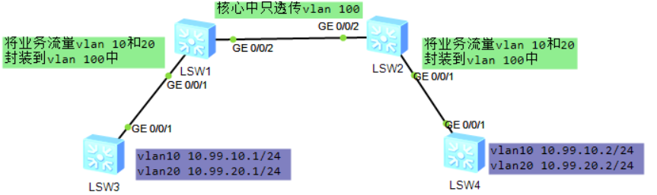
LSW3的GE 0/0/1为trunk口，允许vlan 10 20 通过
LSW4的GE 0/0/1为trunk口，允许vlan 10 20 通过

现在想在核心（LSW1、LSW2）上把业务vlan 10, 20封装起来，封装到vlan 100中进行透明传输（以便和核心上的vlan 10, 20隔离开来）

核心的GE 0/0/2只放通vlan 100，配置省略

LSW1和LSW2的GE 0/0/1配置如下：
[Huawei] int g0/0/1
[Huawei-GigabitEthernet0/0/1] port link-type dot1q-tunnel
[Huawei-GigabitEthernet0/0/1] port default vlan 100 #流量入站时带上外层vlan tag 100，出站时自动剥离
[Huawei-GigabitEthernet0/0/1] quit

②灵活QinQ配置：
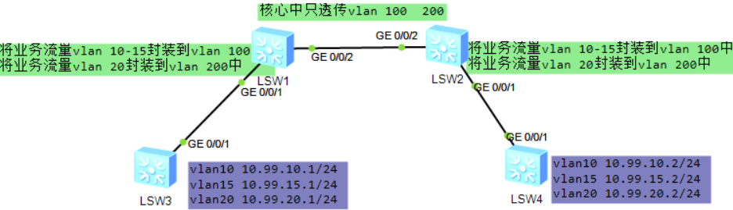

LSW3的GE 0/0/1为trunk口，允许vlan 10 15 20 通过
LSW4的GE 0/0/1为trunk口，允许vlan 10 15 20 通过

现在想在核心（LSW1、LSW2）上把业务vlan 10, 15, 20封装起来，
将vlan 10, 15封装到vlan 100中进行透明传输；将vlan 20封装到vlan 200中进行透明传输

核心的GE 0/0/2只放通vlan 100 200，配置省略

LSW1和LSW2的GE 0/0/1配置如下：
[Huawei] int g0/0/1
[Huawei-GigabitEthernet0/0/1] port link-type hybrid
[Huawei-GigabitEthernet0/0/1] port hybrid untagged vlan 100 200 #流量出站时自动剥离100,200的tag
[Huawei-GigabitEthernet0/0/1] qinq vlan-translation enable
[Huawei-GigabitEthernet0/0/1] port vlan-stacking vlan 10 to 15 stack-vlan 100 #将10-15封装到100
[Huawei-GigabitEthernet0/0/1] port vlan-stacking vlan 20 stack-vlan 200 #将20封装到100
[Huawei-GigabitEthernet0/0/1] quit

★Mux VLAN（主次vlan）
mux VLAN可实现一个大的广播域的分隔以及各广播域内流量的灵活控制
mux将某个大的广播域分隔为主vlan（Principal）及次vlan（Subordinate）
次vlan又分为Group VLAN（互通型从VLAN）和Separate VLAN（隔离型从VLAN）

加入Principal VLAN（主VLAN）的端口，可以与MUX VLAN内的所有端口进行通信
加入Group VLAN（互通型从VLAN）的端口，可以与Principal VLAN的端口互通以及同组内端口互通
加入Separate VLAN（隔离型从VLAN）的端口，可以与Principal VLAN的端口互通（同组内端口不能互通）
拓扑图：
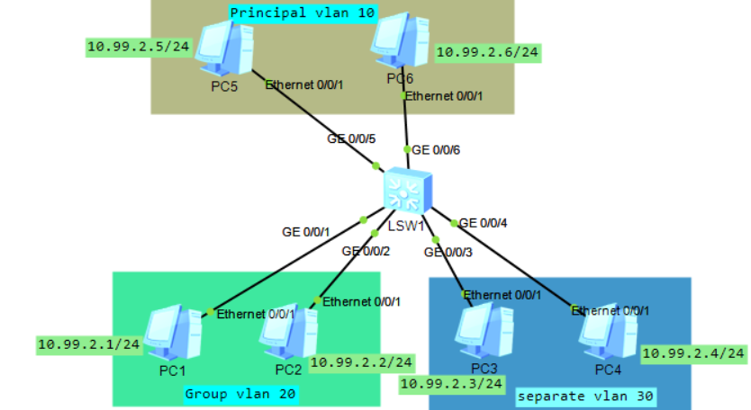

[Huawei] vlan batch 10 20 30
[Huawei] vlan 10
[Huawei-vlan10] mux-vlan
[Huawei-vlan10] subordinate group 20
[Huawei-vlan10] subordinate separate 30

[Huawei] interface GigabitEthernet 0/0/1
[Huawei-GigabitEthernet0/0/1] port link-type access
[Huawei-GigabitEthernet0/0/1] port default vlan 20
[Huawei-GigabitEthernet0/0/1] port mux-vlan enable
[Huawei] interface GigabitEthernet 0/0/2
[Huawei-GigabitEthernet0/0/2] port link-type access
[Huawei-GigabitEthernet0/0/2] port default vlan 20
[Huawei-GigabitEthernet0/0/2] port mux-vlan enable

[Huawei] interface GigabitEthernet 0/0/3
[Huawei-GigabitEthernet0/0/3] port link-type access
[Huawei-GigabitEthernet0/0/3] port default vlan 30
[Huawei-GigabitEthernet0/0/3] port mux-vlan enable
[Huawei] interface GigabitEthernet 0/0/4
[Huawei-GigabitEthernet0/0/4] port link-type access
[Huawei-GigabitEthernet0/0/4] port default vlan 30
[Huawei-GigabitEthernet0/0/4] port mux-vlan enable

[Huawei] interface GigabitEthernet 0/0/5
[Huawei-GigabitEthernet0/0/5] port link-type access
[Huawei-GigabitEthernet0/0/5] port default vlan 10
[Huawei-GigabitEthernet0/0/5] port mux-vlan enable
[Huawei] interface GigabitEthernet 0/0/6
[Huawei-GigabitEthernet0/0/6] port link-type access
[Huawei-GigabitEthernet0/0/6] port default vlan 10
[Huawei-GigabitEthernet0/0/6] port mux-vlan enable

[Huawei] disp vlan
The total number of vlans is : 4
--------------------------------------------------------------------------------
U: Up; D: Down; TG: Tagged; UT: Untagged;
MP: Vlan-mapping; ST: Vlan-stacking;
#: ProtocolTransparent-vlan; *: Management-vlan;
--------------------------------------------------------------------------------
VID Type Ports
--------------------------------------------------------------------------------
1 common UT:GE0/0/7(D) GE0/0/8(D) GE0/0/9(D) GE0/0/10(D)
GE0/0/11(D) GE0/0/12(D) GE0/0/13(D) GE0/0/14(D)
GE0/0/15(D) GE0/0/16(D) GE0/0/17(D) GE0/0/18(D)
GE0/0/19(D) GE0/0/20(D) GE0/0/21(D) GE0/0/22(D)
GE0/0/23(D) GE0/0/24(D)

10 mux UT:GE0/0/5(U) GE0/0/6(U)
20 mux-sub UT:GE0/0/1(U) GE0/0/2(U)
30 mux-sub UT:GE0/0/3(U) GE0/0/4(U)

★Super VLAN（vlan聚合）
super vlan也叫VLAN Aggregation（vlan聚合）
如果每个vlan都要划分一个三层网段的话，会造成ip浪费，或者划分不出这么多数量的子网，这时可以让多个vlan使用同一个ip子网网段（只在二层上隔离，三层上是互通的），假如有多个终端设备，它们的mac地址是相同的，也可以使用super vlan进行隔离。

vlan聚合分为2种类型vlan：
super vlan为管理vlan，可配置三层接口，配置网关ip地址（不可加入端口）需要使能Proxy ARP功能
sub vlan为业务vlan，只可加入业务端口，不可起三层接口，各sub vlan端口之间是二层隔离的，共用一个super vlan的网关
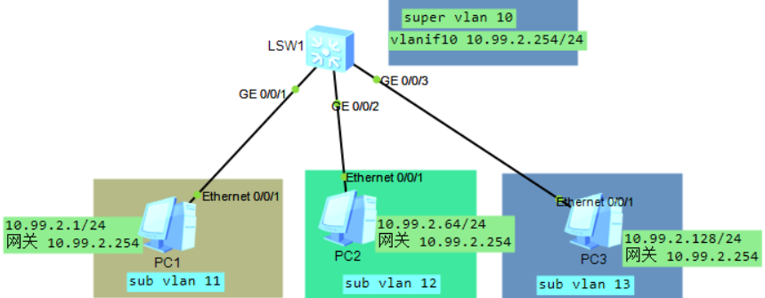

[Huawei] vlan batch 10 to 13
[Huawei] vlan 10
[Huawei-vlan10] aggregate-vlan #将vlan 10设置为super vlan
[Huawei-vlan10] access-vlan 11 to 13 #设置sub vlan
[Huawei-vlan10] quit
[Huawei] int vlanif 10
[Huawei-Vlanif10] ip addr 10.99.2.254 24 #super vlan配置三层接口网关地址
[Huawei-Vlanif10] arp-proxy inner-sub-vlan-proxy enable #开启arp代理功能???
#高版本交换机配置命令为 arp proxy inter-vlan enable

[Huawei] interface GigabitEthernet 0/0/1
[Huawei-GigabitEthernet0/0/1] port link-type access
[Huawei-GigabitEthernet0/0/1] port default vlan 11
[Huawei] interface GigabitEthernet 0/0/2
[Huawei-GigabitEthernet0/0/2] port link-type access
[Huawei-GigabitEthernet0/0/2] port default vlan 12
[Huawei] interface GigabitEthernet 0/0/3
[Huawei-GigabitEthernet0/0/3] port link-type access
[Huawei-GigabitEthernet0/0/3] port default vlan 13

[Huawei] disp vlan
The total number of vlans is : 5
--------------------------------------------------------------------------------
U: Up; D: Down; TG: Tagged; UT: Untagged;
MP: Vlan-mapping; ST: Vlan-stacking;
#: ProtocolTransparent-vlan; *: Management-vlan;
--------------------------------------------------------------------------------
VID Type Ports
--------------------------------------------------------------------------------
1 common UT:GE0/0/4(D) GE0/0/5(D) GE0/0/6(D) GE0/0/7(D)
GE0/0/8(D) GE0/0/9(D) GE0/0/10(D) GE0/0/11(D)
GE0/0/12(D) GE0/0/13(D) GE0/0/14(D) GE0/0/15(D)
GE0/0/16(D) GE0/0/17(D) GE0/0/18(D) GE0/0/19(D)
GE0/0/20(D) GE0/0/21(D) GE0/0/22(D) GE0/0/23(D)
GE0/0/24(D)
10 super
11 sub UT:GE0/0/1(U)
12 sub UT:GE0/0/2(U)
13 sub UT:GE0/0/3(U)

★STP（生成树协议）
生成树协议的作用是防止二层环路，最早使用的是stp协议，后来演进为rstp、mstp等，现在建议在正式环境中只使用MSTP协议，不再建议使用STP/RSTP了，本小节仅供学习原理使用。

[Huawei] stp enable
[Huawei] stp mode stp #stp模式为STP（华为设备默认mstp）可设为stp,rstp,mstp
#在STP/RSTP中，建议手动配置根桥和备份根桥
[Huawei] stp root primary #指定为根桥（优先级为0）
[Huawei] stp root secondary #其他再选一台指定为备份根桥（优先级为4096）
[Huawei] stp priority 61440 # 0~61440，默认32768，可为 0, 4096, 8192,12288 ...
#设置桥优先级，必须为4096的倍数，如果已设置为根桥/备份根桥 则不能再手动指定桥优先级
#对于网络中部分性能低、网络层次低的交换设备，一般会配置其优先级以保证该设备不会成为根桥
#未指定根桥时，将想要成为根桥的设备优先级可配置为4096，指定根桥时，可将其他设备优先级设置为61440

[Huawei] int g0/0/3
[Huawei-GigabitEthernet0/0/3] stp port priority 240 #设置端口的优先级，默认128，必须为16的倍数
# 0~240，可为0, 16, 32, 48......将环路中的某交换设备的端口阻塞从而破除环路，可将其端口优先级设置比缺省值大，使得在选举过程中成为被阻塞的端口。
[Huawei-GigabitEthernet0/0/3] stp cost 200000 #手动指定端口开销
#存在环路的网络环境中，对于链路速率值相对较小的端口，建议将其路径开销值配置相对较大，以使其在生成树算法中被选举成为阻塞端口（反之则设置小值为根端口）

[Huawei] disp stp brief #查看stp基本情况
MSTID Port Role STP State Protection
0 GigabitEthernet0/0/1 DESI FORWARDING NONE
0 GigabitEthernet0/0/3 DESI FORWARDING NONE #根桥
[Huawei2] disp stp brief
MSTID Port Role STP State Protection
0 GigabitEthernet2/0/11 ALTE DISCARDING NONE
0 GigabitEthernet2/0/13 ROOT FORWARDING NONE #设置了小值开销
0 GigabitEthernet2/0/15 DESI FORWARDING NONE

[Huawei2] int GigabitEthernet2/0/15 #进入接口配置界面
[Huawei2-GigabitEthernet2/0/15] stp disable #端口关闭stp协议（不连接交换机的口）

[Huawei2] disp stp int g2/0/11 #查看端口stp信息（开头含网桥stp信息）
CIST RegRoot/IRPC : 61440.60d7-5574-d552 / 0 #本网桥id
Designated Bridge/Port : 0.60d7-5574-fd76 / 128.12 #根桥id及本设备根/指定端口id

*桥ID == 优先级 + MAC地址 #越小越优先
*根端口 本交换机中 到根桥的路径开销最小的端口（一台非根桥设备上只有一个根端口）
*为一对交换机间选指定端口，一条链路（2台交换机之间的）的2个端口，谁到根桥开销小，谁就是指定端口（一台设备可有多个指定端口）

★网桥优先级和端口优先级
网桥优先级和端口优先级都是值越小越优先
网桥优先级默认32768，端口默认优先级128，路径开销算法默认802.1t

★STP端口开销表
端口速率 | 802.1D旧版 | 802.1D-1998开销 | 802.1T/2001开销
10M | 100 | 100 | 2 000 000
100M | 10 | 19(Half) 18(Full) | 200 000
1000M | 1 | 4 | 20 000
10G | 1 | 2 | 2 000
40G | 1 | 1 | 500
100G | 1 | 1 | 200

★指定端口开销算法
[HUAWEI] stp pathcost-standard dot1t
[HUAWEI] stp pathcost-standard ?
dot1d-1998 IEEE 802.1D-1998
dot1t IEEE 802.1T #默认
legacy Legacy
[HUAWEI] stp pathcost-standard dot1t

★超时设置
Forward Delay Time 默认15秒
Hello Time 默认2秒
Max Age Time 默认20秒

★RSTP（快速生成树协议）
基础配置同STP，现在建议在正式环境中只使用MSTP协议，不建议使用STP/RSTP了，本小节仅供学习原理使用。

[Huawei] stp enable
[Huawei] stp mode rstp #stp模式为RSTP（默认mstp）可设为stp,rstp,mstp
#在STP/RSTP中，建议手动配置根桥和备份根桥
[Huawei] stp root primary #指定为根桥
[Huawei] stp root secondary #其他再选一台指定为备份根桥
[Huawei] stp priority 61440 # 0~61440，默认32768，可为 0, 4096, 8192,12288 ...
#设置桥优先级，必须为4096的倍数，如果已设置为根桥/备份根桥 则不能再手动指定桥优先级
#对于网络中部分性能低、网络层次低的交换设备，不适合作为根桥设备，一般会配置其优先级以保证该设备不会成为根桥。
#未指定根桥时，将想要成为根桥的设备优先级可配置为4096，指定根桥时，可将其他设备优先级设置为61440

★RSTP边缘端口配置
[Huawei1] int GigabitEthernet1/0/23
[Huawei1-GigabitEthernet1/0/23] stp edged-port enable #设置为边缘端口
[Huawei1-GigabitEthernet1/0/23] stp bpdu-filter enable #开启bpdu报文过滤
#配置为边缘端口后，端口仍然会发送BPDU报文，这可能导致BPDU报文发送到其他网络，使其他网络产生震荡。因此可以配置边缘端口的BPDU报文过滤功能，使边缘端口不处理、不发送BPDU报文。

★开启BPDU保护功能
[Huawei1] stp bpdu-protection
[Huawei1] error-down auto-recovery cause bpdu-protection interval 180
#开启bpdu保护后，如果边缘端口收到bpdu报文入站，则error-down，可配置error-down自动恢复

★开启TC保护功能
[Huawei1] stp tc-protection interval 10 #默认为hello time时间，2秒
[Huawei1] stp tc-protection threshold 5 #默认为1个报文
#如果在单位时间内，交换设备在收到TC BPDU报文数量大于配置的阈值，那么设备只会处理阈值指定的次数。

★开启根保护功能
[Huawei1] int g1/0/18 #仅在指定端口上配置
[Huawei1-GigabitEthernet1/0/18] stp root-protection
#开启根保护的端口不可以再配置环路保护，根保护功能只能在指定端口上配置生效

★开启环路保护
[Huawei1] int g1/0/20 #交换机的根端口及Alternate端口上都要开启
[Huawei1-GigabitEthernet1/0/20] stp loop-protection
#开启环路保护的端口不可再配置根保护，环路保护功能只能在根端口或Alternate端口上配置生效

★RSTP点对点链路
与点对点链路相连的两个端口如果为根端口或者指定端口，则端口可以通过传送同步报文（Proposal报文和Agreement报文）快速迁移到转发状态，减少了不必要的转发延迟时间。
[Huawei2] int GigabitEthernet2/0/15 #进入端口
[Huawei2-GigabitEthernet2/0/15] stp point-to-point force-true #配置为点对点链路

★端口不使用增强的快速迁移机制
[Huawei1] int g1/0/18 #进入参与stp协议计算的端口
[Huawei1-GEt1/0/18] stp no-agreement-check #端口使用普通的快速迁移方式，默认使用增强的快速迁移机制

[Huawei1] display stp topology-change #查看stp拓扑变化统计信息
CIST topology change information
Number of topology changes : 3
Time since last topology change : 0 days 0h:18m:13s
Topology change initiator(notified) :GigabitEthernet1/0/13
Topology change last received from :60d7-5574-d552
Number of generated topologychange traps : 2
Number of suppressed topologychange traps: 0

★STP/RSTP超时时间
[Huawei2] disp stp global #先查看STP全局配置信息
Protocol Status : Enabled
Bpdu-filter default : Disabled
Tc-protection : Enabled
Tc-protection threshold : 1
Tc-protection interval : 2s
Edged port default : Disabled
Pathcost-standard : Dot1t
Timer-factor : 3 #默认3
Transmit-limit : 6
Bridge-diameter : 7 #直径7
-------[CIST Global Info][Mode RSTP]-------
CIST Bridge : 61440.60d7-5574-d552 #本网桥id
Config Times :Hello 2s MaxAge 20s FwDly 15s MaxHop 20
Active Times :Hello 2s MaxAge 20s FwDly 15s MaxHop 20
CIST Root/ERPC :0 .60d7-5574-fd76 / 2000
CIST RegRoot/IRPC :61440.60d7-5574-d552 / 0
CIST RootPortId :16.14 (GigabitEthernet2/0/13) #本设备的根端口
BPDU-Protection :Disabled
TC or TCN received :252
TC count per hello :0
STP Converge Mode :Normal
Share region-configuration :Enabled
Time since last TC :0 days 0h:4m:1s
Number of TC :92
Last TC occurred :GigabitEthernet2/0/13

[Huawei1] stp bridge-diameter 7 #设置stp网络直径，2~7，默认7，值越大表示网络直径越大
值为2时： Active Times :Hello 2s MaxAge 10s FwDly 7s MaxHop 20
值为3时： Active Times :Hello 2s MaxAge 12s FwDly 9s MaxHop 20
默认值7时： Active Times :Hello 2s MaxAge 20s FwDly 15s MaxHop 20

★如果设备在超时时间（超时时间＝Hello Time × 3 × Timer Factor）内没有收到上游设备发送的BPDU，则生成树会重新进行计算。
[Huawei2] stp timer-factor 3 # 1~10，默认3倍

*建议配置网络直径，而不是直接修改超时时间

*根交换设备的Hello Time、Forward Delay以及Max Age三个时间参数取值之间应该满足如下公式，否则网络会频繁震荡：
• 2 × (Forward Delay － 1 second) >= Max Age
• Max Age >= 2 × (Hello Time + 1 second)

[Huawei1] stp timer forward-delay 1500 #15秒，单位10毫秒，取值400~3000
[Huawei1] stp timer hello 200 #2秒，单位10毫秒，取值100~1000
[Huawei1] stp timer max-age 2000 #20秒，单位10毫秒，取值600~4000

★华为与思科互通rstp
[Huawei1-GigabitEthernet1/0/18] stp compliance dot1s
#在自适应模式下，本端口收到对端的报文，本端能够解析且转发此报文
[Huawei1-GigabitEthernet1/0/18] stp config-digest-snoop
#使能摘要侦听功能可以使交换机的BPDU报文密钥与其他设备制造商设备的BPDU报文密钥一致。

•如果其他厂商设备运行标准的STP/RSTP协议，交换机均可与之对接。
•如果其他厂商设备运行非标准STP/RSTP协议（cisco的pvst除外），部分交换机可在端口下配置stp disable、bpdu enable、l2protocol-tunnel enable命令实现与该厂商设备STP/RSTP报文透传。
•对cisco设备，如果起了pvst，交换机现有版本无法参与协商计算，但是可以透传报文

★MSTP（多生成树协议）
[Huawei] stp enable
[Huawei] stp mode mstp #配置为MSTP模式
[Huawei] stp region-configuration #进入mstp配置模式
[Huawei-mst-region] region-name mstp1 #设置mstp域名为mstp1
[Huawei-mst-region] revision-level 1 #设置修定级别为1
[Huawei-mst-region] instance 1 vlan 1 to 3 #实例与vlan绑定
[Huawei-mst-region] instance 2 vlan 9 to 11 #默认所有未指定的vlan处于instance 0
[Huawei-mst-region] active region-configuration #激活mstp域配置
Info: This operation may take a few seconds. Please wait for a moment...done.
[Huawei-mst-region]

[Huawei] stp instance 1 priority 4096 #设置本交换机的实例1的桥优先级
[Huawei] stp instance 0 root primary #将本交换机指定为实例0的根
[Huawei] disp stp region-configuration #查看mstp域配置
Oper configuration
Format selector :0
Region name :mstp1
Revision level :1
Instance VLANs Mapped
0 4 to 8, 12 to 4094
1 1 to 3
2 9 to 11
[Huawei]

[Huawei] disp stp region-configuration digest #查看mstp域配置的md5消息摘要
Oper configuration
Format selector :0
Region name :mstp1
Revision level :1
Digest :0xCBEA249445F4933BA4ADE3DFE74D536A #只有域配置消息摘要相同的交换机才处于同一个mstp区域中

[Huawei] disp stp global #查看mstp全局信息

<Huawei1> disp stp brief #查看各实例各端口角色状态
MSTID Port Role STP State Protection
0 GigabitEthernet1/0/7 ROOT FORWARDING NONE
0 GigabitEthernet1/0/11 ALTE DISCARDING NONE
0 GigabitEthernet1/0/17 ALTE DISCARDING NONE
1 GigabitEthernet1/0/7 DESI FORWARDING NONE
1 GigabitEthernet1/0/17 DESI FORWARDING NONE
2 GigabitEthernet1/0/11 ROOT FORWARDING NONE
#可知这台交换机在mst实例1为根桥，实例0和2为指定桥

[Huawei] int g0/0/2
[Huawei-GigabitEthernet0/0/2] stp edged-port enable #设置为边缘端口
[Huawei-GigabitEthernet0/0/2] quit
[Huawei] int g0/0/3
[Huawei-GigabitEthernet0/0/3] stp loop-protection #指定桥的根端口开启环路保护
[Huawei-GigabitEthernet0/0/3] quit
[Huawei] int g0/0/4
[Huawei-GigabitEthernet0/0/4] stp root-protection #指定端口上开启根保护
[Huawei-GigabitEthernet0/0/4] quit
[Huawei] stp bpdu-protection #全局下所有边缘端口开启BPDU防护
[Huawei] stp flush disable #全局下配置，当设备MSTP进程0或VBST收到TC BPDU报文后不会删除mac表项（如果mac表项错误则可能造成长时间断流，需谨慎配置）

★VBST（基于vlan的生成树协议）
VBST（VLAN-Based Spanning Tree）是华为私有协议，基于vlan的生成树协议，可在每个vlan上运行STP或RSTP
VBST协议中BID（Bridge-ID）长8字节，由桥优先级（Bridge Priority）、VLAN ID与桥MAC地址构成。
桥优先级数值+VLAN ID占据前面16位，后面的48位是MAC地址。
*桥ID == （优先级 + VLAN ID） 及 MAC地址 #越小越优先
在VBST网络中，桥ID最小的设备会被选举为根桥。

VBST通过在VLAN内传递VBST报文来确定网络拓扑结构。VBST报文基于STP/RSTP报文，但相对STP/RSTP报文，VBST报文在源MAC地址字段和协议长度字段之间加入了四字节的802.1q Tag

VBST报文目的mac地址为0100-0CCC-CCCD
VBST报文中的Data字段依据对接设备填充标准RSTP/STP报文的Data内容，默认填充标准RSTP报文

VBST与标准协议STP/RSTP互通
Trunk口 | VBST设备和RSTP设备对接时，在VLAN1内，VBST设备使用标准的RSTP报文与对端交互，其他VLAN内使用填充RSTP Data的VBST报文与对端交互  VBST设备和STP设备对接时，在VLAN1内，VBST设备使用标准的STP报文与对端交互，其他VLAN内使用填充STP Data的VBST报文与对端交互
Access口 | VBST设备将只根据此端口所在的VLAN使用标准的STP报文（对接STP设备）或RSTP报文（对接RSTP设备）与对端交互。这样，拓扑计算将按照STP/RSTP协议进行，STP/RSTP协议不区分VLAN，所以最终形成一棵各VLAN共享的生成树

VBST与思科PVST协议互通
Trunk口 | VBST设备和Rapid PVST+设备对接时，在VLAN1中，VBST设备使用标准的RSTP报文与对端交互（也会同时发填充RSTP Data的VBST报文），其他VLAN内使用RSTP Data填充的VBST报文与对端交互。  VBST设备和PVST+设备对接时，在VLAN1中，VBST设备使用标准的STP报文与对端交互（也会同时发填充STP Data的VBST报文），其他VLAN内使用STP Data填充的VBST报文与对端交互。  VBST设备和PVST设备对接时，报文交互跟VBST与PVST+对接类似。区别在于，在VLAN1中，VBST设备和PVST设备之间只发送填充STP Data的VBST报文交互。
Access口 | VBST设备将只根据此端口所在VLAN使用标准的STP（对接PVST/PVST+设备）或RSTP（对接Rapid PVST+设备）报文与对端交互。这样，拓扑计算将按照STP/RSTP协议进行，由于STP/RSTP协议不区分VLAN，所以最终形成一棵各VLAN共享的生成树

[Huawei] stp enable
[Huawei] stp mode vbst
[Huawei] stp vlan 10 root primary #将设备设置为vlan 10的根桥
[Huawei] stp vlan 20 root secondary #将设备设置为vlan 20的备份根桥
[Huawei] stp vlan 30 priority 61440 #指定设备在vlan 30的桥优先级
[Huawei] int g0/0/4
[HUAWEI-GigabitEthernet0/0/4] stp vlan 10 port priority 16 #配置端口在指定vlan中的优先级

[HUAWEI-GigabitEthernet0/0/4] stp vlan 10 cost 20000 #配置端口在指定vlan中的端口开销
[HUAWEI-GigabitEthernet0/0/4] stp vlan 20 cost 40000

[HUAWEI] disp stp vlan 10 brief #查看vlan 10情况
VLAN-ID Port Role STP State Protection
10 GigabitEthernet0/0/5 DESI FORWARDING NONE

[HUAWEI] disp stp vlan 20 #查看vlan 20情况
-------[VLAN 20 Global Info][Mode VBST]-------
Bridge ID :4116 .60d7-5574-fd76 # 桥ID中的4116==优先级4096 + VLAN 20
Bridge Diameter :7
Config Times :Hello 2s MaxAge 20s FwDly 15s
Active Times :Hello 2s MaxAge 20s FwDly 15s
Root ID / RPC :4116 .60d7-5574-fd76 / 0 (This bridge is the root)
RootPortId :0.0
Root Type :Secondary

[HUAWEI] int g0/0/22
[HUAWEI-GigabitEthernet0/0/22] stp edged-port enable #配置为边缘端口
[HUAWEI-GigabitEthernet0/0/22] stp bpdu-filter enable #过滤bpdu报文
#某端口配置为边缘端口后，默认仍然会发送BPDU报文，这可能导致BPDU报文发送到其他网络，引起其他网络产生震荡。可以配置边缘端口的BPDU报文过滤功能，使边缘端口不处理、不发送BPDU报文

★第6章、ARP及MAC相关命令

★ARP操作
<Huawei> disp arp #查看ARP表
# IP地址 MAC地址 过期时间（分钟） 类型 接口 vpn实例 vlan
IP ADDRESS MAC ADDRESS EXPIRE(M) TYPE INTERFACE VPN-INSTANCE VLAN
----------------------------------------------------------------------------------
10.1.1.1 4c1f-ccb2-5fd9 I - Vlanif1
10.1.1.3 4c1f-cc28-6616 20 D-0 GE0/0/1 1
10.1.1.2 4c1f-cc6f-0dba 20 D-0 GE0/0/2 1
----------------------------------------------------------------------------------
Total:3 Dynamic:2 Static:0 Interface:1
<Huawei> reset arp dynamic ip 10.1.1.99 #清除某个动态arp记录（因为老化时间默认20分钟太久了）
<Huawei> reset arp dynamic ip 10.1.22.99 vpn-instance xxx #清除某个动态arp记录

[Huawei] arp static 10.1.1.3 4c1f-cc28-6616 #添加静态arp条目

[Huawei] int vlan 1
[Huawei-Vlanif1] arp-proxy enable #在vlan接口上开启arp代理
[Huawei-Vlanif1] arp-proxy enable anyway #在vlan接口上开启arp代理

[Huawei] arp gratuitous-arp send enable #开启免费arp功能
[Huawei] arp gratuitous-arp send interval 20 #免费arp发包周期为20秒

[Huawei] arp speed-limit source-mac maximum 50 #限制arp发包速率为50个每秒
[Huawei] arp speed-limit source-mac 4c1f-cc28-6616 maximum 5 #限制指定源mac的arp发包速率

[Huawei] int vlan 1
[Huawei-Vlanif1] arp expire-time 180 #设置arp老化时间为180秒，默认是20分钟
[Huawei-Vlanif1] arp time-out 30 #设置arp老化时间为30秒（新设备配置方式）
[Huawei] arp constant-send enable #如果arp老化时间配置为30秒，则需要全局开启constant-send

#ARP防攻击配置
[Huawei] arp ip-conflict-detect enable #开启ip地址冲突检测
[Huawei] disp arp ip-conflict track #查看ip冲突记录
Conflict type : Local IP conflict
IP address : 10.99.100.1
System time : 2024-08-12 07:15:35+08:00
Conflict count : 4
Suppress count : 3
Local interface : Vlanif1
Receive interface : GE0/0/12
Receive VLAN/CEVLAN : 1/0
Receive MAC : 000e-c66b-ce6f

[Huawei] arp anti-attack gateway-duplicate enable #开启ARP防网关冲突攻击功能，默认未开启
[Huawei] display arp anti-attack configuration gateway-duplicate #查看ARP防攻击配置是否开启
[Huawei] display arp anti-attack gateway-duplicate item #查看ARP防攻击之网关冲突项
Interface IP address MAC address VLANID Aging time
--------------------------------------------------------------------------------
GigabitEthernet0/0/12 10.99.100.1 000e-c66b-ce6f 1 145
--------------------------------------------------------------------------------
The number of record(s) in gateway conflict table is 1

[Huawei] arp anti-attack rate-limit enable #开启arp报文限速功能
[Huawei] arp anti-attack rate-limit packet 120 interval 1 #默认每秒100个包，interval单位：秒
[Huawei] disp arp anti-attack configuration arp-rate-limit #查看ARP防攻击之报文限速
ARP rate-limit configuration:
--------------------------------------------------------------------------------
Global configuration:
arp anti-attack rate-limit enable
arp anti-attack rate-limit packet 120 interval 1
Interface configuration:
VLAN configuration:
--------------------------------------------------------------------------------

★MAC操作
[Huawei] disp mac-address #查看mac地址表
MAC address table of slot 0:
MAC Address VLAN/VSI/BD Learned-From Type
-------------------------------------------------------------------------------
60d7-5574-fd76 1/-/- GE2/0/15 sticky
94c6-915c-9bff 1/-/- GE2/0/23 dynamic
Total matching items on slot 0 displayed = 2
[Huawei]
[Huawei] mac-address aging-time 300 #设置mac老化时间，默认为300秒
[Huawei] mac-address static 4c1f-cc28-6616 g0/0/3 vlan 1 #添加静态mac条目
[Huawei]
[Huawei] mac-address blackhole 4c1f-cc28-992f vlan 1 #黑洞mac，设备直接丢弃源mac/目的mac为此黑洞mac的报文
[Huawei]

★IPv6-ND

<HUAWEI> disp ipv6 neighbors brief #查看ipv6邻居
D-Dynamic,S-Static,R-Remote
I-INCMP,R-REACH,S-STALE,D-DELAY,P-PROBE
-----------------------------------------------------------------
IPv6 Address Link-layer State Type Interface
-----------------------------------------------------------------
FD00:1234::12 707b-e8bb-13b4 R D GE1/0/1
FD00:1234::FF01 707b-e864-7cdf S D GE1/0/1
FD00:1234::FFFF 0000-5e00-0201 S D GE1/0/1
FE80::727B:E8FF:FE64:7CDF 707b-e864-7cdf R D GE1/0/1
-----------------------------------------------------------------
Total: 4 Dynamic: 4 Static: 0 Remote: 0

<HUAWEI> reset ipv6 neighbors Vlanif 1 #清除ipv6邻居信息

★第7章、DHCP配置

★DHCP服务配置
[Huawei] dhcp enable #全局开启dhcp服务

[Huawei] int vlanif 1
[Huawei-Vlanif1] ip addr 10.1.1.1 255.255.255.0 #先配置vlanif的IP
[Huawei-Vlanif1] dhcp select global #dhcp配置信息使用本地全局的地址池
[Huawei-Vlanif1] quit

[Huawei] ip pool vlan1 #创建一个名为vlan1的ip地址池
[Huawei-ip-pool-vlan1] gateway-list 10.1.1.1 #网关为10.1.1.1
[Huawei-ip-pool-vlan1] network 10.1.1.0 mask 255.255.255.0 #配置网络
[Huawei-ip-pool-vlan1] excluded-ip-address 10.1.1.2 10.1.1.10 #排除地址，不分配10.1.1.2~10
[Huawei-ip-pool-vlan1] lease day 5 hour 4 minute 0 #租期为5天4小时0分钟，默认为1天
[Huawei-ip-pool-vlan1] dns-list 10.1.1.20 114.114.114.114 #dns列表
[Huawei-ip-pool-vlan1] static-bind ip-address 10.1.1.99 mac-address 1418-7709-2fd8
#给目标主机分配固定的IP地址（通过mac地址去匹配）
[Huawei-ip-pool-vlan1] bootfile undionly.kpxe #使用此引导文件
[Huawei-ip-pool-vlan1] next-server 10.99.1.2 #引导文件从这个地址获取
[Huawei-ip-pool-vlan1] option 43 hex HHHHHHHH #下发option 43配置，还可为其他option，以及使用ascii或hex格式配置数据
[Huawei-ip-pool-vlan1] quit

#配置ip地址冲突探测
[Huawei] dhcp server ping packet 2 #下发ip配置之前先对要下发的地址进行ping检测是否已存在
[Huawei] dhcp server ping timeout 2000 #ping检测超时，单位：毫秒，默认500毫秒

#配置DHCP报文限速
[Huawei] int vlanif 1
[Huawei-Vlanif1] dhcp check dhcp-rate enable #开启dhcp报文限速功能
[Huawei-Vlanif1] dhcp check dhcp-rate 50 #将dhcp报文限制为50pps，默认是100pps

[Huawei] disp dhcp statistics #查看dhcp报文收发情况
[Huawei] disp ip pool name vlan1 #查看地址池vlan1的信息，IP分配情况等
Pool-name : vlan1
VPN instance : --
-----------------------------------------------------------------------------
Start End Total Used Idle(Expired) Conflict Disable
-----------------------------------------------------------------------------
10.1.1.1 10.1.1.254 253 1 243(0) 0 9
-----------------------------------------------------------------------------
[Huawei]
<Huawei> reset ip pool name vlan1 ? #收回分配的IP地址，可以是某个范围，也可以是全部收回
X.X.X.X Start IP address
all All IP address
conflict Conflict IP address
expired Expired IP address
used Used IP address

★dhcp-server使用接口上配置的信息
直接在接口上配置dhcp server相关信息（不使用ip pool）
interface GigabitEthernet0/0/1 #三层物理接口，也可以是vlanif接口
undo portswitch
ip address 10.99.100.1 255.255.255.0
dhcp select interface
dhcp server ip-range 10.99.100.10 10.99.100.240 #分配的ip地址范围
dhcp server lease day 5 hour 4 minute 0
dhcp server dns-list 10.99.114.114
dhcp server static-bind ip-address 10.99.100.2 mac-address 1023-4567-89ab
dhcp server option 43 sub-option 3 ascii 10.99.248.12
#

★DHCP中继
[Huawei] int vlan1
[Huawei-Vlanif1] dhcp select relay #配置DHCP模式为中继
[Huawei-Vlanif1] dhcp relay server-ip 10.2.2.33 #配置中继服务器（本交换机收到的dhcp请求报文交给指定的dhcp服务器处理（单播转发））
[Huawei-GE0/0/1.100] arp broadcast enable #在子接口上配置dhcp中继时需开启此功能，终结子接口的ARP广播功能

★DHCP保存地址分配信息
[Huawei] dhcp server database enable #开启保存地址分配信息的服务

[Huawei] dhcp server database recover #使用单一文件保存
[Huawei] dhcp server database write-delay 300 #每分配一个地址后延迟300秒再保存（默认是7200秒）
[Huawei] disp dhcp server database #查看database信息
Status: enable
Recover from files after reboot: enable
File saving lease items: flash:/dhcp/lease.txt #分配信息保存的文件
File saving conflict items: flash:/dhcp/conflict.txt #地址冲突信息保存的文件
Save Interval: 300 (seconds)
[Huawei]

★DHCP Snooping
[Huawei] dhcp snooping enable #开启dhcp snooping

[Huawei] int g0/0/1
[Huawei-GigabitEthernet0/0/1] dhcp snooping enable #接口上开启dhcp snooping，开启后默认是非信任口
[Huawei-GigabitEthernet0/0/1] dhcp snooping trusted #上联口一定要设置为信任口（上联口接dhcp server）
[Huawei-GigabitEthernet0/0/1] quit

[Huawei] int g0/0/3 #所有下联口，接终端机的，都要开启dhcp snooping（防止有终端伪装为dhcp server）
[Huawei-GigabitEthernet0/0/3] dhcp snooping enable #接终端设备的端口上开启dhcp snooping
[Huawei-GigabitEthernet0/0/3] dhcp snooping check dhcp-chaddr #检查客户端报文中的Chaddr字段内容是否和客户端的mac地址一致
[Huawei-GigabitEthernet0/0/3] dhcp snooping sticky-mac #根据DHCP Snooping绑定表生成静态MAC表项
[Huawei-GigabitEthernet0/0/3] quit

[Huawei] vlan 1
[Huawei-vlan1] ip source check user-bind enable #在vlan上应用ip-mac绑定过滤策略后，只有由交换机分配的ip和对应的mac包才允许进入

[Huawei] disp dhcp snooping user-bind all #查看dhcp snooping绑定信息

★第8章、ACL访问控制列表

acl number | 类型 | ip协议 | 匹配对象
2000~2999 | 基本acl | ipv4, ipv6 | 源ip
3000~3999 | 扩展acl | ipv4, ipv6 | 源ip、目的ip；tcp/udp的源port、目的port；IP上层协议号
4000~4999 | 二层acl |  | mac地址，vlanID

★ipv4 ACL及基础应用
★华为的设备，缺省时最后有一条规则是permit any，必要时请在末尾添加一条规则deny any
[Huawei] acl number 2000 #创建基本acl
[Huawei-acl-basic-2000] rule 1 permit source 10.1.1.0 0.0.0.255 #匹配源网段，反掩码（通配符掩码）
[Huawei-acl-basic-2000] rule 10 permit source 10.1.2.22 0 #匹配源ip，掩码为0（或者0.0.0.0）
[Huawei-acl-basic-2000] quit

[Huawei] acl number 3000 #创建扩展 acl
[Huawei-acl-adv-3000] rule 1 permit ip source 10.1.1.0 0.0.0.255 destination 10.18.0.0 0.0.255.255
# ip地址匹配时，只能用反掩码
[Huawei-acl-adv-3000] rule 5 permit tcp source 10.0.0.0 0.255.255.255 source-port eq 40 destination any
destination-port range 10 99
[Huawei-acl-adv-3000] rule 10 permit vpn-instance vpn实例名称 其他配置 #配置vpn实例
[Huawei-acl-adv-3000] quit

[Huawei] acl number 4000 #创建二层acl
[Huawei-acl-L2-4000] rule 1 permit source-mac 4c1f-cc28-6616 ffff-ffff-ffff destination-mac 4c1f-cc28-6617
ffff-ffff-ffff #匹配mac地址时，使用正掩码，全f表示匹配单个mac
[Huawei-acl-L2-4000] quit

[Huawei] int g0/0/9
[Huawei-GigabitEthernet0/0/9] traffic-filter inbound acl 2000 #应用acl到接口上，起到流量过滤的作用
[Huawei-GigabitEthernet0/0/9] traffic-filter acl 2000 inbound #同上
[Huawei-GigabitEthernet0/0/9] quit

★ipv6 ACL及基础应用
[Huawei] acl ipv6 2001
[Huawei-acl6-basic-2001] rule 1 permit source FC00:10::1 128 #128为ipv6前缀长度，正掩码长度
[Huawei-acl6-basic-2001] rule 2047 deny

[Huawei] int g0/0/11
[Huawei-GigabitEthernet0/0/11] traffic-filter inbound acl ipv6 2001 #应用acl到接口上
[Huawei-GigabitEthernet0/0/11] traffic-filter ipv6 acl 2001 inbound #同上
[Huawei-GigabitEthernet0/0/11] quit
[Huawei] disp traffic-statistics inbound acl ipv6 2001

★注意：
如果新增规则时不指定rule序号，则默认规则号以当前最大的rule序号加1-5，就近向5的倍数靠齐
比如：
当前最大的rule序号为25，则新增的规则号取30
当前最大的rule序号为21，则新增的规则号取25（离21最近的5的倍数为25）

★ACL应用时间
首先要确认交换机时间和现实的时间同步
[Huawei] time-range time1 from 18:00 2019/12/04 to 23:00 2019/12/06 #匹配一段时间
[Huawei] time-range time2 10:00 to 15:30 daily #匹配一个周期，每天的某个时段
[Huawei] time-range time3 15:00 to 19:30 ? #也可以是指定的星期几
<0-6> Day of the week(0 is Sunday)
Fri Friday
Mon Monday
Sat Saturday
Sun Sunday
Thu Thursday
Tue Tuesday
Wed Wednesday
daily Every day of the week
off-day Saturday and Sunday
working-day Monday to Friday

★通配符掩码
wildcard通配符掩码中的0表示检查相应的位（bit），严格检查；1表示不检查相应的位
即：
0.0.0.255 00000000 00000000 00000000 11111111 表示前24位要求严格匹配，后8位任意匹配（不检查）
0.0.6.0 00000000 00000000 00000110 00000000 表示22，23位任意匹配，其他的bit严格匹配

★ACL应用注意事项
在交换机上应用acl时，关于in / out方向的解释：
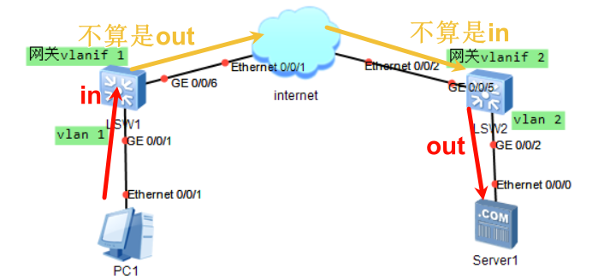
假如接入vlan 1的PC1（ip为10.1.1.1）要访问外部某服务器Server1，
PC1发来的报文要先发给网关vlanif 1，则在LSW1设备上对于vlanif 1而言就是入站（可在in方向做acl）
而vlanif 1收到报文后，要走路由层转发给下一跳设备，★int vlanif 1把报文交给路由层处理的话，不能算是out
★报文经过路由转发到LSW2设备进行路由时不能算是in入站（收到的报文是从路由层转来的，对于vlanif而言不算in）
vlanif 2把外部转来的报文发给本vlan里的主机Server1时，才算out出站（可在out方向做acl）

所以：
从本vlan下的主机发报文给本vlanif接口进行路由转发，算in方向，
从vlanif发报文给本vlan下的主机算out方向，
而经过路由转发的报文，不论是发过来，还是发出去，都不能算是in/out方向

同理，如果报文只是经过此vlan的某2个端口，不发给此vlan的vlanif接口的话，就没有in，也没有out，在vlanif上无法做acl的匹配。而大多数交换机只支持在vlanif接口上应用acl访问控制列表，所以这种情况就没法控制报文了。

而有些高级型号的设备支持在端口上应用acl，直接在端口上应用in/out方向的访问策略，这时的in就是进入交换机的流量，out就是从交换机发出的流量。不考虑是否经过vlanif处理了。

★第9章、设备高可用配置

★VRRP（虚拟路由冗余协议）
VRRP只有advertisment报文，报文传播使用组播地址224.0.0.18，vrrp报文封装在IP报文中，上层协议号为118
Virtual Router（虚拟ip）对应的mac地址为0000-5E00-01-vrid
vrrp设备优先级默认为100，（取值范围0-255）数值越大越优先。
拓扑图：
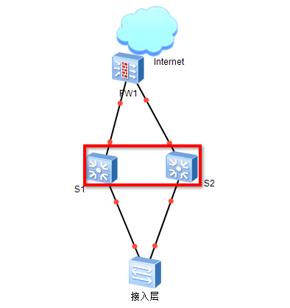
S1（10.10.1.252）和S2（10.10.1.253）虚拟成一个网关（10.10.1.254）vlan10
S1上的配置如下：
[Huawei] vrrp virtual-ip ping enable #允许ping虚拟网关，必须在配置vrrp之前开启
[Huawei] int vlanif 10
[Huawei-Vlanif10] ip add 10.10.1.252 255.255.255.0
[Huawei-Vlanif10] vrrp vrid 10 virtual-ip 10.10.1.254 #虚拟网关ip
[Huawei-Vlanif10] vrrp vrid 10 priority 120 #优先级为120，目的是让其成为master
[Huawei-Vlanif10] vrrp vrid 10 track int g0/0/2 reduced 30
#如果上联口断了则降低优先级，优先级减30，变成备份的
[Huawei-Vlanif10] vrrp vrid 10 track nqa admin test reduced 30
#如果nqa检测失败则降低优先级，优先级减30，变成备份的
[Huawei-Vlanif10] vrrp vrid 10 track bfd session-name s1_to_s2 reduced 30
#如果bfd检测失败则降低优先级，优先级减30，变成备份的
[Huawei-Vlanif10] vrrp vrid 10 track ip route 10.99.8.0 255.255.255.0 reduced 30
#如果路由检测失败则降低优先级，优先级减30，变成备份的（可写多个track，优先级可叠加降低）

[Huawei-Vlanif10] vrrp vrid 10 preempt-mode timer delay 5 #抢占延迟时间设为5秒
[Huawei-Vlanif10] vrrp vrid 10 preempt-mode disable #关闭抢占模式，如果关闭抢占，track检测失败时优先级仍会下降，只是关闭了抢占模式的设备不会抢Master角色，未配置关闭抢占模式的设备仍会抢占。
[Huawei-Vlanif10] quit
[Huawei] vrrp gratuitous-arp timeout 30 #设置vrrp的免费arp发送周期，30秒

[Huawei] disp vrrp brief #查看vrrp信息
VRID State Interface Type Virtual IP
----------------------------------------------------------------
10 Initialize Vlanif10 Normal 10.10.1.254

★VRRPv3
ipv4的VRRP版本为v2， VRRPv3支持ipv4及ipv6（但是，华为的设备，ipv4及ipv6的vrrp要分开配置，ipv4用vrrp v2，ipv6用vrrp v3）
vrrp v3的advertisment报文源地址使用链路本地地址FE80::xxxx
advertisment报文目的地址使用组播地址FF02::12，vrrp报文封装在IPv6中，Next Header为112
ipv6虚拟ip对应的mac地址为0000-5E00-02-vrid

#实验：VRRPv3-ipv6_ce12800
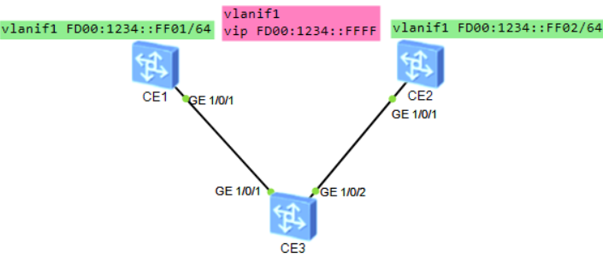

CE1配置：
interface Vlanif1
ipv6 enable
ipv6 address FD00:1234::FF01/64
vrrp6 vrid 1 virtual-ip FE80::1 link-local #vrrp6中第1个vip必须是链路本地地址
vrrp6 vrid 1 virtual-ip FD00:1234::FFFF #唯一本地地址的vip
vrrp6 vrid 1 priority 120 #默认优先级为100，越大越优先
vrrp6 vrid 1 preempt disable
#

CE2配置：
interface Vlanif1
ipv6 enable
ipv6 address FD00:1234::FF02/64
vrrp6 vrid 1 virtual-ip FE80::1 link-local
vrrp6 vrid 1 virtual-ip FD00:1234::FFFF
vrrp6 vrid 1 preempt disable
#

CE1查看：
<HUAWEI> disp vrrp6 1 verbose #查看vrrp6的vrid 1的详情
Vlanif1 | Virtual Router 1
State : Master
Virtual IP : FE80::1
FD00:1234::FFFF
Master IP : FE80::727B:E8FF:FE64:7CDF #VRRP宣告报文中使用此ip为源地址
PriorityRun : 120
PriorityConfig : 120
MasterPriority : 120
Preempt : NO
Hold Multiplier : 3
TimerRun : 100cs
TimerConfig : 100cs
Virtual MAC : 0000-5e00-0201
Check Hop Limit : YES
Config Type : Normal
Create Time : 2024-08-10 22:05:53
Last Change Time : 2024-08-10 22:06:15

CE2查看：
<HUAWEI> disp ipv6 neighbors brief
D-Dynamic,S-Static,R-Remote
I-INCMP,R-REACH,S-STALE,D-DELAY,P-PROBE
-----------------------------------------------------------------
IPv6 Address Link-layer State Type Interface
-----------------------------------------------------------------
FD00:1234::FF01 707b-e864-7cdf R D GE1/0/1
FD00:1234::FFFF 0000-5e00-0201 R D GE1/0/1
-----------------------------------------------------------------
Total: 2 Dynamic: 2 Static: 0 Remote: 0

★iStack堆叠（设备虚拟化）
本章节以S5735型号交换机为例
不同型号交换机具体的配置命令不太一样，需要查看相应的产品配置手册，但大概思路是一致的

#交换机1
[HUAWEI] stack slot 0 renumber 1 #设置当前slot id为1，重启后生效，未重启时当前仍为slot 0
Warning: All the configurations related to the slot ID will be lost after the slot ID is modified.
Do not frequently modify the slot ID because it will make the stack split. Continue? [Y/N]: y #输入y确认
[HUAWEI] stack slot 0 priority 150 #当前设备堆叠优先级，1~255，默认100，越大越优先
Warning: Do not frequently modify the priority because it will make the stack split. Continue? [Y/N]: y #输入y确认
[HUAWEI]
[HUAWEI] interface stack-port 0/1 #创建堆叠逻辑口（slot-id/stack-port，slot-id为0，stack-port取值为1~2）
[HUAWEI-stack-port0/1] port interface g0/0/23 to g0/0/24 enable
#加入物理成员口；S6720-EI、S6720S-EI设备上的XGE端口从左边开始，每4个为一组（例如，1～4为一组，2～5不能作为一组，即从第1个口开始按顺序每4个口为一组），如果将每组内的任意一个接口配置为堆叠物理成员端口，则同组内的另外三个端口下的配置将会丢失，且不能作为普通的业务口来使用。
Warning: Enabling stack function may cause config loss on the interface. Continue? [Y/N]: y #输入y确认
配置为stack口后，原来配置的信息会丢失，端口将默认开启（由于交换机2还未配置，所以链路仍未UP）
[HUAWEI-stack-port0/1] shutdown interface g0/0/23 to g0/0/24 #先关闭堆叠口
[HUAWEI-stack-port0/1]quit
[HUAWEI] quit
<HUAWEI> disp stack configuration #查看堆叠配置
<HUAWEI> save
<HUAWEI> reboot

<HUAWEI> disp stack
Stack mode: Service-port
Stack topology type: Link
Stack system MAC: 60d7-5574-fd76
MAC switch delay time: 10 min
Stack reserved VLAN: 4093
Slot of the active management port: --
Slot Role MAC Address Priority Device Type
-------------------------------------------------------------
1 Master 60d7-5574-fd76 150 S5735S-L24T4S-A

<HUAWEI> disp stack configuration #查看堆叠配置
---------------Configuration on slot 1 Begin---------------
stack enable
stack slot 0 renumber 1
stack slot 1 priority 150
stack reserved-vlan 4093
stack timer mac-address switch-delay 10

interface stack-port 1/1
port interface GigabitEthernet1/0/23 enable
port interface GigabitEthernet1/0/24 enable

interface stack-port 1/2
---------------Configuration on slot 1 End-----------------

#交换机2
[HUAWEI] stack slot 0 renumber 2 #设置当前slot id为2，重启后生效
Warning: All the configurations related to the slot ID will be lost after the slot ID is modified.
Do not frequently modify the slot ID because it will make the stack split. Continue? [Y/N]: y
[HUAWEI] stack slot 0 priority 100 #设备当前设备堆叠优先级，1~255，默认100，越大越优先
Warning: Do not frequently modify the priority because it will make the stack split. Continue? [Y/N]: y
[HUAWEI]
[HUAWEI] interface stack-port 0/2 #创建堆叠逻辑口（stack-port号要和邻居不同（链路对端的）
[HUAWEI-stack-port0/2] port interface g0/0/23 to g0/0/24 enable #加入物理成员口
Warning: Enabling stack function may cause config loss on the interface. Continue? [Y/N]: y
[HUAWEI-stack-port0/2]quit
[HUAWEI] quit
<HUAWEI> disp stack configuration #查看堆叠配置
<HUAWEI> save
<HUAWEI> reboot #等交换机1差不多启动了（大概5分钟）再重启交换机2
在交换机2重启过程中（或者已经重启完成后），登录交换机1，将堆叠口开启（undo shut）
交换机1#
[HUAWEI] interface stack-port 0/1
[HUAWEI-stack-port0/1] undo shutdown interface g0/0/23 to g0/0/24 #打开堆叠口
#链路连接后，开始进行stack协商，首先会比较启动时间，启动时间差在20秒内才会进行优先级的比较，如果启动时间差大于20秒，则最先启动的设备会成为主设备（Master）
注意：
在交换机2重启过程中（未完全启动时），若交换机1打开了堆叠口，则交换机2在启动时就会选举为standby角色，且不会再重启；
若交换机2启动完成后，才打开交换机1的堆叠口，则竞选完成后的备设备（交换机2），会再次重启！

<HUAWEI> disp stack #查看堆叠信息（成员交换机的主机名都是Master原先的主机名）
Stack mode: Service-port
Stack topology type: Link
Stack system MAC: 60d7-5574-fd76
MAC switch delay time: 10 min
Stack reserved VLAN: 4093
Slot of the active management port: --
Slot Role MAC Address Priority Device Type
-------------------------------------------------------------
1 Master 60d7-5574-fd76 150 S5735S-L24T4S-A
2 Standby 60d7-5574-d552 100 S5735S-L24T4S-A

<HUAWEI> disp stack channel all #查看stack通道（物理口信息）
! : Port have received packets with CRC error.
L-Port: Logic stack port
P-Port: Physical port
Slot L-Port P-Port Speed State || P-Port Speed State L-Port Slot
---------------------------------------------------------------------------------------
1 1/1 GE1/0/23 1G UP GE2/0/23 1G UP 2/2 2
1 1/1 GE1/0/24 1G UP GE2/0/24 1G UP 2/2 2
2 2/2 GE2/0/23 1G UP GE1/0/23 1G UP 1/1 1
2 2/2 GE2/0/24 1G UP GE1/0/24 1G UP 1/1 1
---------------------------------------------------------------------------------------

★堆叠创建后的配置文件
<HUAWEI> dir ?
/all List all files
/all-filesystems List files on all filesystems
STRING [drive][path][file name]
flash: Device name #master设备的磁盘
slot2#flash: Device name #standby设备的磁盘
<cr>

<HUAWEI> disp startup #查看各自的启动文件配置情况，
saved-configuration配置文件会同步使用Master设备的
system software系统文件不会同步，各自使用各自设备原来的

#其他配置

★stack物理成员口退出逻辑口
[switch2] interface stack-port 2/1
[switch2-stack-port2/1] shutdown interface g2/0/23 to gt2/0/24
[switch2-stack-port2/1] undo port interface g2/0/23 to g2/0/24 enable
Warning: Deleting member ports may cause stack split and a loss of all config on the interface. Continue? [Y/N]: y
#注意：S6720-EI、S6720S-EI设备上的XGE端口从左边开始，每4个为一组（例如，1～4为一组，2～5不能作为一组，即从第1个口开始按顺序每4个口为一组），如果将每组内的任意一个接口配置为堆叠物理成员端口，则同组内的另外三个端口下的配置将会丢失，且不能作为普通的业务口来使用。

★升级堆叠（平滑升级）
<Huawei> startup system-software flash:/s5735-new-test.cc slot 2 #指定下次启动的系统文件
<Huawei> startup system-software flash:/s5735-new-test.cc all #Master设备上要有此文件，会自动同步到其他成员设备，升级后的系统也要支持平滑升级

[Huawei] upgrade backup-area slot 2 to 2 #配置backup区域的设备（不能含有Master设备）
[Huawei] disp upgrade area
Slot Area Upgrade-Check
------------------------------------
1 active passed
2 backup passed

[Huawei] upgrade start #开始平滑升级（先升级backup区域的）
[Huawei] disp upgrade state #查看平滑升级状态

★堆叠口CRC校验
有些高级系列型号设备堆叠后，堆叠口可以配置crc校验，链路中出现坏包，丢包时shutdown此接口，切换到备份链路上
interface g1/0/1
port crc-statistics trigger error-down
#
trap-threshold crc-statistics #配置crc错误报文告警阈值和告警时间间隔

# error-down auto-recovery cause crc-statistics interval 300 #接口自动恢复
# display error-down recovery #查看接口自动恢复信息

★堆叠系统mac地址切换设置
[HUAWEI] stack timer mac-address switch-delay 10 #设置堆叠系统mac地址切换时间，单位：分钟，默认是10分钟，配置为0表示不切换mac地址
Warning: Do not frequently modify the MAC switching time because it will make the stack split. Continue? [Y/N]:y
[HUAWEI] undo stack timer mac-address switch-delay #表示立即切换
Warning: Do not frequently modify the MAC switching time because it will make the stack split. Continue? [Y/N]:y

★直连接口多主检测
由于MAD报文是BPDU报文，如果直连检测链路上存在中间设备，则中间设备上需要配置转发BPDU报文
接口配置直连方法多主检测功能后，STP端口状态会变成Discarding，会影响数据报文的转发和某些协议报文的上送，所以不要在此接口上再配置其他业务
直连检测方式只能配置于二层以太物理端口上，且端口必须为UP状态
[HUAWEI] int Eth-Trunk 1
[HUAWEI-Eth-Trunk1] mad detect mode direct

★代理多主检测
堆叠成员设备都连到一台代理交换机上
堆叠成员交换机侧配置：
[HUAWEI] int Eth-Trunk 1
[HUAWEI-Eth-Trunk1] mad detect mode relay
代理交换机侧配置：
[HUAWEI] int Eth-Trunk 1
[HUAWEI-Eth-Trunk1] mad relay

多主检测发现堆叠分裂，分裂后的多个堆叠系统之间会进行相互竞争，为防止相同的MAC地址、IP地址引起网络振荡，竞争失败的堆叠系统内成员交换机的所有业务端口会被关闭，以减少对网络的影响。
堆叠分裂后，MAD冲突处理机制使用MAD报文进行MAD竞争，竞争结果为：堆叠系统处于Detect状态或者Recovery状态：
Detect：竞争成功，堆叠系统将处于正常工作状态
Recovery：竞争失败，堆叠系统将状态处于禁用状态，关闭除手动配置的保留端口以外的其它所有物理端口
如果有部分端口仅做报文透传功能，出现堆叠分裂后，这部分端口不会影响网络运行。用户如果希望保留这些端口的业务，可以通过命令将这些端口配置为保留端口。堆叠分裂后，多主检测功能不会关闭保留端口的业务。
缺省情况下，堆叠物理成员端口为保留端口，其它所有业务口均为非保留端口。
堆叠分裂后，用于双主检测的端口也会被关闭
[HUAWEI] mad exclude interface g0/0/8 to g0/0/9 #配置为保留端口
[HUAWEI] mad exclude interface g0/0/12 #可配置多行

[HUAWEI] disp mad verbose #查看mad双主检测情况
Current MAD domain: 0
Current MAD status: Detect
Mad direct detect interfaces configured:
Mad relay detect interfaces configured:
Excluded ports(configurable):
GigabitEthernet0/0/8
GigabitEthernet0/0/9
GigabitEthernet0/0/12
Excluded ports(can not be configured):

★主备切换
<HUAWEI> display switchover state #查看堆叠系统是否满足主备倒换的条件
Slot 1 HA FSM State(master): realtime or routine backup. #只有处于该状态时才可以主备倒换
Slot 2 HA FSM State(slave): receiving realtime or routine data.
[HUAWEI] slave switchover enable #开启堆叠主备倒换功能（默认已开启）
[HUAWEI] slave switchover #主备切换，原理是重启现在的Master设备，使其变为备节点（既然是重启master设备，为何不直接在master上执行reboot重启呢？原因是，堆叠系统任意一台设备上，执行reboot后，都是重启所有成员设备，所以不能使用reboot命令重启某台成员设备，但可以使用reset slot xx命令）
Warning: This operation will switch the slave board to the master board. Continue?[Y/N]:y #输入y确定
Switching...........................................................................OK
This board has been switched slave successfully, and it will be reset!
[HUAWEI]
The stack-port 2 turned to down at 2024-08-12 00:31:07
Slot 2 switched to the master at 2024-08-12 00:31:07.280+08:00

Update Old master 1 unregistered.
Info: IPC Connection time is 0ms.
<HUAWEI>

<SW1> disp stack
Stack mode: Service-port
Stack topology type: Link
Stack system MAC: 60d7-5574-fd76
MAC switch delay time: 10 min
Stack reserved VLAN: 4093
Slot of the active management port: --
Slot Role MAC Address Priority Device Type
-------------------------------------------------------------
1 Standby 60d7-5574-fd76 150 S5735S-L24T4S-A
2 Master 60d7-5574-d552 100 S5735S-L24T4S-A

★重启堆叠中某台设备
<Huawei> reset slot 1 #重启堆叠中某台设备
Warning: Confirm to reset slot 1? [Y/N]:y #输入y确定
Info: The board 1 is reset successfully.

★堆叠分裂后重组
堆叠由于某种原因导致分裂（可能是堆叠线断开了），分裂后的2个堆叠都是Master，现在又将堆叠线重新连接，它们各自的Master节点会比较启动时间：
大于20秒时，启动时间最长的为新的Master，
小于20秒时，根据优先级进行选举新的Master。
重组后的堆叠非Master节点会重启！
（假如现在要让设备1为重组后的Master设备，设备2为重组后的standby设备，但设备2的启动时间比设备1的启动时间久，所以需要先手动重启设备2，再连接堆叠线）

★将某台成员移出堆叠
[HUAWEI] stack slot 2 renumber 0 #将当前slot id为2的设备重新设置为slot id 0
Warning: All the configurations related to the slot ID will be lost after the slot ID is modified.
Do not frequently modify the slot ID because it will make the stack split. Continue? [Y/N]:y #输入y确定
Info: Stack configuration has been changed, and the device needs to restart to make the configuration effective.
[HUAWEI] interface stack-port 2/1
[HUAWEI-stack-port2/1] shutdown interface g2/0/23 to gt2/0/24 #关闭堆叠成员口
此时，2号设备会独立出来，从console口单独登录2号设备进行剩余配置：
[HUAWEI] interface stack-port 2/1
[HUAWEI-stack-port2/1] undo port interface g2/0/23 to g2/0/24 enable #移除堆叠成员口
Warning: Deleting member ports may cause stack split and a loss of all config on the interface. Continue? [Y/N]: y
<Huawei> save
最后，拔掉2号设备的堆叠线，再重启2号设备

★删除堆叠（撤销整个堆叠）
[Huawei1] reset stack configuration #删除整个堆叠配置，谨慎操作
Warning: This operation will clear all stack configurations and may lead to the loss of the slot ID configuration and cause the device to reset immediately. Are you sure you want to continue? [Y/N]: y #输入y确定
Info: This operation may take a few seconds. Please wait....
Info: System is rebooting, please wait...
解除堆叠后，所有成员设备，都会恢复为master的配置，slot id恢复为0，要手动再次清理管理及业务配置，防止ip冲突

★M-LAG跨设备端口聚合
M-LAG（Multichassis Link Aggregation Group）即跨设备链路聚合组，是一种横向虚拟化技术，将双归接入的两台设备在逻辑上虚拟成一台设备。M-LAG本身提供了一个没有环路的二层拓扑同时实现冗余备份，极大的简化了组网及配置。
M-LAG有2种配置方式：
根桥方式 | M-LAG主设备和备设备均作为STP网络中的根桥且配置相同的桥ID，将两台设备模拟成同一个根桥，M-LAG主备设备在二层网络中不受其他组网变化的影响
V-STP方式 | V-STP（Virtual Spanning Tree Protocol）是二层拓扑管理特性，其核心思想是将两台设备的STP协议虚拟成一台设备的STP协议，对外呈现为一台设备进行STP协议计算，v-stp仅支持stp或rstp模式（不支持mstp及vbst）

#根桥方式配置过程

①配置根桥和桥ID
stp mode mstp
stp instance 0 root primary
stp bridge-address 0000-0000-0001 #两台M-LAG设备的桥MAC必须相同，可以选择其中一台设备的系统MAC作为两台设备共同桥MAC（display system mac-address查看系统mac）
stp bpdu-protection
stp tc-protection
#

②创建DAD心跳口的vpn实例
ip vpn-instance vpn_DAD #创建DAD的VRF，建议将DAD的网络单独划分为一个VRF
ipv4-family
#

③配置DFS Group
dfs-group 1 #2台设备的dfs group id要一致，才能配对成功
priority 150 #数值越大越优先，默认为100；值相同则设备系统mac小的优先
source ip vpn-instance vpn_DAD 10.99.9.1 peer 10.99.9.2
dual-active detection enhanced enable
#dual-active detection source ip 10.99.9.1 vpn-instance vpn_DAD peer 10.99.9.2 #上面2行合为一行
authentication-mode hmac-sha256 password xxxxx #指定dfs-group同步报文所使用的验证模式及口令
m-lag up-delay 240 auto-recovery interval 0 #设置延迟up时间为240秒，延迟自动恢复时间为0秒，默认up-delay为240秒，auto-recovery interval为0秒
vbdif mac-address advertise disable #从对端同步过来的vbdif接口的MAC地址不发布到VXLAN远端设备，默认会通过evpn发布
vbdif mac-address synchronization disable #配置vbdif的系统MAC地址不通过M-LAG同步到对端，默认会
vlanif mac-address synchronization disable #配置vlanif的系统MAC地址不通过M-LAG同步到对端，默认会
#

④配置DAD心跳检测口
interface Eth-Trunk0 #DAD口配置（Dual Active Detection双主检测）三层口
description M-LAG_DAD_port
undo portswitch
ip binding vpn-instance vpn_DAD
ip address 10.99.9.1 255.255.255.252
mode lacp-static
m-lag unpaired-port reserved #在peer-link故障但双主检测正常时不被Error-Down，主备设备上相同的接口都要配置；该命令不支持在peer-link接口、M-LAG成员口下配置
trunkport GE1/0/1
trunkport GE1/0/2
#

⑤配置peer-link
interface Eth-Trunk100 #peer-link口配置，二层口
description M-LAG_peer-link_port
undo stp enable #peer-link口在根桥模式下要关闭stp（因为2端设备要模拟成同一个stp根桥，需要保证设备直连接口不会被阻塞），默认是开启了stp的
mode lacp-static #为了提高M-LAG的可靠性，必须配置为静态LACP模式
peer-link 1 #配置为peer-link接口
port vlan exclude 10 to 20 #配置peer-link口不允许通过的vlan，peer-link口为二层口，默认允许所有vlan通过。如果有配置vlanif三层口ip做双主检测，建议将此vlan从peer-link排除出去，防止心跳检测失效
trunkport GE1/0/3
trunkport GE1/0/4
#

⑥创建业务口
interface Eth-Trunk9
mode lacp-static
port link-type access
port default vlan 100
dfs-group 1 m-lag 9 #m-lag后面的数字，在主备2台设备上的相同聚合口上要保持一致
trunkport GE1/0/9
#

#查看
[Huawei] display dfs-group 1 m-lag #查看DFS Group编号为1的M-LAG信息
[Huawei] display dfs-group 1 node 1 m-lag brief #查看node1的m-lag信息
[Huawei] disp dfs-group 1 peer-link #查看peer-link口状态
[Huawei] disp dfs-group 1 heartbeat #查看DAD心跳口状态
[Huawei] disp dfs-group 1 #查看dfs-group信息
[Huawei] display fei m-lag synchronization packet statistics #查看同步信息报文统计
[HUAWEI] disp dfs packet statistics

★如果配置了m-lag，且在主备2台设备上配置了vrrp，则主备2边的vrrp状态都是Master（主），这是正常的

实验：M-LAG_V-STP_CE（ensp_pro）
（ensp_pro模拟器从V100R002C10开始，其CE交换机支持m-lag了）
拓扑如下：
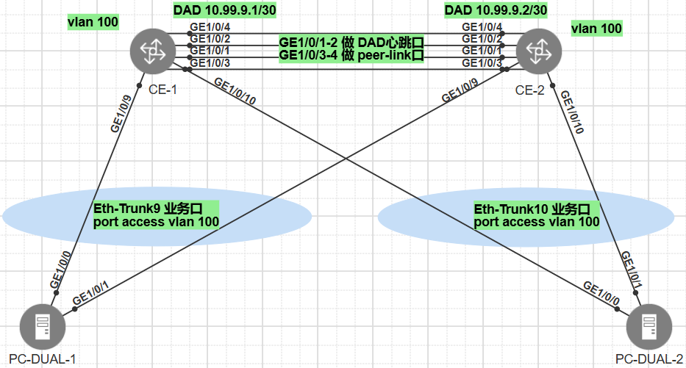

CE-1配置：
dfs-group 1
dual-active detection source ip 10.99.9.1 vpn-instance vpn_DAD peer 10.99.9.2
priority 150
#
vlan batch 100
#
stp bridge-address 0000-0000-0001
stp instance 0 root primary
stp bpdu-protection
stp tc-protection
#
ip vpn-instance vpn_DAD
ipv4-family
#
vlan 100
#
interface Eth-Trunk0
undo portswitch
description M-LAG_DAD_port
ip binding vpn-instance vpn_DAD
ip address 10.99.9.1 255.255.255.252
mode lacp-static
m-lag unpaired-port reserved
#
interface Eth-Trunk9
port default vlan 100
mode lacp-static
dfs-group 1 m-lag 9
#
interface Eth-Trunk10
port default vlan 100
mode lacp-static
dfs-group 1 m-lag 10
#
interface Eth-Trunk100
description M-LAG_peer-link_port
stp disable
mode lacp-static
peer-link 1
#
interface GE1/0/1
eth-trunk 0
#
interface GE1/0/2
eth-trunk 0
#
interface GE1/0/3
eth-trunk 100
#
interface GE1/0/4
eth-trunk 100
#
interface GE1/0/9
eth-trunk 9
#
interface GE1/0/10
eth-trunk 10
#

CE-2配置：
dfs-group 1
dual-active detection source ip 10.99.9.2 vpn-instance vpn_DAD peer 10.99.9.1
priority 120
#
vlan batch 100
#
stp bridge-address 0000-0000-0001
stp instance 0 root primary
stp bpdu-protection
stp tc-protection
#
ip vpn-instance vpn_DAD
ipv4-family
#
vlan 100
#
interface Eth-Trunk0
undo portswitch
description M-LAG_DAD_port
ip binding vpn-instance vpn_DAD
ip address 10.99.9.2 255.255.255.252
mode lacp-static
m-lag unpaired-port reserved
#
interface Eth-Trunk9
port default vlan 100
mode lacp-static
dfs-group 1 m-lag 9
#
interface Eth-Trunk10
port default vlan 100
mode lacp-static
dfs-group 1 m-lag 10
#
interface Eth-Trunk100
description M-LAG_peer-link_port
stp disable
mode lacp-static
peer-link 1
#
interface GE1/0/1
eth-trunk 0
#
interface GE1/0/2
eth-trunk 0
#
interface GE1/0/3
eth-trunk 100
#
interface GE1/0/4
eth-trunk 100
#
interface GE1/0/9
eth-trunk 9
#
interface GE1/0/10
eth-trunk 10
#

CE-1查看：
[Huawei] display dfs-group 1 m-lag #查看DFS Group编号为1的M-LAG信息
* : Local node
Heart beat state : OK
Node 1 *
Dfs-Group ID : 1
Priority : 150
Dual-active Address : 10.99.9.1
VPN-Instance : vpn_DAD
State : Master
Causation : -
System ID : fa4b-893b-0011
SysName : HUAWEI
Version : V300R024C10SPC500
Device Type : CE
Node 2
Dfs-Group ID : 1
Priority : 120
Dual-active Address : 10.99.9.1
VPN-Instance : vpn_DAD
State : Backup
Causation : -
System ID : fa4b-893b-0021
SysName : HUAWEI
Version : V300R024C10SPC500
Device Type : CE
[Huawei] display dfs-group 1 node 1 m-lag brief #查看node1的m-lag信息
* - Local node

M-Lag ID Interface Mode Port State Status Consistency-check
9 Eth-Trunk 9 active-active Up active(*)-active --
10 Eth-Trunk 10 active-active Up active(*)-active --
[Huawei] disp dfs-group 1 peer-link #查看peer-link口状态
Peer-link information
-----------------------------------------------------------------
Total Interface(s): 1
Peer-link Id : 1
Port Name : Eth-Trunk100
Port State : Up
Link Type : Physical link
-----------------------------------------------------------------
[Huawei] disp dfs-group 1 heartbeat #查看DAD心跳口状态
--------------------------------------------------------------------------------
Heart beat status : OK
Local:
Dfs-Group ID : 1
Priority : 150
Udp port : 1025
Dual-active Address : 10.99.9.1
VPN-Instance : vpn_DAD
System ID : fa4b-893b-0011
Heart beat state : Master
Peer:
Dfs-Group ID : 1
Priority : 120
Udp port : 1025
Dual-active Address : 10.99.9.2
VPN-Instance : vpn_DAD
System ID : fa4b-893b-0021
Heart beat state : Backup
--------------------------------------------------------------------------------

[Huawei] disp dfs-group 1 #查看dfs-group信息
Dfs-Group ID : 1
Priority : 150
Dual-active Address : 10.99.9.1
VPN-Instance : vpn_DAD
System ID : fa4b-893b-0011
SysName : HUAWEI
Up-delay/Interval : 240/0
Switch-delay : 0

Configuration consistency check: --

#V-STP方式配置过程
①配置V-STP
stp mode rstp
stp v-stp enable #建议使用v-stp模式
stp bridge-address 0000-0000-0001 #两台M-LAG设备的桥MAC必须相同，可以选择其中一台设备的系统MAC作为两台设备共同桥MAC（display system mac-address查看系统mac）
stp bpdu-protection
stp tc-protection
#

②创建DAD心跳口的vpn实例
ip vpn-instance vpn_DAD #创建DAD的VRF，建议将DAD的网络单独划分为一个VRF
ipv4-family
#

③配置DFS Group
dfs-group 1 #2台设备的dfs group id要一致，才能配对成功
priority 150 #数值越大越优先，默认为100；值相同则设备系统mac小的优先
source ip vpn-instance vpn_DAD 10.99.9.1 peer 10.99.9.2
dual-active detection enhanced enable
#dual-active detection source ip 10.99.9.1 vpn-instance vpn_DAD peer 10.99.9.2 #上面2行合为一行
authentication-mode hmac-sha256 password xxxxx #指定dfs-group同步报文所使用的验证模式及口令
m-lag up-delay 240 auto-recovery interval 0 #设置延迟up时间为240秒，延迟自动恢复时间为0秒，默认up-delay为240秒，auto-recovery interval为0秒
vbdif mac-address advertise disable #从对端同步过来的vbdif接口的MAC地址不发布到VXLAN远端设备，默认会通过evpn发布
vbdif mac-address synchronization disable #配置vbdif的系统MAC地址不通过M-LAG同步到对端，默认会
vlanif mac-address synchronization disable #配置vlanif的系统MAC地址不通过M-LAG同步到对端，默认会
#

④配置DAD心跳检测口
interface Eth-Trunk0 #DAD口配置（Dual Active Detection双主检测）三层口
description M-LAG_DAD_port
undo portswitch
ip binding vpn-instance vpn_DAD
ip address 10.99.9.1 255.255.255.252
mode lacp-static
m-lag unpaired-port reserved #在peer-link故障但双主检测正常时不被Error-Down，主备设备上相同的接口都要配置；该命令不支持在peer-link接口、M-LAG成员口下配置
trunkport GE1/0/1
trunkport GE1/0/2
#

⑤配置peer-link
interface Eth-Trunk100 #peer-link口配置，二层口
description M-LAG_peer-link_port
stp enable #peer-link口在v-stp模式下要开启stp（默认已开启）
mode lacp-static #为了提高M-LAG的可靠性，必须配置为静态LACP模式
peer-link 1 #配置为peer-link接口
port vlan exclude 10 to 20 #配置peer-link口不允许通过的vlan，peer-link口为二层口，默认允许所有vlan通过。如果有配置vlanif三层口ip做双主检测，建议将此vlan从peer-link排除出去，防止心跳检测失效
trunkport GE1/0/3
trunkport GE1/0/4
#

⑥创建业务口
interface Eth-Trunk9
mode lacp-static
port link-type access
port default vlan 100
dfs-group 1 m-lag 9 #m-lag后面的数字，在主备2台设备上的相同聚合口上要保持一致
trunkport GE1/0/9
#

#查看
[Huawei] display dfs-group 1 m-lag #查看DFS Group编号为1的M-LAG信息
[Huawei] display dfs-group 1 node 1 m-lag brief #查看node1的m-lag信息
[Huawei] disp dfs-group 1 peer-link #查看peer-link口状态
[Huawei] disp dfs-group 1 heartbeat #查看DAD心跳口状态
[Huawei] disp dfs-group 1 #查看dfs-group信息
[Huawei] display fei m-lag synchronization packet statistics #查看同步信息报文统计
[HUAWEI] disp dfs packet statistics

★如果配置了m-lag，且在主备2台设备上配置了vrrp，则主备2边的vrrp状态都是Master（主），这是正常的

实验：M-LAG_V-STP_CE（ensp_pro）
（ensp_pro模拟器从V100R002C10开始，其CE交换机支持m-lag了）
拓扑如下：
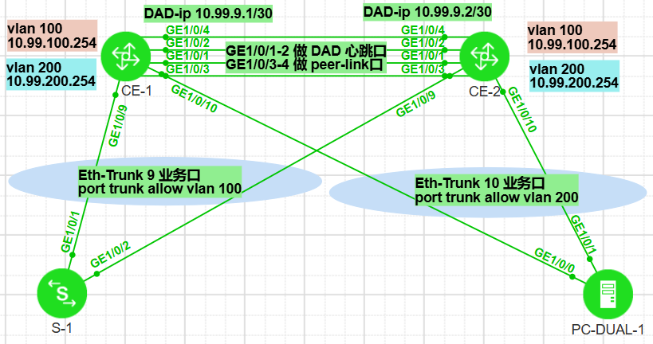

CE-1配置：
dfs-group 1
authentication-mode hmac-sha256 password xxxxx
dual-active detection source ip 10.99.9.1 vpn-instance vpn_DAD peer 10.99.9.2
priority 150
#
vlan batch 100 200
#
stp bridge-address 0000-0000-0001
stp mode rstp
stp v-stp enable
stp bpdu-protection
stp tc-protection
#
ip vpn-instance vpn_DAD
ipv4-family
route-distinguisher 99:10
vpn-target 99:10 export-extcommunity
vpn-target 99:10 import-extcommunity
#
interface Vlanif100
ip address 10.99.100.254 255.255.255.0
mac-address 0000-5e00-0101
#
interface Vlanif200
ip address 10.99.200.254 255.255.255.0
mac-address 0000-5e00-0101
#
interface Eth-Trunk0
undo portswitch
description M-LAG_DAD_port
ip binding vpn-instance vpn_DAD
ip address 10.99.9.1 255.255.255.252
mode lacp-static
#
interface Eth-Trunk9
port link-type trunk
port trunk allow-pass vlan 100
mode lacp-static
dfs-group 1 m-lag 9
#
interface Eth-Trunk10
port default vlan 200
mode lacp-static
dfs-group 1 m-lag 10
#
interface Eth-Trunk100
description M-LAG_peer-link_port
mode lacp-static
peer-link 1
#
interface GE1/0/1
eth-trunk 0
#
interface GE1/0/2
eth-trunk 0
#
interface GE1/0/3
eth-trunk 100
#
interface GE1/0/4
eth-trunk 100
#
interface GE1/0/9
eth-trunk 9
#
interface GE1/0/10
eth-trunk 10
#

CE-2配置：
dfs-group 1
authentication-mode hmac-sha256 password xxxxxx
dual-active detection source ip 10.99.9.2 vpn-instance vpn_DAD peer 10.99.9.1
priority 120
#
vlan batch 100 200
#
stp bridge-address 0000-0000-0001
stp mode rstp
stp v-stp enable
stp bpdu-protection
stp tc-protection
#
ip vpn-instance vpn_DAD
ipv4-family
route-distinguisher 99:10
vpn-target 99:10 export-extcommunity
vpn-target 99:10 import-extcommunity
#
interface Vlanif100
ip address 10.99.100.254 255.255.255.0
mac-address 0000-5e00-0101
#
interface Vlanif200
ip address 10.99.200.254 255.255.255.0
mac-address 0000-5e00-0101
#
interface Eth-Trunk0
undo portswitch
description M-LAG_DAD_port
ip binding vpn-instance vpn_DAD
ip address 10.99.9.2 255.255.255.252
mode lacp-static
#
interface Eth-Trunk9
port link-type trunk
port trunk allow-pass vlan 100
mode lacp-static
dfs-group 1 m-lag 9
#
interface Eth-Trunk10
port default vlan 200
mode lacp-static
dfs-group 1 m-lag 10
#
interface Eth-Trunk100
description M-LAG_peer-link_port
mode lacp-static
peer-link 1
#
interface GE1/0/1
eth-trunk 0
#
interface GE1/0/2
eth-trunk 0
#
interface GE1/0/3
eth-trunk 100
#
interface GE1/0/4
eth-trunk 100
#
interface GE1/0/9
eth-trunk 9
#
interface GE1/0/10
eth-trunk 10
#

CE-1查看：
[Huawei] display dfs-group 1 m-lag
* : Local node
Heart beat state : OK
Node 1 *
Dfs-Group ID : 1
Priority : 150
Dual-active Address : 10.99.9.1
VPN-Instance : vpn_DAD
State : Master
Causation : -
System ID : faf1-294b-0011
SysName : HUAWEI
Version : V300R024C10SPC500
Device Type : CE6866-48S8CQ-P
Node 2
Dfs-Group ID : 1
Priority : 120
Dual-active Address : 10.99.9.2
VPN-Instance : vpn_DAD
State : Backup
Causation : -
System ID : faf1-294b-0021
SysName : HUAWEI
Version : V300R024C10SPC500
Device Type : CE6866-48S8CQ-P

[Huawei] display dfs-group 1 node 1 m-lag brief
* - Local node

M-Lag ID Interface Mode Port State Status Consistency-check
9 Eth-Trunk 9 active-active Up active(*)-active --
10 Eth-Trunk 10 active-active Up active(*)-active --

[Huawei] disp dfs-group 1 peer-link #查看peer-link口状态
Peer-link information
-----------------------------------------------------------------
Total Interface(s): 1
Peer-link Id : 1
Port Name : Eth-Trunk100
Port State : Up
Link Type : Physical link
-----------------------------------------------------------------

[Huawei] disp dfs-group 1 heartbeat #查看DAD心跳口状态
--------------------------------------------------------------------------------
Heart beat status : OK
Local:
Dfs-Group ID : 1
Priority : 150
Udp port : 1025
Dual-active Address : 10.99.9.1
VPN-Instance : vpn_DAD
System ID : faf1-294b-0011
Heart beat state : Master
Peer:
Dfs-Group ID : 1
Priority : 120
Udp port : 1025
Dual-active Address : 10.99.9.2
VPN-Instance : vpn_DAD
System ID : faf1-294b-0021
Heart beat state : Backup
--------------------------------------------------------------------------------

[Huawei] disp dfs-group 1 #查看dfs-group信息
Dfs-Group ID : 1
Priority : 150
Dual-active Address : 10.99.9.1
VPN-Instance : vpn_DAD
System ID : faf1-294b-0011
SysName : HUAWEI
Up-delay/Interval : 240/0
Switch-delay : 0

Configuration consistency check: --

[HUAWEI] disp dfs packet statistics
Last send success type : ARP_SYNC
Last send fail type : MSTPINFO
Last send fail reason : INVALID SOCKCB
Last receive type : ARP_SYNC
Last send success time : 2025-05-04 18:04:04
Last receive time : 2025-05-04 18:04:04
Last send fail time : 2025-05-04 17:12:09
---------------------------------------------------------------------
Type Send success Send fail Receive
---------------------------------------------------------------------
HELLO 2201 0 2203
DEVIINFO 2202 0 2203
UNIPORTINFO 17632 0 17695
IPV4_HEART 3613 0 1283
IPV6_HEART 0 0 0
MSTPINFO 301 2 301
MSTPPORT 2107 0 2106
PORT_REQ 1 0 4
PORT_ASK 4 0 1
ACK 55 0 50
LACPSYSINFO 1 0 1
LACPSYSINFOACK 1 0 1
MSTPPROCINST 2199 0 2202
SYNC_CONFIG 0 0 0
MLAG_CONFIG 2199 0 2202
MLAGIP 1 0 1
MLAGIP_ACK 1 0 1
ARP_SYNC 974 0 974
ND_SYNC 2 0 2
PORTGROUP_BTH 3324 0 3321
PORTGROUP_REAL 0 0 0
PORTGROUP_ACK 0 0 0
SYNC 29 0 27
SYNC_ACK 27 0 29
CHAN_CTRLMSG 30 0 30
LACP 7 0 11
---------------------------------------------------------------------

★第10章、路由配置（ipv4）

★Loopback环回口使用规范★
#同一台设备上的环回口具体编号无强制要求，但各路由协议使用的loopback口ip不允许共用，需要分别创建各自的环回口，建议按以下顺序对环回口依次编号
环回口编号次序 | 描述 | 说明
1 | description for_ospf_router_id
2 | description for_mpls_lsr_id
3 | description for_bgp_router_id
4 | description for_evpn_bgp_router_id | 当使用单独的evpn bgp实例时，才需要此loop口，否则就创建普通的bgp_router_id
5 | description for_vxlan_nve_id | VTEP ip
环回口编号次序仅代表环回口命名编号的优先次序，不代表具体的编号数值。

举例说明：
①假如同一台设备运行了ospf、mpls、及bgp协议，则需要创建3个环回口，标准规划如下：
interface LoopBack 0 # Loop0的ip用作ospf路由器id
description for_ospf_router_id
ip address 10.99.250.1 32
#
interface LoopBack 1 # Loop1的ip用作mpls协议的lsr-id
description for_mpls_lsr_id
ip address 10.99.251.1 32
#
interface LoopBack 2 # Loop2的ip用作bgp路由器id
description for_bgp_router_id
ip address 10.99.252.1 32
#

①假如同一台设备运行了evpn_bgp_vxlan协议，则需要创建3个环回口，标准规划如下：
interface LoopBack 0 # Loop0的ip用作bgp路由器id（underlay的路由协议）
description for_bgp_router_id
ip address 10.99.250.1 32
#
interface LoopBack 1 # Loop1的ip用作evpn bgp实例的路由器id
description for_evpn_bgp_router_id
ip address 10.99.251.1 32
#
interface LoopBack 2 # Loop2的ip用作nve接口的ip，VTEP
description for_vxlan_nve_ip
ip address 10.99.252.1 32
#

★路由协议优先级0-255
在同一台路由器上使用多种路由协议去学习路由信息时，如果学到相同的路由条目，那么最终路由器只选择 优先级最高的那种路由协议学到的路由条目。不同的设备厂商对路由协议的优先级设定的默认值是不同的，在使用时可手动设置，取值0到255（越小越优先），路由优先级仅在本地有效（本设备上有效）

路由协议优先级在路由器上有显示为：
AD（Administrative Distance）管理距离 或者是 Preference优先级

不同厂商设备默认的路由协议优先级：
协议 | Cisco思科 | 华为
Direct直连 | 0 | 0
Static静态 | 1 | 60
RIP | 120 | 100
OSPF | 110 | 10
ospf外部路由 |  | 150
IS-IS | 115 | 15
eBGP | 20 | 255
iBGP | 200 | 255
IGRP | 100 | 80
EIGRP | 90/170

注意：华为的设备，ospf路由优先级比静态路由优先级高

★vpn实例（VRF虚拟路由转发表）
vpn-instance <==> Virtual Routing Forwarding
将一台路由器划分为几个不同的虚拟路由器使用，将不同的接口加入到不同的vpn-instance中，各vpn-instance分别维护各自的路由协议以及RIB路由表和FIB转发表

[Huawei] ip vpn-instance vpn_22 #创建vpn实例，名为vpn_22
[Huawei-vpn-instance-vpn_22] description vpn_22_manager
[Huawei-vpn-instance-vpn_22] ipv4-family
[Huawei-vpn-instance-vpn_22-af-ipv4] route-distinguisher 22:10 # RD
[Huawei-vpn-instance-vpn_22-af-ipv4] vpn-target 22:10 export-extcommunity # eRT
[Huawei-vpn-instance-vpn_22-af-ipv4] vpn-target 22:10 import-extcommunity # iRT

[Huawei] int GigabitEthernet0/0/0 #进入三层接口
[Huawei-GigabitEthernet0/0/0] ip binding vpn-instance vpn_22 #绑定vpn实例，所有ip相关配置都会清空
[Huawei-GigabitEthernet0/0/0] ip add 22.22.22.1 24 #重新配置ip地址
[Huawei-GigabitEthernet0/0/0] quit

[Huawei] int Vlanif 22 #进入vlanif接口
[Huawei-Vlanif22] ip binding vpn-instance vpn_22 #三层口绑定vpn实例

[Huawei] disp ip routing-table #查看默认路由表（public）
[Huawei] disp ip routing-table vpn-instance vpn_22 #查看指定的vpn实例路由表

★ip-prefix匹配路由条目
ACL可以匹配IP地址的前缀，但无法匹配掩码长度，使用ip-prefix可以同时匹配IP地址前缀及掩码长度。
注意：IP-Prefix不能用于流量的过滤（不像ACL那样能直接应用在接口上），只能用于路由信息的过滤（应用于路由策略中）

1、匹配固定长度的前缀路由条目
ip ip-prefix arp-host-prefix1 index 10 permit 0.0.0.0 32 greater-equal 32 less-equal 32
#创建一个名为arp-host-prefix1的ip前缀规则，匹配32位的主机路由

2、匹配前缀范围
ip ip-prefix yewu-prefix1 index 10 permit 10.99.0.0 24 greater-equal 24 less-equal 28
#创建一个名为yewu-prefix1的ip前缀规则，前24位要严格匹配上10.99.0.0/24网段，然后，路由条目的子网掩码长度要在24到28位之间，这样的路由可被匹配上。

★注意：
①ip-prefix默认情况下，末尾有个deny any的规则
②如果新增规则时不指定index，则默认以当前最大的index序号加10，作为新增的规则序号
③如果不指定greater-equal及less-equal，则默认就是精确匹配目标网段

★路由策略
路由策略的操作对象是路由信息，主要实现路由过滤和路由属性设置等功能（用于控制平面）
通过路由过滤来控制某些路由信息的传递（接收与发布），
通过改变路由属性（包括可达性）来改变网络流量所经过的路径

一条route-policy可有多个node组成，一条node匹配通过后，不再匹配剩下的node
一条node中可if-match匹配多个目标，各if-match之间为AND关系，各条if-match都通过才认为通过此node
（即node之间为OR关系，同一node内的各if-match为AND关系）

[Huawei] route-policy rp-01 permit node 10 #创建名为rp-01的路由策略
[Huawei-route-policy] if-match acl 2001 #匹配acl
[Huawei-route-policy] if-match ip-prefix xxx-prefix1 #匹配ip-prefix，各if-match都要被匹配通过
[Huawei-route-policy] apply community 10:10 #才会应用团体属性

★静态路由配置
[Huawei] ip route-static 10.19.0.0 255.255.0.0 10.1.1.2 preference 30 #配置静态路由并指定优先级
#目的网络 子网掩码 下一跳地址 路由优先级
[Huawei] ip route-static vpn-instance xxxx 10.19.0.0 24 10.1.1.2 #配置vpn实例的静态路由
[Huawei] ip route-static 10.0.0.0 255.0.0.0 10.1.1.2 track nqa admin xx #静态路由与nqa联动
[Huawei] ip route-static 10.99.2.0 255.255.255.0 10.99.250.2 inherit-cost #使静态路由继承迭代路由的开销值，还原真实的路径开销（下一跳地址为从其他路由协议学习来的）
[Huawei] disp ip routing-table [ vpn-instance xxxx] #查看路由表
Route Flags: R - relay, D - download to fib
------------------------------------------------------------------------------
Routing Tables: Public
Destinations : 5 Routes : 5
Destination/Mask Proto Pre Cost Flags NextHop Interface
10.1.1.0/24 Direct 0 0 D 10.1.1.1 Vlanif1
10.1.1.1/32 Direct 0 0 D 127.0.0.1 Vlanif1
10.19.0.0/16 Static 30 0 RD 10.1.1.2 Vlanif1
127.0.0.0/8 Direct 0 0 D 127.0.0.1 InLoopBack0

[Huawei] disp ip routing-table limit all-vpn-instance #查看路由限制

静态路由和RIP默认不考虑链路带宽的差异。如果去往某网段的静态路由条目有多条，则默认是开启ECMP等价路由，各链路均匀分担流量负载，当各链路带宽不同时，需要使用UCMP非等成本负载分担，在出接口上都开启UCMP功能，且shutdown/undo shutdown重启接口重新下发FIB表项后才生效，配置如下：
int g1/0/1 #其他接口都需要进行如下配置
load-balance unequal-cost enable #使用UCMP非等成本负载分担
shutdown
undo shutdown
#

★单臂路由
[Huawei] int g0/0/2.10
[Huawei-GigabitEthernet0/0/2.10] dot1q termination vid 10
[Huawei-GigabitEthernet0/0/2.10] ip add 192.168.10.254 255.255.255.0
[Huawei-GigabitEthernet0/0/2.10] arp broadcast enable
[Huawei-GigabitEthernet0/0/2.10] quit
[Huawei] int g0/0/2.20
[Huawei-GigabitEthernet0/0/2.20] dot1q termination vid 20
[Huawei-GigabitEthernet0/0/2.20] ip add 192.168.20.254 255.255.255.0
[Huawei-GigabitEthernet0/0/2.20] arp broadcast enable
[Huawei-GigabitEthernet0/0/2.20] quit
[Huawei]

★黑洞路由
[Huawei] ip route-static 10.255.255.0 255.255.255.0 NULL 0

★RIP
Routing Information Protocol距离矢量路由选择协议 是内部网关协议的一种，基于距离向量的路由选择协议。RIP中从一个路由器到非直连网络的距离定义为：所经过的路由器数加1
RIP协议的距离也称为跳数（hop count），一条路径最多只允许跳数为15，16则认为不可达

★若设备配置了水平分割或毒性逆转，有类聚合将失效，华为设备默认开启水平分割，所以rip v2的路由器默认不会自动聚合
[Huawei] rip 1 #开启rip进程1
[Huawei-rip-1] version 2 #版本为v2
[Huawei-rip-1] undo summary #关闭路由自动汇总
[Huawei-rip-1] verify-source #开启rip更新报文源地址检查
[Huawei-rip-1] preference 50 #设置路由优先级
[Huawei-rip-1] network 10.0.0.0 #宣告网段，即使是v2版本，宣告路由时只可配置为主类地址
[Huawei-rip-1] import-route ospf 1 cost 5 #路由引入（重分布），cost最大15，16表示不可达
[Huawei-rip-1] default-route originate cost 2 #引入默认路由（0.0.0.0/0）
[Huawei-rip-1] silent-interface g0/0/2 # RIP进程里指定 静默接口
[Huawei-rip-1] quit
[Huawei] int g0/0/1
[Huawei-GigabitEthernet0/0/1] rip authentication-mode md5 nonstandard cipher xxx 1 #设置rip接口验证
[Huawei-GigabitEthernet0/0/1] rip authentication-mode md5 usual cipher xxx 1 #设置rip接口验证
[Huawei-GigabitEthernet0/0/1] rip authentication-mode simple cipher xxx #设置rip接口验证
[Huawei-GigabitEthernet0/0/1] rip authentication-mode hmac-sha256 cipher xxx 1 #设置rip接口验证

★MD5验证时，nonstandard表示使用基于IETF国际标准的MD5加密方式
usual表示使用基于华为私有的MD5加密方式

★RIP防环机制
水平分割 | 从某接口学到的路由不再从此接口发出
毒性逆转 | 从某接口学到路由后，将该路由度量值设置为16后再发回此接口
最大计数器 | RIP的距离跳数最大有效值15，达到16则表示路由不可达
触发更新 | 路由表中的某条路由发生变化时，路由器会立刻发送更新报文，不等RIP定时器超时

★实验：rip_v2_ar2240（RIPv2基础配置）
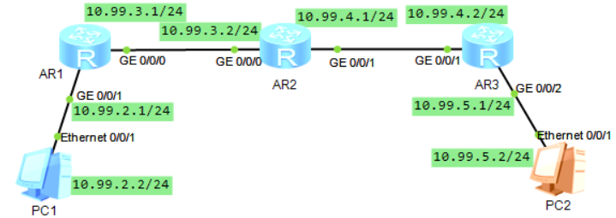

AR1配置：
interface GigabitEthernet0/0/0
ip address 10.99.3.1 255.255.255.0
rip authentication-mode hmac-sha256 hmac-sha256 cipher passwdxx 1
#
interface GigabitEthernet0/0/1
ip address 10.99.2.1 255.255.255.0
#
rip 1
undo summary
default-route originate cost 2
version 2
network 10.0.0.0 #配置时只可写有类地址（主类地址）实际上v2发报文时会发送子网信息
silent-interface GigabitEthernet0/0/1
#

AR2配置：
interface GigabitEthernet0/0/0
ip address 10.99.3.2 255.255.255.0
rip authentication-mode hmac-sha256 hmac-sha256 cipher passwdxx 1
#
interface GigabitEthernet0/0/1
ip address 10.99.4.1 255.255.255.0
rip authentication-mode hmac-sha256 hmac-sha256 cipher passwdxx 1
#
rip 1
undo summary
version 2
network 10.0.0.0
#

AR3配置：
interface GigabitEthernet0/0/1
ip address 10.99.4.2 255.255.255.0
rip authentication-mode hmac-sha256 hmac-sha256 cipher passwdxx 1
#
interface GigabitEthernet0/0/2
ip address 10.99.5.1 255.255.255.0
#
rip 1
undo summary
version 2
network 10.0.0.0
silent-interface GigabitEthernet0/0/2
#

AR3查看路由表：
[Huawei] disp ip routing-table
Route Flags: R - relay, D - download to fib
------------------------------------------------------------------------------
Routing Tables: Public
Destinations : 13 Routes : 13

Destination/Mask Proto Pre Cost Flags NextHop Interface
0.0.0.0/0 RIP 100 4 D 10.99.4.1 GigabitEthernet0/0/1 #AR1引入的默认
10.99.2.0/24 RIP 100 2 D 10.99.4.1 GigabitEthernet0/0/1
10.99.3.0/24 RIP 100 1 D 10.99.4.1 GigabitEthernet0/0/1
10.99.4.0/24 Direct 0 0 D 10.99.4.2 GigabitEthernet0/0/1
10.99.4.2/32 Direct 0 0 D 127.0.0.1 GigabitEthernet0/0/1
10.99.4.255/32 Direct 0 0 D 127.0.0.1 GigabitEthernet0/0/1
10.99.5.0/24 Direct 0 0 D 10.99.5.1 GigabitEthernet0/0/2
10.99.5.1/32 Direct 0 0 D 127.0.0.1 GigabitEthernet0/0/2
10.99.5.255/32 Direct 0 0 D 127.0.0.1 GigabitEthernet0/0/2

<Huawei> disp rip 1 database
---------------------------------------------------
Advertisement State : [A] - Advertised
[I] - Not Advertised/Withdraw
---------------------------------------------------
0.0.0.0/0, cost 4, [A], nexthop 10.99.4.1
10.0.0.0/8, cost 0, ClassfulSumm
10.99.2.0/24, cost 2, [A], nexthop 10.99.4.1
10.99.3.0/24, cost 1, [A], nexthop 10.99.4.1
10.99.4.0/24, cost 0, [A], Rip-interface
10.99.5.0/24, cost 0, [A], Rip-interface

★OSPF
OSPF（Open Shortest Path First）开放最短路径优先协议，是一个内部网关协议，用在单一自治系统（Autonomous System）内决策路由，是对链路状态路由协议的一种实现，使用Dijkstra算法来计算最短路径树
OSPF v2用在ipv4网络，RFC 2328以及RFC 1583
OSPF v3支持ipv6网络，RFC 5340

OSPF中的链路代价cost/metric可取值1~65535，OSPF支持负载均衡（到同一目的网络有多条相同代价的路径时）
（华为设备如果要支持ipv4及ipv6，需要同时配置ospfv2及ospfv3两个路由进程）

[Huawei] ospf router-id 10.1.1.252 1 #开启ospf进程1，同时指定router-id
[Huawei] ospf 1 router-id 10.1.1.252 #同上，开启ospf进程1，同时指定router-id，建议为每个osfp进程配置不同的router-id，一般router-id使用loopback环回接口的ip
[Huawei-ospf-1] bandwidth-reference 100000 #修改参考带宽为100G，全网设备都改为一致的
[Huawei-ospf-1] area 0
[Huawei-ospf-1-area-0.0.0.0] network 10.1.1.0 0.0.0.255 #在区域0宣告网段，使用反掩码
[Huawei-ospf-1-area-0.0.0.0] quit
[Huawei-ospf-1] area 1
[Huawei-ospf-1-area-0.0.0.1] network 10.2.2.0 0.0.0.255 #在区域1宣告网段，使用反掩码
[Huawei-ospf-1-area-0.0.0.1] abr-summary 10.2.0.0 0.0.255.255 cost 2000 #聚合区域间路由
[Huawei-ospf-1-area-0.0.0.1] quit
[Huawei-ospf-1] area 0
[Huawei-ospf-1-area-0.0.0.0] authentication-mode md5 1 cipher xxxx #区域0开启区域验证
[Huawei-ospf-1-area-0.0.0.0] quit
[Huawei-ospf-1] import-route rip 1 cost 20000 #引入RIP路由（路由重分布）
#引入的外部路由显示为O_AES，优先级150，默认cost为1，import-route不能引入其他路由进程中的默认路由
#引入的外部路由默认type 2（不和内部开销相加）
[Huawei-ospf-1] import-route rip 1 cost 20000 type 1 #引入RIP路由，指定为type1的类型
[Huawei-ospf-1] default-route-advertise cost 20000 #引入默认路由（0.0.0.0），ASBR上手动引入
[Huawei-ospf-1] default-route-advertise permit-calculate-other #当多个asbr引入默认路由时，要做比较，实现主备
[Huawei-ospf-1] asbr-summary 10.3.0.0 255.255.0.0 cost 2000 #聚合引入的外部路由
[Huawei-ospf-1] area 1
[Huawei-ospf-1-area-0.0.0.1] vlink-peer 10.2.2.33 #虚链路对端（邻居的router-id）
[Huawei-ospf-1-area-0.0.0.1] vlink-peer 10.2.2.33 md5 1 cipher xxxx #虚链路对端也配置验证
[Huawei-ospf-1-area-0.0.0.1] quit
[Huawei-ospf-1] route-tag 123 #设置VPN Route Tag为123
[Huawei-ospf-1] stub-router on-startup 180 #设置为静默路由器，将度量值设置为65535，180秒后才开始正常工作（当路由器上还开启了其他的路由协议（如BGP）其他路由协议没有ospf启动的快的话，需要让ospf等待其他路由协议正常工作了再开始工作，防止短时内的网络流量中断
[Huawei-ospf-1] nexthop 10.99.1.2 weight 2 #修改去往指定下一跳的路由优先级
[Huawei-ospf-1] maximum load-balancing 8 #配置路由负载分担，当配置的值小于实际可用的等价路径时，按以下原则进行选取使用的转发链路：
看路由优先级，值越小越优先 #可使用 nexthop x.x.x.x weight N 命令修改
比较接口索引值，越大越优先
比较下一跳ip地址，越大越优先

★设置接口网络类型
int g0/0/1
ospf network-type broadcast #还可为：nbma，p2mp，p2p

★设置接口开销
int g0/0/1
ospf cost 500 #设置接口开销
#ospf中，到某目标网段的开销为 到达该网段的路径上的所有出接口的开销之和

★设置接口认证
int g0/0/1
ospf authentication-mode simple plain 123xxxx
ospf authentication-mode md5 1 plain 123xxx

★设置参考带宽
cost = 100M / 接口带宽(M) #默认参考带宽为100M，对于现在的网络而言太小了，建议用100000M
[Huawei] ospf 1
[Huawei-ospf-1] bandwidth-reference 100000 #修改参考带宽为100G，全网设备都改为一致的

★配置为stub/nssa区域
stub及nssa区域都不学习其他区域引入的外部路由（type 5）
[Huawei-ospf-1] area 4
[Huawei-ospf-1-area-0.0.0.4] stub #配置为Stub区域
[Huawei-ospf-1-area-0.0.0.4] stub no-summary #配置为Totally Stub区域
[Huawei-ospf-1-area-0.0.0.4] nssa #配置为NSSA区域
[Huawei-ospf-1-area-0.0.0.4] nssa no-summary #配置为Totally NSSA区域

★过滤3类LSA
ip ip-prefix ip_prefix_1 index 10 deny 10.99.3.1 32
ip ip-prefix ip_prefix_1 index 20 deny 10.99.4.1 32
ip ip-prefix ip_prefix_1 index 1000 permit 0.0.0.0 0 less-equal 32 #最后要permit any
#因为ip-prefix默认情况下，末尾有个deny any的规则
#
ospf 1
area 1
filter ip-prefix ip_prefix_1 import #不往区域1引入这些deny的路由，permit的仍引入
network 10.99.8.0 0.0.0.255
#

★引入静态路由时指定开销（使用路由策略）
acl number 2000
rule 10 permit source 10.99.9.4 0
#
route-policy p001_static_to_ospf permit node 10
if-match acl 2000
apply cost 500
#
ospf 1
import-route static type 2 route-policy p001_static_to_ospf
#

★ospf智能定时器
做spf计算和产生lsa时用到的，
ospf通过以下2个规定来避免网络连接或路由频繁动荡引起的过多占用设备资源的情况：
1. 同一条lsa在1秒之内不能再次生成，且更新时间间隔默认为5秒
2. lsa被接收的时间间隔为1秒

[Huawei] ospf 1
[Huawei-ospf-1] lsa-originate-interval intelligent-timer 5000 500 500 #设置发送定时器，默认是5000，500，500，以毫秒为单位，取值范围0-10000，0-1000，0-5000；参数依次为 max-interval start-interval hold-interval
[Huawei-ospf-1] lsa-arrival-interval intelligent-timer 1000 500 500 #设置接收定时器，默认是1000，500，500，以毫秒为单位，取值范围0-10000，0-1000，0-5000，算法同发送的3条
[Huawei-ospf-1] lsa-schedule-interval intelligent-timer 1000 500 500 #设置计算定时器，默认是1000，500，500，以毫秒为单位，取值范围0-20000，0-1000，0-5000，算法同发送的3条

1）初次更新lsa/接收lsa/计算路由 的间隔由start-interval指定
2）第n次（n>=2）更新lsa/接收lsa/计算路由 的间隔为hold-interval * 2^(n-2)
3）当hold-interval * 2^(n-2)达到指定的max-interval时，ospf连续3次更新lsa/接收lsa/计算路由 的时间间隔都是max-interval时间，之后再返回步骤1
当时间达到max-interval后，刷新智能定时器

★FRR
快速重路由（Fast ReRoute）利用LFA无循环替换（Loop-Free Alternates）算法预先计算出备份路径，保存在转发表中，当主路径故障时快速切换到备份路径上，50ms以内
受链路保护公式的约束，才能保证没有环路
链路保护公式：
cost(N,D) < cost(N,S) + cost(S,D)

节点保护公式：
cost(N,D) < cost(N,E) + cost(E,D)
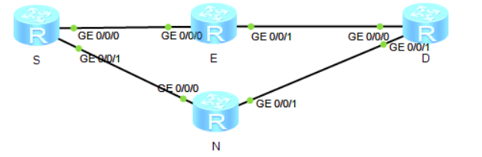
[Huawei] ospf 1
[Huawei-ospf-1] frr #开启FRR功能，此外要还配置BFD才能快速感知到链路故障
[Huawei-ospf-1-frr] loop-free-alternate #使用LFA算法

★设置外部路由数量上限
[Huawei] ospf 1
[Huawei-ospf-1] lsdb-overflow-limit 10
非默认外部路由条目达到上限后，会删除所有的非默认外部路由条目，并启用overflow状态，5秒后退出此状态
再检查，循环此过程，直到小于这个上限才退出此状态

★不同区域默认路由产生情况
区域类型 | 产生情况 | 由谁发布 | LSA类型 | 泛洪范围
普通区域 | 使用命令配置：default-route-advertise | ASBR | type 5 | 普通区域
stub区域 | 自动产生 | ABR | type 3 | stub区域
totally stub区域 | 自动产生 | ABR | type 3 | totally stub区域
nssa区域 | 使用命令配置：default-route-advertise | ASBR | type 7 | nssa区域
totally nssa区域 | 自动产生 | ABR | type 3 | totally nssa区域

★FA地址
FA（Forwarding Address，转发地址），到达所通告的目的地的数据包应该被转发到的地址，如果转发地址为0.0.0.0，那么数据包将被转发到始发ASBR上。
OSPF的Type5 LSA和Type7 LSA中包含一个特别的字段FA，FA的引入使得OSPF在某些特殊的场景下可以避免次优路径问题
当ASBR引入外部路由时，若Type5 LSA中的FA字段为0，表示路由器认为到达目的网段的数据包应该发往该ASBR；若Type5 LSA中的FA字段不为0，表示路由器认为到达目的网段的数据包应该发往这个FA所标识的设备。
当以下条件全部满足时，FA字段才可以被设置为非0：
1、ASBR在其连接外部网络的接口上开启了OSPF
2、该接口没有被配置为Silent-Interface静默接口
3、该接口的OSPF网络类型为BMA或NBMA
4、该接口的IP网段在OSPF中使用network命令宣告了
5、到达FA地址的路由必须是OSPF区域内部路由或区域间路由

★GR平滑重启
GR（Graceful Restart，平滑重启）技术保证了设备在重启过程中转发层面能够继续指导数据的转发，同时控制层面邻居关系的重建以及路由计算等动作不会影响转发层面的功能，从而避免了路由振荡引发的业务中断，保证了关键业务的数据转发，提高了整网的可靠性。
ospf使用Type9 Opaque LSA（Grace-LSA）来承载GR相关配置信息
GR的持续时间：GR持续时间最长不超过1800秒。GR成功或失败都可以提前退出，不必等到超时才退出
GR-Helper退出GR：收到Restarter发送的Age为3600秒的Grace-LSA时与Restarter的邻居关系为Full状态，或者在邻居关系超时后自动退出

<Huawei> reset ospf 1 process #复位ospf进程1，相当于重启了此进程
Warning: The OSPF process will be reset. Continue? [Y/N]:y

[Huawei] disp ospf peer brief #查看ospf邻居及相关信息
[Huawei] disp ospf lsdb #查看ospf链路状态数据库
[Huawei] disp ospf error #查看ospf错误信息

★type-3路由防环之DN位
ospf多实例进程（vpn实例中的ospf进程）会将type-3 lsa中的DN位置为1，其他路由器的多实例ospf进程收到DN置位的type-3 LSA时，会忽略此lsa（普通ospf进程不忽略，仍会正常接收并处理）
可以手动在本端路由器的vpn实例中的ospf进程里设置不启用DN位
ospf 2 router-id 10.99.2.2 vpn-instance xxx
dn-bit-set disable summary #不启用DN位置位功能，默认是自动开启的
#
也可在其他路由器的vpn实例中的ospf进程里配置禁止路由环路检测，操作如下：
ospf 2 router-id 10.99.2.3 vpn-instance xxx
vpn-instance-capability simple #禁止路由环路检测，直接进行路由计算
#
注意：配置vpn-instance-capability simple命令后，OSPF进程不可以引入IBGP路由
默认情况下，当BGP引入OSPF路由时，MED值（MED属性相当于IGP使用的度量值）为OSPF的Cost值加1。配置vpn-instance-capability simple命令后，Cost值不会加1，即MED值变为OSPF的Cost值。因此，会引起BGP引入OSPF路由的MED值变化，影响BGP选路。

★vlink及sham-link
跨越ospf普通区域，连接到骨干区域area 0的链路，称为vlink虚链路，主要是解决area 0分裂问题以及普通区域未能直接与area 0相连的问题
跨越非ospf区域，连接到骨干区域area 0的链路，称为sham-link欺骗链路，一般是连接2个不同物理位置的area 0，使得原来的域间路由变成域内路由

实验：ospf_ar2240（OSPFv2基础配置）
拓扑如下：
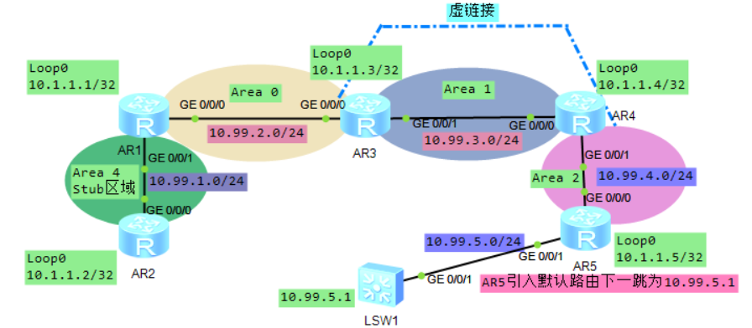

AR1配置：
interface GigabitEthernet0/0/0
ip address 10.99.2.1 255.255.255.0
#
interface GigabitEthernet0/0/1
ip address 10.99.1.1 255.255.255.0
#
interface LoopBack0
description for_OSPF_Router-ID
ip address 10.1.1.1 255.255.255.255
#
ospf 1 router-id 10.1.1.1 #router-id使用loopback0环回接口的ip
bandwidth-reference 100000
area 0.0.0.0
authentication-mode md5 1 cipher passwdxx
network 10.99.2.0 0.0.0.255
area 0.0.0.4
authentication-mode md5 1 cipher passwdxx
network 10.1.1.1 0.0.0.0
network 10.99.1.0 0.0.0.255
stub

AR2配置：
interface GigabitEthernet0/0/0
ip address 10.99.1.2 255.255.255.0
#
interface LoopBack0
description for_OSPF_Router-ID
ip address 10.1.1.2 255.255.255.255
#
ospf 1 router-id 10.1.1.2
bandwidth-reference 100000
area 0.0.0.4
authentication-mode md5 1 cipher passwdxx
network 10.1.1.2 0.0.0.0
network 10.99.1.0 0.0.0.255
stub

AR3配置：
interface GigabitEthernet0/0/0
ip address 10.99.2.2 255.255.255.0
#
interface GigabitEthernet0/0/1
ip address 10.99.3.1 255.255.255.0
#
interface LoopBack0
description for_OSPF_Router-ID
ip address 10.1.1.3 255.255.255.255
#
ospf 1 router-id 10.1.1.3
bandwidth-reference 100000
area 0.0.0.0
authentication-mode md5 1 cipher passwdxx
network 10.1.1.3 0.0.0.0
network 10.99.2.0 0.0.0.255
area 0.0.0.1
authentication-mode md5 1 cipher passwdxx
network 10.99.3.0 0.0.0.255
vlink-peer 10.1.1.4 md5 1 cipher passwdxx #虚链路对端的route-id

AR4配置：
interface GigabitEthernet0/0/0
ip address 10.99.3.2 255.255.255.0
#
interface GigabitEthernet0/0/1
ip address 10.99.4.1 255.255.255.0
#
interface LoopBack0
description for_OSPF_Router-ID
ip address 10.1.1.4 255.255.255.255
#
ospf 1 router-id 10.1.1.4
bandwidth-reference 100000
area 0.0.0.1
authentication-mode md5 1 cipher passwdxx
network 10.1.1.4 0.0.0.0
network 10.99.3.0 0.0.0.255
vlink-peer 10.1.1.3 md5 1 cipher passwdxx #虚链路对端的route-id
area 0.0.0.2
authentication-mode md5 1 cipher passwdxx
network 10.99.4.0 0.0.0.255

AR5配置：
interface GigabitEthernet0/0/0
ip address 10.99.4.2 255.255.255.0
#
interface GigabitEthernet0/0/1
ip address 10.99.5.2 255.255.255.0
#
interface LoopBack0
description for_OSPF_Router-ID
ip address 10.1.1.5 255.255.255.255
#
ospf 1 router-id 10.1.1.5
default-route-advertise cost 20000
bandwidth-reference 100000
area 0.0.0.2
authentication-mode md5 1 cipher passwdxx
network 10.1.1.5 0.0.0.0
network 10.99.4.0 0.0.0.255
#
ip route-static 0.0.0.0 0.0.0.0 10.99.5.1

AR1查看信息：
<Huawei> disp ospf abr-asbr
OSPF Process 1 with Router ID 10.1.1.1
Routing Table to ABR and ASBR
RtType Destination Area Cost Nexthop Type
Intra-area 10.1.1.3 0.0.0.0 100 10.99.2.2 ABR
Intra-area 10.1.1.4 0.0.0.0 200 10.99.2.2 ABR
Inter-area 10.1.1.5 0.0.0.0 300 10.99.2.2 ASBR

<Huawei> disp ospf lsdb
OSPF Process 1 with Router ID 10.1.1.1
Link State Database
Area: 0.0.0.0
Type LinkState ID AdvRouter Age Len Sequence Metric
Router 10.1.1.3 10.1.1.3 1183 60 80000010 0
Router 10.1.1.1 10.1.1.1 673 36 80000005 100
Router 10.1.1.4 10.1.1.4 1184 36 80000001 100
Network 10.99.2.2 10.1.1.3 674 32 80000002 0
Sum-Net 10.99.3.0 10.1.1.3 607 28 80000002 100
Sum-Net 10.99.3.0 10.1.1.4 1352 28 80000001 100
Sum-Net 10.99.1.0 10.1.1.1 718 28 80000002 100
Sum-Net 10.99.4.0 10.1.1.4 1352 28 80000001 100
Sum-Net 10.1.1.5 10.1.1.4 1352 28 80000001 100
Sum-Net 10.1.1.4 10.1.1.3 470 28 80000002 100
Sum-Net 10.1.1.4 10.1.1.4 1352 28 80000001 0
Sum-Net 10.1.1.1 10.1.1.1 718 28 80000002 0
Sum-Net 10.1.1.2 10.1.1.1 718 28 80000002 100
Sum-Asbr 10.1.1.5 10.1.1.4 1026 28 80000001 100

Area: 0.0.0.4
Type LinkState ID AdvRouter Age Len Sequence Metric
Router 10.1.1.2 10.1.1.2 984 48 80000009 100
Router 10.1.1.1 10.1.1.1 977 48 80000006 100
Network 10.99.1.2 10.1.1.2 984 32 80000003 0
Sum-Net 0.0.0.0 10.1.1.1 673 28 80000002 1
Sum-Net 10.99.3.0 10.1.1.1 606 28 80000002 200
Sum-Net 10.99.2.0 10.1.1.1 718 28 80000002 100
Sum-Net 10.99.4.0 10.1.1.1 1181 28 80000001 300
Sum-Net 10.1.1.5 10.1.1.1 1181 28 80000001 300
Sum-Net 10.1.1.4 10.1.1.1 469 28 80000002 200
Sum-Net 10.1.1.3 10.1.1.1 673 28 80000002 100

AS External Database
Type LinkState ID AdvRouter Age Len Sequence Metric
External 0.0.0.0 10.1.1.5 849 36 80000001 20000

★IS-IS
Intermediate System-Intermediate System中间系统到中间系统

[Huawei] isis 1 #1为进程id，可配置为1-65535，默认1，仅本地有效，一台路由器可启动多个isis进程
[Huawei-isis-1] is-level level-1 #指定level，未指定时默认为level-1-2
[Huawei-isis-1] cost-style wide #设置is-is设备接收和发送路由的开销类型为wide，只有路径开销计算类型为wide，路由条目才支持带tag
[Huawei-isis-1] auto-cost enable #根据接口带宽大小计算开销值（默认未开启）
[Huawei-isis-1] bandwidth-reference 100000 #修改参考带宽为100G，全网设备都改为一致的
[Huawei-isis-1] network-entity 49.0001.1111.1111.1111.00 #设置isis网络实体名称（NET）
#同一个level-1区域号要求相同
[Huawei-isis-1] domain-authentication-mode md5 cipher xxxx #设置区域认证
[Huawei-isis-1] is-name ar1 #在LSP中带上此名称方便查看维护
[Huawei-isis-1] attached-bit avoid-learning #不根据att置位学习默认路由
[Huawei-isis-1] attached-bit advertise never #不将att置位，收到att置位的报文后，将其置位信息改为0
[Huawei-isis-1] import-route direct level-1 #引入直连路由
[Huawei-isis-1] import-route isis level-2 into level-1 #将level-2的路由引入level-1中，默认情况下isis level-1只学习level-1的路由，而level-2可学习到level-1以及level-2的路由
[Huawei-isis-1] default-route-advertise always level-1 #引入默认路由（always表示即使本身没有默认路由，也引入）
[Huawei-isis-1] default-route-advertise match default #自己路由表里有缺省路由时才宣告入isis中
[Huawei-isis-1] default-route-advertise route-policy p1 cost 10 tag 5 level-1 #引入默认路由且指定其cost值，设置tag及isis层级（当匹配上名为p1的路由策略时，才引入默认路由，此时不需要带always）
#
★接口上开启isis并设置接口认证
[Huawei] interface GigabitEthernet0/0/1
[Huawei-GigabitEthernet0/0/1] ip address 10.99.1.1 255.255.255.0
[Huawei-GigabitEthernet0/0/1] isis enable 1 #在接口上使能isis进程1
[Huawei-GigabitEthernet0/0/1] isis circuit-level level-1
[Huawei-GigabitEthernet0/0/1] isis authentication-mode md5 cipher passwdxx #配置接口MD5验证

★设置接口网络类型
int g0/0/1
isis circuit-type p2p #默认是broadcast，但无法配置，只能undo isis circuit-type p2p
isis ppp-negotiation 2-way #建立邻居时使用二次握手，默认为3-way三次握手（3-way兼容2-way）
#

★设置接口开销
int g0/0/1
isis cost 50 #设置接口开销
#isis中，到某目标网段的开销为 到达该网段的路径上的所有出接口的开销之和

★接口开销
IS-IS采用 默认度量，接口链路开销为10，需要使用auto-cost enable命令开启根据接口带宽计算开销值
开销计算方式 | 取值范围 | 默认值 | 说明
narrow | 1-63 | 10 | isis默认接口开销计算模式
wide | 1-16777214 | 10 | （参考带宽/接口带宽）*10 （乘10之后，如果小于1，则按1算；有小数点，则使用去尾法保留整数部分）
narrow-compatible |  |  | 可同时接收开销值类型为narrow与wide的报文，但只发送narrow类型报文
wide-compatible |  |  | 可同时接收开销值类型为narrow与wide的报文，但只发送wide类型报文
compatible |  |  | 可同时接收/发送开销值类型为narrow与wide的报文

★设置接口认证
int g0/0/1
isis authentication-mode simple plain 123xxxx
isis authentication-mode md5 plain 123xxx

★设置参考带宽
wide模式下，cost = 100M / 接口带宽(M) *10 #默认参考带宽为100M，对于现在的网络而言太小了，建议用100000M
[Huawei] isis 1
[Huawei-isis-1] auto-cost enable #根据接口带宽大小计算开销值（默认未开启）
[Huawei-isis-1] bandwidth-reference 100000 #修改参考带宽为100G，全网设备都改为一致的
#如果不开启auto-cost enable，则就算修改了bandwidth-reference也不会按此参考带宽计算cost值，仍然是默认的10

★isis智能定时器
做spf计算和产生lsp时用到的，
isis通过以下2个规定来避免网络连接或路由频繁动荡引起的过多占用设备资源的情况：
1. 同一条lsp在1秒之内不能再次生成，且更新时间间隔默认为5秒？
2. lsp被接收的时间间隔为1秒？

[Huawei] isis 1
[Huawei-isis-1] timer lsp-generation 5 500 500 level-1 #设置发送定时器，level-1的，默认是5秒，500毫秒，500毫秒，取值范围1-120，1-60000，1-60000；参数依次为 max-interval initial-interval increment-interval
[Huawei-isis-1] timer lsp-generation 5 500 500 level-1 #设置发送定时器，level-2的
[Huawei-isis-1] timer spf 5 50 200 #设置计算定时器，默认是5秒，50毫秒，200毫秒，取值范围1-120，1-60000，1-60000；参数依次为 max-interval initial-interval increment-interval

1）初次更新lsp/计算路由 的间隔由initial-interval指定
2）第n次（n>=2）更新lsa/接收lsa/计算路由 的间隔为increment-interval * 2^(n-2)
3）当increment-interval * 2^(n-2)达到指定的max-interval时，连续3次更新lsa/计算路由 的时间间隔都是max-interval时间，之后再返回步骤1
当时间达到max-interval后，刷新智能定时器

★FRR
快速重路由（Fast ReRoute）利用LFA无循环替换（Loop-Free Alternates）算法预先计算出备份路径，保存在转发表中，当主路径故障时快速切换到备份路径上
[Huawei] isis 1
[Huawei-isis-1] frr
[Huawei-isis-1-frr] loop-free-alternate level-1
[Huawei-isis-1-frr] loop-free-alternate level-2

★GR平滑重启
GR（Graceful Restart，平滑重启）技术保证了设备在重启过程中转发层面能够继续指导数据的转发，同时控制层面邻居关系的重建以及路由计算等动作不会影响转发层面的功能，从而避免了路由振荡引发的业务中断，保证了关键业务的数据转发，提高了整网的可靠性。
isis使用211号TLV（Restart TLV）来承载GR相关配置信息

★开启LSP分片扩展
在isis中，每个系统id都标识一个系统，每个系统最多可生成256个lsp分片，可通过设置虚拟系统来增加分片数量，一个isis进程最多配置50个虚拟系统，即一个isis进程最多可生成51*256=13056个lsp分片（每分片大概承载100条路由），isis路由器有2种lsp分片模式：
mode-1：将各个虚拟系统当成单独的isis路由器，从本isis进程到这些虚拟系统的isis路由器开销设置为0
mode-2：对端设备知道我是开启了分片功能，将虚拟系统的分片也当成本路由器的信息
[Huawei] isis 1
[Huawei-isis-1] lsp-fragments-extend level-1 mode-2 #开启isis进程的lsp分片扩展功能，默认未开启
[Huawei-isis-1] virtual-system 1111.1111.1112 #为使设备生成扩展lsp分片，至少要配置1个虚拟系统id
[Huawei-isis-1] virtual-system 1111.1111.1113 #一个isis进程最多可配置50个虚拟系统system-id
[Huawei-isis-1] quit
<Huawei> reset isis 1 all #配置了lsp分片功能及虚拟系统id后，要重启isis进程才生效
Warning: The ISIS process(es) will be reset. Continue?[Y/N]y

★IS-IS多拓扑
[Huawei-isis-1] ipv6 enable topology standard #拓扑类型为标准模式（默认），表示ipv6也按ipv4的拓扑来计算，此时要求网络中的ipv4及ipv6拓扑要一致。发布及保存路由信息类型为ipv6 standard
[Huawei-isis-1] ipv6 enable topology ipv6 #开启ipv6多拓扑功能，在SPF计算时，ipv4和ipv6在各自的拓扑中单独进行计算，发布及保存路由信息类型为ipv6 MT
[Huawei-isis-1] ipv6 enable topology compatible #开启ipv6多拓扑功能兼容模式，在SPF计算时，ipv6也按ipv4的拓扑来计算，，发布及保存路由信息类型为ipv6 standard及ipv6 MT

实验：isis_ar2240（ensp）
拓扑如下：
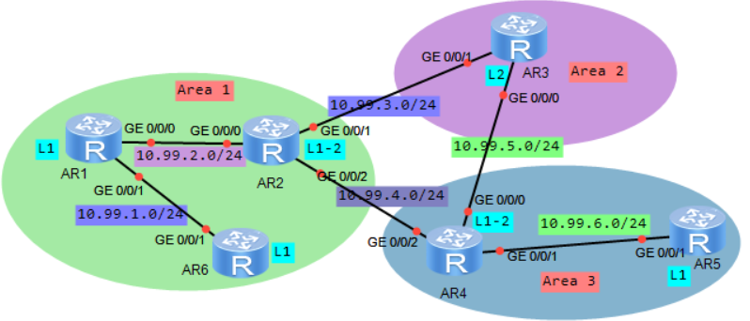

各设备的systemID不能相同！

AR1配置：
isis 1
is-level level-1
cost-style wide
network-entity 49.0001.1111.1111.1111.00
is-name ar1
import-route direct level-1
#
interface GigabitEthernet0/0/0
ip address 10.99.2.1 255.255.255.0
isis enable 1
isis circuit-leve l level-1
isis authentication-mode md5 cipher passwdxx
#
interface GigabitEthernet0/0/1
ip address 10.99.1.1 255.255.255.0
isis enable 1
isis circuit-level level-1
isis authentication-mode md5 cipher passwdxx

AR6配置：
isis 1
is-level level-1
cost-style wide
network-entity 49.0001.1111.1111.6666.00
is-name ar6
import-route direct level-1
#
interface GigabitEthernet0/0/1
ip address 10.99.1.2 255.255.255.0
isis enable 1
isis circuit-level level-1
isis authentication-mode md5 cipher passwdxx

AR2配置：
isis 1
cost-style wide
network-entity 49.0001.1111.1111.2222.00
is-name ar2
import-route direct level-1-2
#
interface GigabitEthernet0/0/0
ip address 10.99.2.2 255.255.255.0
isis enable 1
isis authentication-mode md5 cipher passwdxx
#
interface GigabitEthernet0/0/1
ip address 10.99.3.1 255.255.255.0
isis enable 1
isis authentication-mode md5 cipher passwdxx
#
interface GigabitEthernet0/0/2
ip address 10.99.4.1 255.255.255.0
isis enable 1
isis authentication-mode md5 cipher passwdxx

AR3配置：
isis 1
is-level level-2
cost-style wide
network-entity 49.0002.1111.1111.3333.00
is-name ar3
import-route direct
#
interface GigabitEthernet0/0/0
ip address 10.99.5.1 255.255.255.0
isis enable 1
isis circuit-level level-2
isis authentication-mode md5 cipher passwdxx
#
interface GigabitEthernet0/0/1
ip address 10.99.3.2 255.255.255.0
isis enable 1
isis circuit-level level-2
isis authentication-mode md5 cipher passwdxx

AR4配置：
isis 1
cost-style wide
network-entity 49.0003.1111.1111.4444.00
is-name ar4
import-route direct level-1-2
#
interface GigabitEthernet0/0/0
ip address 10.99.5.2 255.255.255.0
isis enable 1
isis authentication-mode md5 cipher passwdxx
#
interface GigabitEthernet0/0/1
ip address 10.99.6.1 255.255.255.0
isis enable 1
isis authentication-mode md5 cipher passwdxx
#
interface GigabitEthernet0/0/2
ip address 10.99.4.2 255.255.255.0
isis enable 1
isis authentication-mode md5 cipher passwdxx

AR5配置：
isis 1
is-level level-1
cost-style wide
network-entity 49.0003.1111.1111.5555.00
is-name ar5
import-route direct level-1
#
interface GigabitEthernet0/0/1
ip address 10.99.6.2 255.255.255.0
isis enable 1
isis circuit-level level-1
isis authentication-mode md5 cipher passwdxx

AR2查看：
<Huawei> disp isis peer #查看isis邻居
Peer information for ISIS(1)
System Id Interface Circuit Id State HoldTime Type PRI
-------------------------------------------------------------------------------
ar1 GE0/0/0 ar2.01 Up 29s L1 64
ar3 GE0/0/1 ar2.02 Up 22s L2 64
ar4 GE0/0/2 ar2.03 Up 30s L2(L1L2) 64

<Huawei> disp isis lsdb #查看isis链路状态数据库
Database information for ISIS(1)
Level-1 Link State Database
LSPID Seq Num Checksum Holdtime Length ATT/P/OL
-------------------------------------------------------------------------------
ar1.00-00 0x00000008 0x1942 542 93 0/0/0
ar2.00-00* 0x0000000a 0xbd7e 442 94 1/0/0
ar2.01-00* 0x00000002 0x57af 442 54 0/0/0
ar6.00-00 0x00000007 0xd87f 871 70 0/0/0
ar6.01-00 0x00000003 0xec0a 871 54 0/0/0
Total LSP(s): 5
*(In TLV)-Leaking Route, *(By LSPID)-Self LSP, +-Self LSP(Extended),
ATT-Attached, P-Partition, OL-Overload

Level-2 Link State Database
LSPID Seq Num Checksum Holdtime Length ATT/P/OL
-------------------------------------------------------------------------------
ar2.00-00* 0x0000000e 0xd625 442 113 0/0/0
ar2.02-00* 0x00000002 0x5071 442 54 0/0/0
ar2.03-00* 0x00000002 0x4955 442 54 0/0/0
ar3.00-00 0x00000009 0x7dca 692 93 0/0/0
ar4.00-00 0x0000000e 0xea1a 880 105 0/0/0
ar4.02-00 0x00000002 0x1d1c 880 54 0/0/0
Total LSP(s): 6
<Huawei> disp isis lsdb ar1.00-00 verbose #查看lspid对应的详细信息，保存有路由信息

<Huawei> disp ip routing-table protocol isis #查看isis学习到的路由
Route Flags: R - relay, D - download to fib
------------------------------------------------------------------------------
Public routing table : ISIS
Destinations : 3 Routes : 4
ISIS routing table status : <Active>
Destinations : 3 Routes : 4

Destination/Mask Proto Pre Cost Flags NextHop Interface
10.99.1.0/24 ISIS-L1 15 20 D 10.99.2.1 GigabitEthernet0/0/0
10.99.5.0/24 ISIS-L2 15 20 D 10.99.3.2 GigabitEthernet0/0/1 #2条等价路径
ISIS-L2 15 20 D 10.99.4.2 GigabitEthernet0/0/2
10.99.6.0/24 ISIS-L2 15 20 D 10.99.4.2 GigabitEthernet0/0/2

AR6查看：
<Huawei> disp ip routing-table protocol isis #查看isis学习到的路由，level-2的路由引入为默认路由
Route Flags: R - relay, D - download to fib
------------------------------------------------------------------------------
Public routing table : ISIS
Destinations : 4 Routes : 4
ISIS routing table status : <Active>
Destinations : 4 Routes : 4

Destination/Mask Proto Pre Cost Flags NextHop Interface

0.0.0.0/0 ISIS-L1 15 20 D 10.99.1.1 GigabitEthernet0/0/1 #非level-1的路由
10.99.2.0/24 ISIS-L1 15 20 D 10.99.1.1 GigabitEthernet0/0/1
10.99.3.0/24 ISIS-L1 15 30 D 10.99.1.1 GigabitEthernet0/0/1
10.99.4.0/24 ISIS-L1 15 30 D 10.99.1.1 GigabitEthernet0/0/1

★BGP
AS（Autonomous System）在2009年1月之前，使用2字节的AS号，即1到65535，
公有AS号为1~64511，私有AS号为64512~65534
在2009年1月后，IANA决定使用4字节长度的AS号，范围65536到4294967295

#eBGP及BFD联动
eBGP路由器邻居分别属于不同的AS系统，eBGP各路由器之间会相互发送学习到的路由信息
[AR2220-R1] bfd #先全局开启bfd
[AR2220-R1] bgp 300 #开启bgp进程，本设备as号为300（2字节的AS号）
#如果要使用4字节的AS号，则按2字节为一组，中间用.点号分隔，比如 5000:100这种形式
[AR2220-R1-bgp] router-id 10.1.1.1 #手动指定route id
[AR2220-R1-bgp] timer keepalive 10 hold 30 #消息报文周期为10秒，30秒为最大超时；默认情况下keepalive时间为60秒，hold保持时间为180秒。
[AR2220-R1-bgp] timer connect-retry 3 #发起tcp连接建立的重连时间，单位：秒，默认是32秒
[AR2220-R1-bgp] preference 255 255 255 #设置路由优先级，依次为eBGP，iBGP，Local-created，在bgp与igp相互引入的场景中，交叉引入回来的路由，按本地优先级算，若想修改此类路由优先级，需要修改第3个参数（Local-created）
[AR2220-R1-bgp] peer 9.9.9.2 as-number 400 #配置邻居及指定邻居的as号，
#邻居只需要路由可达即可，不一定非得是直连网段的ip。一般情况下：
iBGP一般使用loop口建立对等体关系，物理上可隔着若干个路由器
eBGP一般使用直连接口建立对待体关系，物理上默认只能直连
[AR2220-R1-bgp] peer 9.9.9.2 ebgp-max-hop 10 #如果eBGP对等体之间不是直连，隔着几个路由器，则需要配置eBGP最大跳数，默认最大跳数为1
[AR2220-R1-bgp] peer 9.9.9.2 password cipher passwdxx #配置MD5认证密码，tcp三次握手阶段的认证
[AR2220-R1-bgp] peer 9.9.9.2 bfd enable #和邻居之间使能bfd
[AR2220-R1-bgp] peer 9.9.9.2 bfd min-tx-interval 10 min-rx-interval 10 #周期为10毫秒，3次超时
[AR2220-R1-bgp] peer x.x.x.x allow-as-loop 1 #允许接收带有一次本as号的路由信息，allow-as-loop后面不指定数字时，默认就是1。默认情况下，为了防止AS间产生环路，当收到eBGP对等体发送的路由时，会将带有本地AS号的路由丢弃（eBGP才会带上本地的as号，iBGP不会带上本地AS号）
[AR2220-R1-bgp] peer x.x.x.x substitute-as #将对端的as号替换掉，换为本路由器的as号，经过本路由器传递时，还会带上本路由器自己的as号，所以替换后，一共有2个本路由器as号。
[AR2220-R1-bgp] peer x.x.x.x public-as-only #将对端的as_path中的私有as号删除掉
[AR2220-R1-bgp] peer x.x.x.x next-hop-local #向iBGP对等体通告路由时，把下一跳属性设置为自身的tcp连接源地址，默认情况下本路由器把收到的eBGP路由通告给iBGP对待体时不会改变其next-hop属性（如果本路由器的ibgp邻居不知道这个eBGP路由器宣告的路由条目的next-hop怎么走，则此路由条目不可达）
[AR2220-R1-bgp] peer x.x.x.x next-hop-invariable #宣告路由时，不改变里面的下一跳地址
[AR2220-R1-bgp] ipv4-family unicast #进入ipv4路由配置界面
[AR2220-R1-bgp-af-ipv4] network 10.1.1.1 32 #手动宣告网段/ip
[AR2220-R1-bgp-af-ipv4] aggregate 10.1.1.0 24 detail-suppressed #聚合路由
[AR2220-R1-bgp-af-ipv4] network 10.11.11.0 24 #手动宣告网段，此路由必须处于活跃状态
[AR2220-R1-bgp-af-ipv4] network 9.9.9.0 24 #发布的子网掩码必须和接口上配置的一致
[AR2220-R1-bgp-af-ipv4] import-route direct #引入直连路由
[AR2220-R1-bgp-af-ipv4] maximum load-balancing ebgp 8 #配置ecmp等价路由为最多8条，
#ecmp等价路由数目根据设备型号而定，旧型号的设备一般最大值只可设置为8，有的也可设置为32，64
#ECMP（Equal-Cost Multiple Path）等成本负载分担，指到达同一目的地址有多条等价链路，流量在这些等价链路上平均分配，要求为同一路由协议生成的多条路由，这些路由的优先级和度量都相同
#UCMP（Unequal-Cost Multiple Path）非等成本负载分担，是指到达同一目的地址有多条带宽不同的等价链路，流量根据带宽按比例分担到各条链路上。
#ECMP支持逐流及逐包的负载分担方式，UCMP仅支持逐流的方式（即根据五元组去做hash确定走哪条链路）
#逐包方式为rr均匀轮询方式

#查看
[AR2220-R1] disp bgp peer #查看bgp邻居
[AR2220-R1] disp bgp routing-table #查看bgp学习到的路由
[AR2220-R1] disp ip routing-table protocol bgp #查看bgp生效的路由

实验：eBGP_ar2240（ensp）
拓扑如下：
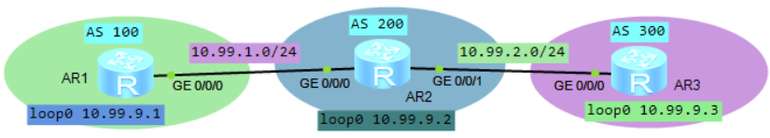

AR1配置：
bfd
#
interface GigabitEthernet0/0/0
ip address 10.99.1.1 255.255.255.0
#
interface LoopBack0
ip address 10.99.9.1 255.255.255.255
#
bgp 100
router-id 10.99.9.1
timer keepalive 10 hold 30
timer connect-retry 3
peer 10.99.1.2 as-number 200
peer 10.99.1.2 bfd min-tx-interval 100 min-rx-interval 100
peer 10.99.1.2 bfd enable
ipv4-family unicast
undo synchronization #默认
network 10.99.1.0 255.255.255.0
network 10.99.9.1 255.255.255.255
maximum load-balancing ebgp 8
peer 10.99.1.2 enable #根据前面配置的peer对等体信息自动生成的

AR2配置：
bfd
#
interface GigabitEthernet0/0/0
ip address 10.99.1.2 255.255.255.0
#
interface GigabitEthernet0/0/1
ip address 10.99.2.1 255.255.255.0
#
interface LoopBack0
description for_bgp_router_id
ip address 10.99.9.2 255.255.255.255
#
bgp 200
router-id 10.99.9.2
timer keepalive 10 hold 30
timer connect-retry 3
peer 10.99.1.1 as-number 100
peer 10.99.1.1 bfd min-tx-interval 100 min-rx-interval 100
peer 10.99.1.1 bfd enable
peer 10.99.2.2 as-number 300
peer 10.99.2.2 bfd min-tx-interval 100 min-rx-interval 100
peer 10.99.2.2 bfd enable
ipv4-family unicast
undo synchronization
import-route direct
peer 10.99.1.1 enable
peer 10.99.2.2 enable

AR3配置：
bfd
#
interface GigabitEthernet0/0/0
ip address 10.99.2.2 255.255.255.0
#
interface LoopBack0
description for_bgp_router_id
ip address 10.99.9.3 255.255.255.255
#
bgp 300
router-id 10.99.9.3
timer keepalive 10 hold 30
timer connect-retry 3
peer 10.99.2.1 as-number 200
peer 10.99.2.1 bfd min-tx-interval 100 min-rx-interval 100
peer 10.99.2.1 bfd enable
ipv4-family unicast
undo synchronization
import-route direct
peer 10.99.2.1 enable

AR2上查看：
<Huawei> disp bgp peer #查看bgp邻居
BGP local router ID : 10.99.9.2
Local AS number : 200
Total number of peers : 2 Peers in established state : 2

Peer V AS MsgRcvd MsgSent OutQ Up/Down State Pre fRcv
10.99.1.1 4 100 79 82 0 00:12:38 Established 2
10.99.2.2 4 300 47 50 0 00:07:16 Established 2

<Huawei> disp ip routing-table protocol bgp #查看bgp路由（生效的）
Route Flags: R - relay, D - download to fib
------------------------------------------------------------------------------
Public routing table : BGP
Destinations : 2 Routes : 2
BGP routing table status : <Active>
Destinations : 2 Routes : 2

Destination/Mask Proto Pre Cost Flags NextHop Interface
10.99.9.1/32 EBGP 255 0 D 10.99.1.1 GigabitEthernet0/0/0
10.99.9.3/32 EBGP 255 0 D 10.99.2.2 GigabitEthernet0/0/1

BGP routing table status : <Inactive>
Destinations : 0 Routes : 0

<Huawei> disp bfd session all #查看bfd会话
--------------------------------------------------------------------------------
Local Remote PeerIpAddr State Type InterfaceName
--------------------------------------------------------------------------------
8192 8192 10.99.1.1 Up D_IP_IF GigabitEthernet0/0/0
8193 8192 10.99.2.2 Up D_IP_IF GigabitEthernet0/0/1
--------------------------------------------------------------------------------
Total UP/DOWN Session Number : 2/0

#iBGP及Route-Reflect路由反射
为了防止AS内产生环路（iBGP水平分割规则限制），BGP设备不会把从iBGP对等体学到的路由通告给其他iBGP对等体，如果要和所有iBGP对等体学习路由信息，需要所有iBGP对等体之间建立全连接，当iBGP对等体数量过多时，会建立相当多的对等体连接导致效率降低，这时可使用BGP路由反射器功能，所有iBGP设备只需要和反射器设备建立对等体连接，路由反射器会将收到的iBGP路由信息发送给其他所有iBGP对等体。

RR的出现，打破了IBGP之间的水平分割规则
非RR的客户之间，保持 水平分割
RR做路由反射时不会修改任何属性，发送给非RC时，可修改属性（比如修改下一跳为自己）
多个RR之间 为非客户关系，要建立全互联关系

实验：iBGP_route_reflect_ar2240（ensp）
拓扑如下：
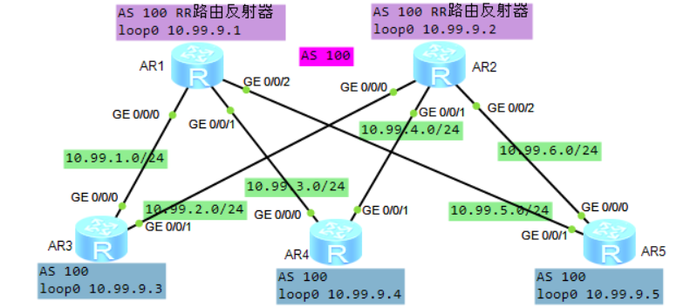
AR1和AR2做路由反射器

AR1配置：
interface GigabitEthernet0/0/0
ip address 10.99.1.1 255.255.255.0
#
interface GigabitEthernet0/0/1
ip address 10.99.3.1 255.255.255.0
#
interface GigabitEthernet0/0/2
ip address 10.99.5.1 255.255.255.0
#
interface LoopBack0
description for_bgp_router_id
ip address 10.99.9.1 255.255.255.255
#
bgp 100
router-id 10.99.9.1
group rc_inter_1 internal #创建对等体组（把同类对端都放入此组，方便配置），
#对等体组配置为internal后，此group不需要再配置as-number，同本bgp的AS号
peer rc_inter_1 reflect-client #使此组内的路由器进行路由反射
peer 10.99.1.2 group rc_inter_1 #将对端放入rc_inter_1组内
peer 10.99.3.2 group rc_inter_1
peer 10.99.5.2 group rc_inter_1
ipv4-family unicast
undo synchronization
reflector cluster-id 1 #配置反射器的cluster-id
import-route direct
peer rc_inter_1 enable
#以下是根据前面的配置自动生成的，配置时不需要输入以下命令
peer rc_inter_1 reflect-client
peer 10.99.1.2 enable
peer 10.99.1.2 group rc_inter_1
peer 10.99.3.2 enable
peer 10.99.3.2 group rc_inter_1
peer 10.99.5.2 enable
peer 10.99.5.2 group rc_inter_1

AR2配置：
interface GigabitEthernet0/0/0
ip address 10.99.2.1 255.255.255.0
#
interface GigabitEthernet0/0/1
ip address 10.99.4.1 255.255.255.0
#
interface GigabitEthernet0/0/2
ip address 10.99.6.1 255.255.255.0
#
interface LoopBack0
description for_bgp_router_id
ip address 10.99.9.2 255.255.255.255
#
bgp 100
router-id 10.99.9.2
group rc_inter_1 internal
peer rc_inter_1 reflect-client
peer 10.99.2.2 group rc_inter_1
peer 10.99.4.2 group rc_inter_1
peer 10.99.6.2 group rc_inter_1
ipv4-family unicast
undo synchronization
reflector cluster-id 1
import-route direct
#以下是根据前面的配置自动生成的，配置时不需要输入以下命令
peer rc_inter_1 enable
peer rc_inter_1 reflect-client
peer 10.99.2.2 enable
peer 10.99.2.2 group rc_inter_1
peer 10.99.4.2 enable
peer 10.99.4.2 group rc_inter_1
peer 10.99.6.2 enable
peer 10.99.6.2 group rc_inter_1

AR3配置：
interface GigabitEthernet0/0/0
ip address 10.99.1.2 255.255.255.0
#
interface GigabitEthernet0/0/1
ip address 10.99.2.2 255.255.255.0
#
interface LoopBack0
description for_bgp_router_id
ip address 10.99.9.3 255.255.255.255
#
bgp 100
router-id 10.99.9.3
group rr_inter_1 internal
peer 10.99.1.1 group rr_inter_1
peer 10.99.2.1 group rr_inter_1
ipv4-family unicast
undo synchronization
import-route direct
maximum load-balancing ibgp 8
#以下是根据前面的配置自动生成的，配置时不需要输入以下命令
peer rr_inter_1 enable
peer 10.99.1.1 enable
peer 10.99.1.1 group rr_inter_1
peer 10.99.2.1 enable
peer 10.99.2.1 group rr_inter_1

AR4及AR5配置同AR3，这里不列出了。

AR3上查看：
<Huawei> disp bgp peer #查看bgp邻居
BGP local router ID : 10.99.9.3
Local AS number : 100
Total number of peers : 2 Peers in established state : 2

Peer V AS MsgRcvd MsgSent OutQ Up/Down State Pre fRcv
10.99.1.1 4 100 29 27 0 00:20:35 Established 8
10.99.2.1 4 100 27 24 0 00:18:54 Established 8

<Huawei> disp ip routing-table protocol bgp #查看bgp路由（生效的）
Route Flags: R - relay, D - download to fib
------------------------------------------------------------------------------
Public routing table : BGP
Destinations : 8 Routes : 14
BGP routing table status : <Active>
Destinations : 8 Routes : 14

Destination/Mask Proto Pre Cost Flags NextHop Interface
10.99.3.0/24 IBGP 255 0 RD 10.99.1.1 GigabitEthernet0/0/0
IBGP 255 0 RD 10.99.4.2 GigabitEthernet0/0/1
10.99.4.0/24 IBGP 255 0 RD 10.99.2.1 GigabitEthernet0/0/1
IBGP 255 0 RD 10.99.3.2 GigabitEthernet0/0/0
10.99.5.0/24 IBGP 255 0 RD 10.99.1.1 GigabitEthernet0/0/0
IBGP 255 0 RD 10.99.6.2 GigabitEthernet0/0/1
10.99.6.0/24 IBGP 255 0 RD 10.99.2.1 GigabitEthernet0/0/1
IBGP 255 0 RD 10.99.5.2 GigabitEthernet0/0/0
10.99.9.1/32 IBGP 255 0 RD 10.99.1.1 GigabitEthernet0/0/0
10.99.9.2/32 IBGP 255 0 RD 10.99.2.1 GigabitEthernet0/0/1
10.99.9.4/32 IBGP 255 0 RD 10.99.3.2 GigabitEthernet0/0/0
IBGP 255 0 RD 10.99.4.2 GigabitEthernet0/0/1
10.99.9.5/32 IBGP 255 0 RD 10.99.5.2 GigabitEthernet0/0/0
IBGP 255 0 RD 10.99.6.2 GigabitEthernet0/0/1

BGP routing table status : <Inactive>
Destinations : 0 Routes : 0

<Huawei> reset bgp 100 #重置bgp连接

#iBGP联盟

实验：iBGP_confederation_ar2240（ensp）
拓扑如下：
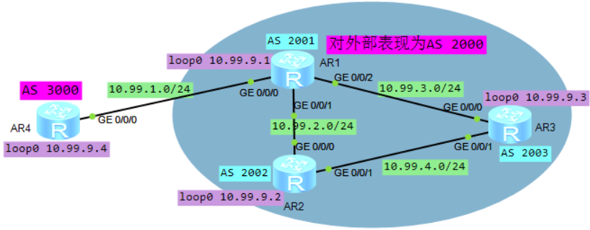

AR1配置：（作为ASBR）
interface GigabitEthernet0/0/0
ip address 10.99.1.1 255.255.255.0
#
interface GigabitEthernet0/0/1
ip address 10.99.2.1 255.255.255.0
#
interface GigabitEthernet0/0/2
ip address 10.99.3.1 255.255.255.0
#
interface LoopBack0
description for_bgp_router_id
ip address 10.99.9.1 255.255.255.255
#
bgp 2001
router-id 10.99.9.1
confederation id 2000 #对外表现为一个AS 2000
confederation peer-as 2002 2003
peer 10.99.1.2 as-number 3000
peer 10.99.2.2 as-number 2002
peer 10.99.3.2 as-number 2003
ipv4-family unicast
undo synchronization
import-route direct
peer 10.99.2.2 next-hop-local #配置这条之后，AR2到外部都要经过R1
peer 10.99.3.2 next-hop-local #配置这条之后，AR3到外部都要经过R1

AR2配置：
interface GigabitEthernet0/0/0
ip address 10.99.2.2 255.255.255.0
#
interface GigabitEthernet0/0/1
ip address 10.99.4.1 255.255.255.0
#
interface LoopBack0
description for_bgp_router_id
ip address 10.99.9.2 255.255.255.255
#
bgp 2002
router-id 10.99.9.2
confederation id 2000
confederation peer-as 2001 2003
peer 10.99.2.1 as-number 2001
peer 10.99.4.2 as-number 2003
ipv4-family unicast
undo synchronization
import-route direct
maximum load-balancing ibgp 8

AR3配置同AR2，这里省略了

AR4配置：
interface GigabitEthernet0/0/0
ip address 10.99.1.2 255.255.255.0
#
interface LoopBack0
description for_bgp_router_id
ip address 10.99.9.4 255.255.255.255
#
bgp 3000
router-id 10.99.9.4
peer 10.99.1.1 as-number 2000
ipv4-family unicast
undo synchronization
import-route direct

#as-path-filter应用
在发布路由或引入路由时，进行as-path的过滤，过滤含有指定as的路由条目

创建as-path-filter：
ip as-path-filter 1 deny _100$ #匹配100结束的，最开始的as号在最后面，所以这里是拒绝以as 100始发的路由；as-path-filter后面数字为编号，取值范围1-256，也可写字符串
ip as-path-filter 1 permit .* #as-path-filter默认行为是deny any，所以最后要permit 所有
#

直接调用
bgp 200
peer 10.99.1.1 as-number 5000
ipv4-family unicast
peer 10.99.1.1 as-path-filter 1 export #不向对端发布以as 100始发的路由条目
#

路由策略方式调用
route-policy as_path_filter_1 permit node 10
if-match as-path-filter 1
#
bgp 200
peer 10.99.1.1 as-number 5000
ipv4-family unicast
peer 10.99.1.1 route-policy as_path_filter_1 export #不向对端发布以as 100始发的路由条目
#

<Huawei> display ip as-path-filter 1
As path filter number: 1
deny _100$
permit .*

<Huawei> display bgp routing-table regular-expression _100$ #查看此正则表达式匹配上的路由

#community-filter应用
在发布路由或引入路由时，进行community属性的过滤，过滤含有指定community的路由条目

创建community-filter
#community-filter后的数字为编号，1-99为basic类型只能匹配指定的community，100-199为advanced，可用正则表达式匹配
ip community-filter 1 permit 10:20 #匹配指定的community，多行community-filter之间为或关系
ip community-filter 1 permit 10:30 200:30 #同一行内的多个community为与关系
#

应用在路由策略上
route-policy comunity_filter_1 deny node 10
if-match community-filter 1
#
route-policy comunity_filter_1 permit node 20
#
bgp 200
peer 10.99.1.1 as-number 5000
ipv4-family unicast
peer 10.99.1.1 route-policy comunity_filter_1 export #不发布匹配comunity_filter_1 deny的路由条目
peer 10.99.1.1 advertise-community #★将团体属性发布给对等体，默认是不发布的
#

#ORF出口路由过滤器
bgp设备可通过配置基于前缀的ORF（Outbound Route Filters）出口路由过滤器来告知对等体按需要发布路由
拓扑如下：
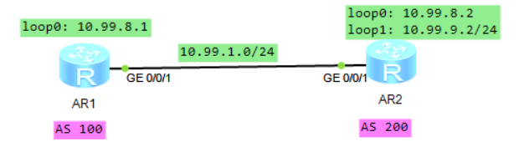
AR1只想让AR2发布10.99.9.0/24的路由

[AR1] ip ip-prefix test-prefix1 index 10 permit 10.99.9.0 24

[AR1] bgp 100
[AR1-bgp] peer 10.99.1.2 as-number 200
[AR1-bgp] peer 10.99.1.2 ip-prefix test-prefix1 import
[AR1-bgp] peer 10.99.1.2 capability-advertise orf ip-prefix send

[AR2-bgp] peer 10.99.1.1 capability-advertise orf ip-prefix receive

[AR1] disp ip routing-table protocol bgp
Route Flags: R - relay, D - download to fib
------------------------------------------------------------------------------
Public routing table : BGP
Destinations : 1 Routes : 1
BGP routing table status : <Active>
Destinations : 1 Routes : 1

Destination/Mask Proto Pre Cost Flags NextHop Interface
10.99.9.0/24 EBGP 255 0 D 10.99.1.2 GigabitEthernet0/0/1

[AR2] disp bgp peer 10.99.1.1 orf ip-prefix
Total number of ip-prefix received: 1
Index Action Prefix MaskLen MinLen MaxLen
10 Permit 10.99.9.0 24

#使用keychain认证
拓扑如下：
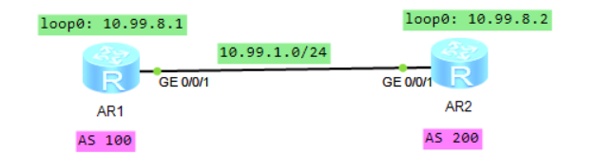

AR1配置：
keychain bgp_key_chain_1 mode periodic daily
receive-tolerance 2
tcp-kind 100
tcp-algorithm-id hmac-sha1-20 17
key-id 1
algorithm hmac-sha1-20
key-string cipher passwdxx
send-time daily 00:00 to 11:59
receive-time daily 00:00 to 11:59
key-id 2
algorithm hmac-sha1-20
key-string cipher passwdxxyy
send-time daily 12:00 to 23:59
receive-time daily 12:00 to 23:59
#
bgp 100
peer 10.99.1.2 as-number 200
peer 10.99.1.2 keychain bgp_key_chain_1
ipv4-family unicast
network 10.99.8.1 255.255.255.255
#
AR2配置同上，这里省略

AR1查看：
<AR1> disp keychain bgp_key_chain_1
Keychain Information:
---------------------
Keychain Name : bgp_key_chain_1
Timer Mode : Daily periodic
Receive Tolerance(min) : 2
TCP Kind : 100
TCP Algorithm IDs :
HMAC-MD5 : 5
HMAC-SHA1-12 : 2
HMAC-SHA1-20 : 17
MD5 : 3
SHA1 : 4
Number of Key IDs : 2
Active Send Key ID : 2
Active Receive Key IDs : 02
Default send Key ID : Not configured

Key ID Information:
-------------------
Key ID : 1
Key string : %$%$L//G.#jjPFZayM*W-_#S3o1m%$%$ (cipher)
Algorithm : HMAC-SHA1-20
SEND TIMER :
Start time : 00:00
End time : 11:59
Status : Inactive
RECEIVE TIMER :
Start time : 00:00
End time : 11:59
Status : Inactive

Key ID : 2
Key string : %$%$|e\ZB]%PT%<r,0VsT(yX3o2y%$%$ (cipher)
Algorithm : HMAC-SHA1-20
SEND TIMER :
Start time : 12:00
End time : 23:59
Status : Active
RECEIVE TIMER :
Start time : 12:00
End time : 23:59
Status : Active

#SoO属性
CE多归属场景下，若开启了as号替换功能，可能会引起路由环路，需要开启SoO（Site of Origin）特性来避免环路
拓扑如下：
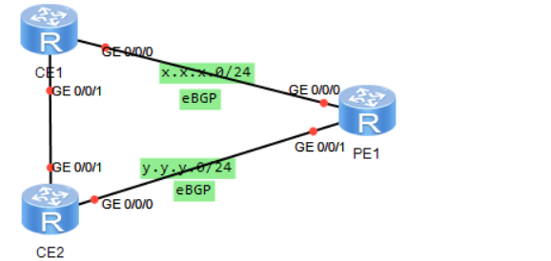
[PE1] bgp xxx
[PE1-bgp] ipv4-family vpn-instance vpn_xx
[PE1-bgp-vpn_xx] peer x.x.x.x soo 30010:600
[PE1-bgp-vpn_xx] peer y.y.y.y soo 30010:600

说明：当本路由器（PE1）从x.x.x.x收到路由时，会带上soo属性值，然后将此路由向其他邻居传递前，会检查配置的soo是否和路由属性中的soo一致，若一致就不通告了，防止引起路由环路

★分布式网关引入arp主机路由
spine-leaf组网中，leaf层配置分布式网关，引入arp主机路由，所有leaf层设备都一样的网关配置

interface Vlanif10
ip address 192.168.10.1 255.255.255.0 #网关地址
mac-address 0000-0000-0001 #如果一台终端连接多个接入层网关时，要求所有接入层网关的mac地址相同
arp timeout 60
arp proxy anyway enable #开启arp代理
arp delete trigger link-down enable #当接口down时，删除其上的所有arp
arp direct-route enable #引入直连路由（仅引入到本设备的路由表中）
arp direct-route preference 1 #引入的直连路由优先级设置为1，默认255
arp smart-discover enable #开启arp智能探测，默认每秒发128个arp请求报文（本网段）
#
arp smart-discover interval 10 count 64 #全局设置为每10秒突发64个arp请求包
#如果网段包含的主机数量过多，如16位的地址段，则不建议开启arp smart-discover，会产生大量的arp包

#前面引入的arp主机路由目前仅存在当前设备中，还得在动态路由协议中宣告出去

ip ip-prefix arp-host-prefix1 index 10 permit 0.0.0.0 32 greater-equal 32 less-equal 32
#创建一个名为arp-host-prefix1的ip前缀规则，匹配32位的主机路由

route-policy arp-host-router1 permit node 10 #创建一个名为arp-host-router1的路由策略
if-match ip-prefix arp-host-prefix1 #匹配ip-prefix
apply community 10:10 #应用团体属性（非必须，可用于路由策略的控制）
#

bgp 100
ipv4-family unicast
import-route direct route-policy arp-host-router1 #引入直连路由时做相应的匹配限制
#

★IGMP
待更新

<Huawei> disp igmp routing-table #查看IGMP路由表
<Huawei> disp multicast routing-table #查看组播路由表
<Huawei> disp multicast forwarding-table #查看组播转发表

★PIM
待更新

<Huawei> disp pim routing-table #查看PIM路由表
<Huawei> disp multicast routing-table #查看组播路由表
<Huawei> disp multicast forwarding-table #查看组播转发表

★第11章、路由配置（ipv6）

★VPNv6实例（VRF虚拟路由转发表）
vpn-instance <==> Virtual Routing Forwarding
将一台路由器划分为几个不同的虚拟路由器使用，将不同的接口加入到不同的vpn-instance中，各vpn-instance分别维护各自的路由协议以及RIB路由表和FIB转发表。同一个vpn实例下可以同时配置ipv4-family以及ipv6-family

[Huawei] ip vpn-instance vpn_22 #创建vpn实例，名为vpn_22
[Huawei-vpn-instance-vpn_22] description vpn_22_manager
[Huawei-vpn-instance-vpn_22] ipv6-family
[Huawei-vpn-instance-vpn_22-af-ipv6] route-distinguisher 22:10 # RD
[Huawei-vpn-instance-vpn_22-af-ipv6] vpn-target 22:10 export-extcommunity # eRT
[Huawei-vpn-instance-vpn_22-af-ipv6] vpn-target 22:10 import-extcommunity # iRT

[Huawei] int Vlanif 22 #进入vlanif接口
[Huawei-Vlanif22] ip binding vpn-instance vpn_22 #三层口绑定vpn实例
[Huawei-Vlanif22] ipv6 enable #开启ipv6功能
[Huawei-Vlanif22] ipv6 address FD00:22::FFFF 64 #配置ipv6地址

[Huawei] disp ipv6 routing-table #查看默认路由表（public）
[Huawei] disp ipv6 routing-table vpn-instance vpn_22 #查看指定的vpn实例路由表

★RIPng
RIP Next Generation下一代RIP协议 是内部网关协议的一种，用于ipv6网络

RIPng使用组播地址FF02::9作为目的地址发送报文，源地址使用链路本地地址FE80::/10

RIPng协议报文共有2种（请求报文和响应报文）封装在UDP报文中，目的端口号521（和ripv1/v2不同）

实验：ripng_ar2240（RIPng基础配置）
拓扑如下：
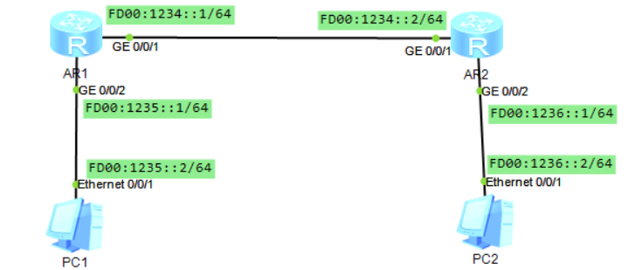

AR1配置：
ipv6
#
interface GigabitEthernet0/0/1
ipv6 enable
ipv6 address FD00:1234::1/64
ripng 1 enable
#
interface GigabitEthernet0/0/2
ipv6 enable
ipv6 address FD00:1235::1/64
ripng 1 enable
#
ripng 1

AR2配置：
ipv6
#
interface GigabitEthernet0/0/1
ipv6 enable
ipv6 address FD00:1234::2/64
ripng 1 enable
#
interface GigabitEthernet0/0/2
ipv6 enable
ipv6 address FD00:1236::1/64
ripng 1 enable
#
ripng 1

AR1查看：
[Huawei] disp ipv6 routing-table protocol ripng #查看ripng路由
Public Routing Table : RIPng
Summary Count : 1

RIPng Routing Table's Status : < Active >
Summary Count : 1

Destination : FD00:1236:: PrefixLength : 64
NextHop : FE80::2E0:FCFF:FE8D:46B8 Preference : 100
Cost : 1 Protocol : RIPng
RelayNextHop : :: TunnelID : 0x0
Interface : GigabitEthernet0/0/1 Flags : D

RIPng Routing Table's Status : < Inactive >
Summary Count : 0

<Huawei> disp ripng 1 database verbose
FD00:1234::/64,
GigabitEthernet0/0/1, cost 0, RIPng-interface
EntryID : 0xb3df21f4 Tag : 0
FD00:1235::/64,
GigabitEthernet0/0/2, cost 0, RIPng-interface
EntryID : 0xb1a91b54 Tag : 0
FD00:1236::/64,
via FE80::2E0:FCFF:FE8D:46B8, GigabitEthernet0/0/1, cost 1
EntryID : 0xb1a91bfc Tag : 0

★OSPF v3

实验：ospf-v3_ar2240（OSPFv3基础配置）
拓扑如下：
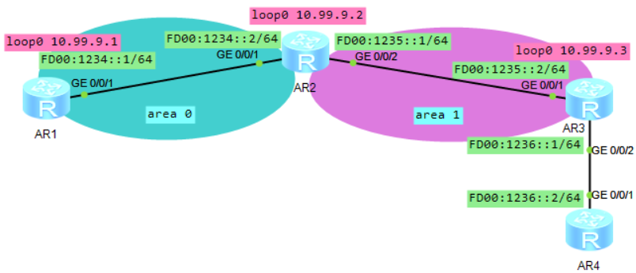
ospfv3的router-id也是一个4字节的无符号整数，采用ipv4地址的形式。如果在同一台设备上运行了多个ospfv3进程，必须为每个进程指定不同的router-id

AR1配置：
ipv6
#
ospfv3 1
router-id 10.99.9.1 #必须手动指定router-id
bandwidth-reference 100000
#
interface GigabitEthernet0/0/1
ipv6 enable
ipv6 address FD00:1234::1/64
ospfv3 1 area 0.0.0.0 #在接口上配置ospfv3区域
#
interface LoopBack0
description for_ospf_router_id
ip address 10.99.9.1 255.255.255.255

AR2配置：
ipv6
#
ospfv3 1
router-id 10.99.9.2
bandwidth-reference 100000
#
interface GigabitEthernet0/0/1
ipv6 enable
ipv6 address FD00:1234::2/64
ospfv3 1 area 0.0.0.0
#
interface GigabitEthernet0/0/2
ipv6 enable
ipv6 address FD00:1235::1/64
ospfv3 1 area 0.0.0.1
#
interface LoopBack0
description for_ospf_router_id
ip address 10.99.9.2 255.255.255.255

AR3配置：
ipv6
#
ospfv3 1
router-id 10.99.9.3
bandwidth-reference 100000
default-route-advertise cost 2000 #引入默认路由
#
interface GigabitEthernet0/0/1
ipv6 enable
ipv6 address FD00:1235::2/64
ospfv3 1 area 0.0.0.1
#
interface GigabitEthernet0/0/2
ipv6 enable
ipv6 address FD00:1236::1/64
#
interface LoopBack0
description for_ospf_router_id
ip address 10.99.9.3 255.255.255.255
#
ipv6 route-static :: 0 FD00:1236::2 #配置默认路由到AR4

AR1查看：
<Huawei> disp ospfv3 routing #查看ospfv3路由信息
Codes : E2 - Type 2 External, E1 - Type 1 External, IA - Inter-Area,
N - NSSA, U - Uninstalled

OSPFv3 Process (1)
Destination Metric Next-hop
E2 ::/0 2000 via FE80::2E0:FCFF:FEB3:6654, GigabitEthernet0/0/1
FD00:1234::/64 99 directly connected, GigabitEthernet0/0/1
IA FD00:1235::/64 198 via FE80::2E0:FCFF:FEB3:6654, GigabitEthernet0/0/1

★IS-IS v6

实验：isis_v6_ne（ensp_pro）
拓扑如下：
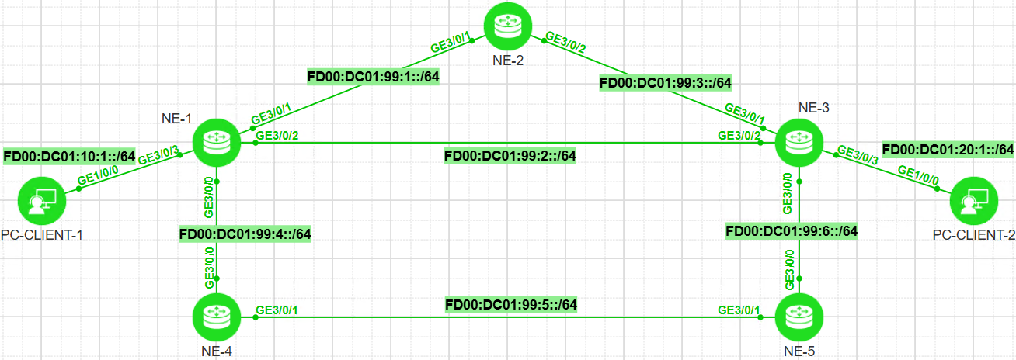
配置步骤：
①首先配置各设备互连口的ipv6地址，具体配置步骤这里省略【所有节点】
interface GigabitEthernet3/0/1
ipv6 enable
ipv6 address FD00:DC01:99:1::1 64
#

②配置底层路由协议isis-v6及BFD【所有节点】
bfd
#
isis 1
is-level level-2
cost-style wide
network-entity 49.0001.1111.1111.1111.00
domain-authentication-mode md5 cipher passwordxxx
ipv6 enable topology ipv6 #开启ipv6多拓扑功能，ipv4和ipv6在各自的拓扑中单独计算，发布及保存路由信息类型为ipv6 MT
ipv6 bfd all-interfaces enable
ipv6 bfd all-interfaces min-tx-interval 10 min-rx-interval 10
ipv6 frr
loop-free-alternate level-2
ti-lfa level-2
#
interface G3/0/1
isis ipv6 enable 1 #在接口上启用ipv6的isis
isis circuit-level level-2
isis circuit-type p2p
isis ppp-negotiation 2-way
isis authentication-mode md5 cipher passwordxxx
isis ipv6 cost 4 #开启ipv6多拓扑时，配置链路cost值需要在ipv6模式下配置，若开启的是standard模式，则isis cost （ipv4模式下配置的cost值）也能继承给ipv6用。
#
interface LoopBack0 #如果有loop环回口，则也需要在环回口上开启isis进程
isis ipv6 enable 1
#

NE-1配置：
bfd
#
isis 1
is-level level-2
cost-style wide
network-entity 49.0001.1111.1111.1111.00
domain-authentication-mode md5 cipher YourPasswdxxx
ipv6 enable topology ipv6
ipv6 bfd all-interfaces enable
ipv6 bfd all-interfaces min-tx-interval 500 min-rx-interval 500
ipv6 frr
loop-free-alternate level-2
ti-lfa level-2
#

interface GigabitEthernet3/0/0
undo shutdown
ipv6 enable
ipv6 address FD00:DC01:99:4::1/64
isis ipv6 enable 1
isis circuit-type p2p
isis circuit-level level-2
isis authentication-mode md5 cipher YourPasswdxxx
isis ipv6 cost 4 #开启ipv6多拓扑时，配置链路cost值需要在ipv6模式下配置
isis ppp-negotiation 2-way
#
interface GigabitEthernet3/0/1
undo shutdown
ipv6 enable
ipv6 address FD00:DC01:99:1::1/64
isis ipv6 enable 1
isis circuit-type p2p
isis circuit-level level-2
isis authentication-mode md5 cipher YourPasswdxxx
isis ppp-negotiation 2-way
#
interface GigabitEthernet3/0/2
undo shutdown
ipv6 enable
ipv6 address FD00:DC01:99:2::1/64
isis ipv6 enable 1
isis circuit-type p2p
isis circuit-level level-2
isis authentication-mode md5 cipher YourPasswdxxx
isis ppp-negotiation 2-way
#
interface GigabitEthernet3/0/3
undo shutdown
ipv6 enable
ipv6 address FD00:DC01:10:1::1/64
isis ipv6 enable 1
#

NE-2配置：
bfd
#
isis 1
is-level level-2
cost-style wide
network-entity 49.0001.2222.2222.2222.00
domain-authentication-mode md5 cipher YourPasswdxxx
ipv6 enable topology ipv6
ipv6 bfd all-interfaces enable
ipv6 bfd all-interfaces min-tx-interval 500 min-rx-interval 500
ipv6 frr
loop-free-alternate level-2
ti-lfa level-2
#
interface GigabitEthernet3/0/1
undo shutdown
ipv6 enable
ipv6 address FD00:DC01:99:1::2/64
isis ipv6 enable 1
isis circuit-type p2p
isis circuit-level level-2
isis authentication-mode md5 cipher YourPasswdxxx
isis ppp-negotiation 2-way
#
interface GigabitEthernet3/0/2
undo shutdown
ipv6 enable
ipv6 address FD00:DC01:99:3::1/64
isis ipv6 enable 1
isis circuit-type p2p
isis circuit-level level-2
isis authentication-mode md5 cipher YourPasswdxxx
isis ppp-negotiation 2-way
#

NE-3配置：
bfd
#
isis 1
is-level level-2
cost-style wide
network-entity 49.0001.3333.3333.3333.00
domain-authentication-mode md5 cipher YourPasswdxxx
ipv6 enable topology ipv6
ipv6 bfd all-interfaces enable
ipv6 bfd all-interfaces min-tx-interval 500 min-rx-interval 500
ipv6 frr
loop-free-alternate level-2
ti-lfa level-2
#
interface GigabitEthernet3/0/0
undo shutdown
ipv6 enable
ipv6 address FD00:DC01:99:6::1/64
isis ipv6 enable 1
isis circuit-type p2p
isis circuit-level level-2
isis authentication-mode md5 cipher YourPasswdxxx
isis ipv6 cost 4 #开启ipv6多拓扑时，配置链路cost值需要在ipv6模式下配置
isis ppp-negotiation 2-way
#
interface GigabitEthernet3/0/1
undo shutdown
ipv6 enable
ipv6 address FD00:DC01:99:3::2/64
isis ipv6 enable 1
isis circuit-type p2p
isis circuit-level level-2
isis authentication-mode md5 cipher YourPasswdxxx
isis ppp-negotiation 2-way
#
interface GigabitEthernet3/0/2
undo shutdown
ipv6 enable
ipv6 address FD00:DC01:99:2::2/64
isis ipv6 enable 1
isis circuit-type p2p
isis circuit-level level-2
isis authentication-mode md5 cipher YourPasswdxxx
isis ppp-negotiation 2-way
#
interface GigabitEthernet3/0/3
undo shutdown
ipv6 enable
ipv6 address FD00:DC01:20:1::1/64
isis ipv6 enable 1
#

NE-4配置：
bfd
#
isis 1
is-level level-2
cost-style wide
network-entity 49.0001.4444.4444.4444.00
domain-authentication-mode md5 cipher YourPasswdxxx
ipv6 enable topology ipv6
ipv6 bfd all-interfaces enable
ipv6 bfd all-interfaces min-tx-interval 500 min-rx-interval 500
ipv6 frr
loop-free-alternate level-2
ti-lfa level-2
#
interface GigabitEthernet3/0/0
undo shutdown
ipv6 enable
ipv6 address FD00:DC01:99:4::2/64
isis ipv6 enable 1
isis circuit-type p2p
isis circuit-level level-2
isis authentication-mode md5 cipher YourPasswdxxx
isis ipv6 cost 4 #开启ipv6多拓扑时，配置链路cost值需要在ipv6模式下配置
isis ppp-negotiation 2-way
#
interface GigabitEthernet3/0/1
undo shutdown
ipv6 enable
ipv6 address FD00:DC01:99:5::1/64
isis ipv6 enable 1
isis circuit-type p2p
isis circuit-level level-2
isis authentication-mode md5 cipher YourPasswdxxx
isis ppp-negotiation 2-way
#

NE-5配置：
bfd
#
isis 1
is-level level-2
cost-style wide
network-entity 49.0001.5555.5555.5555.00
domain-authentication-mode md5 cipher YourPasswdxxx
ipv6 enable topology ipv6
ipv6 bfd all-interfaces enable
ipv6 bfd all-interfaces min-tx-interval 500 min-rx-interval 500
ipv6 frr
loop-free-alternate level-2
ti-lfa level-2
#
interface GigabitEthernet3/0/0
undo shutdown
ipv6 enable
ipv6 address FD00:DC01:99:6::2/64
isis ipv6 enable 1
isis circuit-type p2p
isis circuit-level level-2
isis authentication-mode md5 cipher YourPasswdxxx
isis ipv6 cost 4 #开启ipv6多拓扑时，配置链路cost值需要在ipv6模式下配置
isis ppp-negotiation 2-way
#
interface GigabitEthernet3/0/1
undo shutdown
ipv6 enable
ipv6 address FD00:DC01:99:5::2/64
isis ipv6 enable 1
isis circuit-type p2p
isis circuit-level level-2
isis authentication-mode md5 cipher YourPasswdxxx
isis ppp-negotiation 2-way
#

NE1查看：
<Huawei> disp isis peer
Peer information for ISIS(1)

System Id Interface Circuit Id State HoldTime Type PRI
-------------------------------------------------------------------------
4444.4444.4444* GE3/0/0 006 Up 23s L2 --
2222.2222.2222* GE3/0/1 007 Up 26s L2 --
3333.3333.3333* GE3/0/2 008 Up 23s L2 --

Total Peer(s): 3

<Huawei> disp isis lsdb level-2 3333.3333.3333.00-00 verbose
Database information for ISIS(1)
-----------------------------------
Level-2 Link State Database
LSPID Seq Num Checksum HoldTime Length ATT/P/OL
-----------------------------------------------------------------------------
3333.3333.3333.00-00 0x0000002c 0x4227 1002 224 0/0/0
SOURCE 3333.3333.3333.00
Auth: ***** Len: 16 Type: MD5
NLPID IPV6
AREA ADDR 49.0001
INTF ADDR V6 FD00:DC01:99:3::2
INTF ADDR V6 FD00:DC01:99:6::1
INTF ADDR V6 FD00:DC01:20:1::1
INTF ADDR V6 FD00:DC01:99:2::2
Topology Standard, IPV6
+MT NBR ID 2222.2222.2222.00 COST: 10 MT: 2 (IPV6)
+MT NBR ID 5555.5555.5555.00 COST: 4 MT: 2 (IPV6)
+MT NBR ID 1111.1111.1111.00 COST: 10 MT: 2 (IPV6)
IPV6 FD00:DC01:20:1::/64 COST: 10 MT: 2
IPV6 FD00:DC01:99:3::/64 COST: 10 MT: 2
IPV6 FD00:DC01:99:6::/64 COST: 4 MT: 2
IPV6 FD00:DC01:99:2::/64 COST: 10 MT: 2

Total LSP(s): 1
*(In TLV)-Leaking Route, *(By LSPID)-Self LSP, +-Self LSP(Extended),
ATT-Attached, P-Partition, OL-Overload

<Huawei> disp ipv6 routing-table brief
Route Flags: R - relay, D - download to fib, T - to vpn-instance, B - black hole route
------------------------------------------------------------------------------
Routing Table : _public_
Destinations : 16 Routes : 17
Format :
Destination/Mask Protocol
Nexthop Interface
------------------------------------------------------------------------------
::1/128 Direct
::1 InLoopBack0
::FFFF:127.0.0.0/104 Direct
::FFFF:127.0.0.1 InLoopBack0
::FFFF:127.0.0.1/128 Direct
::1 InLoopBack0
FD00:DC01:10:1::/64 Direct
FD00:DC01:10:1::1 GigabitEthernet3/0/3
FD00:DC01:10:1::1/128 Direct
::1 GigabitEthernet3/0/3
FD00:DC01:20:1::/64 ISIS-L2
FE80::3A58:54FF:FE11:302 GigabitEthernet3/0/2
FD00:DC01:99:1::/64 Direct
FD00:DC01:99:1::1 GigabitEthernet3/0/1
FD00:DC01:99:1::1/128 Direct
::1 GigabitEthernet3/0/1
FD00:DC01:99:2::/64 Direct
FD00:DC01:99:2::1 GigabitEthernet3/0/2
FD00:DC01:99:2::1/128 Direct
::1 GigabitEthernet3/0/2
FD00:DC01:99:3::/64 ISIS-L2
FE80::3A49:76FF:FE11:301 GigabitEthernet3/0/1
FD00:DC01:99:3::/64 ISIS-L2
FE80::3A58:54FF:FE11:302 GigabitEthernet3/0/2
FD00:DC01:99:4::/64 Direct
FD00:DC01:99:4::1 GigabitEthernet3/0/0
FD00:DC01:99:4::1/128 Direct
::1 GigabitEthernet3/0/0
FD00:DC01:99:5::/64 ISIS-L2
FE80::3A09:33FF:FE11:300 GigabitEthernet3/0/0
FD00:DC01:99:6::/64 ISIS-L2
FE80::3A58:54FF:FE11:302 GigabitEthernet3/0/2
FE80::/10 Direct
:: NULL0

<Huawei> disp ipv6 routing-table FD00:DC01:20:1:: 64 verbose
Route Flags: R - relay, D - download to fib, T - to vpn-instance, B - black hole route
------------------------------------------------------------------------------
Routing Table : _public_
Summary Count : 1

Destination : FD00:DC01:20:1:: PrefixLength : 64
NextHop : FE80::3A58:54FF:FE11:302 Preference : 15
Neighbour : :: ProcessID : 1
Label : NULL Protocol : ISIS-L2
State : Active Adv Cost : 20
Entry ID : 0 EntryFlags : 0x00000000
Reference Cnt: 0 Tag : 0
Priority : medium Age : 00h13m01s
IndirectID : 0x1000031 Instance :
RelayNextHop : :: TunnelID : 0x0
Interface : GigabitEthernet3/0/2 Flags : D
RouteColor : 0 QoSInfo : 0x0
BkNextHop : FE80::3A49:76FF:FE11:301 BkInterface : GigabitEthernet3/0/1
BkLabel : NULL BkTunnelID : 0x0
BkPETunnelID : 0x0 BkIndirectID : 0x1000032

shutdown interface GE3/0/2之后：
<Huawei> disp ipv6 routing-table FD00:DC01:20:1:: 64 verbose
Route Flags: R - relay, D - download to fib, T - to vpn-instance, B - black hole route
------------------------------------------------------------------------------
Routing Table : _public_
Summary Count : 1

Destination : FD00:DC01:20:1:: PrefixLength : 64
NextHop : FE80::3A09:33FF:FE11:300 Preference : 15
Neighbour : :: ProcessID : 1
Label : NULL Protocol : ISIS-L2
State : Active Adv Cost : 28
Entry ID : 0 EntryFlags : 0x00000000
Reference Cnt: 0 Tag : 0
Priority : medium Age : 00h00m02s
IndirectID : 0x1000034 Instance :
RelayNextHop : :: TunnelID : 0x0
Interface : GigabitEthernet3/0/0 Flags : D
RouteColor : 0 QoSInfo : 0x0

★第12章、隧道技术

★GRE隧道
Generic Routing Encapsulation通用路由封装协议，GRE封装在IPv4报文中，ipv4上层协议号为47
GRE头部最短4字节，最长16字节，头部之后为被封装的ip报文
解封装过程：网络层发现IP头的协议号为47则剥离IP头部，将剩下的部分交给GRE模块，GRE模块剥离GRE头部后，剩下的内层IP数据包交给网络层继续处理

实验：GRE_ne40e（ensp）
拓扑如下：
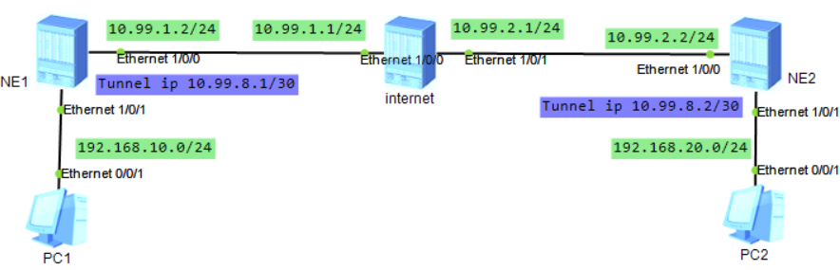
NE1和NE2之间建立一条gre隧道，隧道2端需要配置ip（同一网段的）

NE1配置：
interface Ethernet1/0/0
undo shutdown
ip address 10.99.1.2 255.255.255.0
dcn
dcn mode vlan
binding tunnel gre #出接口需要绑定gre隧道
#
interface Ethernet1/0/1
undo shutdown
ip address 192.168.10.1 255.255.255.0
dcn
dcn mode vlan
#
interface Tunnel0/0/0 #创建隧道接口
ip address 10.99.8.1 255.255.255.252
tunnel-protocol gre #隧道协议为GRE
keepalive #保持连接
keepalive period 10 #保活周期设置为10秒，默认5秒
source 10.99.1.2 #源ip为出接口ip
destination 10.99.2.2 #目的ip为隧道对端设备的出接口ip
#
ip route-static 10.99.2.0 255.255.255.0 10.99.1.1 #普通路由，用于连接到对端的
ip route-static 192.168.20.0 255.255.255.0 Tunnel0/0/0 #业务路由，将目标网段下一跳设置为隧道接口

NE2配置：
interface Ethernet1/0/0
undo shutdown
ip address 10.99.2.2 255.255.255.0
dcn
dcn mode vlan
binding tunnel gre
#
interface Ethernet1/0/1
undo shutdown
ip address 192.168.20.1 255.255.255.0
dcn
dcn mode vlan
#
interface Tunnel0/0/0
ip address 10.99.8.2 255.255.255.252
tunnel-protocol gre
keepalive
keepalive period 10
source 10.99.2.2
destination 10.99.1.2
#
ip route-static 10.99.1.0 255.255.255.0 10.99.2.1
ip route-static 192.168.10.0 255.255.255.0 10.99.8.1 #业务路由，目标网段下一跳也可设置为隧道对端ip

NE1查看：
[~HUAWEI] display tunnel-info all
Tunnel ID Type Destination Status
--------------------------------------------------------------------------------
0x00000000050000001a gre 10.99.2.2 UP

★IPsec VPN

实验：IPsec_VPN_ar2240（ensp）
拓扑如下：
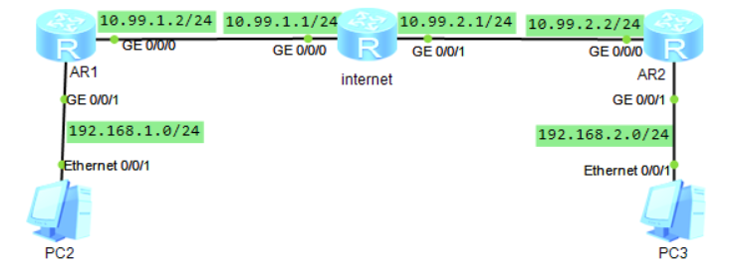
拓扑图如上，AR1的业务网段为192.168.1.0/24，出接口ip为10.99.1.2，网关10.99.1.1
AR2的业务网段为192.168.2.0/24，出接口ip为10.99.2.2，网关10.99.2.1
internet上没有vpn业务网段相关的路由

AR1配置：
acl number 3000 #配置acl匹配目标流（vpn业务流量）
rule 1 permit ip source 192.168.1.0 0.0.0.255 destination 192.168.2.0 0.0.0.255
#
ipsec proposal pro1 #配置ipsec安全提议
esp authentication-algorithm sha1 #消息摘要算法
esp encryption-algorithm aes-128 #数据加密算法
encapsulation-mode tunnel #使用隧道模式（默认）
#
ike proposal 5 #配置ike安全提议
esp authentication-algorithm sha1 #消息摘要算法（默认）
encryption-algorithm aes-cbc-128 #数据加密算法
authentication-method pre-share #认证方式为预共享密码（默认）
#
ike peer peer1 v1 #配置ike对端
pre-shared-key cipher passwdxx
ike-proposal 5
remote-address 10.99.2.2
#
ipsec policy ipsec_po1 10 isakmp #配置ipsec策略
security acl 3000
ike-peer peer1
proposal pro1
#
interface GigabitEthernet0/0/0 #出接口上应用ipsec策略
ip address 10.99.1.2 255.255.255.0
ipsec policy ipsec_po1
#
interface GigabitEthernet0/0/1
ip address 192.168.1.1 255.255.255.0
#
ip route-static 0.0.0.0 0.0.0.0 10.99.1.1 #默认路由（或者前往目标vpn业务网段的路由）下一跳要指向出接口网关

AR2配置：
acl number 3000
rule 1 permit ip source 192.168.2.0 0.0.0.255 destination 192.168.1.0 0.0.0.255
#
ipsec proposal pro1
esp authentication-algorithm sha1
esp encryption-algorithm aes-128
#
ike proposal 5
encryption-algorithm aes-cbc-128
#
ike peer peer1 v1
pre-shared-key cipher passwdxx
ike-proposal 5
remote-address 10.99.1.2
#
ipsec policy ipsec_po1 10 isakmp
security acl 3000
ike-peer peer1
proposal pro1
#
interface GigabitEthernet0/0/0
ip address 10.99.2.2 255.255.255.0
ipsec policy ipsec_po1
#
interface GigabitEthernet0/0/1
ip address 192.168.2.1 255.255.255.0
#
ip route-static 0.0.0.0 0.0.0.0 10.99.2.1

AR1上查看：
<Huawei> disp ipsec sa brief
Number of SAs:2
Src address Dst address SPI VPN Protocol Algorithm
-------------------------------------------------------------------------------
10.99.2.2 10.99.1.2 1049700406 0 ESP E:AES-128 A:SHA1-96
10.99.1.2 10.99.2.2 4120190158 0 ESP E:AES-128 A:SHA1-96
[Huawei] disp ike proposal #查看ike提议
[Huawei] disp ipsec proposal #查看ipsec提议
[Huawei] disp ike peer #查看ike对端
[Huawei] disp ipsec statistics esp #查看ipsec统计情况

★L2TP VPN
L2TP（Layer 2 Tunnel Protocol）二层隧道协议，是将PPP报文封装在L2TP报文里，再封装在1701/UDP里

L2TP应用场景：
③Client-Initaited
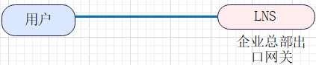
直接由用户侧发起连接（用户侧充当LAC），LNS侧需要为每个远程用户建立一条隧道，建立L2TP隧道，建立L2TP会话（PPP），最后传输数据
LAC（L2TP Access Concentrator）
LNS（L2TP Network Server）

会话是有方向的：
Incomming会话：从LAC到LNS
Outgoing会话：从LNS到LAC

实验：L2TP_VPN_ar2220（实体设备）
拓扑如下：

1.先添加一个用户，用于l2tp拨号的（也可用radius验证）
[Huawei] aaa
[Huawei-aaa] local-user coflee password cipher xxxx
Info: Add a new user.
[Huawei-aaa] local-user coflee service-type ppp
[Huawei-aaa]quit
2.配置拨号后的地址池
[Huawei] ip pool lns
Info: It's successful to create an IP address pool.
[Huawei-ip-pool-lns] network 192.168.33.0 mask 255.255.255.0
[Huawei-ip-pool-lns] gateway-list 192.168.33.1
[Huawei-ip-pool-lns] dns-list 8.8.8.8
[Huawei-ip-pool-lns]quit
3.配置虚拟接口模板
[Huawei] int Virtual-Template 1
Dec 5 2019 11:22:41-08:00 Huawei %%01IFPDT/4/IF_STATE(l)[0]:Interface Virtual-T
emplate1 has turned into UP state.
[Huawei-Virtual-Template1] ip add 192.168.33.1 255.255.255.0
[Huawei-Virtual-Template1] ppp authentication chap
[Huawei-Virtual-Template1] remote address pool lns
[Huawei-Virtual-Template1] quit
[Huawei]
4.配置l2tp vpn
[Huawei] l2tp enable
[Huawei] l2tp-group 1
[Huawei-l2tp1] tunnel name LNS
[Huawei-l2tp1] undo tunnel authentication
[Huawei-l2tp1] allow l2tp Virtual-Template 1
[Huawei-l2tp1] quit

★PPPoe服务器
1.配置虚拟接口模板
[Huawei] int Virtual-Template 2
Dec 5 2019 11:30:10-08:00 Huawei %%01IFPDT/4/IF_STATE(l)[1]:Interface Virtual-T
emplate2 has turned into UP state.
[Huawei-Virtual-Template2] ppp authentication-mode chap call-in domain xxx.com
[Huawei-Virtual-Template2] remote address pool pppoe1
[Huawei-Virtual-Template2] ip address unnumbered interface g0/0/2
[Huawei-Virtual-Template2] quit
2.配置ip地址池
[Huawei] ip pool pppoe1
Info: It's successful to create an IP address pool.
[Huawei-ip-pool-pppoe1] network 10.1.1.0 mask 255.255.255.0
[Huawei-ip-pool-pppoe1] gateway-list 10.1.1.1
[Huawei-ip-pool-pppoe1] dns-list 8.8.8.8
[Huawei-ip-pool-pppoe1]quit
3.配置用户认证（使用radius）
[Huawei] radius-server template rds #创建radius-server模板
Info: Create a new server template.
[Huawei-radius-rds] radius-server shared-key cipher xxxx
[Huawei-radius-rds] radius-server authentication 10.1.1.99 1812 #指定验证服务器及端口
[Huawei-radius-rds] radius-server accounting 10.1.1.99 1813 #指定计费服务器及端口
[Huawei-radius-rds] quit
[Huawei] aaa
[Huawei-aaa] authentication-scheme rdsAuth #创建验证方案
Info: Create a new authentication scheme.
[Huawei-aaa-authen-rdsAuth] authentication-mode radius #验证模式用radius
[Huawei-aaa-authen-rdsAuth] quit
[Huawei-aaa] accounting-scheme rdsAcct #创建计费方案
Info: Create a new accounting scheme.
[Huawei-aaa-accounting-rdsAcct] accounting-mode radius #验证模式用radius
[Huawei-aaa-accounting-rdsAcct] quit
[Huawei-aaa] domain xxx.com #创建域
Info: Success to create a new domain.
[Huawei-aaa-domain-xxx.com] authentication-scheme rdsAuth
[Huawei-aaa-domain-xxx.com] accounting-scheme rdsAcct
[Huawei-aaa-domain-xxx.com] radius-server rds
[Huawei-aaa-domain-xxx.com]quit
[Huawei-aaa]quit
[Huawei]
[Huawei] domain xxx.com #指定该域为默认的，缺省的域
[Huawei] domain xxx.com admin #指定该域为默认的，缺省的域，当用户拨号时若不指定域名，则缺省为该域，然后使用该域的验证方案和计费方案，即radius（注意不要和登录本设备的认证方案冲突了）

4.接口上应用
[Huawei] int g0/0/2
[Huawei-GigabitEthernet0/0/2] pppoe-server bind virtual-template 2
[Huawei-GigabitEthernet0/0/2] mtu 1492 #因为pppoe报文占8字节开销
[Huawei-GigabitEthernet0/0/2] quit

[Huawei] disp pppoe-server session all #查看pppoe会话情况

★PPPoe客户端
[Huawei] int Dialer 1 #创建拨号接口1
Dec 5 2019 11:46:45-08:00 Huawei %%01IFPDT/4/IF_STATE(l)[2]:Interface Dialer1 h
as turned into UP state.
[Huawei-Dialer1] link-potocol ppp
[Huawei-Dialer1] ppp chap user cof
[Huawei-Dialer1] ppp chap password cipher xxx
[Huawei-Dialer1] ip address ppp-negotiate
[Huawei-Dialer1] dialer user cof #该用户名同ppp用户
[Huawei-Dialer1] dialer bundle 1
[Huawei-Dialer1] dialer timer idle 300
INFO: The configuration will become effective after link reset.
[Huawei-Dialer1] dialer-group 1
[Huawei-Dialer1]quit
[Huawei] int g0/0/1
[Huawei-GigabitEthernet0/0/1] pppoe-client dial-bundle-number 1 #出接口上配置为pppoe拨号
[Huawei-GigabitEthernet0/0/1] quit
[Huawei] ip route-static 0.0.0.0 0.0.0.0 Dialer 1 #缺省路由下一跳指向拨号接口1

★MPLS
LSR（Label Switch Router）标签交换路由器
LER（Label Edge Router）标签边界路由器
FEC（Forwarding Equivalence Class转发等价类）

LSP（标签转发路径）mpls报文经过的路径，路径起始lsr称为ingress-LER（入站LER），最后一个lsr称为egress-LER（出站LER）；可以静态创建一条LSP，也可动态创建；一条LSP途经各跳路由器时，在路由器上的label id可以不一样，只要能将报文送达目的地即可，和vlan类似，中间经过的vlan id可不一样，只要将报文送达目标主机即可。
不过：一条LSP的流量是单向的，要想双方可达，需要建立一来一回共2条LSP

LDP（标签分发协议）用于动态建立LSP，在RFC3036中被定义

#静态LSP
一条LSP在各结点上面对应的label值可不一样，一条LSP流量是单向的

实验：mpls_static_LSP_ar2240（ensp）
拓扑如下：
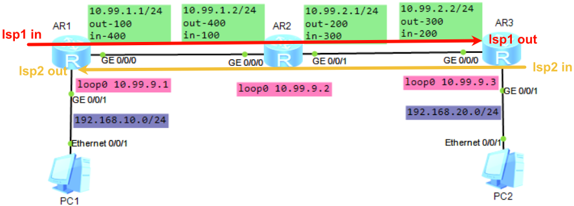
AR1和AR3为LER节点，AR2为Transit节点
在LER（AR1和AR2）上要求配置到2边客户侧的路由，
在transit上不需要配置2端pc的路由，根据mpls label进行转发
ingress负责将匹配到的报文打上mpls label（根据destination目的网段及nexthop下一跳ip进行匹配）
egress负责将 入接口匹配上in-label的流量 剥去mpls label，再进行普通路由转发

AR1配置：
mpls lsr-id 10.99.9.1 #指定mpls的LSR-ID，一般使用loop口的ip，必须手工配置，没有缺省的
mpls #全局开启mpls
#
interface GigabitEthernet0/0/0
ip address 10.99.1.1 255.255.255.0
mpls #LSP经过的接口上开启mpls
#
interface GigabitEthernet0/0/1
ip address 192.168.10.1 255.255.255.0
#
interface LoopBack0
description for_mpls_lsr_id
ip address 10.99.9.1 255.255.255.255
#
ip route-static 192.168.20.0 255.255.255.0 10.99.1.2 #LER节点上要有去往目标网段的路由
#
static-lsp ingress lsp1 destination 192.168.20.0 24 nexthop 10.99.1.2 out-label 100
static-lsp egress lsp2 incoming-interface GigabitEthernet0/0/0 in-label 400

AR2配置：
mpls lsr-id 10.99.9.2
mpls
#
interface GigabitEthernet0/0/0
ip address 10.99.1.2 255.255.255.0
mpls
#
interface GigabitEthernet0/0/1
ip address 10.99.2.1 255.255.255.0
mpls
#
interface LoopBack0
description for_mpls_lsr_id
ip address 10.99.9.2 255.255.255.255
#
# LSP路径中间节点没有任何业务网段的路由
static-lsp transit lsp1 incoming-interface GigabitEthernet0/0/0 in-label 100 nexthop 10.99.2.2 out-label 200
static-lsp transit lsp2 incoming-interface GigabitEthernet0/0/1 in-label 300 nexthop 10.99.1.1 out-label 400

AR3配置：
mpls lsr-id 10.99.9.3
mpls
#
interface GigabitEthernet0/0/0
ip address 10.99.2.2 255.255.255.0
mpls
#
interface GigabitEthernet0/0/1
ip address 192.168.20.1 255.255.255.0
#
interface LoopBack0
description for_mpls_lsr_id
ip address 10.99.9.3 255.255.255.255
#
ip route-static 192.168.10.0 255.255.255.0 10.99.2.1 #LER节点上要有去往目标网段的路由
#
static-lsp ingress lsp2 destination 192.168.10.0 24 nexthop 10.99.2.1 out-label 300
static-lsp egress lsp1 incoming-interface GigabitEthernet0/0/0 in-label 200

AR1上查看：
<Huawei> disp mpls static-lsp #查看静态lsp状态
<Huawei> disp mpls lsp #查看lsp状态
-------------------------------------------------------------------------------
LSP Information: STATIC LSP
-------------------------------------------------------------------------------
FEC In/Out Label In/Out IF Vrf Name
-/- 400/NULL GE0/0/0/-
192.168.20.0/24 NULL/100 -/GE0/0/0

AR2上查看：
<Huawei> disp mpls lsp #查看lsp状态
-------------------------------------------------------------------------------
LSP Information: STATIC LSP
-------------------------------------------------------------------------------
FEC In/Out Label In/Out IF Vrf Name
-/- 100/200 GE0/0/0/GE0/0/1
-/- 300/400 GE0/0/1/GE0/0/0

#动态LSP（mpls-LDP）
1.LSP数据总是从源发往目的，由上游发往下游
2.在lsp路径倒数第2跳弹出mpls label，即离目的路由器的前一个路由器上把目标流量的mpls label剥去，这样当流量传到最后一跳路由器时直接进行普通路由转发，无需再在最后一跳进行mpls label剥离工作，减轻负担

LDP报文基于TCP，封装在646/tcp里（hello报文是封装在udp里，发送目标地址224.0.0.2，每5秒周期发送）
LDP传输地址是用于建立tcp连接的，默认同LSR-ID的ip（可在其他三层接口上指定其为ldp传输地址）

int g0/0/1
mpls ldp transport-address interface #指定使用此接口的ip为传输地址

★LDP标签发布方式
①DU（Downstream Unsolicited）下游自主模式，当建立完ldp会话后，下游主动向上游发布标签映射通告报文
②DoD（Downstream On Demand）下游按需要，触发方式，在收到上游lsp的标签请求报文后，才会发送上游需要的标签映射信息给上游

华为路由器默认使用DU下游自主模式，但默认只发布32位掩码路由的标签映射信息

★LDP标签分配的控制方式
①Independent独立控制方式，中间路由器在没有收到下游lsr发来的标签信息时，就可向上游发布
②Ordered有序控制方式，中间路由器必须收到下游lsr发来的标签信息时，才可向上游发布，（华为路由器默认）
独立控制方式下，中间结点标签通告较自由，但无法保证到目标网络的lsp是连续的，容易发生lsp断裂情况
有序控制方式下，标签通告受到一定的限制，建立lsp效率会受到一定影响，但确保了整条lsp是连续的

★标签的保持方式
①保守方式（conservative retention mode）对于特定的一条FEC，即使从多个LDP邻居都收到了标签映射，该lsr只会将最优的标签保留下来
②自由方式（liberal retention mode）lsr会保存所有收到的标签映射，即使有些标签没有对应的路由或没有下一跳，优点是当网络发生故障时可以立即使用新的标签计算出新的LSP路径，收敛较快
mpls ldp
label-retention conservative #修改标签的默认保留方式为conservative保守方式
华为设备默认为： DU+有序+自由

★LDP和IGP路由同步
当主备链路切换时，IGP路由协议收敛速度要快于LDP协议的，这会导致旧的LSP被删除，而新的LSP未建立好，导致业务中断一会，一般在5s左右，开启LDP和IGP同步后，会在链路切换之前抑制igp邻居关系的建立，先建立新的LSP（旧的LSP仍保留），新的LSP建立完成后，再切换链路删除旧的LSP
int g0/0/1
ospf ldp-sync #配置ospf和LDP同步
isis ldp-sync #配置isis和LDP同步
说明：当主路径断了之后，业务不会中断（标签的保持方式默认是自由模式）可以实现快速路径切换，当主路径恢复后，如果没有配置LDP和IGP路由同步，则会有中断

★在MPLS骨干网内部不建议对路由进行汇总，否则会导致LSP不连续

★动态LSP配置
只需要在全局启动mpls及mpls ldp，再在骨干网接口上启用mpls ldp即可
mpls lsr-id 10.1.1.1 #指定mpls的LSR-ID，一般使用loop口的ip，必须手工配置，没有缺省的
mpls #进入mpls配置界面
mpls ldp #全局开启mpls ldp
#
mpls ldp
label distribution control-mode ordered #设置标签分配控制方式为ordered有序标签分配控制
label-retention conservative #设置标签的默认保留方式为conservative保守方式？
#
int g0/0/1
ip addr 10.2.2.1 24
mpls #LSP经过的接口上开启mpls
mpls ldp #LSP经过的接口上开启mpls ldp
mpls ldp advertisement du #设置标签发布模式为DU下游自由
#默认情况下
#配置DU发布模式，则自动绑定Liberal自由模式的保持方式
#配置DoD发布模式，则自动绑定Conservative保守模式的保持方式

disp mpls ldp session #查看ldp邻居会话状态
disp mpls lsp #查看lsp转发表，默认只学到32位掩码的标签映射，可用lsp-trigger引入其他路由；同一条路由对应2个标签，有NULL的，有非空的，如果本地接收到去往目标前缀的报文时（ingress），使用入标签为NULL的那条lsp，如果接收到带有标签的mpls报文（transit），则使用不带NULL的那条lsp

★给指定的路由分发标签
ip ip-prefix mpls_yewu_01 permit 192.168.20.0 24 #创建一条ip前缀匹配
#
mpls #进入mpls配置界面
lsp-trigger ip-prefix mpls_yewu_01 #将此ip前缀匹配的路由在ldp中宣告
#如果指定使用某ip-prefix进行 触发标签分发，则默认的32位主机路由就不会再分发标签了，已分发的32位主机路由标签也会被撤销。默认情况下不指定lsp-trigger时，就是：lsp-trigger host
可以指定 lsp-trigger all 分发所有FEC标签
#
disp mpls lsp include 192.168.20.0 24 verbose #查看lsp转发表中关于此路由的详细情况

★LDP标签过滤
ip ip-prefix xxx permit 10.22.22.0 24 #创建一条ip前缀匹配
#
mpls
inbound peer 10.2.2.1 fec ip-prefix xxx #配置ldp inbound策略，只接收匹配的标签映射
#

实验：mpls_LDP_ospf_ar2240（ensp）
拓扑如下：
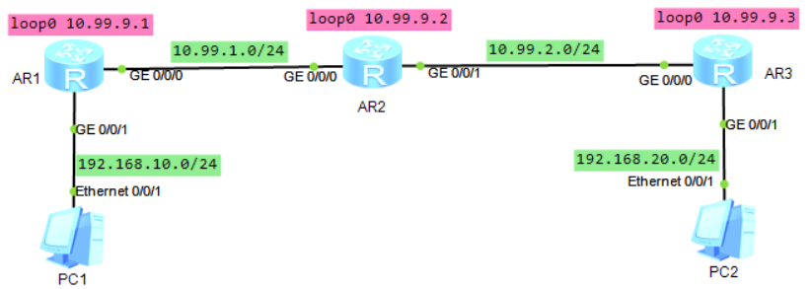

AR1配置：
mpls lsr-id 10.99.9.1
mpls #进入mpls配置界面
lsp-trigger ip-prefix mpls_yewu_01 #将此ip前缀匹配的路由在ldp中宣告（此时不会再给32位主机路由分配标签）
#
mpls ldp #全局开启mpls ldp
#
interface GigabitEthernet0/0/0
ip address 10.99.1.1 255.255.255.0
ospf ldp-sync #配置ospf和LDP同步
mpls #LSP经过的接口上开启mpls
mpls ldp #LSP经过的接口上开启mpls ldp
#
interface GigabitEthernet0/0/1
ip address 192.168.10.1 255.255.255.0
#
interface LoopBack0
description for_mpls_lsr_id__ospf_router_id
ip address 10.99.9.1 255.255.255.255
#
ospf 1 router-id 10.99.9.1
bandwidth-reference 100000
area 0.0.0.0
network 10.99.1.0 0.0.0.255
network 10.99.9.1 0.0.0.0
network 192.168.10.0 0.0.0.255
#
ip ip-prefix mpls_yewu_01 index 10 permit 192.168.10.0 24 #创建一条ip前缀匹配，匹配业务流量
#华为路由器默认使用DU下游自主模式，但默认只发布32位掩码路由的标签映射信息

AR2配置：
mpls lsr-id 10.99.9.2
mpls
#
mpls ldp
#
interface GigabitEthernet0/0/0
ip address 10.99.1.2 255.255.255.0
ospf ldp-sync
mpls
mpls ldp
#
interface GigabitEthernet0/0/1
ip address 10.99.2.1 255.255.255.0
ospf ldp-sync
mpls
mpls ldp
#
interface LoopBack0
description for_mpls_lsr_id__ospf_router_id
ip address 10.99.9.2 255.255.255.255
#
ospf 1 router-id 10.99.9.2
bandwidth-reference 100000
area 0.0.0.0
network 10.99.1.0 0.0.0.255
network 10.99.2.0 0.0.0.255
network 10.99.9.2 0.0.0.0

AR3配置：
mpls lsr-id 10.99.9.3
mpls
lsp-trigger ip-prefix mpls_yewu_01
#
mpls ldp
#
interface GigabitEthernet0/0/0
ip address 10.99.2.2 255.255.255.0
ospf ldp-sync
mpls
mpls ldp
#
interface GigabitEthernet0/0/1
ip address 192.168.20.1 255.255.255.0
#
interface LoopBack0
description for_mpls_lsr_id__ospf_router_id
ip address 10.99.9.3 255.255.255.255
#
ospf 1 router-id 10.99.9.3
bandwidth-reference 100000
area 0.0.0.0
network 10.99.2.0 0.0.0.255
network 10.99.9.3 0.0.0.0
network 192.168.20.0 0.0.0.255
#
ip ip-prefix mpls_yewu_01 index 10 permit 192.168.20.0 24

AR1查看：
<Huawei> disp mpls ldp session #查看ldp邻居会话状态
LDP Session(s) in Public Network
Codes: LAM(Label Advertisement Mode), SsnAge Unit(DDDD:HH:MM)
A '*' before a session means the session is being deleted.
------------------------------------------------------------------------------
PeerID Status LAM SsnRole SsnAge KASent/Rcv
------------------------------------------------------------------------------
10.99.9.2:0 Operational DU Passive 0000:00:24 97/97
------------------------------------------------------------------------------
TOTAL: 1 session(s) Found.

<Huawei> disp mpls lsp #查看lsp转发表
-------------------------------------------------------------------------------
LSP Information: LDP LSP
-------------------------------------------------------------------------------
FEC In/Out Label In/Out IF Vrf Name
10.99.9.2/32 1024/3 -/GE0/0/0
192.168.20.0/24 1026/1026 -/GE0/0/0
192.168.10.0/24 3/NULL -/-

#mpls_VPN

VPN解决的问题：
①不同的用户可使用重叠（相同）的ip地址段，在转发时互不干扰，路由表隔离开来
②用户的ip地址不暴露在外网上，是以隧道的方式传递的（将用户流量封装在外网流量之上）

VPN隧道分类：
①pptp/l2tp/vxlan这些是将用户的二层流量（mac帧）封装在外网的udp报文之上，也称为二层隧道协议
②ipsec这种是将用户的三层流量（ip报文）封装在外网的ip报文之上，也称为三层隧道协议
③mpls vpn这种是在用户的三层流量之前插入一个mpls Label，在外网上只根据mpls label进行转发，也称为第二层之上和第三层之下的隧道技术

外网是指不属于用户内部网络的网络，是用来承载用户内部网络流量并打通用户不同站点之间的通信的网络。

mpls vpn相关概念
①vpn-instance（vpn实例，VRF）
不同的用户可能会使用相同的网段，当一台CE接入路由器连接多个用户网络为多个用户提供服务时，会导致路由冲突，这时可以将不同的用户流量隔离起来，单独使用一套路由转发表，就不会冲突了，
这些路由转发表称为VRF（Virtual Routing and Forwarding table），然后在宣告这些不同的路由转发表信息时得带上一些额外的信息去区分不同的用户

在mpls vpn里，不同的用户VRF数据出站时会打上不同的mpls label

②RD（Route Distinguisher）
RD用于区分使用相同地址空间的IPv4前缀，增加了RD的IPv4地址称为VPN-IPv4地址（即VPNv4地址）。每个vpn实例的RD值全局唯一且不相同
1）不同用户的vpn实例之间RD值不能相同
2）同一用户的vpn实例，在不同设备上/站点上其RD值可以相同（前提是各站点上私网前缀不冲突），也可不相同

RD字段有8字节，其中2字节的类型，6字节的RD值，RD值可写为xx:yy（有以下2种写法）
类型0 | ASN:yy | ASN表示as号，2字节，yy表示服务提供商自己分配给用户vpn实例的一个id，4字节
类型1 | IP-addr:yy | ip-addr使用4字节，yy表示服务提供商自己分配给用户vpn实例的一个id，4字节

③RT（Route Target）
也称为VPN-Target，用于在用户VRF里进行路由引入与导出时进行控制，如果一个用户的不同站点间需要互相学习路由，则需要使用相同的RT，或者说某路由器收到的路由信息中的eRT要与本站点的iRT匹配，才会引入此路由
RT字段有8字节，其中2字节的类型，6字节的RT值，RT值可写为xx:yy （xx和yy不可同时为0）
RT是BGP扩展团体属性，有2种类型
类型值0x0002： 2字节AS：4字节id
类型值0x0102： 4字节ip：2字节id

一条vpn路由可带多个RT值，可灵活地控制不同站点间路由的引入

mpls_VPNv4配置步骤：

1、首先配置各设备互连口的ip地址，具体配置步骤这里省略【所有节点】

2、规划3个loopback接口【所有节点】
interface LoopBack 0
description for_ospf_router_id
ip address 10.99.250.1 32
#
interface LoopBack 1
description for_mpls_lsr_id
ip address 10.99.251.1 32
#
interface LoopBack 2
description for_bgp_router_id
ip address 10.99.252.1 32
#

3、配置底层路由协议，如isis或ospf，本例使用ospf【所有节点】
ospf 1 router-id 10.99.250.1
area 0.0.0.0
network 10.99.1.0 0.0.0.255
network 10.99.250.1 0.0.0.0
#

4、配置mpls【所有节点】
mpls lsr-id 10.99.251.1 #指定mpls的LSR-ID，一般使用loop口的ip，必须手工配置，没有缺省的
mpls #全局开启mpls
#
mpls ldp #全局开启mpls ldp
#
interface GigabitEthernet0/0/0 #域内所有互联接口
ospf ldp-sync #配置ospf和LDP同步
mpls #LSP经过的接口上开启mpls
mpls ldp #LSP经过的接口上开启mpls ldp
#

5、创建业务vpn实例【PE节点】
ip vpn-instance vpn_yewu_1
ipv4-family
route-distinguisher 100:31010
vpn-target 100:31010 export-extcommunity
vpn-target 100:31010 import-extcommunity
#

6、配置BGP【PE节点】
bgp 5000 #创建BGP进程，所有vpn实例相关信息借助bgp去传输
router-id 10.99.252.1
peer 10.99.252.3 as-number 5000
peer 10.99.252.3 connect-interface LoopBack2

ipv4-family vpnv4 #vpn-ipv4地址族，配置路由策略及对等体
policy vpn-target #表示在vpn实例间引入路由时需要匹配eRT和iRT
peer 10.99.252.3 enable #只和这些对等体之间交换vpn相关信息
y
ipv4-family vpn-instance vpn_yewu_1 #在bgp里宣告vpn实例的路由信息
network 192.168.10.0 24 #宣告本vpn里的路由
#

#查看信息
<Huawei> disp ip routing-table vpn-instance vpn_yewu_1 #查看vpn实例对应的路由表
<Huawei> disp mpls lsp #查看lsp转发表（未在vpn实例下指定apply-label per-instance）

实验：mpls_VPNv4_ospf_ar2240（ensp）
拓扑如下：
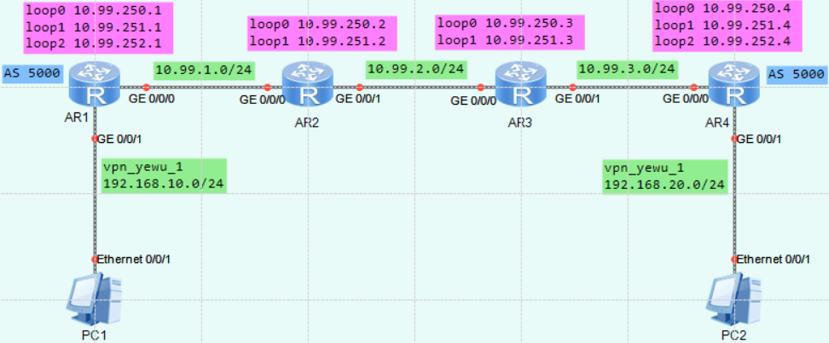
mpls vpn使用BGP去宣告路由信息，仅AR1和AR4配置bgp实例，且为iBGP，使用Loopback2接口通信

相关参数规划：
yyyy表示相应VPN实例对应的编号，4位数字，不足4位前面以0填充；本实验中给业务vpn分配1010编号
vpn实例名称为： vpn_yewu_1
 | vpn-instance |  | 说明
RD | ASN:3yyyy |  | ASN表示路由器的AS号
iRT | ASN:3yyyy
eRT | ASN:3yyyy

AR1配置：
ip vpn-instance vpn_yewu_1 #创建一个名为vpn_yewu_1的vpn实例（vrf）
ipv4-family
route-distinguisher 5000:31010 #配置RD，全局有效，一个vpn实例只可有一个RD
apply-label per-instance #每vpn只分配1个mpls标签，未指定时默认为每条路由分配一个标签
vpn-target 5000:31010 export-extcommunity #eRT全局有效
vpn-target 5000:31010 import-extcommunity # iRT，eRT可有多个
#
mpls lsr-id 10.99.251.1
mpls
#
mpls ldp
#
interface GigabitEthernet0/0/0
ip address 10.99.1.1 255.255.255.0
ospf ldp-sync
mpls
mpls ldp
#
interface GigabitEthernet0/0/1 #业务流量入口
ip binding vpn-instance vpn_yewu_1 #绑定到vpn实例
ip address 192.168.10.1 255.255.255.0
#
interface LoopBack0
description for_ospf_router_id
ip address 10.99.250.1 255.255.255.255
#
interface LoopBack1
description for_mpls_lsr_id
ip address 10.99.251.1 255.255.255.255
#
interface LoopBack2
description for_bgp_router_id
ip address 10.99.252.1 255.255.255.255
#
bgp 5000 #创建BGP进程，所有vpn实例相关信息借助bgp去传输
router-id 10.99.252.1
peer 10.99.252.4 as-number 5000
peer 10.99.252.4 connect-interface LoopBack2
#
ipv4-family unicast
undo synchronization
peer 10.99.252.4 enable
#
ipv4-family vpnv4 #vpn-ipv4地址族，配置路由策略及对等体
policy vpn-target #表示在vpn实例间引入路由时需要匹配eRT和iRT
peer 10.99.252.4 enable #只和这些对等体之间交换vpnv4相关信息
#
ipv4-family vpn-instance vpn_yewu_1 #在bgp里宣告vpn实例的路由信息
network 192.168.10.0 #宣告本vpn实例里的路由
#
ospf 1 router-id 10.99.250.1 # ospf进程用于普通路由的宣告，比如互联口地址及loopback口的ip宣告
area 0.0.0.0
network 10.99.1.0 0.0.0.255
network 10.99.250.1 0.0.0.0
network 10.99.251.1 0.0.0.0
network 10.99.252.1 0.0.0.0
#

AR2配置：（AR2上面没有业务网段的路由，但是lsp经过的所有节点都要开启mpls ldp）
mpls lsr-id 10.99.251.2
mpls
#
mpls ldp
#
interface GigabitEthernet0/0/0
ip address 10.99.1.2 255.255.255.0
ospf ldp-sync
mpls
mpls ldp
#
interface GigabitEthernet0/0/1
ip address 10.99.2.1 255.255.255.0
ospf ldp-sync
mpls
mpls ldp
#
interface LoopBack0
description for_ospf_router_id
ip address 10.99.250.2 255.255.255.255
#
interface LoopBack1
description for_mpls_lsr_id
ip address 10.99.251.2 255.255.255.255
#
ospf 1 router-id 10.99.250.2
area 0.0.0.0
network 10.99.1.0 0.0.0.255
network 10.99.2.0 0.0.0.255
network 10.99.250.2 0.0.0.0
network 10.99.251.2 0.0.0.0
#

AR3配置：
mpls lsr-id 10.99.251.3
mpls
#
mpls ldp
#
interface GigabitEthernet0/0/0
ip address 10.99.2.2 255.255.255.0
ospf ldp-sync
mpls
mpls ldp
#
interface GigabitEthernet0/0/1
ip address 10.99.3.1 255.255.255.0
ospf ldp-sync
mpls
mpls ldp
#
interface LoopBack0
description for_ospf_router_id
ip address 10.99.250.3 255.255.255.255
#
interface LoopBack1
description for_mpls_lsr_id
ip address 10.99.251.3 255.255.255.255
#
ospf 1 router-id 10.99.250.3
area 0.0.0.0
network 10.99.2.0 0.0.0.255
network 10.99.3.0 0.0.0.255
network 10.99.250.3 0.0.0.0
network 10.99.251.3 0.0.0.0
#

AR4配置：
ip vpn-instance vpn_yewu_1
ipv4-family
route-distinguisher 5000:31010
vpn-target 5000:31010 export-extcommunity
vpn-target 5000:31010 import-extcommunity
#
mpls lsr-id 10.99.251.4
mpls
#
mpls ldp
#
interface GigabitEthernet0/0/0
ip address 10.99.3.2 255.255.255.0
ospf ldp-sync
mpls
mpls ldp
#
interface GigabitEthernet0/0/1
ip binding vpn-instance vpn_yewu_1
ip address 192.168.20.1 255.255.255.0
#
interface LoopBack0
description for_ospf_router_id
ip address 10.99.250.4 255.255.255.255
#
interface LoopBack1
description for_mpls_lsr_id
ip address 10.99.251.4 255.255.255.255
#
interface LoopBack2
description for_bgp_router_id
ip address 10.99.252.4 255.255.255.255
#
bgp 5000
router-id 10.99.252.4
peer 10.99.252.1 as-number 5000
peer 10.99.252.1 connect-interface LoopBack2
#
ipv4-family unicast
undo synchronization
peer 10.99.252.1 enable
#
ipv4-family vpnv4
policy vpn-target
peer 10.99.252.1 enable
#
ipv4-family vpn-instance vpn_yewu_1
network 192.168.20.0
#
ospf 1 router-id 10.99.250.4
area 0.0.0.0
network 10.99.3.0 0.0.0.255
network 10.99.250.4 0.0.0.0
network 10.99.251.4 0.0.0.0
network 10.99.252.4 0.0.0.0
#

AR1上查看：
<Huawei> disp ip routing-table vpn-instance vpn_yewu_1 #查看vpn实例对应的路由表
Route Flags: R - relay, D - download to fib
------------------------------------------------------------------------------
Routing Tables: vpn_yewu_1
Destinations : 5 Routes : 5

Destination/Mask Proto Pre Cost Flags NextHop Interface
192.168.10.0/24 Direct 0 0 D 192.168.10.1 GigabitEthernet0/0/1
192.168.10.1/32 Direct 0 0 D 127.0.0.1 GigabitEthernet0/0/1
192.168.10.255/32 Direct 0 0 D 127.0.0.1 GigabitEthernet0/0/1
192.168.20.0/24 IBGP 255 0 RD 10.99.252.4 GigabitEthernet0/0/0 #下一跳为AR4
255.255.255.255/32 Direct 0 0 D 127.0.0.1 InLoopBack0

<Huawei> disp mpls lsp #查看lsp转发表（未在vpn实例下指定apply-label per-instance）
-------------------------------------------------------------------------------
LSP Information: BGP LSP
-------------------------------------------------------------------------------
FEC In/Out Label In/Out IF Vrf Name
192.168.10.0/24 1031/NULL -/- vpn_yewu_1 #明细路由，如果此vpn实例下有多条路由，则有多条lsp
-------------------------------------------------------------------------------
LSP Information: LDP LSP
-------------------------------------------------------------------------------
FEC In/Out Label In/Out IF Vrf Name
10.99.252.1/32 3/NULL -/-
10.99.251.1/32 3/NULL -/-
10.99.250.1/32 3/NULL -/-
10.99.251.2/32 NULL/3 -/GE0/0/0
10.99.251.2/32 1024/3 -/GE0/0/0
10.99.250.2/32 NULL/3 -/GE0/0/0
10.99.250.2/32 1025/3 -/GE0/0/0
10.99.251.3/32 NULL/1027 -/GE0/0/0
10.99.251.3/32 1026/1027 -/GE0/0/0
10.99.250.3/32 NULL/1028 -/GE0/0/0
10.99.250.3/32 1027/1028 -/GE0/0/0
10.99.252.4/32 NULL/1029 -/GE0/0/0
10.99.252.4/32 1028/1029 -/GE0/0/0 #去往业务网段的下一跳为10.99.252.4，这里进行mpls封装
10.99.251.4/32 NULL/1030 -/GE0/0/0
10.99.251.4/32 1029/1030 -/GE0/0/0
10.99.250.4/32 NULL/1031 -/GE0/0/0
10.99.250.4/32 1030/1031 -/GE0/0/0
#在vpn实例下指定apply-label per-instance之后，再查看：
-------------------------------------------------------------------------------
LSP Information: BGP LSP
-------------------------------------------------------------------------------
FEC In/Out Label In/Out IF Vrf Name
-/32 1032/NULL -/- vpn_yewu_1 #不再是明细路由了，只剩一条lsp，-/32表示匹配所有路由
-------------------------------------------------------------------------------
LSP Information: LDP LSP
-------------------------------------------------------------------------------
FEC In/Out Label In/Out IF Vrf Name
10.99.252.1/32 3/NULL -/-
10.99.251.1/32 3/NULL -/-
10.99.250.1/32 3/NULL -/-
10.99.251.2/32 NULL/3 -/GE0/0/0
10.99.251.2/32 1024/3 -/GE0/0/0
10.99.250.2/32 NULL/3 -/GE0/0/0
10.99.250.2/32 1025/3 -/GE0/0/0
10.99.251.3/32 NULL/1027 -/GE0/0/0
10.99.251.3/32 1026/1027 -/GE0/0/0
10.99.250.3/32 NULL/1028 -/GE0/0/0
10.99.250.3/32 1027/1028 -/GE0/0/0
10.99.252.4/32 NULL/1029 -/GE0/0/0
10.99.252.4/32 1028/1029 -/GE0/0/0
10.99.251.4/32 NULL/1030 -/GE0/0/0
10.99.251.4/32 1029/1030 -/GE0/0/0
10.99.250.4/32 NULL/1031 -/GE0/0/0
10.99.250.4/32 1030/1031 -/GE0/0/0

AR2上查看：（transit节点）
<Huawei> disp mpls lsp #查看lsp转发表
-------------------------------------------------------------------------------
LSP Information: LDP LSP
-------------------------------------------------------------------------------
FEC In/Out Label In/Out IF Vrf Name
10.99.252.1/32 NULL/3 -/GE0/0/0
10.99.252.1/32 1024/3 -/GE0/0/0
10.99.251.1/32 NULL/3 -/GE0/0/0
10.99.251.1/32 1025/3 -/GE0/0/0
10.99.250.1/32 NULL/3 -/GE0/0/0
10.99.250.1/32 1026/3 -/GE0/0/0
10.99.251.2/32 3/NULL -/-
10.99.250.2/32 3/NULL -/-
10.99.251.3/32 NULL/3 -/GE0/0/1
10.99.251.3/32 1027/3 -/GE0/0/1
10.99.250.3/32 NULL/3 -/GE0/0/1
10.99.250.3/32 1028/3 -/GE0/0/1
10.99.252.4/32 NULL/1029 -/GE0/0/1
10.99.252.4/32 1029/1029 -/GE0/0/1
10.99.251.4/32 NULL/1030 -/GE0/0/1
10.99.251.4/32 1030/1030 -/GE0/0/1
10.99.250.4/32 NULL/1031 -/GE0/0/1
10.99.250.4/32 1031/1031 -/GE0/0/1

★★★mpls_VPNv4_BFD_isis配置步骤：

1、首先配置各设备互连口的ip地址，具体配置步骤这里省略【所有节点】

2、规划2个loopback接口【所有节点】
interface LoopBack 0
description for_mpls_lsr_id
ip address 10.99.255.1 32
#
interface LoopBack 1
description for_bgp_router_id
ip address 10.99.254.1 32
#

3、配置底层路由协议isis及BFD【所有节点】
bfd
#
isis 1
is-level level-2
cost-style wide
network-entity 49.0001.1111.1111.1111.00
domain-authentication-mode md5 cipher xxxxxx
bfd all-interfaces enable
bfd all-interfaces min-tx-interval 10 min-rx-interval 10 #单位：毫秒
frr
loop-free-alternate level-2
#
interface GigabitEthernet0/0/1 #所有互联口开启isis，并配置认证
ip address 10.99.4.1 255.255.255.0
isis enable 1
isis circuit-level level-2
isis circuit-type p2p
isis ppp-negotiation 2-way
isis authentication-mode md5 cipher xxxxxx
#
interface LoopBack0 #所有loop环回口也要开启isis
isis enable 1
#
interface LoopBack1 #所有loop环回口也要开启isis
isis enable 1
#

4、配置mpls及BFD【所有节点】
bfd
mpls-passive #开启被动创建BFD会话功能，当收到源端发送的携带BFD TLV的LSP ping请求报文后才建立BFD会话
#
mpls lsr-id 10.99.255.1 #指定mpls的LSR-ID，一般使用loop口的ip，必须手工配置，没有缺省的
mpls #全局开启mpls
mpls bfd enable
mpls bfd-trigger host
mpls bfd min-tx-interval 10 min-rx-interval 10
#
mpls ldp #全局开启mpls ldp
auto-frr lsp-trigger host #给32位掩码的备份路由触发LDP建立备份LSP；（在isis或ospf里执行frr命令后，mpls ldp里的auto-frr功能自动开启）默认就是host，所以配置里不显示这行
#
interface GigabitEthernet0/0/1 #域内所有互联接口
isis ldp-sync #配置isis和LDP同步，备用路径回切时，不会产生大量丢包
mpls #LSP经过的接口上开启mpls
mpls ldp #LSP经过的接口上开启mpls ldp
#

5、创建业务vpn实例【PE节点】
ip vpn-instance vpn_yewu_1
ipv4-family
route-distinguisher 5000:31010
vpn-target 5000:31010 export-extcommunity
vpn-target 5000:31010 import-extcommunity
#

6、配置BGP【PE节点】
bgp 5000 #创建BGP进程，所有vpn实例相关信息借助bgp去传输
router-id 10.99.254.1
undo default ipv4-unicast #关闭ipv4-unicast对等体
peer 10.99.254.2 as-number 5000
peer 10.99.254.2 connect-interface LoopBack1

ipv4-family vpnv4 #vpn-ipv4地址族，配置路由策略及对等体
policy vpn-target #表示在vpn实例间引入路由时需要匹配eRT和iRT
peer 10.99.254.2 enable #只和这些对等体之间交换vpn相关信息
y
ipv4-family vpn-instance vpn_yewu_1 #在bgp里宣告vpn实例的路由信息
network 192.168.10.0 24 #宣告本vpn里的路由
#

#查看信息
<Huawei> disp ip routing-table vpn-instance vpn_yewu_1 #查看vpn实例对应的路由表
<Huawei> disp mpls lsp #查看lsp转发表
<Huawei> disp bfd session all #查看bfd会话

实验：mpls_VPNv4_BFD_isis_ar2240（ensp）
拓扑如下：
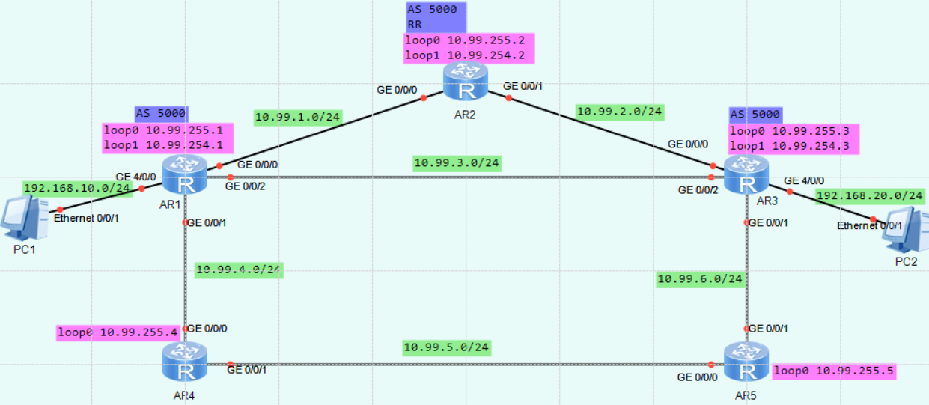
mpls vpn使用BGP去宣告路由信息，AR2作为RR路由反射器，AR1和AR3配置bgp实例，都与AR2建立iiBGP关系，使用Loopback1接口通信。

相关参数规划：
yyyy表示相应VPN实例对应的编号，4位数字，不足4位前面以0填充；本实验中给业务vpn分配1010编号
vpn实例名称为： vpn_yewu_1
 | vpn-instance |  | 说明
RD | ASN:3yyyy |  | ASN表示路由器的AS号
iRT | ASN:3yyyy
eRT | ASN:3yyyy

AR1配置：
ip vpn-instance vpn_yewu_1
ipv4-family
route-distinguisher 5000:31010
vpn-target 5000:31010 export-extcommunity
vpn-target 5000:31010 import-extcommunity
#
bfd
mpls-passive
#
mpls lsr-id 10.99.255.1
mpls
mpls bfd enable
mpls bfd-trigger host
mpls bfd min-tx-interval 500 min-rx-interval 500
#
mpls ldp
#
isis 1
is-level level-2
cost-style wide
bfd all-interfaces enable
bfd all-interfaces min-tx-interval 500 min-rx-interval 500
network-entity 49.0001.1111.1111.1111.00
domain-authentication-mode md5 cipher xxxxxx
frr
loop-free-alternate level-2
#
interface GigabitEthernet0/0/0
ip address 10.99.1.1 255.255.255.0
isis enable 1
isis circuit-type p2p
isis circuit-level level-2
isis authentication-mode md5 cipher xxxxxx
isis ppp-negotiation 2-way
isis ldp-sync
mpls
mpls ldp
#
interface GigabitEthernet0/0/1
ip address 10.99.4.1 255.255.255.0
isis enable 1
isis circuit-type p2p
isis circuit-level level-2
isis authentication-mode md5 cipher xxxxxx
isis cost 4
isis ppp-negotiation 2-way
isis ldp-sync
mpls
mpls ldp
#
interface GigabitEthernet0/0/2
ip address 10.99.3.1 255.255.255.0
isis enable 1
isis circuit-type p2p
isis circuit-level level-2
isis authentication-mode md5 cipher xxxxxx
isis ppp-negotiation 2-way
isis ldp-sync
mpls
mpls ldp
#
interface GigabitEthernet4/0/0
ip binding vpn-instance vpn_yewu_1
ip address 192.168.10.1 255.255.255.0
#
interface GigabitEthernet4/0/1
#
interface LoopBack0
ip address 10.99.255.1 255.255.255.255
isis enable 1
isis circuit-level level-2
#
interface LoopBack1
ip address 10.99.254.1 255.255.255.255
isis enable 1
#
bgp 5000
router-id 10.99.254.1
undo default ipv4-unicast
peer 10.99.254.2 as-number 5000
peer 10.99.254.2 connect-interface LoopBack1
peer 10.99.254.2 password cipher xxxxxx
#
ipv4-family vpnv4
policy vpn-target
peer 10.99.254.2 enable
#
ipv4-family vpn-instance vpn_yewu_1
network 192.168.10.0
#

AR2配置：
bfd
mpls-passive
#
mpls lsr-id 10.99.255.2
mpls
mpls bfd enable
mpls bfd-trigger host
mpls bfd min-tx-interval 500 min-rx-interval 500
#
mpls ldp
#
isis 1
is-level level-2
cost-style wide
bfd all-interfaces enable
bfd all-interfaces min-tx-interval 500 min-rx-interval 500
network-entity 49.0001.2222.2222.2222.00
domain-authentication-mode md5 cipher xxxxxx
frr
loop-free-alternate level-2
#
interface GigabitEthernet0/0/0
ip address 10.99.1.2 255.255.255.0
isis enable 1
isis circuit-type p2p
isis circuit-level level-2
isis authentication-mode md5 cipher xxxxxx
isis ppp-negotiation 2-way
isis ldp-sync
mpls
mpls ldp
#
interface GigabitEthernet0/0/1
ip address 10.99.2.1 255.255.255.0
isis enable 1
isis circuit-type p2p
isis circuit-level level-2
isis authentication-mode md5 cipher xxxxxx
isis ppp-negotiation 2-way
isis ldp-sync
mpls
mpls ldp
#
interface LoopBack0
ip address 10.99.255.2 255.255.255.255
isis enable 1
#
interface LoopBack1
ip address 10.99.254.2 255.255.255.255
isis enable 1
#
bgp 5000
router-id 10.99.254.2
undo default ipv4-unicast
group ibgp internal
peer ibgp connect-interface LoopBack1
peer ibgp password cipher xxxxxx
peer 10.99.254.1 as-number 5000
peer 10.99.254.1 group ibgp
peer 10.99.254.3 as-number 5000
peer 10.99.254.3 group ibgp
#
ipv4-family vpnv4
reflector cluster-id 5000
undo policy vpn-target
peer ibgp enable
peer ibgp reflect-client
peer 10.99.254.1 enable
peer 10.99.254.1 group ibgp #配置了对等体组后，在vpnv4配置界面，仍需显式添加对端ip到对等体组中
peer 10.99.254.3 enable
peer 10.99.254.3 group ibgp
#

AR3配置：
ip vpn-instance vpn_yewu_1
ipv4-family
route-distinguisher 5000:31010
vpn-target 5000:31010 export-extcommunity
vpn-target 5000:31010 import-extcommunity
#
bfd
mpls-passive
#
mpls lsr-id 10.99.255.3
mpls
mpls bfd enable
mpls bfd-trigger host
mpls bfd min-tx-interval 500 min-rx-interval 500
#
mpls ldp
#
isis 1
is-level level-2
cost-style wide
bfd all-interfaces enable
bfd all-interfaces min-tx-interval 500 min-rx-interval 500
network-entity 49.0001.3333.3333.3333.00
domain-authentication-mode md5 cipher xxxxxx
frr
loop-free-alternate level-2
#
interface GigabitEthernet0/0/0
ip address 10.99.2.2 255.255.255.0
isis enable 1
isis circuit-type p2p
isis circuit-level level-2
isis authentication-mode md5 cipher xxxxxx
isis ppp-negotiation 2-way
isis ldp-sync
mpls
mpls ldp
#
interface GigabitEthernet0/0/1
ip address 10.99.6.1 255.255.255.0
isis enable 1
isis circuit-type p2p
isis circuit-level level-2
isis authentication-mode md5 cipher xxxxxx
isis cost 4
isis ppp-negotiation 2-way
isis ldp-sync
mpls
mpls ldp
#
interface GigabitEthernet0/0/2
ip address 10.99.3.2 255.255.255.0
isis enable 1
isis circuit-type p2p
isis circuit-level level-2
isis authentication-mode md5 cipher xxxxxx
isis ppp-negotiation 2-way
isis ldp-sync
mpls
mpls ldp
#
interface GigabitEthernet4/0/0
ip binding vpn-instance vpn_yewu_1
ip address 192.168.20.1 255.255.255.0
#
interface LoopBack0
ip address 10.99.255.3 255.255.255.255
isis enable 1
#
interface LoopBack1
ip address 10.99.254.3 255.255.255.255
isis enable 1
#
bgp 5000
router-id 10.99.254.3
undo default ipv4-unicast
peer 10.99.254.2 as-number 5000
peer 10.99.254.2 connect-interface LoopBack1
peer 10.99.254.2 password cipher xxxxxx
#
ipv4-family vpnv4
policy vpn-target
peer 10.99.254.2 enable
#
ipv4-family vpn-instance vpn_yewu_1
network 192.168.20.0
#

AR4配置：
省略

AR5配置：
省略

AR1上查看：
<Huawei> disp ip routing-table vpn-instance vpn_yewu_1 #查看vpn实例对应的路由表
Route Flags: R - relay, D - download to fib
------------------------------------------------------------------------------
Routing Tables: vpn_yewu_1
Destinations : 5 Routes : 5

Destination/Mask Proto Pre Cost Flags NextHop Interface
192.168.10.0/24 Direct 0 0 D 192.168.10.1 GigabitEthernet4/0/0
192.168.10.1/32 Direct 0 0 D 127.0.0.1 GigabitEthernet4/0/0
192.168.10.255/32 Direct 0 0 D 127.0.0.1 GigabitEthernet4/0/0
192.168.20.0/24 IBGP 255 0 RD 10.99.254.3 GigabitEthernet0/0/2
255.255.255.255/32 Direct 0 0 D 127.0.0.1 InLoopBack0
<Huawei> disp mpls lsp #查看lsp转发表
-------------------------------------------------------------------------------
LSP Information: BGP LSP
-------------------------------------------------------------------------------
FEC In/Out Label In/Out IF Vrf Name
192.168.10.0/24 1030/NULL -/- vpn_yewu_1
-------------------------------------------------------------------------------
LSP Information: LDP LSP
-------------------------------------------------------------------------------
FEC In/Out Label In/Out IF Vrf Name
10.99.254.2/32 NULL/3 -/GE0/0/0
**LDP FRR** /1024 /GE0/0/2
10.99.254.2/32 1024/3 -/GE0/0/0
**LDP FRR** /1024 /GE0/0/2
10.99.255.2/32 NULL/3 -/GE0/0/0
**LDP FRR** /1025 /GE0/0/2
10.99.255.2/32 1025/3 -/GE0/0/0
**LDP FRR** /1025 /GE0/0/2
10.99.254.1/32 3/NULL -/-
10.99.255.1/32 3/NULL -/-
10.99.255.3/32 NULL/3 -/GE0/0/2
**LDP FRR** /1026 /GE0/0/0
10.99.255.3/32 1026/3 -/GE0/0/2
**LDP FRR** /1026 /GE0/0/0
10.99.254.3/32 NULL/3 -/GE0/0/2
**LDP FRR** /1027 /GE0/0/0
10.99.254.3/32 1027/3 -/GE0/0/2
**LDP FRR** /1027 /GE0/0/0
10.99.255.4/32 NULL/3 -/GE0/0/1
10.99.255.4/32 1028/3 -/GE0/0/1
10.99.255.5/32 NULL/1030 -/GE0/0/1
10.99.255.5/32 1029/1030 -/GE0/0/1
10.99.255.5/32 NULL/1029 -/GE0/0/2
10.99.255.5/32 1029/1029 -/GE0/0/2

<Huawei> disp bfd session all #查看
--------------------------------------------------------------------------------
Local Remote PeerIpAddr State Type InterfaceName
--------------------------------------------------------------------------------

8193 8198 10.99.254.2 Up D_LDP_LSP GigabitEthernet0/0/0
8194 8199 10.99.255.2 Up D_LDP_LSP GigabitEthernet0/0/0
8195 8195 10.99.255.2 Up E_Dynamic -
8196 8196 10.99.255.2 Up E_Dynamic -
8197 8197 10.99.1.2 Up D_IP_IF GigabitEthernet0/0/0
8203 8193 10.99.4.2 Up D_IP_IF GigabitEthernet0/0/1
8204 8195 10.99.255.4 Up E_Dynamic -
8205 8198 10.99.255.4 Up E_Dynamic -
8206 8202 10.99.255.4 Up D_LDP_LSP GigabitEthernet0/0/1
8207 8223 10.99.255.5 Up D_LDP_LSP GigabitEthernet0/0/1
8208 8198 10.99.255.5 Up E_Dynamic -
8209 8199 10.99.255.5 Up E_Dynamic -
8256 8264 10.99.3.2 Up D_IP_IF GigabitEthernet0/0/2
8257 8265 10.99.254.3 Up D_LDP_LSP GigabitEthernet0/0/2
8258 8266 10.99.255.3 Up D_LDP_LSP GigabitEthernet0/0/2
8259 8227 10.99.255.5 Up D_LDP_LSP GigabitEthernet0/0/2
8260 8269 10.99.255.3 Up E_Dynamic -
8261 8270 10.99.255.3 Up E_Dynamic -
8262 8228 10.99.255.5 Up E_Dynamic -
8263 8229 10.99.255.5 Up E_Dynamic -
--------------------------------------------------------------------------------
Total UP/DOWN Session Number : 20/0
类型说明：
D_LDP_LSP #为mpls的，本端主动发起的
E_Dynamic #本端配置了bfd mpsl-passive就会有这条，对端的过来，本端就会响应
D_IP_IF #isis的bfd，仅互联口有

#mpls_VPN跨域方案
MPLS-VPN跨域指的是2个自治系统之间不运行LDP协议，各自承载网的mpls标签没法互通，以及2个AS之间的PE没有建立bgp邻居，无法直接传递vpnv4路由；
需要在2个自治系统互联的ASBR上进行承载网标签的终结或转换，实现用户私网流量的跨域传输。

常见的MPLS-VPN跨域方案有3种：
跨域方案 | 实现原理 | 说明
Option-A | 2个自治系统的ASBR都将对面的ASBR当成用户的CE侧设备，有n个用户vrf就在ASBR之间创建n个物理连接/子接口，每个子接口绑定一个vrf，用户流量在ASBR之间为普通ip流量传输，没有mpls标签 | 优点是配置简单，缺点是当用户vrf数量过多时，配置也就相应多了起来
Option-B | 2个自治系统的ASBR建立eBGP连接，传输vpnv4路由，ASBR上不创建用户vrf，需要在bgp里配置undo policy vpn-target取消对接收的vpnv4路由的RT过滤，用户流量在ASBR之间只有一层mpls标签（私网标签） | 当用户数量过多路由条目过多时对ASBR设备压力过大
Option-C | 2个自治系统的ASBR建立eBGP连接或普通的igp连接，将2个AS中与用户侧相连的PE的loop口ip（给bgp协议用的）路由引入，直接使2个AS中PE路由器建立多跳的eBGP连接，传递vpnv4路由；此方案又分2种方式：  type-1：在ASBR上宣告本端的RR及PE路由给对端ASBR，并将对端ASBR宣告的路由也通过bgp传递给本端的RR及PE，使用路由策略强制生成/传递mpls标签（B标签）  type-2：在ASBR上宣告本端的RR及PE路由给对端ASBR，并将对端ASBR宣告的路由引入到底层igp协议（ospf/isis），mpls里配置为带标签的bgp路由触发承载网传输标签 | 减轻了ASBR的压力，但对PE设备性能有一定的要求；PE设备之间不一定要直接建立ebgp关系，可以和本端的RR建立ibgp关系，然后2个AS的RR之间再建立多跳ebgp关系传递vpnv4路由

vpn标签是上游（控制面MP-BGP的上游）分配的，承载网外层转发标签是下游（LDP的下游）分配的

广域网络设备基本角色有三种，CE、PE和P设备，具体定义如下：
CE | Customer Edge，用户边缘设备 | 用户端连接服务提供商的边缘设备，CE连接一个或多个PE，实现用户接入
PE | Provider Edge，服务提供商边缘设备 | 服务提供商连接CE的边缘设备，PE同时连接CE和P设备，是重要的网络节点
P | Provider，服务提供商设备 | 服务提供商骨干设备，不连接任何CE的设备

mpls_VPNv4_option_C_type1配置步骤：

1、首先配置各设备互连口的ip地址，具体配置步骤这里省略【所有节点】

2、规划3个loopback接口【所有节点】
interface LoopBack 0
description for_ospf_router_id
ip address 10.99.250.1 32
#
interface LoopBack 1
description for_mpls_lsr_id
ip address 10.99.251.1 32
#
interface LoopBack 2 # Loop2的ip用作bgp路由器id
description for_bgp_router_id
ip address 10.99.252.1 32
#

3、配置底层路由协议，如isis或ospf，本例使用ospf【所有节点】
ospf 1 router-id 10.99.250.1
area 0.0.0.0
network 10.99.1.0 0.0.0.255
network 10.99.250.1 0.0.0.0
#

4、配置mpls【所有节点】
mpls lsr-id 10.99.251.1
mpls
#
mpls ldp
#
interface GigabitEthernet0/0/0 #域内所有互联接口
mpls
mpls ldp #域内所有互联接口开启ldp协议，跨域设备之间互联口不开启ldp
#

5、创建业务vpn实例以及相应的ospf进程【PE节点】
ip vpn-instance vpn_yewu_1
ipv4-family
route-distinguisher 100:31010
vpn-target 100:31010 export-extcommunity
vpn-target 100:31010 import-extcommunity
#
ospf 31010 router-id 10.99.250.1 vpn-instance vpn_yewu_1
import-route bgp
bandwidth-reference 100000
area 0.0.0.0
network 10.99.8.0 0.0.0.255
#

6、配置路由策略【RR及ASBR节点】
route-policy policy-B2 permit node 10 #RR及ASBR节点都需要配置
if-match mpls-label #当路由条目带有mpls标签信息时，
apply mpls-label #向其他对等体宣告路由时，强制为其分配标签
#
route-policy policy-B1 permit node 10 #仅ASBR节点需要配置
apply mpls-label #向其他对等体宣告路由时，强制为其分配标签
#

7、配置BGP
【PE节点】
bgp 100
router-id 10.99.252.1
peer 10.99.250.3 as-number 100
peer 10.99.250.3 connect-interface LoopBack0

ipv4-family unicast
peer 10.99.252.3 enable
peer 10.99.252.3 label-route-capability #在普通bgp里向RR开启通告标签路由的能力

ipv4-family vpnv4
policy vpn-target
peer 10.99.252.3 enable #和本端RR宣告vpnv4路由
peer 10.99.252.3 next-hop-invariable #通知RR：宣告vpnv4路由时，下一跳地址不变，还是本PE地址

ipv4-family vpn-instance vpn_yewu_1
network 10.99.8.0 255.255.255.0
import-route ospf 31010
#

【RR节点】
bgp 100
router-id 10.99.252.3
peer 10.99.252.7 as-number 200
peer 10.99.252.7 ebgp-max-hop 128 #本端RR和对端RR建立eBGP关系时，中间经过了多个设备，所以...
peer 10.99.252.7 connect-interface LoopBack0
group rc_inter_1 internal
peer rc_inter_1 connect-interface LoopBack0
peer 10.99.252.1 as-number 100
peer 10.99.252.1 group rc_inter_1
peer 10.99.252.4 as-number 100
peer 10.99.252.4 group rc_inter_1

ipv4-family unicast
reflector cluster-id 100
peer 10.99.252.7 enable
peer rc_inter_1 enable
peer rc_inter_1 reflect-client
peer 10.99.252.1 enable
peer 10.99.252.1 group rc_inter_1
peer 10.99.252.1 route-policy policy-B2 export #向本端PE宣告路由信息时，调用路由策略
peer 10.99.252.1 label-route-capability #在普通bgp里向PE开启通告标签路由的能力
peer 10.99.252.4 enable
peer 10.99.252.4 group rc_inter_1
peer 10.99.252.4 label-route-capability #在普通bgp里向ASBR开启通告标签路由的能力

ipv4-family vpnv4
reflector cluster-id 100
undo policy vpn-target
peer 10.99.252.1 enable
peer 10.99.252.1 reflect-client
peer 10.99.252.1 next-hop-invariable #宣告vpnv4路由时，不改变里面的下一跳地址
peer 10.99.252.7 enable
peer 10.99.252.7 next-hop-invariable #宣告vpnv4路由时，不改变里面的下一跳地址

【ASBR节点】
bgp 100
router-id 10.99.252.4
peer 10.99.4.2 as-number 200
peer 10.99.252.3 as-number 100
peer 10.99.252.3 connect-interface LoopBack0

ipv4-family unicast
network 10.99.252.1 255.255.255.255
network 10.99.252.3 255.255.255.255
peer 10.99.4.2 enable
peer 10.99.4.2 route-policy policy-B1 export #向对端ASBR宣告路由信息时调用路由策略强制分配标签
peer 10.99.4.2 label-route-capability #在普通bgp里向对端ASBR开启通告标签路由的能力
peer 10.99.252.3 enable
peer 10.99.252.3 route-policy policy-B2 export #向本端RR宣告路由信息时，调用路由策略
peer 10.99.252.3 label-route-capability #在普通bgp里向RR开启通告标签路由的能力
#

实验：mpls_VPNv4_option_C_type1_ospf_ar2240（ensp）
拓扑如下：
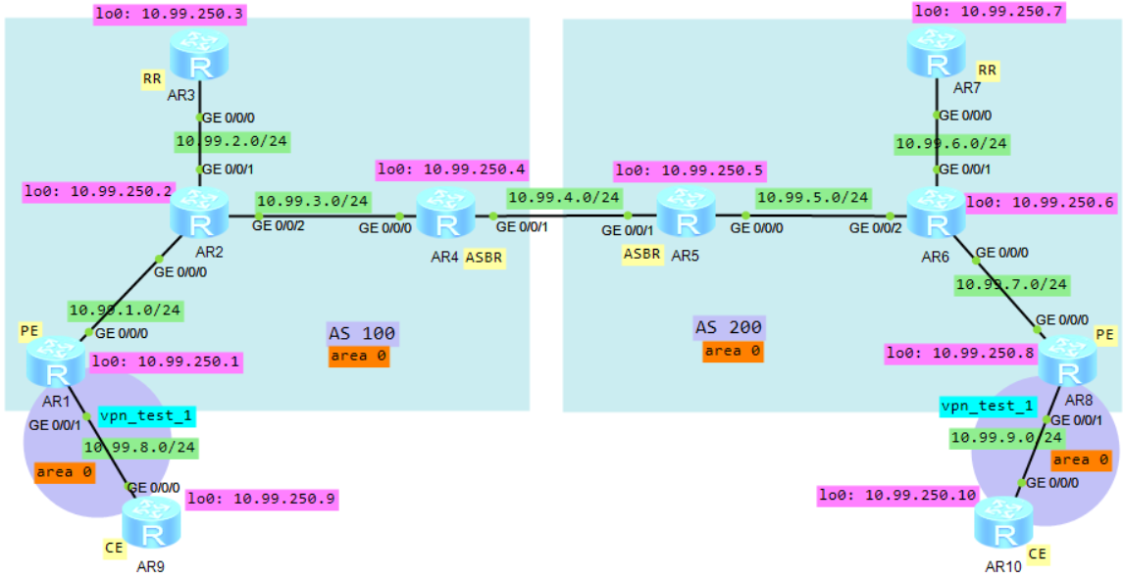
①AS内普通的底层路由协议使用ospf
②运营商PE（AR1/AR8）与用户CE（AR9/AR10）路由器之间运行另一ospf进程，绑定vpn实例
③mpls vpn使用BGP去宣告用户vrf路由信息（vpnv4），AR1与AR3建立iBGP关系、AR8与AR7建立iBGP关系，
AR3为AS100的RR，AR7为AS200的RR，AR3与AR7之间建立多跳的eBGP关系进行vpnv4路由的宣告；
④AR4与AR5为ASBR，相互宣告本端的PE与RR的loop口ip路由；
⑤2个ASBR，都要向对端使用策略强制下发标签，去往对端的PE，然后PE上也要和各自的ASBR激活交换标签路由的能力

用户数据从PE1（AR1）转发到PE2（AR8）时，流量携带标签情况：
角色 | PE1→P1 | P1→ASBR1 | ASBR1→ASBR2 | ASBR2→P2 | P2→PE2
对应拓扑中的 | AR1→AR2 | AR2→AR4 | AR4→AR5 | AR5→AR6 | AR6→AR8
携带标签 | T1,B1,V1 | T2,B2,V1 | B3,V1 | T4,V1 | T5,V1
说明：
流量发出端（AS100）需要带3层标签，最外层T标签为本端的传输层标签，
最里层的V1标签是用户私网标签，
中间层B标签是为了标识去往对端的PE2（这个B标签，是本端ASBR1向本端RR传递对端PE2路由时强制生成的）
当流量到达ASBR后，不再需要T标签了（传输层标签），
在2个ASBR之间只有B标签和用户私网标签V1，然后过了ASBR，
在ASBR2再将B标签转换为对端的T标签，最里层的V1标签不变，在对端AS200只有2层标签了

相关参数规划：
yyyy表示相应VPN实例对应的编号，4位数字，不足4位前面以0填充；本实验中给业务vpn分配1010编号
vpn实例名称为： vpn_yewu_1
 | vpn-instance |  | 说明
RD | ASN:3yyyy |  | ASN表示路由器的AS号
iRT | ASN:3yyyy
eRT | ASN:3yyyy

AR9配置：（CE）
interface GigabitEthernet0/0/0
ip address 10.99.8.2 255.255.255.0
#
interface LoopBack0
description for_ospf_router_id
ip address 10.99.250.9 255.255.255.255
#
ospf 1 router-id 10.99.250.9
bandwidth-reference 100000
area 0.0.0.0
network 10.99.8.0 0.0.0.255
network 10.99.250.9 0.0.0.0
#

AR1配置：（PE）
ip vpn-instance vpn_yewu_1
ipv4-family
route-distinguisher 100:31010
vpn-target 100:31010 export-extcommunity
vpn-target 100:31010 import-extcommunity
#
mpls lsr-id 10.99.250.1
mpls
#
mpls ldp
#
interface GigabitEthernet0/0/0
ip address 10.99.1.2 255.255.255.0
mpls
mpls ldp
#
interface GigabitEthernet0/0/1
ip binding vpn-instance vpn_yewu_1
ip address 10.99.8.1 255.255.255.0
#
interface LoopBack0
description for_mpls_lsr_id__ospf_router_id__bgp_router_id
ip address 10.99.250.1 255.255.255.255
#
bgp 100
router-id 10.99.250.1
peer 10.99.250.3 as-number 100
peer 10.99.250.3 connect-interface LoopBack0
ipv4-family unicast
undo synchronization
peer 10.99.250.3 enable
peer 10.99.250.3 label-route-capability #在普通bgp里向RR开启通告标签路由的能力
ipv4-family vpnv4
policy vpn-target
peer 10.99.250.3 enable #和本端RR宣告vpnv4路由
peer 10.99.250.3 next-hop-invariable #通知RR：宣告vpnv4路由时，下一跳地址不变，还是本PE地址
ipv4-family vpn-instance vpn_yewu_1
network 10.99.8.0 255.255.255.0
import-route ospf 31010
#
ospf 1 router-id 10.99.250.1
bandwidth-reference 100000
area 0.0.0.0
network 10.99.1.0 0.0.0.255
network 10.99.250.1 0.0.0.0
#
ospf 31010 router-id 10.99.250.1 vpn-instance vpn_yewu_1
import-route bgp
bandwidth-reference 100000
area 0.0.0.0
network 10.99.8.0 0.0.0.255
#

AR2配置：（P）
mpls lsr-id 10.99.250.2
mpls
#
mpls ldp
#
interface GigabitEthernet0/0/0
ip address 10.99.1.1 255.255.255.0
mpls
mpls ldp
#
interface GigabitEthernet0/0/1
ip address 10.99.2.2 255.255.255.0
mpls
mpls ldp
#
interface GigabitEthernet0/0/2
ip address 10.99.3.1 255.255.255.0
mpls
mpls ldp
#
interface LoopBack0
description for_mpls_lsr_id__ospf_router_id
ip address 10.99.250.2 255.255.255.255
#
ospf 1 router-id 10.99.250.2
bandwidth-reference 100000
area 0.0.0.0
network 10.99.1.0 0.0.0.255
network 10.99.2.0 0.0.0.255
network 10.99.3.0 0.0.0.255
network 10.99.250.2 0.0.0.0
#

AR3配置：（RR）
mpls lsr-id 10.99.250.3
mpls
#
mpls ldp
#
interface GigabitEthernet0/0/0
ip address 10.99.2.1 255.255.255.0
mpls
mpls ldp
#
interface LoopBack0
description for_mpls_lsr_id__ospf_router_id__bgp_router_id
ip address 10.99.250.3 255.255.255.255
#
bgp 100
router-id 10.99.250.3
peer 10.99.250.7 as-number 200
peer 10.99.250.7 ebgp-max-hop 128 #本端RR和对端RR建立eBGP关系时，中间经过了多个设备，所以...
peer 10.99.250.7 connect-interface LoopBack0
group rc_inter_1 internal
peer rc_inter_1 connect-interface LoopBack0
peer 10.99.250.1 as-number 100
peer 10.99.250.1 group rc_inter_1
peer 10.99.250.4 as-number 100
peer 10.99.250.4 group rc_inter_1
ipv4-family unicast
undo synchronization
reflector cluster-id 100
peer 10.99.250.7 enable
peer rc_inter_1 enable
peer rc_inter_1 reflect-client
peer 10.99.250.1 enable
peer 10.99.250.1 group rc_inter_1
peer 10.99.250.1 route-policy policy-B2 export #向 本端PE宣告路由信息时，调用路由策略
peer 10.99.250.1 label-route-capability #在普通bgp里向PE开启通告标签路由的能力
peer 10.99.250.4 enable
peer 10.99.250.4 group rc_inter_1
peer 10.99.250.4 label-route-capability #在普通bgp里向ASBR开启通告标签路由的能力
ipv4-family vpnv4
reflector cluster-id 100
undo policy vpn-target
peer 10.99.250.1 enable
peer 10.99.250.1 reflect-client
peer 10.99.250.1 next-hop-invariable #宣告vpnv4路由时，不改变里面的下一跳地址
peer 10.99.250.7 enable
peer 10.99.250.7 next-hop-invariable #宣告vpnv4路由时，不改变里面的下一跳地址
#
ospf 1 router-id 10.99.250.3
bandwidth-reference 100000
area 0.0.0.0
network 10.99.2.0 0.0.0.255
network 10.99.250.3 0.0.0.0
#
route-policy policy-B2 permit node 10
if-match mpls-label #若收到的路由带有标签
apply mpls-label #则向其他对等体宣告路由时，也为其分配标签
#

AR4配置：（ASBR）
mpls lsr-id 10.99.250.4
mpls
#
mpls ldp
#
interface GigabitEthernet0/0/0
ip address 10.99.3.2 255.255.255.0
mpls
mpls ldp
#
interface GigabitEthernet0/0/1 #在与其他AS的ASBR连接端口上，只开启mpls，不开启mpls ldp
ip address 10.99.4.1 255.255.255.0
mpls
#
interface LoopBack0
description for_mpls_lsr_id__ospf_router_id__bgp_router_id
ip address 10.99.250.4 255.255.255.255
#
bgp 100
router-id 10.99.250.4
peer 10.99.4.2 as-number 200
peer 10.99.250.3 as-number 100
peer 10.99.250.3 connect-interface LoopBack0
ipv4-family unicast
undo synchronization
network 10.99.250.1 255.255.255.255
network 10.99.250.3 255.255.255.255
peer 10.99.4.2 enable
peer 10.99.4.2 route-policy policy-B1 export #向 对端ASBR宣告路由信息时，调用路由策略，强制分配标签
peer 10.99.4.2 label-route-capability
peer 10.99.250.3 enable
peer 10.99.250.3 route-policy policy-B2 export #向 本端RR宣告路由信息时，调用路由策略
peer 10.99.250.3 label-route-capability
#
ospf 1 router-id 10.99.250.4
bandwidth-reference 100000
area 0.0.0.0
network 10.99.3.0 0.0.0.255
network 10.99.250.4 0.0.0.0
#
route-policy policy-B2 permit node 10
if-match mpls-label #当路由条目带有mpls标签信息时，
apply mpls-label #向其他对等体宣告路由时，强制为其分配标签
#
route-policy policy-B1 permit node 10
apply mpls-label #向其他对等体宣告路由时，强制为其分配标签
#

AR10配置：（CE）
interface GigabitEthernet0/0/0
ip address 10.99.9.2 255.255.255.0
#
interface LoopBack0
description for_ospf_router_id
ip address 10.99.250.10 255.255.255.255
#
ospf 1 router-id 10.99.250.10
bandwidth-reference 100000
area 0.0.0.0
network 10.99.9.0 0.0.0.255
network 10.99.250.10 0.0.0.0
#

AR8配置：（PE）
ip vpn-instance vpn_yewu_1
ipv4-family
route-distinguisher 200:31010
vpn-target 200:31010 export-extcommunity
vpn-target 200:31010 import-extcommunity
#
mpls lsr-id 10.99.250.8
mpls
#
mpls ldp
#
interface GigabitEthernet0/0/0
ip address 10.99.7.2 255.255.255.0
mpls
mpls ldp
#
interface GigabitEthernet0/0/1
ip binding vpn-instance vpn_yewu_1
ip address 10.99.9.1 255.255.255.0
#
interface LoopBack0
description for_mpls_lsr_id__ospf_router_id__bgp_router_id
ip address 10.99.250.8 255.255.255.255
#
bgp 200
router-id 10.99.250.8
peer 10.99.250.7 as-number 200
peer 10.99.250.7 connect-interface LoopBack0
ipv4-family unicast
undo synchronization
peer 10.99.250.7 enable
peer 10.99.250.7 label-route-capability
ipv4-family vpnv4
policy vpn-target
peer 10.99.250.7 enable
peer 10.99.250.7 next-hop-invariable
ipv4-family vpn-instance vpn_yewu_1
import-route ospf 31010
#
ospf 1 router-id 10.99.250.8
bandwidth-reference 100000
area 0.0.0.0
network 10.99.7.0 0.0.0.255
network 10.99.250.8 0.0.0.0
#
ospf 31010 router-id 10.99.250.8 vpn-instance vpn_yewu_1
import-route bgp
bandwidth-reference 100000
area 0.0.0.0
network 10.99.9.0 0.0.0.255
#

AR6配置：（P）
mpls lsr-id 10.99.250.6
mpls
#
mpls ldp
#
interface GigabitEthernet0/0/0
ip address 10.99.7.1 255.255.255.0
mpls
mpls ldp
#
interface GigabitEthernet0/0/1
ip address 10.99.6.2 255.255.255.0
mpls
mpls ldp
#
interface GigabitEthernet0/0/2
ip address 10.99.5.2 255.255.255.0
mpls
mpls ldp
#
interface LoopBack0
description for_mpls_lsr_id__ospf_router_id
ip address 10.99.250.6 255.255.255.255
#
ospf 1 router-id 10.99.250.6
bandwidth-reference 100000
area 0.0.0.0
network 10.99.5.0 0.0.0.255
network 10.99.6.0 0.0.0.255
network 10.99.7.0 0.0.0.255
network 10.99.250.6 0.0.0.0
#

AR7配置：（RR）
mpls lsr-id 10.99.250.7
mpls
#
mpls ldp
#
interface GigabitEthernet0/0/0
ip address 10.99.6.1 255.255.255.0
mpls
mpls ldp
#
interface LoopBack0
description for_mpls_lsr_id__ospf_router_id__bgp_router_id
ip address 10.99.250.7 255.255.255.255
#
bgp 200
router-id 10.99.250.7
peer 10.99.250.3 as-number 100
peer 10.99.250.3 ebgp-max-hop 128
group rc_inter_1 internal
peer rc_inter_1 connect-interface LoopBack0
peer 10.99.250.5 as-number 200
peer 10.99.250.5 group rc_inter_1
peer 10.99.250.8 as-number 200
peer 10.99.250.8 group rc_inter_1
ipv4-family unicast
undo synchronization
reflector cluster-id 200
peer 10.99.250.3 enable
peer rc_inter_1 enable
peer rc_inter_1 reflect-client
peer 10.99.250.5 enable
peer 10.99.250.5 group rc_inter_1
peer 10.99.250.5 label-route-capability
peer 10.99.250.8 enable
peer 10.99.250.8 group rc_inter_1
peer 10.99.250.8 route-policy policy-B2 export
peer 10.99.250.8 label-route-capability
ipv4-family vpnv4
reflector cluster-id 200
undo policy vpn-target
peer 10.99.250.3 enable
peer 10.99.250.3 next-hop-invariable
peer 10.99.250.8 enable
peer 10.99.250.8 reflect-client
peer 10.99.250.8 next-hop-invariable
#
ospf 1 router-id 10.99.250.7
bandwidth-reference 100000
area 0.0.0.0
network 10.99.6.0 0.0.0.255
network 10.99.250.7 0.0.0.0
#
route-policy policy-B2 permit node 10
if-match mpls-label
apply mpls-label
#

AR5配置：（ASBR）
mpls lsr-id 10.99.250.5
mpls
#
mpls ldp
#
interface GigabitEthernet0/0/0
ip address 10.99.5.1 255.255.255.0
mpls
mpls ldp
#
interface GigabitEthernet0/0/1 #在与其他AS的ASBR连接端口上，只开启mpls，不开启mpls ldp
ip address 10.99.4.2 255.255.255.0
mpls
#
interface LoopBack0
description for_mpls_lsr_id__ospf_router_id__bgp_router_id
ip address 10.99.250.5 255.255.255.255
#
bgp 200
router-id 10.99.250.5
peer 10.99.4.1 as-number 100
peer 10.99.250.7 as-number 200
peer 10.99.250.7 connect-interface LoopBack0
ipv4-family unicast
undo synchronization
network 10.99.250.7 255.255.255.255
network 10.99.250.8 255.255.255.255
peer 10.99.4.1 enable
peer 10.99.4.1 route-policy policy-B1 export
peer 10.99.4.1 label-route-capability
peer 10.99.250.7 enable
peer 10.99.250.7 route-policy policy-B2 export
peer 10.99.250.7 label-route-capability
#
ospf 1 router-id 10.99.250.5
bandwidth-reference 100000
area 0.0.0.0
network 10.99.5.0 0.0.0.255
network 10.99.250.5 0.0.0.0
#
route-policy policy-B2 permit node 10
if-match mpls-label
apply mpls-label
#
route-policy policy-B1 permit node 10
apply mpls-label
#

AR1查看：
<AR1> disp ip routing-table vpn-instance vpn_yewu_1
Route Flags: R - relay, D - download to fib
------------------------------------------------------------------------------
Routing Tables: vpn_yewu_1
Destinations : 7 Routes : 7

Destination/Mask Proto Pre Cost Flags NextHop Interface
10.99.8.0/24 Direct 0 0 D 10.99.8.1 GigabitEthernet0/0/1
10.99.8.1/32 Direct 0 0 D 127.0.0.1 GigabitEthernet0/0/1
10.99.8.255/32 Direct 0 0 D 127.0.0.1 GigabitEthernet0/0/1
10.99.9.0/24 IBGP 255 0 RD 10.99.250.8 GigabitEthernet0/0/0
10.99.250.9/32 OSPF 10 100 D 10.99.8.2 GigabitEthernet0/0/1
10.99.250.10/32 IBGP 255 0 RD 10.99.250.8 GigabitEthernet0/0/0
255.255.255.255/32 Direct 0 0 D 127.0.0.1 InLoopBack0

<AR1> disp mpls lsp
-------------------------------------------------------------------------------
LSP Information: BGP LSP
-------------------------------------------------------------------------------
FEC In/Out Label In/Out IF Vrf Name
10.99.8.0/24 1027/NULL -/- vpn_yewu_1
10.99.250.9/32 1028/NULL -/- vpn_yewu_1
10.99.250.7/32 NULL/1028 -/-
10.99.250.8/32 NULL/1027 -/- #BGP宣告的去往对端的PE的B标签
-------------------------------------------------------------------------------
LSP Information: LDP LSP
-------------------------------------------------------------------------------
FEC In/Out Label In/Out IF Vrf Name
10.99.250.2/32 NULL/3 -/GE0/0/0
10.99.250.2/32 1024/3 -/GE0/0/0
10.99.250.3/32 NULL/1024 -/GE0/0/0
10.99.250.3/32 1025/1024 -/GE0/0/0
10.99.250.4/32 NULL/1025 -/GE0/0/0 #承载网传输标签（去往本端ASBR）
10.99.250.4/32 1026/1025 -/GE0/0/0
10.99.250.1/32 3/NULL -/-

<AR1> disp bgp vpnv4 all routing-table 10.99.250.10 32
BGP local router ID : 10.99.250.1
Local AS number : 100

Total routes of Route Distinguisher(200:31010): 1
BGP routing table entry information of 10.99.250.10/32:
Label information (Received/Applied): 1028/NULL #vpn私网标签
From: 10.99.250.3 (10.99.250.3)
Route Duration: 00h18m46s
Relay IP Nexthop: 10.99.1.1
Relay IP Out-Interface: GigabitEthernet0/0/0
Relay Tunnel Out-Interface: GigabitEthernet0/0/0
Relay token: 0x8
Original nexthop: 10.99.250.8
Qos information : 0x0
Ext-Community:RT <31010 : 2>, OSPF DOMAIN ID <0.0.0.0 : 0>,
OSPF RT <0.0.0.0 : 1 : 0>, OSPF ROUTER ID <10.99.250.8 : 0>
AS-path 200, origin incomplete, localpref 100, pref-val 0, valid, internal, bes
t, select, pre 255, IGP cost 200
Not advertised to any peer yet

VPN-Instance vpn_yewu_1, Router ID 10.99.250.1:

Total Number of Routes: 1
BGP routing table entry information of 10.99.250.10/32:
Label information (Received/Applied): 1028/NULL
From: 10.99.250.3 (10.99.250.3)
Route Duration: 00h18m46s
Relay Tunnel Out-Interface: GigabitEthernet0/0/0
Relay token: 0x8
Original nexthop: 10.99.250.8
Qos information : 0x0
Ext-Community:RT <31010 : 2>, OSPF DOMAIN ID <0.0.0.0 : 0>,
OSPF RT <0.0.0.0 : 1 : 0>, OSPF ROUTER ID <10.99.250.8 : 0>
AS-path 200, origin incomplete, localpref 100, pref-val 0, valid, internal, bes
t, select, active, pre 255, IGP cost 200
Not advertised to any peer yet

AR9（CE）查看：
<AR9> disp ip routing-table
Route Flags: R - relay, D - download to fib
------------------------------------------------------------------------------
Routing Tables: Public
Destinations : 10 Routes : 10

Destination/Mask Proto Pre Cost Flags NextHop Interface
10.99.8.0/24 Direct 0 0 D 10.99.8.2 GigabitEthernet0/0/0
10.99.8.2/32 Direct 0 0 D 127.0.0.1 GigabitEthernet0/0/0
10.99.8.255/32 Direct 0 0 D 127.0.0.1 GigabitEthernet0/0/0
10.99.9.0/24 O_ASE 150 1 D 10.99.8.1 GigabitEthernet0/0/0
10.99.250.9/32 Direct 0 0 D 127.0.0.1 LoopBack0
10.99.250.10/32 OSPF 10 101 D 10.99.8.1 GigabitEthernet0/0/0
127.0.0.0/8 Direct 0 0 D 127.0.0.1 InLoopBack0
127.0.0.1/32 Direct 0 0 D 127.0.0.1 InLoopBack0
127.255.255.255/32 Direct 0 0 D 127.0.0.1 InLoopBack0
255.255.255.255/32 Direct 0 0 D 127.0.0.1 InLoopBack0

★从AR9（CE1）访问对端的AR10（CE2），并抓包查看MPLS标签
<AR9> ping -a 10.99.250.9 10.99.250.10
PING 10.99.250.10: 56 data bytes, press CTRL_C to break
Reply from 10.99.250.10: bytes=56 Sequence=1 ttl=249 time=130 ms
Reply from 10.99.250.10: bytes=56 Sequence=2 ttl=249 time=60 ms
Reply from 10.99.250.10: bytes=56 Sequence=3 ttl=249 time=70 ms

抓包查看：（在AR1上捕获GE 0/0/0接口）
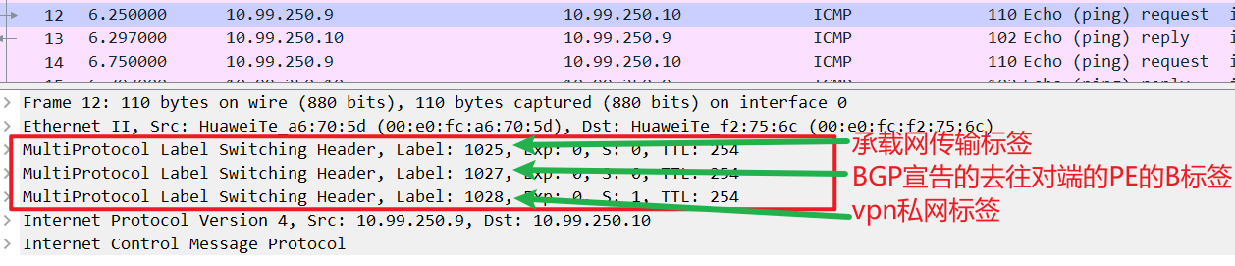

mpls_VPNv4_option_C_type2配置步骤：

1、首先配置各设备互连口的ip地址，具体配置步骤这里省略【所有节点】

2、规划3个loopback接口【所有节点】
interface LoopBack 0
description for_ospf_router_id
ip address 10.99.250.1 32
#
interface LoopBack 1
description for_mpls_lsr_id
ip address 10.99.251.1 32
#
interface LoopBack 2 # Loop2的ip用作bgp路由器id
description for_bgp_router_id
ip address 10.99.252.1 32
#

3、配置底层路由协议，如isis或ospf，本例使用ospf【所有节点】
ospf 1 router-id 10.99.250.1
area 0.0.0.0
network 10.99.1.0 0.0.0.255
network 10.99.250.1 0.0.0.0
#

4、配置mpls【所有节点】
mpls lsr-id 10.99.251.1
mpls
#
mpls ldp
#
interface GigabitEthernet0/0/0 #域内所有互联接口
mpls
mpls ldp #域内所有互联接口开启ldp协议，跨域设备之间互联口不开启ldp
#

5、创建业务vpn实例以及相应的ospf进程【PE节点】
ip vpn-instance vpn_yewu_1
ipv4-family
route-distinguisher 100:31010
vpn-target 100:31010 export-extcommunity
vpn-target 100:31010 import-extcommunity
#
ospf 31010 router-id 10.99.250.1 vpn-instance vpn_yewu_1
import-route bgp
bandwidth-reference 100000
area 0.0.0.0
network 10.99.8.0 0.0.0.255
#

6、配置路由策略【ASBR节点】
route-policy policy-B1 permit node 10 #仅ASBR节点需要配置
apply mpls-label #向其他对等体宣告路由时，强制为其分配标签
#

7、配置mpls【ASBR节点】
mpls
lsp-trigger bgp-label-route #为带标签的公网bgp路由建立ldp lsp
#

8、配置BGP
【PE节点】
bgp 100
router-id 10.99.252.1
peer 10.99.252.3 as-number 100
peer 10.99.252.3 connect-interface LoopBack0

ipv4-family unicast
undo synchronization
peer 10.99.252.3 enable

ipv4-family vpnv4
policy vpn-target
peer 10.99.252.3 enable #和本端RR宣告vpnv4路由
peer 10.99.252.3 next-hop-invariable #通知RR：宣告vpnv4路由时，下一跳地址不变，还是本PE地址

ipv4-family vpn-instance vpn_yewu_1
network 10.99.8.0 255.255.255.0
import-route ospf 31010

【RR节点】
bgp 100
router-id 10.99.252.3
peer 10.99.252.7 as-number 200
peer 10.99.252.7 ebgp-max-hop 128 #本端RR和对端RR建立eBGP关系时，中间经过了多个设备，所以...
peer 10.99.252.7 connect-interface LoopBack0
group rc_inter_1 internal
peer rc_inter_1 connect-interface LoopBack0
peer 10.99.252.1 as-number 100
peer 10.99.252.1 group rc_inter_1

ipv4-family unicast
reflector cluster-id 100
peer 10.99.252.7 enable
peer rc_inter_1 enable
peer rc_inter_1 reflect-client
peer 10.99.252.1 enable
peer 10.99.252.1 group rc_inter_1

ipv4-family vpnv4
reflector cluster-id 100
undo policy vpn-target
peer 10.99.252.1 enable
peer 10.99.252.1 reflect-client
peer 10.99.252.1 next-hop-invariable #宣告vpnv4路由时，不改变里面的下一跳地址
peer 10.99.252.7 enable
peer 10.99.252.7 next-hop-invariable #宣告vpnv4路由时，不改变里面的下一跳地址

【ASBR节点】
bgp 100
router-id 10.99.252.4
peer 10.99.4.2 as-number 200

ipv4-family unicast
undo synchronization
network 10.99.252.1 255.255.255.255
network 10.99.252.3 255.255.255.255
peer 10.99.4.2 enable
peer 10.99.4.2 route-policy policy-B1 export #向对端ASBR宣告路由信息时调用路由策略强制分配标签
peer 10.99.4.2 label-route-capability #在普通bgp里向对端ASBR开启通告标签路由的能力

实验：mpls_VPNv4_option_C_type2_ospf_ar2240（ensp）
拓扑如下：
①AS内普通的底层路由协议使用ospf
②运营商PE（AR1/AR8）与用户CE（AR9/AR10）路由器之间运行另一ospf进程，绑定vpn实例
③mpls vpn使用BGP去宣告用户vrf路由信息（vpnv4），AR1与AR3建立iBGP关系、AR8与AR7建立iBGP关系，
AR3为AS100的RR，AR7为AS200的RR，AR3与AR7之间建立多跳的eBGP关系进行vpnv4路由的宣告；
④AR4与AR5为ASBR，相互宣告本端的PE与RR的loop口ip路由，并将学习到的路由引入到底层ospf/isis中
⑤2个ASBR，都要在mpls里配置为带标签的bgp路由触发承载网传输标签

用户数据从PE1（AR1）转发到PE2（AR8）时，流量携带标签情况：
角色 | PE1→P1 | P1→ASBR1 | ASBR1→ASBR2 | ASBR2→P2 | P2→PE2
对应拓扑中的 | AR1→AR2 | AR2→AR4 | AR4→AR5 | AR5→AR6 | AR6→AR8
携带标签 | T1,V1 | T2,V1 | B1,V1 | T4,V1 | T5,V1
说明：
流量发出端（AS100）需要带2层标签，最外层T标签为本端的传输层标签，
最里层的V1标签是用户私网标签
当流量到达ASBR后，不再需要T标签了（传输层标签），（这里的T标签，其实是根据B标签触发生成的）
并将T标签转换为B标签（对端ASBR2在向ASBR1传递PE2路由时，强制分配的）
在2个ASBR之间只有B标签和用户私网标签V1，然后过了ASBR，
在ASBR2再将B标签转换为对端的T标签，最里层的V1标签不变，在对端AS200只有2层标签了

相关参数规划：
yyyy表示相应VPN实例对应的编号，4位数字，不足4位前面以0填充；本实验中给业务vpn分配1010编号
vpn实例名称为： vpn_yewu_1
 | vpn-instance |  | 说明
RD | ASN:3yyyy |  | ASN表示路由器的AS号
iRT | ASN:3yyyy
eRT | ASN:3yyyy

AR9配置：（CE）
interface GigabitEthernet0/0/0
ip address 10.99.8.2 255.255.255.0
#
interface LoopBack0
description for_ospf_router_id
ip address 10.99.250.9 255.255.255.255
#
ospf 1 router-id 10.99.250.9
bandwidth-reference 100000
area 0.0.0.0
network 10.99.8.0 0.0.0.255
network 10.99.250.9 0.0.0.0
#

AR1配置：（PE）
ip vpn-instance vpn_yewu_1
ipv4-family
route-distinguisher 100:31010
vpn-target 100:31010 export-extcommunity
vpn-target 100:31010 import-extcommunity
#
mpls lsr-id 10.99.250.1
mpls
#
mpls ldp
#
interface GigabitEthernet0/0/0
ip address 10.99.1.2 255.255.255.0
mpls
mpls ldp
#
interface GigabitEthernet0/0/1
ip binding vpn-instance vpn_yewu_1
ip address 10.99.8.1 255.255.255.0
#
interface LoopBack0
description for_mpls_lsr_id__ospf_router_id__bgp_router_id
ip address 10.99.250.1 255.255.255.255
#
bgp 100
router-id 10.99.250.1
peer 10.99.250.3 as-number 100
peer 10.99.250.3 connect-interface LoopBack0
ipv4-family unicast
undo synchronization
peer 10.99.250.3 enable
ipv4-family vpnv4
policy vpn-target
peer 10.99.250.3 enable
peer 10.99.250.3 next-hop-invariable
ipv4-family vpn-instance vpn_yewu_1
network 10.99.8.0 255.255.255.0
import-route ospf 31010
#
ospf 1 router-id 10.99.250.1
bandwidth-reference 100000
area 0.0.0.0
network 10.99.1.0 0.0.0.255
network 10.99.250.1 0.0.0.0
#
ospf 31010 router-id 10.99.250.1 vpn-instance vpn_yewu_1
import-route bgp
bandwidth-reference 100000
area 0.0.0.0
network 10.99.8.0 0.0.0.255
#

AR2配置：（P）
mpls lsr-id 10.99.250.2
mpls
#
mpls ldp
#
interface GigabitEthernet0/0/0
ip address 10.99.1.1 255.255.255.0
mpls
mpls ldp
#
interface GigabitEthernet0/0/1
ip address 10.99.2.2 255.255.255.0
mpls
mpls ldp
#
interface GigabitEthernet0/0/2
ip address 10.99.3.1 255.255.255.0
mpls
mpls ldp
#
interface LoopBack0
description for_mpls_lsr_id__ospf_router_id
ip address 10.99.250.2 255.255.255.255
#
ospf 1 router-id 10.99.250.2
bandwidth-reference 100000
area 0.0.0.0
network 10.99.1.0 0.0.0.255
network 10.99.2.0 0.0.0.255
network 10.99.3.0 0.0.0.255
network 10.99.250.2 0.0.0.0
#

AR3配置：（RR）
mpls lsr-id 10.99.250.3
mpls
#
mpls ldp
#
interface GigabitEthernet0/0/0
ip address 10.99.2.1 255.255.255.0
mpls
mpls ldp
#
interface LoopBack0
description for_mpls_lsr_id__ospf_router_id__bgp_router_id
ip address 10.99.250.3 255.255.255.255
#
bgp 100
router-id 10.99.250.3
peer 10.99.250.7 as-number 200
peer 10.99.250.7 ebgp-max-hop 128
peer 10.99.250.7 connect-interface LoopBack0
group rc_inter_1 internal
peer rc_inter_1 connect-interface LoopBack0
peer 10.99.250.1 as-number 100
peer 10.99.250.1 group rc_inter_1
ipv4-family unicast
undo synchronization
reflector cluster-id 100
peer 10.99.250.7 enable
peer rc_inter_1 enable
peer rc_inter_1 reflect-client
peer 10.99.250.1 enable
peer 10.99.250.1 group rc_inter_1
ipv4-family vpnv4
reflector cluster-id 100
undo policy vpn-target
peer 10.99.250.1 enable
peer 10.99.250.1 reflect-client
peer 10.99.250.1 next-hop-invariable
peer 10.99.250.7 enable
peer 10.99.250.7 next-hop-invariable
#
ospf 1 router-id 10.99.250.3
bandwidth-reference 100000
area 0.0.0.0
network 10.99.2.0 0.0.0.255
network 10.99.250.3 0.0.0.0
#

AR4配置：（ASBR）
mpls lsr-id 10.99.250.4
mpls
lsp-trigger bgp-label-route #为带标签的公网bgp路由建立ldp lsp
#
mpls ldp
#
interface GigabitEthernet0/0/0
ip address 10.99.3.2 255.255.255.0
mpls
mpls ldp
#
interface GigabitEthernet0/0/1 #在与其他AS的ASBR连接端口上，只开启mpls，不开启mpls ldp
ip address 10.99.4.1 255.255.255.0
mpls
#
interface LoopBack0
description for_mpls_lsr_id__ospf_router_id__bgp_router_id
ip address 10.99.250.4 255.255.255.255
#
bgp 100
router-id 10.99.250.4
peer 10.99.4.2 as-number 200
ipv4-family unicast
undo synchronization
network 10.99.250.1 255.255.255.255
network 10.99.250.3 255.255.255.255
peer 10.99.4.2 enable
peer 10.99.4.2 route-policy policy-B1 export
peer 10.99.4.2 label-route-capability
#
ospf 1 router-id 10.99.250.4
import-route bgp
bandwidth-reference 100000
area 0.0.0.0
network 10.99.3.0 0.0.0.255
network 10.99.250.4 0.0.0.0
#
route-policy policy-B1 permit node 10
apply mpls-label
#

AR10配置：（CE）
interface GigabitEthernet0/0/0
ip address 10.99.9.2 255.255.255.0
#
interface LoopBack0
description for_ospf_router_id
ip address 10.99.250.10 255.255.255.255
#
ospf 1 router-id 10.99.250.10
bandwidth-reference 100000
area 0.0.0.0
network 10.99.9.0 0.0.0.255
network 10.99.250.10 0.0.0.0
#

AR8配置：（PE）
ip vpn-instance vpn_yewu_1
ipv4-family
route-distinguisher 200:31010
vpn-target 200:31010 export-extcommunity
vpn-target 200:31010 import-extcommunity
#
mpls lsr-id 10.99.250.8
mpls
#
mpls ldp
#
interface GigabitEthernet0/0/0
ip address 10.99.7.2 255.255.255.0
mpls
mpls ldp
#
interface GigabitEthernet0/0/1
ip binding vpn-instance vpn_yewu_1
ip address 10.99.9.1 255.255.255.0
#
interface LoopBack0
description for_mpls_lsr_id__ospf_router_id__bgp_router_id
ip address 10.99.250.8 255.255.255.255
#
bgp 200
router-id 10.99.250.8
peer 10.99.250.7 as-number 200
peer 10.99.250.7 connect-interface LoopBack0
ipv4-family unicast
undo synchronization
peer 10.99.250.7 enable
ipv4-family vpnv4
policy vpn-target
peer 10.99.250.7 enable
peer 10.99.250.7 next-hop-invariable
ipv4-family vpn-instance vpn_yewu_1
import-route ospf 31010
#
ospf 1 router-id 10.99.250.8
bandwidth-reference 100000
area 0.0.0.0
network 10.99.7.0 0.0.0.255
network 10.99.250.8 0.0.0.0
#
ospf 31010 router-id 10.99.250.8 vpn-instance vpn_yewu_1
import-route bgp
bandwidth-reference 100000
area 0.0.0.0
network 10.99.9.0 0.0.0.255
#

AR6配置：（P）
mpls lsr-id 10.99.250.6
mpls
#
mpls ldp
#
interface GigabitEthernet0/0/0
ip address 10.99.7.1 255.255.255.0
mpls
mpls ldp
#
interface GigabitEthernet0/0/1
ip address 10.99.6.2 255.255.255.0
mpls
mpls ldp
#
interface GigabitEthernet0/0/2
ip address 10.99.5.2 255.255.255.0
mpls
mpls ldp
#
interface LoopBack0
description for_mpls_lsr_id__ospf_router_id
ip address 10.99.250.6 255.255.255.255
#
ospf 1 router-id 10.99.250.6
bandwidth-reference 100000
area 0.0.0.0
network 10.99.5.0 0.0.0.255
network 10.99.6.0 0.0.0.255
network 10.99.7.0 0.0.0.255
network 10.99.250.6 0.0.0.0
#

AR7配置：（RR）
mpls lsr-id 10.99.250.7
mpls
#
mpls ldp
#
interface GigabitEthernet0/0/0
ip address 10.99.6.1 255.255.255.0
mpls
mpls ldp
#
interface LoopBack0
description for_mpls_lsr_id__ospf_router_id__bgp_router_id
ip address 10.99.250.7 255.255.255.255
#
bgp 200
router-id 10.99.250.7
peer 10.99.250.3 as-number 100
peer 10.99.250.3 ebgp-max-hop 128
group rc_inter_1 internal
peer rc_inter_1 connect-interface LoopBack0
peer 10.99.250.8 as-number 200
peer 10.99.250.8 group rc_inter_1
#
ipv4-family unicast
undo synchronization
reflector cluster-id 200
peer 10.99.250.3 enable
peer rc_inter_1 enable
peer rc_inter_1 reflect-client
peer 10.99.250.8 enable
peer 10.99.250.8 group rc_inter_1
#
ipv4-family vpnv4
reflector cluster-id 200
undo policy vpn-target
peer 10.99.250.3 enable
peer 10.99.250.3 next-hop-invariable
peer 10.99.250.8 enable
peer 10.99.250.8 reflect-client
peer 10.99.250.8 next-hop-invariable
#
ospf 1 router-id 10.99.250.7
bandwidth-reference 100000
area 0.0.0.0
network 10.99.6.0 0.0.0.255
network 10.99.250.7 0.0.0.0
#

AR5配置：（ASBR）
mpls lsr-id 10.99.250.5
mpls
lsp-trigger bgp-label-route
#
mpls ldp
#
interface GigabitEthernet0/0/0
ip address 10.99.5.1 255.255.255.0
mpls
mpls ldp
#
interface GigabitEthernet0/0/1 #在与其他AS的ASBR连接端口上，只开启mpls，不开启mpls ldp
ip address 10.99.4.2 255.255.255.0
mpls
#
interface LoopBack0
description for_mpls_lsr_id__ospf_router_id__bgp_router_id
ip address 10.99.250.5 255.255.255.255
#
bgp 200
router-id 10.99.250.5
peer 10.99.4.1 as-number 100
ipv4-family unicast
undo synchronization
network 10.99.250.7 255.255.255.255
network 10.99.250.8 255.255.255.255
peer 10.99.4.1 enable
peer 10.99.4.1 route-policy policy-B1 export
peer 10.99.4.1 label-route-capability
#
ospf 1 router-id 10.99.250.5
import-route bgp
bandwidth-reference 100000
area 0.0.0.0
network 10.99.5.0 0.0.0.255
network 10.99.250.5 0.0.0.0
#
route-policy policy-B1 permit node 10
apply mpls-label
#

AR1查看：
<AR1> disp ip routing-table vpn-instance vpn_yewu_1
Route Flags: R - relay, D - download to fib
------------------------------------------------------------------------------
Routing Tables: vpn_yewu_1
Destinations : 7 Routes : 7

Destination/Mask Proto Pre Cost Flags NextHop Interface
10.99.8.0/24 Direct 0 0 D 10.99.8.1 GigabitEthernet0/0/1
10.99.8.1/32 Direct 0 0 D 127.0.0.1 GigabitEthernet0/0/1
10.99.8.255/32 Direct 0 0 D 127.0.0.1 GigabitEthernet0/0/1
10.99.9.0/24 IBGP 255 0 RD 10.99.250.8 GigabitEthernet0/0/0
10.99.250.9/32 OSPF 10 100 D 10.99.8.2 GigabitEthernet0/0/1
10.99.250.10/32 IBGP 255 0 RD 10.99.250.8 GigabitEthernet0/0/0
255.255.255.255/32 Direct 0 0 D 127.0.0.1 InLoopBack0

<AR1> disp mpls lsp
-------------------------------------------------------------------------------
LSP Information: BGP LSP
-------------------------------------------------------------------------------
FEC In/Out Label In/Out IF Vrf Name
10.99.8.0/24 1029/NULL -/- vpn_yewu_1
10.99.250.9/32 1030/NULL -/- vpn_yewu_1
-------------------------------------------------------------------------------
LSP Information: LDP LSP
-------------------------------------------------------------------------------
FEC In/Out Label In/Out IF Vrf Name
10.99.250.2/32 NULL/3 -/GE0/0/0
10.99.250.2/32 1024/3 -/GE0/0/0
10.99.250.3/32 NULL/1024 -/GE0/0/0
10.99.250.3/32 1025/1024 -/GE0/0/0
10.99.250.4/32 NULL/1027 -/GE0/0/0
10.99.250.4/32 1026/1027 -/GE0/0/0
10.99.250.7/32 NULL/1025 -/GE0/0/0
10.99.250.7/32 1027/1025 -/GE0/0/0
10.99.250.8/32 NULL/1026 -/GE0/0/0 #承载网传输标签（去往对端PE）
10.99.250.8/32 1028/1026 -/GE0/0/0
10.99.250.1/32 3/NULL -/-

<AR1> disp bgp vpnv4 all routing-table 10.99.250.10 32 #查看去往对端CE侧路由
BGP local router ID : 10.99.250.1
Local AS number : 100

Total routes of Route Distinguisher(200:31010): 1
BGP routing table entry information of 10.99.250.10/32:
Label information (Received/Applied): 1030/NULL #vpn私网标签
From: 10.99.250.3 (10.99.250.3)
Route Duration: 00h37m58s
Relay IP Nexthop: 10.99.1.1
Relay IP Out-Interface: GigabitEthernet0/0/0
Relay Tunnel Out-Interface: GigabitEthernet0/0/0
Relay token: 0x9
Original nexthop: 10.99.250.8
Qos information : 0x0
Ext-Community:RT <31010 : 2>, OSPF DOMAIN ID <0.0.0.0 : 0>,
OSPF RT <0.0.0.0 : 1 : 0>, OSPF ROUTER ID <10.99.250.8 : 0>
AS-path 200, origin incomplete, localpref 100, pref-val 0, valid, internal, bes
t, select, pre 255, IGP cost 1
Not advertised to any peer yet

VPN-Instance vpn_yewu_1, Router ID 10.99.250.1:

Total Number of Routes: 1
BGP routing table entry information of 10.99.250.10/32:
Label information (Received/Applied): 1030/NULL
From: 10.99.250.3 (10.99.250.3)
Route Duration: 00h37m58s
Relay Tunnel Out-Interface: GigabitEthernet0/0/0
Relay token: 0x9
Original nexthop: 10.99.250.8
Qos information : 0x0
Ext-Community:RT <31010 : 2>, OSPF DOMAIN ID <0.0.0.0 : 0>,
OSPF RT <0.0.0.0 : 1 : 0>, OSPF ROUTER ID <10.99.250.8 : 0>
AS-path 200, origin incomplete, localpref 100, pref-val 0, valid, internal, bes
t, select, active, pre 255, IGP cost 1
Not advertised to any peer yet

AR9（CE）查看：
<AR9> disp ip routing-table
Route Flags: R - relay, D - download to fib
------------------------------------------------------------------------------
Routing Tables: Public
Destinations : 10 Routes : 10

Destination/Mask Proto Pre Cost Flags NextHop Interface
10.99.8.0/24 Direct 0 0 D 10.99.8.2 GigabitEthernet0/0/0
10.99.8.2/32 Direct 0 0 D 127.0.0.1 GigabitEthernet0/0/0
10.99.8.255/32 Direct 0 0 D 127.0.0.1 GigabitEthernet0/0/0
10.99.9.0/24 O_ASE 150 1 D 10.99.8.1 GigabitEthernet0/0/0
10.99.250.9/32 Direct 0 0 D 127.0.0.1 LoopBack0
10.99.250.10/32 OSPF 10 101 D 10.99.8.1 GigabitEthernet0/0/0
127.0.0.0/8 Direct 0 0 D 127.0.0.1 InLoopBack0
127.0.0.1/32 Direct 0 0 D 127.0.0.1 InLoopBack0
127.255.255.255/32 Direct 0 0 D 127.0.0.1 InLoopBack0
255.255.255.255/32 Direct 0 0 D 127.0.0.1 InLoopBack0

★从AR9（CE1）访问对端的AR10（CE2），并抓包查看MPLS标签
<AR9> ping -a 10.99.250.9 10.99.250.10
PING 10.99.250.10: 56 data bytes, press CTRL_C to break
Reply from 10.99.250.10: bytes=56 Sequence=1 ttl=249 time=130 ms
Reply from 10.99.250.10: bytes=56 Sequence=2 ttl=249 time=70 ms
Reply from 10.99.250.10: bytes=56 Sequence=3 ttl=249 time=50 ms

抓包查看：（在AR1上捕获GE 0/0/0接口）
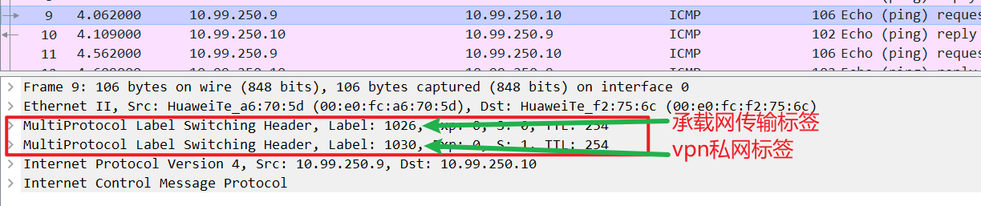

#静态mpls-TE
MPLS-TE 四大构件：
报文转发组件： 通过mpls标签转发
信息发布组件： 靠扩展的igp去发布信息
路径计算组件： 严格源路由
信令组件： 也叫（路径建立组件），用来预留资源，建立lsp，可通过CR-LDP或RSVP-TE协议来完成

MPLS TE（Traffic Engineering）流量工程，把多条LSP联合起来使用，并将这些LSP与一个虚拟隧道接口关联起来，这样的一组LSP称为MPLS TE隧道。
隧道接口 | 是为实现报文的封装而提供的一种点对点类型的虚拟接口
隧道标识 | （Tunnel ID）采用十进制数字来唯一标识一条MPLS TE隧道，以便对隧道进行规划和管理
LSP标识 | （LSP ID）采用十进制数字来唯一标识一条LSP，以便对LSP进行规划和管理
CR-LSP | MPLS TE隧道所使用的LSP称为基于一定约束条件建立的LSP，通常简称为CR-LSP（Constraint-based Routed Label Switched Path），这些约束条件可以称为隧道属性。

与普通LSP（比如LDP LSP）不同，CR-LSP的建立不仅依赖路由信息，还需要满足其他一些约束条件，这些约束条件包括带宽约束和路径约束两个方面: 1、受限标签路径（CR-LSP） 2、信息如何发布
TE信息的发布主要是依靠现有链路状态路由协议的扩展，包括OSPF TE和IS-IS TE。两种IGP路由协议会自动收集信息发布内容，并对这些信息进行泛洪，发布给MPLS TE网络中的其他节点。

★OSPF TE
OSPF是一种基于链路状态信息的路由协议，具有较强的扩展功能。OSPF定义了第1-5、7类的LSA来传递路由信息，并用于路由计算。但是这几种LSA的固定格式不能够适应MPLS TE的需求，因而出现了Opaque LSA和TE LSA扩展。

Opaque LSA分为三类，分别为第9、10、11类LSA。
第9类LSA只能在某一个接口上扩散；
第10类LSA只能在某一个区域内扩散；
第11类LSA则与第5类LSA具有相同的扩散范围，可以在除了STUB、NSSA之外的整个自治系统内部扩散。

实验：mpls_TE_static_ne40e（ensp）
拓扑如下：
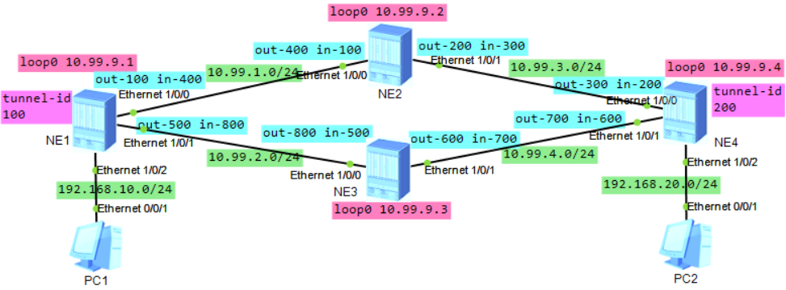

NE1配置：
mpls lsr-id 10.99.9.1
#
mpls
mpls te
#
interface Ethernet1/0/0
undo shutdown
ip address 10.99.1.1 255.255.255.0
mpls
mpls te
dcn
dcn mode vlan
#
interface Ethernet1/0/1
undo shutdown
ip address 10.99.2.1 255.255.255.0
mpls
mpls te
dcn
dcn mode vlan
#
interface Ethernet1/0/2
undo shutdown
ip address 192.168.10.1 255.255.255.0
dcn mode vlan
#
interface LoopBack0
description for_mpls_lsr_id
ip address 10.99.9.1 255.255.255.255
#
interface Tunnel0/0/0
ip address unnumbered interface LoopBack0
tunnel-protocol mpls te
destination 10.99.9.4
mpls te signal-protocol cr-static
mpls te tunnel-id 100
#
ip route-static 192.168.20.0 255.255.255.0 Tunnel0/0/0
#
static-cr-lsp ingress tunnel-interface Tunnel0/0/0 destination 10.99.9.4 nexthop 10.99.2.2 out-label 500 bandwidth ct0 0
#
static-cr-lsp egress lsp2 incoming-interface Ethernet1/0/0 in-label 400
static-cr-lsp egress lsp4 incoming-interface Ethernet1/0/1 in-label 800

#备用配置
static-cr-lsp ingress tunnel-interface Tunnel0/0/0 destination 10.99.9.4 nexthop 10.99.1.2 out-label 100

NE2配置：
mpls lsr-id 10.99.9.2
#
mpls
mpls te
#
interface Ethernet1/0/0
undo shutdown
ip address 10.99.1.2 255.255.255.0
mpls
mpls te
dcn
dcn mode vlan
#
interface Ethernet1/0/1
undo shutdown
ip address 10.99.3.1 255.255.255.0
mpls
mpls te
dcn
dcn mode vlan
#
interface LoopBack0
description for_mpls_lsr_id
ip address 10.99.9.2 255.255.255.255
#
static-cr-lsp transit lsp1 incoming-interface Ethernet1/0/0 in-label 100 nexthop 10.99.3.2 out-label 200 bandwidth ct0 0
static-cr-lsp transit lsp2 incoming-interface Ethernet1/0/1 in-label 300 nexthop 10.99.1.1 out-label 400 bandwidth ct0 0

NE3配置：
mpls lsr-id 10.99.9.3
#
mpls
mpls te
#
interface Ethernet1/0/0
undo shutdown
ip address 10.99.2.2 255.255.255.0
mpls
mpls te
dcn
dcn mode vlan
#
interface Ethernet1/0/1
undo shutdown
ip address 10.99.4.1 255.255.255.0
mpls
mpls te
dcn
dcn mode vlan
#
interface LoopBack0
description for_mpls_lsr_id
ip address 10.99.9.3 255.255.255.255
#
static-cr-lsp transit lsp3 incoming-interface Ethernet1/0/0 in-label 500 nexthop 10.99.4.2 out-label 600 bandwidth ct0 0
static-cr-lsp transit lsp4 incoming-interface Ethernet1/0/1 in-label 700 nexthop 10.99.2.1 out-label 800 bandwidth ct0 0

NE4配置：
mpls lsr-id 10.99.9.4
#
mpls
mpls te
#
interface Ethernet1/0/0
undo shutdown
ip address 10.99.3.2 255.255.255.0
mpls
mpls te
dcn
dcn mode vlan
#
interface Ethernet1/0/1
undo shutdown
ip address 10.99.4.2 255.255.255.0
mpls
mpls te
dcn
dcn mode vlan
#
interface Ethernet1/0/2
undo shutdown
ip address 192.168.20.1 255.255.255.0
dcn mode vlan
#
interface LoopBack0
description for_mpls_lsr_id
ip address 10.99.9.4 255.255.255.255
#
interface Tunnel0/0/0
ip address unnumbered interface LoopBack0
tunnel-protocol mpls te
destination 10.99.9.1
mpls te signal-protocol cr-static
mpls te tunnel-id 200
#
ip route-static 192.168.10.0 255.255.255.0 Tunnel0/0/0
#
static-cr-lsp ingress tunnel-interface Tunnel0/0/0 destination 10.99.9.1 nexthop 10.99.4.1 out-label 700 bandwidth ct0 0
#
static-cr-lsp egress lsp1 incoming-interface Ethernet1/0/0 in-label 200
static-cr-lsp egress lsp3 incoming-interface Ethernet1/0/1 in-label 600
备用配置：
static-cr-lsp ingress tunnel-interface Tunnel0/0/0 destination 10.99.9.1 nexthop 10.99.3.1 out-label 300

NE1查看：
<HUAWEI> display tunnel-info all
Tunnel ID Type Destination Status
-----------------------------------------------------------------------------
0x000000000300000001 te 10.99.9.4 UP

<HUAWEI> disp mpls te tunnel
-------------------------------------------------------------------------------
Ingress LsrId Destination LSPID In/OutLabel R Tunnel-name
-------------------------------------------------------------------------------
10.99.9.1 10.99.9.4 0 -/500 I Tunnel0/0/0
- - - 400/- E lsp2
- - - 800/- E lsp4
-------------------------------------------------------------------------------
R: Role, I: Ingress, T: Transit, E: Egress

<HUAWEI> disp mpls lsp
-------------------------------------------------------------------------------
LSP Information: STATIC CRLSP
-------------------------------------------------------------------------------
FEC In/Out Label In/Out IF Vrf Name
10.99.9.4/32 NULL/500 -/Ethernet1/0/1
-/32 400/NULL Ethernet1/0/0/-
-/32 800/NULL Ethernet1/0/1/-

<HUAWEI> disp mpls static-cr-lsp
TOTAL : 3 STATIC CRLSP(S)
UP : 3 STATIC CRLSP(S)
DOWN : 0 STATIC CRLSP(S)
Name FEC I/O Label I/O If Status
Tunnel0/0/0 10.99.9.4/32 NULL/500 -/Ethernet1/0/1 Up
lsp2 -/32 400/NULL Ethernet1/0/0/- Up
lsp4 -/32 800/NULL Ethernet1/0/1/- Up

NE2查看：
<HUAWEI> disp mpls static-cr-lsp
TOTAL : 2 STATIC CRLSP(S)
UP : 2 STATIC CRLSP(S)
DOWN : 0 STATIC CRLSP(S)
Name FEC I/O Label I/O If Status
lsp1 -/32 100/200 Ethernet1/0/0/Ethernet1/0/1 Up
lsp2 -/32 300/400 Ethernet1/0/1/Ethernet1/0/0 Up

#动态mpls-TE（RSVP-TE）
RSVP（Resource Reservation Protocol）资源预留协议
TE（Traffic Engineering）流量工程

使用LDP来构建LSP时，该技术称为 MPLS-LDP
使用RSVP-TE来构建LSP时，该技术称为动态MPLS-TE

MPLS-TE靠扩展的igp去发布信息

实验：mpls_TE_ospf_ar2240

实验：mpls_TE_isis_ar2240

#mpls_EVPN
当EVPN使用MPLS或SR-MPLS做底层转发面时，需要在目标vpn实例下配置以下命令：
evpn mpls routing-enable #使evpn生成与发布ip前缀路由与irb路由

实验：mpls_EVPN_ospf_ar2240（ensp）
拓扑如下：
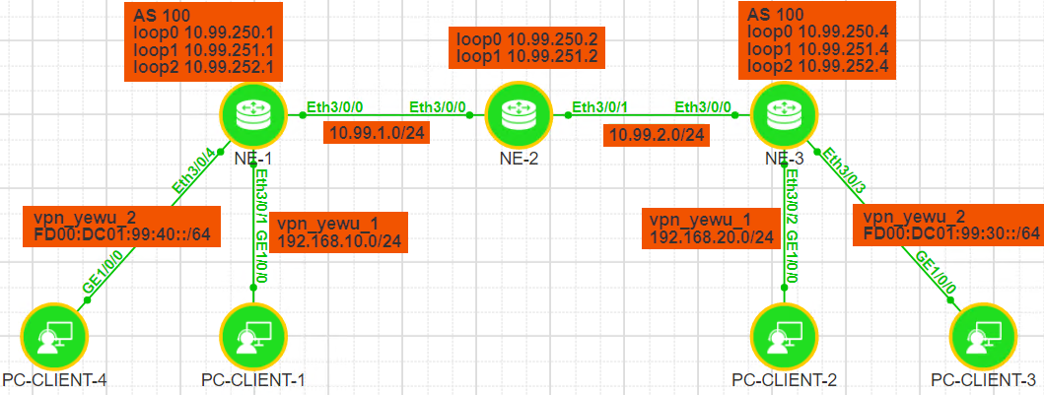
相关参数规划：
yyyy表示相应VPN实例对应的编号，4位数字，不足4位前面以0填充；
vpn实例名称为： vpn_yewu_1 vpn_yewu_2
业务vpn分配编号： 1004 1006
 | vpn-instance |  | 说明
RD | ASN:3yyyy |  | ASN表示路由器的AS号，如果未规划，默认为100
iRT | ASN:3yyyy
eRT | ASN:3yyyy

NE1配置：
ip vpn-instance vpn_yewu_1
ipv4-family
route-distinguisher 100:31004
apply-label per-instance
vpn-target 100:31004 export-extcommunity evpn
vpn-target 100:31004 import-extcommunity evpn
evpn mpls routing-enable
#
ip vpn-instance vpn_yewu_2
ipv6-family
route-distinguisher 100:31006
apply-label per-instance
vpn-target 100:31006 export-extcommunity evpn
vpn-target 100:31006 import-extcommunity evpn
evpn mpls routing-enable
#
mpls lsr-id 10.99.251.1
#
mpls
#
mpls ldp
#
ipv4-family
#
interface Ethernet3/0/0
undo shutdown
ip address 10.99.1.1 255.255.255.0
mpls
mpls ldp
#
interface Ethernet3/0/1
undo shutdown
ip binding vpn-instance vpn_yewu_1
ip address 192.168.10.1 255.255.255.0
#
interface Ethernet3/0/4
undo shutdown
ip binding vpn-instance vpn_yewu_2
ipv6 enable
ipv6 address FD00:DC01:99:40::FFFF/64
#
interface LoopBack0
description for_ospf_router_id
ip address 10.99.250.1 255.255.255.255
#
interface LoopBack1
description for_mpls_lsr_id
ip address 10.99.251.1 255.255.255.255
#
interface LoopBack2
description for_bgp_router_id
ip address 10.99.252.1 255.255.255.255
#
bgp 100
router-id 10.99.252.1
private-4-byte-as enable
peer 10.99.252.4 as-number 100
peer 10.99.252.4 connect-interface LoopBack2

ipv4-family unicast
undo synchronization
peer 10.99.252.4 enable

ipv4-family vpn-instance vpn_yewu_1
import-route direct
advertise l2vpn evpn

ipv6-family vpn-instance vpn_yewu_2
import-route direct
advertise l2vpn evpn

l2vpn-family evpn
policy vpn-target
peer 10.99.252.4 enable
#
ospf 1 router-id 10.99.250.1
opaque-capability enable
area 0.0.0.0
network 10.99.1.0 0.0.0.255
network 10.99.250.1 0.0.0.0
network 10.99.251.1 0.0.0.0
network 10.99.252.1 0.0.0.0
#

NE2配置：
mpls lsr-id 10.99.251.2
#
mpls
#
mpls ldp
#
ipv4-family
#
interface Ethernet3/0/0
undo shutdown
ip address 10.99.1.2 255.255.255.0
mpls
mpls ldp
#
interface Ethernet3/0/1
undo shutdown
ip address 10.99.2.1 255.255.255.0
mpls
mpls ldp
#
interface LoopBack0
description for_ospf_router_id
ip address 10.99.250.2 255.255.255.255
#
interface LoopBack1
description for_mpls_lsr_id
ip address 10.99.251.2 255.255.255.255
#
ospf 1 router-id 10.99.250.2
opaque-capability enable
area 0.0.0.0
network 10.99.1.0 0.0.0.255
network 10.99.2.0 0.0.0.255
network 10.99.250.2 0.0.0.0
network 10.99.251.2 0.0.0.0
#

NE3配置：
ip vpn-instance vpn_yewu_1
ipv4-family
route-distinguisher 100:31004
apply-label per-instance
vpn-target 100:31004 export-extcommunity evpn
vpn-target 100:31004 import-extcommunity evpn
evpn mpls routing-enable
#
ip vpn-instance vpn_yewu_2
ipv6-family
route-distinguisher 100:31006
apply-label per-instance
vpn-target 100:31006 export-extcommunity evpn
vpn-target 100:31006 import-extcommunity evpn
evpn mpls routing-enable
#
mpls lsr-id 10.99.251.4
#
mpls
#
mpls ldp
#
ipv4-family
#
interface Ethernet3/0/0
undo shutdown
ip address 10.99.2.2 255.255.255.0
mpls
mpls ldp
#
interface Ethernet3/0/2
undo shutdown
ip binding vpn-instance vpn_yewu_1
ip address 192.168.20.1 255.255.255.0
#
interface Ethernet3/0/3
undo shutdown
ip binding vpn-instance vpn_yewu_2
ipv6 enable
ipv6 address FD00:DC01:99:30::FFFF/64
#
interface LoopBack0
description for_ospf_router_id
ip address 10.99.250.4 255.255.255.255
#
interface LoopBack1
description for_mpls_lsr_id
ip address 10.99.251.4 255.255.255.255
#
interface LoopBack2
description for_bgp_router_id
ip address 10.99.252.4 255.255.255.255
#
bgp 100
router-id 10.99.252.4
private-4-byte-as enable
peer 10.99.252.1 as-number 100
peer 10.99.252.1 connect-interface LoopBack2

ipv4-family unicast
undo synchronization
peer 10.99.252.1 enable

ipv4-family vpn-instance vpn_yewu_1
import-route direct
advertise l2vpn evpn

ipv6-family vpn-instance vpn_yewu_2
import-route direct
advertise l2vpn evpn

l2vpn-family evpn
policy vpn-target
peer 10.99.252.1 enable
#
ospf 1 router-id 10.99.250.4
opaque-capability enable
area 0.0.0.0
network 10.99.2.0 0.0.0.255
network 10.99.250.4 0.0.0.0
network 10.99.251.4 0.0.0.0
network 10.99.252.4 0.0.0.0
#

NE1查看：
<HUAWEI> disp ospf peer brief
(M) Indicates MADJ neighbor
OSPF Process 1 with Router ID 10.99.250.1
Peer Statistic Information
Total number of peer(s): 1
Peer(s) in full state: 1
-----------------------------------------------------------------------------
Area Id Interface Neighbor id State
0.0.0.0 Eth3/0/0 10.99.250.2 Full
-----------------------------------------------------------------------------

<HUAWEI> disp bgp peer
BGP local router ID : 10.99.252.1
Local AS number : 100
Total number of peers : 1 Peers in established state : 1

Peer V AS MsgRcvd MsgSent OutQ Up/Down State PrefRcv
10.99.252.4 4 100 6 6 0 00:00:10 Established 0

<HUAWEI> disp mpls lsp
Flag after Out IF: (I) - RLFA Iterated LSP, (I*) - Normal and RLFA Iterated LSP
Flag after LDP FRR: (L) - Logic FRR LSP
-------------------------------------------------------------------------------
LSP Information: LDP LSP
-------------------------------------------------------------------------------
FEC In/Out Label In/Out IF Vrf Name
10.99.250.1/32 3/NULL -/-
10.99.250.2/32 NULL/3 -/Eth3/0/0
10.99.250.2/32 48004/3 -/Eth3/0/0
10.99.250.4/32 NULL/48003 -/Eth3/0/0
10.99.250.4/32 48006/48003 -/Eth3/0/0
10.99.251.1/32 3/NULL -/-
10.99.251.2/32 NULL/3 -/Eth3/0/0
10.99.251.2/32 48005/3 -/Eth3/0/0
10.99.251.4/32 NULL/48004 -/Eth3/0/0
10.99.251.4/32 48007/48004 -/Eth3/0/0
10.99.252.1/32 3/NULL -/-
10.99.252.4/32 NULL/48005 -/Eth3/0/0
10.99.252.4/32 48008/48005 -/Eth3/0/0
-------------------------------------------------------------------------------
LSP Information: BGP LSP
-------------------------------------------------------------------------------
FEC In/Out Label In/Out IF Vrf Name
-/32 48000/NULL -/- vpn_yewu_1
-------------------------------------------------------------------------------
LSP Information: BGP IPV6 LSP
-------------------------------------------------------------------------------
FEC : FFFF:FFFF:FFFF:FFFF:FFFF:FFFF:FFFF:FFFF/128
In Label : 48001 Out Label : -----
In Interface : ----- OutInterface : -----
Vrf6 Name : vpn_yewu_2
-------------------------------------------------------------------------------
LSP Information: EVPN L3VPN LSP
-------------------------------------------------------------------------------
FEC In/Out Label In/Out IF Vrf Name
-/32 48002/NULL -/- vpn_yewu_1
-------------------------------------------------------------------------------
LSP Information: EVPN L3VPN IPv6 LSP
-------------------------------------------------------------------------------
FEC : FFFF:FFFF:FFFF:FFFF:FFFF:FFFF:FFFF:FFFF/128
In Label : 48003 Out Label : -----
In Interface : ----- OutInterface : -----
Vrf6 Name : vpn_yewu_2

<HUAWEI> disp tunnel-info all
Tunnel ID Type Destination Status
----------------------------------------------------------------------------------
0x0000000001004c4b44 ldp 10.99.250.2 UP
0x0000000001004c4b45 ldp 10.99.251.2 UP
0x0000000001004c4b46 ldp 10.99.250.4 UP
0x0000000001004c4b47 ldp 10.99.251.4 UP
0x0000000001004c4b48 ldp 10.99.252.4 UP

<HUAWEI> disp tunnel-info 0x0000000001004c4b48
Tunnel ID: 0x0000000001004c4b48
Type: ldp
Name: LDP LSP
Destination: 10.99.252.4
Instance ID: 0
MTU: 1500
Cost: 2
Status: UP
Out Interface: Ethernet3/0/0
NextHop: 10.99.1.2

<HUAWEI> disp ip routing-table vpn-instance vpn_yewu_1
Route Flags: R - relay, D - download to fib, T - to vpn-instance, B - black hole route
------------------------------------------------------------------------------
Routing Table : vpn_yewu_1
Destinations : 6 Routes : 6

Destination/Mask Proto Pre Cost Flags NextHop Interface
127.0.0.0/8 Direct 0 0 D 127.0.0.1 InLoopBack0
192.168.10.0/24 Direct 0 0 D 192.168.10.1 Ethernet3/0/1
192.168.10.1/32 Direct 0 0 D 127.0.0.1 Ethernet3/0/1
192.168.10.255/32 Direct 0 0 D 127.0.0.1 Ethernet3/0/1
192.168.20.0/24 IBGP 255 0 RD 10.99.252.4 Ethernet3/0/0
255.255.255.255/32 Direct 0 0 D 127.0.0.1 InLoopBack0

<HUAWEI> disp ipv6 routing-table vpn-instance vpn_yewu_2
Routing Table : vpn_yewu_2
Destinations : 4 Routes : 4
Destination : FD00:DC01:99:30:: PrefixLength : 64
NextHop : ::FFFF:10.99.252.4 Preference : 255
Cost : 0 Protocol : IBGP
RelayNextHop : ::FFFF:10.99.1.2 TunnelID : 0x0000000001004c4b48
Interface : Ethernet3/0/0 Flags : RD

Destination : FD00:DC01:99:40:: PrefixLength : 64
NextHop : FD00:DC01:99:40::FFFF Preference : 0
Cost : 0 Protocol : Direct
RelayNextHop : :: TunnelID : 0x0
Interface : Ethernet3/0/4 Flags : D

Destination : FD00:DC01:99:40::FFFF PrefixLength : 128
NextHop : ::1 Preference : 0
Cost : 0 Protocol : Direct
RelayNextHop : :: TunnelID : 0x0
Interface : Ethernet3/0/4 Flags : D

Destination : FE80:: PrefixLength : 10
NextHop : :: Preference : 0
Cost : 0 Protocol : Direct
RelayNextHop : :: TunnelID : 0x0
Interface : NULL0 Flags : DB

<HUAWEI> disp bgp evpn all routing-table
Local AS number : 100
BGP Local router ID is 10.99.252.1
Status codes: * - valid, > - best, d - damped, x - best external, a - add path,
h - history, i - internal, s - suppressed, S - Stale
Origin : i - IGP, e - EGP, ? - incomplete

EVPN address family:
Number of Ip Prefix Routes: 4

Route Distinguisher: 100:31004
Network(EthTagId/IpPrefix/IpPrefixLen) NextHop
*> 0:192.168.10.0:24 0.0.0.0
*>i 0:192.168.20.0:24 10.99.252.4

Route Distinguisher: 100:31006
Network(EthTagId/IpPrefix/IpPrefixLen) NextHop
*>i 0:[FD00:DC01:99:30::]:64 ::FFFF:10.99.252.4
*> 0:[FD00:DC01:99:40::]:64 ::

★SR-MPLS
SR MPLS是指基于MPLS转发平面的Segment Routing（指令路由）
Segment Routing使用控制器或IGP路由协议集中算路和分发标签，不再需要RSVP-TE、LDP等隧道协议。

★MPLS-TE 使用rsvp-te协议做控制平面的
★MPLS-VPN 使用MP-BGP协议做控制平面的
★SR-MPLS 使用SR协议做控制平面的

传统MPLS TE是一种面向连接的技术，为了维护连接状态，节点间需要发送和处理大量Keepalive报文，设备控制层面压力大。Segment Routing仅在头节点对报文进行标签操作即可任意控制业务路径，中间节点不需要维护路径信息，设备控制层面压力小。

Segment Routing技术基于源路由理念而设计，通过源节点即可控制数据包在网络中的转发路径。配合集中算路模块，即可灵活简便的实现路径控制与调整

SR-MPLS BE（Segment Routing-MPLS Best Effort）是指IGP使用最短路径算法计算得到的最优SR LSP。SR LSP是指使用Segment Routing技术建立的标签转发路径，由一个Prefix SID或Node SID指导数据包转发。
SR-MPLS BE是一种替代 “LDP+IGP方案” 的一种新方案
使用SID来指导设备基于最短路径进行数据转发，（该最短路径是基于路由协议计算得出的，并且支持等价路由）这种工作机制称为SR-MPLS BE（Best Effort）

使用BFD for SR-MPLS BE 检测SR LSP的连通性。BFD for SR-MPLS BE可触发VPN FRR等应用在主SR LSP故障时进行快速流量切换，以减少对业务的影响

SR-MPLS TE（Traffic Engine）使用多个SID进行组合来指导数据转发，可以对数据的转发路径进行一定约束，从而实现流量工程的需求

实验：SR-MPLS_BE_vpnv4_isis_ne40e（ensp）
拓扑如下：
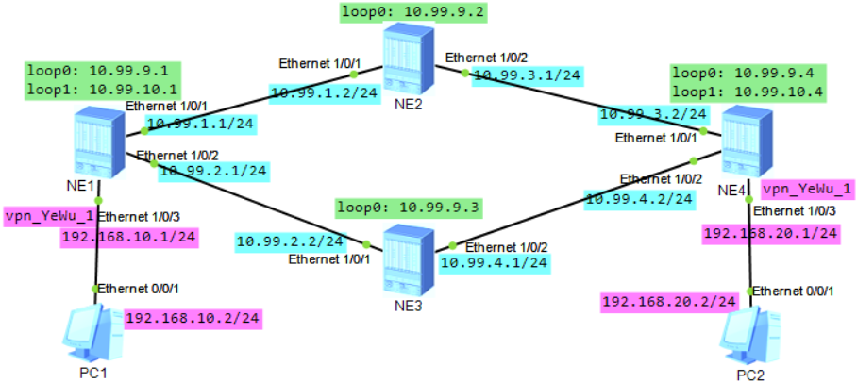
相关参数规划：
yyyy表示相应VPN实例对应的编号，4位数字，不足4位前面以0填充；本实验中给业务vpn分配1010编号
vpn实例名称为： vpn_yewu_1
 | vpn-instance |  | 说明
RD | ASN:3yyyy |  | ASN表示路由器的AS号，如果未规划，默认为100
iRT | ASN:3yyyy
eRT | ASN:3yyyy

NE1配置：
ip vpn-instance vpn_yewu_1
ipv4-family
route-distinguisher 100:31010
tnl-policy p1
vpn-target 100:31010 export-extcommunity
vpn-target 100:31010 import-extcommunity
#
mpls lsr-id 10.99.9.1
#
mpls
#
segment-routing
#
isis 1
is-level level-1
cost-style wide
network-entity 49.0001.1111.1111.1111.00
is-name ne1
segment-routing mpls
segment-routing global-block 16000 20000
frr
loop-free-alternate level-1
ti-lfa level-1
#
interface Ethernet1/0/1
undo shutdown
ip address 10.99.1.1 255.255.255.0
isis enable 1
dcn
dcn mode vlan
#
interface Ethernet1/0/2
undo shutdown
ip address 10.99.2.1 255.255.255.0
isis enable 1
dcn mode vlan
#
interface Ethernet1/0/3
undo shutdown
ip binding vpn-instance vpn_yewu_1
ip address 192.168.10.1 255.255.255.0
dcn mode vlan
#
interface LoopBack0
description for_mpls_lsr_id
ip address 10.99.9.1 255.255.255.255
isis enable 1
isis prefix-sid index 1
#
interface LoopBack1
description for_bgp_router_id
ip address 10.99.10.1 255.255.255.255
isis enable 1
isis prefix-sid index 10
#
bgp 100
router-id 10.99.10.1
peer 10.99.10.4 as-number 100
peer 10.99.10.4 connect-interface LoopBack1
#
ipv4-family unicast
undo synchronization
peer 10.99.10.4 enable
#
ipv4-family vpnv4
policy vpn-target
peer 10.99.10.4 enable
#
ipv4-family vpn-instance vpn_yewu_1
import-route direct
#
tunnel-policy p1
tunnel select-seq sr-lsp load-balance-number 2
#

NE2配置：
mpls lsr-id 10.99.9.2
#
mpls
#
segment-routing
#
isis 1
is-level level-1
cost-style wide
network-entity 49.0001.2222.2222.2222.00
is-name ne2
segment-routing mpls
segment-routing global-block 16000 20000
frr
loop-free-alternate level-1
ti-lfa level-1
#
interface Ethernet1/0/1
undo shutdown
ip address 10.99.1.2 255.255.255.0
isis enable 1
dcn
dcn mode vlan
#
interface Ethernet1/0/2
undo shutdown
ip address 10.99.3.1 255.255.255.0
isis enable 1
dcn mode vlan
#
interface LoopBack0
description for_mpls_lsr_id
ip address 10.99.9.2 255.255.255.255
isis enable 1
isis prefix-sid index 2
#

NE3配置：
mpls lsr-id 10.99.9.3
#
mpls
#
segment-routing
#
isis 1
is-level level-1
cost-style wide
network-entity 49.0001.3333.3333.3333.00
is-name ne3
segment-routing mpls
segment-routing global-block 16000 20000
frr
loop-free-alternate level-1
ti-lfa level-1
#
interface Ethernet1/0/1
undo shutdown
ip address 10.99.2.2 255.255.255.0
isis enable 1
dcn
dcn mode vlan
#
interface Ethernet1/0/2
undo shutdown
ip address 10.99.4.1 255.255.255.0
isis enable 1
dcn mode vlan
#
interface LoopBack0
description for_mpls_lsr_id
ip address 10.99.9.3 255.255.255.255
isis enable 1
isis prefix-sid index 3
#

NE4配置：
ip vpn-instance vpn_yewu_1
ipv4-family
route-distinguisher 100:31010
tnl-policy p1
vpn-target 100:31010 export-extcommunity
vpn-target 100:31010 import-extcommunity
#
mpls lsr-id 10.99.9.4
#
mpls
#
segment-routing
#
isis 1
is-level level-1
cost-style wide
network-entity 49.0001.4444.4444.4444.00
is-name ne4
segment-routing mpls
segment-routing global-block 16000 20000
frr
loop-free-alternate level-1
ti-lfa level-1
#
interface Ethernet1/0/1
undo shutdown
ip address 10.99.3.2 255.255.255.0
isis enable 1
dcn
dcn mode vlan
#
interface Ethernet1/0/2
undo shutdown
ip address 10.99.4.2 255.255.255.0
isis enable 1
dcn mode vlan
#
interface Ethernet1/0/3
undo shutdown
ip binding vpn-instance vpn_yewu_1
ip address 192.168.20.1 255.255.255.0
dcn mode vlan
#
interface LoopBack0
description for_mpls_lsr_id
ip address 10.99.9.4 255.255.255.255
isis enable 1
isis prefix-sid index 4
#
interface LoopBack1
description for_bgp_router_id
ip address 10.99.10.4 255.255.255.255
isis enable 1
isis prefix-sid index 40
#
bgp 100
router-id 10.99.10.4
peer 10.99.10.1 as-number 100
peer 10.99.10.1 connect-interface LoopBack1
#
ipv4-family unicast
undo synchronization
peer 10.99.10.1 enable
#
ipv4-family vpnv4
policy vpn-target
peer 10.99.10.1 enable
#
ipv4-family vpn-instance vpn_yewu_1
import-route direct
#
tunnel-policy p1
tunnel select-seq sr-lsp load-balance-number 2
#

NE1查看：
<HUAWEI> disp tunnel-info all
Tunnel ID Type Destination Status
-----------------------------------------------------------------------------
0x000000002900000004 srbe-lsp 10.99.9.2 UP
0x000000002900000005 srbe-lsp 10.99.9.4 UP
0x000000002900000006 srbe-lsp 10.99.9.3 UP
0x000000002900000007 srbe-lsp 10.99.10.4 UP

<HUAWEI> ping lsp segment-routing ip 10.99.9.4 32 version draft2
LSP PING FEC: SEGMENT ROUTING IPV4 PREFIX 10.99.9.4/32 : 100 data bytes, pres
s CTRL_C to break
Reply from 10.99.9.4: bytes=100 Sequence=1 time=12 ms
Reply from 10.99.9.4: bytes=100 Sequence=2 time=9 ms
Reply from 10.99.9.4: bytes=100 Sequence=3 time=10 ms
Reply from 10.99.9.4: bytes=100 Sequence=4 time=12 ms
Reply from 10.99.9.4: bytes=100 Sequence=5 time=11 ms

<HUAWEI> disp bgp peer
BGP local router ID : 10.99.10.1
Local AS number : 100
Total number of peers : 1 Peers in established state : 1

Peer V AS MsgRcvd MsgSent OutQ Up/Down State PrefRcv
10.99.10.4 4 100 57 57 0 00:43:39 Established 0

<HUAWEI> disp bgp vpnv4 all peer
BGP local router ID : 10.99.10.1
Local AS number : 100
Total number of peers : 1 Peers in established state : 1

Peer V AS MsgRcvd MsgSent OutQ Up/Down State PrefRcv
10.99.10.4 4 100 58 58 0 00:44:32 Established 1

<HUAWEI> disp ip routing-table vpn-instance vpn_yewu_1
Route Flags: R - relay, D - download to fib, T - to vpn-instance, B - black hole
route
------------------------------------------------------------------------------
Routing Table : vpn_yewu_1
Destinations : 6 Routes : 6

Destination/Mask Proto Pre Cost Flags NextHop Interface

127.0.0.0/8 Direct 0 0 D 127.0.0.1 InLoopBack0
192.168.10.0/24 Direct 0 0 D 192.168.10.1 Ethernet1/0/3
192.168.10.1/32 Direct 0 0 D 127.0.0.1 Ethernet1/0/3
192.168.10.255/32 Direct 0 0 D 127.0.0.1 Ethernet1/0/3
192.168.20.0/24 IBGP 255 0 RD 10.99.10.4 Ethernet1/0/1
IBGP 255 0 RD 10.99.10.4 Ethernet1/0/2
255.255.255.255/32 Direct 0 0 D 127.0.0.1 InLoopBack0

PC1 ping PC2
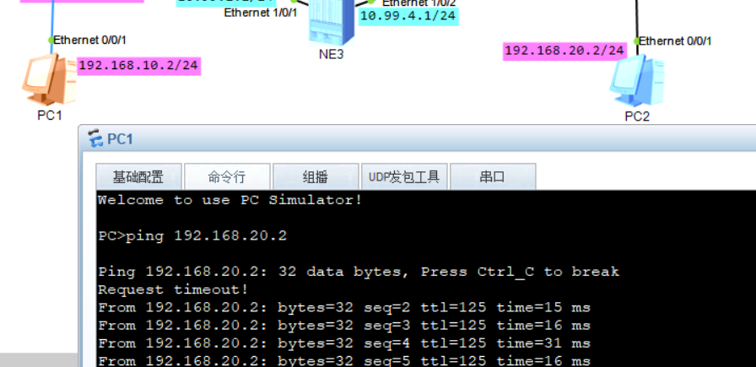

实验：SR-MPLS_BE_vpnv4_ospf_ne40e（ensp）
拓扑如下：
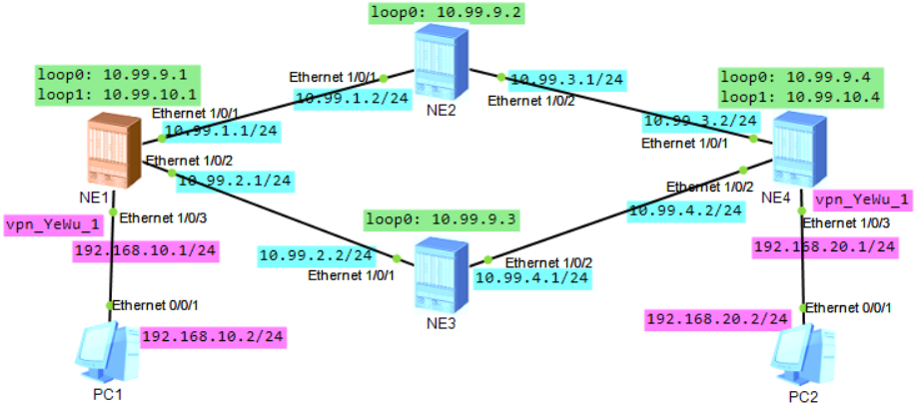
相关参数规划：
yyyy表示相应VPN实例对应的编号，4位数字，不足4位前面以0填充；本实验中给业务vpn分配1010编号
vpn实例名称为： vpn_yewu_1
 | vpn-instance |  | 说明
RD | ASN:3yyyy |  | ASN表示路由器的AS号，如果未规划，默认为100
iRT | ASN:3yyyy
eRT | ASN:3yyyy

NE1配置：
ip vpn-instance vpn_yewu_1
ipv4-family
route-distinguisher 100:31010
tnl-policy p1
vpn-target 100:31010 export-extcommunity
vpn-target 100:31010 import-extcommunity
#
mpls lsr-id 10.99.9.1
#
mpls
#
segment-routing
#
interface Ethernet1/0/1
undo shutdown
ip address 10.99.1.1 255.255.255.0
ospf enable 1 area 0.0.0.0
dcn
dcn mode vlan
#
interface Ethernet1/0/2
undo shutdown
ip address 10.99.2.1 255.255.255.0
ospf enable 1 area 0.0.0.0
dcn mode vlan
#
interface Ethernet1/0/3
undo shutdown
ip binding vpn-instance vpn_yewu_1
ip address 192.168.10.1 255.255.255.0
dcn mode vlan
#
interface LoopBack0
description for_mpls_lsr_id__ospf_router_id__bgp_router_id
ip address 10.99.9.1 255.255.255.255
ospf enable 1 area 0.0.0.0
ospf prefix-sid index 1
#
bgp 100
router-id 10.99.9.1
peer 10.99.9.4 as-number 100
peer 10.99.9.4 connect-interface LoopBack0
#
ipv4-family unicast
undo synchronization
peer 10.99.9.4 enable
#
ipv4-family vpnv4
policy vpn-target
peer 10.99.9.4 enable
#
ipv4-family vpn-instance vpn_yewu_1
import-route direct
#
ospf 1 router-id 10.99.9.1
opaque-capability enable
segment-routing mpls
segment-routing global-block 16000 20000
frr
loop-free-alternate
ti-lfa enable
area 0.0.0.0
#
tunnel-policy p1
tunnel select-seq sr-lsp load-balance-number 2
#

NE2配置：
mpls lsr-id 10.99.9.2
#
mpls
#
segment-routing
#
interface Ethernet1/0/1
undo shutdown
ip address 10.99.1.2 255.255.255.0
ospf enable 1 area 0.0.0.0
dcn
dcn mode vlan
#
interface Ethernet1/0/2
undo shutdown
ip address 10.99.3.1 255.255.255.0
ospf enable 1 area 0.0.0.0
dcn mode vlan
#
interface LoopBack0
description for_mpls_lsr_id__ospf_router_id
ip address 10.99.9.2 255.255.255.255
ospf enable 1 area 0.0.0.0
ospf prefix-sid index 2
#
ospf 1 router-id 10.99.9.2
opaque-capability enable
segment-routing mpls
segment-routing global-block 16000 20000
frr
loop-free-alternate
ti-lfa enable
area 0.0.0.0
#

NE3配置：
mpls lsr-id 10.99.9.3
#
mpls
#
segment-routing
#
interface Ethernet1/0/1
undo shutdown
ip address 10.99.2.2 255.255.255.0
ospf enable 1 area 0.0.0.0
dcn
dcn mode vlan
#
interface Ethernet1/0/2
undo shutdown
ip address 10.99.4.1 255.255.255.0
ospf enable 1 area 0.0.0.0
dcn mode vlan
#
interface LoopBack0
description for_mpls_lsr_id__ospf_router_id
ip address 10.99.9.3 255.255.255.255
ospf enable 1 area 0.0.0.0
ospf prefix-sid index 3
#
ospf 1 router-id 10.99.9.3
opaque-capability enable
segment-routing mpls
segment-routing global-block 16000 20000
frr
loop-free-alternate
ti-lfa enable
area 0.0.0.0
#

NE4配置：
ip vpn-instance vpn_yewu_1
ipv4-family
route-distinguisher 100:31010
tnl-policy p1
vpn-target 100:31010 export-extcommunity
vpn-target 100:31010 import-extcommunity
#
mpls lsr-id 10.99.9.4
#
mpls
#
segment-routing
#
interface Ethernet1/0/1
undo shutdown
ip address 10.99.3.2 255.255.255.0
ospf enable 1 area 0.0.0.0
dcn
dcn mode vlan
#
interface Ethernet1/0/2
undo shutdown
ip address 10.99.4.2 255.255.255.0
ospf enable 1 area 0.0.0.0
dcn mode vlan
#
interface Ethernet1/0/3
undo shutdown
ip binding vpn-instance vpn_yewu_1
ip address 192.168.20.1 255.255.255.0
dcn mode vlan
#
interface LoopBack0
description for_mpls_lsr_id__ospf_router_id__bgp_router_id
ip address 10.99.9.4 255.255.255.255
ospf enable 1 area 0.0.0.0
ospf prefix-sid index 4
#
bgp 100
router-id 10.99.9.4
peer 10.99.9.1 as-number 100
peer 10.99.9.1 connect-interface LoopBack0
#
ipv4-family unicast
undo synchronization
peer 10.99.9.1 enable
#
ipv4-family vpnv4
policy vpn-target
peer 10.99.9.1 enable
#
ipv4-family vpn-instance vpn_yewu_1
import-route direct
#
ospf 1 router-id 10.99.9.4
opaque-capability enable
segment-routing mpls
segment-routing global-block 16000 20000
frr
loop-free-alternate
ti-lfa enable
area 0.0.0.0
#
tunnel-policy p1
tunnel select-seq sr-lsp load-balance-number 2
#

NE1查看：
<HUAWEI> disp tunnel-info all
Tunnel ID Type Destination Status
-----------------------------------------------------------------------
0x000000002900000004 srbe-lsp 10.99.9.2 UP
0x000000002900000005 srbe-lsp 10.99.9.3 UP
0x000000002900000006 srbe-lsp 10.99.9.4 UP

<HUAWEI> ping lsp segment-routing ip 10.99.9.4 32 version draft2
LSP PING FEC: SEGMENT ROUTING IPV4 PREFIX 10.99.9.4/32 : 100 data bytes, pres
s CTRL_C to break
Reply from 10.99.9.4: bytes=100 Sequence=1 time=12 ms
Reply from 10.99.9.4: bytes=100 Sequence=2 time=9 ms
Reply from 10.99.9.4: bytes=100 Sequence=3 time=10 ms
Reply from 10.99.9.4: bytes=100 Sequence=4 time=12 ms
Reply from 10.99.9.4: bytes=100 Sequence=5 time=11 ms

<HUAWEI> disp bgp peer
BGP local router ID : 10.99.1.1
Local AS number : 100
Total number of peers : 1 Peers in established state : 1

Peer V AS MsgRcvd MsgSent OutQ Up/Down State PrefRcv
10.99.9.4 4 100 40 40 0 00:28:42 Established 0

<HUAWEI> disp bgp vpnv4 all peer
BGP local router ID : 10.99.1.1
Local AS number : 100
Total number of peers : 1 Peers in established state : 1

Peer V AS MsgRcvd MsgSent OutQ Up/Down State PrefRcv
10.99.9.4 4 100 40 40 0 00:28:49 Established 1

<HUAWEI> disp ip routing-table vpn-instance vpn_yewu_1
Route Flags: R - relay, D - download to fib, T - to vpn-instance, B - black hole
route
------------------------------------------------------------------------------
Routing Table : vpn_yewu_1
Destinations : 6 Routes : 6

Destination/Mask Proto Pre Cost Flags NextHop Interface

127.0.0.0/8 Direct 0 0 D 127.0.0.1 InLoopBack0
192.168.10.0/24 Direct 0 0 D 192.168.10.1 Ethernet1/0/3
192.168.10.1/32 Direct 0 0 D 127.0.0.1 Ethernet1/0/3
192.168.10.255/32 Direct 0 0 D 127.0.0.1 Ethernet1/0/3
192.168.20.0/24 IBGP 255 0 RD 10.99.9.4 Ethernet1/0/1
IBGP 255 0 RD 10.99.9.4 Ethernet1/0/2
255.255.255.255/32 Direct 0 0 D 127.0.0.1 InLoopBack0

PC1 ping PC2
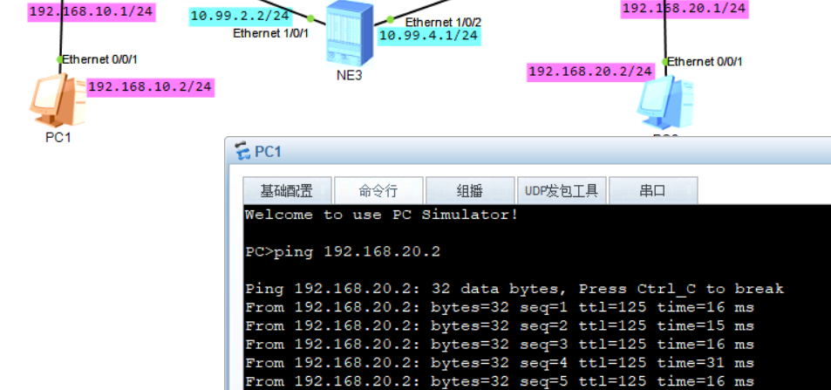

实验：SR-MPLS_TE_vpnv4_isis_ne40e（ensp）
SR-MPLS-TE缺点：很难支持负载分担，一但隧道链路断了，不能自动切换到BE路径

拓扑如下：
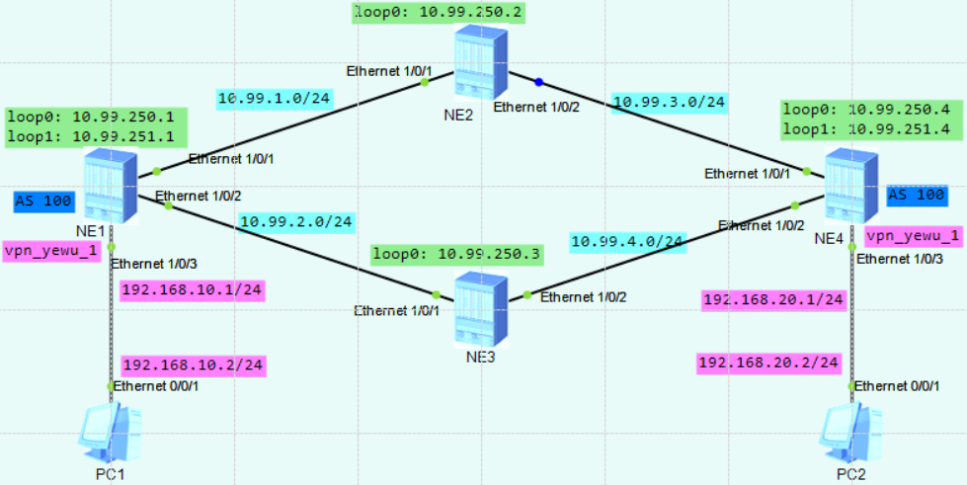
相关参数规划：
yyyy表示相应VPN实例对应的编号，4位数字，不足4位前面以0填充；本实验中给业务vpn分配1010编号
vpn实例名称为： vpn_yewu_1
 | vpn-instance |  | 说明
RD | ASN:3yyyy |  | ASN表示路由器的AS号，如果未规划，默认为100
iRT | ASN:3yyyy
eRT | ASN:3yyyy

NE1配置：
ip vpn-instance vpn_yewu_1
ipv4-family
route-distinguisher 100:31010
tnl-policy tnp1 #调用隧道策略
vpn-target 100:31010 export-extcommunity
vpn-target 100:31010 import-extcommunity
#
mpls lsr-id 10.99.250.1
#
mpls
mpls te
#
explicit-path mpls_te_path_1 #创建一个SR-MPLS TE显式路径
next sid label 20003 type prefix #指定下一个SID标签及类型
next sid label 330002 type adjacency #指定下一个SID标签及类型
#
segment-routing
#
isis 1
is-level level-1
cost-style wide
network-entity 49.0001.1111.1111.1111.00
segment-routing mpls
segment-routing global-block 20000 21000 #配置SRGB，华为设备可取值范围如下：
# <16000-321534, 524288-1048574>
#
interface Ethernet1/0/1
undo shutdown
ip address 10.99.1.1 255.255.255.0
isis enable 1
isis circuit-level level-1
undo dcn
undo dcn mode vlan
#
interface Ethernet1/0/2
undo shutdown
ip address 10.99.2.1 255.255.255.0
isis enable 1
isis circuit-level level-1
undo dcn mode vlan
#
interface Ethernet1/0/3
undo shutdown
ip binding vpn-instance vpn_yewu_1
ip address 192.168.10.1 255.255.255.0
undo dcn mode vlan
#
interface LoopBack0
description for_mpls_lsr_id
ip address 10.99.250.1 255.255.255.255
isis enable 1
isis circuit-level level-1
isis prefix-sid index 1
#
interface LoopBack1
description for_bgp_router_id
ip address 10.99.251.1 255.255.255.255
isis enable 1
isis circuit-level level-1
isis prefix-sid index 11
#
interface Tunnel1
ip address unnumbered interface LoopBack1 #同bgp的router-id的loop口ip
tunnel-protocol mpls te #指定隧道协议为MPLS-TE
destination 10.99.251.4 #同对端PE的bgp的router-id的loop口ip
mpls te signal-protocol segment-routing #指定TE隧道的信令协议为SR
mpls te tunnel-id 100 #配置TE隧道的隧道ID
mpls te path explicit-path mpls_te_path_1 #在隧道接口下调用显式路径
#
bgp 100
router-id 10.99.251.1
peer 10.99.251.4 as-number 100
peer 10.99.251.4 connect-interface LoopBack1
#
ipv4-family unicast
undo synchronization
peer 10.99.251.4 enable
#
ipv4-family vpnv4
policy vpn-target
peer 10.99.251.4 enable
#
ipv4-family vpn-instance vpn_yewu_1
import-route direct
#
tunnel-policy tnp1 #创建隧道策略
tunnel select-seq sr-te load-balance-number 1 #设置 选择隧道的优先级顺序及负载分担数量
#

NE2配置：
mpls lsr-id 10.99.250.2
#
mpls
mpls te
#
segment-routing
#
isis 1
is-level level-1
cost-style wide
network-entity 49.0001.2222.2222.2222.00
segment-routing mpls
segment-routing global-block 20000 21000
#
interface Ethernet1/0/1
undo shutdown
ip address 10.99.1.2 255.255.255.0
isis enable 1
isis circuit-level level-1
undo dcn
undo dcn mode vlan
#
interface Ethernet1/0/2
undo shutdown
ip address 10.99.3.1 255.255.255.0
isis enable 1
isis circuit-level level-1
undo dcn mode vlan
#
interface LoopBack0
description for_mpls_lsr_id
ip address 10.99.250.2 255.255.255.255
isis enable 1
isis circuit-level level-1
isis prefix-sid index 2
#

NE3配置：
mpls lsr-id 10.99.250.3
#
mpls
mpls te
#
segment-routing
ipv4 adjacency local-ip-addr 10.99.2.2 remote-ip-addr 10.99.2.1 sid 330001 #配置Adj SID，取值范围：
ipv4 adjacency local-ip-addr 10.99.4.1 remote-ip-addr 10.99.4.2 sid 330002 # <321536-331775>
#
isis 1
is-level level-1
cost-style wide
network-entity 49.0001.3333.3333.3333.00
segment-routing mpls
segment-routing global-block 20000 21000
segment-routing auto-adj-sid disable
#
interface Ethernet1/0/1
undo shutdown
ip address 10.99.2.2 255.255.255.0
isis enable 1
isis circuit-level level-1
isis cost 50
undo dcn
undo dcn mode vlan
#
interface Ethernet1/0/2
undo shutdown
ip address 10.99.4.1 255.255.255.0
isis enable 1
isis circuit-level level-1
undo dcn mode vlan
#
interface LoopBack0
description for_mpls_lsr_id
ip address 10.99.250.3 255.255.255.255
isis enable 1
isis circuit-level level-1
isis prefix-sid index 3
#

NE4配置：
ip vpn-instance vpn_yewu_1
ipv4-family
route-distinguisher 100:31010
tnl-policy tnp1
vpn-target 100:31010 export-extcommunity
vpn-target 100:31010 import-extcommunity
#
mpls lsr-id 10.99.250.4
#
mpls
mpls te
#
explicit-path mpls_te_path_1
next sid label 20003 type prefix
next sid label 330001 type adjacency
#
segment-routing
#
isis 1
is-level level-1
cost-style wide
network-entity 49.0001.4444.4444.4444.00
segment-routing mpls
segment-routing global-block 20000 21000
#
interface Ethernet1/0/1
undo shutdown
ip address 10.99.3.2 255.255.255.0
isis enable 1
isis circuit-level level-1
undo dcn
undo dcn mode vlan
#
interface Ethernet1/0/2
undo shutdown
ip address 10.99.4.2 255.255.255.0
isis enable 1
isis circuit-level level-1
undo dcn mode vlan
#
interface Ethernet1/0/3
undo shutdown
ip binding vpn-instance vpn_yewu_1
ip address 192.168.20.1 255.255.255.0
undo dcn mode vlan
#
interface LoopBack0
description for_mpls_lsr_id
ip address 10.99.250.4 255.255.255.255
isis enable 1
isis circuit-level level-1
isis prefix-sid index 4
#
interface LoopBack1
description for_bgp_router_id
ip address 10.99.251.4 255.255.255.255
isis enable 1
isis circuit-level level-1
isis prefix-sid index 14
#
interface Tunnel1
ip address unnumbered interface LoopBack1
tunnel-protocol mpls te
destination 10.99.251.1
mpls te signal-protocol segment-routing
mpls te tunnel-id 100
mpls te path explicit-path mpls_te_path_1
#
bgp 100
router-id 10.99.251.4
peer 10.99.251.1 as-number 100
peer 10.99.251.1 connect-interface LoopBack1
#
ipv4-family unicast
undo synchronization
peer 10.99.251.1 enable
#
ipv4-family vpnv4
policy vpn-target
peer 10.99.251.1 enable
#
ipv4-family vpn-instance vpn_yewu_1
import-route direct
#
tunnel-policy tnp1
tunnel select-seq sr-te load-balance-number 1
#

NE1查看：
<HUAWEI> disp tunnel-info all
Tunnel ID Type Destination Status
--------------------------------------------------------------------------
0x000000000300002001 sr-te 10.99.251.4 UP
0x000000002900000004 srbe-lsp 10.99.250.2 UP
0x000000002900000005 srbe-lsp 10.99.250.3 UP
0x000000002900000006 srbe-lsp 10.99.250.4 UP
0x000000002900000008 srbe-lsp 10.99.251.4 UP

<HUAWEI> disp mpls te tunnel-interface Tunnel 1
Tunnel Name : Tunnel1
Signalled Tunnel Name: -
Tunnel State Desc : CR-LSP is Up
Tunnel Attributes :
Active LSP : Primary LSP
Traffic Switch : -
Session ID : 100
Ingress LSR ID : 10.99.250.1 Egress LSR ID: 10.99.251.4
Admin State : UP Oper State : UP
Signaling Protocol : Segment-Routing

<HUAWEI> disp mpls te tunnel path
Tunnel Interface Name : Tunnel1
Lsp ID : 10.99.250.1 :100 :12
Hop Information
Hop 0 Node label 20003
Hop 1 Link label 330002

<HUAWEI> disp ip routing-table vpn-instance vpn_yewu_1
Route Flags: R - relay, D - download to fib, T - to vpn-instance, B - black hole
route
------------------------------------------------------------------------------
Routing Table : vpn_yewu_1
Destinations : 6 Routes : 6

Destination/Mask Proto Pre Cost Flags NextHop Interface

127.0.0.0/8 Direct 0 0 D 127.0.0.1 InLoopBack0
192.168.10.0/24 Direct 0 0 D 192.168.10.1 Ethernet1/0/3
192.168.10.1/32 Direct 0 0 D 127.0.0.1 Ethernet1/0/3
192.168.10.255/32 Direct 0 0 D 127.0.0.1 Ethernet1/0/3
192.168.20.0/24 IBGP 255 0 RD 10.99.251.4 Tunnel1
255.255.255.255/32 Direct 0 0 D 127.0.0.1 InLoopBack0

<HUAWEI> disp ip routing-table vpn-instance vpn_yewu_1 192.168.20.0 verbose
Route Flags: R - relay, D - download to fib, T - to vpn-instance, B - black hole
route
------------------------------------------------------------------------------
Routing Table : vpn_yewu_1
Summary Count : 1

Destination: 192.168.20.0/24
Protocol: IBGP Process ID: 0
Preference: 255 Cost: 0
NextHop: 10.99.251.4 Neighbour: 10.99.251.4
State: Active Adv Relied Age: 01h17m15s
Tag: 0 Priority: low
Label: 48000 QoSInfo: 0x0
IndirectID: 0x1000070 Instance:
RelayNextHop: 0.0.0.0 Interface: Tunnel1
TunnelID: 0x000000000300002001 Flags: RD

<HUAWEI> disp segment-routing prefix mpls forwarding
Segment Routing Prefix MPLS Forwarding Information
--------------------------------------------------------------
Role : I-Ingress, T-Transit, E-Egress, I&T-Ingress And Transit
Prefix Label OutLabel Interface NextHop Role MPLSMtu Mtu State
--------------- --------------------------------------------------------------------
10.99.250.1/32 20001 NULL Loop0 127.0.0.1 E --- 1500 Active
10.99.250.2/32 20002 3 Eth1/0/1 10.99.1.2 I&T --- 1500 Active
10.99.250.3/32 20003 3 Eth1/0/2 10.99.2.2 I&T --- 1500 Active
10.99.250.4/32 20004 20004 Eth1/0/1 10.99.1.2 I&T --- 1500 Active
10.99.250.4/32 20004 20004 Eth1/0/2 10.99.2.2 I&T --- 1500 Active
10.99.251.1/32 20011 NULL Loop1 127.0.0.1 E --- 1500 Active
10.99.251.4/32 20014 20014 Eth1/0/1 10.99.1.2 I&T --- 1500 Active
10.99.251.4/32 20014 20014 Eth1/0/2 10.99.2.2 I&T --- 1500 Active

Total information(s): 8

<HUAWEI> tracert lsp segment-routing te Tunnel 1
LSP Trace Route FEC: SEGMENT ROUTING TE TUNNEL IPV4 SESSION QUERY Tunnel1 , press CTRL_C to break.
TTL Replier Time Type Downstream
0 Ingress 10.99.2.2/[330002 ]
1 10.99.2.2 15 ms Transit 10.99.4.2/[3 ]
2 10.99.251.4 9 ms Egress

<HUAWEI> disp segment-routing adjacency mpls forwarding

Segment Routing Adjacency MPLS Forwarding Information

Label Interface NextHop Type MPLSMtu Mtu
-----------------------------------------------------------------------------
48001 Eth1/0/1 10.99.1.2 ISIS-V4 --- 1500
48002 Eth1/0/2 10.99.2.2 ISIS-V4 --- 1500

Total information(s): 2

<HUAWEI> disp bgp vpnv4 all routing-table
BGP Local router ID is 10.99.251.1
Status codes: * - valid, > - best, d - damped, x - best external, a - add path,
h - history, i - internal, s - suppressed, S - Stale
Origin : i - IGP, e - EGP, ? - incomplete
RPKI validation codes: V - valid, I - invalid, N - not-found

Total number of routes from all PE: 4
Route Distinguisher: 100:31010
Network NextHop MED LocPrf PrefVal Path/Ogn
*> 127.0.0.0/8 0.0.0.0 0 0 ?
*> 192.168.10.0/24 0.0.0.0 0 0 ?
*> 192.168.10.1/32 0.0.0.0 0 0 ?
*>i 192.168.20.0/24 10.99.251.4 0 100 0 ?

VPN-Instance vpn_yewu_1, Router ID 10.99.251.1:
Total Number of Routes: 4
Network NextHop MED LocPrf PrefVal Path/Ogn
*> 127.0.0.0/8 0.0.0.0 0 0 ?
*> 192.168.10.0/24 0.0.0.0 0 0 ?
*> 192.168.10.1/32 0.0.0.0 0 0 ?
*>i 192.168.20.0/24 10.99.251.4 0 100 0 ?

NE3查看：
<HUAWEI> disp segment-routing adjacency mpls forwarding

Segment Routing Adjacency MPLS Forwarding Information

Label Interface NextHop Type MPLSMtu Mtu
-----------------------------------------------------------------------------
330001 Eth1/0/1 10.99.2.1 STATIC-V4 --- 1500
330002 Eth1/0/2 10.99.4.2 STATIC-V4 --- 1500

Total information(s): 2

实验：SR-MPLS_TE_Policy_vpnv4_isis_ne（ensp_pro）
拓扑如下：
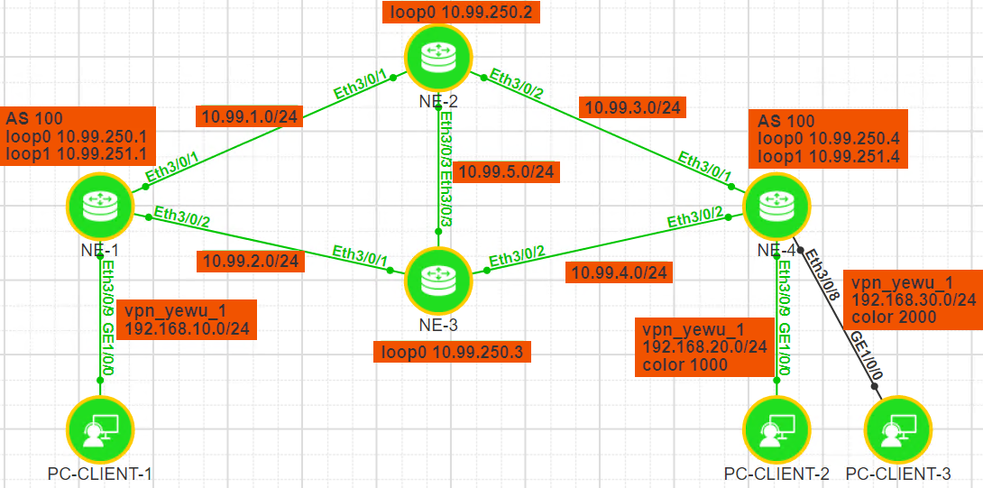
相关参数规划：
yyyy表示相应VPN实例对应的编号，4位数字，不足4位前面以0填充；本实验中给业务vpn分配1010编号
vpn实例名称为： vpn_yewu_1
 | vpn-instance |  | 说明
RD | ASN:3yyyy |  | ASN表示路由器的AS号，如果未规划，默认为100
iRT | ASN:3yyyy
eRT | ASN:3yyyy

NE1配置：
ip vpn-instance vpn_yewu_1
ipv4-family
route-distinguisher 100:31010
default-color 1000
tnl-policy tnp1
apply-label per-instance
vpn-target 100:31010 export-extcommunity
vpn-target 100:31010 import-extcommunity
#
bfd
#
sbfd
#
mpls lsr-id 10.99.250.1
#
mpls
#
segment-routing
sr-te-policy backup hot-standby enable
sr-te-policy seamless-bfd enable
segment-list NE1-NE2-NE3-NE4
index 10 sid label 20002
index 20 sid label 330023
index 30 sid label 330032
index 40 sid label 20004
segment-list NE1-NE2-NE4
index 10 sid label 20002
index 20 sid label 330022
index 40 sid label 20004
segment-list NE1-NE3-NE4
index 10 sid label 20003
index 20 sid label 330032
index 40 sid label 20004
sr-te policy sr_te_policy_1 endpoint 10.99.251.4 color 1000
candidate-path preference 200
segment-list NE1-NE3-NE4
candidate-path preference 100
segment-list NE1-NE2-NE4
sr-te policy sr_te_policy_2 endpoint 10.99.251.4 color 2000
candidate-path preference 200
segment-list NE1-NE2-NE3-NE4
#
isis 1
is-level level-1
cost-style wide
network-entity 49.0001.1111.1111.1111.00
segment-routing mpls
segment-routing global-block 20000 21000
#
interface Ethernet3/0/1
undo shutdown
ip address 10.99.1.1 255.255.255.0
isis enable 1
isis circuit-level level-1
#
interface Ethernet3/0/2
undo shutdown
ip address 10.99.2.1 255.255.255.0
isis enable 1
isis circuit-level level-1
#
interface Ethernet3/0/9
undo shutdown
ip binding vpn-instance vpn_yewu_1
ip address 192.168.10.1 255.255.255.0
#
interface LoopBack0
description for_mpls_lsr_id
ip address 10.99.250.1 255.255.255.255
isis enable 1
isis circuit-level level-1
isis prefix-sid index 1
#
interface LoopBack1
description for_bgp_router_id
ip address 10.99.251.1 255.255.255.255
isis enable 1
isis circuit-level level-1
isis prefix-sid index 11
#
bgp 100
router-id 10.99.251.1
private-4-byte-as enable
peer 10.99.251.4 as-number 100
peer 10.99.251.4 connect-interface LoopBack1

ipv4-family unicast
undo synchronization
peer 10.99.251.4 enable

ipv4-family vpnv4
policy vpn-target
peer 10.99.251.4 enable

ipv4-family vpn-instance vpn_yewu_1
import-route direct
#
tunnel-policy tnp1
tunnel select-seq sr-te-policy load-balance-number 1 unmix
#

NE2配置：
mpls lsr-id 10.99.250.2
#
mpls
#
segment-routing
ipv4 adjacency local-ip-addr 10.99.1.2 remote-ip-addr 10.99.1.1 sid 330021
ipv4 adjacency local-ip-addr 10.99.3.1 remote-ip-addr 10.99.3.2 sid 330022
ipv4 adjacency local-ip-addr 10.99.5.1 remote-ip-addr 10.99.5.2 sid 330023
#
isis 1
is-level level-1
cost-style wide
network-entity 49.0001.2222.2222.2222.00
segment-routing mpls
segment-routing global-block 20000 21000
segment-routing auto-adj-sid disable
#
interface Ethernet3/0/1
undo shutdown
ip address 10.99.1.2 255.255.255.0
isis enable 1
isis circuit-level level-1
#
interface Ethernet3/0/2
undo shutdown
ip address 10.99.3.1 255.255.255.0
isis enable 1
isis circuit-level level-1
#
interface Ethernet3/0/3
undo shutdown
ip address 10.99.5.1 255.255.255.0
isis enable 1
isis circuit-level level-1
#
interface LoopBack0
description for_mpls_lsr_id
ip address 10.99.250.2 255.255.255.255
isis enable 1
isis circuit-level level-1
isis prefix-sid index 2
#

NE3配置：
mpls lsr-id 10.99.250.3
#
mpls
#
segment-routing
ipv4 adjacency local-ip-addr 10.99.2.2 remote-ip-addr 10.99.2.1 sid 330031
ipv4 adjacency local-ip-addr 10.99.4.1 remote-ip-addr 10.99.4.2 sid 330032
ipv4 adjacency local-ip-addr 10.99.5.2 remote-ip-addr 10.99.5.1 sid 330033
#
isis 1
is-level level-1
cost-style wide
network-entity 49.0001.3333.3333.3333.00
segment-routing mpls
segment-routing global-block 20000 21000
segment-routing auto-adj-sid disable
#
interface Ethernet3/0/1
undo shutdown
ip address 10.99.2.2 255.255.255.0
isis enable 1
isis circuit-level level-1
#
interface Ethernet3/0/2
undo shutdown
ip address 10.99.4.1 255.255.255.0
isis enable 1
isis circuit-level level-1
#
interface Ethernet3/0/3
undo shutdown
ip address 10.99.5.2 255.255.255.0
isis enable 1
isis circuit-level level-1
#
interface LoopBack0
description for_mpls_lsr_id
ip address 10.99.250.3 255.255.255.255
isis enable 1
isis circuit-level level-1
isis prefix-sid index 3
#

NE4配置：
ip vpn-instance vpn_yewu_1
ipv4-family
route-distinguisher 100:31010
apply-label per-instance
vpn-target 100:31010 export-extcommunity
vpn-target 100:31010 import-extcommunity
#
bfd
#
sbfd
reflector discriminator 10.99.251.4
#
mpls lsr-id 10.99.250.4
#
mpls
#
acl number 2001
rule 5 permit source 192.168.30.0 0.0.0.255
#
segment-routing
#
isis 1
is-level level-1
cost-style wide
network-entity 49.0001.4444.4444.4444.00
segment-routing mpls
segment-routing global-block 20000 21000
#
interface Ethernet3/0/1
undo shutdown
ip address 10.99.3.2 255.255.255.0
isis enable 1
isis circuit-level level-1
#
interface Ethernet3/0/2
undo shutdown
ip address 10.99.4.2 255.255.255.0
isis enable 1
isis circuit-level level-1
#
interface Ethernet3/0/8
undo shutdown
ip binding vpn-instance vpn_yewu_1
ip address 192.168.30.1 255.255.255.0
#
interface Ethernet3/0/9
undo shutdown
ip binding vpn-instance vpn_yewu_1
ip address 192.168.20.1 255.255.255.0
#
interface LoopBack0
description for_mpls_lsr_id
ip address 10.99.250.4 255.255.255.255
isis enable 1
isis circuit-level level-1
isis prefix-sid index 4
#
interface LoopBack1
description for_bgp_router_id
ip address 10.99.251.4 255.255.255.255
isis enable 1
isis circuit-level level-1
isis prefix-sid index 14
#
bgp 100
router-id 10.99.251.4
private-4-byte-as enable
peer 10.99.251.1 as-number 100
peer 10.99.251.1 connect-interface LoopBack1

ipv4-family unicast
undo synchronization
peer 10.99.251.1 enable

ipv4-family vpnv4
policy vpn-target
peer 10.99.251.1 enable
peer 10.99.251.1 route-policy color_2000 export

ipv4-family vpn-instance vpn_yewu_1
import-route direct
#
route-policy color_2000 permit node 10
if-match acl 2001
apply extcommunity color 0:2000
#
route-policy color_2000 permit node 1000
#

NE1查看：
<HUAWEI> disp tunnel-info all
Tunnel ID Type Destination Status
---------------------------------------------------------------------------------
0x000000002900000004 srbe-lsp 10.99.250.2 UP
0x000000002900000005 srbe-lsp 10.99.250.4 UP
0x000000002900000006 srbe-lsp 10.99.251.4 UP
0x000000002900000008 srbe-lsp 10.99.250.3 UP
0x000000003200004001 srtepolicy 10.99.251.4 UP
0x000000003200004002 srtepolicy 10.99.251.4 UP

<HUAWEI> disp ip routing-table vpn-instance vpn_yewu_1
Route Flags: R - relay, D - download to fib, T - to vpn-instance, B - black hole route
------------------------------------------------------------------------------
Routing Table : vpn_yewu_1
Destinations : 7 Routes : 7

Destination/Mask Proto Pre Cost Flags NextHop Interface

127.0.0.0/8 Direct 0 0 D 127.0.0.1 InLoopBack0
192.168.10.0/24 Direct 0 0 D 192.168.10.1 Ethernet3/0/9
192.168.10.1/32 Direct 0 0 D 127.0.0.1 Ethernet3/0/9
192.168.10.255/32 Direct 0 0 D 127.0.0.1 Ethernet3/0/9
192.168.20.0/24 IBGP 255 0 RD 10.99.251.4 sr_te_policy_1
192.168.30.0/24 IBGP 255 0 RD 10.99.251.4 sr_te_policy_2
255.255.255.255/32 Direct 0 0 D 127.0.0.1 InLoopBack0

<HUAWEI> tracert -vpn-instance vpn_yewu_1 192.168.20.2
traceroute to vpn_yewu_1 192.168.20.2(192.168.20.2), max hops: 64, packet length: 40, press CTRL_C to break
1 * * *
2 192.168.20.1 54 ms 22 ms 21 ms
3 192.168.20.2 19 ms 21 ms 38 ms

<HUAWEI> tracert -vpn-instance vpn_yewu_1 192.168.30.2
traceroute to vpn_yewu_1 192.168.30.2(192.168.30.2), max hops: 64, packet length: 40, press CTRL_C to break
1 * * *
2 * * *
3 192.168.30.1 10 ms 25 ms 23 ms
4 192.168.30.2 13 ms 25 ms 28 ms

<HUAWEI> disp segment-routing prefix mpls forwarding
Segment Routing Prefix MPLS Forwarding Information
--------------------------------------------------------------
Role : I-Ingress, T-Transit, E-Egress, I&T-Ingress And Transit
Prefix Label OutLabel Interface NextHop Role MPLSMtu Mtu State
----------------------------------------------------------------------------------------
10.99.250.1/32 20001 NULL Loop0 127.0.0.1 E --- 1500 Active
10.99.250.2/32 20002 3 Eth3/0/1 10.99.1.2 I&T --- 1500 Active
10.99.250.3/32 20003 3 Eth3/0/2 10.99.2.2 I&T --- 1500 Active
10.99.250.4/32 20004 20004 Eth3/0/1 10.99.1.2 I&T --- 1500 Active
10.99.250.4/32 20004 20004 Eth3/0/2 10.99.2.2 I&T --- 1500 Active
10.99.251.1/32 20011 NULL Loop1 127.0.0.1 E --- 1500 Active
10.99.251.4/32 20014 20014 Eth3/0/1 10.99.1.2 I&T --- 1500 Active
10.99.251.4/32 20014 20014 Eth3/0/2 10.99.2.2 I&T --- 1500 Active

Total information(s): 8

<HUAWEI> disp segment-routing adjacency mpls forwarding
Segment Routing Adjacency MPLS Forwarding Information

Label Interface NextHop Type MPLSMtu Mtu VPN-Name
--------------------------------------------------------------------------------------
48000 Eth3/0/1 10.99.1.2 ISIS-V4 --- 1500 _public_
48001 Eth3/0/2 10.99.2.2 ISIS-V4 --- 1500 _public_

Total information(s): 2

<HUAWEI> tracert lsp segment-routing ip 10.99.251.4 32
LSP Trace Route FEC: SEGMENT ROUTING IPV4 PREFIX 10.99.251.4/32 , press CTRL_C to break.
TTL Replier Time Type Downstream
0 Ingress 10.99.1.2/[20014 ]
1 10.99.1.2 16 ms Transit 10.99.3.2/[3 ]
2 10.99.251.4 26 ms Egress

<HUAWEI> disp bgp vpnv4 all routing-table
BGP Local router ID is 10.99.251.1
Status codes: * - valid, > - best, d - damped, x - best external, a - add path,
h - history, i - internal, s - suppressed, S - Stale
Origin : i - IGP, e - EGP, ? - incomplete
RPKI validation codes: V - valid, I - invalid, N - not-found

Total number of routes from all PE: 5
Route Distinguisher: 100:31010
Network NextHop MED LocPrf PrefVal Path/Ogn
*> 127.0.0.0/8 0.0.0.0 0 0 ?
*> 192.168.10.0/24 0.0.0.0 0 0 ?
*> 192.168.10.1/32 0.0.0.0 0 0 ?
*>i 192.168.20.0/24 10.99.251.4 0 100 0 ?
*>i 192.168.30.0/24 10.99.251.4 0 100 0 ?

VPN-Instance vpn_yewu_1, Router ID 10.99.251.1:
Total Number of Routes: 5
Network NextHop MED LocPrf PrefVal Path/Ogn
*> 127.0.0.0/8 0.0.0.0 0 0 ?
*> 192.168.10.0/24 0.0.0.0 0 0 ?
*> 192.168.10.1/32 0.0.0.0 0 0 ?
*>i 192.168.20.0/24 10.99.251.4 0 100 0 ?
*>i 192.168.30.0/24 10.99.251.4 0 100 0 ?

<HUAWEI> disp bfd session all
(w): State in WTR
(*): State is invalid
--------------------------------------------------------------------------------
Local Remote PeerIpAddr State Type InterfaceName
--------------------------------------------------------------------------------
16385 174324484 10.99.251.4 Up D_SID_LIST -
16386 174324484 10.99.251.4 Up D_SID_LIST -
16387 174324484 10.99.251.4 Up D_SID_LIST -
--------------------------------------------------------------------------------
Total UP/DOWN Session Number : 3/0

NE2查看:
<HUAWEI> disp segment-routing adjacency mpls forwarding #查看 Adj-SID
Segment Routing Adjacency MPLS Forwarding Information

Label Interface NextHop Type MPLSMtu Mtu VPN-Name
--------------------------------------------------------------------------------------
330021 Eth3/0/1 10.99.1.1 STATIC-V4 --- 1500 _public_
330022 Eth3/0/2 10.99.3.2 STATIC-V4 --- 1500 _public_
330023 Eth3/0/3 10.99.5.2 STATIC-V4 --- 1500 _public_

Total information(s): 3

NE3查看:
<HUAWEI> disp segment-routing adjacency mpls forwarding #查看 Adj-SID
Segment Routing Adjacency MPLS Forwarding Information

Label Interface NextHop Type MPLSMtu Mtu VPN-Name
-------------------------------------------------------------------------------------
330031 Eth3/0/1 10.99.2.1 STATIC-V4 --- 1500 _public_
330032 Eth3/0/2 10.99.4.2 STATIC-V4 --- 1500 _public_
330033 Eth3/0/3 10.99.5.1 STATIC-V4 --- 1500 _public_

Total information(s): 3

NE4查看:
<HUAWEI> disp sbfd reflector discriminator
Total Discriminator Num : 1
-------------------------------------------------------------------------------------
SBFD-Discr(INT) SBFD-Discr(IP) State CreateType Advertising
-------------------------------------------------------------------------------------
174324484 10.99.251.4 Active IP Yes
-------------------------------------------------------------------------------------

实验：SR-MPLS_TE_Policy_EVPN_isis_ne（ensp_pro）
拓扑如下：
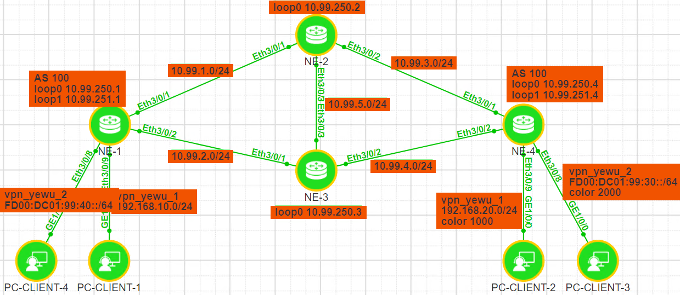
相关参数规划：
yyyy表示相应VPN实例对应的编号，4位数字，不足4位前面以0填充；
vpn实例名称为： vpn_yewu_1 vpn_yewu_2
业务vpn分配编号： 1004 1006
 | vpn-instance |  | 说明
RD | ASN:3yyyy |  | ASN表示路由器的AS号，如果未规划，默认为100
iRT | ASN:3yyyy
eRT | ASN:3yyyy

当EVPN使用MPLS或SR-MPLS做底层转发面时，需要在目标vpn实例下配置以下命令：
evpn mpls routing-enable #使evpn生成与发布ip前缀路由与irb路由

NE1配置：
ip vpn-instance vpn_yewu_1
ipv4-family
route-distinguisher 100:31004
apply-label per-instance
vpn-target 100:31004 export-extcommunity evpn
vpn-target 100:31004 import-extcommunity evpn
tnl-policy tnp1 evpn
evpn mpls routing-enable #使evpn生成与发布ip前缀路由与irb路由
#
ip vpn-instance vpn_yewu_2
ipv6-family
route-distinguisher 100:31006
apply-label per-instance
vpn-target 100:31006 export-extcommunity evpn
vpn-target 100:31006 import-extcommunity evpn
tnl-policy tnp1 evpn
evpn mpls routing-enable #使evpn生成与发布ip前缀路由与irb路由
#
bfd
#
sbfd
#
mpls lsr-id 10.99.250.1
#
mpls
#
acl number 2002
rule 5 permit source 192.168.20.0 0.0.0.255
#
segment-routing
sr-te-policy backup hot-standby enable
sr-te-policy seamless-bfd enable
segment-list NE1-NE2-NE3-NE4
index 10 sid label 20002
index 20 sid label 330023
index 30 sid label 330032
index 40 sid label 20004
segment-list NE1-NE2-NE4
index 10 sid label 20002
index 20 sid label 330022
index 40 sid label 20004
segment-list NE1-NE3-NE4
index 10 sid label 20003
index 20 sid label 330032
index 40 sid label 20004
sr-te policy sr_te_policy_1 endpoint 10.99.251.4 color 1000
candidate-path preference 200
segment-list NE1-NE3-NE4
candidate-path preference 100
segment-list NE1-NE2-NE4
sr-te policy sr_te_policy_2 endpoint 10.99.251.4 color 2000
candidate-path preference 200
segment-list NE1-NE2-NE3-NE4
#
isis 1
is-level level-1
cost-style wide
network-entity 49.0001.1111.1111.1111.00
segment-routing mpls
segment-routing global-block 20000 21000
#
interface Ethernet3/0/1
undo shutdown
ip address 10.99.1.1 255.255.255.0
isis enable 1
isis circuit-level level-1
#
interface Ethernet3/0/2
undo shutdown
ip address 10.99.2.1 255.255.255.0
isis enable 1
isis circuit-level level-1
#
interface Ethernet3/0/8
undo shutdown
ip binding vpn-instance vpn_yewu_2
ipv6 enable
ipv6 address FD00:DC01:99:40::FFFF/64
#
interface Ethernet3/0/9
undo shutdown
ip binding vpn-instance vpn_yewu_1
ip address 192.168.10.1 255.255.255.0
#
interface LoopBack0
description for_mpls_lsr_id
ip address 10.99.250.1 255.255.255.255
isis enable 1
isis circuit-level level-1
isis prefix-sid index 1
#
interface LoopBack1
description for_bgp_router_id
ip address 10.99.251.1 255.255.255.255
isis enable 1
isis circuit-level level-1
isis prefix-sid index 11
#
bgp 100
router-id 10.99.251.1
private-4-byte-as enable
peer 10.99.251.4 as-number 100
peer 10.99.251.4 connect-interface LoopBack1
#
ipv4-family unicast
undo synchronization
peer 10.99.251.4 enable
#
ipv4-family vpn-instance vpn_yewu_1
import-route direct
advertise l2vpn evpn
#
ipv6-family vpn-instance vpn_yewu_2
import-route direct
advertise l2vpn evpn
#
l2vpn-family evpn
policy vpn-target
peer 10.99.251.4 enable
peer 10.99.251.4 route-policy color_1000 import
#
route-policy color_1000 permit node 10
if-match acl 2002
apply extcommunity color 0:1000
#
tunnel-policy tnp1
tunnel select-seq sr-te-policy load-balance-number 1 unmix
#

NE2配置：
mpls lsr-id 10.99.250.2
#
mpls
#
segment-routing
ipv4 adjacency local-ip-addr 10.99.1.2 remote-ip-addr 10.99.1.1 sid 330021
ipv4 adjacency local-ip-addr 10.99.3.1 remote-ip-addr 10.99.3.2 sid 330022
ipv4 adjacency local-ip-addr 10.99.5.1 remote-ip-addr 10.99.5.2 sid 330023
#
isis 1
is-level level-1
cost-style wide
network-entity 49.0001.2222.2222.2222.00
segment-routing mpls
segment-routing global-block 20000 21000
segment-routing auto-adj-sid disable
#
interface Ethernet3/0/1
undo shutdown
ip address 10.99.1.2 255.255.255.0
isis enable 1
isis circuit-level level-1
#
interface Ethernet3/0/2
undo shutdown
ip address 10.99.3.1 255.255.255.0
isis enable 1
isis circuit-level level-1
#
interface Ethernet3/0/3
undo shutdown
ip address 10.99.5.1 255.255.255.0
isis enable 1
isis circuit-level level-1
#
interface LoopBack0
ip address 10.99.250.2 255.255.255.255
isis enable 1
isis circuit-level level-1
isis prefix-sid index 2
#

NE3配置：
mpls lsr-id 10.99.250.3
#
mpls
#
segment-routing
ipv4 adjacency local-ip-addr 10.99.2.2 remote-ip-addr 10.99.2.1 sid 330031
ipv4 adjacency local-ip-addr 10.99.4.1 remote-ip-addr 10.99.4.2 sid 330032
ipv4 adjacency local-ip-addr 10.99.5.2 remote-ip-addr 10.99.5.1 sid 330033
#
isis 1
is-level level-1
cost-style wide
network-entity 49.0001.3333.3333.3333.00
segment-routing mpls
segment-routing global-block 20000 21000
segment-routing auto-adj-sid disable
#
interface Ethernet3/0/1
undo shutdown
ip address 10.99.2.2 255.255.255.0
isis enable 1
isis circuit-level level-1
#
interface Ethernet3/0/2
undo shutdown
ip address 10.99.4.1 255.255.255.0
isis enable 1
isis circuit-level level-1
#
interface Ethernet3/0/3
undo shutdown
ip address 10.99.5.2 255.255.255.0
isis enable 1
isis circuit-level level-1
#
interface LoopBack0
ip address 10.99.250.3 255.255.255.255
isis enable 1
isis circuit-level level-1
isis prefix-sid index 3
#

NE4配置：
ip vpn-instance vpn_yewu_1
ipv4-family
route-distinguisher 100:31004
apply-label per-instance
vpn-target 100:31004 export-extcommunity evpn
vpn-target 100:31004 import-extcommunity evpn
evpn mpls routing-enable
#
ip vpn-instance vpn_yewu_2
ipv6-family
route-distinguisher 100:31006
apply-label per-instance
vpn-target 100:31006 export-extcommunity evpn
vpn-target 100:31006 import-extcommunity evpn
evpn mpls routing-enable
#
bfd
#
sbfd
reflector discriminator 10.99.251.4
#
mpls lsr-id 10.99.250.4
#
mpls
#
acl ipv6 number 2001
rule 5 permit source FD00:DC01:99:30::/64
#
segment-routing
#
isis 1
is-level level-1
cost-style wide
network-entity 49.0001.4444.4444.4444.00
segment-routing mpls
segment-routing global-block 20000 21000
#
interface Ethernet3/0/1
undo shutdown
ip address 10.99.3.2 255.255.255.0
isis enable 1
isis circuit-level level-1
#
interface Ethernet3/0/2
undo shutdown
ip address 10.99.4.2 255.255.255.0
isis enable 1
isis circuit-level level-1
#
interface Ethernet3/0/8
undo shutdown
ip binding vpn-instance vpn_yewu_2
ipv6 enable
ipv6 address FD00:DC01:99:30::FFFF/64
#
interface Ethernet3/0/9
undo shutdown
ip binding vpn-instance vpn_yewu_1
ip address 192.168.20.1 255.255.255.0
#
interface LoopBack0
description for_mpls_lsr_id
ip address 10.99.250.4 255.255.255.255
isis enable 1
isis circuit-level level-1
isis prefix-sid index 4
#
interface LoopBack1
description for_bgp_router_id
ip address 10.99.251.4 255.255.255.255
isis enable 1
isis circuit-level level-1
isis prefix-sid index 14
#
bgp 100
router-id 10.99.251.4
private-4-byte-as enable
peer 10.99.251.1 as-number 100
peer 10.99.251.1 connect-interface LoopBack1
#
ipv4-family unicast
undo synchronization
peer 10.99.251.1 enable
#
ipv4-family vpn-instance vpn_yewu_1
import-route direct
advertise l2vpn evpn
#
ipv6-family vpn-instance vpn_yewu_2
import-route direct
advertise l2vpn evpn
#
l2vpn-family evpn
policy vpn-target
peer 10.99.251.1 enable
peer 10.99.251.1 route-policy color_2000 export
#
route-policy color_2000 permit node 10
if-match ipv6 address acl 2001
apply extcommunity color 0:2000
#

NE1查看：
<HUAWEI> disp tunnel-info all
Tunnel ID Type Destination Status
------------------------------------------------------------------------------
0x000000002900000004 srbe-lsp 10.99.250.2 UP
0x000000002900000006 srbe-lsp 10.99.250.3 UP
0x000000002900000007 srbe-lsp 10.99.250.4 UP
0x000000002900000008 srbe-lsp 10.99.251.4 UP
0x000000003200000001 srtepolicy 10.99.251.4 UP
0x000000003200000002 srtepolicy 10.99.251.4 UP

<HUAWEI> disp ip routing-table vpn-instance vpn_yewu_1
Route Flags: R - relay, D - download to fib, T - to vpn-instance, B - black hole route
------------------------------------------------------------------------------
Routing Table : vpn_yewu_1
Destinations : 6 Routes : 6

Destination/Mask Proto Pre Cost Flags NextHop Interface
127.0.0.0/8 Direct 0 0 D 127.0.0.1 InLoopBack0
192.168.10.0/24 Direct 0 0 D 192.168.10.1 Ethernet3/0/9
192.168.10.1/32 Direct 0 0 D 127.0.0.1 Ethernet3/0/9
192.168.10.255/32 Direct 0 0 D 127.0.0.1 Ethernet3/0/9
192.168.20.0/24 IBGP 255 0 RD 10.99.251.4 sr_te_policy_1
255.255.255.255/32 Direct 0 0 D 127.0.0.1 InLoopBack0

<HUAWEI> disp ipv6 routing-table vpn-instance vpn_yewu_2
Routing Table : vpn_yewu_2
Destinations : 4 Routes : 4

Destination : FD00:DC01:99:30:: PrefixLength : 64
NextHop : ::FFFF:10.99.251.4 Preference : 255
Cost : 0 Protocol : IBGP
RelayNextHop : :: TunnelID : 0x000000003200000002
Interface : sr_te_policy_2 Flags : RD

Destination : FD00:DC01:99:40:: PrefixLength : 64
NextHop : FD00:DC01:99:40::FFFF Preference : 0
Cost : 0 Protocol : Direct
RelayNextHop : :: TunnelID : 0x0
Interface : Ethernet3/0/8 Flags : D

Destination : FD00:DC01:99:40::FFFF PrefixLength : 128
NextHop : ::1 Preference : 0
Cost : 0 Protocol : Direct
RelayNextHop : :: TunnelID : 0x0
Interface : Ethernet3/0/8 Flags : D

Destination : FE80:: PrefixLength : 10
NextHop : :: Preference : 0
Cost : 0 Protocol : Direct
RelayNextHop : :: TunnelID : 0x0
Interface : NULL0 Flags : DB

<HUAWEI> disp segment-routing prefix mpls forwarding
Segment Routing Prefix MPLS Forwarding Information
--------------------------------------------------------------
Role : I-Ingress, T-Transit, E-Egress, I&T-Ingress And Transit

Prefix Label OutLabel Interface NextHop Role MPLSMtu Mtu State
---------------------------------------------------------------------------------------------
10.99.250.1/32 20001 NULL Loop0 127.0.0.1 E --- 1500 Active
10.99.250.2/32 20002 3 Eth3/0/1 10.99.1.2 I&T --- 1500 Active
10.99.250.3/32 20003 3 Eth3/0/2 10.99.2.2 I&T --- 1500 Active
10.99.250.4/32 20004 20004 Eth3/0/1 10.99.1.2 I&T --- 1500 Active
10.99.250.4/32 20004 20004 Eth3/0/2 10.99.2.2 I&T --- 1500 Active
10.99.251.1/32 20011 NULL Loop1 127.0.0.1 E --- 1500 Active
10.99.251.4/32 20014 20014 Eth3/0/1 10.99.1.2 I&T --- 1500 Active
10.99.251.4/32 20014 20014 Eth3/0/2 10.99.2.2 I&T --- 1500 Active

Total information(s): 8

<HUAWEI> disp segment-routing adjacency mpls forwarding
Segment Routing Adjacency MPLS Forwarding Information
Label Interface NextHop Type MPLSMtu Mtu VPN-Name
-------------------------------------------------------------------------------------
48000 Eth3/0/1 10.99.1.2 ISIS-V4 --- 1500 _public_
48001 Eth3/0/2 10.99.2.2 ISIS-V4 --- 1500 _public_

Total information(s): 2

<HUAWEI> tracert lsp segment-routing ip 10.99.251.4 32
LSP Trace Route FEC: SEGMENT ROUTING IPV4 PREFIX 10.99.251.4/32 , press CTRL_C to break.
TTL Replier Time Type Downstream
0 Ingress 10.99.1.2/[20014 ]
1 10.99.1.2 156 ms Transit 10.99.3.2/[3 ]
2 10.99.251.4 56 ms Egress

<HUAWEI> disp bgp evpn peer
BGP local router ID : 10.99.251.1
Local AS number : 100
Total number of peers : 1 Peers in established state : 1

Peer V AS MsgRcvd MsgSent OutQ Up/Down State PrefRcv
10.99.251.4 4 100 35 31 0 00:22:21 Established 2

<HUAWEI> disp bgp evpn all routing-table
Local AS number : 100
BGP Local router ID is 10.99.251.1
Status codes: * - valid, > - best, d - damped, x - best external, a - add path,
h - history, i - internal, s - suppressed, S - Stale
Origin : i - IGP, e - EGP, ? - incomplete

EVPN address family:
Number of Ip Prefix Routes: 4
Route Distinguisher: 100:31004
Network(EthTagId/IpPrefix/IpPrefixLen) NextHop
*> 0:192.168.10.0:24 0.0.0.0
*>i 0:192.168.20.0:24 10.99.251.4
Route Distinguisher: 100:31006
Network(EthTagId/IpPrefix/IpPrefixLen) NextHop
*>i 0:[FD00:DC01:99:30::]:64 ::FFFF:10.99.251.4
*> 0:[FD00:DC01:99:40::]:64 ::

<HUAWEI> disp bgp vpnv4 all routing-table
BGP Local router ID is 10.99.251.1
Status codes: * - valid, > - best, d - damped, x - best external, a - add path,
h - history, i - internal, s - suppressed, S - Stale
Origin : i - IGP, e - EGP, ? - incomplete
RPKI validation codes: V - valid, I - invalid, N - not-found

Total number of routes from all PE: 3
Route Distinguisher: 100:31004
Network NextHop MED LocPrf PrefVal Path/Ogn
*> 127.0.0.0/8 0.0.0.0 0 0 ?
*> 192.168.10.0/24 0.0.0.0 0 0 ?
*> 192.168.10.1/32 0.0.0.0 0 0 ?

VPN-Instance vpn_yewu_1, Router ID 10.99.251.1:
Total Number of Routes: 4
Network NextHop MED LocPrf PrefVal Path/Ogn
*> 127.0.0.0/8 0.0.0.0 0 0 ?
*> 192.168.10.0/24 0.0.0.0 0 0 ?
*> 192.168.10.1/32 0.0.0.0 0 0 ?
*>i 192.168.20.0/24 10.99.251.4 0 100 0 ?

<HUAWEI> disp bgp vpnv6 all routing-table
BGP Local router ID is 10.99.251.1
Status codes: * - valid, > - best, d - damped, x - best external, a - add path,
h - history, i - internal, s - suppressed, S - Stale
Origin : i - IGP, e - EGP, ? - incomplete
RPKI validation codes: V - valid, I - invalid, N - not-found

Total number of routes from all PE: 3
Route Distinguisher: 100:31006
*> Network : FD00:DC01:99:40:: PrefixLen : 64
NextHop : :: LocPrf :
MED : 0 PrefVal : 0
Label :
Path/Ogn : ?
*> Network : FD00:DC01:99:40::FFFF PrefixLen : 128
NextHop : :: LocPrf :
MED : 0 PrefVal : 0
Label :
Path/Ogn : ?
*> Network : FE80:: PrefixLen : 10
NextHop : :: LocPrf :
MED : 0 PrefVal : 0
Label :
Path/Ogn : ?

VPN-Instance vpn_yewu_2, Router ID 10.99.251.1:
Total Number of Routes: 4
*>i Network : FD00:DC01:99:30:: PrefixLen : 64
NextHop : ::FFFF:10.99.251.4 LocPrf : 100
MED : 0 PrefVal : 0
Label : 48062/NULL
Path/Ogn : ?
*> Network : FD00:DC01:99:40:: PrefixLen : 64
NextHop : :: LocPrf :
MED : 0 PrefVal : 0
Label :
Path/Ogn : ?
*> Network : FD00:DC01:99:40::FFFF PrefixLen : 128
NextHop : :: LocPrf :
MED : 0 PrefVal : 0
Label :
Path/Ogn : ?
*> Network : FE80:: PrefixLen : 10
NextHop : :: LocPrf :
MED : 0 PrefVal : 0
Label :
Path/Ogn : ?

<HUAWEI> disp bfd session all
(w): State in WTR
(*): State is invalid
--------------------------------------------------------------------------------
Local Remote PeerIpAddr State Type InterfaceName
--------------------------------------------------------------------------------
16385 174324484 10.99.251.4 Up D_SID_LIST -
16386 174324484 10.99.251.4 Up D_SID_LIST -
16387 174324484 10.99.251.4 Up D_SID_LIST -
--------------------------------------------------------------------------------
Total UP/DOWN Session Number : 3/0

NE2查看：
<HUAWEI> disp segment-routing adjacency mpls forwarding
Segment Routing Adjacency MPLS Forwarding Information
Label Interface NextHop Type MPLSMtu Mtu VPN-Name
-------------------------------------------------------------------------------------
330021 Eth3/0/1 10.99.1.1 STATIC-V4 --- 1500 _public_
330022 Eth3/0/2 10.99.3.2 STATIC-V4 --- 1500 _public_
330023 Eth3/0/3 10.99.5.2 STATIC-V4 --- 1500 _public_

Total information(s): 3

NE3查看：
<HUAWEI> disp segment-routing adjacency mpls forwarding
Segment Routing Adjacency MPLS Forwarding Information
Label Interface NextHop Type MPLSMtu Mtu VPN-Name
-------------------------------------------------------------------------------------
330031 Eth3/0/1 10.99.2.1 STATIC-V4 --- 1500 _public_
330032 Eth3/0/2 10.99.4.2 STATIC-V4 --- 1500 _public_
330033 Eth3/0/3 10.99.5.1 STATIC-V4 --- 1500 _public_

Total information(s): 3

NE4查看：
<HUAWEI> disp sbfd reflector discriminator
Total Discriminator Num : 1
--------------------------------------------------------------------------------
SBFD-Discr(INT) SBFD-Discr(IP) State CreateType Advertising
--------------------------------------------------------------------------------
174324484 10.99.251.4 Active IP Yes
--------------------------------------------------------------------------------

★SRv6

实验：SRv6_BE_vpnv4_isis_ne40e（ensp）
拓扑如下：
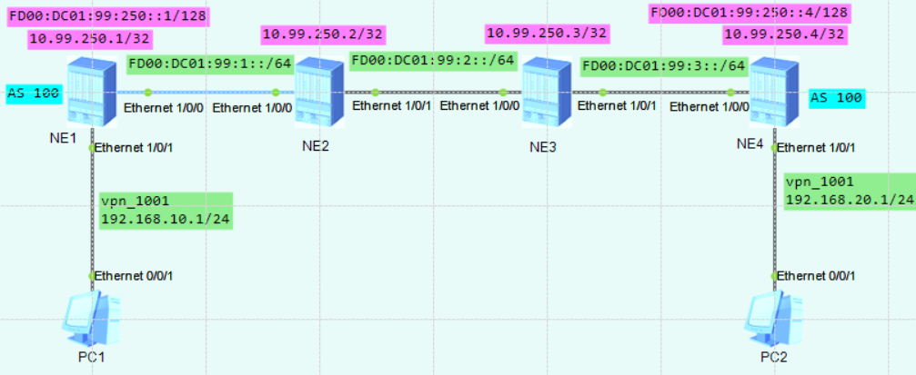
相关参数规划：
yyyy表示相应VPN实例对应的编号，4位数字，不足4位前面以0填充；本实验中给业务vpn分配1010编号
vpn实例名称为： vpn_yewu_1
 | vpn-instance |  | 说明
RD | ASN:3yyyy |  | ASN表示路由器的AS号，如果未规划，默认为100
iRT | ASN:3yyyy
eRT | ASN:3yyyy

NE1配置：
sysname NE1
#
ip vpn-instance vpn_yewu_1
ipv4-family
route-distinguisher 100:1001
vpn-target 100:1001 export-extcommunity
vpn-target 100:1001 import-extcommunity
#
segment-routing ipv6 #开启SRv6并进入SRv6配置界面
encapsulation source-address FD00:DC01:99:250::1 #配置SRv6 VPN封装的源地址（隧道源地址）
locator locator_a ipv6-prefix FD00:DC01:101:1:: 64 static 32 #配置Locator，长度64位，静态段占32位，动态段占64-32=32位，节点配置Locator后，系统会自动生成一条对应的网段路由，通过该网段路由可定位到本节点，本节点发布的所有SID也可通过此网段路由访问到
opcode ::1 end-dt4 vpn-instance vpn_yewu_1 #为vpn_yewu_1实例下的路由分配SRv6 SID（私网标签）
#
isis 1
is-level level-2
cost-style wide
bandwidth-reference 100000
auto-cost enable
network-entity 49.0001.1111.1111.1111.00
ipv6 enable topology ipv6 #开启isis进程的ipv6能力，并指定拓扑类型为ipv6拓扑
segment-routing ipv6 locator locator_a auto-sid-disable #将locator_a对应的网段路由发布出去，且关闭自动分配end与end.x（默认end与end.x是由IGP自动分配的）
#
interface Ethernet1/0/0
undo shutdown
ipv6 enable
ipv6 address FD00:DC01:99:1::1/64
isis ipv6 enable 1
#
interface Ethernet1/0/1
undo shutdown
ip binding vpn-instance vpn_yewu_1
ip address 192.168.10.1 255.255.255.0
#
interface LoopBack0
description for_bgp_router_id
ipv6 enable
ip address 10.99.250.1 255.255.255.255
ipv6 address FD00:DC01:99:250::1/128
isis ipv6 enable 1
#
bgp 100
router-id 10.99.250.1
peer FD00:DC01:99:250::4 as-number 100
peer FD00:DC01:99:250::4 connect-interface LoopBack0
ipv4-family unicast
undo synchronization
ipv4-family vpnv4
policy vpn-target
peer FD00:DC01:99:250::4 enable #开启与对等体交换BGP-VPNv4路由信息的能力
y
peer FD00:DC01:99:250::4 prefix-sid #向对端通告SRv6 SID
ipv4-family vpn-instance vpn_yewu_1
network 192.168.10.0 255.255.255.0
segment-routing ipv6 locator locator_a auto-sid-disable #对vpn_yewu_1下的路由使用locator_a并关闭自动配置opcode（使用手动配置方式）
segment-routing ipv6 best-effort #启用SRv6 BE
#

NE2配置：
sysname NE2
#
isis 1
is-level level-2
cost-style wide
bandwidth-reference 100000
auto-cost enable
network-entity 49.0001.2222.2222.2222.00
ipv6 enable topology ipv6
#
interface Ethernet1/0/0
undo shutdown
ipv6 enable
ipv6 address FD00:DC01:99:1::2/64
isis ipv6 enable 1
#
interface Ethernet1/0/1
undo shutdown
ipv6 enable
ipv6 address FD00:DC01:99:2::1/64
isis ipv6 enable 1
#
interface LoopBack0
ip address 10.99.250.2 255.255.255.255
#

NE3配置：
sysname NE3
#
isis 1
is-level level-2
cost-style wide
bandwidth-reference 100000
auto-cost enable
network-entity 49.0001.3333.3333.3333.00
ipv6 enable topology ipv6
#
interface Ethernet1/0/0
undo shutdown
ipv6 enable
ipv6 address FD00:DC01:99:2::2/64
isis ipv6 enable 1
#
interface Ethernet1/0/1
undo shutdown
ipv6 enable
ipv6 address FD00:DC01:99:3::1/64
isis ipv6 enable 1
#
interface LoopBack0
ip address 10.99.250.3 255.255.255.255
#

NE4配置：
sysname NE4
#
ip vpn-instance vpn_yewu_1
ipv4-family
route-distinguisher 100:1001
vpn-target 100:1001 export-extcommunity
vpn-target 100:1001 import-extcommunity
#
segment-routing ipv6
encapsulation source-address FD00:DC01:99:250::4
locator locator_a ipv6-prefix FD00:DC01:101:4:: 64 static 32
opcode ::1 end-dt4 vpn-instance vpn_yewu_1
#
isis 1
is-level level-2
cost-style wide
bandwidth-reference 100000
auto-cost enable
network-entity 49.0001.4444.4444.4444.00
ipv6 enable topology ipv6
segment-routing ipv6 locator locator_a auto-sid-disable
#
interface Ethernet1/0/0
undo shutdown
ipv6 enable
ipv6 address FD00:DC01:99:3::2/64
isis ipv6 enable 1
#
interface Ethernet1/0/1
undo shutdown
ip binding vpn-instance vpn_yewu_1
ip address 192.168.20.1 255.255.255.0
#
interface LoopBack0
description for_bgp_router_id
ipv6 enable
ip address 10.99.250.4 255.255.255.255
ipv6 address FD00:DC01:99:250::4/128
isis ipv6 enable 1
#
bgp 100
router-id 10.99.250.4
peer FD00:DC01:99:250::1 as-number 100
peer FD00:DC01:99:250::1 connect-interface LoopBack0
ipv4-family unicast
undo synchronization
ipv4-family vpnv4
policy vpn-target
peer FD00:DC01:99:250::1 enable
y
peer FD00:DC01:99:250::1 prefix-sid
ipv4-family vpn-instance vpn_yewu_1
network 192.168.20.0 255.255.255.0
segment-routing ipv6 locator locator_a auto-sid-disable
segment-routing ipv6 best-effort
#

NE1查看：
[~NE1] disp bgp vpnv4 all routing-table
BGP Local router ID is 10.99.250.1
Status codes: * - valid, > - best, d - damped, x - best external, a - add path,
h - history, i - internal, s - suppressed, S - Stale
Origin : i - IGP, e - EGP, ? - incomplete
RPKI validation codes: V - valid, I - invalid, N - not-found

Total number of routes from all PE: 2
Route Distinguisher: 100:1001
Network NextHop MED LocPrf PrefVal Path/Ogn
*> 192.168.10.0/24 0.0.0.0 0 0 i
*>i 192.168.20.0/24 FD00:DC01:99:250::4 0 100 0 i

VPN-Instance vpn_yewu_1, Router ID 10.99.250.1:
Total Number of Routes: 2
Network NextHop MED LocPrf PrefVal Path/Ogn
*> 192.168.10.0/24 0.0.0.0 0 0 i
*>i 192.168.20.0/24 FD00:DC01:99:250::4 0 100 0 i

[~NE1] disp ip routing-table vpn-instance vpn_yewu_1
Route Flags: R - relay, D - download to fib, T - to vpn-instance, B - black hole route
------------------------------------------------------------------------------
Routing Table : vpn_yewu_1
Destinations : 6 Routes : 6

Destination/Mask Proto Pre Cost Flags NextHop Interface
127.0.0.0/8 Direct 0 0 D 127.0.0.1 InLoopBack0
192.168.10.0/24 Direct 0 0 D 192.168.10.1 Ethernet1/0/1
192.168.10.1/32 Direct 0 0 D 127.0.0.1 Ethernet1/0/1
192.168.10.255/32 Direct 0 0 D 127.0.0.1 Ethernet1/0/1
192.168.20.0/24 IBGP 255 0 RD FD00:DC01:101:4::1 Ethernet1/0/0
255.255.255.255/32 Direct 0 0 D 127.0.0.1 InLoopBack0

[~NE1] disp segment-routing ipv6 local-sid end-dt4 forwarding
My Local-SID End.DT4 Forwarding Table
-------------------------------------

SID : FD00:DC01:101:1::1/128 FuncType : End.DT4
VPN Name : vpn_yewu_1 VPN ID : 2
LocatorName: locator_a LocatorID: 2

Total SID(s): 1

[~NE1] disp ip routing-table vpn-instance vpn_yewu_1 192.168.20.0 verbose
Route Flags: R - relay, D - download to fib, T - to vpn-instance, B - black hole route
------------------------------------------------------------------------------
Routing Table : vpn_yewu_1
Summary Count : 1

Destination: 192.168.20.0/24
Protocol: IBGP Process ID: 0
Preference: 255 Cost: 0
NextHop: FD00:DC01:101:4::1 Neighbour: FD00:DC01:99:250::4
State: Active Adv Relied Age: 00h12m30s
Tag: 0 Priority: low
Label: 3 QoSInfo: 0x0
IndirectID: 0x10000C8 Instance:
RelayNextHop: FE80::3A22:D7FF:FE02:100 Interface: Ethernet1/0/0(这里应该是SRv6 BE)
TunnelID: 0x0 Flags: RD

#SRv6_TE_Policy_vpnv4/6配置步骤：

1、首先配置各设备互连口的ipv6地址，具体配置步骤这里省略【所有节点】

2、规划1个loopback接口【所有节点】
interface LoopBack 0 # Loop0的ip用作bgp路由器id
description for_bgp_router_id #一定要写上环回口的描述
ipv6 enable
ip address 10.99.250.1 255.255.255.255
ipv6 address FD00:DC01:99:250::1/128
#

3、配置底层路由协议，如isis或ospf，本例使用isis【所有节点】
isis 1
is-level level-1
cost-style wide
network-entity 49.0001.1111.1111.1111.00
ipv6 enable topology ipv6 #开启isis进程的ipv6能力，并指定拓扑类型为ipv6拓扑
#
interface Ethernet1/0/0
isis ipv6 enable 1 #在接口上启用ipv6的isis
isis circuit-level level-1
#
interface LoopBack0
isis ipv6 enable 1
isis circuit-level level-1
#

4、创建业务vpn实例【PE节点】
ip vpn-instance vpn_yewu_1 #创建一个名为vpn_yewu_1的VPN实例
ipv4-family #进入ipv4地址族
route-distinguisher 100:31004 #配置RD
apply-label per-instance
vpn-target 100:31004 export-extcommunity #配置eRT
vpn-target 100:31004 import-extcommunity #配置iRT
#
ip vpn-instance vpn_yewu_2 #创建一个名为vpn_yewu_2的VPN实例
ipv6-family #进入ipv6地址族
route-distinguisher 100:31006 #配置RD
apply-label per-instance
vpn-target 100:31006 export-extcommunity #配置eRT
vpn-target 100:31006 import-extcommunity #配置iRT
#

5、配置SRv6相关内容：locator、segment-list、srv6-te policy，并在底层路由协议宣告locator路由/SID
segment-routing ipv6 #开启SRv6功能并进入SRv6配置界面
encapsulation source-address FD00:DC01:99:250::1 #指定SRv6 VPN封装的源地址（隧道源地址）
locator locator_1 ipv6-prefix FD00:DC01:101:1:: 64 static 32 #配置Locator，长度64位，静态段占32位，动态段占32位（64-32），节点配置Locator后，系统会自动生成一条对应的网段路由，通过该网段路由可定位到本节点，本节点发布的所有SID也可通过此网段路由访问到（srv6的sid就是一个个ipv6地址）
opcode ::1 end psp #创建prefix SID（节点sid），并指定使用PSP（倒数第二跳弹出）标记
opcode ::4 end-dt4 vpn-instance vpn_yewu_1 #为vpn_yewu_1实例下的路由分配SRv6 SID（私网标签）
opcode ::6 end-dt6 vpn-instance vpn_yewu_2 #为vpn_yewu_2实例下的路由分配SRv6 SID（私网标签）
srv6-te-policy backup hot-standby enable #在srv6配置界面下开启热备份功能
srv6-te-policy bfd seamless enable #在srv6配置界面下开启sbfd检测功能
segment-list NE1-NE2-NE3-NE4 #创建一个名为NE1-NE2-NE3-NE4的路径列表，只在PE节点创建，中间的P节点不创建
index 10 sid ipv6 FD00:DC01:101:2::1 #按index顺序从小到大依次压入标签
index 20 sid ipv6 FD00:DC01:101:2::13
index 30 sid ipv6 FD00:DC01:101:3::12
index 40 sid ipv6 FD00:DC01:101:4::1
segment-list NE1-NE2-NE4 #创建一个名为NE1-NE2-NE4的路径列表
index 10 sid ipv6 FD00:DC01:101:2::1
index 20 sid ipv6 FD00:DC01:101:4::1
segment-list NE1-NE3-NE4 #创建一个名为NE1-NE3-NE4的路径列表
index 10 sid ipv6 FD00:DC01:101:3::1
index 20 sid ipv6 FD00:DC01:101:4::1
srv6-te policy srv6_te_policy_1 endpoint FD00:DC01:99:250::4 color 1000 #创建一个名为srv6_te_policy_1的srv6-te策略，（策略名称，隧道终点，color）只在PE节点配置
candidate-path preference 200 #在srv6-te策略下创建候选路径1，优先级数字越大越优先
segment-list NE1-NE2-NE4 weight 20 #调用前面创建好了的路径列表
candidate-path preference 100 #在srv6-te策略下创建候选路径2
segment-list NE1-NE2-NE3-NE4 #调用前面创建好了的路径列表
srv6-te policy srv6_te_policy_2 endpoint FD00:DC01:99:250::4 color 2000 #创建一个名为srv6_te_policy_2的srv6-te策略，（策略名称，隧道终点，color）只在PE节点配置
candidate-path preference 200
segment-list NE1-NE3-NE4
#
#在底层路由协议宣告locator路由/SID
isis 1
segment-routing ipv6 locator locator_1 auto-sid-disable #将locator_a对应的网段路由发布出去，且关闭自动分配end与end.x（默认end与end.x是由IGP自动分配的）
#

P设备仅配置end及end.x，不配置segment-list及srv6-te policy：
segment-routing ipv6
encapsulation source-address FD00:DC01:99:250::2
locator locator_2 ipv6-prefix FD00:DC01:101:2:: 64 static 32
opcode ::1 end psp
opcode ::11 end-x interface Ethernet3/0/1 nexthop FD00:DC01:99:1::1 psp
opcode ::12 end-x interface Ethernet3/0/2 nexthop FD00:DC01:99:3::2 psp
opcode ::13 end-x interface Ethernet3/0/3 nexthop FD00:DC01:99:5::2 psp
#

6、配置路由策略，将目标路由条目染色，引流到srv6隧道【PE节点】
acl number 2002
rule 5 permit source 192.168.20.0 0.0.0.255
#
route-policy color_1000 permit node 10
if-match acl 2002
apply extcommunity color 0:1000 #为目标路由染色，在选择srv6隧道时，会匹配相应的color
#

acl ipv6 number 2001
rule 5 permit source FD00:DC01:99:30::/64
#
route-policy color_2000 permit node 10
if-match ipv6 address acl 2001
apply extcommunity color 0:2000
#
★注意：不建议在同一个路由策略里，同时匹配ipv4及ipv6的acl，目前路由器未能很好支持此功能。需要做成2个路由策略，ipv4的放一个策略里，ipv6的放另一个策略里。
也可以直接在vpn-instance下应用策略：
ip vpn-instance vpn_yewu_1
ipv4-family
import route-policy color_1000
#
ip vpn-instance vpn_yewu_2
ipv6-family
import route-policy color_2000
#

7、创建BGP对待体，并配置vpnv4及vpnv6对等体【PE节点】
bgp 100
router-id 10.99.250.1
private-4-byte-as enable
peer FD00:DC01:99:250::4 as-number 100
peer FD00:DC01:99:250::4 connect-interface LoopBack0

ipv4-family vpnv4
policy vpn-target
peer FD00:DC01:99:250::4 enable
peer FD00:DC01:99:250::4 route-policy color_1000 import #引入对端路由时，应用路由策略
peer FD00:DC01:99:250::4 prefix-sid

ipv4-family vpn-instance vpn_yewu_1
import-route direct
segment-routing ipv6 locator locator_1 #对vpn_yewu_1下的路由使用locator_a，即：让vpn实例中的evpn路由迭代到srv6 policy
segment-routing ipv6 traffic-engineer best-effort #启用SRv6 BE，即同时使用srv6 BE隧道作为逃生路径

ipv6-family vpnv6
policy vpn-target
peer FD00:DC01:99:250::4 enable
peer FD00:DC01:99:250::4 route-policy color_2000 import #引入对端路由时，应用路由策略
peer FD00:DC01:99:250::4 prefix-sid

ipv6-family vpn-instance vpn_yewu_2
import-route direct
segment-routing ipv6 locator locator_1
segment-routing ipv6 traffic-engineer best-effort
#

8、创建隧道策略，并在vpn实例里启用【PE节点】
tunnel-policy tnp1 #创建一个名为tnp1的隧道策略
tunnel select-seq ipv6 srv6-te-policy load-balance-number 1 #配置选择隧道的优先顺序及负载分担数量
#
ip vpn-instance vpn_yewu_1
ipv4-family
tnl-policy tnp1 #调用隧道策略
#
ip vpn-instance vpn_yewu_2
ipv6-family
tnl-policy tnp1 #调用隧道策略
#

9、配置sbfd【PE节点】
bfd #开启bfd检测功能
#
sbfd #开启sbfd检测功能
destination ipv6 FD00:DC01:99:250::4 remote-discriminator 10.99.250.4 #配置endpoint地址与远端标识符的映射关系
#
te ipv6-router-id FD00:DC01:99:250::1 #配置全局TE IPv6的router-id，SRv6隧道场景下，MCP计算sbfd时，需要将te ipv6-router-id地址配置成srv6隧道源地址，否则MCP将无法计算bfd报文的SLA结果
#

反射端：
bfd
#
sbfd
reflector discriminator 10.99.250.4 #配置sbfd反射端描述符
#

★查看信息
<HUAWEI> disp tunnel-info all
<HUAWEI> disp tunnel-info 0x000000003400000001
<HUAWEI> disp ip routing-table vpn-instance vpn_yewu_1
<HUAWEI> disp ipv6 routing-table vpn-instance vpn_yewu_2
<HUAWEI> tracert -vpn-instance vpn_yewu_1 192.168.20.2
<HUAWEI> tracert ipv6 vpn-instance vpn_yewu_2 fd00:dc01:99:30::2
<HUAWEI> disp bgp vpnv4 all peer
<HUAWEI> disp bgp vpnv4 all routing-table
<HUAWEI> disp bgp vpnv4 vpn-instance vpn_yewu_1 routing-table 192.168.20.0 24
<HUAWEI> disp bgp vpnv6 all peer
<HUAWEI> disp bgp vpnv6 all routing-table
<HUAWEI> disp bgp vpnv6 vpn-instance vpn_yewu_2 routing-table FD00:DC01:99:30:: 64
<HUAWEI> disp segment-routing ipv6 local-sid forwarding
<HUAWEI> disp bfd session all
<HUAWEI> disp sbfd reflector discriminator

实验：SRv6_TE_Policy_vpnv4/6_isis_ne（ensp_pro）
拓扑如下：
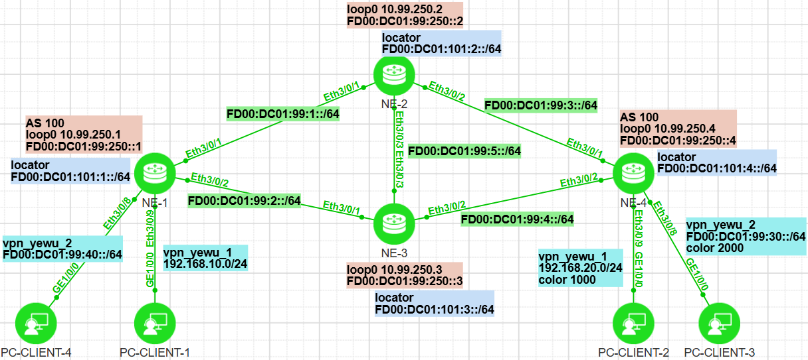
相关参数规划：
yyyy表示相应VPN实例对应的编号，4位数字，不足4位前面以0填充；
vpn实例名称为： vpn_yewu_1 vpn_yewu_2
业务vpn分配编号： 1004 1006
 | vpn-instance |  | 说明
RD | ASN:3yyyy |  | ASN表示路由器的AS号，如果未规划，默认为100
iRT | ASN:3yyyy
eRT | ASN:3yyyy

NE1配置：
ip vpn-instance vpn_yewu_1
ipv4-family
route-distinguisher 100:31004
tnl-policy tnp1 #调用隧道策略
apply-label per-instance
vpn-target 100:31004 export-extcommunity
vpn-target 100:31004 import-extcommunity
#
ip vpn-instance vpn_yewu_2
ipv6-family
route-distinguisher 100:31006
tnl-policy tnp1 #调用隧道策略
apply-label per-instance
vpn-target 100:31006 export-extcommunity
vpn-target 100:31006 import-extcommunity
#
bfd
#
sbfd
destination ipv6 FD00:DC01:99:250::4 remote-discriminator 10.99.250.4
#
te ipv6-router-id FD00:DC01:99:250::1
#
acl number 2002
rule 5 permit source 192.168.20.0 0.0.0.255
#
segment-routing ipv6
encapsulation source-address FD00:DC01:99:250::1
locator locator_1 ipv6-prefix FD00:DC01:101:1:: 64 static 32
opcode ::1 end psp
opcode ::4 end-dt4 vpn-instance vpn_yewu_1
opcode ::6 end-dt6 vpn-instance vpn_yewu_2
srv6-te-policy backup hot-standby enable
srv6-te-policy bfd seamless enable
segment-list NE1-NE2-NE3-NE4
index 10 sid ipv6 FD00:DC01:101:2::1
index 20 sid ipv6 FD00:DC01:101:2::13
index 30 sid ipv6 FD00:DC01:101:3::12
index 40 sid ipv6 FD00:DC01:101:4::1
segment-list NE1-NE2-NE4
index 10 sid ipv6 FD00:DC01:101:2::1
index 20 sid ipv6 FD00:DC01:101:4::1
segment-list NE1-NE3-NE4
index 10 sid ipv6 FD00:DC01:101:3::1
index 20 sid ipv6 FD00:DC01:101:4::1
srv6-te policy srv6_te_policy_1 endpoint FD00:DC01:99:250::4 color 1000
candidate-path preference 200
segment-list NE1-NE2-NE4 weight 20
segment-list NE1-NE3-NE4 weight 10
candidate-path preference 100
segment-list NE1-NE2-NE3-NE4
srv6-te policy srv6_te_policy_2 endpoint FD00:DC01:99:250::4 color 2000
candidate-path preference 200
segment-list NE1-NE3-NE4
#
isis 1
is-level level-1
cost-style wide
network-entity 49.0001.1111.1111.1111.00
ipv6 enable topology ipv6
segment-routing ipv6 locator locator_1 auto-sid-disable
#
#
interface Ethernet3/0/1
undo shutdown
ipv6 enable
ipv6 address FD00:DC01:99:1::1/64
isis ipv6 enable 1
isis circuit-level level-1
#
interface Ethernet3/0/2
undo shutdown
ipv6 enable
ipv6 address FD00:DC01:99:2::1/64
isis ipv6 enable 1
isis circuit-level level-1
#
interface Ethernet3/0/8
undo shutdown
ip binding vpn-instance vpn_yewu_2
ipv6 enable
ipv6 address FD00:DC01:99:40::FFFF/64
#
interface Ethernet3/0/9
undo shutdown
ip binding vpn-instance vpn_yewu_1
ip address 192.168.10.1 255.255.255.0
#
interface LoopBack0
ipv6 enable
ip address 10.99.250.1 255.255.255.255
ipv6 address FD00:DC01:99:250::1/128
isis ipv6 enable 1
isis circuit-level level-1
#
bgp 100
router-id 10.99.250.1
private-4-byte-as enable
peer FD00:DC01:99:250::4 as-number 100
peer FD00:DC01:99:250::4 connect-interface LoopBack0

ipv4-family unicast
undo synchronization

ipv4-family vpnv4
policy vpn-target
peer FD00:DC01:99:250::4 enable
peer FD00:DC01:99:250::4 route-policy color_1000 import
peer FD00:DC01:99:250::4 prefix-sid

ipv4-family vpn-instance vpn_yewu_1
import-route direct
segment-routing ipv6 locator locator_1
segment-routing ipv6 traffic-engineer best-effort

ipv6-family vpnv6
policy vpn-target
peer FD00:DC01:99:250::4 enable
peer FD00:DC01:99:250::4 prefix-sid

ipv6-family vpn-instance vpn_yewu_2
import-route direct
segment-routing ipv6 locator locator_1
segment-routing ipv6 traffic-engineer best-effort
#
route-policy color_1000 permit node 10
if-match acl 2002
apply extcommunity color 0:1000
#
tunnel-policy tnp1
tunnel select-seq ipv6 srv6-te-policy load-balance-number 1
#

NE2配置：
segment-routing ipv6
encapsulation source-address FD00:DC01:99:250::2
locator locator_2 ipv6-prefix FD00:DC01:101:2:: 64 static 32
opcode ::1 end psp
opcode ::11 end-x interface Ethernet3/0/1 nexthop FD00:DC01:99:1::1 psp
opcode ::12 end-x interface Ethernet3/0/2 nexthop FD00:DC01:99:3::2 psp
opcode ::13 end-x interface Ethernet3/0/3 nexthop FD00:DC01:99:5::2 psp
#
isis 1
is-level level-1
cost-style wide
network-entity 49.0001.2222.2222.2222.00
ipv6 enable topology ipv6
segment-routing ipv6 locator locator_2 auto-sid-disable
#
#
interface Ethernet3/0/1
undo shutdown
ipv6 enable
ipv6 address FD00:DC01:99:1::2/64
isis ipv6 enable 1
isis circuit-level level-1
#
interface Ethernet3/0/2
undo shutdown
ipv6 enable
ipv6 address FD00:DC01:99:3::1/64
isis ipv6 enable 1
isis circuit-level level-1
#
interface Ethernet3/0/3
undo shutdown
ipv6 enable
ipv6 address FD00:DC01:99:5::1/64
isis ipv6 enable 1
isis circuit-level level-1
#
interface LoopBack0
ipv6 enable
ip address 10.99.250.2 255.255.255.255
ipv6 address FD00:DC01:99:250::2/128
isis ipv6 enable 1
isis circuit-level level-1
#

NE3配置：
segment-routing ipv6
encapsulation source-address FD00:DC01:99:250::3
locator locator_3 ipv6-prefix FD00:DC01:101:3:: 64 static 32
opcode ::1 end psp
opcode ::11 end-x interface Ethernet3/0/1 nexthop FD00:DC01:99:2::1 psp
opcode ::12 end-x interface Ethernet3/0/2 nexthop FD00:DC01:99:4::2 psp
opcode ::13 end-x interface Ethernet3/0/3 nexthop FD00:DC01:99:5::1 psp
#
isis 1
is-level level-1
cost-style wide
network-entity 49.0001.3333.3333.3333.00
ipv6 enable topology ipv6
segment-routing ipv6 locator locator_3 auto-sid-disable
#
#
interface Ethernet3/0/1
undo shutdown
ipv6 enable
ipv6 address FD00:DC01:99:2::2/64
isis ipv6 enable 1
isis circuit-level level-1
#
interface Ethernet3/0/2
undo shutdown
ipv6 enable
ipv6 address FD00:DC01:99:4::1/64
isis ipv6 enable 1
isis circuit-level level-1
#
interface Ethernet3/0/3
undo shutdown
ipv6 enable
ipv6 address FD00:DC01:99:5::2/64
isis ipv6 enable 1
isis circuit-level level-1
#
interface LoopBack0
ipv6 enable
ip address 10.99.250.3 255.255.255.255
ipv6 address FD00:DC01:99:250::3/128
isis ipv6 enable 1
isis circuit-level level-1
#

NE4配置：
ip vpn-instance vpn_yewu_1
ipv4-family
route-distinguisher 100:31004
apply-label per-instance
vpn-target 100:31004 export-extcommunity
vpn-target 100:31004 import-extcommunity
#
ip vpn-instance vpn_yewu_2
ipv6-family
route-distinguisher 100:31006
apply-label per-instance
vpn-target 100:31006 export-extcommunity
vpn-target 100:31006 import-extcommunity
#
bfd
#
sbfd
reflector discriminator 10.99.250.4
#
acl ipv6 number 2001
rule 5 permit source FD00:DC01:99:30::/64
#
segment-routing ipv6
encapsulation source-address FD00:DC01:99:250::4
locator locator_4 ipv6-prefix FD00:DC01:101:4:: 64 static 32
opcode ::1 end psp
opcode ::4 end-dt4 vpn-instance vpn_yewu_1
opcode ::6 end-dt6 vpn-instance vpn_yewu_2
#
isis 1
is-level level-1
cost-style wide
network-entity 49.0001.4444.4444.4444.00
ipv6 enable topology ipv6
segment-routing ipv6 locator locator_4 auto-sid-disable
#
#
interface Ethernet3/0/1
undo shutdown
ipv6 enable
ipv6 address FD00:DC01:99:3::2/64
isis ipv6 enable 1
isis circuit-level level-1
#
interface Ethernet3/0/2
undo shutdown
ipv6 enable
ipv6 address FD00:DC01:99:4::2/64
isis ipv6 enable 1
isis circuit-level level-1
#
interface Ethernet3/0/8
undo shutdown
ip binding vpn-instance vpn_yewu_2
ipv6 enable
ipv6 address FD00:DC01:99:30::FFFF/64
#
interface Ethernet3/0/9
undo shutdown
ip binding vpn-instance vpn_yewu_1
ip address 192.168.20.1 255.255.255.0
#
interface LoopBack0
ipv6 enable
ip address 10.99.250.4 255.255.255.255
ipv6 address FD00:DC01:99:250::4/128
isis ipv6 enable 1
isis circuit-level level-1
#
bgp 100
router-id 10.99.250.4
private-4-byte-as enable
peer FD00:DC01:99:250::1 as-number 100
peer FD00:DC01:99:250::1 connect-interface LoopBack0

ipv4-family unicast
undo synchronization

ipv4-family vpnv4
policy vpn-target
peer FD00:DC01:99:250::1 enable
peer FD00:DC01:99:250::1 prefix-sid

ipv4-family vpn-instance vpn_yewu_1
import-route direct
segment-routing ipv6 locator locator_4
segment-routing ipv6 traffic-engineer best-effort

ipv6-family vpnv6
policy vpn-target
peer FD00:DC01:99:250::1 enable
peer FD00:DC01:99:250::1 route-policy color_2000 export
peer FD00:DC01:99:250::1 prefix-sid

ipv6-family vpn-instance vpn_yewu_2
import-route direct
segment-routing ipv6 locator locator_4
segment-routing ipv6 traffic-engineer best-effort
#
route-policy color_2000 permit node 10
if-match ipv6 address acl 2001
apply extcommunity color 0:2000
#

NE1查看：
<HUAWEI> disp tunnel-info all
Tunnel ID Type Destination Status
---------------------------------------------------------------------------------
0x000000003400000001 srv6tepolicy FD00:DC01:99:250::4 UP
0x000000003400000002 srv6tepolicy FD00:DC01:99:250::4 UP

<HUAWEI> disp tunnel-info 0x000000003400000001
Tunnel ID: 0x000000003400000001
Type: srv6tepolicy
Name: srv6_te_policy_1
Destination: FD00:DC01:99:250::4
Instance ID: 0
Cost: 0
Status: UP
Color: 1000

<HUAWEI> disp tunnel-info 0x000000003400000002
Tunnel ID: 0x000000003400000002
Type: srv6tepolicy
Name: srv6_te_policy_2
Destination: FD00:DC01:99:250::4
Instance ID: 0
Cost: 0
Status: UP
Color: 2000

<HUAWEI> disp ip routing-table vpn-instance vpn_yewu_1
Route Flags: R - relay, D - download to fib, T - to vpn-instance, B - black hole route
------------------------------------------------------------------------------
Routing Table : vpn_yewu_1
Destinations : 6 Routes : 6

Destination/Mask Proto Pre Cost Flags NextHop Interface

127.0.0.0/8 Direct 0 0 D 127.0.0.1 InLoopBack0
192.168.10.0/24 Direct 0 0 D 192.168.10.1 Ethernet3/0/9
192.168.10.1/32 Direct 0 0 D 127.0.0.1 Ethernet3/0/9
192.168.10.255/32 Direct 0 0 D 127.0.0.1 Ethernet3/0/9
192.168.20.0/24 IBGP 255 0 RD FD00:DC01:99:250::4 srv6_te_policy_1
255.255.255.255/32 Direct 0 0 D 127.0.0.1 InLoopBack0

<HUAWEI> disp ipv6 routing-table vpn-instance vpn_yewu_2
Routing Table : vpn_yewu_2
Destinations : 4 Routes : 4

Destination : FD00:DC01:99:30:: PrefixLength : 64
NextHop : FD00:DC01:99:250::4 Preference : 255
Cost : 0 Protocol : IBGP
RelayNextHop : :: TunnelID : 0x000000003400000002
Interface : srv6_te_policy_2 Flags : RD

Destination : FD00:DC01:99:40:: PrefixLength : 64
NextHop : FD00:DC01:99:40::FFFF Preference : 0
Cost : 0 Protocol : Direct
RelayNextHop : :: TunnelID : 0x0
Interface : Ethernet3/0/8 Flags : D

Destination : FD00:DC01:99:40::FFFF PrefixLength : 128
NextHop : ::1 Preference : 0
Cost : 0 Protocol : Direct
RelayNextHop : :: TunnelID : 0x0
Interface : Ethernet3/0/8 Flags : D

Destination : FE80:: PrefixLength : 10
NextHop : :: Preference : 0
Cost : 0 Protocol : Direct
RelayNextHop : :: TunnelID : 0x0
Interface : NULL0 Flags : DB

<HUAWEI> tracert -vpn-instance vpn_yewu_1 192.168.20.2
traceroute to vpn_yewu_1 192.168.20.2(192.168.20.2), max hops: 64, packet length: 40, press CTRL_C to break
1 * * *
2 * * *
3 * 192.168.20.2 24 ms 28 ms

<HUAWEI> tracert ipv6 vpn-instance vpn_yewu_2 fd00:dc01:99:30::2
traceroute to vpn_yewu_2 FD00:DC01:99:30::2 64 hops max,60 bytes packet
1 * * *
2 FD00:DC01:99:30::FFFF 31 ms 26 ms 22 ms
3 * FD00:DC01:99:30::2 23 ms 34 ms

<HUAWEI> disp bgp vpnv4 all peer
BGP local router ID : 10.99.250.1
Local AS number : 100
Total number of peers : 1 Peers in established state : 1

Peer V AS MsgRcvd MsgSent OutQ Up/Down State PrefRcv
FD00:DC01:99:250::4 4 100 40 38 0 00:26:50 Established 1

<HUAWEI> disp bgp vpnv4 all routing-table
BGP Local router ID is 10.99.250.1
Status codes: * - valid, > - best, d - damped, x - best external, a - add path,
h - history, i - internal, s - suppressed, S - Stale
Origin : i - IGP, e - EGP, ? - incomplete
RPKI validation codes: V - valid, I - invalid, N - not-found

Total number of routes from all PE: 4
Route Distinguisher: 100:31004
Network NextHop MED LocPrf PrefVal Path/Ogn
*> 127.0.0.0/8 0.0.0.0 0 0 ?
*> 192.168.10.0/24 0.0.0.0 0 0 ?
*> 192.168.10.1/32 0.0.0.0 0 0 ?
*>i 192.168.20.0/24 FD00:DC01:99:250::4 0 100 0 ?

VPN-Instance vpn_yewu_1, Router ID 10.99.250.1:
Total Number of Routes: 4
Network NextHop MED LocPrf PrefVal Path/Ogn
*> 127.0.0.0/8 0.0.0.0 0 0 ?
*> 192.168.10.0/24 0.0.0.0 0 0 ?
*> 192.168.10.1/32 0.0.0.0 0 0 ?
*>i 192.168.20.0/24 FD00:DC01:99:250::4 0 100 0 ?

<HUAWEI> disp bgp vpnv4 vpn-instance vpn_yewu_1 routing-table 192.168.20.0 24
BGP local router ID : 10.99.250.1
Local AS number : 100

VPN-Instance vpn_yewu_1, Router ID 10.99.250.1:
Paths: 1 available, 1 best, 1 select, 0 best-external, 0 add-path
BGP routing table entry information of 192.168.20.0/24:
Route Distinguisher: 100:31004
Remote-Cross route
Label information (Received/Applied): 3/NULL
From: FD00:DC01:99:250::4 (10.99.250.4)
Route Duration: 0d00h02m06s
Relay IP Nexthop: FE80::3A21:25FF:FE11:301
Relay IP Out-Interface: Ethernet3/0/1
Relay Tunnel Out-Interface: srv6_te_policy_1(srv6tepolicy)
Original nexthop: FD00:DC01:99:250::4
Qos information : 0x0
Ext-Community: RT <100 : 31004>, Color <0 : 1000>
Prefix-sid: FD00:DC01:101:4::4
AS-path Nil, origin incomplete, MED 0, localpref 100, pref-val 0, valid, internal, best, select, pre 255
Not advertised to any peer yet

<HUAWEI> disp bgp vpnv6 all peer
BGP local router ID : 10.99.250.1
Local AS number : 100
Total number of peers : 1 Peers in established state : 1

Peer V AS MsgRcvd MsgSent OutQ Up/Down State PrefRcv
FD00:DC01:99:250::4 4 100 40 38 0 00:26:59 Established 1

<HUAWEI> disp bgp vpnv6 all routing-table
BGP Local router ID is 10.99.250.1
Status codes: * - valid, > - best, d - damped, x - best external, a - add path,
h - history, i - internal, s - suppressed, S - Stale
Origin : i - IGP, e - EGP, ? - incomplete
RPKI validation codes: V - valid, I - invalid, N - not-found

Total number of routes from all PE: 4
Route Distinguisher: 100:31006
*>i Network : FD00:DC01:99:30:: PrefixLen : 64
NextHop : FD00:DC01:99:250::4 LocPrf : 100
MED : 0 PrefVal : 0
Label : 3/NULL
Path/Ogn : ?
*> Network : FD00:DC01:99:40:: PrefixLen : 64
NextHop : :: LocPrf :
MED : 0 PrefVal : 0
Label :
Path/Ogn : ?
*> Network : FD00:DC01:99:40::FFFF PrefixLen : 128
NextHop : :: LocPrf :
MED : 0 PrefVal : 0
Label :
Path/Ogn : ?
*> Network : FE80:: PrefixLen : 10
NextHop : :: LocPrf :
MED : 0 PrefVal : 0
Label :
Path/Ogn : ?

VPN-Instance vpn_yewu_2, Router ID 10.99.250.1:
Total Number of Routes: 4
*>i Network : FD00:DC01:99:30:: PrefixLen : 64
NextHop : FD00:DC01:99:250::4 LocPrf : 100
MED : 0 PrefVal : 0
Label : 3/NULL
Path/Ogn : ?
*> Network : FD00:DC01:99:40:: PrefixLen : 64
NextHop : :: LocPrf :
MED : 0 PrefVal : 0
Label :
Path/Ogn : ?
*> Network : FD00:DC01:99:40::FFFF PrefixLen : 128
NextHop : :: LocPrf :
MED : 0 PrefVal : 0
Label :
Path/Ogn : ?
*> Network : FE80:: PrefixLen : 10
NextHop : :: LocPrf :
MED : 0 PrefVal : 0
Label :
Path/Ogn : ?

<HUAWEI> disp bgp vpnv6 vpn-instance vpn_yewu_2 routing-table FD00:DC01:99:30:: 64
BGP local router ID : 10.99.250.1
Local AS number : 100

VPN-Instance vpn_yewu_2, Router ID 10.99.250.1:
Paths: 1 available, 1 best, 1 select, 0 best-external, 0 add-path
BGP routing table entry information of FD00:DC01:99:30::/64:
Route Distinguisher: 100:31006
Remote-Cross route
Label information (Received/Applied): 3/NULL
From: FD00:DC01:99:250::4 (10.99.250.4)
Route Duration: 0d00h03m40s
Relay IP Nexthop: FE80::3A21:25FF:FE11:301
Relay IP Out-Interface: Ethernet3/0/1
Relay Tunnel Out-Interface: srv6_te_policy_2(srv6tepolicy)
Original nexthop: FD00:DC01:99:250::4
Qos information : 0x0
Ext-Community: RT <100 : 31006>, Color <0 : 2000>
Prefix-sid: FD00:DC01:101:4::6, Endpoint Behavior: 18
AS-path Nil, origin incomplete, MED 0, localpref 100, pref-val 0, valid, internal, best, select, pre 255
Not advertised to any peer yet

<HUAWEI> disp segment-routing ipv6 local-sid forwarding
My Local-SID Forwarding Table
-------------------------------------
SID : FD00:DC01:101:1::1/128 FuncType : End
LocatorName: locator_1 LocatorID: 1
SidCompress: NO

SID : FD00:DC01:101:1::4/128 FuncType : End.DT4
LocatorName: locator_1 LocatorID: 1
SidCompress: NO

SID : FD00:DC01:101:1::6/128 FuncType : End.DT6
LocatorName: locator_1 LocatorID: 1
SidCompress: NO

Total SID(s): 3

<HUAWEI> disp bfd session all
(w): State in WTR
(*): State is invalid
------------------------------------------------------------------------------
Local Remote PeerIpAddr State Type InterfaceName
------------------------------------------------------------------------------
16385 174324228 FD00:DC01:99:250::4 Up D_SID_LIST -
16386 174324228 FD00:DC01:99:250::4 Up D_SID_LIST -
16387 174324228 FD00:DC01:99:250::4 Up D_SID_LIST -
16388 174324228 FD00:DC01:99:250::4 Up D_SID_LIST -
------------------------------------------------------------------------------
Total UP/DOWN Session Number : 4/0

NE2查看：
<HUAWEI> disp segment-routing ipv6 local-sid forwarding
My Local-SID Forwarding Table
-------------------------------------
SID : FD00:DC01:101:2::1/128 FuncType : End
LocatorName: locator_2 LocatorID: 1
SidCompress: NO

SID : FD00:DC01:101:2::11/128 FuncType : End.X
LocatorName: locator_2 LocatorID: 1
SidCompress: NO

SID : FD00:DC01:101:2::12/128 FuncType : End.X
LocatorName: locator_2 LocatorID: 1
SidCompress: NO

SID : FD00:DC01:101:2::13/128 FuncType : End.X
LocatorName: locator_2 LocatorID: 1
SidCompress: NO

Total SID(s): 4

NE3查看：
<HUAWEI> disp segment-routing ipv6 local-sid forwarding
My Local-SID Forwarding Table
-------------------------------------
SID : FD00:DC01:101:3::1/128 FuncType : End
LocatorName: locator_3 LocatorID: 1
SidCompress: NO

SID : FD00:DC01:101:3::11/128 FuncType : End.X
LocatorName: locator_3 LocatorID: 1
SidCompress: NO

SID : FD00:DC01:101:3::12/128 FuncType : End.X
LocatorName: locator_3 LocatorID: 1
SidCompress: NO

SID : FD00:DC01:101:3::13/128 FuncType : End.X
LocatorName: locator_3 LocatorID: 1
SidCompress: NO

Total SID(s): 4

NE4查看：
<HUAWEI> disp sbfd reflector discriminator
Total Discriminator Num : 1
-----------------------------------------------------------------------------------------------
SBFD-Discr(INT) SBFD-Discr(IP) State CreateType Advertising
-----------------------------------------------------------------------------------------------
174324228 10.99.250.4 Active IP Yes
-----------------------------------------------------------------------------------------------

#SRv6_TE_Policy_EVPN配置步骤：

1、首先配置各设备互连口的ipv6地址，具体配置步骤这里省略【所有节点】

2、规划1个loopback接口【所有节点】
interface LoopBack 0 # Loop0的ip用作bgp路由器id
description for_bgp_router_id #一定要写上环回口的描述
ipv6 enable
ip address 10.99.250.1 255.255.255.255
ipv6 address FD00:DC01:99:250::1/128
#

3、配置底层路由协议，如isis-v6或ospf v3，本例使用isis-v6【所有节点】
isis 1
is-level level-1
cost-style wide
network-entity 49.0001.1111.1111.1111.00
ipv6 enable topology ipv6 #开启isis进程的ipv6能力，并指定拓扑类型为ipv6拓扑
#
interface G3/0/1
isis ipv6 enable 1 #在接口上启用ipv6的isis
isis circuit-level level-1
#
interface LoopBack0
isis ipv6 enable 1
isis circuit-level level-1
#

4、创建业务vpn实例【PE节点】
ip vpn-instance vpn_yewu_1 #创建一个名为vpn_yewu_1的VPN实例
ipv4-family #进入ipv4地址族
route-distinguisher 100:31004 #配置RD
apply-label per-instance
vpn-target 100:31004 export-extcommunity evpn #配置eRT，并指定evpn地址族
vpn-target 100:31004 import-extcommunity evpn #配置iRT，并指定evpn地址族
#

5、配置SRv6相关内容：locator、segment-list、srv6-te policy，并在底层路由协议宣告locator路由/SID
segment-routing ipv6 #开启SRv6功能并进入SRv6配置界面
encapsulation source-address FD00:DC01:99:250::1 #指定SRv6 VPN封装的源地址（隧道源地址）
locator locator_1 ipv6-prefix FD00:DC01:101:1:: 64 static 32 #配置Locator，长度64位，静态段占32位，动态段占32位（64-32），节点配置Locator后，系统会自动生成一条对应的网段路由，通过该网段路由可定位到本节点，本节点发布的所有SID也可通过此网段路由访问到（srv6的sid就是一个个ipv6地址）
opcode ::1 end psp #创建prefix SID（节点sid），并指定使用PSP（倒数第二跳弹出）标记
opcode ::4 end-dt4 vpn-instance vpn_yewu_1 evpn #为vpn_yewu_1实例下的路由分配SRv6 SID（私网标签）
opcode ::6 end-dt6 vpn-instance vpn_yewu_2 evpn #为vpn_yewu_2实例下的路由分配SRv6 SID（私网标签）
srv6-te-policy backup hot-standby enable #在srv6配置界面下开启热备份功能
srv6-te-policy bfd seamless enable #在srv6配置界面下开启sbfd检测功能
segment-list NE1-NE2-NE3-NE4 #创建一个名为NE1-NE2-NE3-NE4的路径列表，只在PE节点创建，中间的P节点不创建
index 10 sid ipv6 FD00:DC01:101:2::1 #按index顺序从小到大依次压入标签
index 20 sid ipv6 FD00:DC01:101:2::13
index 30 sid ipv6 FD00:DC01:101:3::12
index 40 sid ipv6 FD00:DC01:101:4::1
segment-list NE1-NE2-NE4 #创建一个名为NE1-NE2-NE4的路径列表
index 10 sid ipv6 FD00:DC01:101:2::1
index 20 sid ipv6 FD00:DC01:101:4::1
segment-list NE1-NE3-NE4 #创建一个名为NE1-NE3-NE4的路径列表
index 10 sid ipv6 FD00:DC01:101:3::1
index 20 sid ipv6 FD00:DC01:101:4::1
srv6-te policy srv6_te_policy_1 endpoint FD00:DC01:99:250::4 color 1000 #创建一个名为srv6_te_policy_1的srv6-te策略，（策略名称，隧道终点，color）只在PE节点配置
candidate-path preference 200 #在srv6-te策略下创建候选路径1，优先级数字越大越优先
segment-list NE1-NE2-NE4 weight 20 #调用前面创建好了的路径列表
segment-list NE1-NE3-NE4 weight 10 #调用前面创建好了的路径列表
candidate-path preference 100 #在srv6-te策略下创建候选路径2
segment-list NE1-NE2-NE3-NE4
srv6-te policy srv6_te_policy_2 endpoint FD00:DC01:99:250::4 color 2000 #创建一个名为srv6_te_policy_2的srv6-te策略，（策略名称，隧道终点，color）只在PE节点配置
candidate-path preference 200
segment-list NE1-NE3-NE4
#
#在底层路由协议宣告locator路由/SID
isis 1
segment-routing ipv6 locator locator_1 auto-sid-disable #将locator_a对应的网段路由发布出去，且关闭自动分配end与end.x（默认end与end.x是由IGP自动分配的）
#

P设备（中间转发设备）仅配置end及end.x，不配置segment-list及srv6-te policy：
segment-routing ipv6
encapsulation source-address FD00:DC01:99:250::2
locator locator_2 ipv6-prefix FD00:DC01:101:2:: 64 static 32
opcode ::1 end psp
opcode ::11 end-x interface Ethernet3/0/1 nexthop FD00:DC01:99:1::1 psp
opcode ::12 end-x interface Ethernet3/0/2 nexthop FD00:DC01:99:3::2 psp
opcode ::13 end-x interface Ethernet3/0/3 nexthop FD00:DC01:99:5::2 psp
#

6、配置路由策略，将目标路由条目染色，引流到srv6隧道【PE节点】
acl number 2002
rule 5 permit source 192.168.20.0 0.0.0.255
#
route-policy color_1000 permit node 10
if-match acl 2002
apply extcommunity color 0:1000 #为目标路由染色，在选择srv6隧道时，会匹配相应的color
#

acl ipv6 number 2001
rule 5 permit source FD00:DC01:99:30::/64
#
route-policy color_2000 permit node 10
if-match ipv6 address acl 2001
apply extcommunity color 0:2000
#
★注意：不建议在同一个路由策略里，同时匹配ipv4及ipv6的acl，目前路由器未能很好支持此功能。需要做成2个路由策略，但在bgp里，对同一个对等体只能调1个路由策略，所以，需要放到2边的bgp实例去，一边应用import匹配其中一个路由策略，另一边bgp实例里匹配另一个路由策略。

7、创建BGP对待体，并配置evpn【PE节点】
bgp 100
router-id 10.99.250.1
private-4-byte-as enable
peer FD00:DC01:99:250::4 as-number 100
peer FD00:DC01:99:250::4 connect-interface LoopBack0

ipv4-family vpn-instance vpn_yewu_1
import-route direct
advertise l2vpn evpn #向evpn实例发布ip路由，即通过evpn进行路由通告，默认情况下ipv4的vpn路由，只通过vpnv4通告给其他PE路由器
segment-routing ipv6 locator locator_1 evpn #对vpn_yewu_1下的路由使用locator_a，即：让vpn实例中的evpn路由迭代到srv6 policy
segment-routing ipv6 traffic-engineer best-effort evpn #启用SRv6 BE，即同时使用srv6 BE隧道作为逃生路径

ipv6-family vpn-instance vpn_yewu_2
import-route direct
advertise l2vpn evpn
segment-routing ipv6 locator locator_1 evpn
segment-routing ipv6 traffic-engineer best-effort evpn

l2vpn-family evpn #进入evpn地址族配置界面
policy vpn-target
peer FD00:DC01:99:250::4 enable
peer FD00:DC01:99:250::4 route-policy color_1000 import #引入对端路由时，应用路由策略
peer FD00:DC01:99:250::4 advertise encap-type srv6 #默认情况下发送的evpn路由携带的是mpls封装属性，无法用于srv6转发，配置该命令后，可实现evpn路由迭代到srv6转发
#
如果在evpn里应用路由策略，没法一边应用ipv4的color，一边应用ipv6的color，这是模拟器的问题。
此时，可以在ip vpn-instance下应用路由策略（同一台PE路由器上配置2个策略）
ip vpn-instance vpn_yewu_1
ipv4-family
import route-policy color_1000 evpn #引入BGP对端路由时，应用路由策略，即去往这些路由时，走srv6-te隧道
#
ip vpn-instance vpn_yewu_2
ipv6-family
import route-policy color_2000 evpn
#

8、创建隧道策略，并在vpn实例里启用【PE节点】
tunnel-policy tnp1 #创建一个名为tnp1的隧道策略
tunnel select-seq ipv6 srv6-te-policy load-balance-number 1 #配置选择隧道的优先顺序及负载分担数量
#
ip vpn-instance vpn_yewu_1
ipv4-family
tnl-policy tnp1 evpn #在evpn下调用隧道策略
#

9、配置sbfd【PE节点】
bfd #开启bfd检测功能
#
sbfd #开启sbfd检测功能
destination ipv6 FD00:DC01:99:250::4 remote-discriminator 10.99.250.4 #配置endpoint地址与远端标识符的映射关系
#
te ipv6-router-id FD00:DC01:99:250::1 #配置全局TE IPv6的router-id，SRv6隧道场景下，MCP计算sbfd时，需要将te ipv6-router-id地址配置成srv6隧道源地址，否则MCP将无法计算bfd报文的SLA结果
#

反射端：
bfd
#
sbfd
reflector discriminator 10.99.250.4 #配置sbfd反射端描述符
#

★查看信息：
<HUAWEI> disp tunnel-info all
<HUAWEI> disp tunnel-info 0x000000003400000001
<HUAWEI> disp ip routing-table vpn-instance vpn_yewu_1
<HUAWEI> disp ipv6 routing-table vpn-instance vpn_yewu_2
<HUAWEI> tracert -vpn-instance vpn_yewu_1 192.168.20.2
<HUAWEI> tracert ipv6 vpn-instance vpn_yewu_2 fd00:dc01:99:30::2
<HUAWEI> disp bgp evpn peer
<HUAWEI> disp bgp evpn all routing-table
<HUAWEI> disp bgp evpn all routing-table prefix-route 0:[FD00:DC01:99:30::]:64
<HUAWEI> disp segment-routing ipv6 local-sid forwarding
<HUAWEI> disp bfd session all
<HUAWEI> disp sbfd reflector discriminator

实验：SRv6_TE_Policy_EVPN_isis_ne（ensp_pro）
拓扑如下：
相关参数规划：
yyyy表示相应VPN实例对应的编号，4位数字，不足4位前面以0填充；
vpn实例名称为： vpn_yewu_1 vpn_yewu_2
业务vpn分配编号： 1004 1006
 | vpn-instance |  | 说明
RD | ASN:3yyyy |  | ASN表示路由器的AS号，如果未规划，默认为100
iRT | ASN:3yyyy
eRT | ASN:3yyyy

NE1配置：
ip vpn-instance vpn_yewu_1
ipv4-family
route-distinguisher 100:31004
apply-label per-instance
vpn-target 100:31004 export-extcommunity evpn
vpn-target 100:31004 import-extcommunity evpn
tnl-policy tnp1 evpn
#
ip vpn-instance vpn_yewu_2
ipv6-family
route-distinguisher 100:31006
apply-label per-instance
vpn-target 100:31006 export-extcommunity evpn
vpn-target 100:31006 import-extcommunity evpn
tnl-policy tnp1 evpn
#
bfd
#
sbfd
destination ipv6 FD00:DC01:99:250::4 remote-discriminator 10.99.250.4
#
te ipv6-router-id FD00:DC01:99:250::1
#
acl number 2002
rule 5 permit source 192.168.20.0 0.0.0.255
#
segment-routing ipv6
encapsulation source-address FD00:DC01:99:250::1
locator locator_1 ipv6-prefix FD00:DC01:101:1:: 64 static 32
opcode ::1 end psp
opcode ::4 end-dt4 vpn-instance vpn_yewu_1 evpn
opcode ::6 end-dt6 vpn-instance vpn_yewu_2 evpn
srv6-te-policy backup hot-standby enable
srv6-te-policy bfd seamless enable
segment-list NE1-NE2-NE3-NE4
index 10 sid ipv6 FD00:DC01:101:2::1
index 20 sid ipv6 FD00:DC01:101:2::13
index 30 sid ipv6 FD00:DC01:101:3::12
index 40 sid ipv6 FD00:DC01:101:4::1
segment-list NE1-NE2-NE4
index 10 sid ipv6 FD00:DC01:101:2::1
index 20 sid ipv6 FD00:DC01:101:4::1
segment-list NE1-NE3-NE4
index 10 sid ipv6 FD00:DC01:101:3::1
index 20 sid ipv6 FD00:DC01:101:4::1
srv6-te policy srv6_te_policy_1 endpoint FD00:DC01:99:250::4 color 1000
candidate-path preference 200
segment-list NE1-NE2-NE4 weight 20
segment-list NE1-NE3-NE4 weight 10
candidate-path preference 100
segment-list NE1-NE2-NE3-NE4
srv6-te policy srv6_te_policy_2 endpoint FD00:DC01:99:250::4 color 2000
candidate-path preference 200
segment-list NE1-NE3-NE4
#
isis 1
is-level level-1
cost-style wide
network-entity 49.0001.1111.1111.1111.00
ipv6 enable topology ipv6
segment-routing ipv6 locator locator_1 auto-sid-disable
#
#
interface Ethernet3/0/1
undo shutdown
ipv6 enable
ipv6 address FD00:DC01:99:1::1/64
isis ipv6 enable 1
isis circuit-level level-1
#
interface Ethernet3/0/2
undo shutdown
ipv6 enable
ipv6 address FD00:DC01:99:2::1/64
isis ipv6 enable 1
isis circuit-level level-1
#
interface Ethernet3/0/8
undo shutdown
ip binding vpn-instance vpn_yewu_2
ipv6 enable
ipv6 address FD00:DC01:99:40::FFFF/64
#
interface Ethernet3/0/9
undo shutdown
ip binding vpn-instance vpn_yewu_1
ip address 192.168.10.1 255.255.255.0
#
interface LoopBack0
ipv6 enable
ip address 10.99.250.1 255.255.255.255
ipv6 address FD00:DC01:99:250::1/128
isis ipv6 enable 1
isis circuit-level level-1
#
bgp 100
router-id 10.99.250.1
private-4-byte-as enable
peer FD00:DC01:99:250::4 as-number 100
peer FD00:DC01:99:250::4 connect-interface LoopBack0

ipv4-family unicast
undo synchronization

ipv4-family vpn-instance vpn_yewu_1
import-route direct
advertise l2vpn evpn
segment-routing ipv6 locator locator_1 evpn
segment-routing ipv6 traffic-engineer best-effort evpn

ipv6-family vpn-instance vpn_yewu_2
import-route direct
advertise l2vpn evpn
segment-routing ipv6 locator locator_1 evpn
segment-routing ipv6 traffic-engineer best-effort evpn

l2vpn-family evpn
policy vpn-target
peer FD00:DC01:99:250::4 enable
peer FD00:DC01:99:250::4 route-policy color_1000 import
peer FD00:DC01:99:250::4 advertise encap-type srv6
#
route-policy color_1000 permit node 10
if-match acl 2002
apply extcommunity color 0:1000
#
tunnel-policy tnp1
tunnel select-seq ipv6 srv6-te-policy load-balance-number 1
#

NE2配置：
segment-routing ipv6
encapsulation source-address FD00:DC01:99:250::2
locator locator_2 ipv6-prefix FD00:DC01:101:2:: 64 static 32
opcode ::1 end psp
opcode ::11 end-x interface Ethernet3/0/1 nexthop FD00:DC01:99:1::1 psp
opcode ::12 end-x interface Ethernet3/0/2 nexthop FD00:DC01:99:3::2 psp
opcode ::13 end-x interface Ethernet3/0/3 nexthop FD00:DC01:99:5::2 psp
#
isis 1
is-level level-1
cost-style wide
network-entity 49.0001.2222.2222.2222.00
ipv6 enable topology ipv6
segment-routing ipv6 locator locator_2 auto-sid-disable
#
#
interface Ethernet3/0/1
undo shutdown
ipv6 enable
ipv6 address FD00:DC01:99:1::2/64
isis ipv6 enable 1
isis circuit-level level-1
#
interface Ethernet3/0/2
undo shutdown
ipv6 enable
ipv6 address FD00:DC01:99:3::1/64
isis ipv6 enable 1
isis circuit-level level-1
#
interface Ethernet3/0/3
undo shutdown
ipv6 enable
ipv6 address FD00:DC01:99:5::1/64
isis ipv6 enable 1
isis circuit-level level-1
#
interface LoopBack0
ipv6 enable
ip address 10.99.250.2 255.255.255.255
ipv6 address FD00:DC01:99:250::2/128
isis ipv6 enable 1
isis circuit-level level-1
#

NE3配置：
segment-routing ipv6
encapsulation source-address FD00:DC01:99:250::3
locator locator_3 ipv6-prefix FD00:DC01:101:3:: 64 static 32
opcode ::1 end psp
opcode ::11 end-x interface Ethernet3/0/1 nexthop FD00:DC01:99:2::1 psp
opcode ::12 end-x interface Ethernet3/0/2 nexthop FD00:DC01:99:4::2 psp
opcode ::13 end-x interface Ethernet3/0/3 nexthop FD00:DC01:99:5::1 psp
#
isis 1
is-level level-1
cost-style wide
network-entity 49.0001.3333.3333.3333.00
ipv6 enable topology ipv6
segment-routing ipv6 locator locator_3 auto-sid-disable
#
#
interface Ethernet3/0/1
undo shutdown
ipv6 enable
ipv6 address FD00:DC01:99:2::2/64
isis ipv6 enable 1
isis circuit-level level-1
#
interface Ethernet3/0/2
undo shutdown
ipv6 enable
ipv6 address FD00:DC01:99:4::1/64
isis ipv6 enable 1
isis circuit-level level-1
#
interface Ethernet3/0/3
undo shutdown
ipv6 enable
ipv6 address FD00:DC01:99:5::2/64
isis ipv6 enable 1
isis circuit-level level-1
#
interface LoopBack0
ipv6 enable
ip address 10.99.250.3 255.255.255.255
ipv6 address FD00:DC01:99:250::3/128
isis ipv6 enable 1
isis circuit-level level-1
#

NE4配置：
ip vpn-instance vpn_yewu_1
ipv4-family
route-distinguisher 100:31004
apply-label per-instance
vpn-target 100:31004 export-extcommunity evpn
vpn-target 100:31004 import-extcommunity evpn
#
ip vpn-instance vpn_yewu_2
ipv6-family
route-distinguisher 100:31006
apply-label per-instance
vpn-target 100:31006 export-extcommunity evpn
vpn-target 100:31006 import-extcommunity evpn
#
bfd
#
sbfd
reflector discriminator 10.99.250.4
#
acl ipv6 number 2001
rule 5 permit source FD00:DC01:99:30::/64
#
segment-routing ipv6
encapsulation source-address FD00:DC01:99:250::4
locator locator_4 ipv6-prefix FD00:DC01:101:4:: 64 static 32
opcode ::1 end psp
opcode ::4 end-dt4 vpn-instance vpn_yewu_1 evpn
opcode ::6 end-dt6 vpn-instance vpn_yewu_2 evpn
#
isis 1
is-level level-1
cost-style wide
network-entity 49.0001.4444.4444.4444.00
ipv6 enable topology ipv6
segment-routing ipv6 locator locator_4 auto-sid-disable
#
#
interface Ethernet3/0/1
undo shutdown
ipv6 enable
ipv6 address FD00:DC01:99:3::2/64
isis ipv6 enable 1
isis circuit-level level-1
#
interface Ethernet3/0/2
undo shutdown
ipv6 enable
ipv6 address FD00:DC01:99:4::2/64
isis ipv6 enable 1
isis circuit-level level-1
#
interface Ethernet3/0/8
undo shutdown
ip binding vpn-instance vpn_yewu_2
ipv6 enable
ipv6 address FD00:DC01:99:30::FFFF/64
#
interface Ethernet3/0/9
undo shutdown
ip binding vpn-instance vpn_yewu_1
ip address 192.168.20.1 255.255.255.0
#
interface LoopBack0
ipv6 enable
ip address 10.99.250.4 255.255.255.255
ipv6 address FD00:DC01:99:250::4/128
isis ipv6 enable 1
isis circuit-level level-1
#
bgp 100
router-id 10.99.250.4
private-4-byte-as enable
peer FD00:DC01:99:250::1 as-number 100
peer FD00:DC01:99:250::1 connect-interface LoopBack0

ipv4-family unicast
undo synchronization

ipv4-family vpn-instance vpn_yewu_1
import-route direct
advertise l2vpn evpn
segment-routing ipv6 locator locator_4 evpn
segment-routing ipv6 traffic-engineer best-effort evpn

ipv6-family vpn-instance vpn_yewu_2
import-route direct
advertise l2vpn evpn
segment-routing ipv6 locator locator_4 evpn
segment-routing ipv6 traffic-engineer best-effort evpn

l2vpn-family evpn
policy vpn-target
peer FD00:DC01:99:250::1 enable
peer FD00:DC01:99:250::1 route-policy color_2000 export
peer FD00:DC01:99:250::1 advertise encap-type srv6
#
route-policy color_2000 permit node 10
if-match ipv6 address acl 2001
apply extcommunity color 0:2000
#

NE1查看：
<HUAWEI> disp tunnel-info all
Tunnel ID Type Destination Status
---------------------------------------------------------------------------
0x000000003400000001 srv6tepolicy FD00:DC01:99:250::4 UP
0x000000003400000002 srv6tepolicy FD00:DC01:99:250::4 UP

<HUAWEI> disp tunnel-info 0x000000003400000001
Tunnel ID: 0x000000003400000001
Type: srv6tepolicy
Name: srv6_te_policy_1
Destination: FD00:DC01:99:250::4
Instance ID: 0
Cost: 0
Status: UP
Color: 1000

<HUAWEI> disp tunnel-info 0x000000003400000002
Tunnel ID: 0x000000003400000002
Type: srv6tepolicy
Name: srv6_te_policy_2
Destination: FD00:DC01:99:250::4
Instance ID: 0
Cost: 0
Status: UP
Color: 2000

<HUAWEI> disp ip routing-table vpn-instance vpn_yewu_1
Route Flags: R - relay, D - download to fib, T - to vpn-instance, B - black hole route
------------------------------------------------------------------------------
Routing Table : vpn_yewu_1
Destinations : 6 Routes : 6

Destination/Mask Proto Pre Cost Flags NextHop Interface
127.0.0.0/8 Direct 0 0 D 127.0.0.1 InLoopBack0
192.168.10.0/24 Direct 0 0 D 192.168.10.1 Ethernet3/0/9
192.168.10.1/32 Direct 0 0 D 127.0.0.1 Ethernet3/0/9
192.168.10.255/32 Direct 0 0 D 127.0.0.1 Ethernet3/0/9
192.168.20.0/24 IBGP 255 0 RD FD00:DC01:99:250::4 srv6_te_policy_1
255.255.255.255/32 Direct 0 0 D 127.0.0.1 InLoopBack0

<HUAWEI> disp ipv6 routing-table vpn-instance vpn_yewu_2
Routing Table : vpn_yewu_2
Destinations : 4 Routes : 4

Destination : FD00:DC01:99:30:: PrefixLength : 64
NextHop : FD00:DC01:99:250::4 Preference : 255
Cost : 0 Protocol : IBGP
RelayNextHop : :: TunnelID : 0x000000003400000001
Interface : srv6_te_policy_2 Flags : RD

Destination : FD00:DC01:99:40:: PrefixLength : 64
NextHop : FD00:DC01:99:40::FFFF Preference : 0
Cost : 0 Protocol : Direct
RelayNextHop : :: TunnelID : 0x0
Interface : Ethernet3/0/8 Flags : D

Destination : FD00:DC01:99:40::FFFF PrefixLength : 128
NextHop : ::1 Preference : 0
Cost : 0 Protocol : Direct
RelayNextHop : :: TunnelID : 0x0
Interface : Ethernet3/0/8 Flags : D

Destination : FE80:: PrefixLength : 10
NextHop : :: Preference : 0
Cost : 0 Protocol : Direct
RelayNextHop : :: TunnelID : 0x0
Interface : NULL0 Flags : DB

<HUAWEI> tracert -vpn-instance vpn_yewu_1 192.168.20.2
traceroute to vpn_yewu_1 192.168.20.2(192.168.20.2), max hops: 64, packet length: 40, press CTRL_C to break
1 * * *
2 * * *
3 192.168.20.2 47 ms 26 ms 24 ms

<HUAWEI> tracert ipv6 vpn-instance vpn_yewu_2 fd00:dc01:99:30::2
traceroute to vpn_yewu_2 FD00:DC01:99:30::2 64 hops max,60 bytes packet
1 * * *
2 FD00:DC01:99:30::FFFF 24 ms 19 ms 20 ms
3 FD00:DC01:99:30::2 18 ms 24 ms 31 ms

<HUAWEI> disp bgp evpn peer
BGP local router ID : 10.99.250.1
Local AS number : 100
Total number of peers : 1 Peers in established state : 1

Peer V AS MsgRcvd MsgSent OutQ Up/Down State PrefRcv
FD00:DC01:99:250::4 4 100 370 370 0 05:08:06 Established 2

<HUAWEI> disp bgp evpn all routing-table
Local AS number : 100
BGP Local router ID is 10.99.250.1
Status codes: * - valid, > - best, d - damped, x - best external, a - add path,
h - history, i - internal, s - suppressed, S - Stale
Origin : i - IGP, e - EGP, ? - incomplete

EVPN address family:
Number of Ip Prefix Routes: 4

Route Distinguisher: 100:31004
Network(EthTagId/IpPrefix/IpPrefixLen) NextHop
*> 0:192.168.10.0:24 0.0.0.0
*>i 0:192.168.20.0:24 FD00:DC01:99:250::4

Route Distinguisher: 100:31006
Network(EthTagId/IpPrefix/IpPrefixLen) NextHop
*>i 0:[FD00:DC01:99:30::]:64 FD00:DC01:99:250::4
*> 0:[FD00:DC01:99:40::]:64 ::

<HUAWEI> disp bgp evpn all routing-table prefix-route 0:[FD00:DC01:99:30::]:64
BGP local router ID : 10.99.250.1
Local AS number : 100
Total routes of Route Distinguisher(100:31006): 1
BGP routing table entry information of 0:[FD00:DC01:99:30::]:64:
Label information (Received/Applied): 3/NULL
From: FD00:DC01:99:250::4 (10.99.250.4)
Route Duration: 0d00h09m08s
Relay IP Nexthop: FE80::3A61:88FF:FE11:301
Relay IP Out-Interface: Ethernet3/0/1
Relay Tunnel Out-Interface:
Original nexthop: FD00:DC01:99:250::4
Qos information : 0x0
Ext-Community: RT <100 : 31006>, Color <0 : 2000>
Prefix-sid: FD00:DC01:101:4::6, Endpoint Behavior: 18
AS-path Nil, origin incomplete, MED 0, localpref 100, pref-val 0, valid, internal, best, select, pre 255, IGP cost 20
Route Type: 5 (Ip Prefix Route)
Ethernet Tag ID: 0, IPv6 Prefix/Len: FD00:DC01:99:30::/64, ESI: 0000.0000.0000.0000.0000, GW IPv6 Address: ::
Not advertised to any peer yet

<HUAWEI> disp segment-routing ipv6 local-sid forwarding
My Local-SID Forwarding Table
-------------------------------------
SID : FD00:DC01:101:1::1/128 FuncType : End
LocatorName: locator_1 LocatorID: 1
SidCompress: NO

SID : FD00:DC01:101:1::4/128 FuncType : End.DT4
LocatorName: locator_1 LocatorID: 1
SidCompress: NO

SID : FD00:DC01:101:1::6/128 FuncType : End.DT6
LocatorName: locator_1 LocatorID: 1
SidCompress: NO

Total SID(s): 3

<HUAWEI> disp bfd session all
(w): State in WTR
(*): State is invalid
------------------------------------------------------------------------------
Local Remote PeerIpAddr State Type InterfaceName
------------------------------------------------------------------------------
16385 174324228 FD00:DC01:99:250::4 Up D_SID_LIST -
16386 174324228 FD00:DC01:99:250::4 Up D_SID_LIST -
16387 174324228 FD00:DC01:99:250::4 Up D_SID_LIST -
16388 174324228 FD00:DC01:99:250::4 Up D_SID_LIST -
------------------------------------------------------------------------------
Total UP/DOWN Session Number : 4/0

NE2查看：
<HUAWEI> disp segment-routing ipv6 local-sid forwarding
My Local-SID Forwarding Table
-------------------------------------
SID : FD00:DC01:101:2::1/128 FuncType : End
LocatorName: locator_2 LocatorID: 1
SidCompress: NO

SID : FD00:DC01:101:2::11/128 FuncType : End.X
LocatorName: locator_2 LocatorID: 1
SidCompress: NO

SID : FD00:DC01:101:2::12/128 FuncType : End.X
LocatorName: locator_2 LocatorID: 1
SidCompress: NO

SID : FD00:DC01:101:2::13/128 FuncType : End.X
LocatorName: locator_2 LocatorID: 1
SidCompress: NO

Total SID(s): 4

NE4查看：
<HUAWEI> disp sbfd reflector discriminator
Total Discriminator Num : 1
-------------------------------------------------------------------------------
SBFD-Discr(INT) SBFD-Discr(IP) State CreateType Advertising
-------------------------------------------------------------------------------
174324228 10.99.250.4 Active IP Yes
-------------------------------------------------------------------------------

★★★SRv6_TE_Policy_EVPN_isis-v6_BFD配置步骤：

1、首先配置各设备互连口的ipv6地址，具体配置步骤这里省略【所有节点】

2、规划1个loopback接口【所有节点】
interface LoopBack 0 # Loop0的ip用作bgp路由器id
description for_bgp_router_id #一定要写上环回口的描述
ip address 10.99.250.1 255.255.255.255
ipv6 enable
ipv6 address FD00:DC01:99:250::1/128
#

3、配置底层路由协议isis-v6及BFD【所有节点】
bfd
#
isis 1
is-level level-2
cost-style wide
network-entity 49.0001.1111.1111.1111.00
domain-authentication-mode md5 cipher passwordxxx
ipv6 enable topology standard #开启isis进程的ipv6能力，并指定拓扑类型为standard标准模式
ipv6 bfd all-interfaces enable
ipv6 bfd all-interfaces min-tx-interval 10 min-rx-interval 10
ipv6 frr
loop-free-alternate level-2
ti-lfa level-2
#
interface G3/0/1
isis ipv6 enable 1 #在接口上启用ipv6的isis
isis circuit-level level-2
isis circuit-type p2p
isis ppp-negotiation 2-way
isis authentication-mode md5 cipher passwordxxx
#
interface LoopBack0
isis ipv6 enable 1
#

4、创建业务vpn实例【PE节点】
ip vpn-instance vpn_yewu_1 #创建一个名为vpn_yewu_1的VPN实例
ipv4-family #进入ipv4地址族
route-distinguisher 100:31004 #配置RD
vpn frr
apply-label per-instance
vpn-target 100:31004 export-extcommunity evpn #配置eRT，并指定evpn地址族
vpn-target 100:31004 import-extcommunity evpn #配置iRT，并指定evpn地址族
#
interface G3/0/0
ip binding vpn-instance vpn_yewu_1 #业务口绑定相应vpn实例
ip address 192.168.10.1 255.255.255.0
#

5、配置SRv6相关内容：locator、segment-list、srv6-te policy，并在底层路由协议宣告locator路由/SID
segment-routing ipv6 #开启SRv6功能并进入SRv6配置界面
encapsulation source-address FD00:DC01:99:250::1 #指定SRv6 VPN封装的源地址（隧道源地址）
locator locator_1 ipv6-prefix FD00:DC01:101:1:: 64 static 32 #配置Locator，长度64位，静态段32位
opcode ::1 end no-flavor #创建prefix SID（节点sid）有的设备只有no-psp
opcode ::100 end-op
opcode ::10 end-x interface G3/0/1 nexthop FD00:DC01:99:1::2 no-flavor
opcode ::20 end-x interface G3/0/2 nexthop FD00:DC01:99:2::2 no-flavor
srv6-te-policy backup hot-standby enable #在srv6配置界面下开启热备份功能
srv6-te-policy bfd seamless enable #在srv6配置界面下开启sbfd检测功能
segment-list NE1_NE3 #创建一个名为NE1-NE2-NE3-NE4的路径列表
index 10 sid ipv6 FD00:DC01:101:1::10 #按index顺序从小到大依次压入标签
index 20 sid ipv6 FD00:DC01:101:3::1
segment-list NE1_NE3_BK #创建一个名为NE1-NE2-NE4的路径列表
index 10 sid ipv6 FD00:DC01:101:1::20
index 20 sid ipv6 FD00:DC01:101:2::20
index 30 sid ipv6 FD00:DC01:101:3::1
srv6-te policy srv6_te_policy_1 endpoint FD00:DC01:99:250::3 color 1000 #创建一个名为srv6_te_policy_1的srv6-te策略，（策略名称，隧道终点，color）只在PE节点配置
candidate-path preference 200 #在srv6-te策略下创建候选路径1，优先级数字越大越优先
segment-list NE1_NE3 #调用前面创建好了的路径列表
candidate-path preference 100 #在srv6-te策略下创建候选路径2
segment-list NE1_NE3_BK
#
#在底层路由协议宣告locator路由/SID
isis 1
segment-routing ipv6 locator locator_1 auto-sid-disable #将locator_a对应的网段路由发布出去，且关闭自动分配end与end.x（默认end与end.x是由IGP自动分配的）
avoid-microloop frr-protected #开启IS-IS Remote LFA FRR功能或TI-LFA FRR功能后，在主链路发生故障切换备份链路，当路由重新收敛时，路由从备份链路切换到新的主链路，在切换到新的主链路过程中，网络中可能存在短时间的环路，为了避免这个问题，可以通过配置avoid-microloop frr-protected命令开启IS-IS本地防微环功能，此功能通过延时切换到新的主下一跳，实现避免环路的功能
avoid-microloop frr-protected rib-update-delay 2000 #配置IS-IS路由延迟下发时间，单位：ms，默认100ms
ipv6 avoid-microloop segment-routing #开启SRv6的回切防微环功能
ipv6 avoid-microloop segment-routing rib-update-delay 2000 #配置SRv6场景IS-IS路由的延迟下发时间，单位：ms，默认是5000ms
#

P设备（中间转发设备）仅配置end及end.x，不配置segment-list及srv6-te policy：
segment-routing ipv6
encapsulation source-address FD00:DC01:99:250::2
locator locator_2 ipv6-prefix FD00:DC01:101:2:: 64 static 32
opcode ::1 end no-flavor #创建prefix SID（节点sid）
opcode ::100 end-op
opcode ::10 end-x interface G3/0/1 nexthop FD00:DC01:99:1::1 no-flavor
opcode ::20 end-x interface G3/0/2 nexthop FD00:DC01:99:3::2 no-flavor
#

6、配置路由策略，将目标路由条目染色，引流到srv6隧道【PE节点】
acl number 2002
rule 5 permit source 192.168.10.0 0.0.0.255
#
route-policy color_1000 permit node 10
if-match acl 2002
apply extcommunity color 0:1000 #为目标路由染色，在选择srv6隧道时，会匹配相应的color
#
★注意：不建议在同一个路由策略里，同时匹配ipv4及ipv6的acl，目前路由器未能很好支持此功能。需要做成2个路由策略，但在bgp里，对同一个对等体只能调1个路由策略，所以，需要放到2边的bgp实例去，一边应用import匹配其中一个路由策略，另一边bgp实例里匹配另一个路由策略。

7、创建BGP对待体，并配置evpn【PE节点】
bgp 100
router-id 10.99.250.1
private-4-byte-as enable
undo default ipv4-unicast
peer FD00:DC01:99:250::3 as-number 100
peer FD00:DC01:99:250::3 connect-interface LoopBack0
peer FD00:DC01:99:250::3 password cipher passwordxxx

ipv4-family vpn-instance vpn_yewu_1
import-route direct
advertise l2vpn evpn #向evpn实例发布ip路由，即通过evpn进行路由通告，默认情况下ipv4的vpn路由，只通过vpnv4通告给其他PE路由器
segment-routing ipv6 locator locator_1 evpn #对vpn_yewu_1下的路由使用locator_a，即：让vpn实例中的evpn路由迭代到srv6 policy
segment-routing ipv6 traffic-engineer best-effort evpn #启用SRv6 BE，即同时使用srv6 BE隧道作为逃生路径

l2vpn-family evpn #进入evpn地址族配置界面
policy vpn-target
peer FD00:DC01:99:250::3 enable
peer FD00:DC01:99:250::3 advertise encap-type srv6 #默认情况下发送的evpn路由携带的是mpls封装属性，无法用于srv6转发，配置该命令后，可实现evpn路由迭代到srv6转发
#
在evpn里应用路由策略，没法一边应用ipv4的color，一边应用ipv6的color，这是模拟器的问题。
此时可以在ip vpn-instance下应用路由策略（同一台PE路由器上配置2个策略，ipv4及ipv6的vpn实例分别应用）
ip vpn-instance vpn_yewu_1
ipv4-family
export route-policy color_1000 evpn #配置实例出方向策略，本实例下的路由在向bgp对端宣告时，应用相应的路由策略（前提是要被此路由策略匹配，然后才会按策略里配置的color进行染色）
default-color 1000 evpn #配置实例入方向default-color，即本实例下学习到的路由若未指定color属性，则默认就认为是color 1000
#

8、创建隧道策略，并在vpn实例里启用【PE节点】
tunnel-policy tnp1 #创建一个名为tnp1的隧道策略
tunnel select-seq ipv6 srv6-te-policy load-balance-number 1 #配置选择隧道的优先顺序及负载分担数量
#
ip vpn-instance vpn_yewu_1
ipv4-family
tnl-policy tnp1 evpn #在evpn下调用隧道策略
#

9、配置sbfd【PE节点】
bfd #开启bfd检测功能
#
sbfd #开启sbfd检测功能
destination ipv6 FD00:DC01:99:250::3 remote-discriminator 10.99.250.3 #配置endpoint地址与远端标识符的映射关系
#
te ipv6-router-id FD00:DC01:99:250::1 #配置全局TE IPv6的router-id，SRv6隧道场景下，MCP计算sbfd时，需要将te ipv6-router-id地址配置成srv6隧道源地址，否则MCP将无法计算bfd报文的SLA结果
#

反射端（检测的目的端）：
bfd
#
sbfd
reflector discriminator 10.99.250.3 #配置sbfd反射端描述符
#

★查看信息：
<HUAWEI> disp tunnel-info all
<HUAWEI> disp tunnel-info 0x000000003400000001
<HUAWEI> disp ip routing-table vpn-instance vpn_yewu_1
<HUAWEI> tracert -vpn-instance vpn_yewu_1 192.168.20.2
<HUAWEI> tracert ipv6 vpn-instance vpn_yewu_2 fd00:dc01:99:30::2
<HUAWEI> disp bgp evpn peer
<HUAWEI> disp bgp evpn all routing-table
<HUAWEI> disp bgp evpn all routing-table prefix-route 0:192.168.20.0:24
<HUAWEI> disp segment-routing ipv6 local-sid forwarding
<HUAWEI> disp bfd session all
<HUAWEI> disp sbfd reflector discriminator
<HUAWEI> disp srv6-te policy brief
<HUAWEI> disp srv6-te policy policy-name srv6_te_policy_1
<HUAWEI> disp ip vpn-instance tunnel-info

实验：SRv6_TE_Policy_EVPN_isis-v6_BFD_ne（ensp_pro）
拓扑如下：
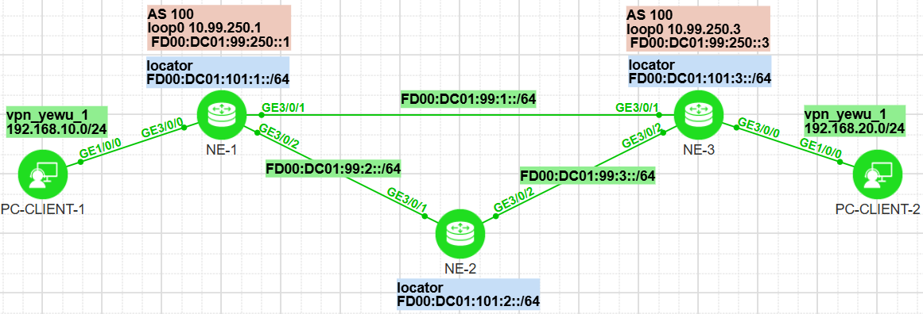
相关参数规划：
yyyy表示相应VPN实例对应的编号，4位数字，不足4位前面以0填充；
vpn实例名称为： vpn_yewu_1
业务vpn分配编号： 1004
 | vpn-instance |  | 说明
RD | ASN:3yyyy |  | ASN表示路由器的AS号，如果未规划，默认为100
iRT | ASN:3yyyy
eRT | ASN:3yyyy

#NE1配置：
ip vpn-instance vpn_yewu_1
ipv4-family
route-distinguisher 100:31004
vpn frr
apply-label per-instance
export route-policy color_1000 evpn
vpn-target 100:31004 export-extcommunity evpn
vpn-target 100:31004 import-extcommunity evpn
tnl-policy tnp1 evpn
default-color 1000 evpn
#
bfd
#
sbfd
destination ipv6 FD00:DC01:99:250::3 remote-discriminator 10.99.250.3
#
te ipv6-router-id FD00:DC01:99:250::1
#
acl number 2002
rule 5 permit source 192.168.10.0 0.0.0.255
#
segment-routing ipv6
encapsulation source-address FD00:DC01:99:250::1
locator locator_1 ipv6-prefix FD00:DC01:101:1:: 64 static 32
opcode ::1 end no-flavor
opcode ::10 end-x interface GigabitEthernet3/0/1 nexthop FD00:DC01:99:1::2 no-flavor
opcode ::20 end-x interface GigabitEthernet3/0/2 nexthop FD00:DC01:99:2::2 no-flavor
opcode ::100 end-op
srv6-te-policy backup hot-standby enable
srv6-te-policy bfd seamless enable
segment-list NE1_NE3
index 10 sid ipv6 FD00:DC01:101:1::10
index 20 sid ipv6 FD00:DC01:101:3::1
segment-list NE1_NE3_BK
index 10 sid ipv6 FD00:DC01:101:1::20
index 20 sid ipv6 FD00:DC01:101:2::20
index 30 sid ipv6 FD00:DC01:101:3::1
srv6-te policy srv6_te_policy_1 endpoint FD00:DC01:99:250::3 color 1000
candidate-path preference 200
segment-list NE1_NE3
candidate-path preference 100
segment-list NE1_NE3_BK
#
isis 1
is-level level-2
cost-style wide
network-entity 49.0001.1111.1111.1111.00
avoid-microloop frr-protected
avoid-microloop frr-protected rib-update-delay 2000
domain-authentication-mode md5 cipher %^%#@th-N0+X%SYMiM0}r[yD#f4!9VyY&/_-&&Qj:w.Y%^%#
ipv6 enable topology standard
ipv6 bfd all-interfaces enable
ipv6 bfd all-interfaces min-tx-interval 500 min-rx-interval 500
segment-routing ipv6 locator locator_1 auto-sid-disable
ipv6 avoid-microloop segment-routing
ipv6 avoid-microloop segment-routing rib-update-delay 2000
ipv6 frr
loop-free-alternate level-2
ti-lfa level-2
#
interface GigabitEthernet3/0/0
undo shutdown
ip binding vpn-instance vpn_yewu_1
ip address 192.168.10.1 255.255.255.0
#
interface GigabitEthernet3/0/1
undo shutdown
ipv6 enable
ipv6 address FD00:DC01:99:1::1/64
isis ipv6 enable 1
isis circuit-type p2p
isis circuit-level level-2
isis authentication-mode md5 cipher %^%#{&$%>kf$9=`A_ZXRU\MG>qEW9X2_&18/*J6GfaV!%^%#
isis ppp-negotiation 2-way
#
interface GigabitEthernet3/0/2
undo shutdown
ipv6 enable
ipv6 address FD00:DC01:99:2::1/64
isis ipv6 enable 1
isis circuit-type p2p
isis circuit-level level-2
isis authentication-mode md5 cipher %^%#6Shb5JQMtVy`rh%$QplV,m2p>*"|B/vx`3<aFK9*%^%#
isis ppp-negotiation 2-way
#
interface LoopBack0
ipv6 enable
ip address 10.99.250.1 255.255.255.255
ipv6 address FD00:DC01:99:250::1/128
isis ipv6 enable 1
#
bgp 100
router-id 10.99.250.1
undo default ipv4-unicast
private-4-byte-as enable
peer FD00:DC01:99:250::3 as-number 100
peer FD00:DC01:99:250::3 connect-interface LoopBack0
peer FD00:DC01:99:250::3 password cipher %^%#ZSIx7dGV"$A;hz'U;p-@;Q,2.=E)}FT_2x>aj%30%^%#

ipv4-family unicast
undo synchronization

ipv4-family vpn-instance vpn_yewu_1
import-route direct
advertise l2vpn evpn
segment-routing ipv6 locator locator_1 evpn
segment-routing ipv6 traffic-engineer best-effort evpn

l2vpn-family evpn
policy vpn-target
peer FD00:DC01:99:250::3 enable
peer FD00:DC01:99:250::3 advertise encap-type srv6
#
route-policy color_1000 permit node 10
if-match acl 2002
apply extcommunity color 0:1000
#
tunnel-policy tnp1
tunnel select-seq ipv6 srv6-te-policy load-balance-number 1
#

#NE2配置：
bfd
#
segment-routing ipv6
encapsulation source-address FD00:DC01:99:250::2
locator locator_2 ipv6-prefix FD00:DC01:101:2:: 64 static 32
opcode ::1 end no-flavor
opcode ::10 end-x interface GigabitEthernet3/0/1 nexthop FD00:DC01:99:1::1 no-flavor
opcode ::20 end-x interface GigabitEthernet3/0/2 nexthop FD00:DC01:99:3::2 no-flavor
opcode ::100 end-op
#
isis 1
is-level level-2
cost-style wide
network-entity 49.0001.2222.2222.2222.00
avoid-microloop frr-protected
avoid-microloop frr-protected rib-update-delay 2000
domain-authentication-mode md5 cipher %^%#4s)E"{j-g3wE3p5-7L|3\HVHW_VWo(r,\^@*1"4O%^%#
ipv6 enable topology standard
ipv6 bfd all-interfaces enable
ipv6 bfd all-interfaces min-tx-interval 500 min-rx-interval 500
segment-routing ipv6 locator locator_2 auto-sid-disable
ipv6 avoid-microloop segment-routing
ipv6 avoid-microloop segment-routing rib-update-delay 2000
ipv6 frr
loop-free-alternate level-2
ti-lfa level-2
#
interface GigabitEthernet3/0/1
undo shutdown
ipv6 enable
ipv6 address FD00:DC01:99:2::2/64
isis ipv6 enable 1
isis circuit-type p2p
isis circuit-level level-2
isis authentication-mode md5 cipher %^%#zy-ROZ;%(+FL+<2>0av9L9(t=kIU^Ee0~rHjs.YL%^%#
isis ppp-negotiation 2-way
#
interface GigabitEthernet3/0/2
undo shutdown
ipv6 enable
ipv6 address FD00:DC01:99:3::1/64
isis ipv6 enable 1
isis circuit-type p2p
isis circuit-level level-2
isis authentication-mode md5 cipher %^%#{>e^2DKj[B,abV'po^=0R`h~Er|.0CT`T~=NPI3-%^%#
isis ppp-negotiation 2-way
#

#NE3配置：
ip vpn-instance vpn_yewu_1
ipv4-family
route-distinguisher 100:31004
vpn frr
apply-label per-instance
vpn-target 100:31004 export-extcommunity evpn
vpn-target 100:31004 import-extcommunity evpn
#
bfd
#
sbfd
reflector discriminator 10.99.250.3
#
segment-routing ipv6
encapsulation source-address FD00:DC01:99:250::3
locator locator_3 ipv6-prefix FD00:DC01:101:3:: 64 static 32
opcode ::1 end no-flavor
opcode ::10 end-x interface GigabitEthernet3/0/1 nexthop FD00:DC01:99:1::1 no-flavor
opcode ::20 end-x interface GigabitEthernet3/0/2 nexthop FD00:DC01:99:3::1 no-flavor
opcode ::100 end-op
#
isis 1
is-level level-2
cost-style wide
network-entity 49.0001.3333.3333.3333.00
avoid-microloop frr-protected
avoid-microloop frr-protected rib-update-delay 2000
domain-authentication-mode md5 cipher %^%#<)v=Wsx_\WSJL(25Igq(0B*X~bCi+A;"#L"Z.pW"%^%#
ipv6 enable topology standard
ipv6 bfd all-interfaces enable
ipv6 bfd all-interfaces min-tx-interval 500 min-rx-interval 500
segment-routing ipv6 locator locator_3 auto-sid-disable
ipv6 avoid-microloop segment-routing
ipv6 avoid-microloop segment-routing rib-update-delay 2000
ipv6 frr
loop-free-alternate level-2
ti-lfa level-2
#
interface GigabitEthernet3/0/0
undo shutdown
ip binding vpn-instance vpn_yewu_1
ip address 192.168.20.1 255.255.255.0
#
interface GigabitEthernet3/0/1
undo shutdown
ipv6 enable
ipv6 address FD00:DC01:99:1::2/64
isis ipv6 enable 1
isis circuit-type p2p
isis circuit-level level-2
isis authentication-mode md5 cipher %^%#gV8=C,3#pCxquAA!&Gl/g5oYPV>$+'!\o*"i5-'%%^%#
isis ppp-negotiation 2-way
#
interface GigabitEthernet3/0/2
undo shutdown
ipv6 enable
ipv6 address FD00:DC01:99:3::2/64
isis ipv6 enable 1
isis circuit-type p2p
isis circuit-level level-2
isis authentication-mode md5 cipher %^%##M\!Gxk_'O8[v+,Ot,\MfAfTF#!B6Tml3%Go%~LJ%^%#
isis ppp-negotiation 2-way
#
interface LoopBack0
ipv6 enable
ip address 10.99.250.3 255.255.255.255
ipv6 address FD00:DC01:99:250::3/128
isis ipv6 enable 1
#
bgp 100
router-id 10.99.250.3
undo default ipv4-unicast
private-4-byte-as enable
peer FD00:DC01:99:250::1 as-number 100
peer FD00:DC01:99:250::1 connect-interface LoopBack0
peer FD00:DC01:99:250::1 password cipher %^%#N9'JSu%8e&oT,~.aI=2#r,2BWmR1qM|bjr(G<qX1%^%#

ipv4-family unicast
undo synchronization

ipv4-family vpn-instance vpn_yewu_1
import-route direct
advertise l2vpn evpn
segment-routing ipv6 locator locator_3 evpn
segment-routing ipv6 traffic-engineer best-effort evpn

l2vpn-family evpn
policy vpn-target
peer FD00:DC01:99:250::1 enable
peer FD00:DC01:99:250::1 advertise encap-type srv6
#

★NE1查看信息：
<HUAWEI> disp tunnel-info all
Tunnel ID Type Destination Status
------------------------------------------------------------------------------
0x000000003400000001 srv6tepolicy FD00:DC01:99:250::3 UP

<HUAWEI> disp tunnel-info 0x000000003400000001
Tunnel ID: 0x000000003400000001
Type: srv6tepolicy
Name: srv6_te_policy_1
Destination: FD00:DC01:99:250::3
Instance ID: 0
Cost: 0
Status: UP
Color: 1000

<HUAWEI> disp ip routing-table vpn-instance vpn_yewu_1
Route Flags: R - relay, D - download to fib, T - to vpn-instance, B - black hole route
------------------------------------------------------------------------------
Routing Table : vpn_yewu_1
Destinations : 6 Routes : 6

Destination/Mask Proto Pre Cost Flags NextHop Interface
127.0.0.0/8 Direct 0 0 D 127.0.0.1 InLoopBack0
192.168.10.0/24 Direct 0 0 D 192.168.10.1 GigabitEthernet3/0/0
192.168.10.1/32 Direct 0 0 D 127.0.0.1 GigabitEthernet3/0/0
192.168.10.255/32 Direct 0 0 D 127.0.0.1 GigabitEthernet3/0/0
192.168.20.0/24 IBGP 255 0 RD FD00:DC01:99:250::3 srv6_te_policy_1
255.255.255.255/32 Direct 0 0 D 127.0.0.1 InLoopBack0

<HUAWEI> tracert -vpn-instance vpn_yewu_1 192.168.20.2
traceroute to vpn_yewu_1 192.168.20.2(192.168.20.2), max hops: 64, packet length: 40, press CTRL_C to break
1 * * *
2 * 192.168.20.2 8 ms 18 ms
关闭NE1上的GE3/0/1后：
traceroute to vpn_yewu_1 192.168.20.2(192.168.20.2), max hops: 64, packet length: 40, press CTRL_C to break
1 * * *
2 * * *
3 192.168.20.2 15 ms 28 ms 40 ms

<HUAWEI> disp bgp evpn peer
BGP local router ID : 10.99.250.1
Local AS number : 100
Total number of peers : 1 Peers in established state : 1

Peer V AS MsgRcvd MsgSent OutQ Up/Down State PrefRcv
FD00:DC01:99:250::3 4 100 15 16 0 00:10:00 Established 1

<HUAWEI> disp bgp evpn all routing-table
Local AS number : 100

BGP Local router ID is 10.99.250.1
Status codes: * - valid, > - best, d - damped, x - best external, a - add path,
h - history, i - internal, s - suppressed, S - Stale
Origin : i - IGP, e - EGP, ? - incomplete

EVPN address family:
Number of Ip Prefix Routes: 2
Route Distinguisher: 100:31004
Network(EthTagId/IpPrefix/IpPrefixLen) NextHop
*> 0:192.168.10.0:24 0.0.0.0
*>i 0:192.168.20.0:24 FD00:DC01:99:250::3

<HUAWEI> disp bgp evpn all routing-table prefix-route 0:192.168.20.0:24
BGP local router ID : 10.99.250.1
Local AS number : 100
Total routes of Route Distinguisher(100:31004): 1
BGP routing table entry information of 0:192.168.20.0:24:
Label information (Received/Applied): 3/NULL
From: FD00:DC01:99:250::3 (10.99.250.3)
Route Duration: 0d00h10m49s
Relay IP Nexthop: FE80::3A98:17FF:FE11:301
Relay IP Out-Interface: GigabitEthernet3/0/1
Relay Tunnel Out-Interface:
Original nexthop: FD00:DC01:99:250::3
Qos information : 0x0
Ext-Community: RT <100 : 31004> #收到NE3宣告的路由，不带color属性，但vpn实例里配置了default-color后，就将去往此路由的下一跳改为了srv6隧道
Prefix-sid: FD00:DC01:101:3:0:1:0:3, Endpoint Behavior: DT4(19)
AS-path Nil, origin incomplete, MED 0, localpref 100, pref-val 0, valid, internal, best, select, pre 255, IGP cost 10
Route Type: 5 (Ip Prefix Route)
Ethernet Tag ID: 0, IP Prefix/Len: 192.168.20.0/24, ESI: 0000.0000.0000.0000.0000, GW IP Address: 0.0.0.0
Not advertised to any peer yet

<HUAWEI> disp bgp evpn all routing-table prefix-route 0:192.168.10.0:24
BGP local router ID : 10.99.250.1
Local AS number : 100
Total routes of Route Distinguisher(100:31004): 1
BGP routing table entry information of 0:192.168.10.0:24:
Imported route.
From: 0.0.0.0 (0.0.0.0)
Route Duration: 0d00h04m57s
Direct Out-interface: GigabitEthernet3/0/0
Original nexthop: 192.168.10.1
Qos information : 0x0
Ext-Community: RT <100 : 31004>, Color <0 : 1000>
Prefix-sid: FD00:DC01:101:1:0:1:0:3, Endpoint Behavior: DT4(19)
AS-path Nil, origin incomplete, MED 0, pref-val 0, valid, local, best, select, pre 255
Route Type: 5 (Ip Prefix Route)
Ethernet Tag ID: 0, IP Prefix/Len: 192.168.10.0/24, ESI: 0000.0000.0000.0000.0000, GW IP Address: 0.0.0.0
Advertised to such 1 peers:
FD00:DC01:99:250::3

<HUAWEI> disp segment-routing ipv6 local-sid forwarding
My Local-SID Forwarding Table
-------------------------------------

SID : FD00:DC01:101:1::1/128 FuncType : End
LocatorName: locator_1 LocatorID: 1
SidCompress: NO

SID : FD00:DC01:101:1::10/128 FuncType : End.X
LocatorName: locator_1 LocatorID: 1
SidCompress: NO

SID : FD00:DC01:101:1::20/128 FuncType : End.X
LocatorName: locator_1 LocatorID: 1
SidCompress: NO

SID : FD00:DC01:101:1::100/128 FuncType : End.OP
LocatorName: locator_1 LocatorID: 1
SidCompress: NO

SID : FD00:DC01:101:1:0:1:0:3/128 FuncType : End.DT4
LocatorName: locator_1 LocatorID: 1
SidCompress: NO

Total SID(s): 5

<HUAWEI> disp bfd session all
(w): State in WTR
(*): State is invalid
--------------------------------------------------------------------------------
Local Remote PeerIpAddr State Type InterfaceName
--------------------------------------------------------------------------------
16385 174324227 FD00:DC01:99:250::3
Up D_SID_LIST -
16386 174324227 FD00:DC01:99:250::3
Up D_SID_LIST -
16387 16386 FE80::3A98:17FF:FE11:301
Up D_IP_IF GigabitEthernet3/0/1
16388 16386 FE80::3A52:44FF:FE11:301
Up D_IP_IF GigabitEthernet3/0/2
--------------------------------------------------------------------------------
Total UP/DOWN Session Number : 4/0

<HUAWEI> disp sbfd reflector discriminator #NE3上查看
Total Discriminator Num : 1
-----------------------------------------------------------------------------------------------
SBFD-Discr(INT) SBFD-Discr(IP) State CreateType Advertising
-----------------------------------------------------------------------------------------------
174324227 10.99.250.3 Active IP Yes
-----------------------------------------------------------------------------------------------

<HUAWEI> disp srv6-te policy brief
Policy Name : srv6_te_policy_1
Color : 1000 Endpoint : FD00:DC01:99:250::3
TunnelId : 1
Policy State : Up State Change Time : 2025-08-07 13:50:52
Binding SID : -
Candidate-path Count : 2

<HUAWEI> disp srv6-te policy policy-name srv6_te_policy_1
Policy Name : srv6_te_policy_1
Color : 1000 Endpoint : FD00:DC01:99:250::3
TunnelId : 1
TunnelType : SRv6-TE Policy DelayTimerRemain : -
Policy State : Up State Change Time : 2025-08-07 13:50:52
Admin State : Up Traffic Statistics : Disable
Backup Hot-Standby : Enable BFD : SBFD Enable
Interface Index : - Interface Name : -
Interface State : - Encapsulation Mode : Insert
Active Metric : - Metric Source : -
Binding SID : -
BFD Slice Inherit Match : Disable
Delete Hold : Disable
Candidate-path Count : 2

Candidate-path Preference : 200
Policy Name : srv6_te_policy_1
Candidate-path Name :
Path State : Active Path Type : Primary
Protocol-Origin : Configuration(30) Originator : 0, 0.0.0.0
Discriminator : 200 Binding SID : -
GroupId : 2
Template ID : 0 Path Verification : Disable
DelayTimerRemain : - Network Slice ID : -
Active Metric : -
Metric :
IGP Metric : - TE Metric : -
Delay Metric : - Hop Counts : -
Segment-List Count : 1
Segment-List : NE1_NE3
Segment-List ID : 2 XcIndex : 1
List State : Up DelayTimerRemain : -
Verification State : - SuppressTimeRemain : -
PMTU : 9600 Active PMTU : 9600
Weight : 1 BFD State : Up
Loop Detection State : Up BFD Delay Remain : -
Network Slice ID : -
Binding SID : -
Reverse Binding SID : -
XSID : -
Reverse XSID : -
Metric :
IGP Metric : - TE Metric : -
Delay Metric : - Hop Counts : -
SID :
FD00:DC01:101:1::10
FD00:DC01:101:3::1

Candidate-path Preference : 100
Policy Name : srv6_te_policy_1
Candidate-path Name :
Path State : Active Path Type : Backup
Protocol-Origin : Configuration(30) Originator : 0, 0.0.0.0
Discriminator : 100 Binding SID : -
GroupId : 1
Template ID : 0 Path Verification : Disable
DelayTimerRemain : - Network Slice ID : -
Active Metric : -
Metric :
IGP Metric : - TE Metric : -
Delay Metric : - Hop Counts : -
Segment-List Count : 1
Segment-List : NE1_NE3_BK
Segment-List ID : 1 XcIndex : 2
List State : Up DelayTimerRemain : -
Verification State : - SuppressTimeRemain : -
PMTU : 9600 Active PMTU : 9600
Weight : 1 BFD State : Up
Loop Detection State : Up BFD Delay Remain : -
Network Slice ID : -
Binding SID : -
Reverse Binding SID : -
XSID : -
Reverse XSID : -
Metric :
IGP Metric : - TE Metric : -
Delay Metric : - Hop Counts : -
SID :
FD00:DC01:101:1::20
FD00:DC01:101:2::20
FD00:DC01:101:3::1

<HUAWEI> disp ip vpn-instance tunnel-info
Total VPN-Instances configured : 1

VPN-Instance Name and ID : vpn_yewu_1, 1
Address family ipv4
Nexthop Address Tunnel ID
FD00:DC01:99:250::3 1
Tunnel Name Tunnel Type
srv6_te_policy_1 52
IID Color
16777326 1000
Address family ipv6

★VXLAN
NVE概念：Network Virtualization Edge网络虚拟化边缘节点，负责vxlan数据的封装与解封装，NVE视图里可配置多个vxlan隧道

#VxLAN大二层网络隧道
VxLAN是一种隧道技术，能在三层网络的基础上建立二层以太网络，vxlan的实现方法是将原始的以太网帧加上8字节的vxlan头部，再封装在一个UDP报文里，此报文目的端口为8472/udp，即对端的隧道终端服务监听8472/udp端口。
所以vxlan可以理解为 MAC帧over UDP，Linux内核在3.7.0版本才开始支持vxlan，但linux 3.7发布时，相关的vxlan标准未规定使用哪个端口号，所以大多数厂商使用8472/udp端口，后来IANA分配了4789/udp作为vxlan的目的端口

VTEP（Vxlan Tunnel End Point）vxlan隧道终端节点，实现vxlan报文的封装/解封装

VxLAN头部：
8 bit | 24 bit | 24 bit | 8 bit
vxlan tag | Reserved | VNI | Reserved
VNI：（Vxlan Network Identifier），类似于vlan的id，vni区分一个vxlan虚拟overlay网络，vni有24bit，可表示16M个vxlan网络（即16777216个）
vxlan隧道底层网络的mtu如果是1500的话，那么vxlan要求被封装的报文网络mtu为1450
1500 - ( 20+8+8+14 ) = 1450 所以vxan设备的mtu一般为1450
20表示ip头，8为udp头，8为vxlan头，14为被封装流量的mac帧头（不带vlan tag）
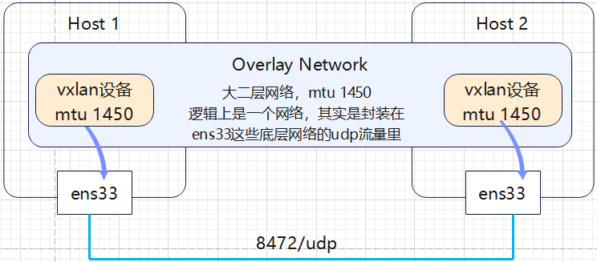

#静态VXLAN
配置步骤：
1、创建BD大二层广播域
bridge-domain 10 #创建一个二层广播域，相当于vlan，本地有效
vxlan vni 1010 #指定vxlan的id，全局唯一
#
2、创建vbdif三层接口
int Vbdif10 #创建vxlan二层广播域对应的三层接口，相当于vlan if
ip addr 192.168.10.1 255.255.255.0
#
3、创建NVE接口
int Nve1 #创建nve接口，用于封装解封装vxlan载荷数据
source 10.10.1.22 #选用本设备的一个loopback接口的ip
vni 1010 head-end peer-list 10.10.1.33 #指定对端的nve接口ip
vni 2020 head-end peer-list 10.10.1.44
#
4、创建vxlan业务接入点
int g1/0/2.1 mode l2 #一个子接口为一个业务vlan，可配置多个子接口
encapsulation dot1q vid 10 #encap untag为不打tag
bridge-domain 10 #关联vxlan二层广播域
#

实验：static_VXLAN_ce12800（ensp）
拓扑如下：
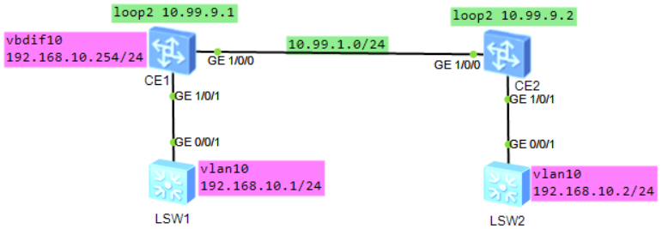
CE1配置：
bridge-domain 10
vxlan vni 1010
#
interface Vbdif10
ip address 192.168.10.254 255.255.255.0
#
interface GE1/0/0
undo portswitch
undo shutdown
ip address 10.99.1.1 255.255.255.0
#
interface GE1/0/1.1 mode l2
encapsulation dot1q vid 10
bridge-domain 10
#
interface LoopBack2
description for_vxlan_nve_id
ip address 10.99.9.1 255.255.255.255
#
interface Nve1
source 10.99.9.1
vni 1010 head-end peer-list 10.99.9.2
#
ip route-static 10.99.9.2 255.255.255.255 10.99.1.2

CE2配置：
bridge-domain 10
vxlan vni 1010
#
interface GE1/0/0
undo portswitch
undo shutdown
ip address 10.99.1.2 255.255.255.0
#
interface GE1/0/1.1 mode l2
encapsulation dot1q vid 10
bridge-domain 10
#
interface LoopBack2
description for_vxlan_nve_id
ip address 10.99.9.2 255.255.255.255
#
interface Nve1
source 10.99.9.2
vni 1010 head-end peer-list 10.99.9.1
#
ip route-static 10.99.9.1 255.255.255.255 10.99.1.1

LSW1配置：
vlan batch 10
#
interface Vlanif10
ip address 192.168.10.1 255.255.255.0
#
interface GigabitEthernet0/0/1
port link-type trunk
port trunk allow-pass vlan 2 to 4094

CE1查看：
<HUAWEI> disp vxlan peer vni 1010
Number of peers : 1
Vni ID Source Destination Type Out Vni ID
-------------------------------------------------------------------------------
1010 10.99.9.1 10.99.9.2 static 1010

<HUAWEI> disp vxlan tunnel
Number of vxlan tunnel : 1
Tunnel ID Source Destination State Type Uptime
-----------------------------------------------------------------------------------
4026531841 10.99.9.1 10.99.9.2 up static 00:14:47

<HUAWEI> disp bridge-domain 10
--------------------------------------------------------------------------------
MAC_LRN: MAC learning; STAT: Statistics; SPLIT: Split-horizon;
BC: Broadcast; MC: Unknown multicast; UC: Unknown unicast;
*down: Administratively down; FWD: Forward; DSD: Discard;
U: Up; D: Down;
--------------------------------------------------------------------------------

BDID Ports
--------------------------------------------------------------------------------
10 GE1/0/1.1(U)

BDID State MAC-LRN STAT BC MC UC SPLIT Description
--------------------------------------------------------------------------------
10 up enable disable FWD FWD FWD disable

BDID VLANIDs
--------------------------------------------------------------------------------
10

#VXLAN_EVPN

VXLAN_EVPN配置步骤：

1、首先配置各设备互连口的ip地址，具体配置步骤这里省略【所有节点】

2、规划3个loopback接口【所有节点】
interface LoopBack 0 # Loop0的ip用作bgp路由器id（underlay的路由协议）
description for_bgp_router_id #一定要写上环回口的描述
ip address 10.10.1.1 32
#
interface LoopBack 1 # Loop1的ip用作evpn bgp实例的路由器id
description for_evpn_bgp_router_id
ip address 10.10.1.2 32
#
interface LoopBack 2 # Loop2的ip用作nve接口的ip，VTEP
description for_vxlan_nve_ip
ip address 10.10.1.3 32
#

3、配置底层路由协议，如bgp或ospf，本例使用bgp【所有节点】
#在Spine-Leaf组网架构下，建议使用bgp做underlay路由协议
bgp 100
router-id 10.10.1.1
peer 10.2.1.2 as-number 200
peer 10.2.1.2 allow-as-loop
ipv4-family unicast
network 10.10.1.1 32
network 10.10.1.2 32
network 10.10.1.3 32
maximum load-balancing ebgp 32
#

4、优化VXLAN网络负载【所有节点】
ip tunnel mode vxlan
assign forward nvo3 acl extend enable #配置VXLAN隧道模式并使能VXLAN的ACL扩展功能
assign forward nvo3 f-linecard compatibility enable #配置非增强模式下防止VXLAN流量不通功能
assign forward nvo3 ecmp hash enable #VXLAN报文通过ECMP等价路由时采用负载均衡效果优化
assign forward nvo3 eth-trunk hash enable #使能VXLAN报文通过聚合口时采用负载均衡效果优化
assign forward nvo3 hash-polarization enhanced enable #使能VXLAN IPv4报文哈希极化增强功能
assign forward nvo3 hash-polarization ipv6 enhanced enable #使能VXLAN IPv6报文哈希极化增强功能

5、开启evpn功能（使能EVPN作VXLAN控制平面）【所有节点】
evpn-overlay enable #开启evpn之后，才可在bgp里配置evpn地址族相关命令
commit

6、创建vpn实例（vrf）【仅leaf节点】
ip vpn-instance vpn10
vxlan vni 5010 #设置三层vni
ipv4-family
route-distinguisher 10:1 #RD
vpn-target 10:5010 export-extcommunity evpn #eRT
vpn-target 10:5010 import-extcommunity evpn #iRT
#

7、创建bridge-domain及evpn实例【仅leaf节点】
bridge-domain 10
vxlan vni 10
evpn
route-distinguisher 10:2 #evpn的RD
vpn-target 10:3 both #iRT,eRT
vpn-target 10:5010 export-extcommunity #新增一个eRT
#
#ARP广播抑制
arp广播抑制是 替换arp报文中的广播地址为单播地址
bridge-domain 10
arp broadcast-supress enable #在BD下配置arp广播抑制
#
disp arp broadcast-suppress user bridge-domain 10 #查看arp广播抑制表

8、创建vxlan业务接入口【仅leaf节点】
int g1/0/2.1 mode l2 #同一接口可配置多个子接口，此时可根据封装的vid来区别
encapsulation dot1q vid 10 #根据vlan tag10来区别，要求入站的数据包带有vlan tag 10，
#encapsulation untag #匹配不打tag的流量（同一主接口上只能有一个子接口配置为untag）
bridge-domain 10 #将此子接口划入BD 10
#

9、创建vxlan三层网关（分布式网关）【仅leaf节点】
①引入主机路由的形式（type5）
interface Vbdif10
ip binding vpn-instance vpn10
ip address 192.168.10.1 255.255.255.0
arp timeout 60
arp proxy anyway enable
mac-address 0000-0000-0001
arp direct-route enable
arp direct-route preference 1 #将引入的arp路由优先级改为1，必须比eBGP的优先级高才会生效
#
ip ip-prefix arp-host-prefix1 index 10 permit 0.0.0.0 32 greater-equal 32 less-equal 32
#创建一个名为arp-host-prefix1的ip前缀规则，匹配32位的主机路由
#
route-policy arp-host-router1 permit node 10 #创建一个名为arp-host-router1的路由策略
if-match ip-prefix arp-host-prefix1 #匹配ip-prefix
apply community 10:10 #应用团体属性（非必须，可用于路由策略的控制）
#

②引入irb路由的形式（type2）
interface Vbdif10
ip binding vpn-instance vpn10
ip address 192.168.10.1 255.255.255.0
arp timeout 60
arp broadcast-detect enable
mac-address 0000-0000-0001
vxlan anycast-gateway enable
arp collect host enable #引入irb路由
#

10、leaf之间建立BGP-EVPN对等体关系，发布IP前缀路由/IRB路由
一般一台路由设备只允许开启一个bgp实例，华为设备为BGP-EVPN额外支持一个bgp实例
当然了，evpn也可配置在普通的bgp实例下，为了区分开来，方便管理，建议在单独的bgp实例里配置
在单独的BGP-EVPN实例里，只能用iBGP，如有必要，请配置Route-Reflect路由反射
在Spine-Leaf组网下，可以使用Spine节点充当RR反射器
bgp 5000 instance evpnxx
router-id 10.10.1.2
peer 10.10.2.2 as-number 5000
peer 10.10.2.2 connect-interface LoopBack1

l2vpn-family evpn
policy vpn-target #对接收到的vpn路由进行vpn-target（RT）过滤
peer 10.10.2.2 enable
y
peer 10.10.2.2 advertise irb #向对等体宣告irb路由

ipv4-family vpn-instance vpn10
advertise l2vpn evpn #在相应的vpn实例下宣告evpn路由
maximum load-balancing 32
#import-route direct #引入直连路由
import-route direct route-policy arp-host-router1 #引入直连路由时做相应的匹配限制
#

11、创建头端复制，nve封装接口【仅leaf节点】
interface Nve1
source 10.10.1.3
vni 10 head-end peer-list protocol bgp
#

★查看信息
<HUAWEI> disp vxlan peer
<HUAWEI> disp vxlan vni 21002
<HUAWEI> disp bridge-domain 21002 verbose #查看BD广播域信息
<HUAWEI> disp arp
<HUAWEI> disp ipv6 neighbors brief
<HUAWEI> disp ip routing-table vpn-instance vpn_yewu_1
<HUAWEI> disp ipv6 routing-table vpn-instance vpn_yewu_1
<HUAWEI> disp bgp instance evpnxx evpn peer #查看evpn bgp对等体信息
<HUAWEI> disp bgp instance evpnxx evpn peer 10.99.8.4 verbose #查看evpn bgp对等体详细信息
<HUAWEI> disp bgp instance evpnxx evpn all routing-table #查看evpn bgp路由信息

<HUAWEI> disp bgp instance evpnxx evpn all routing-table mac-route #查看evpn MAC路由信息
<HUAWEI> disp bgp instance evpnxx evpn all routing-table mac-route 0:48:6852-8d9e-051c:32:192.168.10.2

<HUAWEI> disp bgp instance evpnxx evpn all routing-table prefix-route #查看evpn前缀路由信息
<HUAWEI> disp bgp instance evpnxx evpn all routing-table prefix-route X:X.X.X.X:M

实验：VXLAN_EVPN_bgp_ce12800（ensp）
拓扑如下：
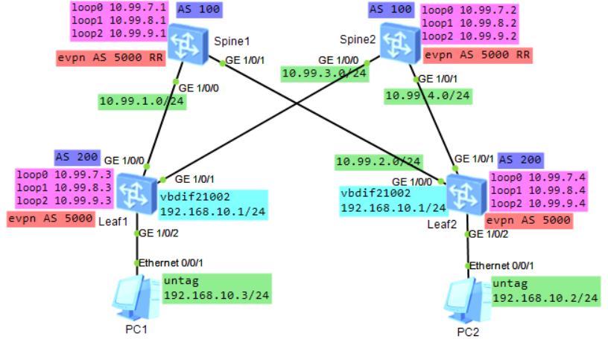
evpn相关参数规划：
yyyy表示相应VPN实例对应的编号，4位数字，不足4位前面以0填充；本实验中给业务vpn分配1010编号
vpn实例名称为： vpn_yewu_1（一个vpn实例可绑定到多个的vlan网段上）
xxxx表示相应网段对应的vlan号，4位数字，不足4位前面以0填充；本实验中业务vlan配置为1002
bridge-domain编号为： 2xxxx
 | vpn-instance | evpn | 说明
vni | 3yyyy | 2xxxx
RD | ASN:3yyyy | ASN:2xxxx | ASN表示路由器的AS号
iRT | ASN:3yyyy | ASN:2xxxx
eRT | ASN:3yyyy | ASN:2xxxx ASN:3yyyy

Spine1配置：
evpn-overlay enable
#
interface GE1/0/0
undo portswitch
undo shutdown
ip address 10.99.1.1 255.255.255.0
#
interface GE1/0/1
undo portswitch
undo shutdown
ip address 10.99.2.1 255.255.255.0
#
interface LoopBack0
description for_bgp_router_id
ip address 10.99.7.1 255.255.255.255
#
interface LoopBack1
description for_evpn_bgp_router_id
ip address 10.99.8.1 255.255.255.255
#
interface LoopBack2
description for_vxlan_nve_ip
ip address 10.99.9.1 255.255.255.255
#
bgp 100
router-id 10.99.7.1
group exter_group_leaf external
peer exter_group_leaf as-number 200
peer 10.99.1.2 group exter_group_leaf
peer 10.99.2.2 group exter_group_leaf
ipv4-family unicast
network 10.99.7.1 255.255.255.255
network 10.99.8.1 255.255.255.255
network 10.99.9.1 255.255.255.255
maximum load-balancing ebgp 32
#
#以下evpn_bgp路由反射器配置，在模拟器里，不支持配置在evpn的bgp实例上
#bgp 5000 instance evpnxx
# router-id 10.99.8.1
# group evpn_inter_group_leaf internal
# peer 10.99.8.3 group evpn_inter_group_leaf
# peer 10.99.8.4 group evpn_inter_group_leaf
# peer evpn_inter_group_leaf connect-interface LoopBack1
# peer evpn_inter_group_leaf reflect-client
# l2vpn-family evpn
# policy vpn-target
# peer evpn_inter_group_leaf enable
# peer evpn_inter_group_leaf advertise irb

Spine2配置：
evpn-overlay enable
#
interface GE1/0/0
undo portswitch
undo shutdown
ip address 10.99.3.1 255.255.255.0
#
interface GE1/0/1
undo portswitch
undo shutdown
ip address 10.99.4.1 255.255.255.0
#
interface LoopBack0
description for_bgp_router_id
ip address 10.99.7.2 255.255.255.255
#
interface LoopBack1
description for_evpn_bgp_router_id
ip address 10.99.8.2 255.255.255.255
#
interface LoopBack2
description for_vxlan_nve_ip
ip address 10.99.9.2 255.255.255.255
#
bgp 100
router-id 10.99.7.2
group exter_group_leaf external
peer exter_group_leaf as-number 200
peer 10.99.3.2 group exter_group_leaf
peer 10.99.4.2 group exter_group_leaf
ipv4-family unicast
network 10.99.7.2 255.255.255.255
network 10.99.8.2 255.255.255.255
network 10.99.9.2 255.255.255.255
maximum load-balancing ebgp 32
#
#以下路由反射器配置，在模拟器里，不支持配置在evpn的bgp实例上
#bgp 5000 instance evpnxx
# router-id 10.99.8.2
# group evpn_inter_group_leaf internal
# peer 10.99.8.3 group evpn_inter_group_leaf
# peer 10.99.8.4 group evpn_inter_group_leaf
# peer evpn_inter_group_leaf connect-interface LoopBack1
# peer evpn_inter_group_leaf reflect-client
# l2vpn-family evpn
# policy vpn-target
# peer evpn_inter_group_leaf enable
# peer evpn_inter_group_leaf advertise irb

Leaf1配置：
evpn-overlay enable
#
ip vpn-instance vpn_yewu_1
ipv4-family
route-distinguisher 200:31010
vpn-target 200:31010 export-extcommunity
vpn-target 200:31010 import-extcommunity
vxlan vni 31010
#
bridge-domain 21002
vxlan vni 21002
evpn
route-distinguisher 5000:21002
vpn-target 5000:21002 export-extcommunity
vpn-target 200:31010 export-extcommunity
vpn-target 5000:21002 import-extcommunity
#
#以下为发布arp路由的配置，宣告的是type5类型的ip前缀路由
interface Vbdif21002
ip binding vpn-instance vpn_yewu_1
ip address 192.168.10.1 255.255.255.0
mac-address 0000-0000-0001 #模拟器中给vbdif配置mac地址后，会导致流量不通，实体设备需要配置
arp timeout 60
arp proxy anyway enable
arp direct-route enable
arp direct-route preference 1
#
#以下为发布mac路由，宣告的是type2类型的mac路由（irb）在bgp里引入直连路由即可（无需过滤）
#interface Vbdif21002
# ip binding vpn-instance vpn_yewu_1
# ip address 192.168.10.1 255.255.255.0
# mac-address 0000-0000-0001
# arp broadcast-detect enable
# vxlan anycast-gateway enable
# arp collect host enable
#一般在vxlan集中式网关场景下选择发布ARP路由，在vxlan分布式网关场景下选择发布IRB路由
#
interface GE1/0/0
undo portswitch
undo shutdown
ip address 10.99.1.2 255.255.255.0
#
interface GE1/0/1
undo portswitch
undo shutdown
ip address 10.99.3.2 255.255.255.0
#
interface GE1/0/2
undo shutdown
#
interface GE1/0/2.1002 mode l2
encapsulation untag
bridge-domain 21002
#
interface LoopBack0
description for_bgp_router_id
ip address 10.99.7.3 255.255.255.255
#
interface LoopBack1
description for_evpn_bgp_router_id
ip address 10.99.8.3 255.255.255.255
#
interface LoopBack2
description for_vxlan_nve_ip
ip address 10.99.9.3 255.255.255.255
#
interface Nve1
source 10.99.9.3
vni 21002 head-end peer-list protocol bgp
#
bgp 200
router-id 10.99.7.3
group exter_group_spine external
peer exter_group_spine as-number 100
peer exter_group_spine allow-as-loop
peer 10.99.1.1 group exter_group_spine
peer 10.99.3.1 group exter_group_spine
ipv4-family unicast
network 10.99.7.3 255.255.255.255
network 10.99.8.3 255.255.255.255
network 10.99.9.3 255.255.255.255
maximum load-balancing ebgp 32
#
ipv4-family vpn-instance vpn_yewu_1
import-route direct route-policy arp-host-router1
maximum load-balancing 32
advertise l2vpn evpn
#
bgp 5000 instance evpnxx
router-id 10.99.8.3
#group evpn_inter_group_spine internal #模拟器不支持在evpn的bgp实例上配置路由反射器
#peer evpn_inter_group_spine connect-interface LoopBack1
#peer 10.99.8.1 group evpn_inter_group_spine
#peer 10.99.8.2 group evpn_inter_group_spine
peer 10.99.8.4 as-number 5000 #由于模拟器不支持，这里直接和另一leaf建立邻居
peer 10.99.8.4 connect-interface LoopBack1
l2vpn-family evpn
policy vpn-target #对接收到的vpn路由进行vpn-target（RT）过滤
#peer evpn_inter_group_spine enable
#peer evpn_inter_group_spine advertise irb
peer 10.99.8.4 enable
peer 10.99.8.4 advertise irb
#
route-policy arp-host-router1 permit node 10
if-match ip-prefix arp-host-prefix1
apply community 10:10 #这个comm暂时没用上，先预留
#
ip ip-prefix arp-host-prefix1 index 10 permit 0.0.0.0 32 greater-equal 32 less-equal 32

Leaf2配置：
evpn-overlay enable
#
ip vpn-instance vpn_yewu_1
ipv4-family
route-distinguisher 200:31010
vpn-target 200:31010 export-extcommunity
vpn-target 200:31010 import-extcommunity
vxlan vni 31010
#
bridge-domain 21002
vxlan vni 21002
evpn
route-distinguisher 5000:21002
vpn-target 5000:21002 export-extcommunity
vpn-target 200:31010 export-extcommunity
vpn-target 5000:21002 import-extcommunity
#
interface Vbdif21002
ip binding vpn-instance vpn_yewu_1
ip address 192.168.10.1 255.255.255.0
mac-address 0000-0000-0001
arp timeout 60
arp proxy anyway enable
arp direct-route enable
arp direct-route preference 1
#
interface GE1/0/0
undo portswitch
undo shutdown
ip address 10.99.2.2 255.255.255.0
#
interface GE1/0/1
undo portswitch
undo shutdown
ip address 10.99.4.2 255.255.255.0
#
interface GE1/0/2
undo shutdown
#
interface GE1/0/2.1002 mode l2
encapsulation untag
bridge-domain 21002
#
interface LoopBack0
description for_bgp_router_id
ip address 10.99.7.4 255.255.255.255
#
interface LoopBack1
description for_evpn_bgp_router_id
ip address 10.99.8.4 255.255.255.255
#
interface LoopBack2
description for_vxlan_nve_ip
ip address 10.99.9.4 255.255.255.255
#
interface Nve1
source 10.99.9.4
vni 21002 head-end peer-list protocol bgp
#
bgp 200
router-id 10.99.7.4
group exter_group_spine external
peer exter_group_spine as-number 100
peer exter_group_spine allow-as-loop
peer 10.99.2.1 group exter_group_spine
peer 10.99.4.1 group exter_group_spine
ipv4-family unicast
network 10.99.7.4 255.255.255.255
network 10.99.8.4 255.255.255.255
network 10.99.9.4 255.255.255.255
maximum load-balancing ebgp 32
#
ipv4-family vpn-instance vpn_yewu_1
import-route direct route-policy arp-host-router1
maximum load-balancing 32
advertise l2vpn evpn
#
bgp 5000 instance evpnxx
router-id 10.99.8.4
peer 10.99.8.3 as-number 5000
peer 10.99.8.3 connect-interface LoopBack1
#group evpn_inter_group_spine internal #模拟器不支持在evpn的bgp实例上配置路由反射器
#peer evpn_inter_group_spine connect-interface LoopBack1
#peer 10.99.8.1 group evpn_inter_group_spine
#peer 10.99.8.2 group evpn_inter_group_spine
l2vpn-family evpn
policy vpn-target
#peer evpn_inter_group_spine enable
#peer evpn_inter_group_spine advertise irb
peer 10.99.8.3 enable
peer 10.99.8.3 advertise irb
#
route-policy arp-host-router1 permit node 10
if-match ip-prefix arp-host-prefix1
apply community 10:10
#
ip ip-prefix arp-host-prefix1 index 10 permit 0.0.0.0 32 greater-equal 32 less-equal 32

Leaf1查看：
<HUAWEI> disp vxlan peer
Number of peers : 1
Vni ID Source Destination Type Out Vni ID
-------------------------------------------------------------------------------
21002 10.99.9.3 10.99.9.4 dynamic 21002

<HUAWEI> disp vxlan vni 21002
VNI BD-ID State
---------------------------------------
21002 21002 up

<HUAWEI> disp bridge-domain 21002 verbose #查看BD广播域信息
Bridge-domain ID : 21002
Description :
State : Up
MAC Learning : Enable
Statistics : Disable
Broadcast : Forward
Unknown-unicast : Forward
Unknown-multicast : Forward
Split-horizon : Disable
Vxlan Vni : 21002
VSI :
EVPN :

----------------
Interface State
GE1/0/2.1002 up

<HUAWEI> disp arp
ARP Entry Types: D - Dynamic, S - Static, I - Interface, O - OpenFlow, RD - Redirect
EXP: Expire-time VLAN:VLAN or Bridge Domain

IP ADDRESS MAC ADDRESS EXP(M) TYPE/VLAN INTERFACE VPN-INSTANCE
----------------------------------------------------------------------------------
192.168.10.1 0000-0000-0001 I Vbdif21002 vpn_yewu_1
192.168.10.2 5489-98a4-5575 1 D/BD21002 10.99.9.4 vpn_yewu_1
192.168.10.3 5489-98e5-3d8f 1 D/BD21002 GE1/0/2.1002 vpn_yewu_1
10.99.1.2 3814-0903-0100 I GE1/0/0
10.99.1.1 3814-0901-0100 10 D GE1/0/0
10.99.3.2 3814-0903-0101 I GE1/0/1
10.99.3.1 3814-0902-0100 10 D GE1/0/1
----------------------------------------------------------------------------------
Total:7 Dynamic:4 Static:0 Interface:3 OpenFlow:0 Redirect:0

<HUAWEI> disp ip routing-table vpn-instance vpn_yewu_1
Proto: Protocol Pre: Preference
Route Flags: R - relay, D - download to fib, T - to vpn-instance, B - black hole
route
------------------------------------------------------------------------------
Routing Table : vpn_yewu_1
Destinations : 6 Routes : 6

Destination/Mask Proto Pre Cost Flags NextHop Interface

192.168.10.0/24 Direct 0 0 D 192.168.10.1 Vbdif21002
192.168.10.1/32 Direct 0 0 D 127.0.0.1 Vbdif21002
192.168.10.2/32 Direct 1 0 0.0.0.0 Vbdif21002
192.168.10.3/32 Direct 1 0 0.0.0.0 Vbdif21002
192.168.10.255/32 Direct 0 0 D 127.0.0.1 Vbdif21002
255.255.255.255/32 Direct 0 0 D 127.0.0.1 InLoopBack0

<HUAWEI> disp bgp instance evpnxx evpn peer 10.99.8.4 verbose #查看evpn bgp对等体详细信息
<HUAWEI> disp bgp instance evpnxx evpn all routing-table #查看evpn bgp路由信息
<HUAWEI> disp bgp instance evpnxx evpn peer #查看evpn bgp对等体信息
BGP local router ID : 10.99.8.3
Local AS number : 5000
Total number of peers : 1
Peers in established state : 1

Peer V AS MsgRcvd MsgSent OutQ Up/Down State PrefRcv
10.99.8.4 4 5000 41 36 0 00:20:16 Established 2

实验：VXLAN_EVPN_bgp_ce（ensp_pro）
拓扑如下：
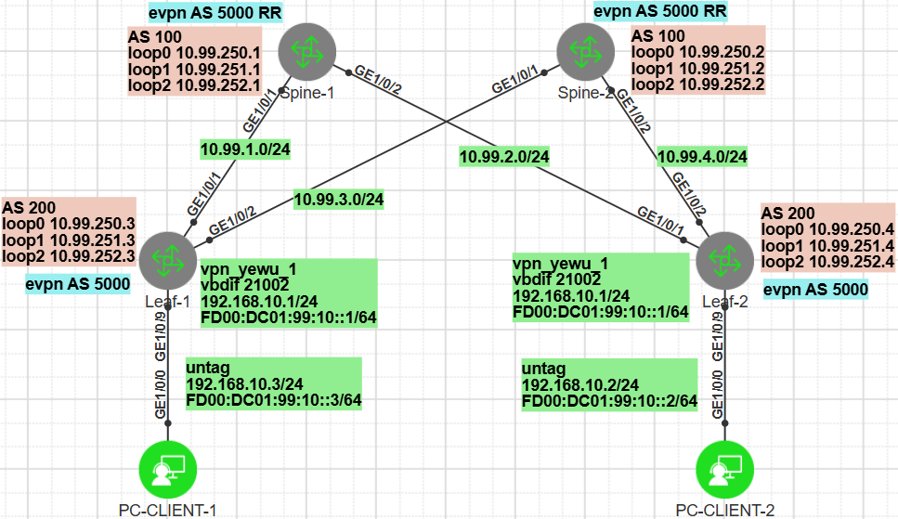
evpn相关参数规划：
yyyy表示相应VPN实例对应的编号，4位数字，不足4位前面以0填充；本实验中给业务vpn分配1010编号
vpn实例名称为： vpn_yewu_1（一个vpn实例可绑定到多个的vlan网段上）
xxxx表示相应网段对应的vlan号，4位数字，不足4位前面以0填充；本实验中业务vlan配置为1002
bridge-domain编号为： 2xxxx
 | vpn-instance | evpn | 说明
vni | 3yyyy | 2xxxx
RD | ASN:3yyyy | ASN:2xxxx | ASN表示路由器的AS号
iRT | ASN:3yyyy | ASN:2xxxx
eRT | ASN:3yyyy | ASN:2xxxx ASN:3yyyy

spine-1配置：
#
interface GE1/0/1
undo portswitch
ip address 10.99.1.1 255.255.255.0
#
interface GE1/0/2
undo portswitch
ip address 10.99.2.1 255.255.255.0
#
interface LoopBack0
ip address 10.99.250.1 255.255.255.255
#
interface LoopBack1
ip address 10.99.251.1 255.255.255.255
#
interface LoopBack2
ip address 10.99.252.1 255.255.255.255
#
bgp 100
router-id 10.99.250.1
private-4-byte-as enable
group exter_group_leaf external
peer exter_group_leaf as-number 200
peer 10.99.1.2 as-number 200
peer 10.99.1.2 group exter_group_leaf
peer 10.99.2.2 as-number 200
peer 10.99.2.2 group exter_group_leaf
#
ipv4-family unicast
network 10.99.250.1 255.255.255.255
network 10.99.251.1 255.255.255.255
network 10.99.252.1 255.255.255.255
maximum load-balancing ebgp 32
peer exter_group_leaf enable
peer 10.99.1.2 enable
peer 10.99.1.2 group exter_group_leaf
peer 10.99.2.2 enable
peer 10.99.2.2 group exter_group_leaf
#

spine-2配置：
#
interface GE1/0/1
undo portswitch
ip address 10.99.3.1 255.255.255.0
#
interface GE1/0/2
undo portswitch
ip address 10.99.4.1 255.255.255.0
#
interface LoopBack0
ip address 10.99.250.2 255.255.255.255
#
interface LoopBack1
ip address 10.99.251.2 255.255.255.255
#
interface LoopBack2
ip address 10.99.252.2 255.255.255.255
#
bgp 100
router-id 10.99.250.2
private-4-byte-as enable
group exter_group_leaf external
peer exter_group_leaf as-number 200
peer 10.99.3.2 as-number 200
peer 10.99.3.2 group exter_group_leaf
peer 10.99.4.2 as-number 200
peer 10.99.4.2 group exter_group_leaf
#
ipv4-family unicast
network 10.99.250.2 255.255.255.255
network 10.99.251.2 255.255.255.255
network 10.99.252.2 255.255.255.255
maximum load-balancing ebgp 32
peer exter_group_leaf enable
peer 10.99.3.2 enable
peer 10.99.3.2 group exter_group_leaf
peer 10.99.4.2 enable
peer 10.99.4.2 group exter_group_leaf
#

leaf-1配置：
#
evpn-overlay enable
#
ip vpn-instance vpn_yewu_1
ipv4-family
route-distinguisher 200:31010
vpn-target 200:31010 export-extcommunity evpn
vpn-target 200:31010 import-extcommunity evpn
ipv6-family
route-distinguisher 200:31010
vpn-target 200:31010 export-extcommunity evpn
vpn-target 200:31010 import-extcommunity evpn
vxlan vni 31010
#
bridge-domain 21002
vxlan vni 21002
#
evpn
route-distinguisher 5000:21002
vpn-target 5000:21002 export-extcommunity
vpn-target 200:31010 export-extcommunity
vpn-target 5000:21002 import-extcommunity
#
interface Vbdif21002
ip binding vpn-instance vpn_yewu_1
ipv6 enable
ip address 192.168.10.1 255.255.255.0
ipv6 address FD00:DC01:99:10::1/64
arp broadcast-detect enable
mac-address 0000-0000-0001
ipv6 nd collect host enable
vxlan anycast-gateway enable
arp collect host enable
#
interface GE1/0/1
undo portswitch
ip address 10.99.1.2 255.255.255.0
#
interface GE1/0/2
undo portswitch
ip address 10.99.3.2 255.255.255.0
#
interface GE1/0/9.1002 mode l2
encapsulation untag
bridge-domain 21002
#
interface LoopBack0
ip address 10.99.250.3 255.255.255.255
#
interface LoopBack1
ip address 10.99.251.3 255.255.255.255
#
interface LoopBack2
ip address 10.99.252.3 255.255.255.255
#
interface Nve1
source 10.99.252.3
vni 21002 head-end peer-list protocol bgp
#
bgp 200
router-id 10.99.250.3
private-4-byte-as enable
group exter_group_spine external
peer exter_group_spine as-number 100
peer 10.99.1.1 as-number 100
peer 10.99.1.1 group exter_group_spine
peer 10.99.3.1 as-number 100
peer 10.99.3.1 group exter_group_spine
#
ipv4-family unicast
network 10.99.250.3 255.255.255.255
network 10.99.251.3 255.255.255.255
network 10.99.252.3 255.255.255.255
maximum load-balancing ebgp 32
peer exter_group_spine enable
peer exter_group_spine allow-as-loop
peer 10.99.1.1 enable
peer 10.99.1.1 group exter_group_spine
peer 10.99.3.1 enable
peer 10.99.3.1 group exter_group_spine
#
ipv4-family vpn-instance vpn_yewu_1
maximum load-balancing 32
advertise l2vpn evpn
#
ipv6-family vpn-instance vpn_yewu_1
maximum load-balancing 32
advertise l2vpn evpn
#
bgp 5000 instance evpnxx
router-id 10.99.251.3
private-4-byte-as enable
peer 10.99.251.4 as-number 5000
peer 10.99.251.4 connect-interface LoopBack1
#
l2vpn-family evpn
policy vpn-target
peer 10.99.251.4 enable
peer 10.99.251.4 advertise irb
peer 10.99.251.4 advertise irbv6
#

leaf-2配置：
evpn-overlay enable
#
ip vpn-instance vpn_yewu_1
ipv4-family
route-distinguisher 200:31010
vpn-target 200:31010 export-extcommunity evpn
vpn-target 200:31010 import-extcommunity evpn
ipv6-family
route-distinguisher 200:31010
vpn-target 200:31010 export-extcommunity evpn
vpn-target 200:31010 import-extcommunity evpn
vxlan vni 31010
#
bridge-domain 21002
vxlan vni 21002
#
evpn
route-distinguisher 5000:21002
vpn-target 5000:21002 export-extcommunity
vpn-target 200:31010 export-extcommunity
vpn-target 5000:21002 import-extcommunity
#
interface Vbdif21002
ip binding vpn-instance vpn_yewu_1
ipv6 enable
ip address 192.168.10.1 255.255.255.0
ipv6 address FD00:DC01:99:10::1/64
arp broadcast-detect enable
mac-address 0000-0000-0001
ipv6 nd collect host enable
vxlan anycast-gateway enable
arp collect host enable
#
interface GE1/0/1
undo portswitch
ip address 10.99.2.2 255.255.255.0
#
interface GE1/0/2
undo portswitch
ip address 10.99.4.2 255.255.255.0
#
interface GE1/0/9.1002 mode l2
encapsulation untag
bridge-domain 21002
#
interface LoopBack0
ip address 10.99.250.4 255.255.255.255
#
interface LoopBack1
ip address 10.99.251.4 255.255.255.255
#
interface LoopBack2
ip address 10.99.252.4 255.255.255.255
#
interface Nve1
source 10.99.252.4
vni 21002 head-end peer-list protocol bgp
#
bgp 200
router-id 10.99.250.4
private-4-byte-as enable
group exter_group_spine external
peer exter_group_spine as-number 100
peer 10.99.2.1 as-number 100
peer 10.99.2.1 group exter_group_spine
peer 10.99.4.1 as-number 100
peer 10.99.4.1 group exter_group_spine
#
ipv4-family unicast
network 10.99.250.4 255.255.255.255
network 10.99.251.4 255.255.255.255
network 10.99.252.4 255.255.255.255
maximum load-balancing ebgp 32
peer exter_group_spine enable
peer exter_group_spine allow-as-loop
peer 10.99.2.1 enable
peer 10.99.2.1 group exter_group_spine
peer 10.99.4.1 enable
peer 10.99.4.1 group exter_group_spine
#
ipv4-family vpn-instance vpn_yewu_1
maximum load-balancing 32
advertise l2vpn evpn
#
ipv6-family vpn-instance vpn_yewu_1
maximum load-balancing 32
advertise l2vpn evpn
#
bgp 5000 instance evpnxx
router-id 10.99.251.4
private-4-byte-as enable
peer 10.99.251.3 as-number 5000
peer 10.99.251.3 connect-interface LoopBack1
#
l2vpn-family evpn
policy vpn-target
peer 10.99.251.3 enable
peer 10.99.251.3 advertise irb
peer 10.99.251.3 advertise irbv6
#

Leaf1查看：
<HUAWEI> disp vxlan peer
Number of peers : 1
Vni ID Source Destination Type Out Vni ID Creation Mode
--------------------------------------------------------------------------------------------
21002 10.99.252.3 10.99.252.4 dynamic 21002 explicit

<HUAWEI> disp vxlan vni 21002
VNI BD-ID State
---------------------------------------
21002 21002 up

<HUAWEI> disp bridge-domain 21002 verbose #查看BD广播域信息
Bridge-domain ID : 21002
Description :
State : Up
MAC Learning : Enable
Statistics : Disable
Broadcast : Forward
Unknown-unicast : Forward
Unknown-multicast : Forward
Split-horizon : Disable
Vxlan Vni : 21002
VSI :
EVPN :

----------------
Interface State
GE1/0/9.1002 up

<HUAWEI> disp arp
ARP Entry Types: D - Dynamic, S - Static, I - Interface, O - OpenFlow, RD - Redirect
EXP: Expire-time VLAN: VLAN or Bridge Domain

IP ADDRESS MAC ADDRESS EXP(M) TYPE/VLAN INTERFACE VPN-INSTANCE
----------------------------------------------------------------------------------------
10.99.1.2 fa1f-fc52-0032 I GE1/0/1
10.99.1.1 fa1f-fc52-0012 15 D GE1/0/1
10.99.3.2 fa1f-fc52-0032 I GE1/0/2
10.99.3.1 fa1f-fc52-0ff2 15 D GE1/0/2
192.168.10.1 0000-0000-0001 I Vbdif21002 vpn_yewu_1
192.168.10.3 a4d2-1df3-3265 18 D/BD21002 GE1/0/9.1002 vpn_yewu_1
----------------------------------------------------------------------------------------
Total:6 Dynamic:3 Static:0 Interface:3 OpenFlow:0
Redirect:0

<HUAWEI> disp ipv6 neighbors brief
D-Dynamic,S-Static,R-Remote
I-INCMP,R-REACH,S-STALE,D-DELAY,P-PROBE
-----------------------------------------------------------------
IPv6 Address Link-layer State Type Interface
-----------------------------------------------------------------
FD00:DC01:99:10::3
a4d2-1df3-3265 R D GE1/0/9.1002
FE80::A6D2:1DFF:FEF3:3265
a4d2-1df3-3265 R D GE1/0/9.1002
-----------------------------------------------------------------
Total: 2 Dynamic: 2 Static: 0 Remote: 0

<HUAWEI> disp ip routing-table vpn-instance vpn_yewu_1
Proto: Protocol Pre: Preference
Route Flags: R - relay, D - download to fib, T - to vpn-instance, B - black hole route
------------------------------------------------------------------------------
Routing Table : vpn_yewu_1
Destinations : 5 Routes : 5

Destination/Mask Proto Pre Cost Flags NextHop Interface

192.168.10.0/24 Direct 0 0 D 192.168.10.1 Vbdif21002
192.168.10.1/32 Direct 0 0 D 127.0.0.1 Vbdif21002
192.168.10.2/32 IBGP 255 0 RD 10.99.252.4 VXLAN
192.168.10.255/32 Direct 0 0 D 127.0.0.1 Vbdif21002
255.255.255.255/32 Direct 0 0 D 127.0.0.1 InLoopBack0

<HUAWEI> disp ipv6 routing-table vpn-instance vpn_yewu_1 simple
Route Flags: R - relay, D - download to fib, T - to vpn-instance, B - black hole route
--------------------------------------------------------------------------------------------------
Routing Table : vpn_yewu_1
Destinations : 4 Routes : 4

Destination/Mask Proto Pre Cost Flags NextHop Interface
FD00:DC01:99:10::/64 Direct 0 0 D FD00:DC01:99:10::1 Vbdif21002
FD00:DC01:99:10::1/128 Direct 0 0 D ::1 Vbdif21002
FD00:DC01:99:10::2/128 IBGP 255 0 RD ::FFFF:10.99.252.4 VXLAN
FE80::/10 Direct 0 0 DB :: NULL0

<HUAWEI> disp bgp instance evpnxx evpn peer #查看evpn bgp对等体信息
Status codes: * - Dynamic
BGP local router ID : 10.99.251.3
Local AS number : 5000
Total number of peers : 1
Peers in established state : 1
Total number of dynamic peers : 0

Peer V AS MsgRcvd MsgSent OutQ Up/Down State PrefRcv
10.99.251.4 4 5000 65 59 0 00:26:26 Established 5

<HUAWEI> disp bgp instance evpnxx evpn peer 10.99.251.4 verbose #查看evpn bgp对等体详细信息
<HUAWEI> disp bgp instance evpnxx evpn all routing-table #查看evpn bgp路由信息
Local AS number : 5000

BGP Local router ID is 10.99.251.3
Status codes: * - valid, > - best, d - damped, x - best external, a - add path,
h - history, i - internal, s - suppressed, S - Stale
Origin : i - IGP, e - EGP, ? - incomplete

EVPN address family:
Number of Mac Routes: 10
Route Distinguisher: 5000:21002
Network(EthTagId/MacAddrLen/MacAddr/IpAddrLen/IpAddr) NextHop
*> 0:48:0000-0000-0001:0:0.0.0.0 0.0.0.0
* i 10.99.252.4
*> 0:48:0081-1e61-a9a2:0:0.0.0.0 0.0.0.0
*>i 0:48:6852-8d9e-051c:32:192.168.10.2 10.99.252.4
*> 0:48:a4d2-1df3-3265:0:0.0.0.0 0.0.0.0
*> 0:48:a4d2-1df3-3265:32:192.168.10.3 0.0.0.0
*> 0:48:0081-1e61-a9a2:128:[FE80::281:1EFF:FE61:A9A2] 0.0.0.0
*>i 0:48:0081-8173-a8fe:128:[FE80::281:81FF:FE73:A8FE] 10.99.252.4
*>i 0:48:6852-8d9e-051c:128:[FD00:DC01:99:10::2] 10.99.252.4
*> 0:48:a4d2-1df3-3265:128:[FD00:DC01:99:10::3] 0.0.0.0

EVPN-Instance 21002:
Number of Mac Routes: 10
Network(EthTagId/MacAddrLen/MacAddr/IpAddrLen/IpAddr) NextHop
*> 0:48:0000-0000-0001:0:0.0.0.0 0.0.0.0
* i 10.99.252.4
*> 0:48:0081-1e61-a9a2:0:0.0.0.0 0.0.0.0
*>i 0:48:6852-8d9e-051c:32:192.168.10.2 10.99.252.4
*> 0:48:a4d2-1df3-3265:0:0.0.0.0 0.0.0.0
*> 0:48:a4d2-1df3-3265:32:192.168.10.3 0.0.0.0
*> 0:48:0081-1e61-a9a2:128:[FE80::281:1EFF:FE61:A9A2] 0.0.0.0
*>i 0:48:0081-8173-a8fe:128:[FE80::281:81FF:FE73:A8FE] 10.99.252.4
*>i 0:48:6852-8d9e-051c:128:[FD00:DC01:99:10::2] 10.99.252.4
*> 0:48:a4d2-1df3-3265:128:[FD00:DC01:99:10::3] 0.0.0.0

EVPN address family:
Number of Inclusive Multicast Routes: 2
Route Distinguisher: 5000:21002
Network(EthTagId/IpAddrLen/OriginalIp) NextHop
*> 0:32:10.99.252.3 0.0.0.0
*>i 0:32:10.99.252.4 10.99.252.4

EVPN-Instance 21002:
Number of Inclusive Multicast Routes: 2
Network(EthTagId/IpAddrLen/OriginalIp) NextHop
*> 0:32:10.99.252.3 0.0.0.0
*>i 0:32:10.99.252.4 10.99.252.4

<HUAWEI> disp bgp instance evpnxx evpn all routing-table mac-route #查看evpn MAC路由信息
Local AS number : 5000

BGP Local router ID is 10.99.251.3
Status codes: * - valid, > - best, d - damped, x - best external, a - add path,
h - history, i - internal, s - suppressed, S - Stale
Origin : i - IGP, e - EGP, ? - incomplete

EVPN address family:
Number of Mac Routes: 10
Route Distinguisher: 5000:21002
Network(EthTagId/MacAddrLen/MacAddr/IpAddrLen/IpAddr) NextHop
*> 0:48:0000-0000-0001:0:0.0.0.0 0.0.0.0
* i 10.99.252.4
*> 0:48:0081-1e61-a9a2:0:0.0.0.0 0.0.0.0
*>i 0:48:6852-8d9e-051c:32:192.168.10.2 10.99.252.4
*> 0:48:a4d2-1df3-3265:0:0.0.0.0 0.0.0.0
*> 0:48:a4d2-1df3-3265:32:192.168.10.3 0.0.0.0
*> 0:48:0081-1e61-a9a2:128:[FE80::281:1EFF:FE61:A9A2] 0.0.0.0
*>i 0:48:0081-8173-a8fe:128:[FE80::281:81FF:FE73:A8FE] 10.99.252.4
*>i 0:48:6852-8d9e-051c:128:[FD00:DC01:99:10::2] 10.99.252.4
*> 0:48:a4d2-1df3-3265:128:[FD00:DC01:99:10::3] 0.0.0.0

EVPN-Instance 21002:
Number of Mac Routes: 10
Network(EthTagId/MacAddrLen/MacAddr/IpAddrLen/IpAddr) NextHop
*> 0:48:0000-0000-0001:0:0.0.0.0 0.0.0.0
* i 10.99.252.4
*> 0:48:0081-1e61-a9a2:0:0.0.0.0 0.0.0.0
*>i 0:48:6852-8d9e-051c:32:192.168.10.2 10.99.252.4
*> 0:48:a4d2-1df3-3265:0:0.0.0.0 0.0.0.0
*> 0:48:a4d2-1df3-3265:32:192.168.10.3 0.0.0.0
*> 0:48:0081-1e61-a9a2:128:[FE80::281:1EFF:FE61:A9A2] 0.0.0.0
*>i 0:48:0081-8173-a8fe:128:[FE80::281:81FF:FE73:A8FE] 10.99.252.4
*>i 0:48:6852-8d9e-051c:128:[FD00:DC01:99:10::2] 10.99.252.4
*> 0:48:a4d2-1df3-3265:128:[FD00:DC01:99:10::3] 0.0.0.0

<HUAWEI> disp bgp instance evpnxx evpn all routing-table mac-route 0:48:6852-8d9e-051c:32:192.168.10.2
BGP local router ID : 10.99.251.3
Local AS number : 5000
Total routes of Route Distinguisher(5000:21002): 1
BGP routing table entry information of 0:48:6852-8d9e-051c:32:192.168.10.2:
Label information (Received/Applied): 21002 31010/NULL
From: 10.99.251.4 (10.99.251.4)
Route Duration: 0d00h13m27s
Relay IP Nexthop: 10.99.1.1
Relay IP Out-Interface: GE1/0/1
Relay Tunnel Out-Interface: VXLAN
Original nexthop: 10.99.252.4
Qos information : 0x0
Ext-Community: RT <200 : 31010>, RT <5000 : 21002>, Tunnel Type <VxLan>, Router's MAC <fa1f-fc52-0081>
AS-path Nil, origin igp, localpref 100, pref-val 0, valid, internal, best, select, pre 255
Route Type: 2 (MAC Advertisement Route)
Ethernet Tag ID: 0, MAC Address/Len: 6852-8d9e-051c/48, IP Address/Len: 192.168.10.2/32, ESI:0000.0000.0000.0000.0000
Not advertised to any peer yet

EVPN-Instance 21002:
Number of Mac Routes: 1
BGP routing table entry information of 0:48:6852-8d9e-051c:32:192.168.10.2:
Route Distinguisher: 5000:21002
Remote-Cross route
Label information (Received/Applied): 21002 31010/NULL
From: 10.99.251.4 (10.99.251.4)
Route Duration: 0d00h13m28s
Relay Tunnel Out-Interface: VXLAN
Original nexthop: 10.99.252.4
Qos information : 0x0
Ext-Community: RT <200 : 31010>, RT <5000 : 21002>, Tunnel Type <VxLan>, Router's MAC <fa1f-fc52-0081>
AS-path Nil, origin igp, localpref 100, pref-val 0, valid, internal, best, select, pre 255
Route Type: 2 (MAC Advertisement Route)
Ethernet Tag ID: 0, MAC Address/Len: 6852-8d9e-051c/48, IP Address/Len: 192.168.10.2/32, ESI:0000.0000.0000.0000.0000
Not advertised to any peer yet

<HUAWEI> disp bgp instance evpnxx evpn all routing-table mac-route \
0:48:6852-8d9e-051c:128:[FD00:DC01:99:10::2]
BGP local router ID : 10.99.251.3
Local AS number : 5000
Total routes of Route Distinguisher(5000:21002): 1
BGP routing table entry information of 0:48:6852-8d9e-051c:128:[FD00:DC01:99:10::2]:
Label information (Received/Applied): 21002 31010/NULL
From: 10.99.251.4 (10.99.251.4)
Route Duration: 0d00h06m55s
Relay IP Nexthop: 10.99.1.1
Relay IP Out-Interface: GE1/0/1
Relay Tunnel Out-Interface: VXLAN
Original nexthop: 10.99.252.4
Qos information : 0x0
Ext-Community: RT <200 : 31010>, RT <5000 : 21002>, Tunnel Type <VxLan>, Router's MAC <fa1f-fc52-0081>, ND <O:1 R:0>
AS-path Nil, origin igp, localpref 100, pref-val 0, valid, internal, best, select, pre 255
Route Type: 2 (MAC Advertisement Route)
Ethernet Tag ID: 0, MAC Address/Len: 6852-8d9e-051c/48, IPv6 Address/Len: FD00:DC01:99:10::2/128, ESI:0000.0000.0000.0000.0000
Not advertised to any peer yet

EVPN-Instance 21002:
Number of Mac Routes: 1
BGP routing table entry information of 0:48:6852-8d9e-051c:128:[FD00:DC01:99:10::2]:
Route Distinguisher: 5000:21002
Remote-Cross route
Label information (Received/Applied): 21002 31010/NULL
From: 10.99.251.4 (10.99.251.4)
Route Duration: 0d00h06m55s
Relay Tunnel Out-Interface: VXLAN
Original nexthop: 10.99.252.4
Qos information : 0x0
Ext-Community: RT <200 : 31010>, RT <5000 : 21002>, Tunnel Type <VxLan>, Router's MAC <fa1f-fc52-0081>, ND <O:1 R:0>
AS-path Nil, origin igp, localpref 100, pref-val 0, valid, internal, best, select, pre 255
Route Type: 2 (MAC Advertisement Route)
Ethernet Tag ID: 0, MAC Address/Len: 6852-8d9e-051c/48, IPv6 Address/Len: FD00:DC01:99:10::2/128, ESI:0000.0000.0000.0000.0000
Not advertised to any peer yet

★VLAN-VXLAN-MPLS概念对照
vlan，vxlan，mpls的某些概念有互通之处
 | ID | id字段长度 | id号范围 | 区域概念 | 二层转发表 | 三层接口 | 信息交换协议
vlan | vlanid | 12 bit | 0-4095 | vlan | FIB | vlanif | gvrp,vtp,vcmp
vxlan | vni | 24 bit | 0-16M | bridge-domain | 无 | vbdif | evpn-bgp
mpls | mpls label | 20 bit | 0-1M | vpn-instance | LFIB | 无 | ldp,mp-bgp

★第13章、网络连通性检测

★NQA网络质量检测
Network Quality Analysis网络质量检测，一般用于检测出口网关的连通性，应用在静态路由上
[Huawei] nqa test-instance admin isp1 #创建名为（admin, isp1）的nqa探测实例
[Huawei-nqa-admin-isp1] test-type icmp
[Huawei-nqa-admin-isp1] destination-address ipv4 200.1.1.2 #探测目标ip，一般为上行出口网关ip
[Huawei-nqa-admin-isp1] source-address ipv4 200.1.1.1 #探测时使用的源ip
[Huawei-nqa-admin-isp1] frequency 10 #每10秒进行一次nqa探测
#注意，如果不指定frequency，则只进行一次nqa探测，不会周期探测
[Huawei-nqa-admin-isp1] probe-count 3 #每次nqa探测发3个icmp包
[Huawei-nqa-admin-isp1] interval seconds 3 #每个icmp包发送时间间隔为3秒
[Huawei-nqa-admin-isp1] timeout 2 #ping超时2秒，默认为3秒
[Huawei-nqa-admin-isp1] vpn-instance xxxx #绑定vpn实例（vrf），可选
[Huawei-nqa-admin-isp1] start now #立即启动nqa探测
[Huawei-nqa-admin-isp1] undo start #结束探测，再次启动nqa后才会恢复路由优先级，不支持抢占
[Huawei-nqa-admin-isp1] start now
[Huawei-nqa-admin-isp1] quit
★说明：frequency的值表示一次nqa探测周期，而不是发包的频率，frequency的值要满足以下要求：
frequency > interval * ( probeCount - 1 ) + timeout #不满足时直接返回no result，探测失败
例如：interval为3秒，probe-count为3，timeout为2，则frequency要大于 (3*(3-1)+2)即8秒

[Huawei] disp nqa results #查看nqa结果
[Huawei] disp nqa history #查看nqa历史情况

★nqa和静态路由联动
[Huawei] ip route-static 0.0.0.0 0.0.0.0 10.1.1.2 track nqa admin isp1 # isp1为nqa实例
[Huawei] ip route-static 0.0.0.0 0.0.0.0 20.2.1.2 track nqa admin isp2 # isp2为nqa实例
#当nqa检测到某个网关ping不通时，就会通知路由模块取消某条路由或策略

★nqa和策略路由联动
[Huawei] traffic behavior be1
[Huawei-behavior-be1] redirect ip-nexthop 10.1.1.2 track nqa admin isp1
[Huawei-behavior-be1] quit
[Huawei] traffic behavior be2
[Huawei-behavior-be2] redirect ip-nexthop 20.2.1.2 track nqa admin isp2
[Huawei-behavior-be2] quit

★BFD双向转发检测
Bidirectional Forwarding Detection双向转发检测是一种通用的快速故障检测协议，用于检测网络转发连通状况
一般的网络协议都有发送hello报文进行连通性检测（比如ospf，isis，bgp，mpls ldp），但其超时时间都比较长（几秒钟以上）这对于某些业务而言时间太长了，而BFD可以实现毫秒级的快速检测连通状态的能力。当BFD发现其检测的链路不通时就会立即通知其服务的上层协议，让上层协议及时处理（而不用等上层协议的hello超时）。

BFD为应用层协议，其端口号为 3784/udp
BFD控制报文：普通的检测报文
BFD Echo报文：特殊的BFD控制报文，用于单臂回声检测，源、目的地址都是自己

单跳故障检测：
对两个直连系统进行IP连通性检测，即不能跨越三层建立BFD会话（BFD会话绑定出接口）
目的地址为组播IP地址，缺省组播IP地址为224.0.0.184

多跳故障检测：
对任意两个系统间的任意路径进行检测，可以跨三层建立BFD会话（BFD会话绑定对端IP地址）
目的地址为IP单播地址

BFD默认参数：
报文优先级：7（最高级）
发送间隔：1000毫秒
接收间隔：1000毫秒
本地检测倍数：3

#BFD单跳检测三层链路
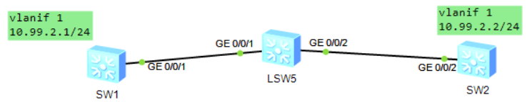
SW1配置
[Huawei] int vlanif 1
[Huawei-Vlanif1] ip add 10.99.2.1 24
[Huawei-Vlanif1] qui
[Huawei] bfd #全局开启BFD功能
[Huawei-bfd] quit
[Huawei] bfd s1_to_s2 bind peer-ip 10.99.2.2 interface vlanif 1 #创建一个名为s1_to_s2的bfd会话
[Huawei-bfd-session-s1_to_s2] discriminator local 1 #配置bfd会话的本地标识符，取值1-8191
[Huawei-bfd-session-s1_to_s2] discriminator remote 2 #配置bfd会话的远端标识符
[Huawei-bfd-session-s1_to_s2] min-tx-interval 300 #设置bfd报文发送时间间隔（毫秒）
[Huawei-bfd-session-s1_to_s2] min-rx-interval 300 #设置bfd报文接收时间间隔
[Huawei-bfd-session-s1_to_s2] detect-multiplier 3 #配置本地检测倍数（3次检测不到就失败）

SW2配置
[Huawei] int vlanif 1
[Huawei-Vlanif1] ip add 10.99.2.2 24
[Huawei-Vlanif1] qui
[Huawei] bfd
[Huawei-bfd] quit
[Huawei] bfd s2_to_s1 bind peer-ip 10.99.2.1 interface vlanif 1
[Huawei-bfd-session-s2_to_s1] discriminator local 2 #取值1-8191
[Huawei-bfd-session-s2_to_s1] discriminator remote 1
[Huawei-bfd-session-s2_to_s1] min-tx-interval 300 #设置bfd报文发送时间间隔（毫秒）
[Huawei-bfd-session-s2_to_s1] min-rx-interval 300 #设置bfd报文接收时间间隔
[Huawei-bfd-session-s2_to_s1] detect-multiplier 3 #配置本地检测倍数（默认是3次）
BFD会话两端设备的本地标识符和远端标识符需要分别对应（本端的本地标识符与对端的远端标识符相同）

[Huawei] disp bfd session all verbose #查看bfd会话

由于路由协议up的时间比接口up时间晚，可能会导致bfd会话一开始就检测到失败了，需要开启bfd会话延迟up功能，弥补路由协议up晚于接口up的时间差。
[HUAWEI] bfd
[HUAWEI-bfd] delay-up 5 #全局bfd界面，配置bfd会话延迟up功能，单位：秒，默认未配置
[HUAWEI-bfd] quit

#BFD单跳检测二层链路
拓扑如下：
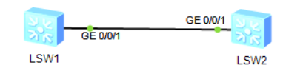
检测交换机之间的直连线路是否连通，直连端口为二层口（无ip）
LSW1配置：
[Huawei] interface GigabitEthernet 0/0/1
[Huawei-GigabitEthernet0/0/1] port link-type access
[Huawei-GigabitEthernet0/0/1] port default vlan 1
[Huawei-GigabitEthernet0/0/1] quit
[Huawei] bfd
[Huawei-bfd] quit
[Huawei] bfd s1_to_s2 bind peer-ip default-ip interface GigabitEthernet 0/0/1
[Huawei-bfd-session-s1_to_s2] discriminator local 1 #取值1-8191
[Huawei-bfd-session-s1_to_s2] discriminator remote 2

LSW2配置：
[Huawei] interface GigabitEthernet 0/0/1
[Huawei-GigabitEthernet0/0/1] port link-type access
[Huawei-GigabitEthernet0/0/1] port default vlan 1
[Huawei-GigabitEthernet0/0/1] quit
[Huawei] bfd
[Huawei-bfd] quit
[Huawei] bfd s2_to_s1 bind peer-ip default-ip interface GigabitEthernet 0/0/1
[Huawei-bfd-session-s2_to_s1] discriminator local 2 #取值1-8191
[Huawei-bfd-session-s2_to_s1] discriminator remote 1

[Huawei] disp bfd session all verbose #查看bfd会话

#BFD与静态路由联动

[Huawei] ip route-static 0.0.0.0 0.0.0.0 10.99.2.2 track bfd-session s1_to_s2
[Huawei] ip route-static 0.0.0.0 0.0.0.0 10.99.3.2 preference 90
#当bfd检测到某个网关不通时，就会通知路由模块取消某条路由或策略

#BFD与OSPF联动
实验：BFD_OSPF_ce12800（ensp）
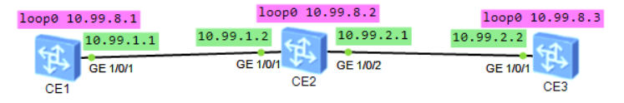

CE1配置：
bfd #全局开启bfd功能
#
interface GE1/0/1
undo portswitch
undo shutdown
ip address 10.99.1.1 255.255.255.0
#
interface LoopBack0
ip address 10.99.8.1 255.255.255.255
#
ospf 1 router-id 10.99.8.1
bfd all-interfaces enable #所有接口开启bfd功能
bfd all-interfaces min-tx-interval 500 min-rx-interval 500 detect-multiplier 3 #bfd参数设置，根据实际需求调整数值，单位：毫秒，要求和对端设备配置一致
bandwidth-reference 100000
area 0.0.0.0
network 10.99.1.0 0.0.0.255
network 10.99.8.1 0.0.0.0
#

CE2配置：
bfd
#
interface GE1/0/1
undo portswitch
undo shutdown
ip address 10.99.1.2 255.255.255.0
#
interface GE1/0/2
undo portswitch
undo shutdown
ip address 10.99.2.1 255.255.255.0
#
interface LoopBack0
ip address 10.99.8.2 255.255.255.255
#
ospf 1 router-id 10.99.8.2
bfd all-interfaces enable
bfd all-interfaces min-tx-interval 500 min-rx-interval 500 #（默认detect-multiplier值为3，不显示）
bandwidth-reference 100000
area 0.0.0.0
network 10.99.1.0 0.0.0.255
network 10.99.2.0 0.0.0.255
network 10.99.8.2 0.0.0.0
#

CE3配置：
bfd
#
interface GE1/0/1
undo portswitch
undo shutdown
ip address 10.99.2.2 255.255.255.0
#
interface LoopBack0
ip address 10.99.8.3 255.255.255.255
#
ospf 1 router-id 10.99.8.3
bfd all-interfaces enable
bfd all-interfaces min-tx-interval 500 min-rx-interval 500
bandwidth-reference 100000
area 0.0.0.0
network 10.99.2.0 0.0.0.255
network 10.99.8.3 0.0.0.0
#

CE2查看：
<HUAWEI> disp bfd session all #查看bfd会话
Total UP/DOWN Session Number : 2/0
--------------------------------------------------------------------------------
Local Remote PeerIpAddr State Type InterfaceName
--------------------------------------------------------------------------------
16385 16385 10.99.1.1 Up D/IP-IF GE1/0/1
16386 16385 10.99.2.2 Up D/IP-IF GE1/0/2
--------------------------------------------------------------------------------

<HUAWEI> disp ospf 1 bfd session all #查看ospf 1进程对应的bfd会话
OSPF Process 1 with Router ID 10.99.8.2

Area 0.0.0.0 interface 10.99.1.2 (GE1/0/1)'s BFD Sessions
NeighborId:10.99.8.1 AreaId:0.0.0.0 Interface:GE1/0/1
BFDState:Up rx :500 tx :500
Multiplier:3 BFD Local Dis:16385 LocalIpAdd:10.99.1.2
RemoteIpAdd:10.99.1.1 Diagnostic Info:No diagnostic information

Area 0.0.0.0 interface 10.99.2.1 (GE1/0/2)'s BFD Sessions
NeighborId:10.99.8.3 AreaId:0.0.0.0 Interface:GE1/0/2
BFDState:Up rx :500 tx :500
Multiplier:3 BFD Local Dis:16386 LocalIpAdd:10.99.2.1
RemoteIpAdd:10.99.2.2 Diagnostic Info:No diagnostic information

Total UP/DOWN/UNKNOWN BFD Session Number : 2 / 0 / 0

#BFD与ISIS联动
实验：BFD_ISIS_ce12800（ensp）

CE1配置：
bfd #全局开启bfd功能
#
isis 1
is-level level-1
cost-style wide
bfd all-interfaces enable
bfd all-interfaces min-tx-interval 500 min-rx-interval 500 #根据实际需求调整数值，单位：毫秒
network-entity 49.0001.1111.1111.1111.00
is-name ce1
import-route direct level-1
#
interface GE1/0/1
undo portswitch
undo shutdown
ip address 10.99.1.1 255.255.255.0
isis enable 1
isis circuit-level level-1
#
interface LoopBack0
ip address 10.99.8.1 255.255.255.255
#

CE2配置：
bfd
#
isis 1
is-level level-1
cost-style wide
bfd all-interfaces enable
bfd all-interfaces min-tx-interval 500 min-rx-interval 500
network-entity 49.0001.2222.2222.2222.00
is-name ce2
import-route direct level-1
#
interface GE1/0/1
undo portswitch
undo shutdown
ip address 10.99.1.2 255.255.255.0
isis enable 1
isis circuit-level level-1
#
interface GE1/0/2
undo portswitch
undo shutdown
ip address 10.99.2.1 255.255.255.0
isis enable 1
isis circuit-level level-1
#
interface LoopBack0
ip address 10.99.8.2 255.255.255.255
#

CE3配置：
bfd
#
isis 1
is-level level-1
cost-style wide
bfd all-interfaces enable
bfd all-interfaces min-tx-interval 500 min-rx-interval 500
network-entity 49.0001.3333.3333.3333.00
is-name ce3
import-route direct level-1
#
interface GE1/0/1
undo portswitch
undo shutdown
ip address 10.99.2.2 255.255.255.0
isis enable 1
isis circuit-level level-1
#
interface LoopBack0
ip address 10.99.8.3 255.255.255.255
#

CE2查看：
<HUAWEI> disp bfd session all
Total UP/DOWN Session Number : 2/0
--------------------------------------------------------------------------------
Local Remote PeerIpAddr State Type InterfaceName
--------------------------------------------------------------------------------
16385 16385 10.99.1.1 Up D/IP-IF GE1/0/1
16386 16385 10.99.2.2 Up D/IP-IF GE1/0/2
--------------------------------------------------------------------------------

<HUAWEI> disp isis 1 bfd session all
BFD session information for ISIS(1)
------------------------------------------------------------------------------
Peer System ID : ce1 Interface : GE1/0/1
TX : 500 BFD State : up Peer IP Address : 10.99.1.1
RX : 500 LocDis : 16385 Local IP Address: 10.99.1.2
Multiplier : 3 RemDis : 16385 Type : L1
Diag : No diagnostic information
Peer System ID : ce3 Interface : GE1/0/2
TX : 500 BFD State : up Peer IP Address : 10.99.2.2
RX : 500 LocDis : 16386 Local IP Address: 10.99.2.1
Multiplier : 3 RemDis : 16385 Type : L1
Diag : No diagnostic information
Total BFD session(s): 2

#BFD与BGP联动
实验：BFD_BGP_ce12800（ensp）
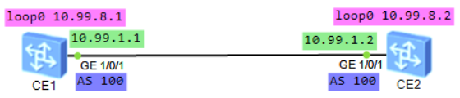

CE1配置：
bfd #全局开启bfd功能
#
interface GE1/0/1
undo portswitch
undo shutdown
ip address 10.99.1.1 255.255.255.0
#
interface LoopBack0
ip address 10.99.8.1 255.255.255.255
#
bgp 100
router-id 10.99.8.1
peer 10.99.1.2 as-number 100
peer 10.99.1.2 bfd min-tx-interval 500 min-rx-interval 500 detect-multiplier 3 #根据实际需求调整数值，单位：毫秒，3次检测失败则认为对端down了
peer 10.99.1.2 bfd enable
#
ipv4-family unicast
network 10.99.1.0 255.255.255.0
network 10.99.8.1 255.255.255.255
peer 10.99.1.2 enable
#

CE2配置：
bfd
#
interface GE1/0/1
undo portswitch
undo shutdown
ip address 10.99.1.2 255.255.255.0
#
interface LoopBack0
ip address 10.99.8.2 255.255.255.255
#
bgp 100
router-id 10.99.8.2
peer 10.99.1.1 as-number 100
peer 10.99.1.1 bfd min-tx-interval 500 min-rx-interval 500 detect-multiplier 3
peer 10.99.1.1 bfd enable
#
ipv4-family unicast
network 10.99.1.0 255.255.255.0
network 10.99.8.2 255.255.255.255
peer 10.99.1.1 enable
#

CE1查看：
<HUAWEI> disp bfd session all
Total UP/DOWN Session Number : 1/0
--------------------------------------------------------------------------------
Local Remote PeerIpAddr State Type InterfaceName
--------------------------------------------------------------------------------
16386 16386 10.99.1.2 Up D/IP-PEER -
--------------------------------------------------------------------------------

<HUAWEI> disp bgp bfd session all
--------------------------------------------------------------------------------
Local_Address Peer_Address Interface
10.99.1.1 10.99.1.2 Unknown
Tx-interval(ms) Rx-interval(ms) Multiplier Session-State
500 500 3 Up
Wtr-interval(m)
0
--------------------------------------------------------------------------------

#动态BFD检测MPLS LSP
在LSP链路上建立BFD会话，利用BFD检测机制快速检测LSP链路的故障，可以提供端到端的保护。使用BFD检测单向LSP路径时，反向链路可以是IP链路、LSP或TE隧道。检测MPLS LSP的连通性时，BFD会话协商有静态配置BFD和动态创建BFD两种方式，其中，动态创建BFD方式只支持动态LSP，静态配置BFD方式则支持静态和动态LSP。

实验：BFD_MPLS_LSP_ar2240（ensp）
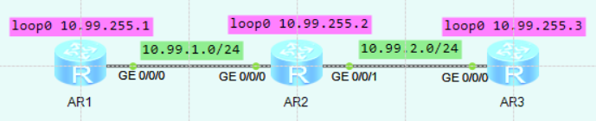

AR1配置：
bfd
#
mpls lsr-id 10.99.255.1
mpls
mpls bfd enable
mpls bfd-trigger fec-list fec-to-ar3 #默认是根据 host 去触发bfd检测
mpls bfd min-tx-interval 100 min-rx-interval 100 #根据实际需求调整数值，单位：毫秒
#
fec-list fec-to-ar3
fec-node 10.99.255.3
#
mpls ldp
#
isis 1
is-level level-2
cost-style wide
network-entity 49.0001.1111.1111.1111.00
#
interface GigabitEthernet0/0/0
ip address 10.99.1.1 255.255.255.0
isis enable 1
isis ldp-sync
mpls
mpls ldp
#
interface LoopBack0
ip address 10.99.255.1 255.255.255.255
isis enable 1
#

AR2配置：
mpls lsr-id 10.99.255.2
mpls
#
mpls ldp
#
isis 1
is-level level-2
cost-style wide
network-entity 49.0001.2222.2222.2222.00
#
interface GigabitEthernet0/0/0
ip address 10.99.1.2 255.255.255.0
isis enable 1
isis ldp-sync
mpls
mpls ldp
#
interface GigabitEthernet0/0/1
ip address 10.99.2.1 255.255.255.0
isis enable 1
isis ldp-sync
mpls
mpls ldp
#
interface LoopBack0
ip address 10.99.255.2 255.255.255.255
isis enable 1
#

AR3配置：
bfd
mpls-passive #开启被动创建BFD会话功能，当收到源端发送的携带BFD TLV的LSP ping请求报文后才建立BFD会话
#
mpls lsr-id 10.99.255.3
mpls
#
mpls ldp
#
isis 1
is-level level-2
cost-style wide
network-entity 49.0001.3333.3333.3333.00
#
interface GigabitEthernet0/0/0
ip address 10.99.2.2 255.255.255.0
isis enable 1
isis ldp-sync
mpls
mpls ldp
#
interface LoopBack0
ip address 10.99.255.3 255.255.255.255
isis enable 1
#

AR1查看：
[Huawei] disp ip routing-table
Route Flags: R - relay, D - download to fib
------------------------------------------------------------------------------
Routing Tables: Public
Destinations : 11 Routes : 11

Destination/Mask Proto Pre Cost Flags NextHop Interface
10.99.1.0/24 Direct 0 0 D 10.99.1.1 GigabitEthernet0/0/0
10.99.1.1/32 Direct 0 0 D 127.0.0.1 GigabitEthernet0/0/0
10.99.1.255/32 Direct 0 0 D 127.0.0.1 GigabitEthernet0/0/0
10.99.2.0/24 ISIS-L2 15 20 D 10.99.1.2 GigabitEthernet0/0/0
10.99.255.1/32 Direct 0 0 D 127.0.0.1 LoopBack0
10.99.255.2/32 ISIS-L2 15 10 D 10.99.1.2 GigabitEthernet0/0/0
10.99.255.3/32 ISIS-L2 15 20 D 10.99.1.2 GigabitEthernet0/0/0
127.0.0.0/8 Direct 0 0 D 127.0.0.1 InLoopBack0
127.0.0.1/32 Direct 0 0 D 127.0.0.1 InLoopBack0
127.255.255.255/32 Direct 0 0 D 127.0.0.1 InLoopBack0
255.255.255.255/32 Direct 0 0 D 127.0.0.1 InLoopBack0

[Huawei] disp mpls lsp
-------------------------------------------------------------------------------
LSP Information: LDP LSP
-------------------------------------------------------------------------------
FEC In/Out Label In/Out IF Vrf Name
10.99.255.2/32 NULL/3 -/GE0/0/0
10.99.255.2/32 1024/3 -/GE0/0/0
10.99.255.1/32 3/NULL -/-
10.99.255.3/32 NULL/1025 -/GE0/0/0
10.99.255.3/32 1025/1025 -/GE0/0/0

[Huawei] disp bfd session all
--------------------------------------------------------------------------------
Local Remote PeerIpAddr State Type InterfaceName
--------------------------------------------------------------------------------

8192 8192 10.99.255.3 Up D_LDP_LSP GigabitEthernet0/0/0
--------------------------------------------------------------------------------
Total UP/DOWN Session Number : 1/0

AR3查看：
[Huawei] disp ip routing-table
Route Flags: R - relay, D - download to fib
------------------------------------------------------------------------------
Routing Tables: Public
Destinations : 11 Routes : 11

Destination/Mask Proto Pre Cost Flags NextHop Interface
10.99.1.0/24 ISIS-L2 15 20 D 10.99.2.1 GigabitEthernet0/0/0
10.99.2.0/24 Direct 0 0 D 10.99.2.2 GigabitEthernet0/0/0
10.99.2.2/32 Direct 0 0 D 127.0.0.1 GigabitEthernet0/0/0
10.99.2.255/32 Direct 0 0 D 127.0.0.1 GigabitEthernet0/0/0
10.99.255.1/32 ISIS-L2 15 20 D 10.99.2.1 GigabitEthernet0/0/0
10.99.255.2/32 ISIS-L2 15 10 D 10.99.2.1 GigabitEthernet0/0/0
10.99.255.3/32 Direct 0 0 D 127.0.0.1 LoopBack0
127.0.0.0/8 Direct 0 0 D 127.0.0.1 InLoopBack0
127.0.0.1/32 Direct 0 0 D 127.0.0.1 InLoopBack0
127.255.255.255/32 Direct 0 0 D 127.0.0.1 InLoopBack0
255.255.255.255/32 Direct 0 0 D 127.0.0.1 InLoopBack0

[Huawei] disp mpls lsp
-------------------------------------------------------------------------------
LSP Information: LDP LSP
-------------------------------------------------------------------------------
FEC In/Out Label In/Out IF Vrf Name
10.99.255.1/32 NULL/1024 -/GE0/0/0
10.99.255.1/32 1024/1024 -/GE0/0/0
10.99.255.2/32 NULL/3 -/GE0/0/0
10.99.255.2/32 1025/3 -/GE0/0/0
10.99.255.3/32 3/NULL -/-

[Huawei] disp bfd session passive-dynamic
--------------------------------------------------------------------------------
Local Remote PeerIpAddr State Type InterfaceName
--------------------------------------------------------------------------------

8192 8192 10.99.255.1 Up E_Dynamic -
--------------------------------------------------------------------------------
Total UP/DOWN Session Number : 1/0

★第14章、NAT地址转换
交换机不支持NAT地址转换功能，需要使用路由器去配置
①静态NAT
一对一映射，映射的公网IP不可与出接口的ip相同
interface g0/0/1
ip add 100.1.1.1 255.255.255.0 #接口配置公网ip
nat server global 100.1.1.2 inside 10.1.1.45 #配置ip转换，将内网的10.1.1.45转为公网的100.1.1.2
nat static enable #开启静态NAT
#

②端口复用PAT
acl number 2009
rule 1 permit source 10.1.1.0 0.0.0.255 #acl匹配内网网段
#
interface g0/0/1
nat outbound 2009 #出接口上应用nat，内网ip转换为出接口的ip
#
#使用地址池替换内网IP及端口号
nat address-group 1 10.255.4.2 10.255.4.100 #创建公网地址池
#
interface g0/0/1
nat outbound 2009 address-group 1
#

③端口映射（dNAT）
interface g0/0/1
nat static protocol tcp global current-interface 8888 inside 10.1.1.22 80 #将外网访问过来的的流量目的地址为 本接口ip:8888转为内网的10.1.1.22:80
nat static protocol tcp global 100.1.1.5 9999 inside 10.1.1.35 443 #将外网的100.1.1.5:9999转为内网的10.1.1.35:443
#

disp nat session all #查看nat会话情况

★第15章、QoS服务质量

★Qos-DiffServ-MQC概念
QoS服务质量（Quality of Service）是在发生网络拥塞时为不同的业务流量提供不同级别的质量保证，QoS是一个服务方案，当网络中2个主机通信时，只有当其流量经过的网络中所有设备都遵循统一的QoS服务模型时，才能实现端到端的服务质量保证。目前存在多种QoS服务模型，其中应用最广的是差分服务模型（Differentiated Services）

QoS涉及的4个部分：
流分类和标记 | Classification and Marking 将不同业务类型的流量标记为不同的优先级
流量监管和整形 | Policing and Shaping 将目标优先级的流量限制为某个特定的带宽，超过带宽的部分流量将被丢弃或缓存，将超过的流量丢弃的技术称为流量监管，将超过的流量缓存的技术称为流量整形
拥塞管理 | Congestion Management 当发生拥塞时，将报文放入相应的队列中缓存，并采取某种调度算法进行转发
拥塞避免 | Congestion Avoidance 当发现网络有拥塞加剧的趋势时采取主动丢弃报文的策略来解除网络过载

★DiffServ差分服务模型
差分服务模型（Differentiated Services）
DiffServ模型的基本原理是将网络中的流量分成多个类，当网络出现拥塞时不同的类会享受不同级别的处理。而同一类的业务在网络中会被聚合起来统一发送，保证相同的时延、抖动、丢包率等QoS指标。

流量入口设备可以通过多种条件灵活地对报文进行分类，对不同的报文设置不同的优先级，而其他设备只需要简单地识别报文中的这些优先级，即可进行资源分配和流量控制。

设备支持的QoS技术都是基于DiffServ服务模型的

QoS技术提供了如下报文分类的方式：
★复杂流分类（MQC流分类）
复杂流分类采用复杂的规则，如由五元组（源地址、源端口号、协议号码、目的地址、目的端口号）对报文进行精细的分类，并为同一类报文提供相同的QoS服务。复杂流分类可以通过模块化QoS命令行MQC（Modular QoS Command-Line Interface）中的流分类实现。

MQC包含三个要素，分别是流分类、流行为和流策略，三要素通过下面的方式配合使用完成对流量的处理：
1.配置流分类 | （traffic classifier）定义报文匹配规则
2.配置流行为 | （traffic behavior）确定报文处理动作。根据不同的流行为，可以实现不同的QoS功能
3.配置流策略 | （traffic policy）将配置好的流分类和流行为绑定到一起后在指定接口下应用流策略

流分类中各规则之间的关系分为：and或or，缺省情况下的关系为or。

流策略可绑定多个流分类和流行为

流分类的使用注意事项：
1 | 在流分类中匹配带vpn-instance的ACL规则时，会忽略其中的vpn-instance字段，即公网流量和私网流量都会匹配。若需要精确匹配私网流量，请在对应的三层接口上应用流策略
2 | 在流分类中匹配带外层VLAN ID的ACL规则并叠加了VLAN Mapping功能时：◾入方向匹配的是VLAN Mapping映射后的VLAN ID，出方向匹配的是VLAN Mapping映射前的VLAN ID
3 | 流分类不支持匹配二层子接口的VLAN ID
4 | 若在一个流分类中同时包含if-match any以及其他匹配规则，则实际生效的匹配字段取决于除if-match any外的匹配规则能够匹配到的具体报文类型

流行为的使用注意事项：
在同一流行为下同时配置重定向与其他流动作时，包含该流行为的流策略生效命中的报文以重定向的生效范围为准。

流策略的使用注意事项：
1 | 在三层主接口下应用的流策略，对三层子接口的流量也能生效
2 | 在同一接口同一方向下应用2个流策略（假设先应用的流策略是p1，后应用的流策略是p2）的情况下，若去应用先配置的流策略p1，然后再重新应用流策略（可以是p1，也可以是其他的流策略），则流策略p2会失效一段时间，且重新应用的流策略的实际生效时间相对配置提交时间会有延时。
3 | 当在某一接口下，需要同时匹配同一类报文（如二层报文、IPv4报文、IPv6报文等）的多个字段时，请在该接口下应用1个流策略，并在该流策略中指定多个流分类及其所需的流行为。若需要同时匹配IPv4报文和IPv6报文，请为这两类报文分别创建1个流策略

★简单流分类（QoS优先级分类）
简单流分类就是指采用简单的规则，根据报文中的某个优先级字段，对报文进行粗略的分类。优先级的概念如下：
外部优先级 | 又称为报文优先级、QoS优先级，即使用报文中某些特定字段比如VLAN报文的802.1p值、IP报文的DSCP值等记录QoS信息。需要注意的是，设备只可以根据设备内部优先级处理收到的报文，为不同的业务提供不同的QoS服务，所以上述外部优先级在进入设备后会映射为设备内部的优先级。
内部优先级 | 又称为服务等级（Class of Service）、PHB行为（Per Hop Behavior）、本地优先级，支持8种取值，优先级从高到低依次为CS7、CS6、EF、AF4、AF3、AF2、AF1、BE，与出端口的8个队列从高到低依次对应。因此内部优先级决定了报文在设备内部所属的队列。当针对某一个队列配置QoS业务时，即对所有通过该队列转发的报文都设置了相同的QoS服务。
丢弃优先级 | 又称为颜色（Color），是指报文在设备内部的丢弃优先级，用于决定当一个队列发生拥塞时报文的丢弃顺序，对内部优先级与队列的映射关系没有影响，丢弃优先级有3种取值，IEEE定义的优先级从低到高依次为Green、Yellow、Red。缺省情况下，丢弃优先级越高，则队列发生拥塞时，对应优先级的报文会被优先丢弃。  然而报文是否会被优先丢弃实际取决于参数的配置。例如，配置WRED丢弃模板中Green最大只能使用50%缓存，Red最大可以使用100%缓存，则队列发生拥塞时，标记为Green的报文将比标记为Red的报文优先丢弃。

设备在处理QoS业务时，在端口入方向将报文的外部优先级映射到合适的内部优先级和丢弃优先级，在端口出方向将内部优先级和丢弃优先级映射到外部优先级。

★调整外部与内部优先级的映射关系的方法：
报文重标记配置 | 基于MQC方式，在流行为中使用重标记行为，将报文的优先级或者标志位进行设置，重新定义报文的外部优先级。
优先级映射配置 | 在DiffServ模型中，设备定义了DiffServ域来管理和记录外部优先级与内部优先级、丢弃优先级之间的映射关系，不同DiffServ域允许有不同的优先级映射关系。优先级映射通过配置DiffServ域来设定不同的优先级映射关系，从而实现不同的QoS服务。

★PHB行为（内部优先级）
在每一个DS节点上对报文的处理称为PHB。PHB描述了DS节点对报文采用的外部可见的转发行为。PHB可以用优先级来定义，也可以用一些可见的服务特征如报文延迟、抖动或丢包率来定义。PHB只定义了一些外部可见的转发行为，没有指定特定的实现方式。RFC定义了四种标准的PHB：
CS（Class Selector） | 可以细分为CS7和CS6，CS代表的服务等级与网络中使用的IP Precedence相同。在所有标准PHB中，CS的优先级最高。
EF（Expedited Forwarding） | EF被定义为这样的一种转发处理：从任何DS节点发出的信息流速率在任何情况下必须获得等于或大于设定的速率。EF PHB在DS域内不能被重新标记，仅允许在边界节点重新标记。EF流要求低时延、低抖动、低丢包率，对应于实际应用中的视频、语音、会议电视等实时业务。
AF（Assured Forwarding） | 可以细分为AF4、AF3、AF2、AF1  AF的推出是为了满足这样的需求：用户在与ISP订购带宽服务时，允许业务量超出所订购的规格。对不超出所订购规格的流量要求确保转发的质量；对超出规格的流量将降低服务待遇继续转发，而不只是简单地被丢弃。
BE（Best-Effort） | BE对应于传统的IP报文投递服务，只关注可达性，其他方面不做任何要求。任何交换机必须支持BE PHB

★TP流量监管
流量监管（Traffic Policing）是指对进入设备的流量进行监控，确保其没有滥用网络资源。通过监控进入网络的某一流量的规格，限制它在一个允许的范围之内，若某个连接的报文流量过大，就丢弃报文，或重新设置该报文的优先级（比如限制HTTP报文不能占用超过50%的网络带宽），以保护网络资源和运营商的利益不受损害。

运营商之间都签有服务水平协议（SLA），其中包含每种业务流的承诺速率CIR（Committed Information Rate）、峰值速率PIR（Peak Information Rate）、承诺突发尺寸CBS（Committed Burst Size）、峰值突发尺寸PBS（Peak Burst Size）等流量参数，对超出SLA约定的流量报文可指定给予pass（通过）、drop（直接丢弃）或markdown（降级）等处理，此处降级是指降低服务等级（Service Class），或者是提高丢弃等级（Color），即报文在网络拥塞时将被优先丢弃，从而保证在SLA约定范围之内的报文享受到SLA预定的服务。

术语 | 含义 | 单位 | 说明
CIR | 承诺信息速率 | kbps | 表示向令牌桶中投放令牌的速率
CBS | 承诺突发尺寸 | byte | 表示流量速率未超过CIR时所允许的最大突发流量，令牌桶的容量
PIR | 峰值信息速率 | kbps | 表示端口允许的突发流量的最大速率，大于CIR
PBS | 峰值突发尺寸 | byte | 每次突发所允许的最大的流量尺寸，令牌桶的容量，大于CBS
EBS | 峰值突发尺寸 | byte | 在CBS桶溢出时，会往EBS桶存放令牌（用于双桶单速三色标记法）

流量监管采用承诺访问速率CAR（Committed Access Rate）来对流量进行控制。CAR使用令牌桶算法进行流量速率的评估，依据评估结果，实施预先设定好的监管动作。对应于SLA预定的处理动作，流量监管动作包括：
转发（pass） | Green | 对测量结果不超过CIR的报文通常处理为继续正常转发
丢弃（discard） | Yellow | 对测量结果超过PIR的报文通常进行丢弃
重标记（remark） | Red | 对处于承诺速率（CIR）与峰值速率（PIR）之间的流量通常执行Remark动作，此时的报文不丢弃，而是通过Remark降低优先级进行尽力而为转发

可使用的令牌桶类型：
单桶单速
双桶单速
双桶双速（适用于长期突发的流量）

流量监管对于超限的流量默认丢弃，流量监管可以应用在设备进出方向
流量整形对于超限的流量默认缓存，流量整形只能应用在设备出方向

★MQC应用

#traffic-policy限速策略
[Huawei] traffic classifier class1 #定义流类（流分类）
[Huawei-classifier-class1] if-match any #匹配数据，可以是所有数据，也可用acl限定
[Huawei-classifier-class1] quit
[Huawei]
[Huawei] traffic behavior behav1 #定义流行为
[Huawei-behavior-behav1] car cir 10000 cbs 1000000 pbs 1200000 green pass yellow pass red discard
#流量监管使用CAR，设置最大允许带宽，超出的丢弃，单位：Kbit/s, byte/s, byte/s，可应用在进方向及出方向
#green表示速率小于CIR时，默认为pass
#yellow表示速率大于CIR但小于PIR时，默认为pass
#red表示速率大于CIR时，默认为discard
[Huawei-behavior-behav1] gts cir 10000 cbs 1000000 queue-length 1000
#流量整形GTS（General Traffic Shape）确保最小带宽，超出的缓存，单位：Kbit/s, byte/s, packet/s，只能应用在出方向
[Huawei-behavior-behav1] quit
[Huawei]
[Huawei] traffic policy policy1 #定义流策略
[Huawei-trafficpolicy-policy1] classifier class1 behavior behav1 #匹配 流分类 及 流行为
[Huawei-trafficpolicy-policy1] quit
[Huawei]
[Huawei] int g0/0/3
[Huawei-GigabitEthernet0/0/3] traffic-policy policy1 inbound #在接口上应用策略（入方向）出方向为outbound
[Huawei-GigabitEthernet0/0/3] quit

<Huawei> disp traffic-policy applied-record policy1 #查看策略的应用情况
-------------------------------------------------
Policy Name: policy1
Policy Index: 2
Classifier:class1 Behavior:behav1
-------------------------------------------------
*interface GigabitEthernet0/0/3
traffic-policy policy1 inbound
slot 0 : success
*interface GigabitEthernet0/0/3
traffic-policy policy1 outbound
slot 0 : success
-------------------------------------------------
Policy total applied times: 2.

★系统自定义了一个默认的classifier，名为 default-class
[Huawei] disp traffic classifier system-defined
System Defined Classifier Information:
Classifier: default-class
Operator: AND
Rule(s) :
if-match any #默认匹配所有流量

#traffic-policy流量统计
有时需要在交换机上查看是否有某个源ip/目的ip的报文经过，可以使用流量统计功能

#先创建 acl 3001，匹配 ip source destination

[Huawei] traffic classifier class2 #定义流类
[Huawei-classifier-class2] if-match acl 3001 #匹配数据，用acl限定
[Huawei-classifier-class2] quit
[Huawei]
[Huawei] traffic behavior behav2 #定义流行为
[Huawei-behavior-behav2] statistics enable #流量统计
[Huawei-behavior-behav2] quit
[Huawei]
[Huawei] traffic policy policy2 #定义流策略
[Huawei-trafficpolicy-policy2] classifier class2 behavior behav2 precedence 5 #匹配流类及流行为
[Huawei-trafficpolicy-policy2] quit
[Huawei]
[Huawei] int g0/0/3
[Huawei-GigabitEthernet0/0/3] traffic-policy policy2 inbound #在接口上使用策略
[Huawei-GigabitEthernet0/0/3] traffic-policy policy2 outbound #2个方向上都可应用
[Huawei-GigabitEthernet0/0/3] quit

<Huawei> disp traffic-policy applied-record policy2 #查看策略的应用情况
<Huawei> disp traffic policy statistics policy-name policy2 #查看流量匹配统计情况
<Huawei> disp traffic policy statistics interface g0/0/3 #查看流量匹配统计情况

#traffic-policy报文重定向
[Huawei] acl number 2000 #创建基本acl
[Huawei-acl-basic-2000] rule 1 permit source 10.1.1.0 0.0.0.255 #匹配源网段，反掩码
[Huawei-acl-basic-2000] quit

[Huawei] traffic classifier class3 #定义流类
[Huawei-classifier-class3] if-match acl 2000 #匹配acl，该acl匹配目标流量
[Huawei-classifier-class3] quit
[Huawei]
[Huawei] traffic behavior behav3 #定义流行为
[Huawei-behavior-behav3] redirect ip-nexthop 10.1.1.1 #指定下一跳
[Huawei-behavior-behav3] quit
[Huawei]
[Huawei] traffic policy policy3 #定义流策略
[Huawei-trafficpolicy-policy3] classifier class3 behavior behav3 #匹配相应的类和行为
[Huawei-trafficpolicy-policy3] quit
[Huawei]
[Huawei] int g0/0/1
[Huawei-GigabitEthernet0/0/1] traffic-policy policy3 inbound #在接口上应用策略
[Huawei-GigabitEthernet0/0/1] quit

[Huawei] disp traffic-policy applied-record #查看策略应用情况
-------------------------------------------------
Policy Name: policy3
Policy Index: 0
Classifier:class3 Behavior:behav3
-------------------------------------------------
*interface GigabitEthernet0/0/1
traffic-policy policy3 inbound
slot 0 : success
-------------------------------------------------

★报文重定向其他方式
acl number 3001
rule 5 permit ip source 192.168.2.7 0 destination 10.99.20.0 0.0.0.255
#
interface vlanif10
traffic-redirect inbound acl 3001 ip-nexthop 10.99.10.1 #下一跳指向10.99.10.1
#

★报文重定向之PBR
PBR（Policy-Based Routing）策略路由的操作对象是数据包（用于转发平面），在路由表已经产生的情况下，不按照路由表进行转发，而是根据实际需求按照某种策略改变数据包的转发路径，在数据包进入路由转发层之前进行控制。

policy-based-route pbr_test1 permit node 10 #创建一条名为pbr_test1的PBR
if-match acl 2000 #匹配acl
apply ip-address next-hop 10.99.1.2 #指定下一跳ip
#
ip local policy-based-route pbr_test1 #全局应用此策略路由
#或者单独应用到某个接口下
int g0/0/0
ip policy-based-route pbr_test1
#
Info: Ip policy-based-route can only be applied to output-interface of MPLS-TE tunnel.

disp policy-based-route pbr_test1 verbose #查看策略路由应用情况

#traffic-policy重标记报文优先级
[Huawei] traffic classifier class4 #定义流类
[Huawei-classifier-class4] if-match dscp 36 #匹配ip报文中的dscp
[Huawei-classifier-class4] quit
[Huawei]
[Huawei] traffic behavior behav4 #定义流行为
[Huawei-behavior-behav4] remark dscp 46 #重新标记dscp值为46，也可写内部优先级字母代码，比如：af11-13，af21-23，af31-33，af41-43，cs1-7，ef
[Huawei-behavior-behav4] quit
[Huawei]
[Huawei] traffic policy policy4 #定义流策略
[Huawei-trafficpolicy-policy4] classifier class4 behavior behav4 #匹配相应的类和行为
[Huawei-trafficpolicy-policy4] quit
[Huawei]
[Huawei] int g0/0/1
[Huawei-GigabitEthernet0/0/1] traffic-policy policy4 inbound #在接口上应用策略
[Huawei-GigabitEthernet0/0/1] quit

[Huawei] disp traffic-policy applied-record #查看策略应用情况

#traffic-policy流量过滤
[Huawei] traffic classifier class1 #定义流类
[Huawei-classifier-class1] if-match acl 2000 #匹配数据，可以是所有数据，也可用acl限定
[Huawei-classifier-class1] quit
[Huawei]
[Huawei] traffic behavior behav1 #定义流行为
[Huawei-behavior-behav1] deny #禁止匹配到的流量通过
[Huawei-behavior-behav1] quit
[Huawei]
[Huawei] traffic policy policy1 #定义流策略
[Huawei-trafficpolicy-policy1] classifier class1 behavior behav1 #匹配 流类 及 流行为
[Huawei-trafficpolicy-policy1] quit
[Huawei]
[Huawei] int g0/0/3
[Huawei-GigabitEthernet0/0/3] traffic-policy policy1 inbound #在接口上使用策略
[Huawei-GigabitEthernet0/0/3] traffic-policy policy1 outbound #2个方向上都可应用
[Huawei-GigabitEthernet0/0/3] quit

为匹配ACL规则的报文指定报文过滤动作时：
如果此ACL中的rule规则配置为permit，则设备对此报文采取的动作由流行为中配置的deny或permit决定；
如果此ACL中的rule规则配置为deny，则无论流行为中配置了deny或permit，此报文都被丢弃。

★DiffServ应用

★DiffServ优先级默认映射关系
PHB行为（内部优先级） | 802.1p优先级 | mpls EXP优先级 | DSCP
BE | 0 | 0 | 0-7,9,11,13,15,17,19,21,23,25,27,29,  31,33,35,37,39,41-45,47,49-55,57-63
AF1 | 1 | 1 | 8,10,12,14
AF2 | 2 | 2 | 16,18,20,22,
AF3 | 3 | 3 | 24,26,28,30,
AF4 | 4 | 4 | 32,34,36,38
EF | 5 | 5 | 40,46,
CS6 | 6 | 6 | 48
CS7 | 7 | 7 | 56

★队列调度算法
算法 | 说明 | 优点 | 缺点
FIFO | First In First Out | 实现机制简单，处理速度快 | 不能差别对待各优先级报文
PQ | Priority Queuing | 高优先级报文优先转发 | 低优先级队列可能会出现“饿死”现象
SP | Strict Priority | 严格优先级，严格按照队列优先级的高低顺序进行调度
WRR | Weighted Round Robin | 避免了PQ调度算法易出现的“饿死”现象 | 基于报文个数来调度，易出现包长尺寸不同的报文出现不平等调度，低时延业务得不到及时调度
WFQ | Weighted Fair Queuing | 按照权重分配带宽，自动分类，配置简单 | 低时延业务得不到及时调度，无法实现用户自定义分类规则
DRR | Deficit Weighted Round Robin
PQ+WFQ |  | 可保证低时延业务得到及时调度，实现按权重分配带宽 | 无法实现根据用户自定义灵活分类报文的需求
CBQ | Class-Based Queuing | 支持自定义类，为不同的业务定义不同的调度策略 | 涉及复杂流分类，会耗费较多的系统资源

★队列装满后的处理方式（丢弃算法）
处理方式 | 说明
Tail Drop | 尾丢弃，当某一队列被装满时，后续向该队列发送的报文全部丢弃，易引发TCP全局同步问题
RED | Random Early Detection，早期随机检测，在队列未装满前（队列长度在高门限和低门限之间时）先随机丢弃一部分报文，预先降低一部分tcp连接的速度，避免TCP全局同步问题；无法对流量进行区分丢弃，易造成TCP饿死现象
WRED | Weighted Random Early Detection，加权随机先期检测，对不同优先级队列设置相应的丢弃策略，对不同的流量进行区分丢弃

★配置拥塞避免和拥塞管理
1、重标记报文优先级（可选）
参考前面一小节：MQC应用→traffic-policy重标记报文优先级

2、创建diffserv domain并应用到入接口
[Switch] diffserv domain diffserv_domain_1
[Switch-dsdomain-ds1] 8021p-inbound 6 phb ef green #映射到5号队列
[Switch-dsdomain-ds1] 8021p-inbound 5 phb af3 yellow #映射到3号队列
[Switch-dsdomain-ds1] 8021p-inbound 2 phb af1 red #映射到1号队列
[Switch-dsdomain-ds1] quit

[Switch] interface gigabitethernet 0/0/3
[Switch-GigabitEthernet0/0/3] trust upstream diffserv_domain_1
[Switch-GigabitEthernet0/0/3] trust 8021p inner
[Switch-GigabitEthernet0/0/3] quit

3、创建丢弃模板并应用到出接口
[Switch] drop-profile drop_profile_wred_1
[Switch-drop-wred1] color green low-limit 80 high-limit 100 discard-percentage 10
[Switch-drop-wred1] color yellow low-limit 60 high-limit 80 discard-percentage 20
[Switch-drop-wred1] color red low-limit 40 high-limit 60 discard-percentage 40
[Switch-drop-wred1] quit

[Switch] interface gigabitethernet 0/0/1
[Switch-GigabitEthernet0/0/1] qos wred drop_profile_wred_1
[Switch-GigabitEthernet0/0/1] qos queue 5 wred drop_profile_wred_1
[Switch-GigabitEthernet0/0/1] qos queue 3 wred drop_profile_wred_1
[Switch-GigabitEthernet0/0/1] qos queue 1 wred drop_profile_wred_1
[Switch-GigabitEthernet0/0/1] quit

[Switch] display diffserv domain name diffserv_domain_1
[Switch] display drop-profile name drop_profile_wred_1

创建队列调度模板并应用到出接口
[Huawei] qos queue-profile queue_profile_1
[Huawei-qos-queue-profile-queue_profile_1] schedule pq 5 wrr 1 to 3
[Huawei-qos-queue-profile-queue_profile_1] quit
[Switch]
[Switch] interface gigabitethernet 0/0/1
[Switch-GigabitEthernet0/0/1] qos queue-profile queue_profile_1
[Switch-GigabitEthernet0/0/1] quit

[Huawei] disp qos queue-profile queue_profile_1 #查看
Queue-profile: queue_profile_1
Queue Schedule Weight Length(Bytes/Packets) GTS(CIR/CBS)
-----------------------------------------------------------------
1 WRR 10 -/- -/-
2 WRR 10 -/- -/-
3 WRR 10 -/- -/-
5 PQ - -/- -/-

★智能无损网络配置
智能无损网络基于PFC机制提供了智能化拥塞控制技术，可以解决传统以太网络拥塞丢包、时延大的约束，为RoCEv2分布式应用提供“无丢包、低时延、高吞吐”的网络环境，满足分布式应用的高性能需求。

★PFC反压通知↑
PFC（Priority-based Flow Control）基于优先级的流量控制 也称为Per Priority Pause或CBFC（Class Based Flow Control），是对Pause机制的一种增强。以太网的Pause机制（IEEE 802.3 Annex 31B）也能达到无丢包的要求，原理如下：当下游设备发现接收能力小于上游设备的发送能力时，会主动发Pause帧给上游设备，要求暂停流量的发送，等待一定时间后再继续发送数据。但是以太Pause机制的流量暂停是针对整个接口，即在出现拥塞时会将链路上所有的流量都暂停。

而PFC允许在一条以太网链路上创建8个虚拟通道，并为每条虚拟通道指定一个优先等级，允许单独暂停和重启其中任意一条虚拟通道，同时允许其它虚拟通道的流量无中断通过。这一方法使网络能够为单个虚拟链路创建无丢包类别的服务，使其能够与同一接口上的其它流量类型共存。
当下游设备某个队列缓存消耗过快（收到数据过多）时就会向上游设备发送反压信号（PFC）信号（封装在mac帧中，上层协议类型为0x8808）

设备会为端口上的8个队列设置各自的PFC门限值，当队列已使用的缓存超过PFC门限值时，则向上游发送PFC反压通知报文，通知上游设备停止发包；当队列已使用的缓存降低到PFC门限值以下时，则向上游发送PFC反压停止报文，通知上游设备重新发包，从而最终实现报文的无丢包传输。

设备支持基于802.1p优先级的PFC和基于DSCP优先级的PFC：
（1）基于802.1p优先级的PFC：设备将报文中的802.1p优先级值与端口队列一一对应，即优先级值为0对应0号队列、优先级值为1对应1号队列，以此类推。
（2）基于DSCP优先级的PFC：设备根据配置的DiffServ域将报文中的DSCP优先级映射为内部优先级，内部优先级与端口队列一一对应

★ECN显式拥塞通知↓
当设备转发队列中的报文超过ECN门限时，设备会向宿端服务器发送携带ECN标记的报文以告知宿端设备网络中出现拥塞。宿端设备收到携带ECN标记的报文后，会向源端服务器发送CNP拥塞通知报文，以通知源端服务器进行流量降速。

传统的ECN（Explicit Congestion Notification）显式拥塞通知采用的是入队列标记方式。入队列标记方式是指报文在入队列时判断队列已使用的缓存是否超过ECN门限，若超过则在入队列的报文中打上ECN拥塞标记（将报文的ECN字段置为11）。再将报文按正常的出队列发出到下游设备，在网络拥堵严重的情况下，这种入队列标记方式容易造成队列拥堵恶化。

快速ECN拥塞标记采用的是出队列标记方式。它在报文出队列时判断队列已使用的缓存是否超过ECN门限，若超过则在出队列的报文中打上ECN拥塞标记（将报文的ECN字段置为11）。此时，设备给报文打上ECN拥塞标记与设备将携带ECN拥塞标记的报文转发出去同步进行，从而缩短了携带ECN拥塞标记报文在设备队列中的转发时间，使得宿端服务器能够尽快的收到携带ECN标记的报文。

★CNP拥塞通知↑
中间设备向目标主机发送ECN拥塞标记报文后，目标主机会向源主机发送CNP（Congestion Notification Packet）报文以通知源主机进行降速处理。
在中间设备（转发设备）上使能快速CNP拥塞通知功能后，转发设备会在转发报文时将报文的信息记录在流表表项中，并在后续收到携带ECN拥塞标记的报文时，基于学习到的流表表项信息向源端服务器发送CNP拥塞通知报文，缩短了拥塞反馈路径，从而及时调整源端服务器的流速，缓解转发设备缓存的拥塞。
即未经过目标主机，中间设备直接向源发送CNP报文，同时目标主机也会发送CNP报文，所以开通快速CNP功能后，可能会导致源主机过度降速。

★配置过程
dcb pfc pfc_01 #创建一个名为pfc_01的pfc模板
priority 4 #针对优先级4使能PFC优先级流量控制
priority 4 deadlock-detect time 1 #队列4开启pfc死锁检测，单位：100毫秒
priority 4 deadlock-recovery time 1 #队列4 pfc死锁检测恢复时间，单位：100毫秒
#
dcb pfc dscp-mapping enable slot 1 # slot 1上全局开启pfc功能
#
diffserv domain ds1 #创建一个名为ds1的diffserv domain
ip-dscp-inbound 36 phb af4 green #将入站报文中dscp值为36的报文映射为队列4
# IP报文中tos字段共8bit，分为6bit的dscp和2bit的ecn
#
interface 100ge 1/0/2
dcb pfc enable pfc_01 mode manual #入接口上使能pfc功能，应用pfc_01这个模板
trust dscp #使能PFC功能基于DSCP映射后的优先级进行反压
trust upstream ds1 #入接口上应用diffserv模板
dcb pfc buffer 3 xoff dynamic 6 hdrm 330 #手工配置无损队列的缓存空间优化功能，将Queue Headroom缓存空间增大为330 cells
#
low-latency fabric #配置低时延网络功能，开启后，需要重启交换机才生效
undo qos buffer auto-configuration enable #关闭无损队列的缓存空间自动优化功能（默认开启）
qos dynamic-ecn-threshold target-delay 30 mark-percentage 25 #使能动态ECN门限的无损队列的期望转发时延为30us，ECN标记概率为25
qos fast-cnp enable #使能快速CNP拥塞通知功能
qos fast-cnp aggregate-time 60 #配置设备向源端服务器发送CNP拥塞通知报文的聚合时间为60微秒
#

实验：dcb_pfc_ce12800（ensp模拟器不支持）
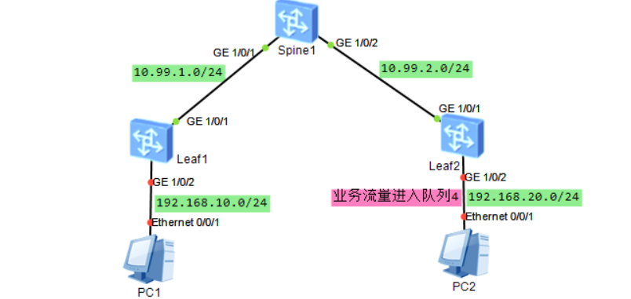

Leaf1配置：

★第16章、维护模式

★恢复密码（保留原配置）
1.开机或重启设备时，出现Press Ctrl+B or Ctrl+E to xxx提示字符串时立即按下 Ctrl键和B键，进入BootRom模式
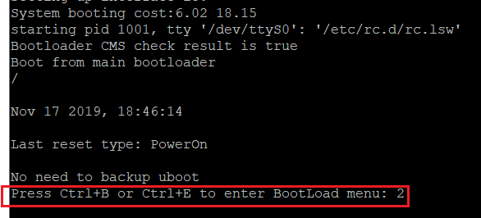
2.输入BootRom密码：
一般新型号设备密码为 Admin@huawei.com 旧型号密码为 Admin@huawei 或者是 huawei 或者是 9300

3.进入BootRom后，根据提示输入 6 （清除console密码），yes确定。
The default password is used now. Change the password.
BootLoad Menu
1. Boot with default mode
2. Enter startup submenu
3. Enter ethernet submenu
4. Enter filesystem submenu
5. Enter password submenu
6. Clear password for console user
7. Reboot
(Press Ctrl+E to enter diag menu)
Enter your choice(1-7): 6
Note: Clear password for console user? Yes or No(Y/N): y
Clear password for console user successfully.
Note: Choose "1. Boot with default mode" to boot, then set a new password.
Enter your choice(1-7): 1

其他可能的界面：
Enter Password: ************
Default Password,Please Set New Password.
Main Menu
1. Default Startup
2. Serial Menu
3. Network Menu
4. Startup Select
5. File Manager
6. Reboot
7. Password Manager
Enter your choice(1-7): 7
PassWord Menu
1. Modify the menu password
2. Clear the console login password
0. Return
Enter your choice(0-2): 2
Clear the console login password Succeed!
PassWord Menu
1. Modify the menu password
2. Clear the console login password
0. Return
Enter your choice(0-2): 0
Main Menu
1. Default Startup
2. Serial Menu
3. Network Menu
4. Startup Select
5. File Manager
6. Reboot
7. Password Manager
Enter your choice(1-7): 1

4.再输入1（Default Startup以默认模式进入系统），不要选择 Reboot（重启），不然还是要密码验证。
5.以默认模式进入系统后，一般不要求输入密码，这时我们可以在配置模式下重新配置管理员密码，保存即可。
★有的设备要求配置console登录的初始密码，需要记录好配置的密码。
Please configure the login password (8-16) #要求我们设置登录密码
Enter Password: #输入密码
Confirm Password: #再次输入密码
Warning: The authentication mode was changed to password authentication and the user level was changed to 15 on con0 at the first user login.

初始化账号密码：
s5735 账号 admin 密码 admin@huawei.com
ar2220 默认console密码 admin@huawei

★维护模式传文件
1.开机或重启设备时，出现Press Ctrl+B or Ctrl+E to xxx字符提示时立即按下 Ctrl键和B键，进入BootRom模式
2.输入BootRom密码：
一般新型号设备密码为 Admin@huawei.com 旧型号密码为 Admin@huawei 或者是 huawei 或者是 9300

3.进入BootRom后，根据提示输入 6
BootLoad Menu
1. Boot with default mode
2. Enter startup submenu
3. Enter ethernet submenu
4. Enter filesystem submenu
5. Enter password submenu
6. Clear password for console user
7. Reboot
(Press Ctrl+E to enter diag menu)

Enter your choice(1-7): 3 #输入3，进入ethernet子菜单

ETHERNET SUBMENU
1. Download file to Flash through ethernet interface
2. Modify ethernet interface boot parameter
3. Return to main menu

Enter your choice(1-3): 2 #输入2，设置使用何种协议进行下载文件（下载到交换机上）

BOOTLINE SUBMENU
1. Set TFTP protocol parameters
2. Set FTP protocol parameters
3. Set SFTP protocol parameters
4. Return to ethernet menu

Enter your choice(1-4): 2 #输入2，设置ftp协议相关参数，如交换机的ip，ftp服务端ip以及要下载的文件名
Warning: FTP is not a secure protocol. SFTP is recommended.

'.' = clear field; '-' = go to previous field; 'Ctrl+D' = quit

Load File name : s5735_back_config.cfg #要通过ftp下载的文件名
Switch IP address : 192.168.2.2 #设置交换机管理口的ip，管理口ip要和ftp服务端ip在同一网段
Server IP address : 192.168.2.1 #ftp服务端ip
FTP User Name : cof #ftp用户名
FTP User Password : #ftp密码

Starting to write BOOTLINE into flash ... done
BOOTLINE SUBMENU
1. Set TFTP protocol parameters
2. Set FTP protocol parameters
3. Set SFTP protocol parameters
4. Return to ethernet menu
Enter your choice(1-4): 4 #输入4回到上一级菜单

ETHERNET SUBMENU
1. Download file to Flash through ethernet interface
2. Modify ethernet interface boot parameter
3. Return to main menu
Enter your choice(1-3): 1 #输入1开始下载文件

Use ftp to download file : s5735_back_config.cfg , please wait for a moment.
Download file successfully. #出现successfully表示下载文件成功
ETHERNET SUBMENU
1. Download file to Flash through ethernet interface
2. Modify ethernet interface boot parameter
3. Return to main menu
Enter your choice(1-3): 3 #输入3回到上一级菜单，然后可进行其他设置，比如进行startup子菜单设置启动系统文件

★第17章、防火墙配置
eNSP模拟器里面的USG6000防火墙默认账号为admin，默认密码为Admin@123，支持HRP双机热备及vsys虚拟系统功能

★创建用户
[USG6300E] aaa #进入aaa界面
[USG6300E-aaa] manager-user admin #创建一个名为admin的用户
[USG6300E-aaa-manager-user-admin] password cipher passwdxxx #设置密码
[USG6300E-aaa-manager-user-admin] service-type terminal ssh web #账号服务类型
[USG6300E-aaa-manager-user-admin] level 15 #权限级别
[USG6300E-aaa-manager-user-admin] quit
[USG6300E-aaa] bind manager-user admin role system-admin #绑定管理员角色
[USG6300E-aaa] manager-user password valid-days 0 #密码过期时间，单位天
#设置为0时表示永不过期，默认90天，设置为0后，初次登录不用强制改密码

★防火墙三层子接口打vlan-tag
interface Eth-Trunk1.100
vlan-type dot1q 100
ip addresss 10.1.1.2 24
#

★接口安全域
[USG6300E] disp zone priority #查看防火墙的安全域
2025-01-16 00:36:52.190 #默认有以下4个安全域
local
priority is 100
#
trust
priority is 85
#
untrust
priority is 5
#
dmz
priority is 50

★安全域优先级说明
每个安全域都有一个priority优先级，取值范围0-100，默认的4个区域不能改优先级数值，自定义的区域可以修改
这个优先级数值只有一个作用，就是区别各个区域间流量的走向（方向）：
优先级数值小的区域 访问 数值大的区域 称为入方向 inbound
优先级数值大的区域 访问 数值小的区域 称为出方向 outbound
比如：
从trust（85）访问untrust（5），从大到小就是出方向，
从untrust（5）访问trust（85），从小到大就是入方向

★新建安全区域
[USG6300E] firewall zone name internalxx #创建自定义的安全域，名称为internalxx
[USG6300E-zone-internalxx] set priority 80 #设置安全域优先级，1~100，默认为0
[USG6300E-zone-internalxx] add interface GigabitEthernet0/0/1 #将接口加入安全域

[USG6300E] disp zone internalxx #查看internalxx域的信息

★安全域流量放通（创建放通策略）
★防火墙本地接口上的ip监听的服务（含路由服务）认为自己处于local的安全域，即使这个接口配置到了trust安全域，从trust访问此接口上的ip的某服务（如http,ssh,ping,ospf,bgp等），也算是从trust到local，从本地ip访问到外部 则算是从local到trust

[USG6300E] security-policy #进入安全策略配置界面
[USG6300E-policy-security] rule name sec-policy-internalxx-local #创建一条名为sec-policy-internalxx-local的策略
[USG6300E-xx] source-zone internalxx #源安全域
[USG6300E-xx] source-zone local #源安全域
[USG6300E-xx] destination-zone local #目的安全域
[USG6300E-xx] destination-zone internalxx #目的安全域
[USG6300E-xx] source-address 9.9.9.0 0.0.0.255 #源ip网段，反掩码
[USG6300E-xx] destination-address 9.9.9.0 0.0.0.255 #目的ip网段，反掩码
[USG6300E-xx] action permit #匹配后的动作为permit，也可配置为deny
[USG6300E-xx] disable #disable表示不启用这条策略，默认是enable（启用）

[USG6300E] disp security-policy rule all #查看安全策略
Total:2
RULE ID RULE NAME STATE ACTION HITS
-------------------------------------------------------------------------------
2 sec-policy-internalxx-local enable permit 2
0 default enable deny 331
#最后有条默认的rule，名为default，规则是deny所有

★放行基本协议报文
[USG6300E] undo firewall packet-filter basic-protocol enable #放行基本协议报文，比如ospf报文

★同安全区域内流量控制
默认情况下，同一安全区域内的流量不受安全策略控制，可以执行以下命令开启
[USG6300E] security-policy #进入安全策略配置界面
[USG6300E-policy-security] default packet-filter intrazone enable #开启同一安全域内流量控制，若不需要开启，则undo default packet-filter intrazone enable 即可

★新增一条策略
#首先创建源ip地址集；address-set 名称长度为1-63字符，若有空格，需要用""引号括起来（长度不含引号）
ip address-set policy-test-srcip type object
description policy-test-srcip
address 0 10.88.0.0 mask 16
address 1 10.99.1.2 mask 32
quit
#创建目的ip地址集；address-set 名称长度为1-63字符，若有空格，需要用""引号括起来（长度不含引号）
ip address-set policy-test-destip type object
description policy-test-destip
address 0 172.16.33.0 mask 24
quit
#创建目的端口集；service-set 名称长度为1-63字符，若有空格，需要用""引号括起来（长度不含引号）
ip service-set policy-test-service type object
description policy-test-service
service 0 protocol tcp source-port 0 to 65535 destination-port 443
service 1 protocol udp source-port 0 to 65535 destination-port 123
quit
#新增一条策略；rule name策略名长度为1-32字符，若有空格，需要用""引号括起来（长度不含引号）
security-policy
rule name policy-test
#parent-group group_YeWu #加入到指定的策略组【可选操作】
source-address address-set policy-test-srcip
destination-address address-set policy-test-destip
service policy-test-service
policy logging #记录策略命中日志★
session logging #记录会话日志★
profile av default #反病毒
profile ips default #入侵防御
action permit #允许匹配的流量通过
quit
#默认情况下，新增的策略放在末尾（在default之前）
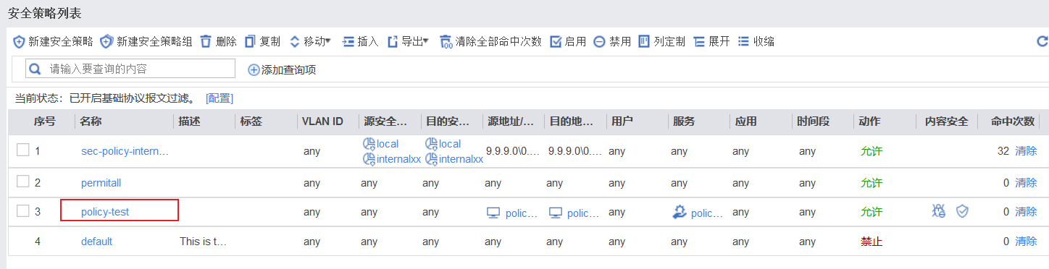

#移动新增的策略到某条策略之后
security-policy
rule move policy-test after sec-policy-internalxx-local
quit
#
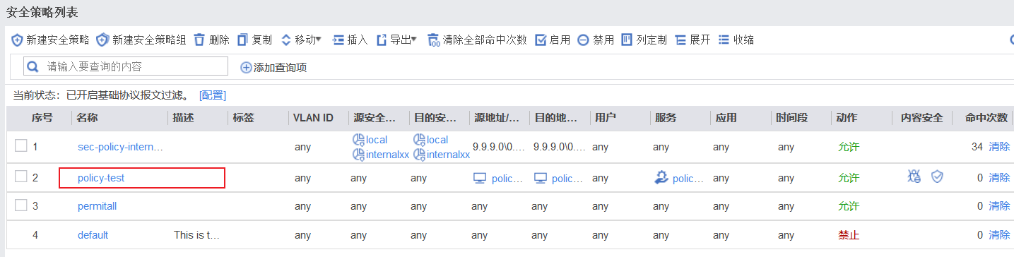

★ASPF多通道协议设置
ASPF（Application SpecificPacket Filter）针对应用层的特殊包过滤技术（基于应用层包过滤），其原理是检测通过设备的报文的应用层协议信息，记录临时协商的数据连接，使得某些在安全策略中没有明确定义要放行的报文也能够得到正常转发。

ALG（Application Layer Gateway）应用层网关技术能对多通道协议进行应用层报文信息的解析和地址转换，将载荷中需要进行地址转换的IP地址和端口或者需特殊处理的字段进行相应的转换和处理，从而保证应用层通信的正确性。
主动模式穿越SNAT主要用于FTP服务器部署在公网，客户端需要通过SNAT转换访问服务器。
此时需要借助ALG技术才可以完成穿越防火墙。

ASPF和ALG功能使用的是同一个配置，只是不同场景下FW对报文的处理不同，因而叫法不同。
非NAT场景下叫ASPF，NAT场景下叫ALG

策略→ASPF配置
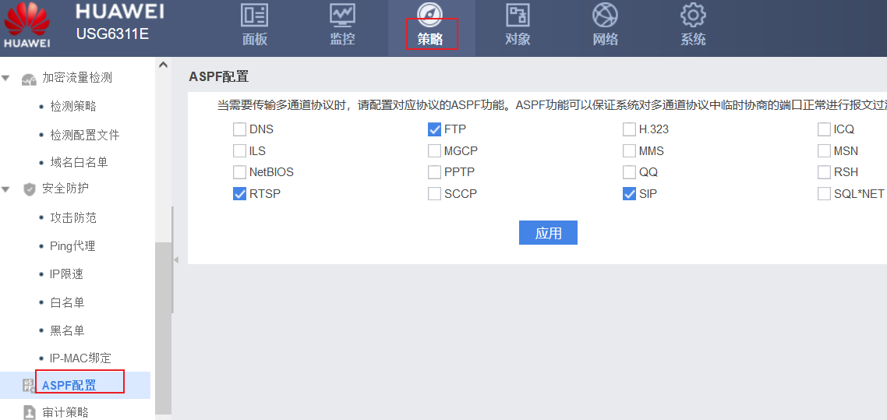

★设置TCP最大报文长度
tcp-mss，默认为1460，如果有vpn流量经过，则承载的数据可能会因为此tcp-mss过大，而导致报文被丢弃。
因为vpn隧道2端设备不知道自己的流量会经过vpn，所以将tcp-mss设置为默认值1460，vpn本身有外部的报文信息开销，导致1460字节长度的数据封装在vpn隧道传输时，无法通过防火墙（1460数据加ip层封装再放到vpn的tcp报文里，则vpn流量的tcp数据长度大于了防火墙的tcp-mss）

此时若将vpn经过的防火墙tcp-mss设置小一点（减去vpn的报文开销），比如1360，则经过vpn的流量都能正常经过防火墙（防火墙把这些流量分片了）

系统→配置→高级配置→配置TCP选项
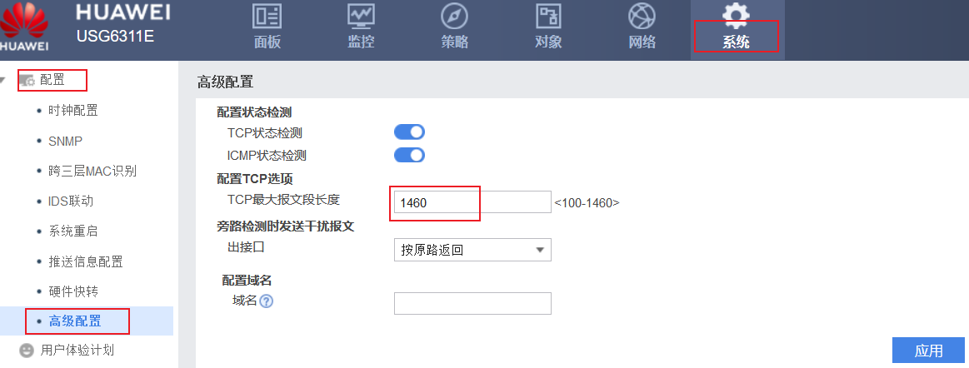

★接口管理服务配置（允许访问管理口）
[USG6300E] interface GigabitEthernet0/0/1
[USG6300E-GigabitEthernet0/0/1] ip add 9.9.9.33 255.255.255.0 #配置ip
[USG6300E-GigabitEthernet0/0/1] service-manage ping permit #允许icmp服务
[USG6300E-GigabitEthernet0/0/1] service-manage https permit #允许https服务
[USG6300E-GigabitEthernet0/0/1] service-manage ssh permit #允许ssh服务
[USG6300E-GigabitEthernet0/0/1] service-manage all permit #允许所有服务

#安全域还需要放通策略，目的安全域为local
[USG6300E] security-policy #进入安全策略配置界面
[USG6300E-policy-security] rule name sec-policy-internalxx-local #创建一条名为sec-policy-internalxx-local的策略
[USG6300E-xx] source-zone internalxx #源安全域
[USG6300E-xx] source-zone local #源安全域
[USG6300E-xx] destination-zone local #目的安全域
[USG6300E-xx] destination-zone internalxx #目的安全域
[USG6300E-xx] source-address 9.9.9.0 0.0.0.255 #源ip网段，反掩码
[USG6300E-xx] destination-address 9.9.9.0 0.0.0.255 #目的ip网段，反掩码
[USG6300E-xx] action permit #匹配后的动作为permit，也可配置为deny

★开启web服务
#防火墙默认已开启web服务（默认已有以下三行配置）
web-manager security version tlsv1.1 tlsv1.2 # TLS版本
web-manager enable
web-manager security enable
#
按前面几小节操作即可：
①创建管理员账号并开启web服务
②接口配置ip并加入某个安全域
③接口安全域与local安全域放通流量
④接口管理服务开启https与ssh

# https web界面默认8443端口号
如： https://9.9.9.33:8443
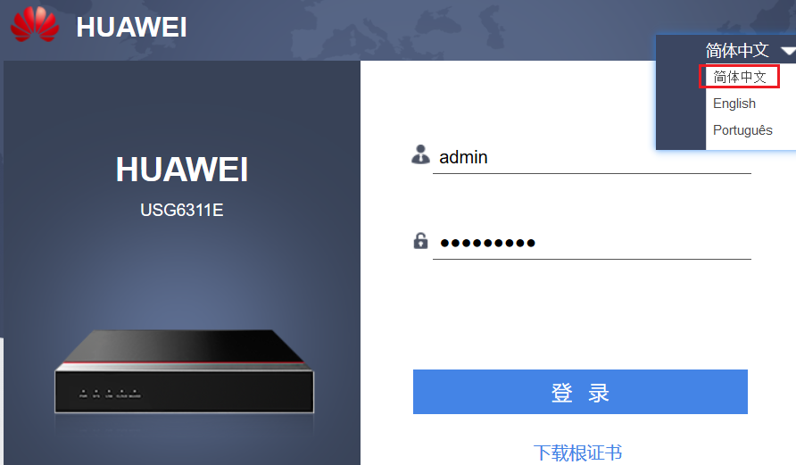

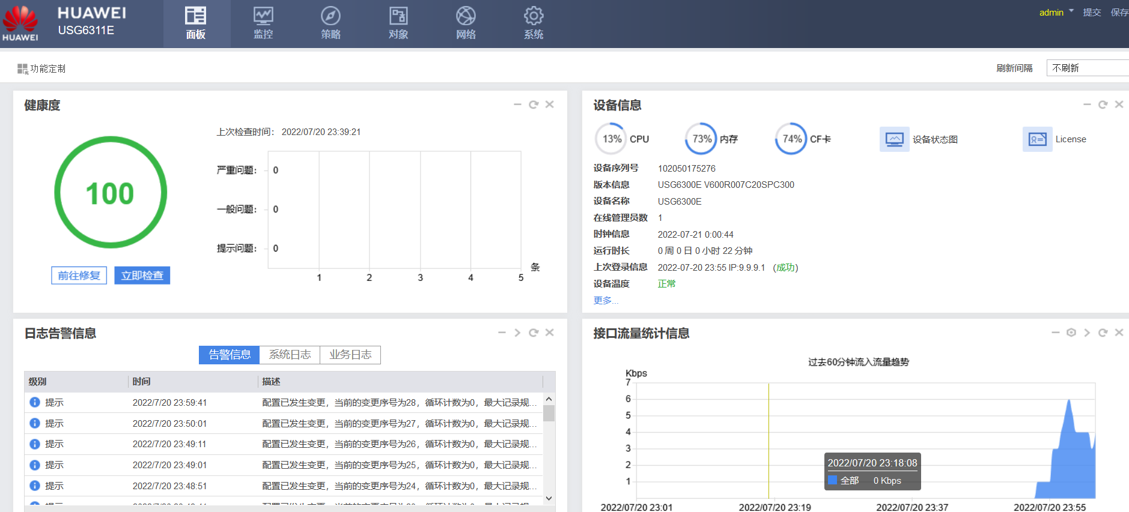

★ensp模拟器里的防火墙也能使用web登录，https://x.x.x.x:8443
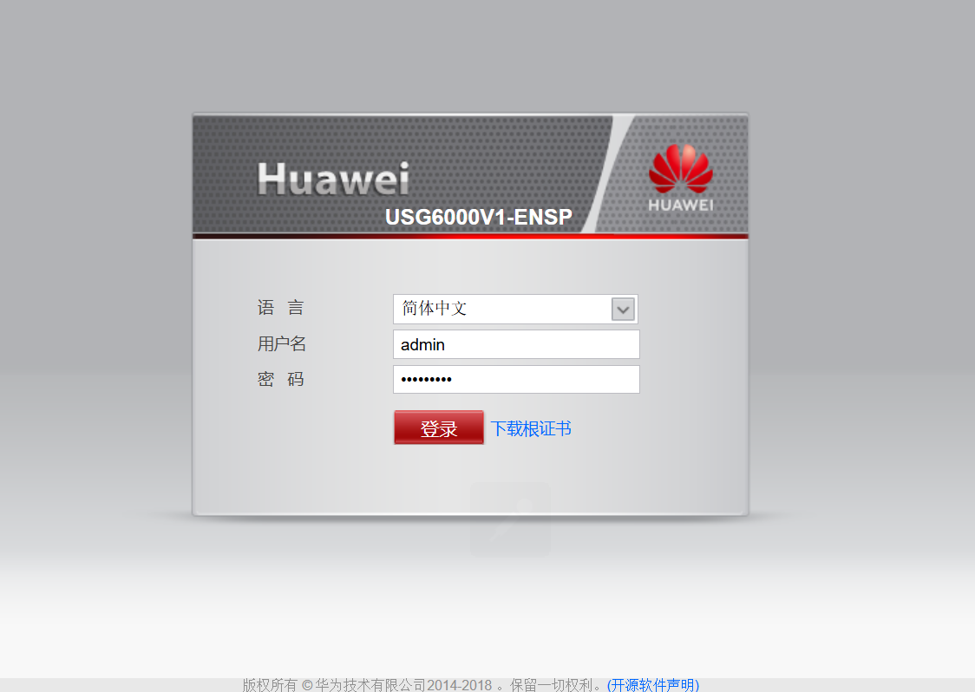

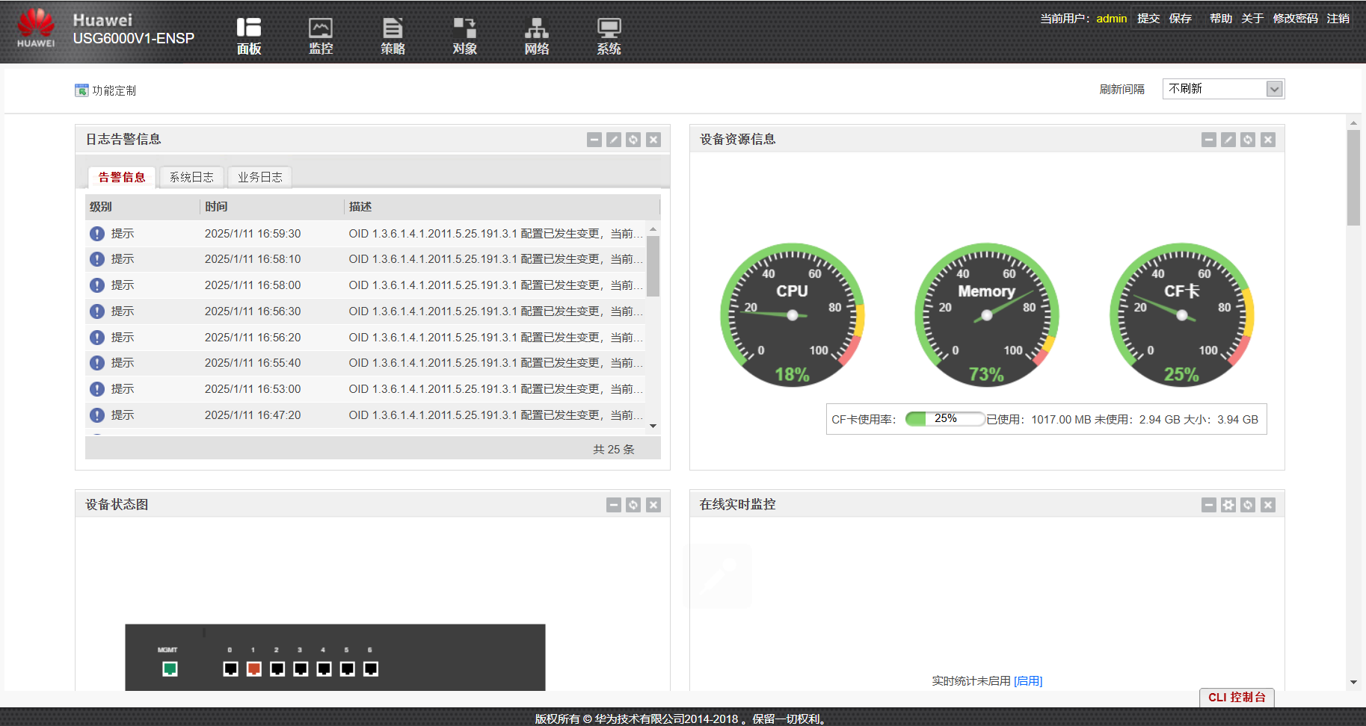

★安装弱安全组件
有些防火墙默认安全要求较高，ssh服务默认只支持ecc密钥，没有rsa密钥，导致某些shell终端无法通过ssh远程登录这些防火墙
[USG6300E] ssh server publickey ?
ecc ECC public key algorithm
可以安装防火墙弱安全组件，使其支持rsa密钥

到华为官网查找目标型号的软件：
https://support.huawei.com/enterprise/zh/security/usg-pid-22914752/software

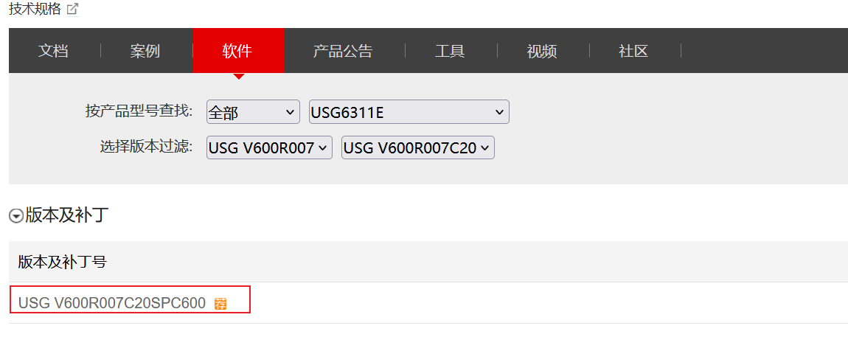

首先要注册产品，才能下载相应产品的软件：
https://support.huawei.com/enterprisemysupport/mysupport#click=productreg
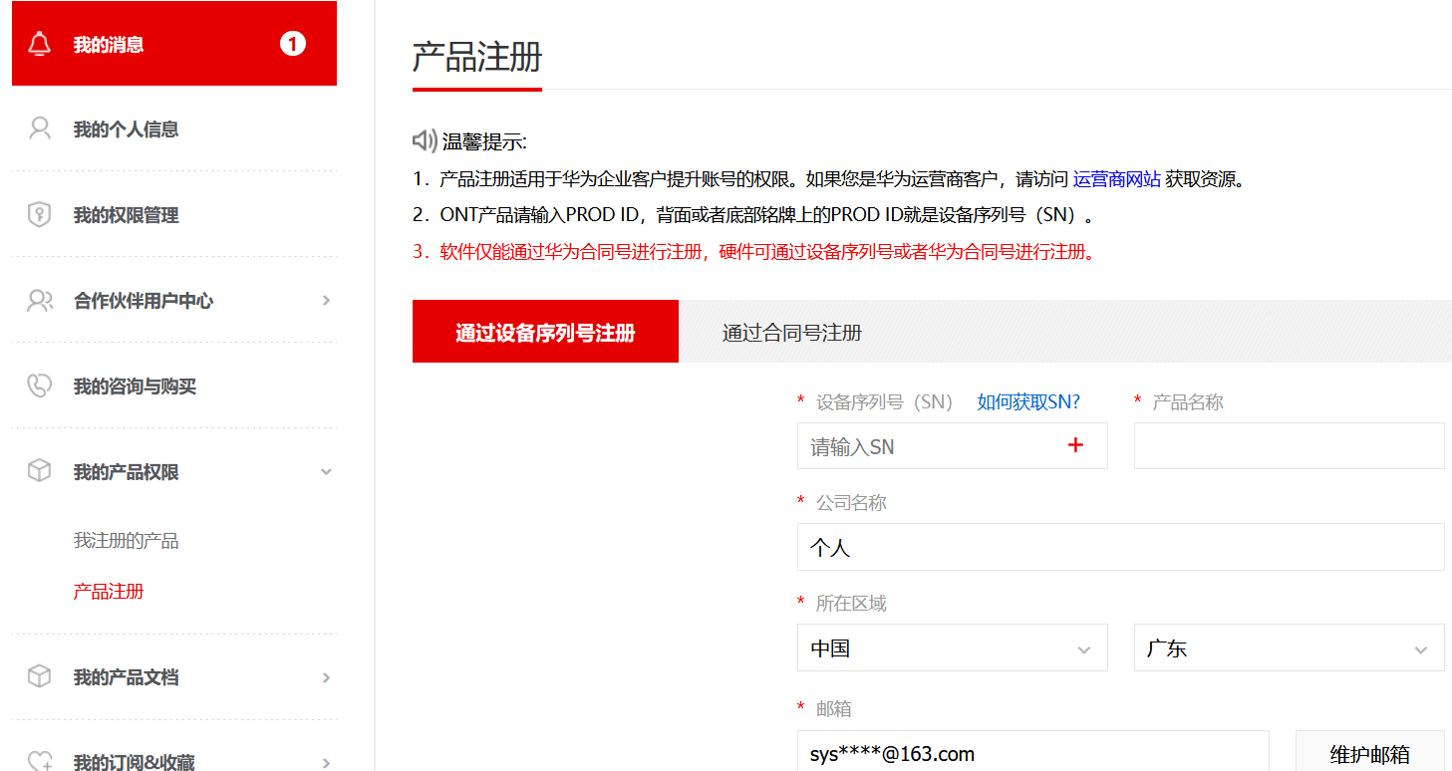

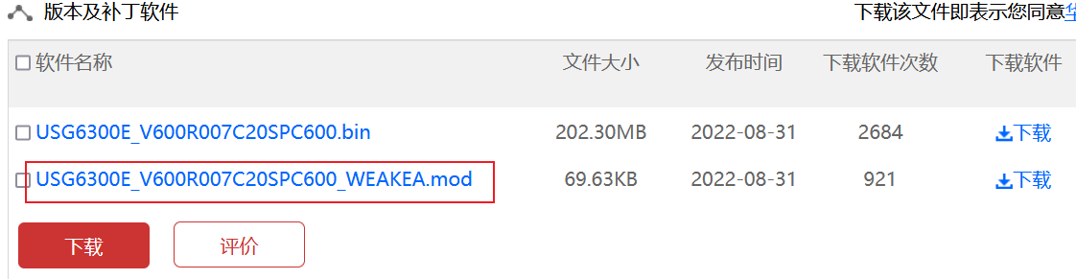
下载组件版本和当前系统版本要保持一致，不一致的先升级系统版本，
点击组件名称，进入下载页
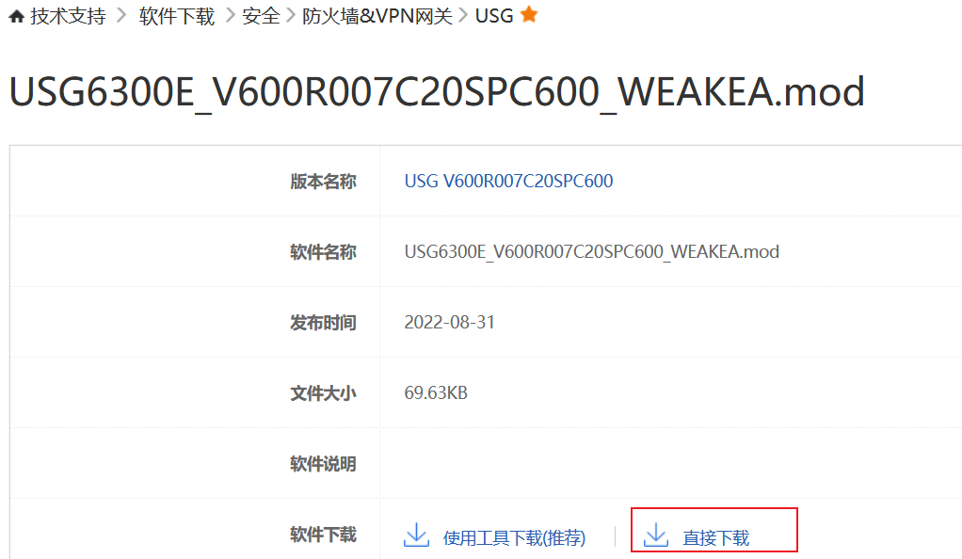
点击直接下载
下载后，使用ftp/tftp上传到防火墙上
> install-module usg6300e_v600r007c20spc600_weakea.mod
Error: The file hda1:/$_install_mod/usg6300e_v600r007c20spc600_weakea.mod does not exist on the main board.
在根目录下，直接安装不行，它默认是要到hda1:/$_install_mod/子目录下去找组件，所以先复制到此子目录下
> copy usg6300e_v600r007c20spc600_weakea.mod hda1:/$_install_mod/usg6300e_v600r007c20spc600_weakea.mod
> install-module usg6300e_v600r007c20spc600_weakea.mod
/---------------------------------------------------------------------------------\
| Warning: The weak encryption algorithm component package is being loaded, |
| which brings security risks to the device. Therefore, confirm that you need to |
| use the weak encryption algorithm before the installation. In addition, if the |
| device is deployed in a hot standby environment, ensure that this component |
| is loaded on both devices to prevent exceptions. |
\---------------------------------------------------------------------------------/
Continue?[Y/N]: y #输入y确认
Info: Installing the module hda1:/$_install_mod/usg6300e_v600r007c20spc600_weakea.mod.........
Info: Succeeded in MOD Install..
Info: Succeeded in installing the module on the master board.
Info: The slot 11 does not have module to be installed......

[USG6300E] ssh server publickey ? #安装完弱安全组件后，就支持rsa了
dsa DSA public key algorithm
ecc ECC public key algorithm
rsa RSA public key algorithm
rsa_sha2_256
rsa_sha2_512

★vsys虚拟系统
防火墙的虚拟系统是基于vrf（vpn-instance）做了些扩展，将一台实体防火墙设备虚拟为若干个逻辑设备，各个虚拟系统可以有自己的物理接口、路由表、安全区域及其他资源。（虚拟系统只支持静态路由）
默认情况下，一台实体设备默认就是一个虚拟系统，名为public（根系统），默认有一个虚拟接口Virtual-if0
各个虚拟系统之间通过Virtual-if0接口通信，各个虚拟系统之间通信必须依赖public根系统

#创建vsys虚拟系统
[USG6000V1] vsys enable #开启虚拟系统功能
[USG6000V1] vsys name vsys_a 1 #创建一个名为vsys_a的虚拟系统，编号为1，编号范围1-31
[USG6000V1-vsys-vsys_a] assign interface g1/0/2 #将物理接口分配给虚拟系统
Info: All related configurations on this interface are removed.
[USG6000V1-vsys-vsys_a] quit

创建虚拟系统后，防火墙会自动创建一个同名的vpn实例：
ip vpn-instance vsys_a
ipv4-family
ipv6-family
同时也会创建一个虚拟接口，接口编号同vsys编号
interface Virtual-if1

将物理接口分配给虚拟系统后，本质是把接口绑定到相应的vpn实例（所以接口原配置会被清空）：
interface GigabitEthernet1/0/2
undo shutdown
ip binding vpn-instance vsys_a

<USG6000V1> disp vsys #查看虚拟系统
2025-01-16 01:06:10.200
Total Virtual system Configured: 2 Remained : 19
--------------------------------------------------------------------------------
Name ID Startup Time
--------------------------------------------------------------------------------
public 0 2025/01/16 00:24:14
vsys_a 1 2025/01/16 00:24:23
--------------------------------------------------------------------------------

[USG6000V1] switch vsys vsys_a #切换到vsys_a的虚拟系统配置界面
<USG6000V1-vsys_a> system-view
[USG6000V1-vsys_a] int g1/0/2
[USG6000V1-vsys_a-GigabitEthernet1/0/2] ip add 10.99.22.1 24
[USG6000V1-vsys_a-GigabitEthernet1/0/2] quit
[USG6000V1-vsys_a] disp ip int bri #查看到的是vsys_a相关的资源情况
2025-01-23 03:18:08.520
*down: administratively down
^down: standby
(l): loopback
(s): spoofing
(d): Dampening Suppressed
(E): E-Trunk down
Interface IP Address/Mask Physical Protocol
GigabitEthernet1/0/2 10.99.22.1/24 up up
Virtual-if1 unassigned up up(s)
<USG6000V1-vsys_a> quit #退出vsys_a配置界面，回到默认的public根系统界面
[USG6000V1]
[USG6000V1] disp ip vpn-instance vsys_a interface #在根系统下，查看虚拟系统的接口
2025-05-02 13:41:24.230
VPN-Instance Name and ID : vsys_a, 1
Interface Number : 2
Interface list : GigabitEthernet1/0/2,
Virtual-if1

★虚拟系统添加loop口及vlan
由于在虚拟系统里，无法创建接口，所以loop口及vlan/vlanif都在根系统下创建，再分配给虚拟系统
vlan batch 20
interface vlanif 20
#
vsys name vsys_xx
assign interface LoopBack1
assign vlan 20 #添加vlan后，相应的vlanif也自动加入到此虚拟系统中
#
#如果将vlan分配给了vsys，但前面忘记创建vlanif了，没关系，后面再创建vlanif时，会自动绑定相应的vpn实例。

★虚拟系统只能配置静态路由，动态路由协议无法直接在虚拟系统界面下配置，只能在根系统下配置

★虚拟系统特性：
能否创建vlan | 不能
能否创建vlanif | 不能
能否配置vlanif IP地址 | 能
能否配置virtual-if IP地址 | 能
能否配置ospf | 不能，只能配置静态路由
能否配置接口的vpn-instance | 不能，接口划分给vsys时自动加入vpn实例
能否创建或删除vpn-instance | 不能，创建vsys时自动创建相应的vpn实例
virtual-if接口 | 不能加入任何vpn实例，virtual-if接口编号同vsys编号

#虚拟系统之间通信
各个虚拟系统之间通过Virtual-if0接口通信，各个虚拟系统之间通信必须依赖public根系统
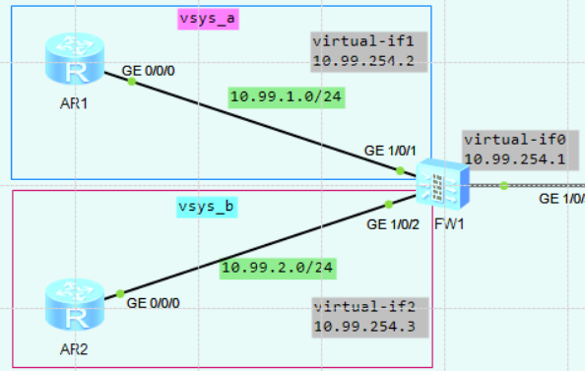

FW1配置：
[USG6000V1] vsys enable #开启虚拟系统功能

[USG6000V1] vsys name vsys_a 1 #创建一个名为vsys_a的虚拟系统，编号为1
[USG6000V1-vsys-vsys_a] assign interface g1/0/1
[USG6000V1-vsys-vsys_a] quit
[USG6000V1] vsys name vsys_b 2 #创建一个名为vsys_b的虚拟系统，编号为2
[USG6000V1-vsys-vsys_a] assign interface g1/0/2
[USG6000V1-vsys-vsys_a] quit

[USG6000V1] switch vsys vsys_a #切换到vsys_a的虚拟系统配置界面
<USG6000V1-vsys_a> system-view
[USG6000V1-vsys_a] interface g1/0/1
[USG6000V1-vsys_a-GigabitEthernet1/0/1] ip address 10.99.1.1 255.255.255.0
[USG6000V1-vsys_a-GigabitEthernet1/0/1] service-manage ping permit
[USG6000V1-vsys_a] int Virtual-if 1
[USG6000V1-vsys_a] ip address 10.99.254.2 255.255.255.255
[USG6000V1-vsys_a] quit
[USG6000V1-vsys_a] firewall zone trust
[USG6000V1-vsys_a-zone-trust] add interface GigabitEthernet1/0/1
[USG6000V1-vsys_a] firewall zone untrust
[USG6000V1-vsys_a-zone-untrust] add interface Virtual-if1

[USG6000V1-vsys_a] security-policy
[USG6000V1-vsys_a-policy-security] rule name trust-to-untrust
[USG6000V1-vsys_a-policy-security-rule-trust-to-untrust] source-zone trust
[USG6000V1-vsys_a-policy-security-rule-trust-to-untrust] destination-zone untrust
[USG6000V1-vsys_a-policy-security-rule-trust-to-untrust] action permit
[USG6000V1-vsys_a-policy-security] rule name untrust-to-trust
[USG6000V1-vsys_a-policy-security-rule-trust-to-untrust] source-zone untrust
[USG6000V1-vsys_a-policy-security-rule-trust-to-untrust] destination-zone trust
[USG6000V1-vsys_a-policy-security-rule-trust-to-untrust] action permit

[USG6000V1] switch vsys vsys_b #切换到vsys_b的虚拟系统配置界面
<USG6000V1-vsys_b> system-view
[USG6000V1-vsys_b] interface g1/0/2
[USG6000V1-vsys_b-GigabitEthernet1/0/2] ip address 10.99.2.1 255.255.255.0
[USG6000V1-vsys_b-GigabitEthernet1/0/2] service-manage ping permit
[USG6000V1-vsys_b] int Virtual-if 2
[USG6000V1-vsys_b] ip address 10.99.254.3 255.255.255.255
[USG6000V1-vsys_b] quit
[USG6000V1-vsys_b] firewall zone trust
[USG6000V1-vsys_b-zone-trust] add interface GigabitEthernet1/0/2
[USG6000V1-vsys_b] firewall zone untrust
[USG6000V1-vsys_b-zone-untrust] add interface Virtual-if2

[USG6000V1-vsys_b] security-policy
[USG6000V1-vsys_b-policy-security] rule name trust-to-untrust
[USG6000V1-vsys_b-policy-security-rule-trust-to-untrust] source-zone trust
[USG6000V1-vsys_b-policy-security-rule-trust-to-untrust] destination-zone untrust
[USG6000V1-vsys_b-policy-security-rule-trust-to-untrust] action permit
[USG6000V1-vsys_b-policy-security] rule name untrust-to-trust
[USG6000V1-vsys_b-policy-security-rule-trust-to-untrust] source-zone untrust
[USG6000V1-vsys_b-policy-security-rule-trust-to-untrust] destination-zone trust
[USG6000V1-vsys_b-policy-security-rule-trust-to-untrust] action permit

#public系统配置（虚拟系统之间的相互通信，需要在public系统下配置静态路由）
[USG6000V1] interface Virtual-if0
[USG6000V1-Virtual-if0] ip address 10.99.254.1 255.255.255.255
[USG6000V1]
[USG6000V1] ip route-static vpn-instance vsys_a 10.99.2.0 24 vpn-instance vsys_b
[USG6000V1] ip route-static vpn-instance vsys_b 10.99.1.0 24 vpn-instance vsys_a

#在AR1（vsys_a）访问AR2（vsys_b）
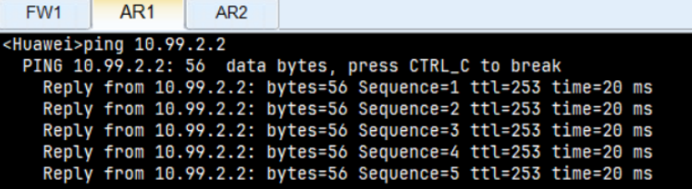
<USG6000V1-vsys_a> disp firewall session table
2025-03-30 01:56:02.440
Current Total Sessions : 1
icmp VPN: vsys_a --> vsys_b 10.99.1.2:57003 --> 10.99.2.2:2048

<USG6000V1-vsys_b> disp firewall session table
2025-03-30 01:57:27.400
Current Total Sessions : 1
icmp VPN: vsys_b --> vsys_b 10.99.1.2:57259 --> 10.99.2.2:2048

#虚拟系统访问根系统
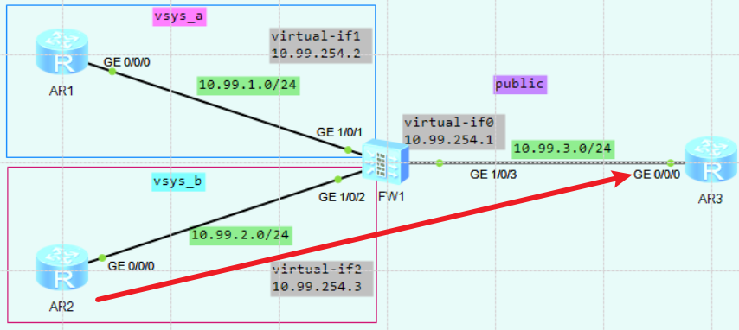
要让虚拟系统单向访问根系统，只需要在虚拟系统上配置去往public的路由（前提是根系统上的virtaul-if0和目标网络接口之间的安全策略已打开）
[USG6000V1-vsys_b] ip route-static 10.99.3.0 24 public

#在vsys_b访问public
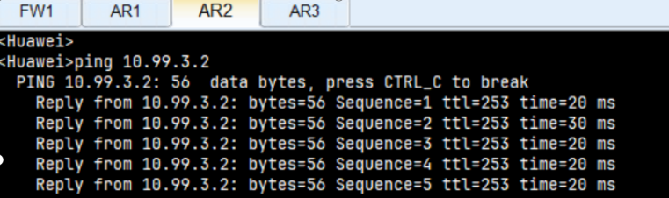
<USG6000V1-vsys_b> disp firewall session table
2025-03-30 02:04:34.290
Current Total Sessions : 1
icmp VPN: vsys_b --> public 10.99.2.2:56235 --> 10.99.3.2:2048

[USG6000V1] disp firewall session table
2025-03-30 02:07:47.320
Current Total Sessions : 1
icmp VPN: public --> public 10.99.2.2:56491 --> 10.99.3.2:2048

[USG6000V1-vsys_b] disp ip routing-table
2025-03-30 02:01:26.990
Route Flags: R - relay, D - download to fib
------------------------------------------------------------------------------
Routing Tables: vsys_b
Destinations : 5 Routes : 5

Destination/Mask Proto Pre Cost Flags NextHop Interface
10.99.1.0/24 Static 60 0 D 10.99.254.2 Virtual-if1
10.99.2.0/24 Direct 0 0 D 10.99.2.1 GigabitEthernet1/0/2
10.99.2.1/32 Direct 0 0 D 127.0.0.1 GigabitEthernet1/0/2
10.99.3.0/24 Static 60 0 D 10.99.254.1 Virtual-if0
10.99.254.3/32 Direct 0 0 D 127.0.0.1 Virtual-if2

★要让根系统单向访问虚拟系统，只需要在根系统上配置路由（前提是根系统上的virtaul-if0和目标网络接口之间的安全策略已打开）：
[USG6000V1] ip route-static 10.99.2.0 24 vpn-instance vsys_b
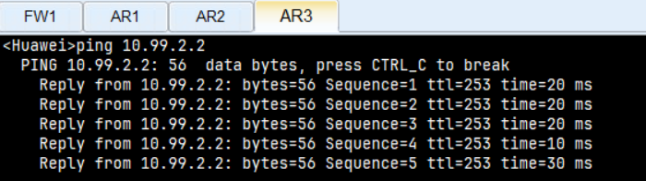

[USG6000V1] disp firewall session table
2025-03-30 02:10:09.160
Current Total Sessions : 1
icmp VPN: public --> vsys_b 10.99.3.2:54187 --> 10.99.2.2:2048

[USG6000V1-vsys_b] disp firewall session table
2025-03-30 02:15:38.630
Current Total Sessions : 1
icmp VPN: vsys_b --> vsys_b 10.99.3.2:54699 --> 10.99.2.2:2048

★防火墙HRP双机热备配置
HRP协议是华为私有协议，主要是在VGMP协议的基础上进行扩展得到的；而VGMP也是华为的私有协议，主要是用来管理VRRP的。不管是VGMP的报文，还是HRP的报文，都是VRRP的报文，只是防火墙在识别这些报文的时候能根据自己定义的字段判断出是VGMP的报文、HRP的报文、或者是普通的VRRP的报文。

HRP的作用主要是备份防火墙的基础配置、会话表、server-map表以及ASPF模块中的公私网地址映射表等。

两台防火墙正确配置VRRP，VGMP，以及HRP之后，将会形成主备关系，这个时候防火墙的命令行上会自动显示防火墙状态是主还是备，如果命令行上有HRP_M的标识，表示此防火墙和另外一台防火墙进行协商之后抢占为主防火墙，如果命令行上有HRP_S的标识，表示此防火墙和另外一台防火墙进行协商之后抢占为备防火墙。防火墙的主备状态只能在两台防火墙之间进行协商。

★2台防火墙都需要操作的步骤：
1）新建安全区域
firewall zone name hrp #创建自定义的安全域，名称为hrp
set priority 80 #设置安全域优先级，1~100
add interface GigabitEthernet1/0/1 #将hrp心跳口加入安全域
#
心跳口只需要加入安全域，不需要放通任何策略

★FW1
hrp enable #使能HRP之后防火墙将形成主备状态
undo hrp preempt enable #关闭抢占功能
hrp device active #主墙
hrp mirror config enable #开启“配置快速备份”功能
hrp mirror session enable #开启“会话快速备份”功能
hrp interface Eth-Trunk0 remote 10.99.255.2 #添加防火墙配置会话备份通道，即防火墙心跳口
hrp authentication-key xxxx #配置认证密码
hrp timer hello 1000 #配置hello报文发送间隔时间，单位：毫秒，默认1000ms
hrp track interface g0/0/1 #对目标链路进行监控，若目标链路down了，则优先级减2，若有vrrp，则优先级减去（2+vrrp组数量*2）
hrp track interface Eth-Trunk1 #对目标链路进行监控，若目标链路down了，则优先级减去（此聚合口的成员口数量*2）
hrp track vlan 100 #对目标vlan接口进行监控，若目标链路down了，则优先级减去（此vlan的端口数量*2）

★FW2
hrp enable
undo hrp preempt enable
hrp device standby #备墙，也可配置为hrp standby-device
hrp mirror config enable
hrp mirror session enable
hrp interface Eth-Trunk0 remote 10.99.255.1 #添加防火墙配置会话备份通道，即防火墙心跳口
hrp authentication-key xxxx #配置认证密码
hrp timer hello 1000
hrp track interface Eth-Trunk1
hrp track interface Eth-Trunk2
#

★开启HRP功能后，只能在主墙上进行命令配置，不能在备墙进行配置，且主墙的配置会覆盖掉备墙上相同接口的配置。如果需要在备墙上配置命令，需要取消配置自动备份功能，再允许备墙修改配置：
undo hrp mirror config enable
undo hrp auto-sync config
hrp standby config enable

当备墙配置完成后，最好是再关闭备墙的配置功能：
hrp mirror config enable #主要是这条命令，不让备墙做配置
hrp auto-sync config
undo hrp standby config enable

★查看HRP信息
HRP_M[USG6000V1] disp hrp state #查看当前hrp的状态信息
2025-01-11 16:01:09.420
Role: active, peer: standby (should be "standby-active")
Running priority: 45000, peer: 45000
Backup channel usage: 0.00%
Stable time: 0 days, 8 hours, 8 minutes
Last state change information: 2025-01-11 7:52:19 HRP link changes to up.
HRP_M[USG6000V1] display hrp verbose #显示当前hrp的详细状态信息
2025-01-11 16:06:32.400
Role: active, peer: standby (should be "standby-active")
Running priority: 45000, peer: 45000
Backup channel usage: 0.00%
Stable time: 0 days, 8 hours, 14 minutes
Last state change information: 2025-01-11 7:52:19 HRP link changes to up.

Configuration:
hello interval: 1000ms
preempt: off
mirror configuration: on
mirror session: on
track trunk member: on
auto-sync configuration: on
auto-sync connection-status: on
adjust ospf-cost: on
adjust ospfv3-cost: on
adjust bgp-cost: on
nat resource: off

Detail information:
ospf-cost: +0 (should be "+65500")
ospfv3-cost: +0 (should be "+65500")
bgp-cost: +0 (should be "+100")

HRP_M[USG6000V1] hrp switch standby #切换为备墙
HRP_S[USG6000V1] hrp switch active #切换为主墙
HRP_M[USG6000V1] disp hrp state
2025-01-11 16:22:47.490
Role: active, peer: standby ("hrp switch active" on this device)
Running priority: 45001, peer: 45000
Backup channel usage: 0.00%
Stable time: 0 days, 0 hours, 0 minutes
Last state change information: 2025-01-11 16:22:43 HRP core state changed, old_
state = abnormal(standby), new_state = abnormal(active), local_priority = 45001,
peer_priority = 45000.

★其他配置：
HRP_M[USG6000V1] hrp configuration check acl #检查主备防火墙两端的ACL的配置是否一致
HRP_M[USG6000V1] display hrp configuration check acl #查看两边的配置是否一致
2025-01-11 16:04:35.700
Module State Start-time End-time Result
acl finish 2025/01/11 16:04:21 2025/01/11 16:04:21 Same Configuration

HRP_M[USG6000V1] hrp configuration check hrp #检查主备防火墙两端的 HRP的配置是否一致
HRP_M[USG6000V1] display hrp configuration check hrp #查看两边的配置是否一致
2025-01-11 16:05:24.260
Module State Start-time End-time Result
hrp finish 2025/01/11 16:04:30 2025/01/11 16:04:30 Same Configuration

HRP_M[USG6000V1] hrp interface Ethernet 1/0/0 high-availability #配置防火墙的高可用性接口。主要是用来实现防火墙的会话快速备份，如果不配置high-availability 会话快速备份的命令将不能执行
HRP_M[USG6000V1] hrp mirror session enable #开启“会话快速备份”功能，开启后防火墙上对新建的会话或者是刷新的会话立即备份到对端防火墙上，在配置high-availability 之后才能配置此命令。
HRP_M[USG6000V1] hrp mirror packet enable #开启“报文搬迁”功能，如果ICMP的应答报文或者是TCP的ACK报文在其中一台防火墙上找不到会话，会把报文搬迁到另外一台防火墙上，如果在另外一台防火墙上找到会话，报文根据会话转发，如果找不到会话，直接丢弃。此功能现在保留，但是基本上不再使用，因为防火墙会话快速备份使能之后会话在建立或者是刷新的时候马上就能备份到对端防火墙上，并且报文搬迁占用比较多的带宽，所以这个命令推荐不使用

HRP_M[USG6000V1] hrp auto-sync connection-status #开启自动备份防火墙连接状态，防火墙会话备份不分防火墙是主防火墙或者是备防火墙，开启此功能后，防火墙都能把自己建立的会话或者是刷新的会话备份到对端防火墙上。此命令行在防火墙hrp enable 执行之后就默认使能了
HRP_M[USG6000V1] hrp auto-sync config #开启自动备份防火墙配置，在主防火墙上配置的命令行如 ACL，域等都可以自动备份到备防火墙上，保证命令行能实时同步。此功能在hrp enable执行之后就默认开启了，此时在备防火墙上是默认不能配置 ACL等配置的，但是如果需要单独配置，执行undo hrp auto-sync config就可以在备防火墙上配置此命令行了，主防火墙上执行ACL等配置发送到备防火墙上不会备执行，如果在主防火墙上执行此命令，主防火墙上将不把配置发送到备防火墙上执行
HRP_M[USG6000V1] hrp auto-sync config batch-backup #开启“防火墙配置批量备份”功能，在防火墙发生主备倒换之后，新的主防火墙备自动把配置备份到新的备防火墙上。此功能默认是关闭的，现在也不推荐使用，因为批量备份将消耗大量的 CPU资源，可能在执行批量备份的时候影响某些业务

HRP_M[USG6000V1] hrp sync config #防火墙配置批量备份命令。执行此命令后主防火墙能把自己的配置发送到备防火墙上执行，此命令行在用户视图下使用，在开启了hrp之后才能使用。此命令默认是也不推荐使用，因为批量备份将消耗大量的CPU资源，可能在执行批量备份的时候影响某些业务。
HRP_M[USG6000V1] hrp sync connection-status #手工同步连接状态信息命令，会进行会话，黑名单，地址转换表，以及ARP表等的备份等，同时对于Eudemon 1000来说还会刷新备份的通道

★硬件Bypass功能
#FW提供Bypass接口对来实现硬件Bypass功能。当FW下电或者重启时，Bypass接口对将设备的上下游设备直接相连，使流量直接通过设备，而不做检测和拦截等任何处理，保证业务不中断；当故障排除后，所有流量恢复由设备处理后再发送，保证业务的安全性。
firewall feature-bypass bandwidth-policy enable level 2 priority 1
firewall feature-bypass ddos enable level 2 priority 2

★第18章、WLAN配置

AP有线口数据转发方式有隧道转发和直接转发，隧道转发时，有线用户的数据报文到达AP的有线口后，经过CAPWAP隧道封装后发送给AC，然后由AC再转发到上层网络；直接转发时，有线用户的数据报文到达AP的有线口后，不经过CAPWAP隧道封装直接转发到上层网络。

CAPWAP（Control And Provisioning of Wireless Access Points）无线接入点的控制和配置协议，由IETF（互联网工程任务组）标准化组织于2009年3月定义的一个通用的隧道协议，完成AP发现AC等基本协议功能，RFC5415
CAPWAP 通过5246/udp（控制端口）,5247/udp（数据端口）进行通信

实验：WLAN_AC6605（ensp）直通模式
拓扑如下：
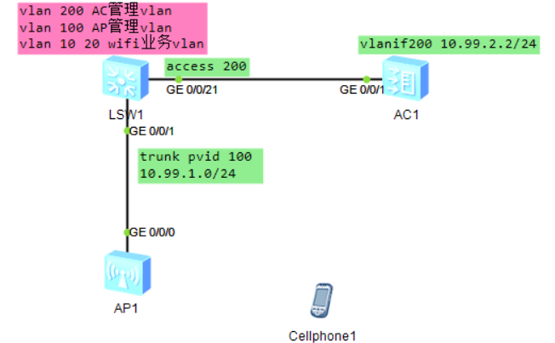

LSW1配置（做dhcp server）：
vlan batch 10 20 100 200
#
dhcp enable
#
ip pool vlan10 #业务网段的地址池
gateway-list 192.168.10.1
network 192.168.10.0 mask 255.255.255.0
#
ip pool vlan20
gateway-list 192.168.20.1 #业务网段的地址池
network 192.168.20.0 mask 255.255.255.0
#
ip pool vlan100 #ap管理网段的地址池
gateway-list 10.99.1.1
network 10.99.1.0 mask 255.255.255.0
option 43 sub-option 2 ip-address 10.99.2.2 #配置为AC的capwap监听地址
#说明：
# sub-option 1为 hex xxxxxxxx 以16进制数指定ipv4地址，报文中此字段数据长度4字节
# sub-option 2为 以点分十进制形式指定ipv4地址，，报文中此字段数据长度4字节
# sub-option 3为 以字符串ascii码形式指定ipv4地址，报文中此字段数据长度为多个字节
#也可直接使用十六进制格式配置子选项，比如：
# option 43 hex 01040A630202 #表示类型1，子选项长度4，最后4字节为ipv4地址
#
interface Vlanif10
ip address 192.168.10.1 255.255.255.0
dhcp select global
#
interface Vlanif20
ip address 192.168.20.1 255.255.255.0
dhcp select global
#
interface Vlanif100
ip address 10.99.1.1 255.255.255.0
dhcp select global
#
interface Vlanif200
ip address 10.99.2.1 255.255.255.0
#
interface GigabitEthernet0/0/1 #接AP的口
port link-type trunk
port trunk pvid vlan 100
port trunk allow-pass vlan 10 20 100
#
interface GigabitEthernet0/0/21 #接AC的口
port link-type access
port default vlan 200
#

AC1配置：
vlan batch 200
#
interface GigabitEthernet0/0/1
port link-type access
port default vlan 200
#
interface Vlanif200
ip address 10.99.2.2 255.255.255.0
#
ip route-static 0.0.0.0 0.0.0.0 10.99.2.1
#
capwap source interface Vlanif 200
#
vlan pool vlan_pool_Free-Wifi
vlan 10 20
assignment even #vlan分配算法，even（连续）或hash（随机）
#
dhcp update vlan assignment threshold 3 time 120 #当用户在120秒内从vlan对应的地址池中获取地址失败达到3次时，则vlan pool将不再给用户分配该vlan（锁定30分钟），重新分配其他vlan
#
wlan
ssid-profile name ssid_profile_Free-Wifi
ssid Free-Wifi
security-profile name sec_profile_Free-Wifi
security wpa2 psk pass-phrase Paswd_123 aes
vap-profile name vap_profile_Free-Wifi
forward-mode direct-forward #未指定时，默认就是direct-forward直接转发模式
service-vlan vlan-id 10 #只给此vap分配vlan 10
service-vlan vlan-pool vlan_pool_Free-Wifi #给此vap分配vlan pool，和前面的vlan-id配置项互斥
ssid-profile ssid_profile_Free-Wifi
security-profile sec_profile_Free-Wifi
Warning: This action may cause service interruption. Continue?[Y/N] y
regulatory-domain-profile name domain_cn
country-code CN
ap-group name ap_group_guest #创建ap-group，在组里配置国家代码及vap-profile
regulatory-domain-profile domain_cn
Warning: Modifying the country code will clear channel, power and antenna gain configurations of the radio and reset the AP. Continue?[Y/N]: y
vap-profile vap_profile_Free-Wifi wlan 1 radio 0 #wlan 1-16，radio 0-2；也可指定radio all
vap-profile vap_profile_Free-Wifi wlan 1 radio all
ap auth-mode mac-auth
ap-id 1 ap-mac 00e0-fc29-16e0 #添加AP，ap-id范围0-8191
ap-name ap_3F_308_C
ap-group ap_group_guest
Warning: This operation may cause AP reset. If the country code changes, it will clear channel, power and antenna gain configurations of the radio, Whether to continue? [Y/N]: y
quit
quit
#

AC1查看：
[AC6605] disp ap all #查看所有的ap状态
Info: This operation may take a few seconds. Please wait for a moment.done.
Total AP information:
nor : normal [1]
------------------------------------------------------------------------------------------------------
ID MAC Name Group IP Type State STA Uptime
------------------------------------------------------------------------------------------------------
1 00e0-fc29-16e0 ap_3F_308_C ap_group_guest 10.99.1.254 AP4050DN-E nor 0 9S
------------------------------------------------------------------------------------------------------
Total: 1

[AC6605] disp ap-type all #查看支持的AP型号
--------------------------------------------------------------------------------
ID Type
--------------------------------------------------------------------------------
17 AP6010SN-GN
19 AP6010DN-AGN
......
61 AP4050DN-E
62 AP4050DN-HD
64 AP430-E
65 R250D
66 R250D-E
68 AP1010SN
69 AP2050DN
70 AP2050DN-E
71 AP8130DN-W
73 AP2050DN-S
74 AP5030DN-C
--------------------------------------------------------------------------------
Total: 49

如果我们的AP型号较新，在AC上查看不到，则需要手动添加类型：
[AC6605] wlan
[AC6605-wlan-view] ap-type AirEngine5762-12 type-id 173 #添加AP类型

[AC6605] disp capwap configuration
---------------------------------------------------------------
Source interface : vlanif200
Source ip-address : -
Echo interval(seconds) : 25
Echo times : 6
Control priority(server to client) : 7
Control priority(client to server) : 7
Control-link DTLS encrypt : disable
DTLS PSK value : ******
PSK mandatroy match switch : disable
Control-link inter-controller DTLS encrypt : disable
Inter-controller DTLS PSK value : ******
IPv6 status : disable
Message-integrity PSK value : ******
Message-integrity check switch : enable
---------------------------------------------------------------

<AC6605> disp ap run-info ap-id 1 #查看ap运行信息
Info: Waiting for AP response.
--------------------------------------------------------------------------------

AP type : AP4050DN-E
Country code : CN
Software version : V200R007C10SPC300
Hardware version :
BIOS version : unknown
BOM version : 000
Memory size(MB) : 0
Flash size(MB) : 64
SD Card size(MB) : -
Manufacture : Huawei Technologies Co., Ltd.
Software vendor : Huawei Technologies Co., Ltd.
Online time(ddd:hh:mm:ss) : 3M:42S
Run time(ddd:hh:mm:ss) : 6M:4S
IP address : 10.99.1.254
IP mask : 255.255.255.0
Gateway : 10.99.1.1
DNS server : 0.0.0.0
GigabitEthernet port 0
Port speed(Mbps) : -
Port speed mode : forced
Port duplex : half
Port duplex mode : forced
Port state : up
STP down recovery time(ddd:hh:mm:ss) : -
GigabitEthernet port 1
Port speed(Mbps) : -
Port speed mode : forced
Port duplex : half
Port duplex mode : forced
Port state : down
STP down recovery time(ddd:hh:mm:ss) : -
Card status : slot 1: -, slot 2: -, slot 3: -
-------------------------------------------------------------------------------

<AC6605> disp ap performance statistics ap-id 1 #查看ap性能状态
--------------------------------------------------------------------------------
Memory usage(%) : 10
Memory average usage(%) : 10
CPU usage(%) : 1
CPU average usage(%) : 1
Available space size(KB) : 914768
Temperature(degree C) : 0
Online user number : 0
......

AP查看mac等信息：
<Huawei> disp system-information
System Information
===============================================
Serial Number : 210235448310993CB66D
System Time : 2024-10-29 04:09:25
System Up time : 31min 6sec
System Name : Huawei
Country Code : US
MAC Address : 00:e0:fc:29:16:e0

AP上线后，信息自动变更为配置的：
<ap_3F_308_C> disp system-information
System Information
===============================================
Serial Number :
System Time : 2024-10-29 06:38:27
System Up time : 7min 46sec
System Name : ap_3F_308_C
Country Code : CN
MAC Address : 00:e0:fc:29:16:e0
Radio 0 MAC Address : 00:00:00:00:00:00
Radio 1 MAC Address : 00:00:00:00:00:10
IP Address : 10.99.1.254
Subnet Mask : 255.255.255.0
Default Gateway : 10.99.1.1

AP上线后，会下发wifi业务，拓扑图中会显示其wifi信息覆盖范围
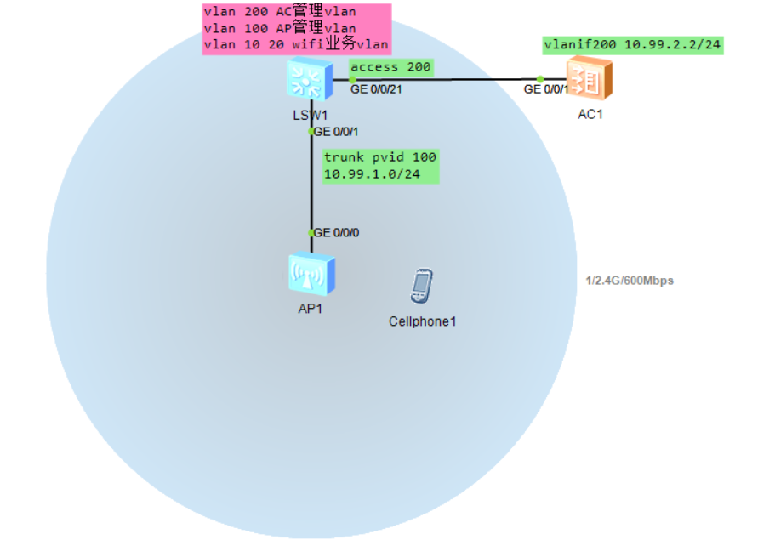

手机连接wifi：
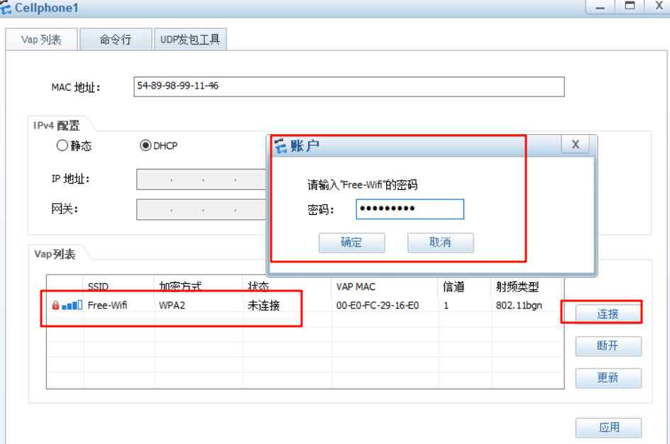

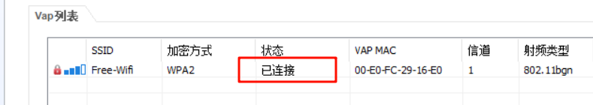

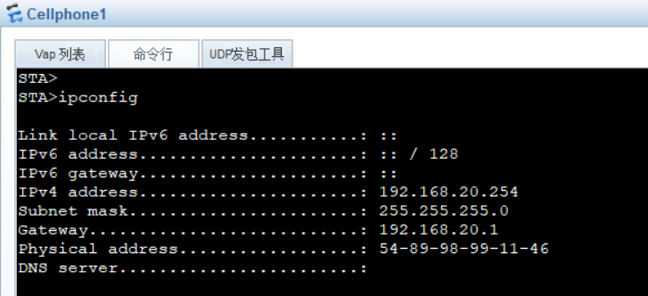

实验：WLAN_AC6605（ensp）隧道模式
拓扑如下：
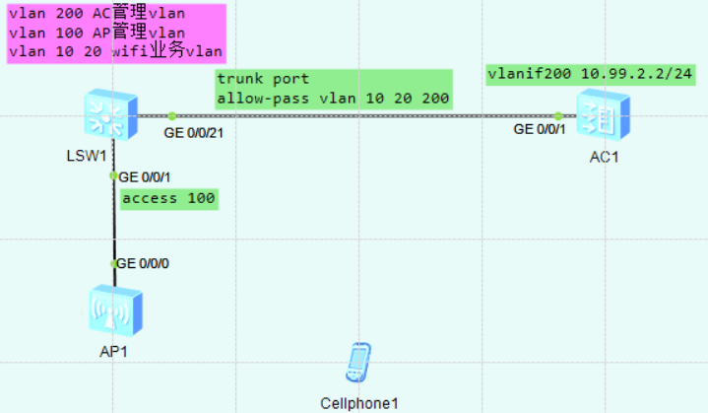

LSW1配置（做dhcp server）：
vlan batch 10 20 100 200
#
dhcp enable
#
ip pool vlan10 #业务网段的地址池
gateway-list 192.168.10.1
network 192.168.10.0 mask 255.255.255.0
#
ip pool vlan20
gateway-list 192.168.20.1 #业务网段的地址池
network 192.168.20.0 mask 255.255.255.0
#
ip pool vlan100 #ap管理网段的地址池
gateway-list 10.99.1.1
network 10.99.1.0 mask 255.255.255.0
option 43 sub-option 2 ip-address 10.99.2.2 #配置为AC的capwap监听地址
#说明：
# sub-option 1为 hex xxxxxxxx 以16进制数指定ipv4地址，报文中此字段数据长度4字节
# sub-option 2为 以点分十进制形式指定ipv4地址，，报文中此字段数据长度4字节
# sub-option 3为 以字符串ascii码形式指定ipv4地址，报文中此字段数据长度为多个字节
#也可直接使用十六进制格式配置子选项，比如：
# option 43 hex 01040A630202 #表示类型1，子选项长度4，最后4字节为ipv4地址
#
interface Vlanif10
ip address 192.168.10.1 255.255.255.0
dhcp select global
#
interface Vlanif20
ip address 192.168.20.1 255.255.255.0
dhcp select global
#
interface Vlanif100
ip address 10.99.1.1 255.255.255.0
dhcp select global
#
interface Vlanif200
ip address 10.99.2.1 255.255.255.0
#
interface GigabitEthernet0/0/1 #接AP的口
port link-type access
port default vlan 100
#
interface GigabitEthernet0/0/21 #接AC的口
port link-type trunk
port trunk allow-pass vlan 10 20 200
#

AC1配置：
vlan batch 10 20 200
#
interface GigabitEthernet0/0/1
port link-type trunk
port trunk allow-pass vlan 10 20 200
#
interface Vlanif200
ip address 10.99.2.2 255.255.255.0
#
ip route-static 0.0.0.0 0.0.0.0 10.99.2.1
#
capwap source interface Vlanif 200
#
vlan pool vlan_pool_Free-Wifi
vlan 10 20
assignment even #vlan分配算法，even（连续）或hash（随机）
#
dhcp update vlan assignment threshold 3 time 120 #当用户在120秒内从vlan对应的地址池中获取地址失败达到3次时，则vlan pool将不再给用户分配该vlan（锁定30分钟），重新分配其他vlan
#
wlan
ssid-profile name ssid_profile_Free-Wifi
ssid Free-Wifi
security-profile name sec_profile_Free-Wifi
security wpa2 psk pass-phrase Paswd_123 aes
vap-profile name vap_profile_Free-Wifi
forward-mode tunnel #指定为隧道模式，默认是direct-forward直接转发模式
service-vlan vlan-id 10 #只给此vap分配vlan 10
service-vlan vlan-pool vlan_pool_Free-Wifi #给此vap分配vlan pool，和前面的vlan-id配置项互斥
ssid-profile ssid_profile_Free-Wifi
security-profile sec_profile_Free-Wifi
Warning: This action may cause service interruption. Continue?[Y/N] y
regulatory-domain-profile name domain_cn
country-code CN
ap-group name ap_group_guest #创建ap-group，在组里配置国家代码及vap-profile
regulatory-domain-profile domain_cn
Warning: Modifying the country code will clear channel, power and antenna gain configurations of the radio and reset the AP. Continue?[Y/N]: y
vap-profile vap_profile_Free-Wifi wlan 1 radio 0 #wlan 1-16，radio 0-2；也可指定radio all
vap-profile vap_profile_Free-Wifi wlan 1 radio all #radio 0为2.4G，radio 1为5G
ap auth-mode mac-auth
ap-id 1 ap-mac 00e0-fc57-0700 #添加AP，ap-id范围0-8191
ap-name ap_3F_308_C
ap-group ap_group_guest
Warning: This operation may cause AP reset. If the country code changes, it will clear channel, power and antenna gain configurations of the radio, Whether to continue? [Y/N]: y
quit
quit
#

AC1查看：
[AC6605] disp ap all #查看所有的ap状态
Info: This operation may take a few seconds. Please wait for a moment.done.
Total AP information:
nor : normal [1]
--------------------------------------------------------------------------------------------
ID MAC Name Group IP Type State STA Uptime
--------------------------------------------------------------------------------------------
1 00e0-fc57-0700 ap_3F_308_C ap_group_guest 10.99.1.254 AP4050DN-E nor 1 6M:15S
--------------------------------------------------------------------------------------------
Total: 1

手机连接wifi
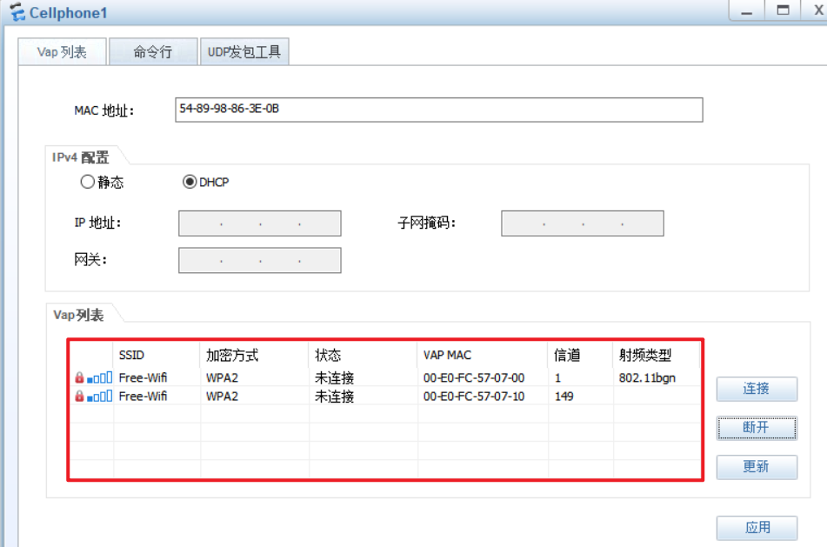

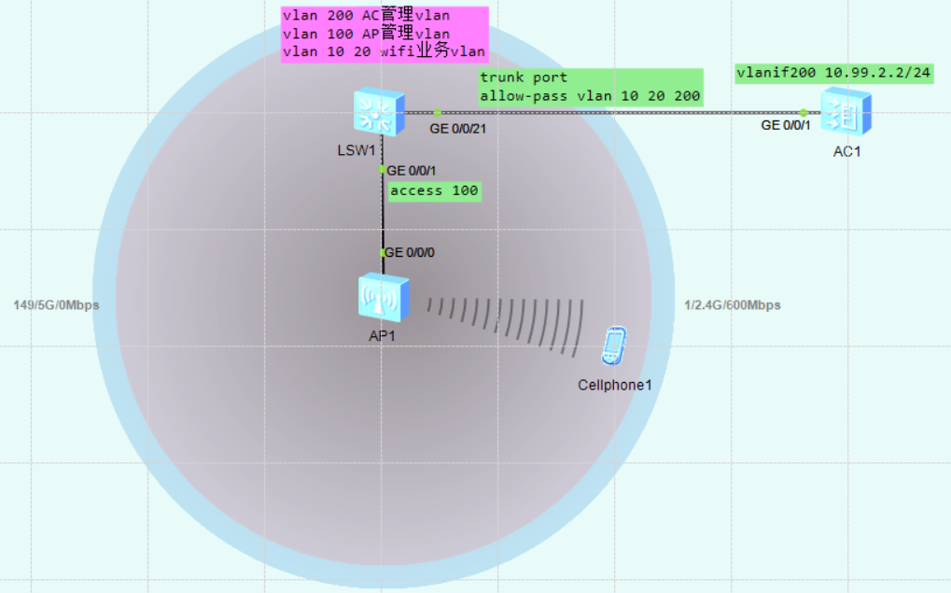

wifi流量封装在capwap协议里
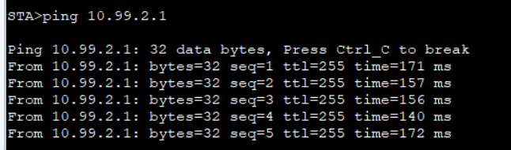

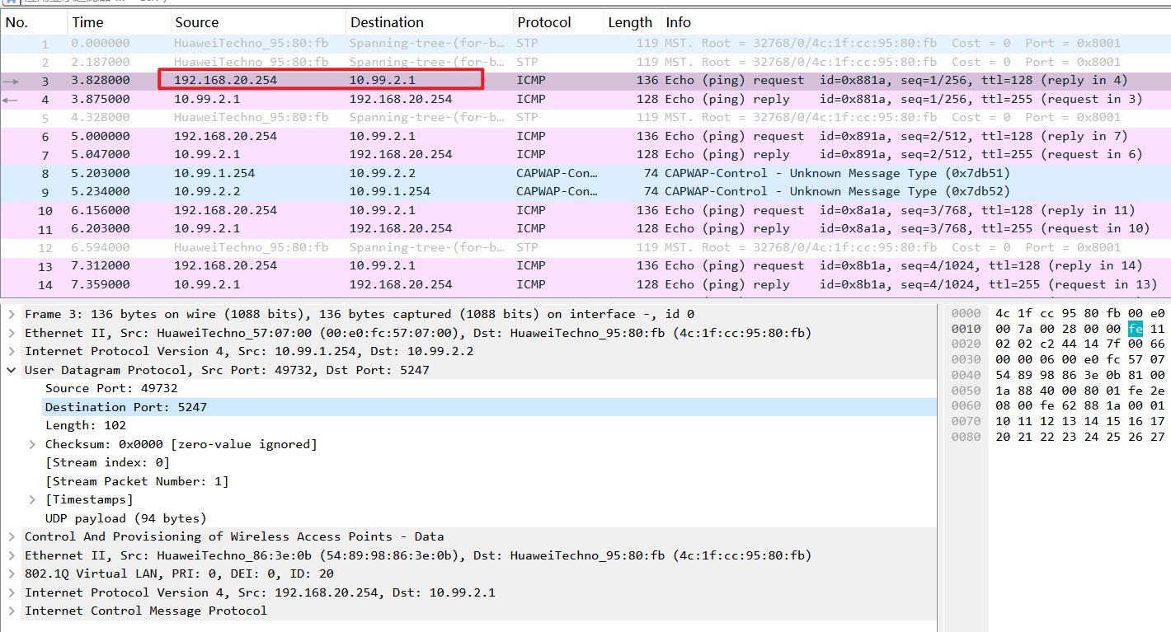

实验：WLAN_AC（ensp_pro）
拓扑如下：
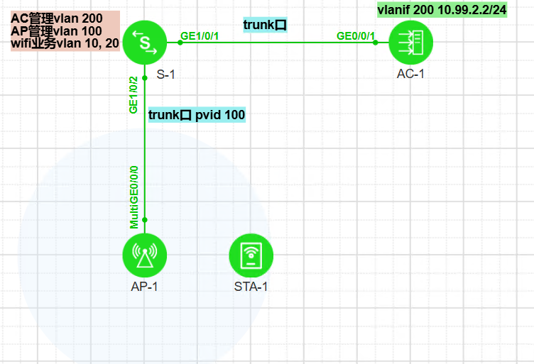

AC配置：
wlan
temporary-management psk Passwordxxx
ap username admin password cipher Passwordxxx
#
capwap dtls psk Passwordxxx
capwap source interface vlanif 1
#

---------------------------------------------

★附录（软件、文档、序列号查询）

★设备软件下载地址
https://support.huawei.com/enterprise/zh/switches/cloudengine-s5735s-h24s4xc-a-pid-251695484/software?offeringId=6691579

★设备序列号查询维保信息
https://support.huawei.com/enterprise/ecareWechat
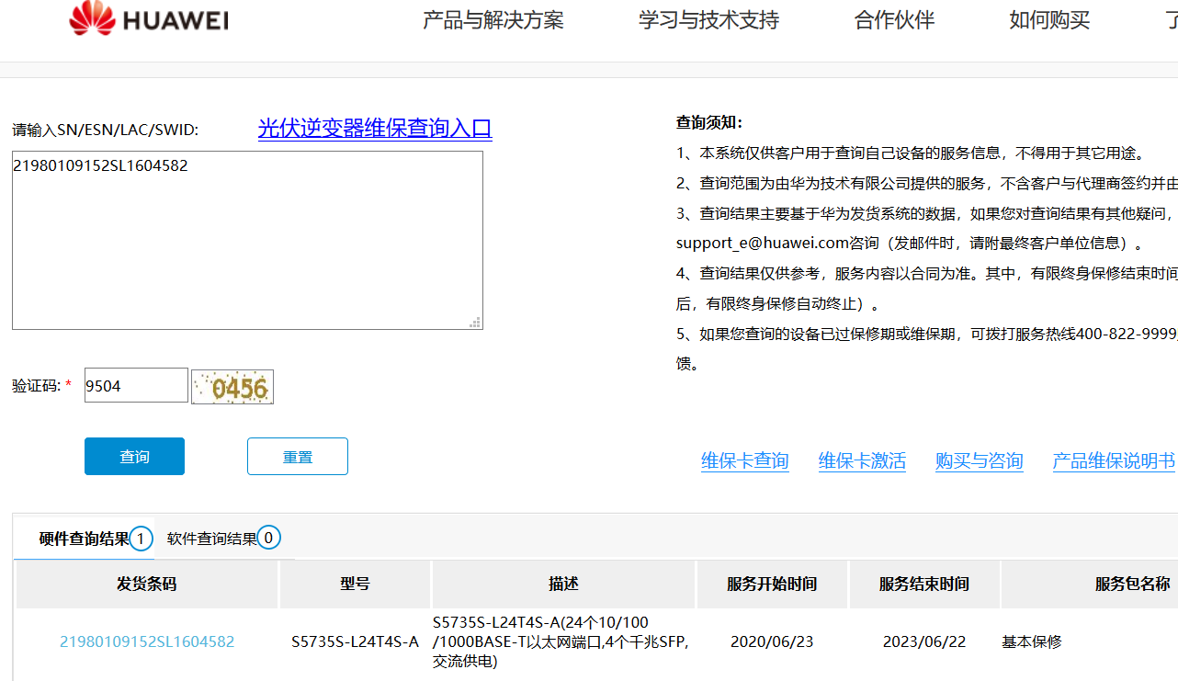

★防火墙病毒库升级
系统→升级中心，如果防火墙无法访问外网，可以点击本地升级，导入下载好的更新包

特征库更新包下载地址：
https://isecurity.huawei.com/sec/web/freesignature.do#
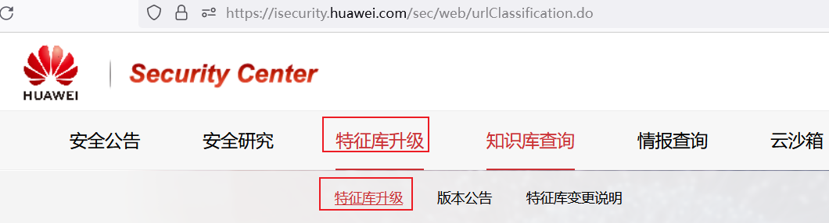
要先注册账号：
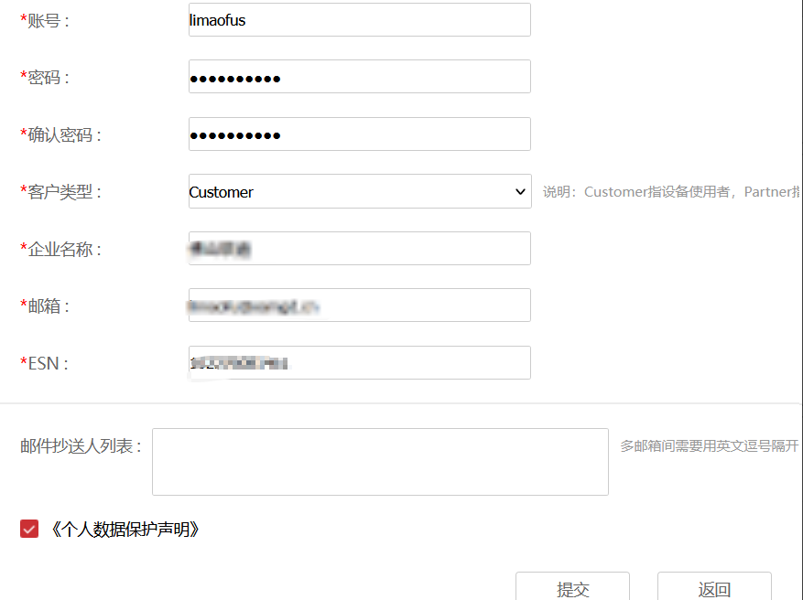
注册成功后，再根据目标防火墙的型号去下载相应版本的病毒库特征库等压缩包

★附录（hccn_tool命令）
华为atlas设备的npu网卡默认在操作系统里无法显示，不可用ip addr或ifconfig命令操作，
得安装npu驱动后再使用hccn_tool命令操作

参考地址： https://support.huawei.com/enterprise/zh/doc/EDOC1100257828/eead0d2f

